MANUAL TEST REPORT
Online Food Ordering System
Manual Test Case Design & Testing Levels
Black-box design (BVA, ECP, Cause–Effect Graph, Decision Table) · White-box testing & source code coverage · Unit, Integration, System & Acceptance testing

TEAM 4
Name | Register Number (RA) | Responsibility
Bhaskar Lukram | RA2311033010003 | Test planning, test scenarios, Boundary Value Analysis
Khushi Raghav | RA2311033010015 | Equivalence Class Partitioning, Cause–Effect Graph, Decision Table
Kartik Gupta | RA2311033010045 | White-box testing, code coverage, unit & integration testing
Ayush Pandey | RA2311033010044 | System & acceptance testing, defect reporting

Application | FOODIE: Online Food Ordering System (test build)
Document type | Manual Test Report (test design, execution, defects)
Version / Date | 1.0 · October 2026
Total test cases | 10 executed · 7 passed · 3 failed · pass rate 70%
Defects | 3 (1 Critical, 2 Major)

Table of Contents
Table of Contents 2
1. Introduction 4
1.1 Purpose 4
1.2 Application Overview 4
1.3 Scope 4
1.4 Business Rules Under Test 4
1.5 Test Environment 4
1.6 Test Approach, Entry & Exit Criteria 4
1.7 Severity & Priority Definitions 5
2. Test Scenarios 5
3. Black-Box Test Case Design 6
3.1 Boundary Value Analysis (BVA) 6
3.2 Equivalence Class Partitioning (ECP) 6
3.3 Cause–Effect Graphing 7
3.4 Decision Table 8
4. White-Box Testing & Source Code Coverage 10
4.1 Source Code Under Test 10
4.2 Control Flow Graph 10
4.3 Cyclomatic Complexity 11
4.4 Independent Paths and Test Data (TC-05) 11
4.5 Source Code Coverage Problems 11
5. Test Case Design for Testing Levels 13
5.1 Unit Testing 13
5.2 Integration Testing 13
5.3 System Testing 13
5.4 Acceptance Testing 13
6. Test Cases 15
6.1 Test Case Summary 15
6.2 Detailed Test Cases 15
TC-01: Verify item quantity boundaries in the cart 15
TC-02: Verify delivery fee at the free-delivery threshold 16
TC-03: Verify mobile number validation on registration 16
TC-04: Verify coupon application rules 17
TC-05: Verify calculateTotal() through all basis paths 17
TC-06: Verify amount flows correctly from cart to billing to payment 18
TC-07: Verify end-to-end order placement and tracking 18
TC-08: Verify order handling when payment fails 19
TC-09: Verify layout, session timeout and page load 19
TC-10: User acceptance of the ordering flow 19
7. Test Execution Results 21
8. Defect Reports 22
8.1 Defect Summary 22
8.2 Detailed Defect Reports 22
BUG-01: Cart accepts quantity 11 when typed manually 22
BUG-02: ₹40 delivery fee charged at exactly ₹199 23
BUG-03: Order status shows “Placed” after payment fails 23
9. Requirement Traceability Matrix 24
10. Conclusion & Recommendations 24
10.1 Key Findings 24
10.2 Exit Criteria Status 24
10.3 Recommendation 24
10.4 Team Members 24

1. Introduction

1.1 Purpose
This report documents the complete manual testing of the Online Food Ordering System (FOODIE). Test cases were designed with black-box techniques (Boundary Value Analysis, Equivalence Class Partitioning, Cause–Effect Graphing and Decision Tables) and white-box techniques (control flow graph, cyclomatic complexity and source code coverage). They were executed across the four testing levels: unit, integration, system and acceptance. The results, defects and the final release recommendation are recorded here.

1.2 Application Overview
FOODIE lets a customer register with a mobile number, search restaurants, add dishes to a cart, apply a coupon, pay online (UPI / card) and track the order until delivery.

1.3 Scope
- In scope: Registration & login (auth), menu & search, cart, billing & coupons, payment, order tracking.
- Out of scope: Restaurant/admin portal, real bank settlement, load/stress testing beyond basic page-load timing, security penetration testing.

1.4 Business Rules Under Test
Table 1: Business rules (requirements) used as the test basis
Rule ID | Requirement
BR-01 | Mobile number must be exactly 10 digits and start with 6, 7, 8 or 9.
BR-02 | Quantity of a single dish in the cart must be between 1 and 10 (inclusive).
BR-03 | Delivery is free when the item subtotal is ₹199 or more; otherwise a ₹40 fee applies.
BR-04 | A coupon applies only if the code exists, is not expired and the cart total is ≥ ₹299; otherwise the matching error message is shown.
BR-05 | The payable total can never be negative.
BR-06 | If payment fails, the order must NOT be placed; the user sees “Payment failed” and can retry.
BR-07 | Pages load in under 3 s; session expires after 15 min idle; layout works on a 360 px mobile screen.

1.5 Test Environment
Table 2: Test environment
Item | Details
Application build | FOODIE test build (defect-evidence build)
Client | Google Chrome (mobile view 360×800 and desktop 1920×1080)
Operating systems | Android 14 (mobile), Windows 11 (desktop)
Payment | Sandbox UPI / card gateway (success and decline modes)
Unit testing | Test driver calling billing functions directly; payment gateway stub
Evidence | Device screenshots attached to each defect report

1.6 Test Approach, Entry & Exit Criteria
- Approach: Requirements were split into 6 scenarios. Test cases were derived with BVA, ECP, cause–effect graphing and decision tables (black-box), and with basis-path testing (white-box). Each test case is data-driven: one test case runs several test values.
- Entry criteria: Test build deployed, test data and sandbox payment available, requirements frozen.
- Exit criteria: All planned test cases executed, 100% statement and branch coverage of the billing function, no open Critical defect, all Major defects fixed or accepted.

1.7 Severity & Priority Definitions
Table 3: Severity and priority scale
Level | Meaning
Critical | Breaks a core business flow or causes financial loss; no workaround.
Major | Wrong functional behaviour with business impact; a workaround exists.
Minor | Cosmetic or message issue with little impact.
P1 / P2 / P3 | Fix immediately / fix before release / fix when possible.

2. Test Scenarios
Each module the customer interacts with was mapped to one high-level test scenario.
Table 4: Test scenarios
Scenario ID | Module | Test Scenario | Linked Test Cases
TS-01 | auth | Register and log in with a mobile number | TC-03
TS-02 | menu | Search restaurants and browse the menu | TC-07, TC-10
TS-03 | cart | Add, update and remove items in the cart | TC-01, TC-06
TS-04 | billing | Apply coupon and compute the bill total | TC-02, TC-04, TC-05, TC-06
TS-05 | payment | Check out and pay online | TC-06, TC-07, TC-08
TS-06 | tracking | Track the order status | TC-07, TC-10
All | all | Non-functional: layout, session timeout, page load | TC-09

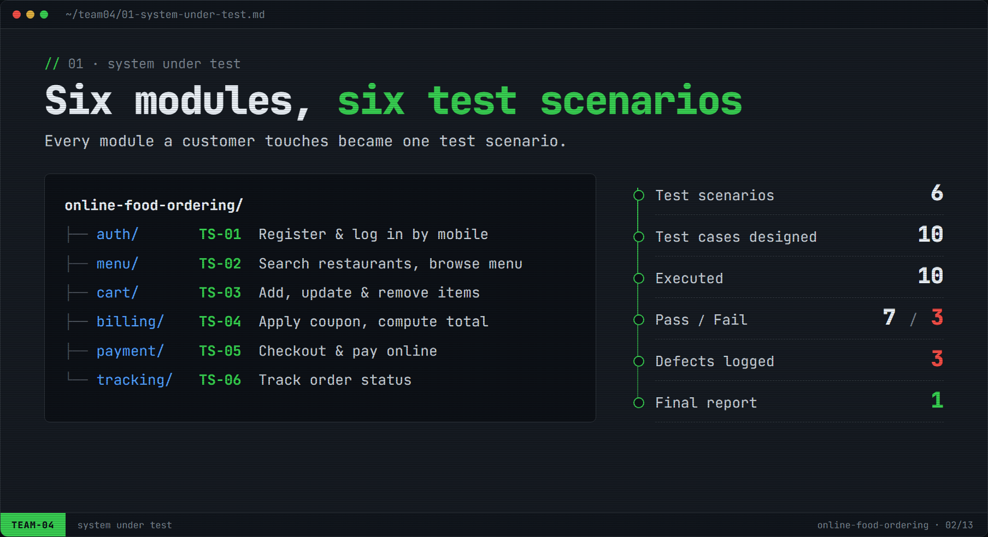
Figure 1: Modules, scenarios and testing pipeline

3. Black-Box Test Case Design
Black-box techniques derive test cases from the requirements only, without looking at the code.

3.1 Boundary Value Analysis (BVA)
Errors cluster at the edges of input ranges. For a range [min, max] we test min−1, min, min+1, max−1, max and max+1. BVA was applied to BR-02 (quantity 1–10) in TC-01 and to BR-03 (free-delivery threshold ₹199) in TC-02.
Table 5: TC-01: BVA test values for item quantity (valid range 1–10)
Value | Boundary | Expected | Actual | Result
0 | min − 1 | Rejected | Rejected | PASS
1 | min | Accepted | Accepted | PASS
2 | min + 1 | Accepted | Accepted | PASS
9 | max − 1 | Accepted | Accepted | PASS
10 | max | Accepted | Accepted | PASS
11 | max + 1 | Rejected | Accepted (11 in cart) | FAIL → BUG-01

Table 6: TC-02: BVA test values for the free-delivery threshold (≥ ₹199)
Subtotal | Boundary | Expected fee | Actual fee | Result
₹198 | just below | ₹40 | ₹40 | PASS
₹199 | on boundary | ₹0 (free) | ₹40 | FAIL → BUG-02
₹200 | just above | ₹0 (free) | ₹0 | PASS

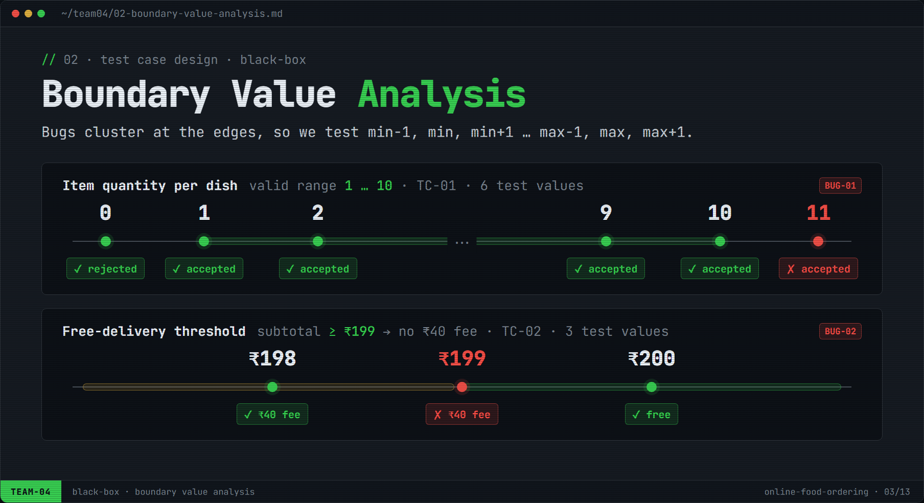
Figure 2: Boundary value analysis on quantity and delivery threshold

3.2 Equivalence Class Partitioning (ECP)
Inputs that the system treats the same way form one equivalence class; one representative value per class is enough. For BR-01 (mobile number) there is one valid and four invalid classes, tested together in TC-03.
Table 7: TC-03: Equivalence classes for the mobile number field
Class | Type | Description | Representative | Expected | Actual | Result
V1 | Valid | 10 digits, starts 6–9 | 9876543210 | Accepted | Accepted | PASS
I1 | Invalid | Fewer than 10 digits | 98765 | Rejected | Rejected | PASS
I2 | Invalid | More than 10 digits | 98765432101 | Rejected | Rejected | PASS
I3 | Invalid | Contains letters/symbols | 98765abcde | Rejected | Rejected | PASS
I4 | Invalid | Starts with 0–5 | 1234567890 | Rejected | Rejected | PASS

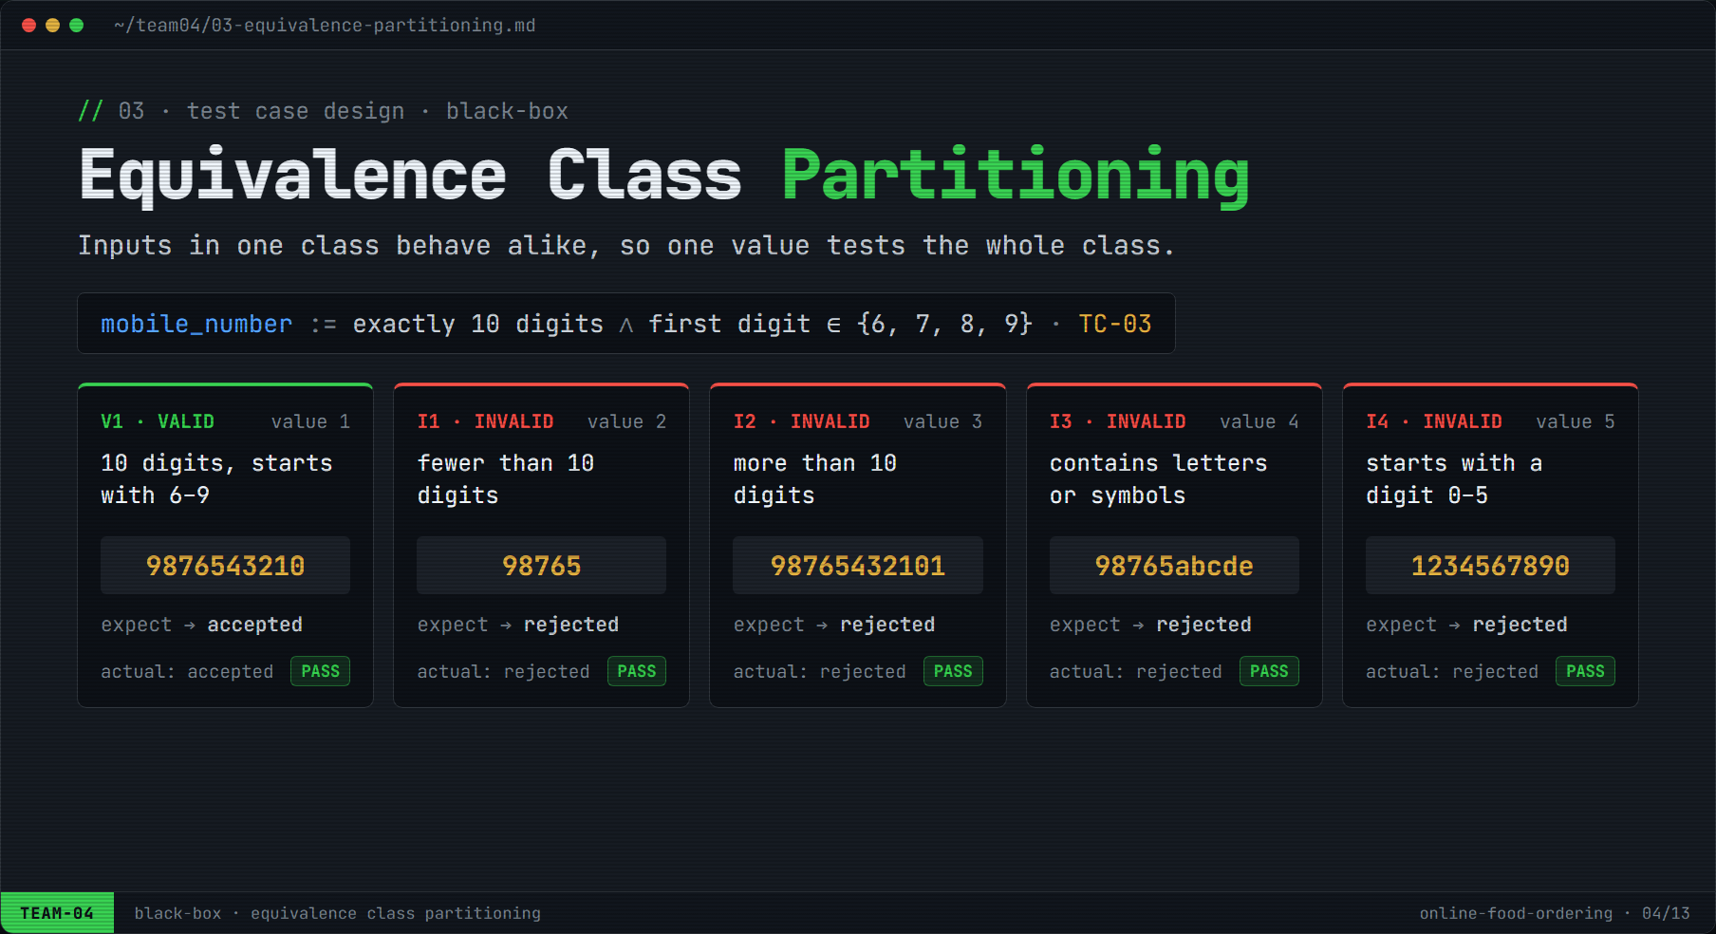
Figure 3: Equivalence class partitioning of the mobile number

3.3 Cause–Effect Graphing
The coupon feature (BR-04) depends on several conditions at once, so it was modelled as a cause–effect graph. Causes are input conditions, effects are system responses.
Table 8: Causes and effects for applying a coupon
ID | Cause (input condition) | ID | Effect (system response)
C1 | Coupon code exists | E1 | Discount applied
C2 | Coupon is not expired | E2 | Message “invalid coupon”
C3 | Cart total ≥ ₹299 | E3 | Message “coupon expired”
 |  | E4 | Message “add ₹X more”

Boolean relationships derived from the graph:
E1 = C1 AND C2 AND C3
E4 = C1 AND C2 AND NOT C3
E3 = C1 AND NOT C2
E2 = NOT C1

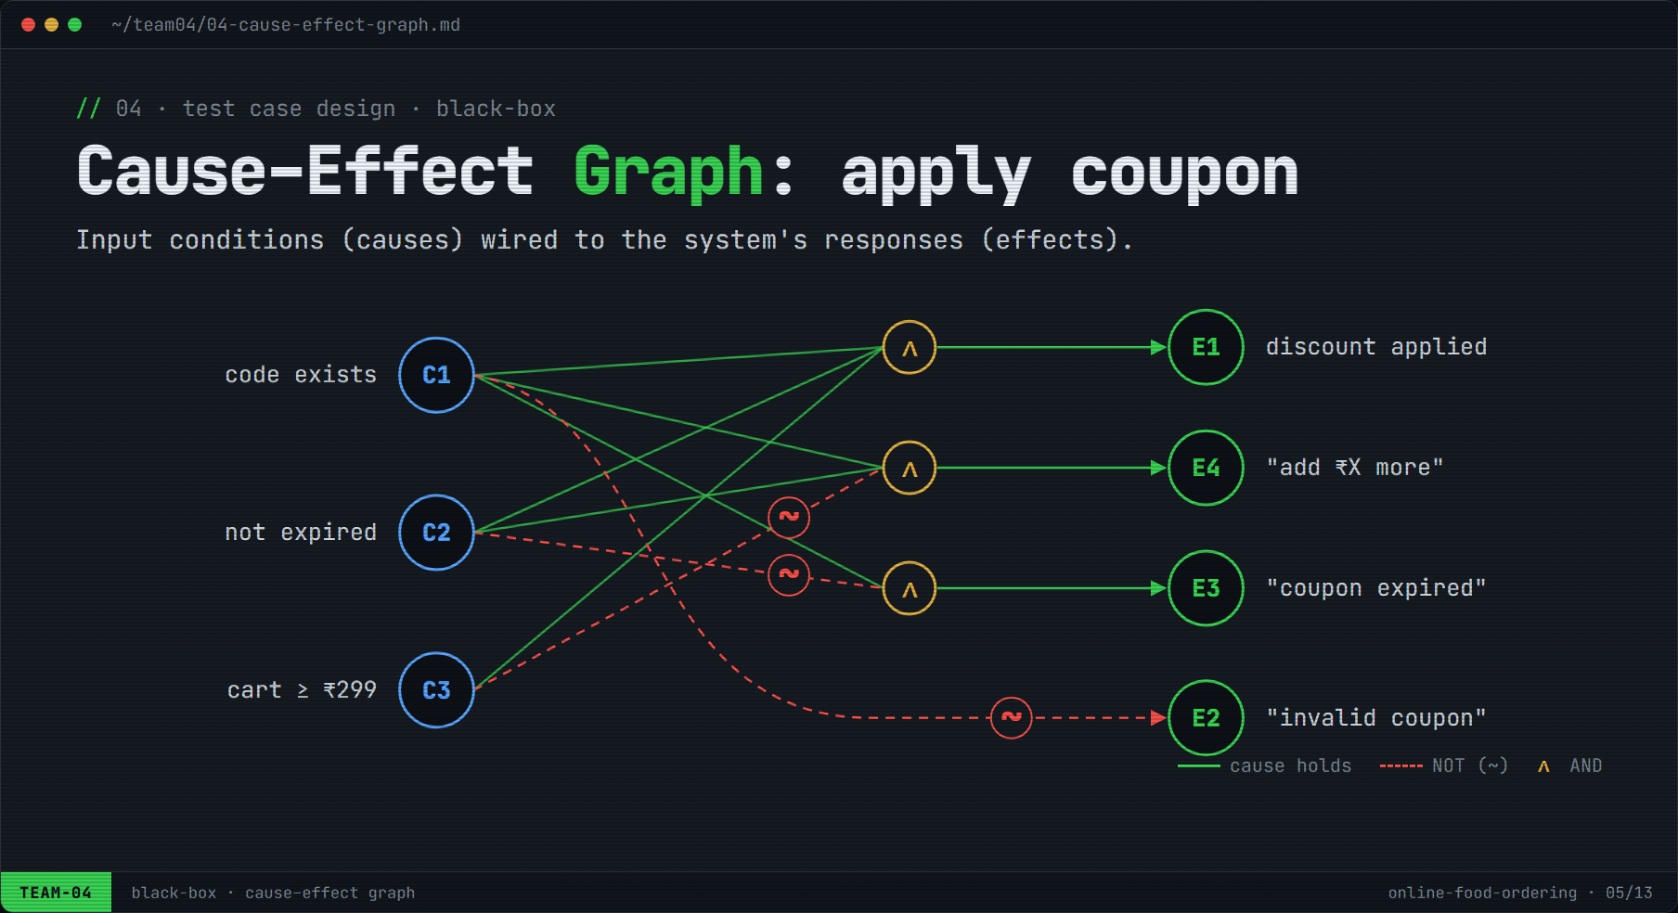
Figure 4: Cause–effect graph for applying a coupon (∧ = AND, dashed ~ = NOT)

3.4 Decision Table
The graph was converted to a decision table. Three binary conditions give 2³ = 8 combinations; using don't-care entries (–) they reduce to 4 rules without losing coverage. Each rule is one test value of TC-04.
Table 9: TC-04: Decision table for applying a coupon
Conditions / Actions | R1 | R2 | R3 | R4
C1 Coupon code exists | F | T | T | T
C2 Coupon not expired | – | F | T | T
C3 Cart total ≥ ₹299 | – | – | F | T
E1 Apply discount |  |  |  | ✓
E2 Show “invalid coupon” | ✓
E3 Show “coupon expired” |  | ✓
E4 Show “add ₹X more” |  |  | ✓
Test data | FOOD99X, cart ₹350 | SUMMER50 (expired), ₹350 | FEAST100, cart ₹250 | FEAST100, cart ₹350
Result | PASS | PASS | PASS | PASS

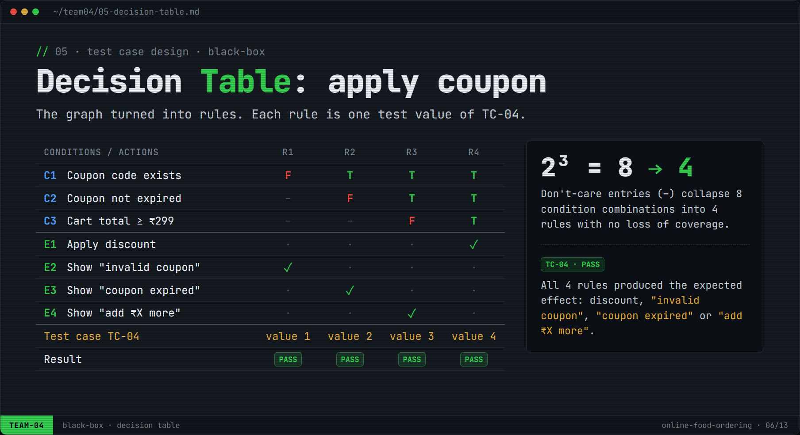
Figure 5: Decision table derived from the cause–effect graph

4. White-Box Testing & Source Code Coverage
White-box testing uses the source code. The billing function calculateTotal() was analysed with a control flow graph (CFG), its cyclomatic complexity was computed, independent paths were tested (TC-05) and statement, branch and path coverage were measured.

4.1 Source Code Under Test
1 function calculateTotal(subtotal, discount) {
2 let total = subtotal;
3 if (subtotal <= 199) { // BUG-02: should be < 199
4 total = total + 40; // delivery fee
5 }
6 if (discount > 0) {
7 total = total - discount;
8 }
9 if (total < 0) {
10 total = 0;
11 }
12 return total;
13 }

4.2 Control Flow Graph
Table 10: CFG nodes
Node | Source lines | Type
A | L2–L3 | Decision: subtotal <= 199
B | L4 | Add ₹40 delivery fee
C | L6 | Decision: discount > 0
D | L7 | Subtract discount
E | L9 | Decision: total < 0
F | L10 | Reset total to 0
G | L12 | Return total (exit)

Edges (9): A→B, A→C, B→C, C→D, C→E, D→E, E→F, E→G, F→G. Nodes (7): A–G. Predicate (decision) nodes (3): A, C, E.
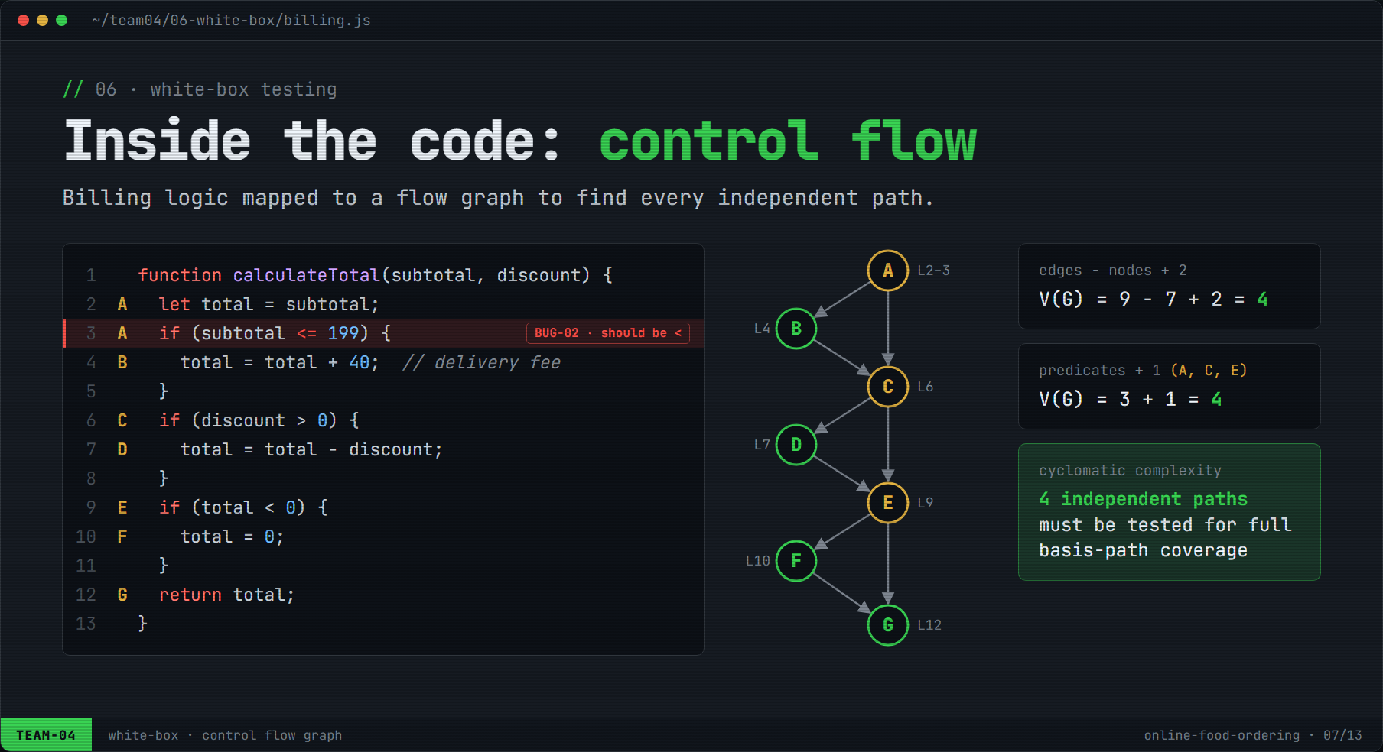
Figure 6: Source code, control flow graph and cyclomatic complexity

4.3 Cyclomatic Complexity
Method 1: V(G) = E − N + 2 = 9 − 7 + 2 = 4
Method 2: V(G) = P + 1 = 3 + 1 = 4
Method 3: V(G) = number of regions in the CFG = 4

Therefore at least 4 test cases (independent paths) are needed for full basis-path coverage.

4.4 Independent Paths and Test Data (TC-05)
Table 11: Basis paths executed in TC-05
Path | Route | Input (subtotal, discount) | Expected | Actual | Result
P1 | A→C→E→G | (₹250, ₹0) | ₹250 | ₹250 | PASS
P2 | A→B→C→E→G | (₹150, ₹0) | ₹190 | ₹190 | PASS
P3 | A→C→D→E→G | (₹300, ₹100) | ₹200 | ₹200 | PASS
P4 | A→B→C→D→E→F→G | (₹50, ₹100)* | ₹0 | ₹0 | PASS

* P4 cannot be reached through the user interface (a coupon requires a cart ≥ ₹299, so the discount never exceeds the total). It was executed at unit level through a test driver.

4.5 Source Code Coverage Problems
Executable statements: L2, L3, L4, L6, L7, L9, L10, L12 = 8. Branch outcomes: 3 decisions × 2 (true/false) = 6. Independent paths: V(G) = 4.
Problem 1: coverage achieved by the black-box (UI) tests alone, i.e. paths P1–P3.
Statement coverage = statements executed / total statements × 100
= 7 / 8 × 100 = 87.5 % (L10 never executed)
Branch coverage = branch outcomes taken / total outcomes × 100
= 5 / 6 × 100 = 83.3 % (E-true never taken)
Path coverage = paths executed / V(G) × 100
= 3 / 4 × 100 = 75 %

Problem 2: coverage after adding the white-box unit test for path P4.
Statement coverage = 8 / 8 × 100 = 100 %
Branch coverage = 6 / 6 × 100 = 100 %
Path coverage = 4 / 4 × 100 = 100 %

Table 12: Coverage summary for calculateTotal()
Coverage metric | Black-box only (P1–P3) | After white-box (P1–P4)
Statement | 7/8 = 87.5% | 8/8 = 100%
Branch (decision) | 5/6 = 83.3% | 6/6 = 100%
Condition | 5/6 = 83.3% | 6/6 = 100%
Basis path | 3/4 = 75% | 4/4 = 100%

Each decision contains a single atomic condition, so condition coverage equals branch coverage.
Note: Key observation: 100% path coverage did not reveal BUG-02, because none of the basis-path inputs lies exactly on ₹199. The defect was found by BVA (TC-02) and its root cause (the <= operator on line 3) was located by code review during white-box analysis. Black-box and white-box testing complement each other.
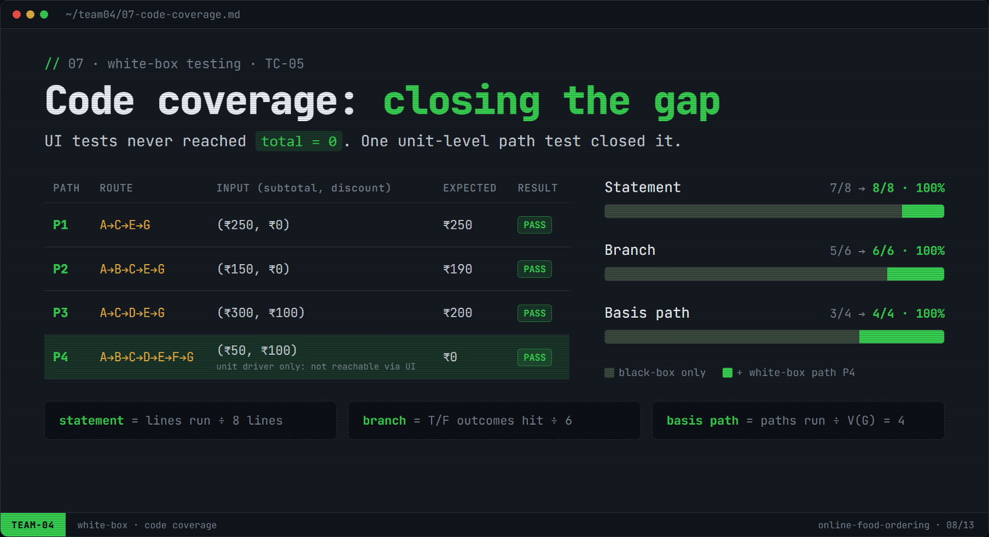
Figure 7: Basis paths and coverage before and after white-box testing

5. Test Case Design for Testing Levels
Table 13: Test design per testing level
Level | Objective | Technique / setup | Test cases | Result
Unit | Verify a single function in isolation | White-box basis paths; driver calls the function; payment gateway replaced by a stub | TC-05 | PASS
Integration | Verify modules work together | Bottom-up: cart + billing → + coupon → + payment; stubs replaced one at a time | TC-06 | PASS
System | Verify the complete application end to end | Black-box functional, negative and non-functional tests on the full build | TC-07, TC-08, TC-09 | 2 PASS / 1 FAIL
Acceptance | Confirm readiness for real customers | Alpha UAT with 4 users outside the team against acceptance criteria | TC-10 | PASS

5.1 Unit Testing
calculateTotal() was tested through all 4 basis paths (TC-05). validateMobile() and applyCoupon() were also exercised in isolation with the ECP and decision-table data. A test driver supplied inputs and compared return values; the payment gateway was replaced by a stub that returns a fixed response.

5.2 Integration Testing
A bottom-up strategy was used: cart and billing were integrated first, then the coupon module, then payment. TC-06 verified that data passes correctly across interfaces: cart subtotal → bill total → amount received by the payment module.
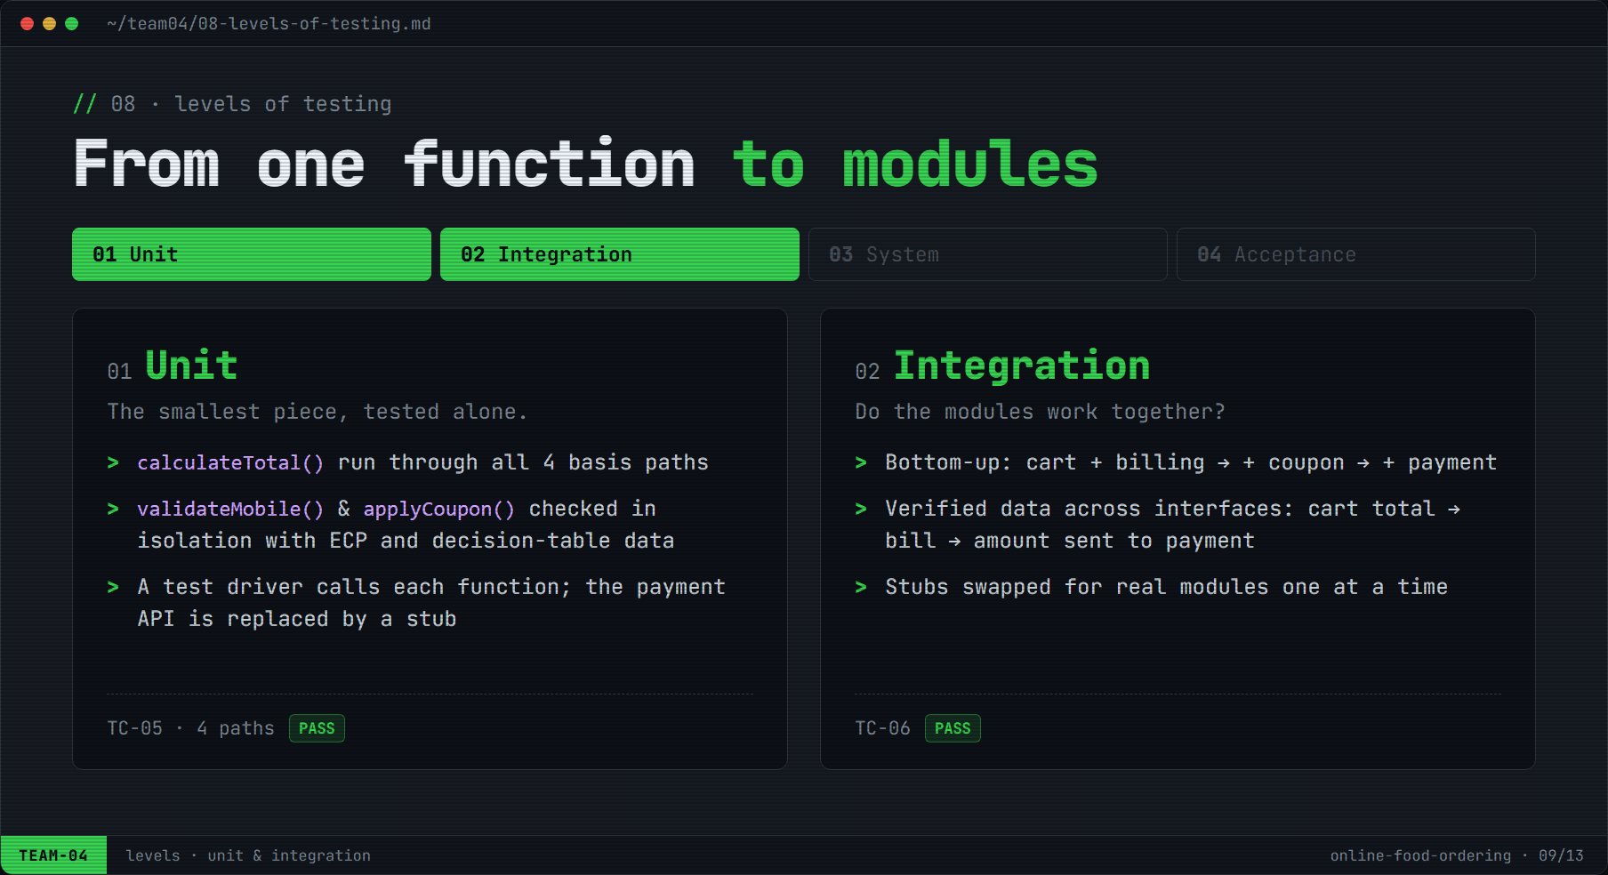
Figure 8: Unit and integration testing

5.3 System Testing
The full application was tested as a black box: the end-to-end order flow (TC-07), the payment-failure negative path (TC-08) and non-functional requirements such as layout, session timeout and page load (TC-09). TC-08 revealed the critical defect BUG-03.

5.4 Acceptance Testing
Alpha user acceptance testing (TC-10) used these acceptance criteria:
- AC-1: A first-time user can place an order in under 2 minutes without help.
- AC-2: The bill (items, fee, discount, total) is correct.
- AC-3: Order status updates are shown live until delivery.
All criteria were met. Sign-off is conditional on fixing BUG-03.
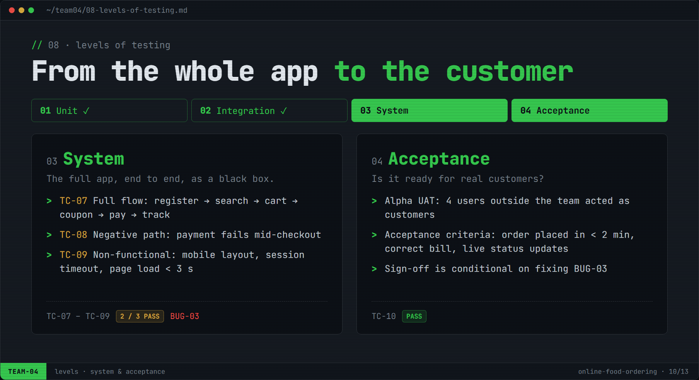
Figure 9: System and acceptance testing

6. Test Cases

6.1 Test Case Summary
Table 14: Test case summary
TC ID | Title | Module | Technique / Level | Status | Defect
TC-01 | Item quantity boundaries in cart | cart | BVA | FAIL | BUG-01
TC-02 | Delivery fee at free-delivery threshold | billing | BVA | FAIL | BUG-02
TC-03 | Mobile number validation | auth | ECP | PASS | –
TC-04 | Coupon application rules | billing | Cause–effect + decision table | PASS | –
TC-05 | calculateTotal() basis paths | billing | White-box / Unit | PASS | –
TC-06 | Amount flow cart → bill → payment | cart, billing, payment | Integration | PASS | –
TC-07 | End-to-end order placement | all | System | PASS | –
TC-08 | Order handling when payment fails | payment | System (negative) | FAIL | BUG-03
TC-09 | Layout, session timeout, page load | all | System (non-functional) | PASS | –
TC-10 | User acceptance of ordering flow | all | Acceptance (alpha) | PASS | –

6.2 Detailed Test Cases

TC-01: Verify item quantity boundaries in the cart
Test Case ID | TC-01
Scenario | TS-03
Module | cart
Technique / Level | Black-box · Boundary Value Analysis (BR-02)
Priority | High
Preconditions | User is logged in. Restaurant “Burger Corner” is open; “Classic Chicken Burger” (₹219) is available.
Test Steps | 1. Open the Burger Corner menu.  2. Add “Classic Chicken Burger” to the cart.  3. In the cart, type each test value into the quantity field and confirm.  4. Observe whether the quantity is accepted and the item total updates.
Test Data | Quantity = 0, 1, 2, 9, 10, 11
Expected Result | 0 and 11 rejected with “Quantity must be between 1 and 10”; 1, 2, 9, 10 accepted.
Actual Result | 0 rejected; 1, 2, 9, 10 accepted; 11 ACCEPTED: 11 items in cart, item total ₹2,409.
Status | FAIL
Defect ID | BUG-01
Executed by | Bhaskar Lukram · Oct 2026

TC-02: Verify delivery fee at the free-delivery threshold
Test Case ID | TC-02
Scenario | TS-04
Module | billing
Technique / Level | Black-box · Boundary Value Analysis (BR-03)
Priority | High
Preconditions | User is logged in; delivery address “Home, Chennai” saved; cart is empty.
Test Steps | 1. Add test-catalogue items so that the item subtotal equals the test value.  2. Proceed to checkout.  3. Read the delivery fee and “To pay” amount in Bill details.
Test Data | Subtotal = ₹198, ₹199, ₹200
Expected Result | ₹198 → fee ₹40 (pay ₹238); ₹199 → fee ₹0 (pay ₹199); ₹200 → fee ₹0 (pay ₹200).
Actual Result | ₹198 → ₹40; ₹199 → fee ₹40 charged, to pay ₹239; ₹200 → ₹0.
Status | FAIL
Defect ID | BUG-02
Executed by | Bhaskar Lukram · Oct 2026

TC-03: Verify mobile number validation on registration
Test Case ID | TC-03
Scenario | TS-01
Module | auth
Technique / Level | Black-box · Equivalence Class Partitioning (BR-01)
Priority | Medium
Preconditions | App opened on the Register screen; user not logged in.
Test Steps | 1. Enter the test value in the mobile number field.  2. Tap “Send OTP”.  3. Observe whether an OTP is sent or a validation error is shown.  4. Repeat for each value.
Test Data | 9876543210 (V1), 98765 (I1), 98765432101 (I2), 98765abcde (I3), 1234567890 (I4)
Expected Result | Only 9876543210 accepted (OTP sent); all others show “Enter a valid 10-digit mobile number”.
Actual Result | As expected for all five values.
Status | PASS
Defect ID | –
Executed by | Khushi Raghav · Oct 2026

TC-04: Verify coupon application rules
Test Case ID | TC-04
Scenario | TS-04
Module | billing
Technique / Level | Black-box · Cause–Effect Graph & Decision Table (BR-04)
Priority | High
Preconditions | User is logged in. Coupons: FEAST100 (valid, ₹100 off, min ₹299), SUMMER50 (expired 30-Jun-2026).
Test Steps | 1. Build a cart with the stated total.  2. Open “Apply coupon” and enter the code.  3. Tap Apply and observe the message and the bill.
Test Data | R1: FOOD99X, ₹350 · R2: SUMMER50, ₹350 · R3: FEAST100, ₹250 · R4: FEAST100, ₹350
Expected Result | R1 “invalid coupon”; R2 “coupon expired”; R3 “add ₹49 more”; R4 ₹100 off, total ₹250.
Actual Result | All four rules behaved as expected.
Status | PASS
Defect ID | –
Executed by | Khushi Raghav · Oct 2026

TC-05: Verify calculateTotal() through all basis paths
Test Case ID | TC-05
Scenario | TS-04
Module | billing
Technique / Level | White-box · Basis path testing · Unit level
Priority | High
Preconditions | Unit test driver available for calculateTotal(); payment gateway replaced by a stub.
Test Steps | 1. Call calculateTotal(subtotal, discount) with each input pair through the driver.  2. Compare the returned value with the expected total.  3. Record the path covered.
Test Data | P1 (250, 0) · P2 (150, 0) · P3 (300, 100) · P4 (50, 100)
Expected Result | ₹250 · ₹190 · ₹200 · ₹0
Actual Result | ₹250 · ₹190 · ₹200 · ₹0. Coverage: statement, branch and path 100%.
Status | PASS
Defect ID | –
Executed by | Kartik Gupta · Oct 2026

TC-06: Verify amount flows correctly from cart to billing to payment
Test Case ID | TC-06
Scenario | TS-03, TS-04, TS-05
Module | cart, billing, coupon, payment
Technique / Level | Integration testing (bottom-up)
Priority | High
Preconditions | Cart, billing and coupon modules integrated; payment module integrated with sandbox gateway that logs the amount received.
Test Steps | 1. Add 2 × “Veg Biryani” (₹180 each) to the cart.  2. Apply coupon FEAST100.  3. Proceed to pay.  4. Compare cart subtotal, bill total and amount received by payment.
Test Data | 2 × ₹180, coupon FEAST100
Expected Result | Subtotal ₹360, discount ₹100, delivery ₹0, total ₹260; payment receives ₹260.
Actual Result | Values matched at every interface.
Status | PASS
Defect ID | –
Executed by | Kartik Gupta · Oct 2026

TC-07: Verify end-to-end order placement and tracking
Test Case ID | TC-07
Scenario | TS-02, TS-05, TS-06
Module | all
Technique / Level | System testing (functional)
Priority | High
Preconditions | Registered user; sandbox payment set to success.
Test Steps | 1. Log in.  2. Search “Pizza” and open a restaurant.  3. Add an item and apply a valid coupon.  4. Pay via UPI.  5. Open order tracking and follow the status.
Test Data | Sandbox UPI: success
Expected Result | Order confirmed; status moves Placed → Preparing → Out for delivery → Delivered.
Actual Result | As expected.
Status | PASS
Defect ID | –
Executed by | Ayush Pandey · Oct 2026

TC-08: Verify order handling when payment fails
Test Case ID | TC-08
Scenario | TS-05
Module | payment
Technique / Level | System testing (negative path, BR-06)
Priority | Critical
Preconditions | User logged in; cart worth ₹438; sandbox UPI set to decline.
Test Steps | 1. Proceed to pay and choose UPI.  2. Let the sandbox decline the transaction.  3. Return to the app and open the order status screen.
Test Data | Amount ₹438, sandbox UPI: decline
Expected Result | “Payment failed” shown; order not placed / cancelled; “Retry payment” offered.
Actual Result | Order #FO10482 shows “Order Placed” while payment status is “Failed”.
Status | FAIL
Defect ID | BUG-03
Executed by | Ayush Pandey · Oct 2026

TC-09: Verify layout, session timeout and page load
Test Case ID | TC-09
Scenario | All
Module | all
Technique / Level | System testing (non-functional, BR-07)
Priority | Medium
Preconditions | App available on a 360×800 mobile viewport and on desktop; 4G network throttling enabled.
Test Steps | 1. Open home, menu, cart and checkout on the mobile viewport; check for overlap or horizontal scroll.  2. Stay idle for 15 minutes, then perform an action.  3. Measure home page load time.
Test Data | Viewport 360×800; idle 15 min; 4G profile
Expected Result | No layout issues; session expires and asks to log in; load < 3 s.
Actual Result | Layout correct; session expired as required; load time 1.8 s.
Status | PASS
Defect ID | –
Executed by | Kartik Gupta · Oct 2026

TC-10: User acceptance of the ordering flow
Test Case ID | TC-10
Scenario | TS-02 – TS-06
Module | all
Technique / Level | Acceptance testing (alpha UAT)
Priority | High
Preconditions | 4 users from outside the team; acceptance criteria AC-1 to AC-3 agreed.
Test Steps | 1. Each user places an order without guidance; time is recorded.  2. Bill is checked against a manual calculation.  3. Users watch the status updates.
Test Data | 4 users, 1 order each
Expected Result | AC-1 order < 2 min; AC-2 bill correct; AC-3 live status updates.
Actual Result | Average 1 min 20 s; all bills correct; status updated live.
Status | PASS
Defect ID | –
Executed by | Ayush Pandey · Oct 2026

7. Test Execution Results
Table 15: Execution summary
Metric | Value
Test cases planned | 10
Test cases executed | 10
Passed | 7
Failed | 3
Pass rate | 70%
Defects raised | 3 (1 Critical, 2 Major)

Table 16: Results by technique and testing level
Category | Test cases | Executed | Passed | Failed
Black-box design (BVA, ECP, CEG/DT) | TC-01 – TC-04 | 4 | 2 | 2
Unit (white-box) | TC-05 | 1 | 1 | 0
Integration | TC-06 | 1 | 1 | 0
System | TC-07 – TC-09 | 3 | 2 | 1
Acceptance | TC-10 | 1 | 1 | 0
Total |  | 10 | 7 | 3

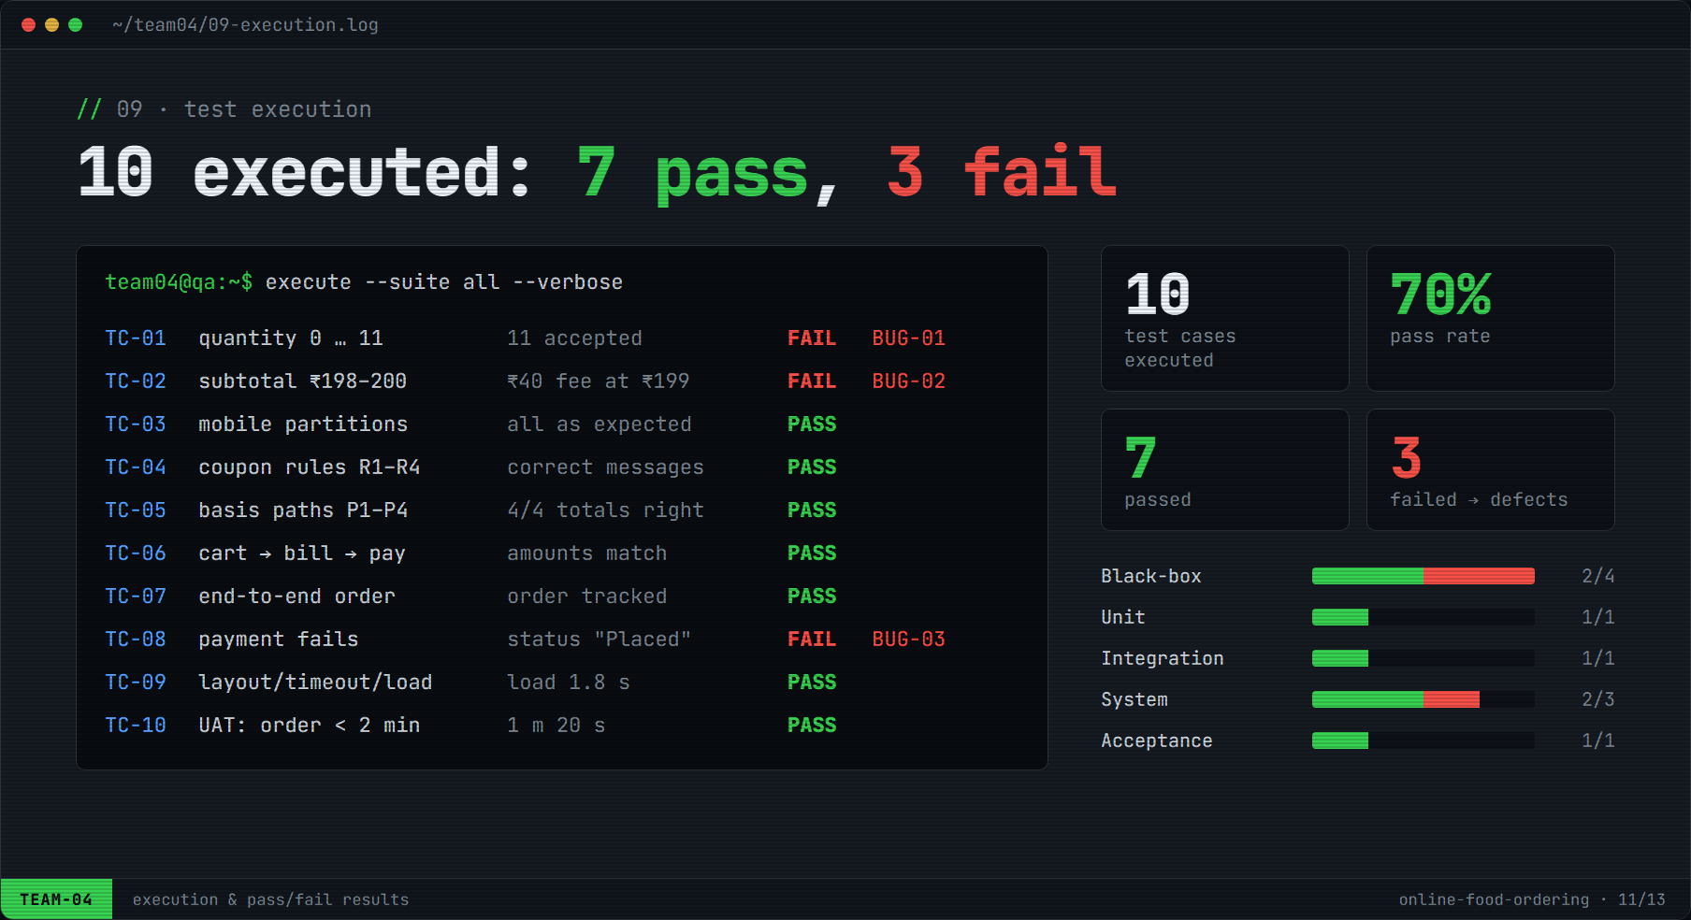
Figure 10: Execution log and pass/fail results

8. Defect Reports

8.1 Defect Summary
Table 17: Defect summary
Defect ID | Title | Module | Linked TC | Severity | Priority | Status
BUG-01 | Quantity 11 accepted when typed manually | cart | TC-01 | Major | P2 | Open
BUG-02 | ₹40 delivery fee charged at exactly ₹199 | billing | TC-02 | Major | P2 | Open
BUG-03 | Order shows “Placed” after payment fails | payment | TC-08 | Critical | P1 | Open

8.2 Detailed Defect Reports

BUG-01: Cart accepts quantity 11 when typed manually
 | 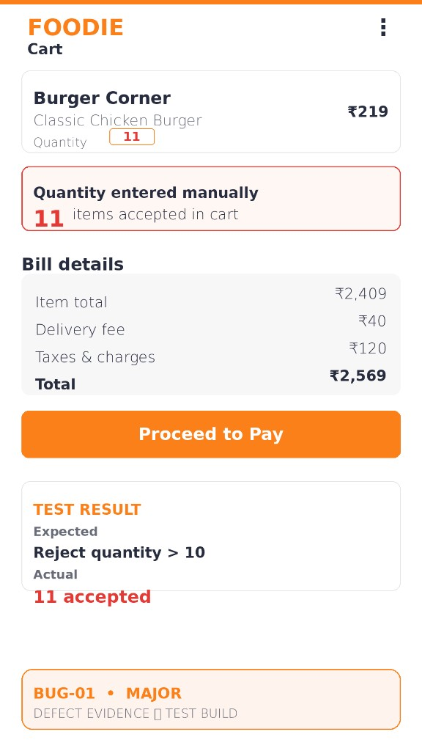  Figure 11: BUG-01 screenshot evidence
  Defect ID | BUG-01
  Title | Cart accepts quantity 11 when typed manually
  Module | cart
  Linked Test Case | TC-01 (BVA)
  Severity | Major
  Priority | P2: fix before release
  Status | Open
  Environment | FOODIE test build · Chrome on Android 14 (360×800)
  Reported by / Date | Bhaskar Lukram · Oct 2026
  Steps to Reproduce | 1. Log in and open “Burger Corner”.  2. Add “Classic Chicken Burger” (₹219) to the cart.  3. Tap the quantity field and type 11.  4. Confirm the value.
  Expected Result | Quantity above 10 is rejected with “Quantity must be between 1 and 10”.
  Actual Result | 11 items are accepted in the cart; item total ₹2,409 and total ₹2,569. The “+” button stops at 10, but typed input bypasses the limit.
  Root Cause (analysis) | The upper limit is enforced only by the stepper button; typed input is not validated on the client or the server.
  Suggested Fix | Validate the quantity field on input and on the server; clamp or reject values outside 1–10.

BUG-02: ₹40 delivery fee charged at exactly ₹199
 | 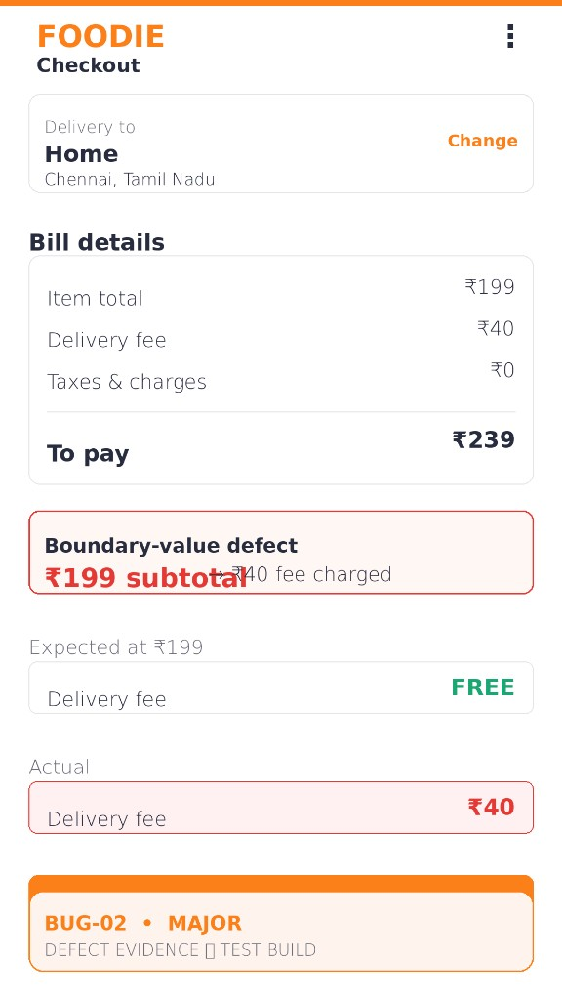  Figure 12: BUG-02 screenshot evidence
  Defect ID | BUG-02
  Title | ₹40 delivery fee charged at exactly ₹199
  Module | billing
  Linked Test Case | TC-02 (BVA), confirmed by white-box review
  Severity | Major
  Priority | P2: fix before release
  Status | Open
  Environment | FOODIE test build · Chrome on Android 14 (360×800)
  Reported by / Date | Bhaskar Lukram · Oct 2026
  Steps to Reproduce | 1. Log in; set delivery address to Home, Chennai.  2. Add items so the item total is exactly ₹199.  3. Proceed to checkout and view Bill details.
  Expected Result | Delivery fee FREE (₹0); to pay ₹199.
  Actual Result | Delivery fee ₹40; to pay ₹239.
  Root Cause (analysis) | calculateTotal() line 3 uses “subtotal <= 199” instead of “subtotal < 199” (off-by-one boundary error).
  Suggested Fix | Change the condition to “subtotal < 199” and add a regression test at ₹198, ₹199 and ₹200.

BUG-03: Order status shows “Placed” after payment fails
 | 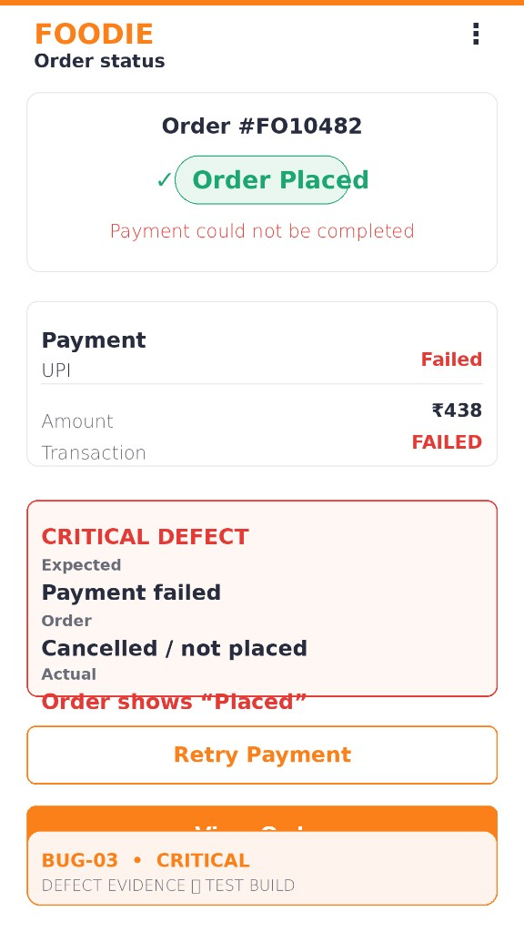  Figure 13: BUG-03 screenshot evidence
  Defect ID | BUG-03
  Title | Order status shows “Placed” after payment fails
  Module | payment
  Linked Test Case | TC-08 (System, negative)
  Severity | Critical
  Priority | P1: fix immediately
  Status | Open
  Environment | FOODIE test build · Chrome on Android 14 (360×800)
  Reported by / Date | Ayush Pandey · Oct 2026
  Steps to Reproduce | 1. Log in and build a cart worth ₹438.  2. Proceed to pay with UPI.  3. Let the transaction fail (sandbox decline).  4. Open the order status screen.
  Expected Result | “Payment failed” is shown; the order is cancelled / not placed; “Retry payment” is offered.
  Actual Result | Order #FO10482 shows a green “Order Placed” badge while Payment = Failed and Transaction = FAILED; the screen also says “Payment could not be completed”.
  Root Cause (analysis) | The order is saved with status “Placed” before the payment result is confirmed; the failure callback does not roll the status back.
  Suggested Fix | Create orders as “Pending payment”; set “Placed” only on a success callback and “Payment failed / Cancelled” on failure. Add a system test for every payment outcome.

9. Requirement Traceability Matrix
Table 18: Requirement traceability matrix
Requirement | Scenario | Test case(s) | Result | Defect
BR-01 Mobile number format | TS-01 | TC-03 | PASS | –
BR-02 Quantity 1–10 | TS-03 | TC-01 | FAIL | BUG-01
BR-03 Free delivery ≥ ₹199 | TS-04 | TC-02, TC-05 | FAIL | BUG-02
BR-04 Coupon rules | TS-04 | TC-04, TC-06 | PASS | –
BR-05 Total never negative | TS-04 | TC-05 | PASS | –
BR-06 No order on failed payment | TS-05 | TC-08 | FAIL | BUG-03
BR-07 Non-functional | All | TC-09 | PASS | –
End-to-end ordering & acceptance | TS-02, TS-05, TS-06 | TC-07, TC-10 | PASS | –

10. Conclusion & Recommendations
Ten test cases covering six scenarios were designed and executed on the Online Food Ordering System. Seven passed and three failed (70% pass rate). White-box testing achieved 100% statement, branch and path coverage of the billing function. Three defects were raised: one Critical and two Major.

10.1 Key Findings
- Edges hide bugs: Boundary value analysis found 2 of the 3 defects (BUG-01, BUG-02), both exactly at a boundary.
- Code reveals causes: White-box review traced BUG-02 to a single operator and raised coverage from 87.5% / 83.3% / 75% to 100%.
- Every level counts: The critical BUG-03 appeared only in end-to-end system testing; unit and integration tests could not detect it.

10.2 Exit Criteria Status
Table 19: Exit criteria
Exit criterion | Status
All planned test cases executed | Met (10/10)
100% statement and branch coverage of billing function | Met
No open Critical defect | Not met (BUG-03 open)
All Major defects fixed or accepted | Not met (BUG-01, BUG-02 open)

10.3 Recommendation
Verdict: The build is NOT READY for release. Fix BUG-03 (P1) and BUG-01 / BUG-02 (P2), then re-execute TC-01, TC-02 and TC-08 (confirmation testing) and run a full regression of all 10 test cases before sign-off.

10.4 Team Members
RA Number | Student Name | Role in testing
RA2311033010003 | Bhaskar Lukram | Test planning, test scenarios, Boundary Value Analysis
RA2311033010015 | Khushi Raghav | Equivalence Class Partitioning, Cause–Effect Graph, Decision Table
RA2311033010045 | Kartik Gupta | White-box testing, code coverage, unit & integration testing
RA2311033010044 | Ayush Pandey | System & acceptance testing, defect reporting

