MANUAL TEST REPORT
Online Food Ordering System
Manual Test Case Design & Testing Levels
Black-box design (BVA, ECP, Cause–Effect Graph, Decision Table) · White-box testing & source code coverage · Unit, Integration, System & Acceptance testing

TEAM 4
Name | Register Number (RA) | Responsibility
Bhaskar Lukram | RA______________ | Test planning, test scenarios, Boundary Value Analysis
Khushi Raghav | RA______________ | Equivalence Class Partitioning, Cause–Effect Graph, Decision Table
Kartik Gupta | RA______________ | White-box testing, code coverage, unit & integration testing
Ayush Pandey | RA______________ | System & acceptance testing, defect reporting

Application | FOODIE: Online Food Ordering System (test build)
Document type | Manual Test Report (test design, execution, defects)
Version / Date | 1.0 · October 2026
Total test cases | 10 executed · 7 passed · 3 failed · pass rate 70%
Defects | 3 (1 Critical, 2 Major)

1. Introduction
This report documents the manual testing of FOODIE, an Online Food Ordering System where a customer registers with a mobile number, adds dishes to a cart, applies a coupon, pays online and tracks the order. Test cases were designed with black-box techniques (BVA, ECP, Cause–Effect Graphing, Decision Tables) and white-box techniques (control flow graph, cyclomatic complexity, code coverage), and were executed at the unit, integration, system and acceptance levels.

1.1 Business Rules Under Test
Table 1: Business rules used as the test basis
Rule ID | Requirement
BR-01 | Mobile number must be exactly 10 digits and start with 6, 7, 8 or 9.
BR-02 | Quantity of a single dish in the cart must be between 1 and 10.
BR-03 | Delivery is free when the item subtotal is ₹199 or more; otherwise a ₹40 fee applies.
BR-04 | A coupon applies only if the code exists, is not expired and the cart total is ≥ ₹299.
BR-05 | The payable total can never be negative.
BR-06 | If payment fails, the order must NOT be placed; the user can retry.
BR-07 | Pages load in under 3 s; session expires after 15 min idle; layout works on a 360 px screen.

1.2 Test Scenarios
Table 2: Test scenarios
Scenario ID | Module | Test scenario | Test cases
TS-01 | auth | Register and log in with a mobile number | TC-03
TS-02 | menu | Search restaurants and browse the menu | TC-07, TC-10
TS-03 | cart | Add, update and remove items in the cart | TC-01, TC-06
TS-04 | billing | Apply coupon and compute the bill total | TC-02, TC-04, TC-05, TC-06
TS-05 | payment | Check out and pay online | TC-06, TC-07, TC-08
TS-06 | tracking | Track the order status | TC-07, TC-10
All | all | Non-functional: layout, session timeout, page load | TC-09

1.3 Environment and Criteria
- Environment: FOODIE test build on Chrome (Android 14, 360×800 and Windows 11, 1920×1080); sandbox UPI/card gateway; unit test driver with a payment stub.
- Entry criteria: Build deployed, test data and sandbox payment available, requirements frozen.
- Exit criteria: All test cases executed, 100% statement and branch coverage of the billing function, no open Critical defect, all Major defects fixed or accepted.
- Severity / priority: Critical = core flow broken, no workaround; Major = wrong behaviour, workaround exists. P1 = fix immediately; P2 = fix before release.

2. Black-Box Test Case Design

2.1 Boundary Value Analysis (TC-01, TC-02)
For a range [min, max] we test min−1, min, min+1, max−1, max and max+1, because errors cluster at the edges.
Table 3: TC-01: item quantity (valid range 1–10)
Quantity | Boundary | Expected | Actual | Result
0 | min − 1 | Rejected | Rejected | PASS
1 | min | Accepted | Accepted | PASS
2 | min + 1 | Accepted | Accepted | PASS
9 | max − 1 | Accepted | Accepted | PASS
10 | max | Accepted | Accepted | PASS
11 | max + 1 | Rejected | Accepted (11 in cart) | FAIL → BUG-01

Table 4: TC-02: free-delivery threshold (≥ ₹199)
Subtotal | Boundary | Expected fee | Actual fee | Result
₹198 | just below | ₹40 | ₹40 | PASS
₹199 | on boundary | ₹0 (free) | ₹40 | FAIL → BUG-02
₹200 | just above | ₹0 (free) | ₹0 | PASS

2.2 Equivalence Class Partitioning (TC-03)
Inputs treated the same way form one class, so one representative value per class is enough.
Table 5: TC-03: equivalence classes for the mobile number
Class | Type | Description | Value | Expected | Actual | Result
V1 | Valid | 10 digits, starts 6–9 | 9876543210 | Accepted | Accepted | PASS
I1 | Invalid | Fewer than 10 digits | 98765 | Rejected | Rejected | PASS
I2 | Invalid | More than 10 digits | 98765432101 | Rejected | Rejected | PASS
I3 | Invalid | Letters or symbols | 98765abcde | Rejected | Rejected | PASS
I4 | Invalid | Starts with 0–5 | 1234567890 | Rejected | Rejected | PASS

2.3 Cause–Effect Graph (TC-04)
Table 6: Causes and effects for applying a coupon
ID | Cause (input condition) | ID | Effect (system response)
C1 | Coupon code exists | E1 | Discount applied
C2 | Coupon is not expired | E2 | Message “invalid coupon”
C3 | Cart total ≥ ₹299 | E3 | Message “coupon expired”
 |  | E4 | Message “add ₹X more”

E1 = C1 AND C2 AND C3 E3 = C1 AND NOT C2
E4 = C1 AND C2 AND NOT C3 E2 = NOT C1

2.4 Decision Table (TC-04)
Three conditions give 2³ = 8 combinations; don't-care entries (–) reduce them to 4 rules.
Table 7: TC-04: decision table for applying a coupon
Conditions / Actions | R1 | R2 | R3 | R4
C1 Coupon code exists | F | T | T | T
C2 Coupon not expired | – | F | T | T
C3 Cart total ≥ ₹299 | – | – | F | T
E1 Apply discount |  |  |  | ✓
E2 “invalid coupon” | ✓
E3 “coupon expired” |  | ✓
E4 “add ₹X more” |  |  | ✓
Test data | FOOD99X, ₹350 | SUMMER50, ₹350 | FEAST100, ₹250 | FEAST100, ₹350
Result | PASS | PASS | PASS | PASS

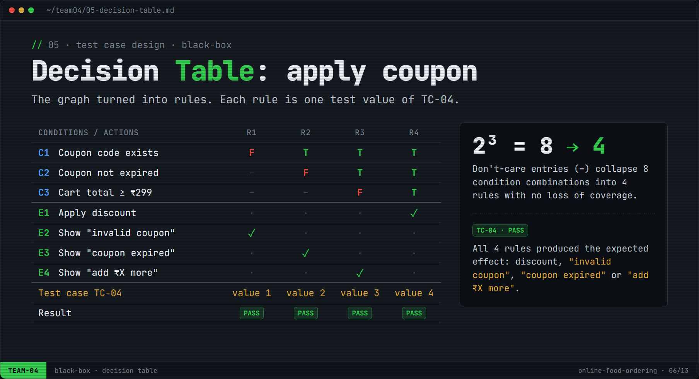
Figure 1: Decision table derived from the cause–effect graph

3. White-Box Testing & Code Coverage
The billing function calculateTotal() was analysed with a control flow graph (CFG), its cyclomatic complexity was computed, all independent paths were tested (TC-05) and coverage was measured.
1 function calculateTotal(subtotal, discount) {
2 let total = subtotal;
3 if (subtotal <= 199) { // BUG-02: should be < 199
4 total = total + 40; // delivery fee
5 }
6 if (discount > 0) {
7 total = total - discount;
8 }
9 if (total < 0) {
10 total = 0;
11 }
12 return total;
13 }

CFG nodes: A (L2–3, decision), B (L4), C (L6, decision), D (L7), E (L9, decision), F (L10), G (L12, exit). Edges (9): A→B, A→C, B→C, C→D, C→E, D→E, E→F, E→G, F→G.
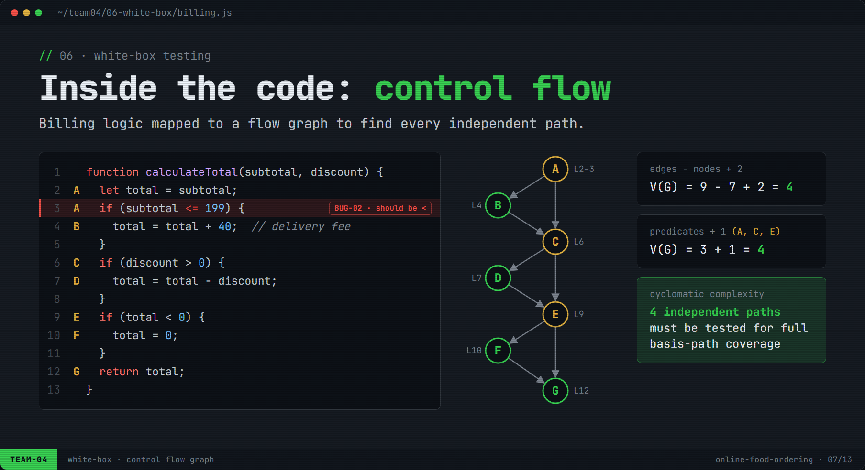
Figure 2: Source code, control flow graph and cyclomatic complexity

3.1 Cyclomatic Complexity and Basis Paths (TC-05)
V(G) = E − N + 2 = 9 − 7 + 2 = 4 V(G) = P + 1 = 3 + 1 = 4 Regions = 4

Table 8: Basis paths executed in TC-05
Path | Route | Input (subtotal, discount) | Expected | Actual | Result
P1 | A→C→E→G | (₹250, ₹0) | ₹250 | ₹250 | PASS
P2 | A→B→C→E→G | (₹150, ₹0) | ₹190 | ₹190 | PASS
P3 | A→C→D→E→G | (₹300, ₹100) | ₹200 | ₹200 | PASS
P4 | A→B→C→D→E→F→G | (₹50, ₹100)* | ₹0 | ₹0 | PASS

* P4 is not reachable from the UI (a coupon needs a cart ≥ ₹299), so it was run through a unit test driver.

3.2 Code Coverage Problems
Statements: 8 (L2, L3, L4, L6, L7, L9, L10, L12). Branch outcomes: 3 decisions × 2 = 6. Paths: V(G) = 4.
Problem 1: black-box tests only (P1–P3)
Statement = 7/8 × 100 = 87.5 % (L10 never executed)
Branch = 5/6 × 100 = 83.3 % (E-true never taken)
Path = 3/4 × 100 = 75 %
Problem 2: after adding the white-box unit test for P4
Statement = 8/8 = 100 % Branch = 6/6 = 100 % Path = 4/4 = 100 %

Note: 100% path coverage did not reveal BUG-02 because no basis-path input lies exactly on ₹199. BVA found it (TC-02) and code review located the cause (<= on line 3), so black-box and white-box testing complement each other.
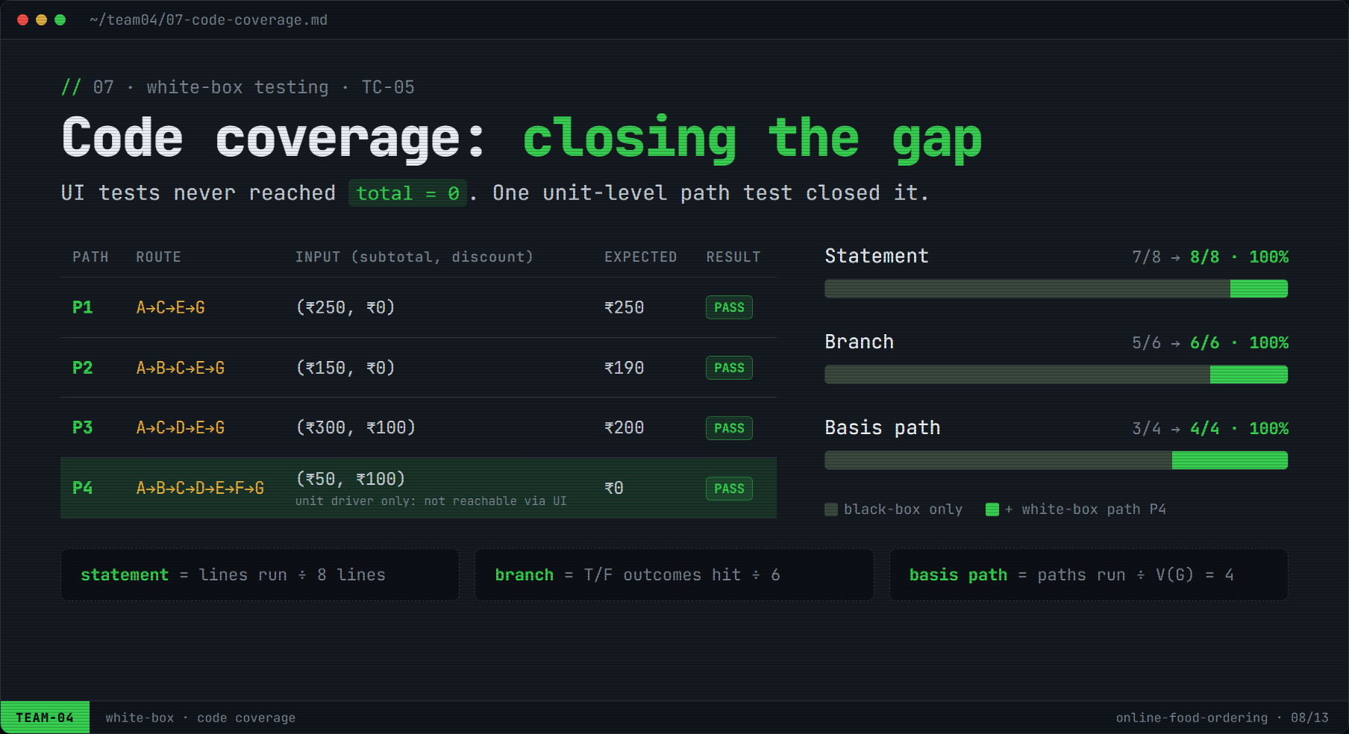
Figure 3: Basis paths and coverage before and after white-box testing

4. Test Case Design for Testing Levels
Table 9: Test design per testing level
Level | Objective | Technique / setup | Test cases | Result
Unit | Verify one function in isolation | White-box basis paths; test driver; payment gateway replaced by a stub | TC-05 | PASS
Integration | Verify modules work together | Bottom-up: cart + billing → + coupon → + payment; stubs replaced one at a time | TC-06 | PASS
System | Verify the full application end to end | Functional, negative and non-functional black-box tests on the full build | TC-07, TC-08, TC-09 | 2 PASS / 1 FAIL
Acceptance | Confirm readiness for real users | Alpha UAT: 4 users outside the team, against AC-1 to AC-3 | TC-10 | PASS

- Unit: calculateTotal() through all 4 basis paths; validateMobile() and applyCoupon() with the ECP and decision-table data.
- Integration: TC-06 checked that cart subtotal → bill total → amount received by payment match.
- System: end-to-end order (TC-07), payment-failure path (TC-08, found BUG-03), layout, timeout and page load (TC-09).
- Acceptance: AC-1 order in under 2 min without help; AC-2 bill correct; AC-3 live status updates. All met.
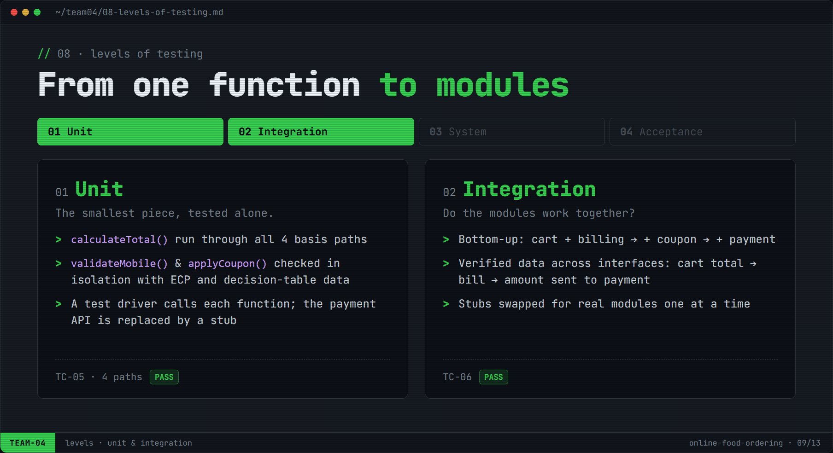
Figure 4: Unit and integration testing
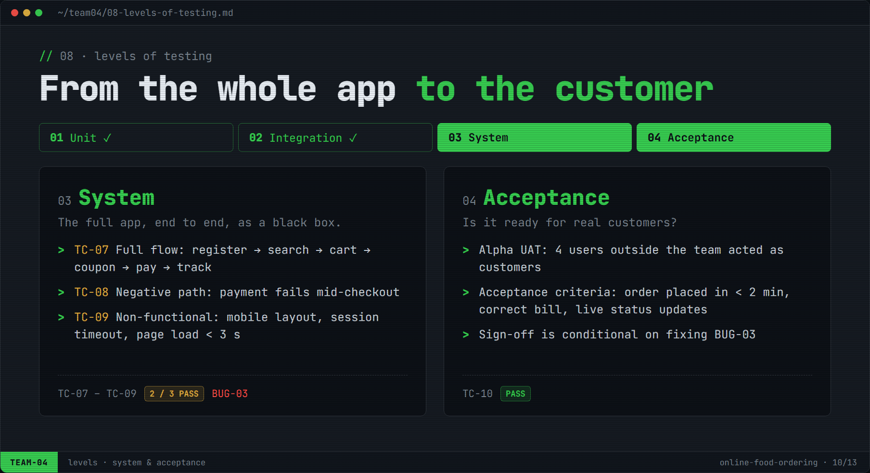
Figure 5: System and acceptance testing

5. Test Cases

5.1 Test Case Descriptions
Table 10: Test case descriptions
TC ID | Description and steps | Technique / level | Module | Priority | Executed by
TC-01 | Verify item quantity boundaries: add “Classic Chicken Burger”, type each quantity in the cart, check it is accepted or rejected. | BVA (BR-02) | cart | High | Bhaskar Lukram
TC-02 | Verify delivery fee at the threshold: build a cart with each subtotal, check the fee in Bill details. | BVA (BR-03) | billing | High | Bhaskar Lukram
TC-03 | Verify mobile number validation: enter each value on Register, tap “Send OTP”. | ECP (BR-01) | auth | Medium | Khushi Raghav
TC-04 | Verify coupon rules: build the cart, apply the code, check message and bill. | Cause–effect graph + decision table (BR-04) | billing | High | Khushi Raghav
TC-05 | Verify calculateTotal() through all basis paths using a unit test driver. | White-box / unit | billing | High | Kartik Gupta
TC-06 | Verify the amount flows cart → bill → payment: 2 × Veg Biryani, coupon FEAST100, pay. | Integration (bottom-up) | cart, billing, payment | High | Kartik Gupta
TC-07 | Verify end-to-end order: log in, search, add item, coupon, pay by UPI, track order. | System (functional) | all | High | Ayush Pandey
TC-08 | Verify order handling when payment fails: pay ₹438 by UPI with sandbox set to decline, open order status. | System (negative, BR-06) | payment | Critical | Ayush Pandey
TC-09 | Verify layout on 360 px, 15-min session timeout and home page load time. | System (non-functional, BR-07) | all | Medium | Kartik Gupta
TC-10 | 4 users outside the team place an order unaided; time, bill and status checked. | Acceptance (alpha UAT) | all | High | Ayush Pandey

5.2 Test Execution and Results
Table 11: Execution log
TC ID | Test data | Expected result | Actual result | Status | Defect
TC-01 | Qty 0, 1, 2, 9, 10, 11 | 0 and 11 rejected; 1–10 accepted | 11 accepted (item total ₹2,409) | FAIL | BUG-01
TC-02 | Subtotal ₹198, ₹199, ₹200 | Fee ₹40, ₹0, ₹0 | Fee ₹40, ₹40, ₹0 (to pay ₹239 at ₹199) | FAIL | BUG-02
TC-03 | V1, I1, I2, I3, I4 | Only V1 accepted | As expected | PASS | –
TC-04 | Rules R1–R4 | Invalid / expired / add ₹49 more / ₹100 off | As expected | PASS | –
TC-05 | P1–P4 | ₹250, ₹190, ₹200, ₹0 | As expected; 100% coverage | PASS | –
TC-06 | 2 × ₹180, FEAST100 | Total ₹260 at every interface | Values matched | PASS | –
TC-07 | Sandbox UPI success | Order confirmed and tracked to delivery | As expected | PASS | –
TC-08 | ₹438, UPI decline | “Payment failed”; order not placed | “Order Placed” with payment Failed | FAIL | BUG-03
TC-09 | 360×800, idle 15 min, 4G | No layout issues; timeout; load < 3 s | Correct; load 1.8 s | PASS | –
TC-10 | 4 users | Order < 2 min; bill correct; live status | Avg 1 min 20 s; all correct | PASS | –

Table 12: Execution summary
Executed | Passed | Failed | Pass rate | Defects
10 | 7 | 3 | 70% | 3 (1 Critical, 2 Major)

6. Defect Reports
Table 13: Defect summary
Defect ID | Title | Module | Linked TC | Severity | Priority | Status
BUG-01 | Quantity 11 accepted when typed manually | cart | TC-01 | Major | P2 | Open
BUG-02 | ₹40 delivery fee charged at exactly ₹199 | billing | TC-02 | Major | P2 | Open
BUG-03 | Order shows “Placed” after payment fails | payment | TC-08 | Critical | P1 | Open

BUG-01: Cart accepts quantity 11 when typed manually
 | 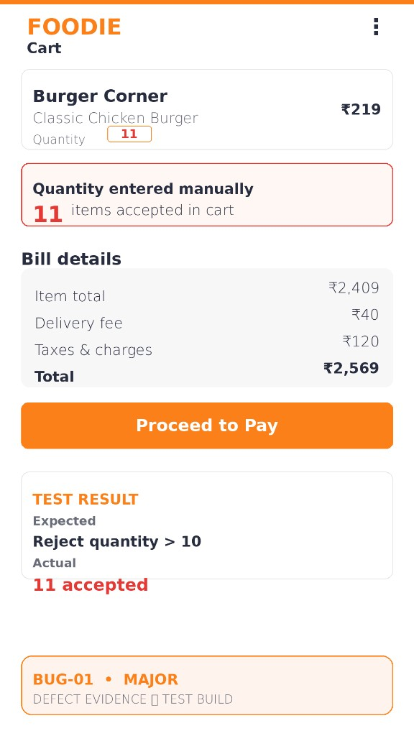  Figure 6: BUG-01 screenshot
  Defect ID | BUG-01
  Module / Test case | cart · TC-01 (BVA)
  Severity / Priority | Major · P2
  Status | Open
  Reported by | Bhaskar Lukram · Oct 2026
  Steps to reproduce | 1. Open “Burger Corner” and add “Classic Chicken Burger” (₹219).  2. In the cart, type 11 in the quantity field and confirm.
  Expected result | Rejected with “Quantity must be between 1 and 10”.
  Actual result | 11 items accepted; item total ₹2,409, total ₹2,569.
  Root cause | Limit enforced only by the “+” button; typed input not validated.
  Suggested fix | Validate quantity on input and on the server (1–10).

BUG-02: ₹40 delivery fee charged at exactly ₹199
 | 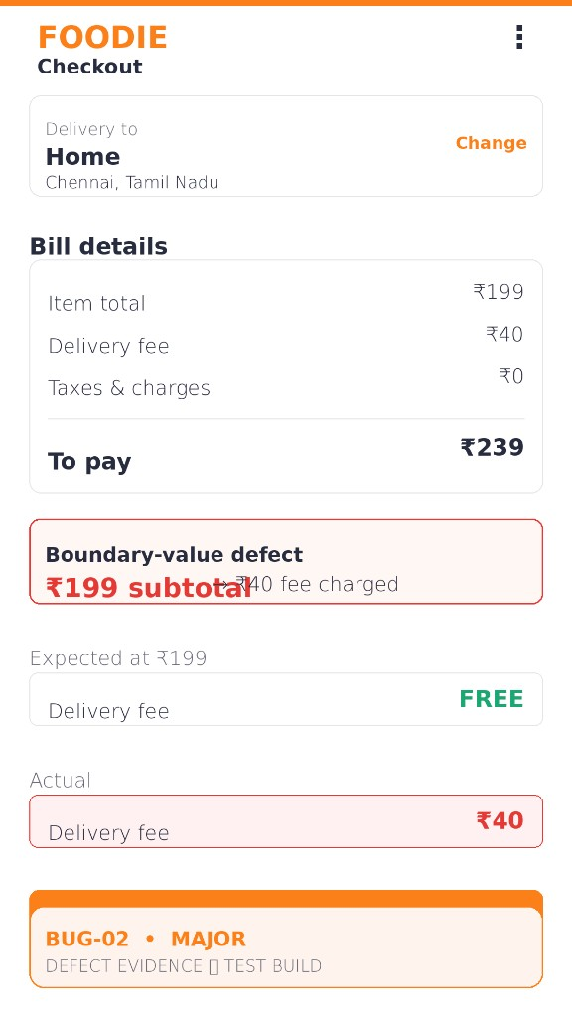  Figure 7: BUG-02 screenshot
  Defect ID | BUG-02
  Module / Test case | billing · TC-02 (BVA)
  Severity / Priority | Major · P2
  Status | Open
  Reported by | Bhaskar Lukram · Oct 2026
  Steps to reproduce | 1. Add items so the item total is exactly ₹199.  2. Go to checkout and view Bill details.
  Expected result | Delivery fee FREE; to pay ₹199.
  Actual result | Delivery fee ₹40; to pay ₹239.
  Root cause | calculateTotal() line 3 uses “<= 199” instead of “< 199”.
  Suggested fix | Change to “< 199”; add regression tests at ₹198/199/200.

BUG-03: Order status shows “Placed” after payment fails
 | 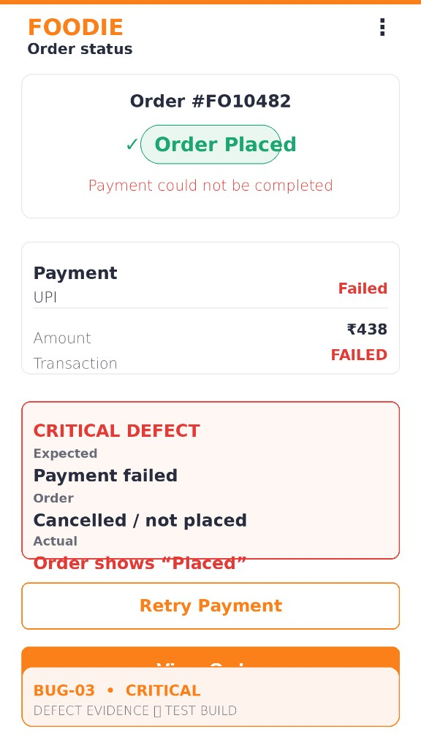  Figure 8: BUG-03 screenshot
  Defect ID | BUG-03
  Module / Test case | payment · TC-08 (System)
  Severity / Priority | Critical · P1
  Status | Open
  Reported by | Ayush Pandey · Oct 2026
  Steps to reproduce | 1. Build a cart worth ₹438 and pay by UPI.  2. Let the sandbox decline the payment.  3. Open the order status screen.
  Expected result | “Payment failed”; order not placed; “Retry payment” offered.
  Actual result | Order #FO10482 shows “Order Placed” while payment is Failed.
  Root cause | Order saved as “Placed” before the payment result; no rollback on failure.
  Suggested fix | Create orders as “Pending payment”; set “Placed” only on success.

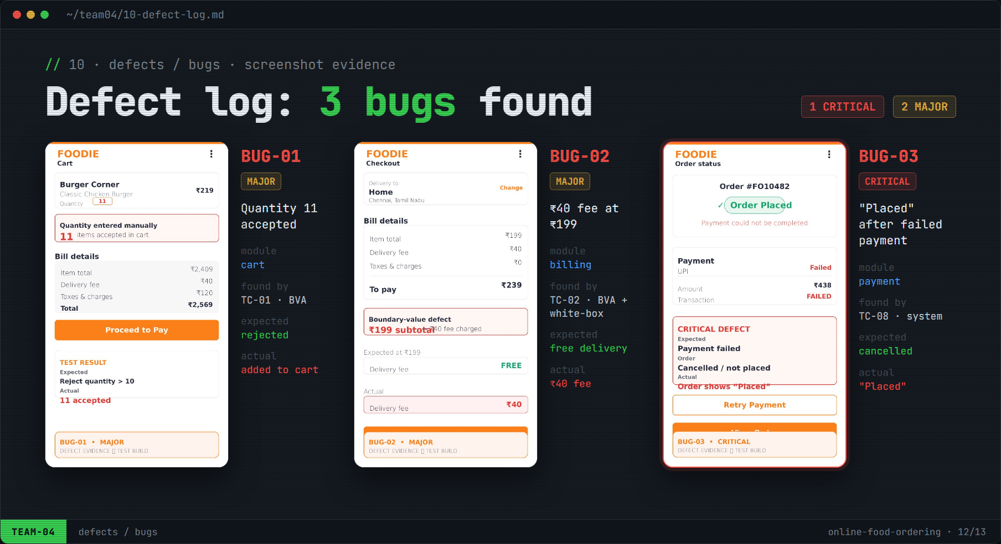
Figure 9: Defect log: all three defects with screenshot evidence

7. Conclusion
Ten test cases covering six scenarios were executed: seven passed and three failed (70%). White-box testing raised coverage of the billing function from 87.5% statement / 83.3% branch / 75% path to 100%. Three defects were raised: one Critical and two Major.
- Edges hide bugs: BVA found 2 of the 3 defects, both exactly at a boundary.
- Code reveals causes: white-box review traced BUG-02 to a single operator.
- Every level counts: the critical BUG-03 appeared only in end-to-end system testing.
Table 14: Requirement traceability matrix
Requirement | Test case(s) | Result | Defect
BR-01 Mobile number format | TC-03 | PASS | –
BR-02 Quantity 1–10 | TC-01 | FAIL | BUG-01
BR-03 Free delivery ≥ ₹199 | TC-02, TC-05 | FAIL | BUG-02
BR-04 Coupon rules | TC-04, TC-06 | PASS | –
BR-05 Total never negative | TC-05 | PASS | –
BR-06 No order on failed payment | TC-08 | FAIL | BUG-03
BR-07 Non-functional | TC-09 | PASS | –
End-to-end ordering & acceptance | TC-07, TC-10 | PASS | –

Verdict: NOT READY for release. Fix BUG-03 (P1) and BUG-01 / BUG-02 (P2), re-run TC-01, TC-02 and TC-08, then run a full regression of all 10 test cases.

Sign-off
Name | Register Number (RA) | Role | Signature
Bhaskar Lukram | RA______________ | Tester
Khushi Raghav | RA______________ | Tester
Kartik Gupta | RA______________ | Tester
Ayush Pandey | RA______________ | Tester

