Step 1. Create mongodb cluster
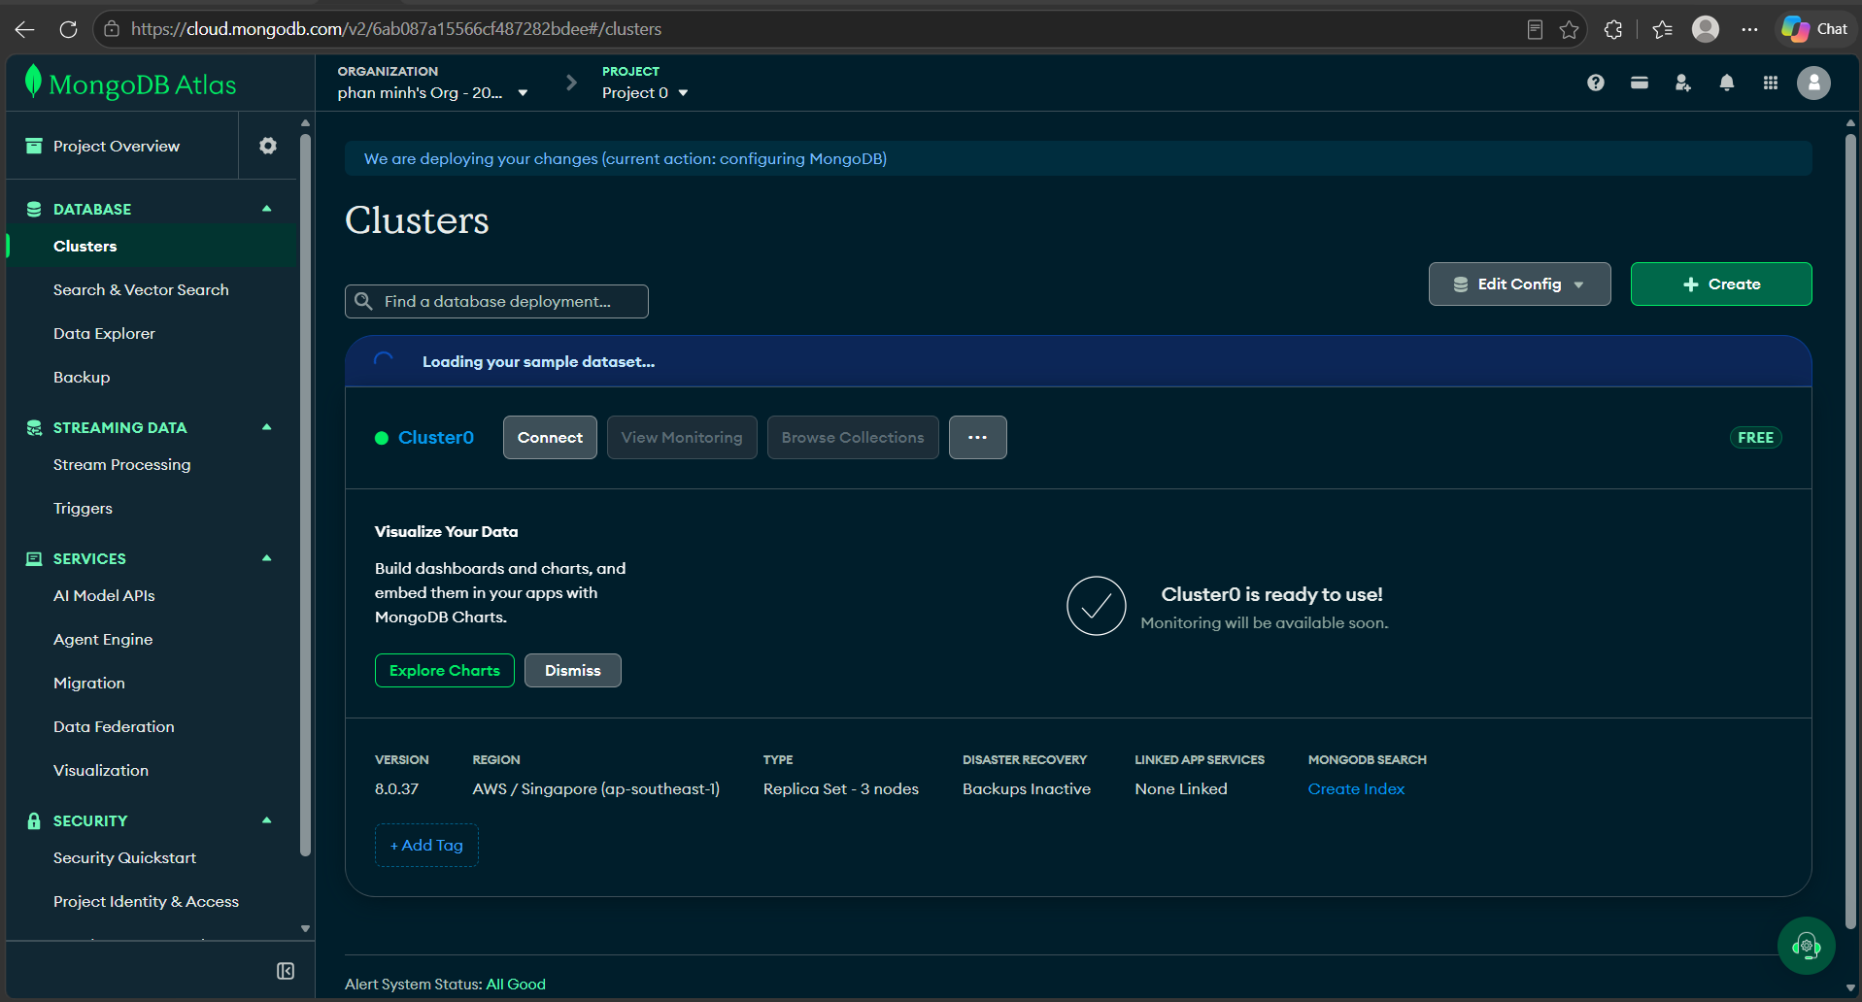

Step 2. Create database user
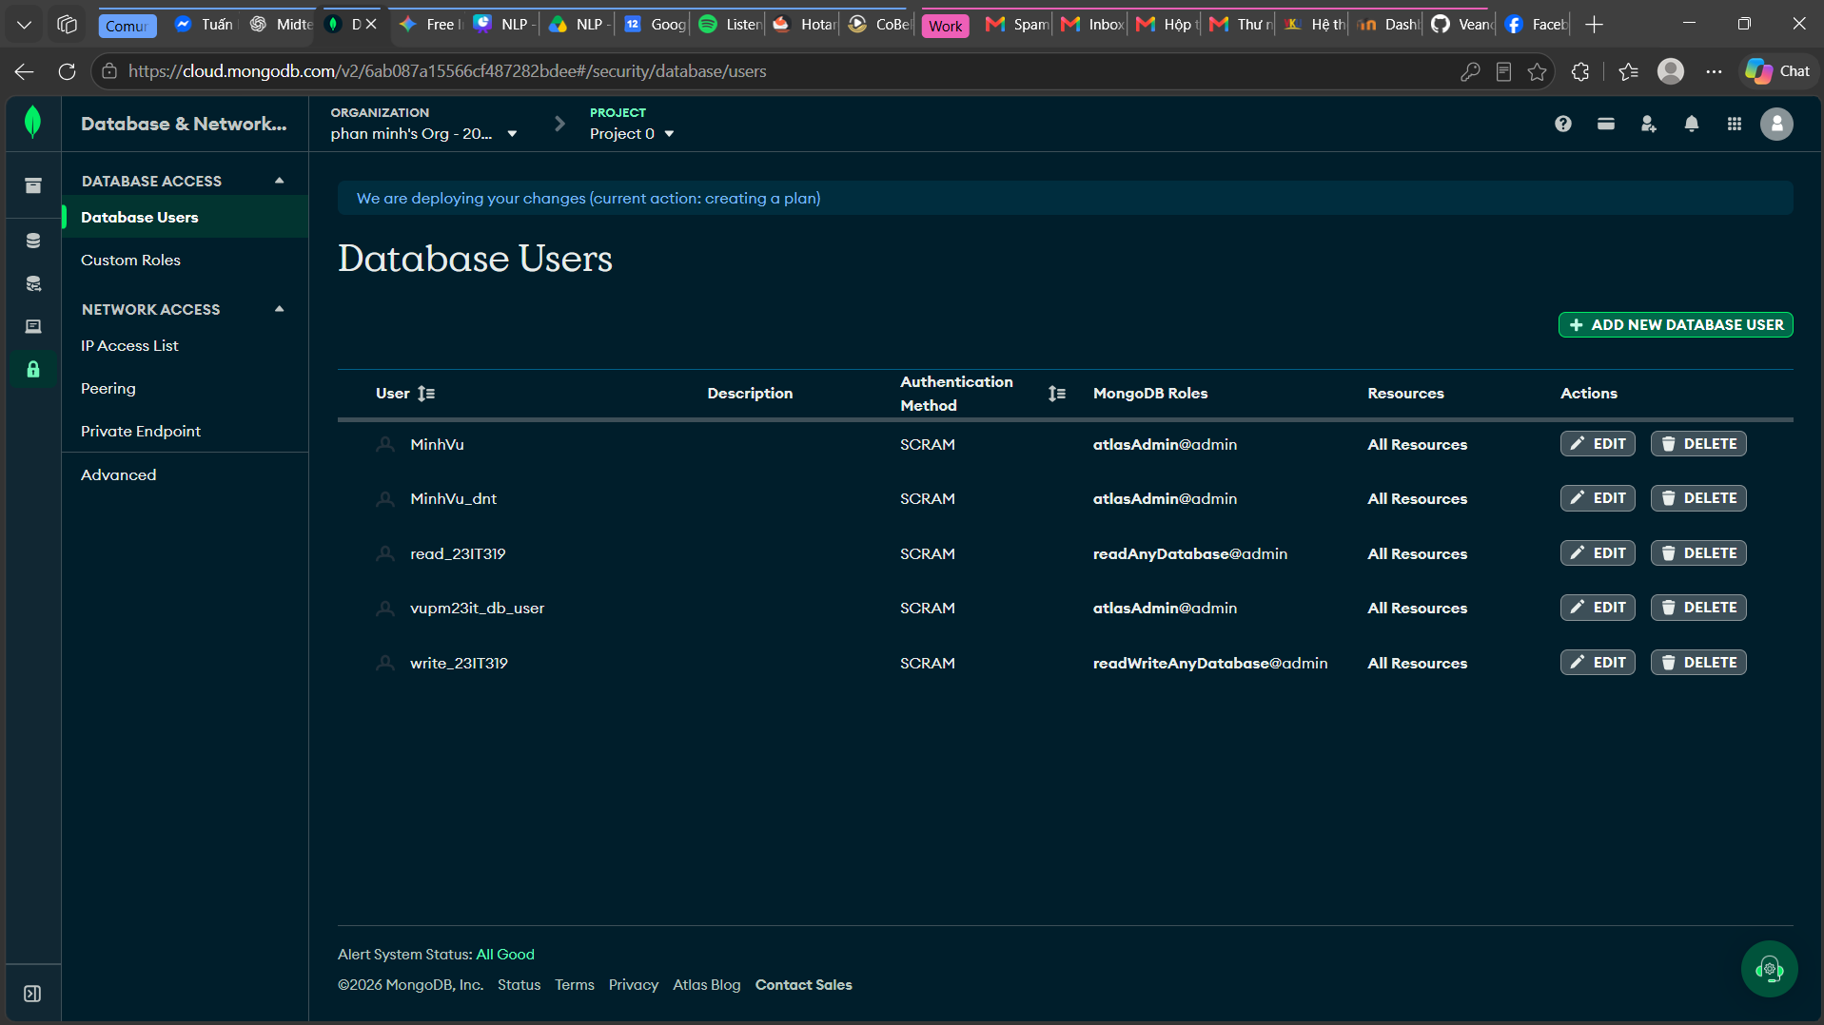
Step 3. Create database and collection
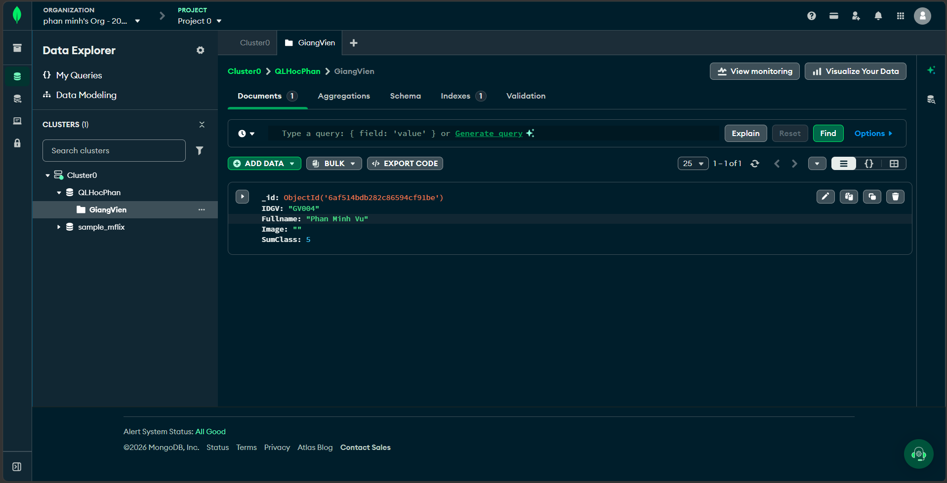
Step 4. Initialize project structure
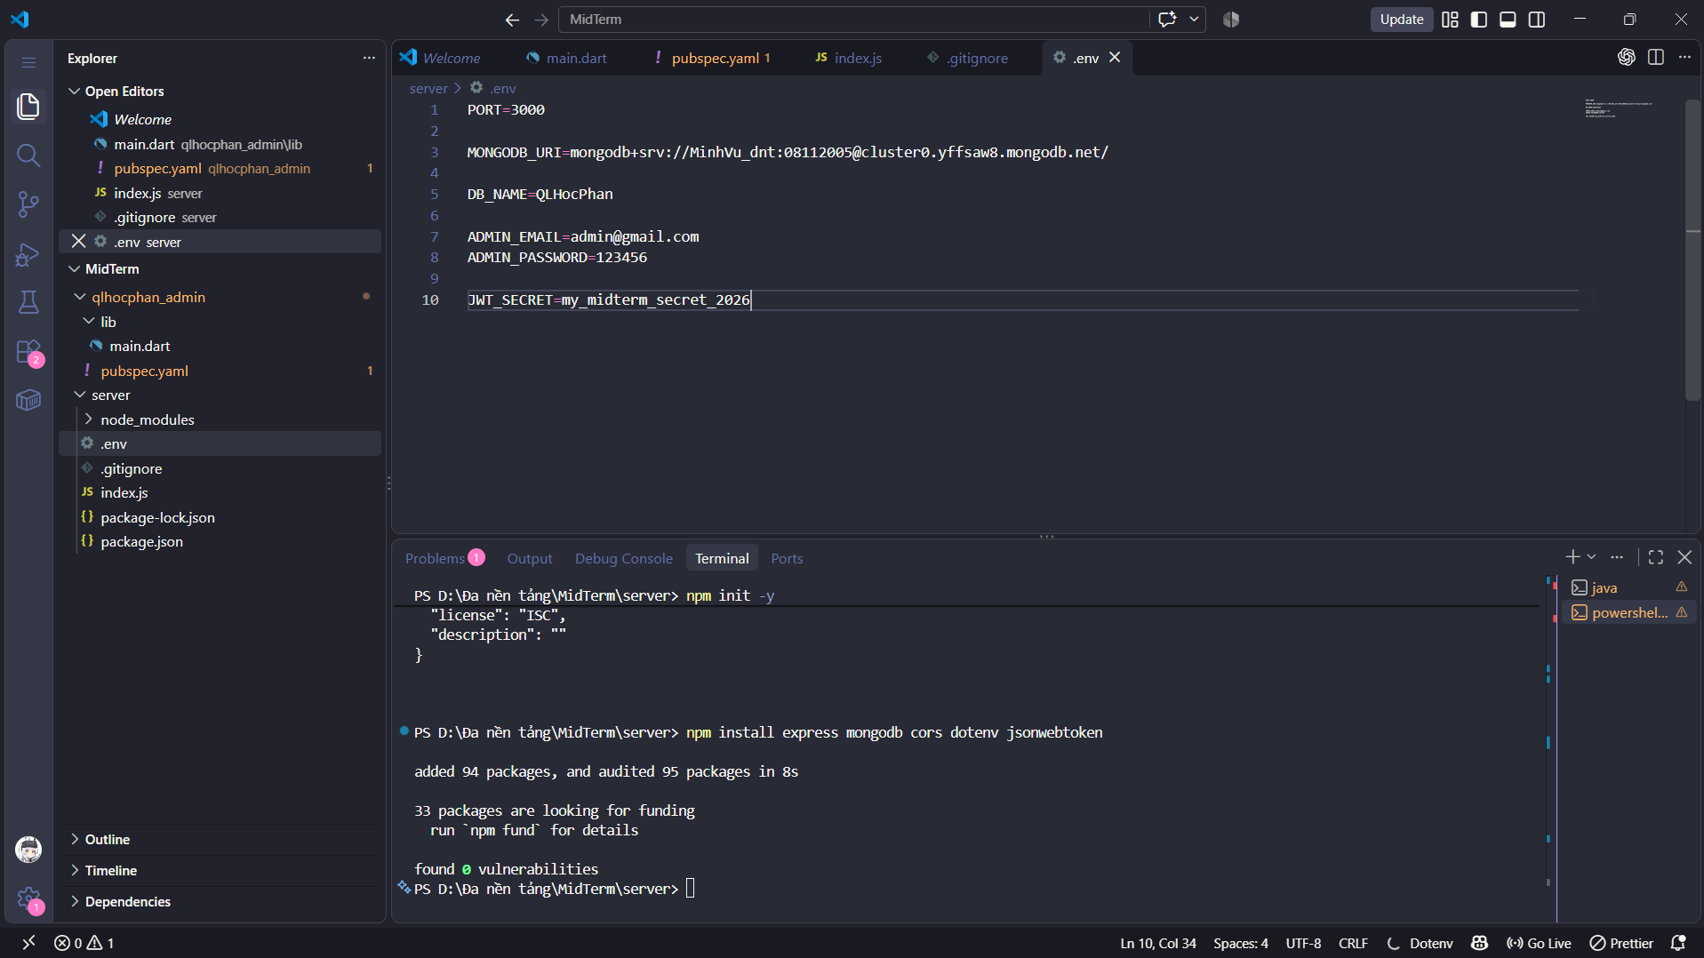

Step 5. Code for the login function
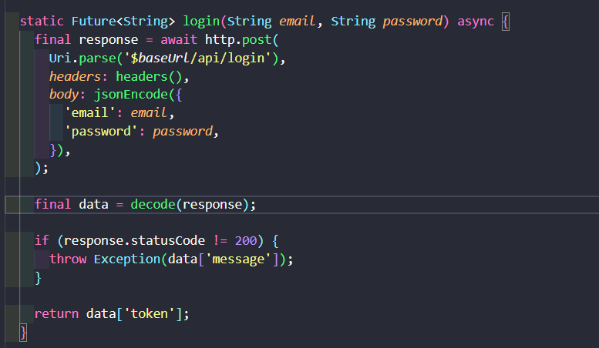
Step 6. Code for the load lecture function (view)
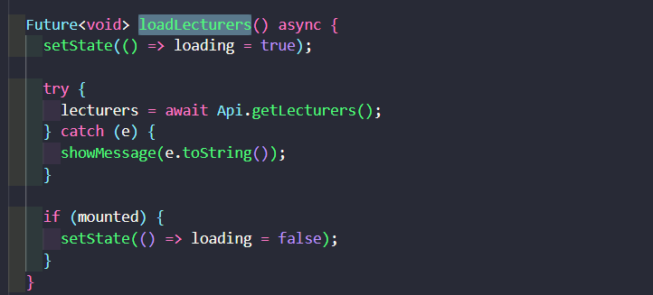
Step 7. Code for the Create & Update Lecturer (with Image Upload) function
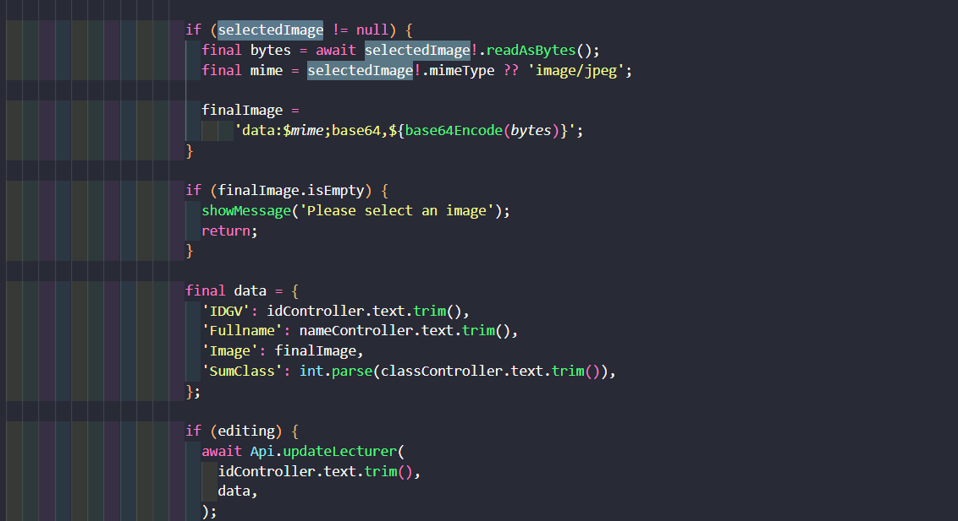
Step 8. Code for the Delete Lecturer (Delete) function
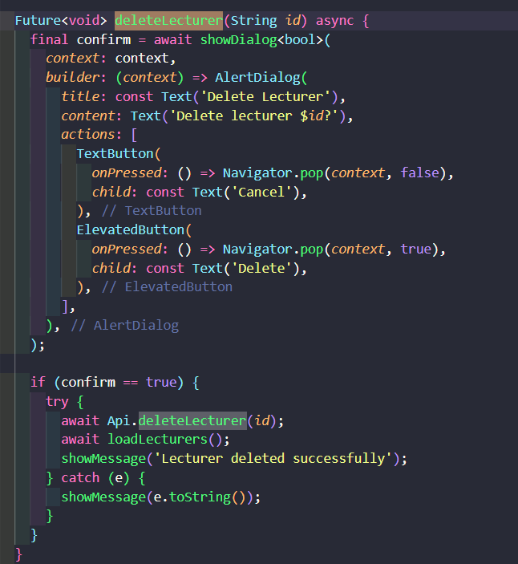

Step 9. Code for Base64 Image Decoding (Avatar Display) function
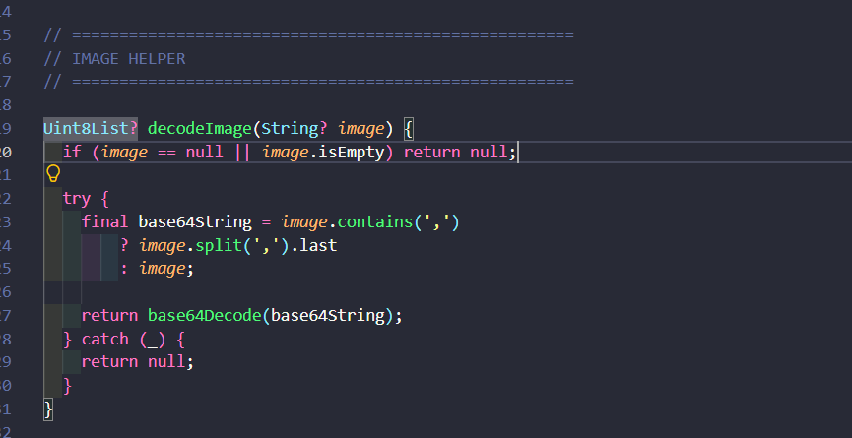

Step 10. Code for Database Connection (MongoDB)
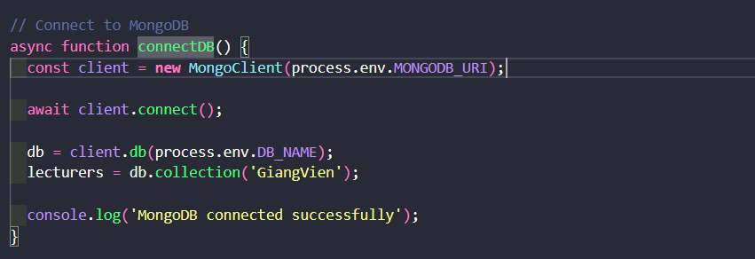

Step 11. Code for Administrator Login & JWT Token Generation

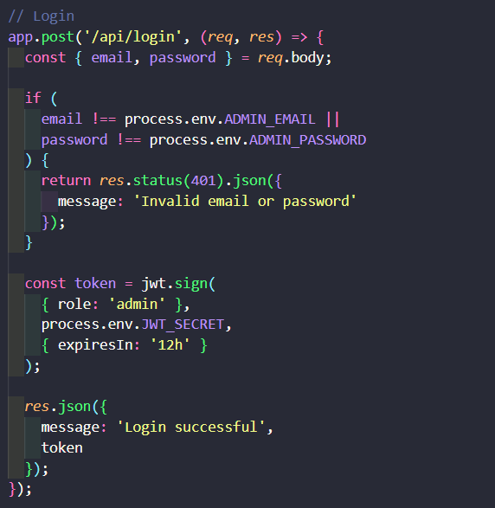

Step 12. Code for Authentication Middleware (Security Guard)

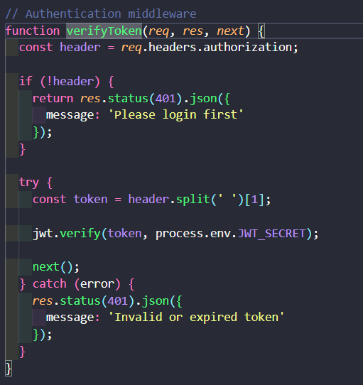

Step 13. Code for Fetch All Lecturers (GET /api/lecturers)
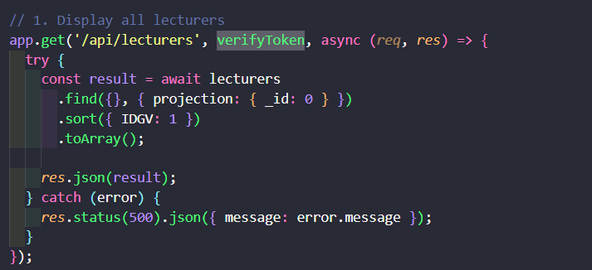
Step 14. Code for Create New Lecturer (POST /api/lecturers)

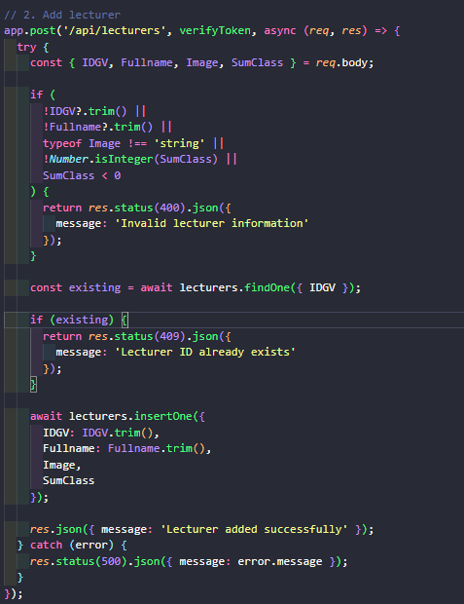
Step 15. Code for Update Existing Lecturer (PUT /api/lecturers/:idgv)
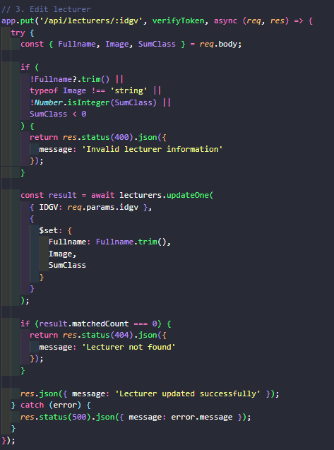
Step 16. Code for Delete Lecturer (DELETE /api/lecturers/:idgv)
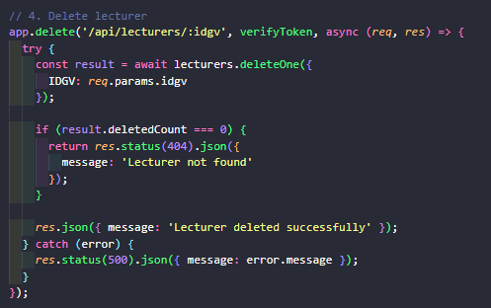

Result
Web UI
1 Login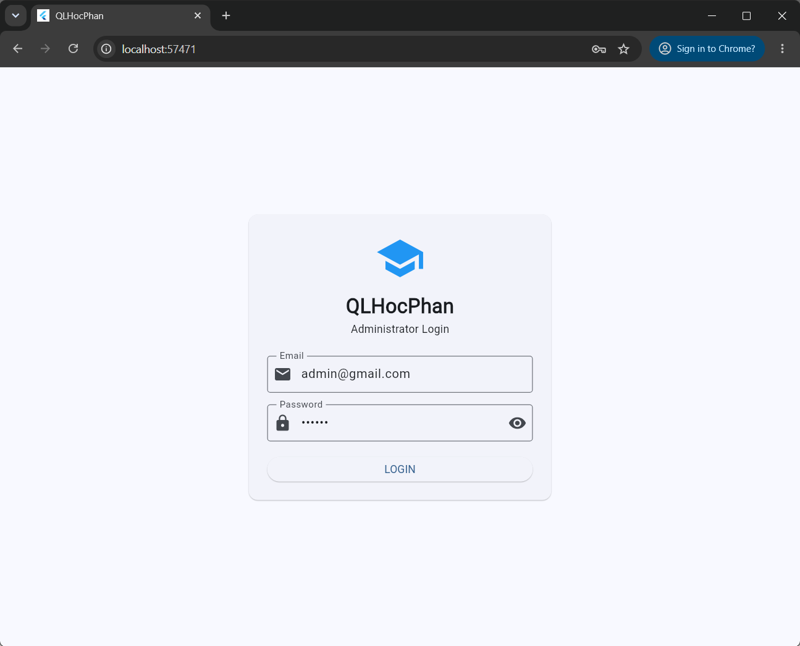2 Homepage
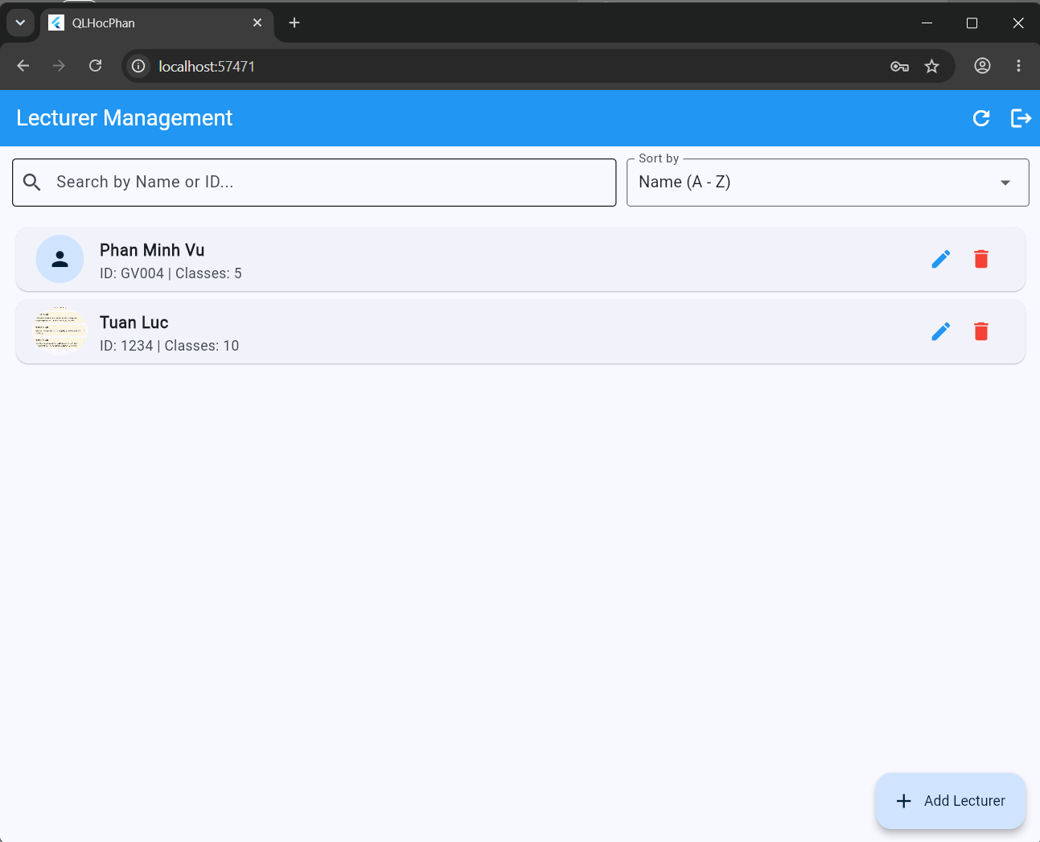3 Add lecturer 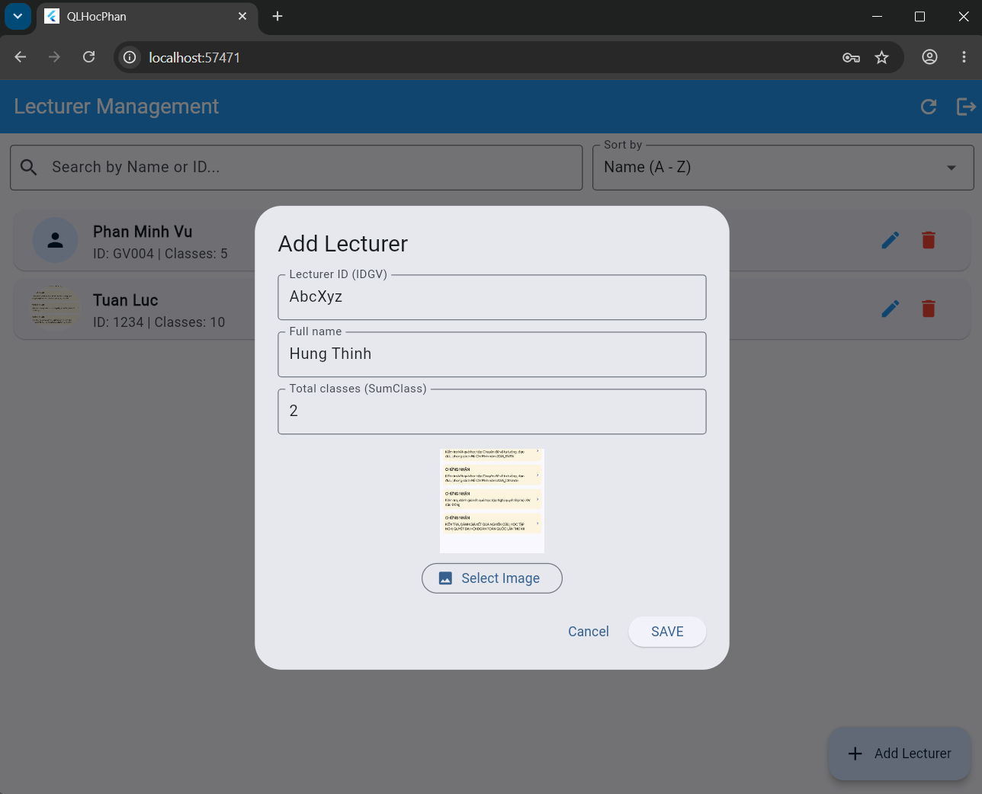
4 Edit lectures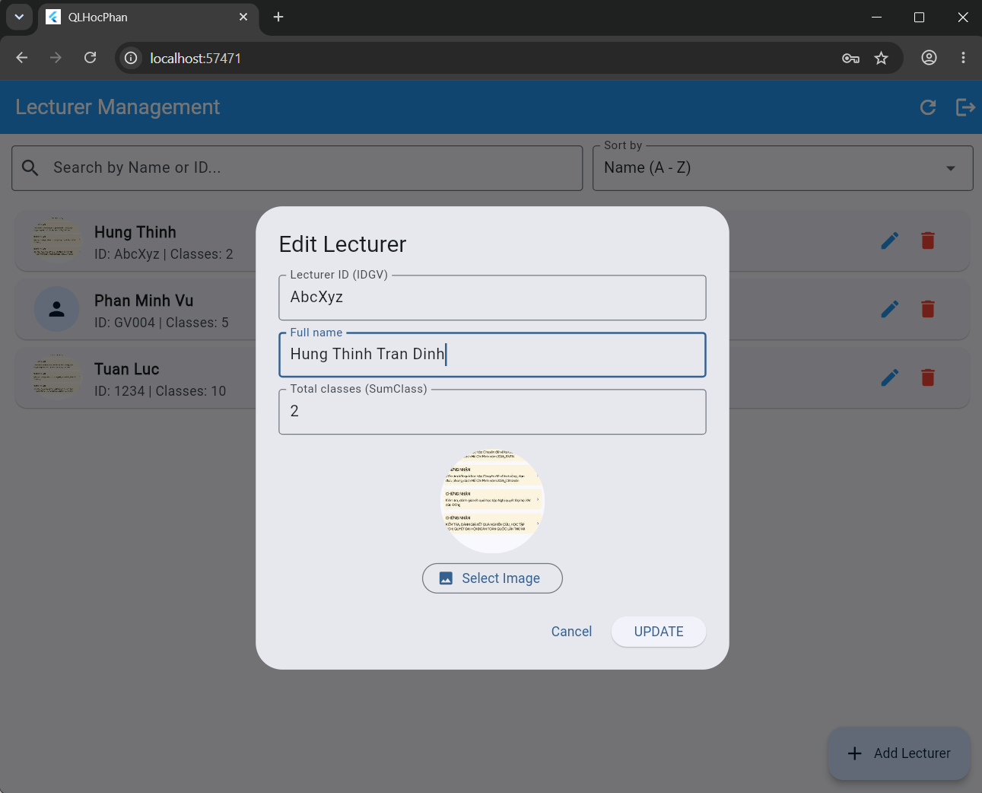
5 Delete Lecturers
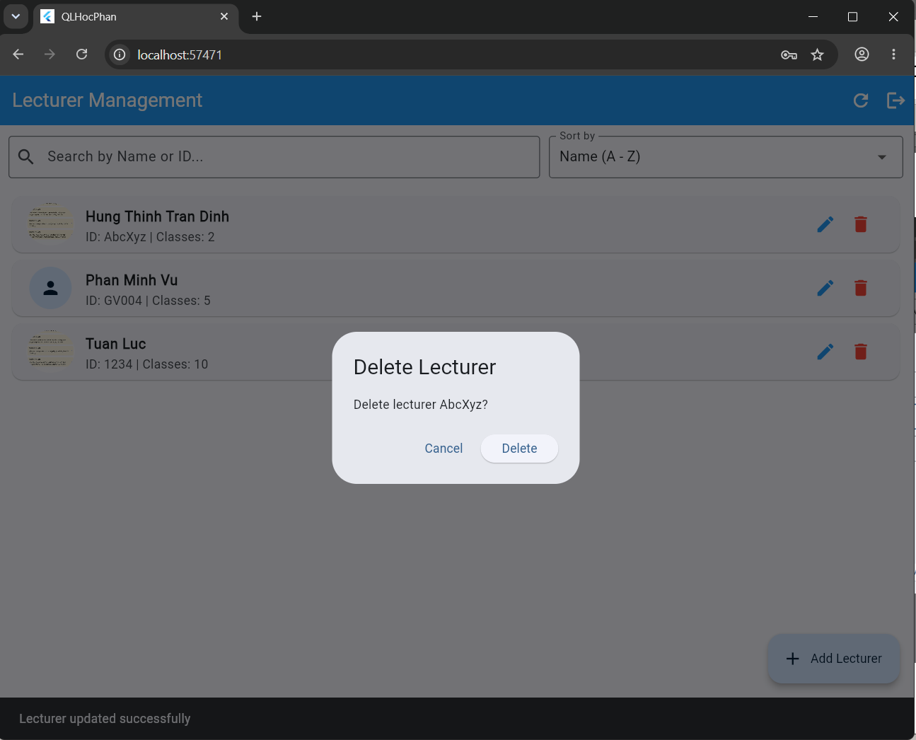
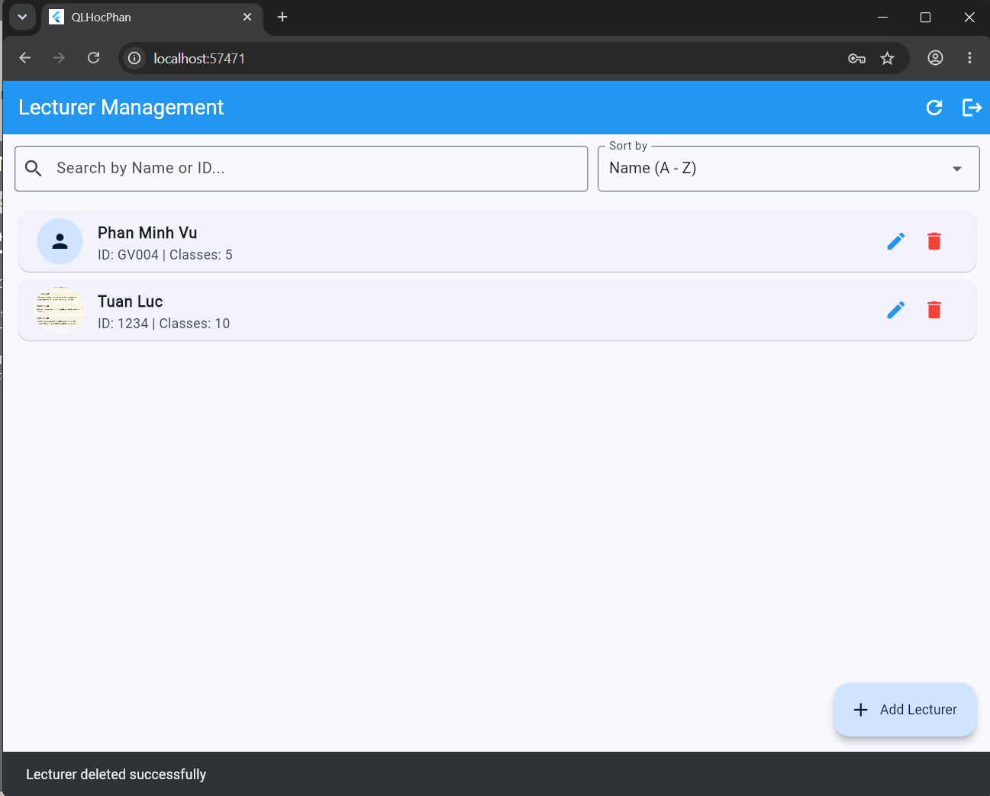
6 Search and sort lecturers 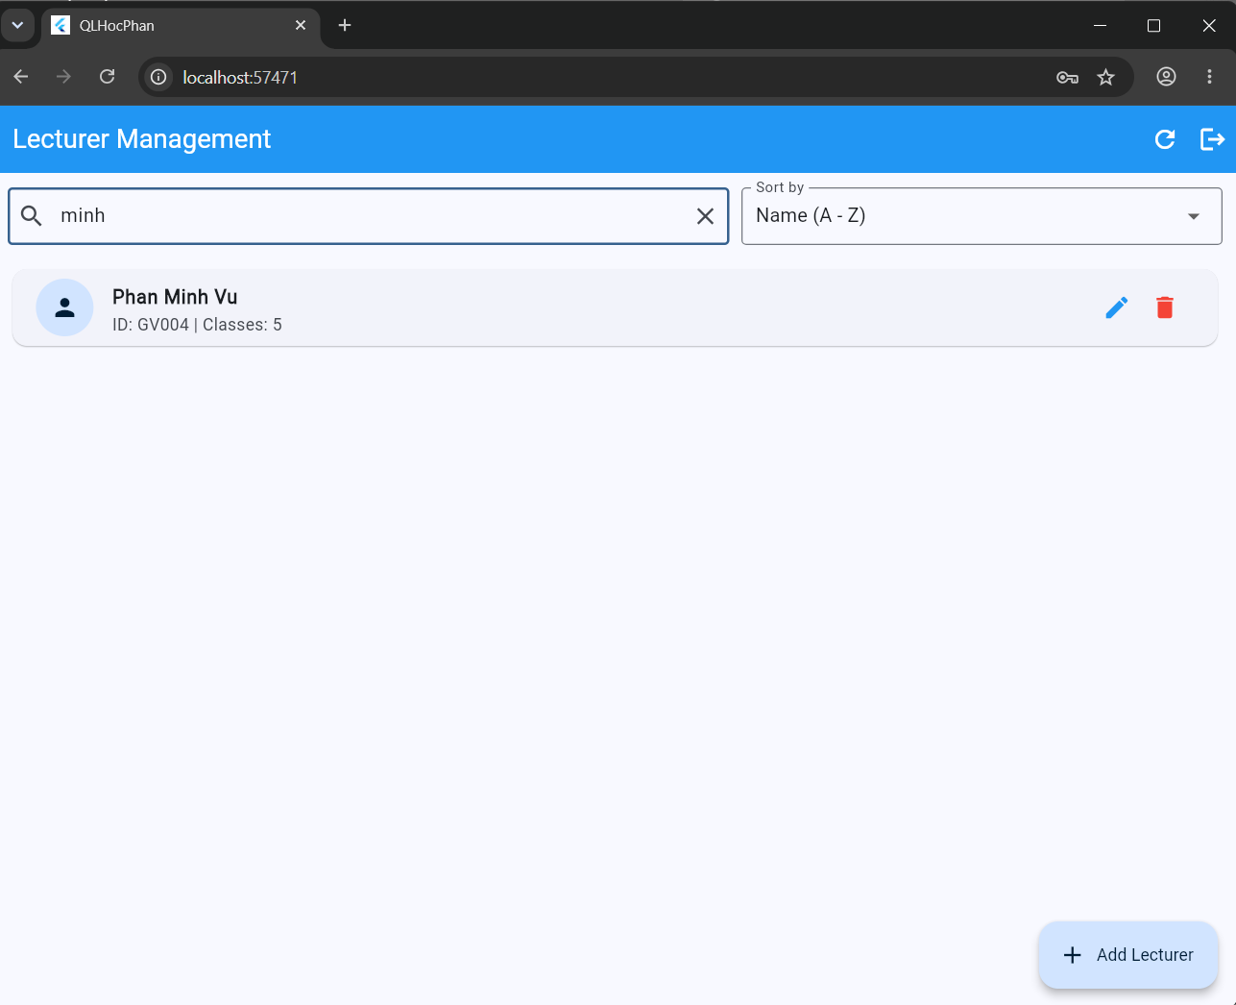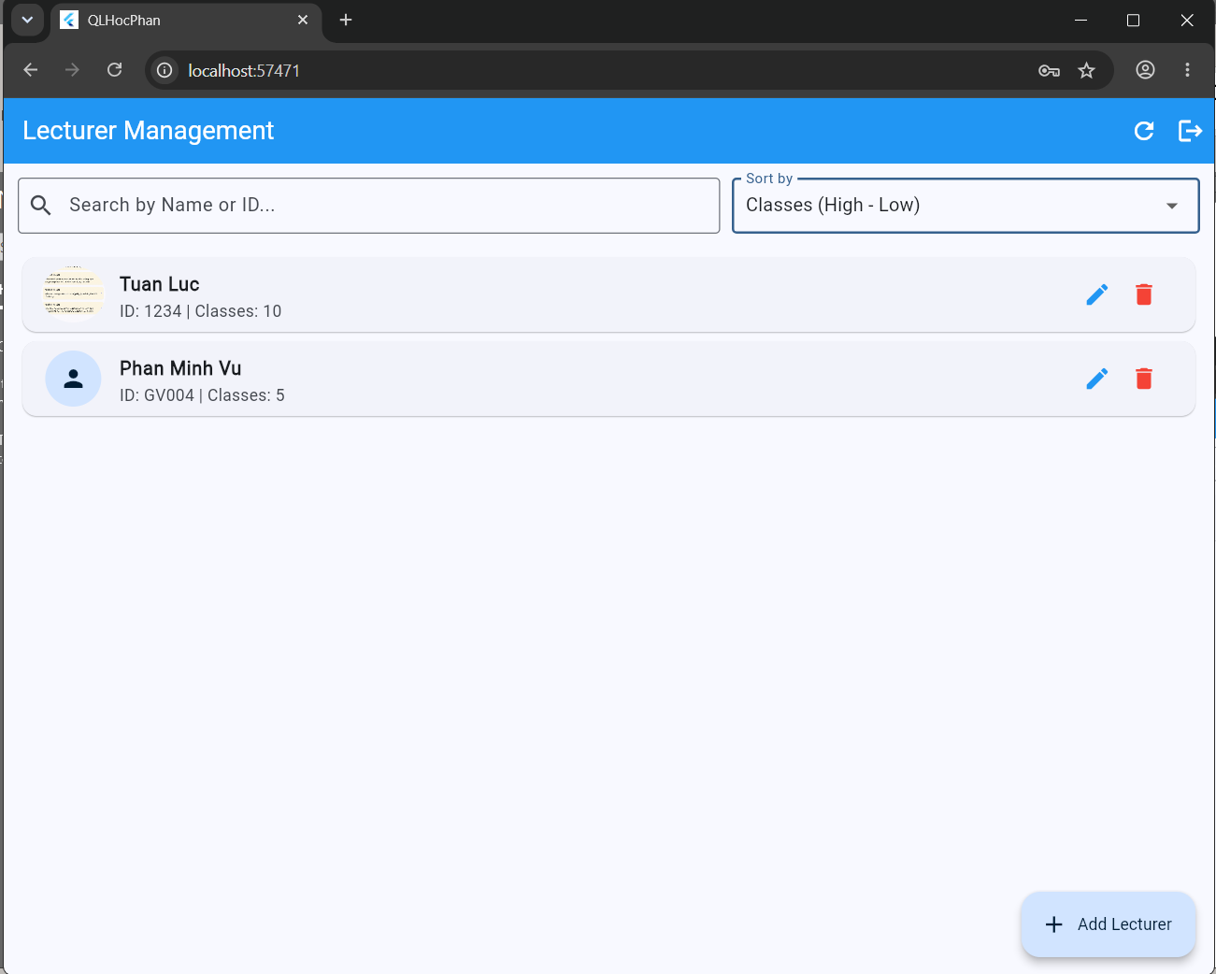

Mobile App UI
1 Login
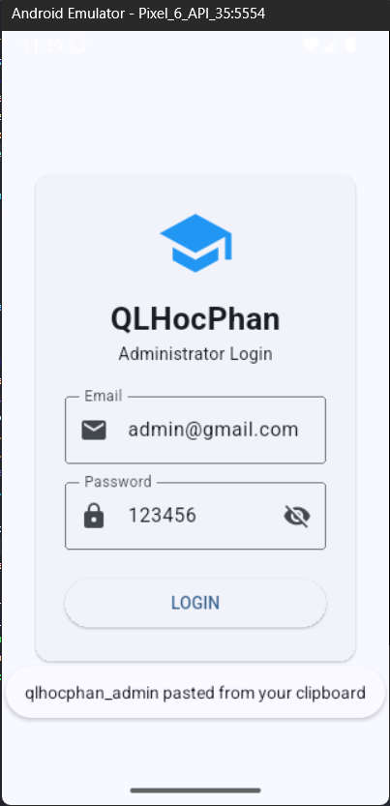

2 Homepage
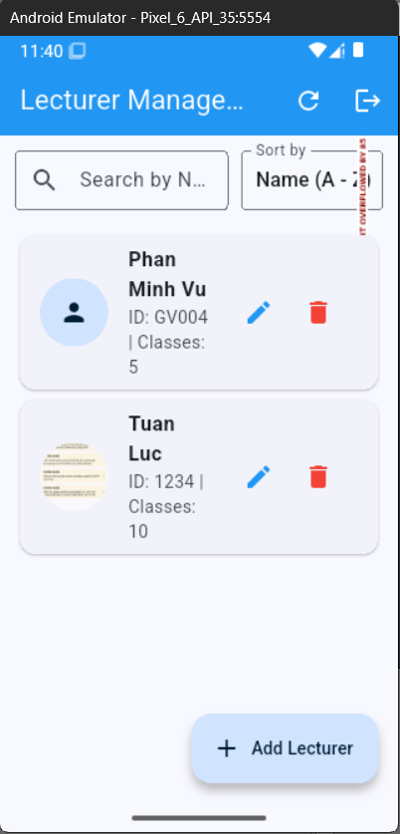
3 Add lecturer
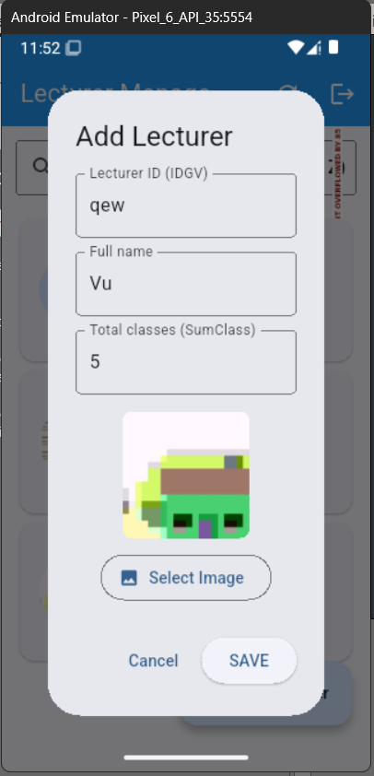
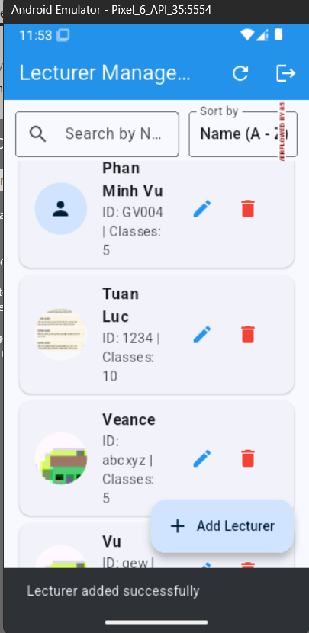

4 Edit lecturers
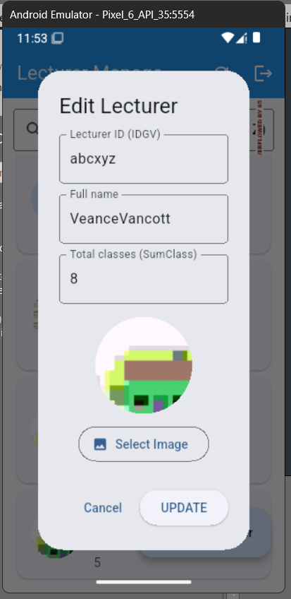
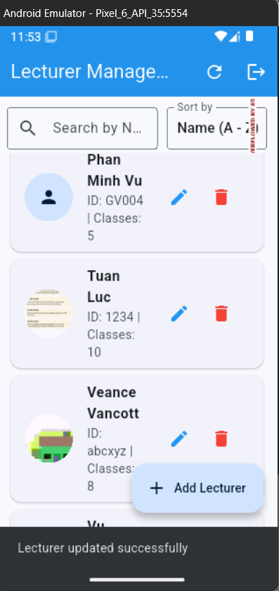
5 Delete Lecturers
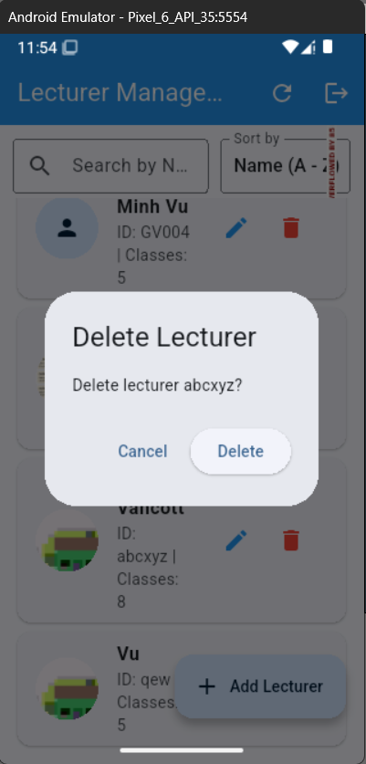
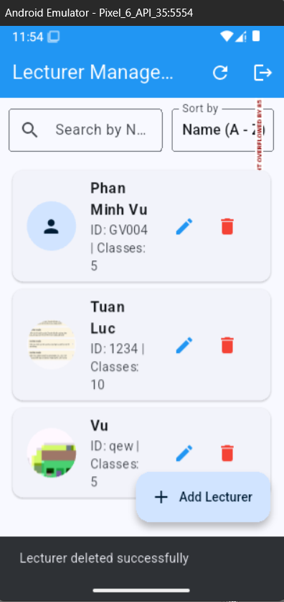

6 Search and sort lecturers


