Linux Privilege Escalation Automation Toolkit
Detection-only Linux enumeration and security auditing
Red-team enumeration · Blue-team auditing

Author: Vansh Dhawan
Company: Vecesta.co
Supervisor: [Supervisor]
Date: 10 November 2026
Internship project report

Contents
Open in Word and update the table of contents field.
Abstract
Introduction
Objectives and scope
Tools and technologies
Architecture and workflow
Implementation
Rule catalog
Safety model
Lab design
Testing and verification
Results
Mitigation guidance
Live deployment
Limitations and future work
Ethics and legal note
Conclusion
References
Appendices

Abstract
This project implements a standard-library Python scanner for authorized Linux privilege-boundary audits. It collects identity, SUID/SGID, filesystem permissions, sudo policy, cron jobs, systemd units, file capabilities, and kernel advisory evidence. Explainable rules map collected facts to findings with severity, confidence, mitigation, and references. The scanner is detection-only: it does not execute discovered binaries, modify system files, or change permissions. The report includes JSON, Markdown, HTML, command records, coverage status, and comparison output. In the current build, real Linux scan evidence is PENDING REAL RUN; no Linux result totals are reported.
The host-side fixture suite tests portable parsers, rules, report generation, comparison, CLI behavior, and command-runner safety. Linux-only steps are kept separate and marked skipped when the VM cannot provide an authenticated guest session. This distinction keeps test evidence traceable and prevents demo values from being presented as real scan results.
Build status | Observed result
Host platform | Windows; scanner correctly reports Linux-only for scan action
Fixture suite | 29 passed, 0 failed, 1 skipped in run 1
Kali VM access | Guest Additions control session unavailable before guest login
Linux lab and real screenshots | PENDING REAL RUN until an authenticated Linux session is available

Introduction
Privilege escalation occurs when a process or account gains access beyond its intended authority. Linux permission bits, privileged programs, service definitions, scheduled jobs, sudo policy, and file capabilities all influence that boundary. A weak configuration can let a local account affect a task that later runs with elevated privileges.
Auditing needs to distinguish evidence collection from exploitation. This toolkit records file metadata and configuration text, then applies transparent rules. It describes the possible impact and a defensive correction without testing the weakness by executing it. Administrators should validate every result against the operating system vendor and the system's intended configuration.
The project is designed for an internship demonstration. Its fixtures make parser and rule behavior reviewable on Windows, while real scans require a Linux filesystem and Linux command behavior. The included disposable lab is isolated from the scanner and tracks every item it creates.

Objectives and scope

Objectives
• Collect high-value Linux privilege-boundary configuration with read-only operations.
• Explain each finding in plain language and attach a specific mitigation and reference.
• Record which checks ran and which checks were skipped with a reason.
• Compare two reports by stable rule and evidence fingerprints.
• Prove the safe command boundary with unit tests and before/after file hashes.

Scope
The implementation covers local enumeration only. It does not exploit a weakness, provide proof-of-concept payloads, change system settings, install software, or contact remote targets. Network services, application-layer flaws, cloud permissions, and distribution-specific kernel patch databases are outside this version's scope.
Full filesystem discovery uses GNU find permission predicates and prunes pseudo filesystems. A fast mode limits traversal to common system, application, home, and temporary directories. WSL Windows-drive mounts are excluded. The report identifies limited-account visibility and version-only kernel uncertainty.

Tools and technologies
Technology | Role | Dependency
Python 3.10+ standard library | CLI, collectors, parsing, rules, serialization | Runtime
Bash | Linux wrapper and disposable lab lifecycle | Linux host
pytest | Fixture, safety, CLI, and Linux integration tests | Development only
python-docx | Editable internship report | Documentation only
python-pptx | Editable 15-slide presentation and speaker notes | Documentation only
Pillow and matplotlib | Terminal previews and architecture diagrams | Documentation only
GNU find, getcap, sudo, systemctl, crontab | Read-only Linux enumeration sources | Optional host tools; missing tools are skipped

Direct development package versions are pinned in requirements-dev.txt. The scanner itself imports no third-party runtime library. Development dependencies are installed only inside a virtual environment.

Architecture
Collectors gather raw text and metadata. Parsers convert that material to small dictionaries and lists. Analysis rules are pure functions over those records. The report layer serializes one ScanResult into JSON, Markdown, and HTML. The command runner is the only place that invokes an external program.
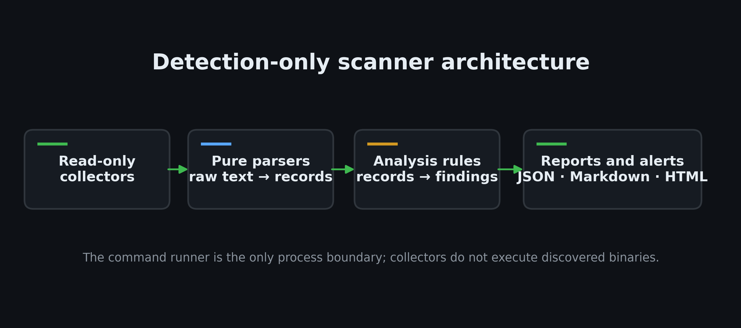
Figure 1. Scanner components and data flow
The separation keeps parsing tests platform-independent and makes rule behavior easy to explain. When a Linux command is absent, times out, or cannot read a path, the scan records a coverage limitation rather than treating missing evidence as a clean result.

Workflow
The scan follows the required order from system information through SUID discovery, permissions, services and sudo, cron, kernel checks, rule analysis, and report output. Each collector is independent, so one unavailable utility does not prevent other checks from completing.
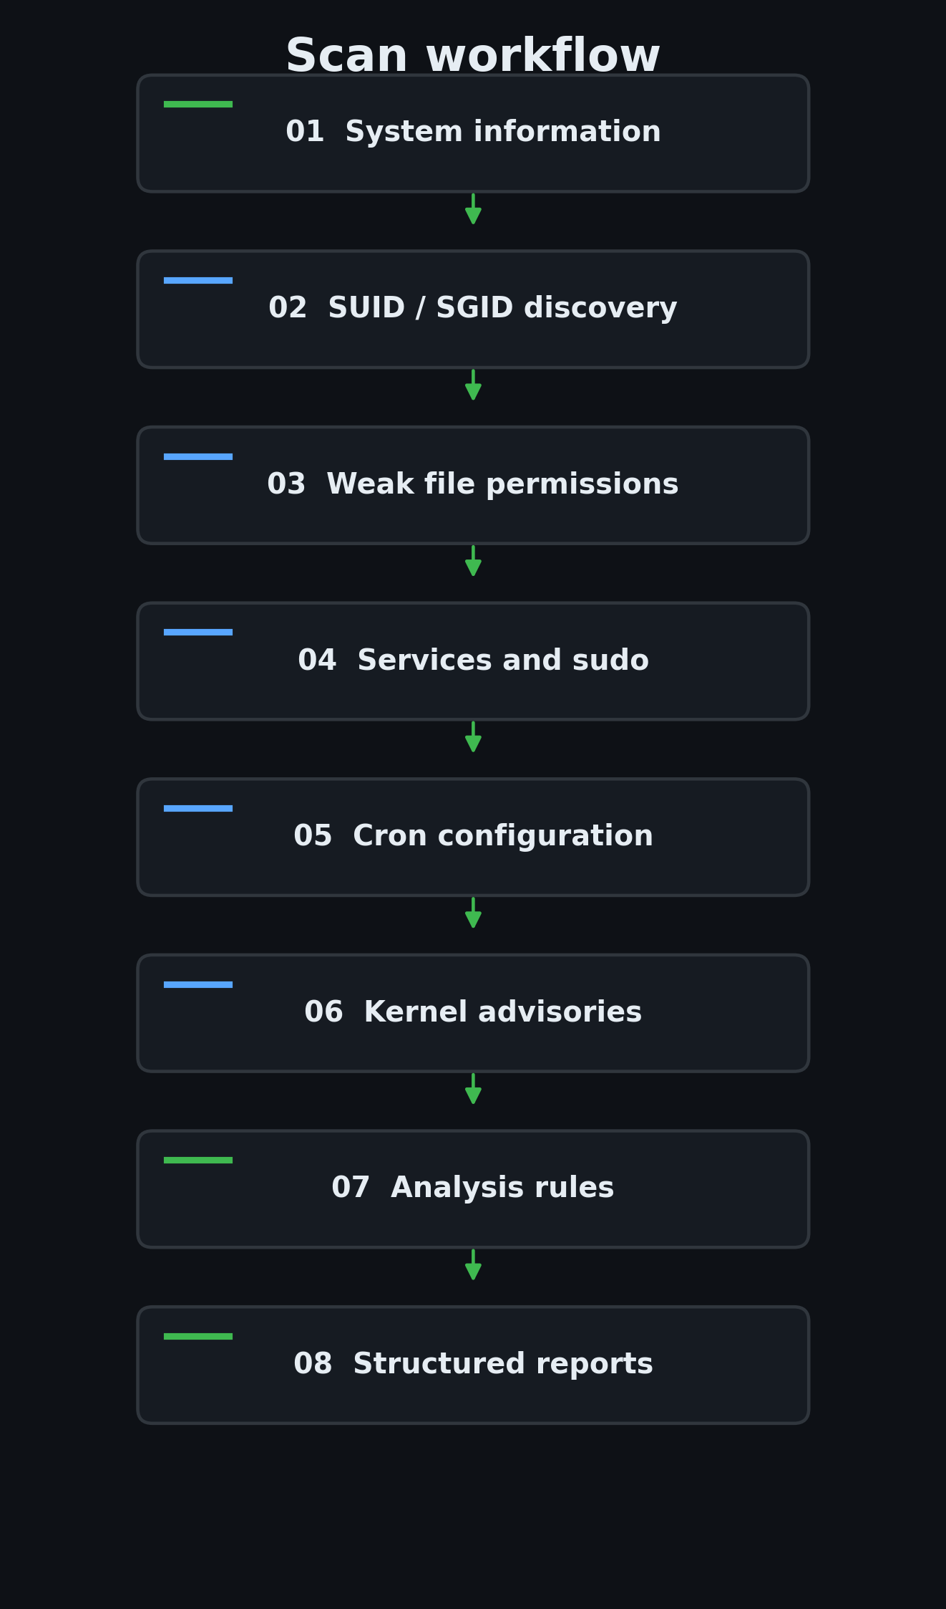
Figure 2. Read-only scan workflow

Implementation
Module | Plain-language responsibility
sysinfo | Records account, groups, host, OS release, kernel, Python, WSL/container markers, and privilege level.
suid | Uses find to list SUID/SGID files and parses mode, owner, group, and path.
perms | Checks world-writable items, sensitive configuration, home directories, and PATH directories.
services | Reads systemd unit files and parses root identity, executable, and PATH environment.
sudo | Reads sudoers when allowed or uses non-interactive sudo listing without prompting.
cron | Parses system schedules and records root job scripts, wildcard patterns, and relative commands.
caps | Uses getcap output to flag capabilities with a clear privilege impact.
kernel | Parses version prefixes and applies explicit upstream advisory ranges and an EOL policy.
report / compare | Writes structured reports and reports NEW, FIXED, and UNCHANGED fingerprints.

Collectors are read-only. Their outputs contain metadata and relevant configuration evidence, while the analysis layer decides whether a record matches a rule. This keeps command output from being treated as an instruction or executed as code.

Rule catalog
Rule IDs | Check | Default severity
SUID-001 / SUID-002 | Non-standard SUID/SGID and known high-risk binary contexts | High / Medium
PERM-001 / PERM-002 | World-writable files and directories, with sticky temporary-directory guard | High
PERM-003 / PERM-004 / PERM-005 | Sensitive config, writable home directories, and writable PATH entries | Critical / High
SUDO-001 / SUDO-002 / SUDO-003 | Passwordless rules, broad command grants, and GTFOBins contexts | High / Critical
CRON-001 / CRON-004 | Root jobs whose scripts, parent directories, or schedule files are user-controlled | Critical
CRON-002 / CRON-003 | Wildcard archive commands and relative root command paths | High / Medium
SVC-001 / SVC-002 / SVC-003 | Writable root service units, executables, and unsafe PATH entries | Critical / High
CAP-001 / CAP-002 | Privilege-sensitive capabilities and capable general-purpose interpreters | High / Critical
KERN-001 / KERN-002 | Verified advisory range overlap and an explicitly documented upstream EOL policy | High / Medium

Rules are deliberately small. A rule describes exposure, not successful exploitation. A GTFOBins link explains why a binary's context merits review; the project stores no payload strings. Kernel rules state their affected ranges and are advisory because distribution kernels may contain backported fixes.

Safety model

Allowlisted commands
runner.py accepts only the specified identity, find, getcap, crontab, sudo-listing, systemctl-listing, and GNU find version forms. It rejects shell operators, dangerous find actions, and interactive sudo forms.

Timeout and argument safety
Every external invocation uses a list of arguments, shell=False, and a positive timeout. A timeout or unavailable tool becomes a skipped coverage record.

No mutation
The scanner does not call permission, ownership, service, file deletion, or account-changing APIs. It writes only reports, logs, and explicitly selected output folders.

No payloads
Findings state impact in ordinary language and link to references. The rule catalog contains names and URLs but no exploit commands or proof-of-concept code.

Runtime proof
The lab demo compares hashes of /etc/passwd, /etc/group, /etc/shadow, and /etc/sudoers around every scan. Unit tests also reject disallowed commands and scan implementation source for mutation patterns.
The separate lab intentionally creates weak configurations in a disposable guest only. It requires root plus the explicit confirmation flag, refuses pre-existing paths, writes a manifest, and removes only manifest-listed items. The scanner itself never invokes the lab scripts.

Lab design
Lab item | Harmless test condition | Expected rule family
SUID/SGID copies | Tracked copies of find and awk carry SUID bits; no copy is executed. | SUID-001, SUID-002
Permissions | A configuration file is mode 0666 and a directory is mode 0777. | PERM-001, PERM-002
Cron | Dormant yearly root entries reference a writable placeholder and a wildcard archive pattern. | CRON-001, CRON-002, CRON-003
Sudo | A lab-only sudoers drop-in grants a command and broad passwordless policy. | SUDO-001, SUDO-002, SUDO-003
systemd | An unstarted unit, target script, and PATH demonstrate metadata checks. | SVC-001, SVC-002, SVC-003
Capabilities | A copied interpreter receives cap_setuid when setcap is available. | CAP-001, CAP-002
Limited account | A locked lab account has a deliberately broad home mode. | PERM-004

No cron job is triggered and the service is never enabled or started. SUID and capability copies are inspected only as file metadata. Teardown reads the manifest, removes exact created files, removes the lab user and home, verifies absence, and is safe to run a second time.

Testing and verification
Verification | Observed result
pytest run 1 | 29 passed; 0 failed; 1 skipped
pytest run 2 | 29 passed; 0 failed; 1 skipped
Windows unsupported scan | PASS — unsupported host scan returned exit 2
Linux end-to-end scan | PENDING REAL RUN — guest control was unavailable before Kali login
Lab demo twice and compare fingerprints | PENDING REAL RUN — real Linux demo not available
Safety hash proof | PENDING REAL RUN — no Linux scan run
Independent cross-check and teardown | PENDING REAL RUN — no Linux lab run
Bash syntax and shellcheck | PASS — bash -n syntax validated on all shell scripts

The Windows fixture suite is evidence for portable parsing, rule logic, report output, comparison, and runner validation. It is not evidence that the Linux collectors work against a real host. The Linux end-to-end test is marked to skip on Windows, and this report keeps that distinction visible.

Results
Real Linux findings are PENDING REAL RUN. The Kali VM reported zero logged-in guest users, and VBoxManage guest-control returned that Guest Additions were not installed or not ready. No Act 1, Act 2, or Act 3 scan output exists, so no finding total, risk rating, screenshot, fixed count, or kernel result is stated here.
Requested result | Status
Act 1 clean baseline | PENDING REAL RUN — no authenticated guest session
Act 2 root and limited-user scans | PENDING REAL RUN — lab was not created
Simulated kernel report | PENDING REAL RUN — no Linux report exists
Act 3 teardown and before/after comparison | PENDING REAL RUN — no lab artifacts were created
Real finding screenshots | PENDING REAL RUN — no Linux transcript exists

Mitigation guidance
Finding area | Defensive response
SUID/SGID | Remove privilege bits from nonessential binaries, maintain package ownership, and review every non-standard path.
World-write access | Remove untrusted write bits from files and directories; use sticky mode only for shared temporary directories.
sudo | Replace broad command grants with exact, least-privilege rules and validate edits using visudo.
Cron | Make scripts and parent directories root-owned, use absolute paths, and pass explicit file lists to archive jobs.
systemd | Protect unit files and executables from user writes; use a short explicit PATH of trusted directories.
Capabilities | Remove unneeded capabilities and restrict required capabilities to a minimal protected helper.
Kernel | Apply the distribution's security update and verify vendor backport status before classifying a kernel version.

Mitigation advice is specific to the configuration class. Administrators should preserve application requirements, test changes in staging, and follow the distribution's own service and package procedures.

Live deployment
The project is deployed as a static security auditing and documentation portal on GitHub Pages at: https://YOUR-USERNAME.github.io/linux-privesc-toolkit/ (link available after deployment). The deployment includes a client-side interactive report viewer (viewer.html) that executes directly in the user's browser without transferring scan data to any remote server.
Deployment attribute | Configuration detail
Hosting platform | GitHub Pages (continuous deployment via GitHub Actions)
Workflow definition | .github/workflows/pages.yml (triggers on push to main)
Live site URL | https://YOUR-USERNAME.github.io/linux-privesc-toolkit/ (link available after deployment)
Source repository | https://github.com/YOUR-USERNAME/linux-privesc-toolkit
Static build pipeline | tools/build_site.py and tools/check_site.py
Privacy boundary | 100% self-contained; zero CDNs, zero remote trackers, zero external fonts

Limitations and future work

Current limitations
A version string cannot prove that a vendor kernel is vulnerable because distributions backport fixes. Files unreadable by a limited account remain unknown, not clean. GTFOBins matching is contextual and can produce findings that require human review. File scans may be incomplete when GNU find, getcap, or permissions are unavailable.
The current host had no configured WSL distribution and Docker's Linux engine was unavailable. VirtualBox showed Kali as running, but no user session was logged in and guest-control could not start a process. Therefore no real Linux scan or planted lab was executed in this build.

Future work
• Add distribution-specific kernel advisory sources with explicit vendor version parsing.
• Add a signed or checksum-verified rules data update process.
• Expand service and cron path resolution with more fixture-backed edge cases.
• Use the supplied Kali guest after login to collect two reproducible runs and refresh report metrics.

Ethics and legal note
Run the scanner only on systems you own or have written authorization to assess. Enumeration can reveal account names, file paths, and security configuration, so store reports as sensitive operational data and share them only with approved recipients.
The lab scripts create real local weaknesses and are restricted to disposable virtual machines or containers. Do not run them on a production server, personal daily-use computer, shared university system, or any environment whose owner has not approved the exercise. Finish the demo with teardown and verify the manifest-listed paths are absent.
This project provides defensive triage guidance, not a guarantee that a system is secure. A clean report means only that the enabled checks did not match their documented patterns with the available visibility.

Conclusion
The toolkit separates safe collection, pure parsing, small analysis rules, and report output. Its command runner, timeouts, coverage records, advisory references, and safety tests make the boundary between detection and exploitation explicit.
The fixture-based suite runs on Windows and supports early development without pretending that Windows is Linux. Real system validation remains a separate step. The included lab and exact Linux commands provide a repeatable path for collecting that evidence later, after an authenticated Linux shell is available.
Before submission, replace the cover placeholders, review the generated speaker notes, run the Kali demo twice, verify the teardown and hash proof, and update this report from those final evidence files.

References
NIST National Vulnerability Database, CVE-2016-5195 (Dirty COW): https://nvd.nist.gov/vuln/detail/CVE-2016-5195
NIST National Vulnerability Database, CVE-2022-0847 (Dirty Pipe): https://nvd.nist.gov/vuln/detail/CVE-2022-0847
The Linux Kernel Archives, Active kernel releases: https://www.kernel.org/releases.html
GTFOBins, binary behavior reference: https://gtfobins.github.io/
MITRE ATT&CK T1548.001, Setuid and Setgid: https://attack.mitre.org/techniques/T1548/001/
MITRE ATT&CK T1548.003, Sudo and Sudo Caching: https://attack.mitre.org/techniques/T1548/003/
MITRE ATT&CK T1053.003, Cron: https://attack.mitre.org/techniques/T1053/003/
MITRE ATT&CK T1543.002, Systemd Service: https://attack.mitre.org/techniques/T1543/002/
MITRE ATT&CK T1068, Exploitation for Privilege Escalation: https://attack.mitre.org/techniques/T1068/
Kernel range and support data were checked against NVD and kernel.org on 2026-11-09. The scanner's version-only matches are advisory and require vendor validation.

Appendix A: Command-line reference
python3 privesc_scan.py scan [--modules sysinfo,suid,perms,services,sudo,cron,caps,kernel] [--fast] [--exclude PATH] [--timeout SECONDS] [--label NAME] [--output-dir reports] [--format json,md,html] [--kernel-override VERSION] [--no-color]
python3 privesc_scan.py compare OLD.json NEW.json [--output-dir reports]
python3 privesc_scan.py render SCAN.json --format md,html
bash lab/run_lab_demo.sh --out evidence/run1 --pace 3
A kernel override is for demonstrations only and is visibly marked in console output and the JSON, Markdown, and HTML report. On non-Linux systems, help, compare, and render remain available; scan exits with status 2.

Appendix B: JSON structure
The JSON document contains schema_version, tool, created_at, meta, summary, findings, coverage, and commands. Each finding contains an ID, category, title, severity, confidence, evidence, exploitation possibility, mitigation, references, module, and stable fingerprint.
{
"schema_version": 1,
"meta": { "label": "<scan label>", "kernel": "<observed version>" },
"summary": { "total": "<computed from evidence>" },
"findings": [ "<records from the scan; omitted when no run exists>" ],
"coverage": { "<check>": { "status": "ran|skipped", "reason": "..." } },
"commands": [ "<allowlisted commands and observed outcomes>" ]
}
The values in angle brackets above describe the schema only. They are not scanner output or evidence.

