Secure File Transfer Monitoring System Project Report
Internship Project Report
[Your Name]
[Company]
[Supervisor]
[Date]

Abstract
This project implements a defensive Python utility that monitors configured folders, records file activity, applies path and user policy, compares file hashes, and produces audit reports. A deterministic synthetic demo exercises ordinary transfers, approved backup, USB and cloud movement, tampering, deletion, and bulk activity.

1. Introduction and problem statement
Sensitive information can be copied, moved, changed, or removed without a clear audit trail. The system provides a local file-event record and rule-based alerts to make those actions easier to review. It does not inspect network traffic or enforce operating-system access controls.

2. Objectives
- Log file creation, copy-like, move, delete, and modify activity.
- Detect sensitive-file movement to unapproved and configured external folders.
- Compare SHA-256 hashes to identify content changes.
- Raise readable alerts and generate an audit report.
- Verify the design using tests and repeatable synthetic scenarios.

3. Scope and tools
Python 3.10+, watchdog, pathlib, hashlib, argparse, JSON Lines, pytest, python-docx, python-pptx, Pillow, and matplotlib. The runtime uses no database, web service, or network connection. The demo touches only dummy text files inside the project.

4. System architecture and workflow
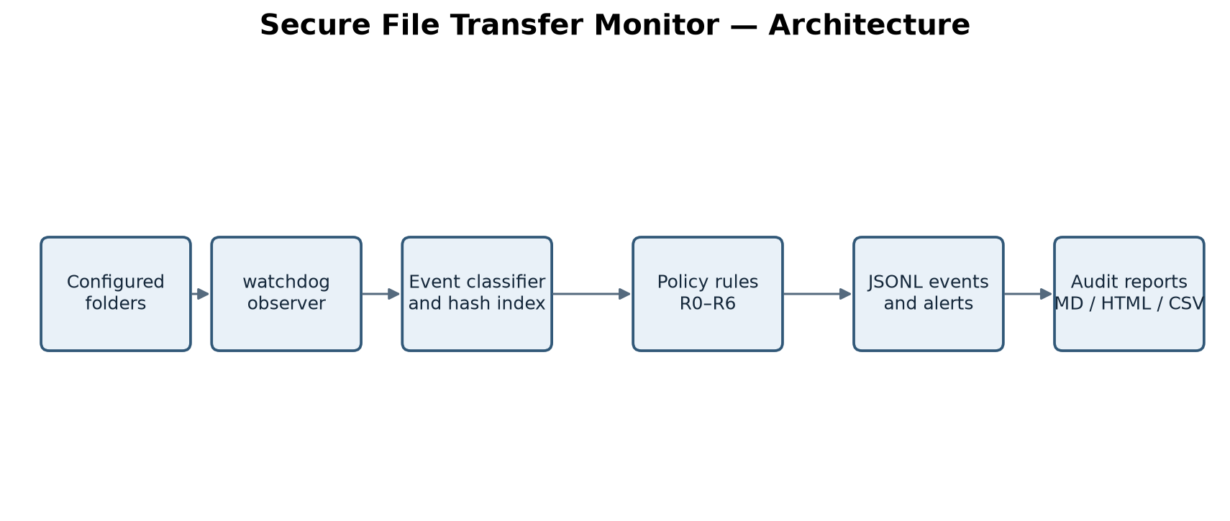
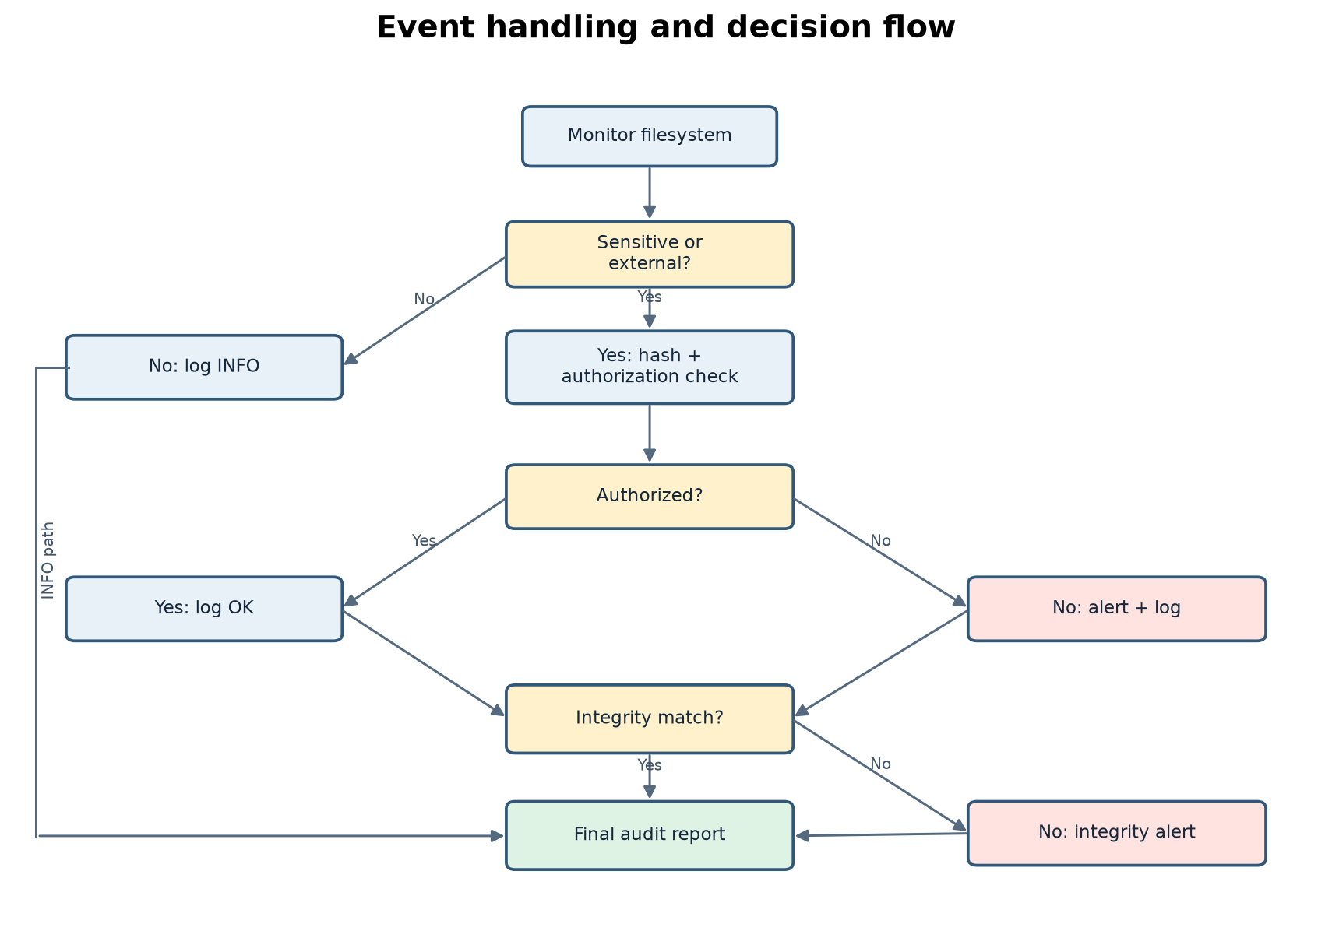

5. Implementation
main.py — CLI dispatch for baseline, monitor, report, hashing, verification, and demo.
hasher.py — Chunked SHA-256/MD5 hashing and stable-file retries.
baseline.py — Initial per-file hash and filesystem metadata index.
policy.py — Path resolution, sensitivity and zone classification, authorization, and rules.
logger.py — Thread-safe JSONL and alert log writers.
handler.py — Small watchdog adapter that sends changes to the monitor worker pool.
monitor.py — Copy/move inference, integrity comparisons, and bulk aggregation.
report.py — Markdown, HTML, and CSV audit report generation.
demo/run_demo.py — Nine synthetic filesystem scenarios with polling-based event confirmation.

6. Detection rules
Rule | Condition | Severity
R1 | Sensitive copy/move outside approved path | HIGH
R2 | Transfer into USB/cloud/share zone | MEDIUM or HIGH
R3 | Hash mismatch or changed file | CRITICAL
R4 | More than threshold transfers in a time window | HIGH
R5 | Sensitive-file deletion | HIGH
R6 | Sensitive access by a non-authorized user | HIGH
R0 | No violation found | INFO

7. Testing and observed results
Observed latest clean run: 415 event records and 11 alert lines. Event totals: BULK=1, COPY=5, CREATE=200, DELETE=1, MODIFY=207, MOVE=1. See evidence/run1 and evidence/run2 for transcripts and copied outputs.
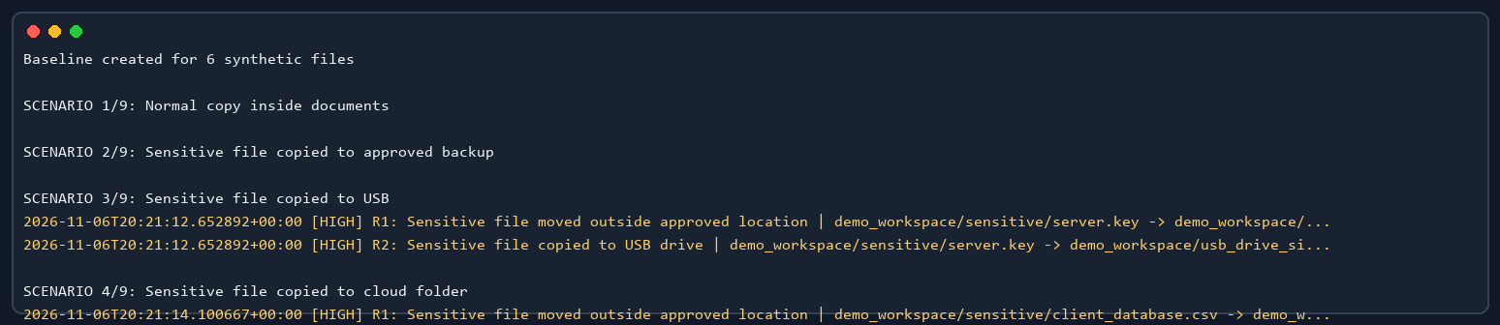
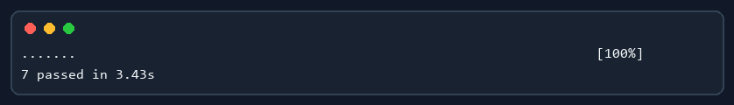

8. Integrity evidence
The evidence folder includes a correct copy and an altered copy checked through the CLI. MATCH means both SHA-256 values are identical; MISMATCH means the content changed. All evidence files are synthetic.

9. Limitations and future work
Filesystem notification behavior differs across operating systems; copy detection is inferred from hashes and moves may arrive as paired notifications. USB/cloud/share zones require explicit configured paths. Process attribution is best-effort. The Windows build does not record open/read access, and this session did not verify macOS or Linux. Future work could add platform-specific access auditing, retention controls, and signed reports.

10. Conclusion
The project demonstrates a small, explainable pipeline from filesystem notification to policy evaluation, hash comparison, alert logging, and report generation. The synthetic scenarios and tests provide repeatable evidence for the stated scope.

References
- Python documentation — pathlib, hashlib, argparse: https://docs.python.org/3/
- watchdog documentation: https://python-watchdog.readthedocs.io/
- pytest documentation: https://docs.pytest.org/

