Secure File Transfer Monitoring System
Project report and verification record
  - Blue Team · Data Loss Prevention · File Integrity Monitoring
Vansh Dhawan
First internship project · Unified Mentors
[Supervisor]
[Date]

Contents
Contents 2
Abstract 3
1. Introduction and problem statement 4
2. Objectives and learning outcomes 5
3. Scope and tools 6
4. System architecture 7
5. Workflow and policy branches 8
6. Implementation modules 9
7. Detection rules 10
8. Testing and verification 11
9. Demonstration results 12
10. Integrity evidence 13
11. Limitations 14
12. Future work 15
13. Conclusion 16
References 17
Appendix A. Policy sample 18
Appendix B. Command reference 19
Appendix C. Traceability and evidence 20

Abstract
This report describes a local Python monitor that records file-system changes, classifies configured paths, compares SHA-256 hashes, applies rules R0–R6, and creates audit reports. The deterministic demo exercises ordinary and approved copies, simulated external destinations, file changes, deletion, and a 200-file burst. The final captured demo contains 210 event rows. The tool is an audit aid: it does not block transfers or observe network protocols.
The final automated suite reports 20 passed in 19.23s. Two clean runs, independent hashes, sabotage checks, and the source limitations are detailed below.

1. Introduction and problem statement
A file can leave an approved folder, change after transfer, or disappear without a single readable audit trail. Security teams need to see which file changed, where it went, when it happened, and which policy rule applies. This project demonstrates that record using local folder notifications and a small JSON policy.
The monitor uses path labels to represent USB storage, cloud sync folders, and network shares. These are configured directories, not device-level or network-level detectors. The system records evidence for review; it does not prevent an operating-system action.

2. Objectives and learning outcomes
Objective | Demonstration
Activity logging | Timestamped JSONL records include source, destination, user, process, hashes, and policy result.
DLP-style checks | R1/R2 mark sensitive transfers outside approved locations and into configured zones.
Integrity | SHA-256 compares baseline and observed content; R3 flags a mismatch.
Alerting and audit | Rules write console and log findings; reports summarize the timeline.
Testing | Unit and watcher tests plus deterministic scenarios check behavior.
A file-system transfer is a create, copy-like, move, delete, or modify event in a watched folder. A data-loss prevention rule applies policy to a file and its destination. A cryptographic hash is a content fingerprint: the same bytes should produce the same SHA-256 value. Monitoring records activity; auditing reviews those records to decide whether an action needs investigation.

3. Scope and tools
The implementation uses Python, watchdog, pathlib, hashlib, argparse, JSON Lines, pytest, python-docx, python-pptx, Pillow, and matplotlib. The runtime writes local files and uses no database, web application, or external service. Demo data is synthetic and contains no real credentials or customer records.
The project was exercised in Windows PowerShell from a OneDrive-synchronized folder whose path contains spaces and parentheses. Linux and macOS were not available for direct observation. Windows open/read auditing is outside the implementation.
In scope | Out of scope
Configured folder monitoring, classification, hashes, alerts, reports. | Blocking or quarantining a transfer.
Folder paths as USB, cloud, and share examples. | Hardware-level USB detection or cloud APIs.
Best-effort process field. | Reliable attribution when OS data is unavailable.

4. System architecture
The observer forwards filesystem notifications to a worker pool. The monitor classifies the event, checks baseline state, hashes stable files, and appends a structured record. Rule findings also go to the alert log. The report builder reads the event log and writes Markdown, HTML, and CSV views.
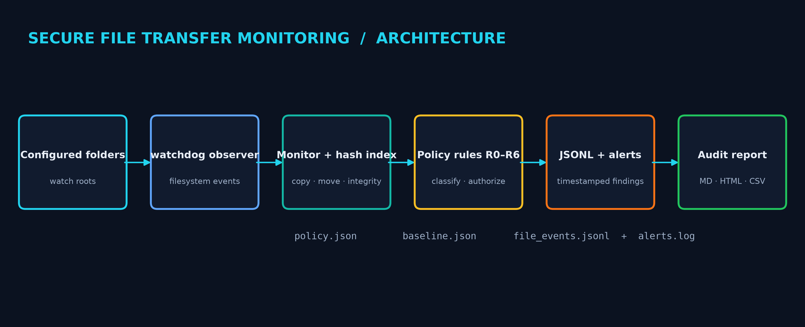
Figure 1. Monitoring modules and evidence flow.
The baseline maps each configured file to SHA-256, optional MD5, size, and modification time. The path index supports integrity checks; the hash index helps infer copies. A copy is inferred from notifications and matching content, not from a native copy signal supplied by watchdog.

5. Workflow and policy branches
The monitor classifies every event. If no sensitive or external policy condition applies, it records ordinary activity. A trigger leads to hash and authorization checks. A disallowed user produces R6; a content mismatch produces R3. The event is logged on each branch so the report can preserve a complete timeline.
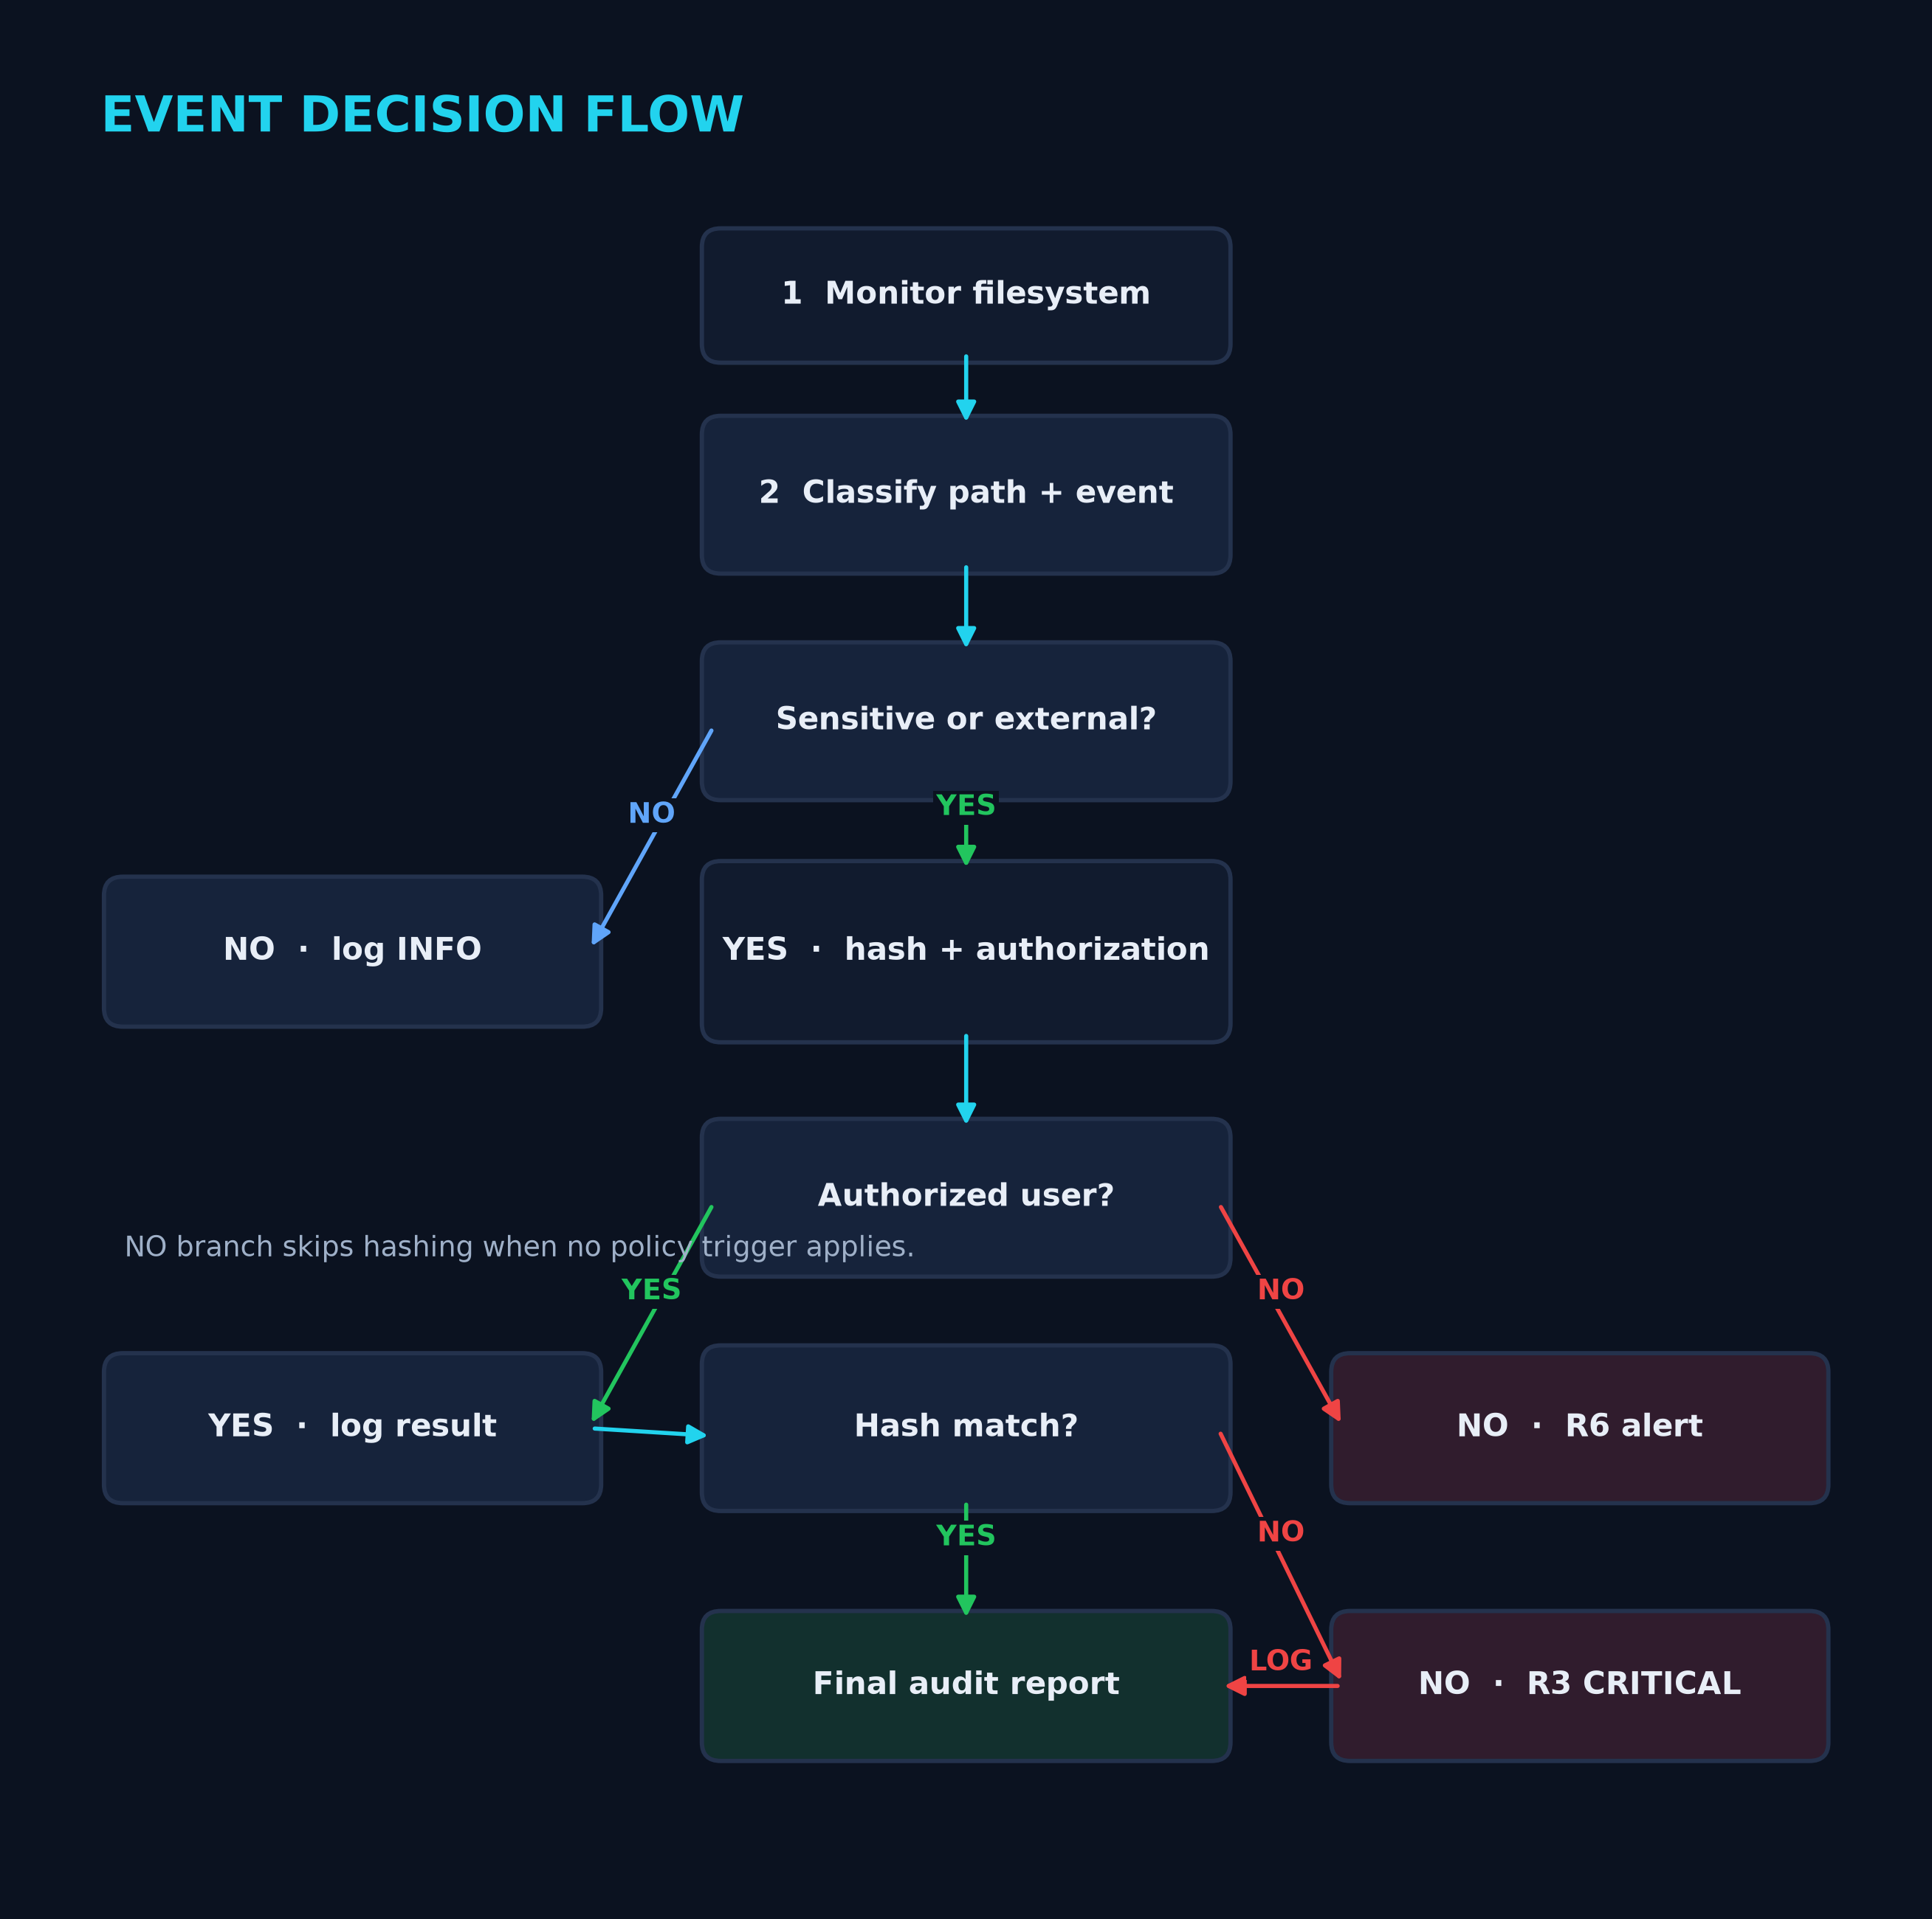
Figure 2. Classification, authorization, and integrity decisions.

6. Implementation modules
main.py Argparse dispatch for hash, baseline, monitor, report, verify, and demo.
hasher.py Chunked hashes and stable-file polling.
baseline.py Initial hash and metadata index.
policy.py Path resolution, sensitive names, zones, authorization, and rules.
handler.py Watchdog adapter for filesystem notifications.
monitor.py Indexes, copy inference, rename correlation, and burst aggregation.
logger.py Thread-safe JSONL and alert output with optional ANSI color.
report.py Markdown, HTML, and CSV summaries and timelines.
demo/run_demo.py Nine synthetic scenarios with event checks.

7. Detection rules
Rule | Condition | Severity / result
R0 | Routine or approved activity | INFO
R1 | Sensitive copy or move outside approval | HIGH
R2 | Transfer into configured USB, cloud, or share zone | MEDIUM or HIGH
R3 | Observed SHA-256 differs from indexed content | CRITICAL
R4 | Configured count exceeded in one time window | HIGH; one summary per window
R5 | Sensitive file deletion | HIGH
R6 | Sensitive event by user outside allow-list | HIGH
Rules are additive: a sensitive USB transfer can match R1 and R2. The event row stores combined rule IDs and the strongest severity. The alert log stores a separate line for each finding.

8. Testing and verification
Check | Run 1 | Run 2
Automated tests | 20 passed in 19.23s | 20 passed in 13.62s
Acceptance | 16/16 checks | 16/16 checks
Event rows | 210 | 210
Event types | BULK=1, COPY=5, CREATE=200, DELETE=1, MODIFY=2, MOVE=1 | BULK=1, COPY=5, CREATE=200, DELETE=1, MODIFY=2, MOVE=1
Severity totals | CRITICAL=2, HIGH=6, INFO=202 | CRITICAL=2, HIGH=6, INFO=202
Tests cover hash vectors, classification and authorization, integrity match/mismatch, copy inference, one alert per bulk window, report generation, watcher delivery, stable writes, event ordering, process path matching, and privacy-safe external paths. The sabotage record documents three deliberate faults and the failures they caused.

9. Demonstration results
The nine scenarios cover normal copy, approved backup, USB copy, cloud copy, move, altered share copy, in-place tampering, sensitive deletion, and a 200-file burst. Every item is synthetic. Final logs and acceptance files are the source for the counts below.
Measure | Run 1 | Run 2
Event records | 210 | 210
Event types | BULK=1, COPY=5, CREATE=200, DELETE=1, MODIFY=2, MOVE=1 | BULK=1, COPY=5, CREATE=200, DELETE=1, MODIFY=2, MOVE=1
Severity | CRITICAL=2, HIGH=6, INFO=202 | CRITICAL=2, HIGH=6, INFO=202
Acceptance | 16/16 checks | 16/16 checks
Figure 3. USB alert from final log.
Figure 4. Integrity mismatch from final log.
Figure 5. Aggregated 200-file alert.

10. Integrity evidence
File | SHA-256
altered_copy.txt | 71f06f874c7584504ea350174c5eae3c193136f9f947cf5e00cd19c4f3cc0157
correct_copy.txt | 6ce3452e9266c630f079baaa8a4f0f18576c11bc1857a94b4da5ee7a70af0118
original.txt | 6ce3452e9266c630f079baaa8a4f0f18576c11bc1857a94b4da5ee7a70af0118
verify_match.txt | fb902f661b5e7f38be9401f9997911a6e3cc65272441f49faa64c8ffced41bf2
verify_mismatch.txt | ee3454e12c1ae69528540b373bdffa15247f68b6cd570cc3d6e95145c6fa58c9
PowerShell Get-FileHash independently checked five files. The original and correct copy share a digest. The altered copy differs. The project verify command prints MATCH for the correct pair and MISMATCH for the altered pair.
python main.py verify evidence/integrity/original.txt evidence/integrity/correct_copy.txt
python main.py verify evidence/integrity/original.txt evidence/integrity/altered_copy.txt

11. Limitations
Limit | Effect
No enforcement | The monitor reports activity but cannot stop or reverse it.
Folder-based zones | Zone labels depend on configured paths; there is no hardware or network inspection.
No open/read audit | Windows notifications do not show every file access; R6 applies to observed events.
Process field | All final demo records say unknown; psutil is not installed here.
Platform variability | Windows was checked; other systems need their own verification.
OneDrive sync | Sidecar and rename notifications can add noise; desktop.ini is ignored by default.

12. Future work
A production extension could add Windows-specific access auditing, removable-drive identity, cloud-provider events, and SIEM forwarding. Deployment should also define log retention, access controls, alert ownership, and an incident review process. These features are outside this project and have not been tested.

13. Conclusion
The project turns configured file-system changes into structured evidence. Hash comparisons identify changed content, policy rules mark risky paths and users, and the report ties individual events to a summary. The repeatable demo and tests show behavior within the stated path-based scope.
For submission, replace the four identity placeholders, review the limits, and run the demo on the presentation computer before recording.

References
- Python pathlib and hashlib: https://docs.python.org/3/
- watchdog: https://python-watchdog.readthedocs.io/
- pytest: https://docs.pytest.org/
- python-docx: https://python-docx.readthedocs.io/
- python-pptx: https://python-pptx.readthedocs.io/

Appendix A. Policy sample
{
"watched_dirs": ["demo_workspace"],
"sensitive_dirs": ["demo_workspace/sensitive"],
"restricted_extensions": [".key", ".pem", ".kdbx"],
"restricted_name_keywords": ["password", "salary", "confidential"],
"allowed_destinations": ["demo_workspace/approved_backup"],
"external_zones": {
"USB": ["demo_workspace/usb_drive_sim"],
"CLOUD": ["demo_workspace/cloud_sync_sim"],
"NETWORK_SHARE": ["demo_workspace/network_share_sim"]
},
"authorized_users": [],
"bulk_transfer": {"threshold_files": 50, "window_seconds": 60},
"hash_algorithms": ["sha256", "md5"],
"ignore_patterns": ["*.tmp", "*.swp", "~$*", ".DS_Store", "desktop.ini"]
}
Replace the sample folders with local paths. Keep approved destinations narrow and review the allow-list before monitoring sensitive files.

Appendix B. Command reference
usage: main.py [-h] {baseline,monitor,report,verify,hash,demo} ...
Secure File Transfer Monitoring System
positional arguments:
{baseline,monitor,report,verify,hash,demo}
options:
-h, --help show this help message and exit
Command | Purpose
python main.py baseline | Create a hash baseline.
python main.py monitor | Watch configured folders until Ctrl+C.
python main.py report | Rebuild reports from the current log.
python main.py hash FILE | Print SHA-256 and MD5.
python main.py verify SOURCE COPY | Compare SHA-256; mismatch exits 1.
python main.py demo --clean --pace 3 | Run the demo with recording pauses.
python -m pytest -q | Run the automated suite.

Appendix C. Traceability and evidence
See docs/TRACEABILITY_MATRIX.md for the requirement-to-test links. Each final run folder contains its console transcript, logs, reports, and acceptance result. The evidence/final directory also stores both test outputs, independent hashes, negative acceptance, sabotage checks, and the clean-clone record.

