Opis implementacije recommender sistema.

- Content features per hotel come from name, city, description, and tags also plus numeric rating and cheapest room price.
- ML.NET pipeline builds a normalized feature vector: text featurization + normalized rating + normalized price, concatenated and L2‑normalized.
- User profile vector = average of vectors of hotels the user has interacted with (wishlist + reservations + reviews).
- Similarity = cosine similarity (dot product of normalized vectors). Highest scores are recommended.
- Cold‑start: if the user has no interactions, it falls back to:
  - top‑booked or top‑rated hotels in the last 30 days, then
  - rating/price fallback if no recent data.

Putanju i printscreen source code-a glavne logike recommender sistema

I used :
Roomwise.Services/Services/MLRecommendationService
Roomwise.Services/Interface/IrecommendationService
Roomwise.Api/Controller /RecommendationsController

Main logic lives in MLRecommendationService.cs. That file contains the full recommendation pipeline (feature extraction + ML.NET pipeline + cosine similarity + cold‑start fallback).

public async Task<IReadOnlyList<HotelSearchItemResponse>> GetForUserAsync(string userId, int top = 10, CancellationToken ct = default)
{
top = Math.Max(1, top);

var interactedIds = await _db.Set<Wishlist>().Where(w => w.UserId == userId).Select(w => w.HotelId)
.Concat(_db.Set<Reservation>().Where(r => r.UserId == userId).Select(r => r.HotelId))
.Concat(_db.Set<Review>().Where(rv => rv.UserId == userId).Select(rv => rv.HotelId))
.Distinct()
.ToListAsync(ct);

var hotels = await _db.Set<Hotel>()
.Include(h => h.City)
.Include(h => h.Images)
.Include(h => h.RoomTypes)
.Include(h => h.HotelTags).ThenInclude(ht => ht.Tag)
.AsNoTracking()
.ToListAsync(ct);

var rows = new List<HotelFeatureRow>(hotels.Count);
foreach (var h in hotels)
{
var cheapest = h.RoomTypes.OrderBy(rt => rt.BasePrice).FirstOrDefault()?.BasePrice ?? 0m;
var tagText = string.Join(' ', h.HotelTags.Select(ht => ht.Tag.Name));
var text = $"{h.Name} {h.City.Name} {h.Description} {tagText}";

rows.Add(new HotelFeatureRow
{
HotelId = h.Id,
Text = text,
Rating = (float)h.Rating,
Price = (float)cheapest
});
}

var data = _ml.Data.LoadFromEnumerable(rows);
var pipeline = _ml.Transforms.Text.FeaturizeText("TextFeats", nameof(HotelFeatureRow.Text))
.Append(_ml.Transforms.NormalizeMeanVariance("RatingNorm", nameof(HotelFeatureRow.Rating)))
.Append(_ml.Transforms.NormalizeMeanVariance("PriceNorm", nameof(HotelFeatureRow.Price)))
.Append(_ml.Transforms.Concatenate("Features", "TextFeats", "RatingNorm", "PriceNorm"))
.Append(_ml.Transforms.NormalizeLpNorm("Features"));

var model = pipeline.Fit(data);
var transformed = model.Transform(data);
var vectors = _ml.Data.CreateEnumerable<HotelFeatureVector>(transformed, reuseRowObject: false).ToList();
var hotelVectorMap = vectors.ToDictionary(v => v.HotelId, v => v.Features);

if (interactedIds.Count == 0)
{
// cold‑start: top‑booked/top‑rated in last 30 days, else rating+price fallback
}

// build user profile vector (average of interacted hotel vectors)
// cosine similarity ranking
}

Putanju i printscreen iz pokrenute aplikacije gdje se prikazuju preporuke

GET /api/recommendations?top=10

It’s used on the landing page of my application

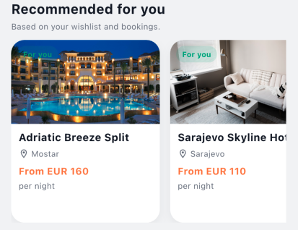

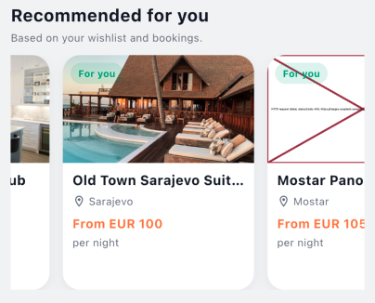
Also when we open a hotel preview on the bottom of the screen we see other hotels on the recommended.
