Dysarthric Speech Recognition with Whisper and Facial Surface EMG
Abstract—Dysarthric speech is transcribed by Whisper Small English with a low-rank adapter trained on TORGO and UA-Speech, and may be spoken back in one fixed voice. Facial surface electromyography (EMG) supplies gesture timing, lip and jaw coordination, and effort, because those cues survive when the acoustic waveform does not. On 951 utterances from two held-out TORGO speakers, five-beam decoding reaches 22.77% word error, against 50.02% for the unmodified model scored before silence trimming. Severe speech remains at 30.65% word error, and the lowest intelligibility band remains above 60%.
Index Terms—dysarthria, automatic speech recognition, Whisper, low-rank adaptation, surface electromyography

I. AIM
The system writes down speech that is hard to understand, and can read the words aloud. Playback uses one Piper voice, en_US-lessac-medium, for every speaker. The spoken reply is a clear preset voice. It is not a reconstruction of the talker's own voice.
Recognition uses Whisper Small English. A low-rank adapter is trained on dysarthric and control recordings from TORGO and UA-Speech [1], [2]. Two TORGO speakers, F03 (moderate) and M02 (severe), are held out of training so the test measures speakers the adapter has not seen. Facial surface EMG is read with the audio. The waveform is a weak clock for the start of a word, for a pause inside a word, and for which facial gesture produced two similar-sounding words. Fig. 1 is that path, from the board and the EMG electrodes to the transcript and the optional voice.
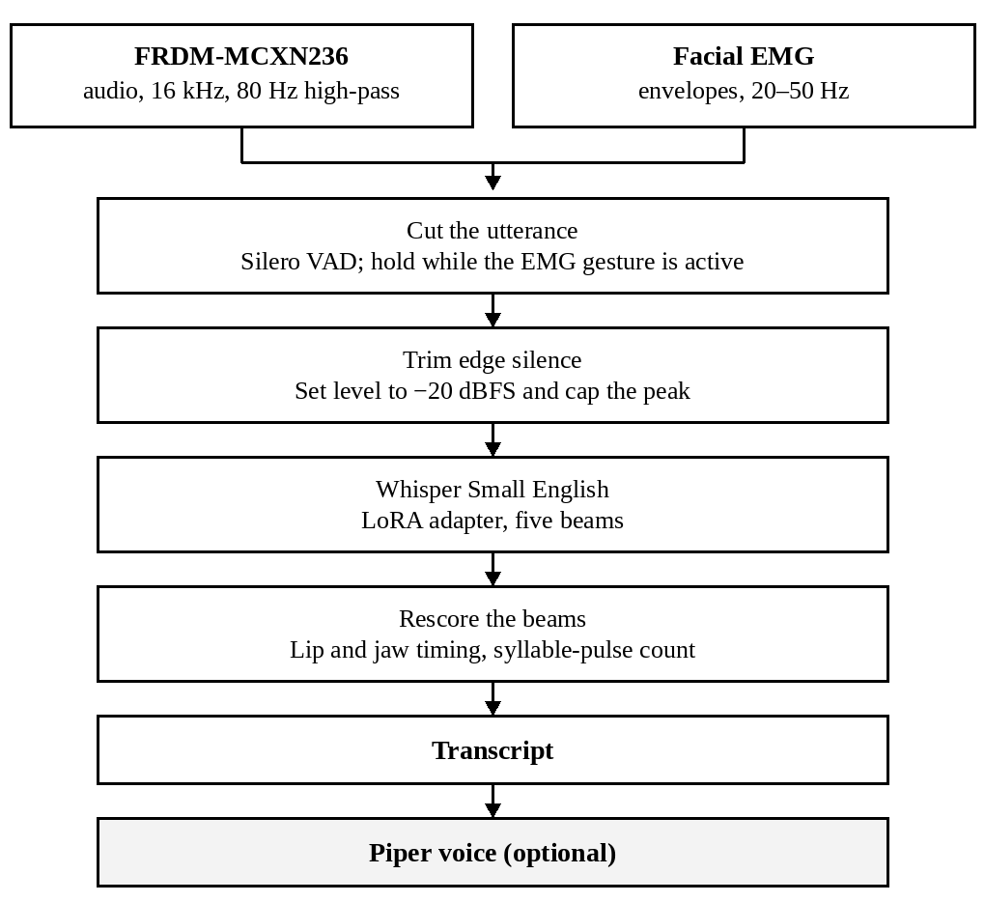
Fig. 1. Pipeline from the acquisition board and the facial EMG electrodes to the transcript. Spoken playback is optional.
II. COMPONENTS
The recognizer is openai/whisper-small.en, an encoder-decoder trained with weak supervision [3]. Only a LoRA adapter is trained [4]. Rank is 32, alpha is 64, and dropout is 0.05. The update is applied to the query, key, value, and output projections and to the two feed-forward layers. The base weights stay frozen. Live decoding uses five beams, at most 36 new tokens, a repetition penalty of 1.15, and a ban on repeating any trigram. Training uses one beam.
Speech boundaries on the audio use Silero voice-activity detection on 32 ms blocks. A one-pole high-pass filter at 80 Hz removes low rumble before that detector. Optional speech output is the Piper voice named above, at 22,050 Hz.
Facial EMG is taken from snap electrodes on the face and brought to a breadboard front end, shown in Fig. 2. The leads in the figure are the red, yellow, and green snaps, with a separate reference pad. A battery supplies the analog side. The slow envelopes of these channels, not the raw carrier, are what the recognizer uses.
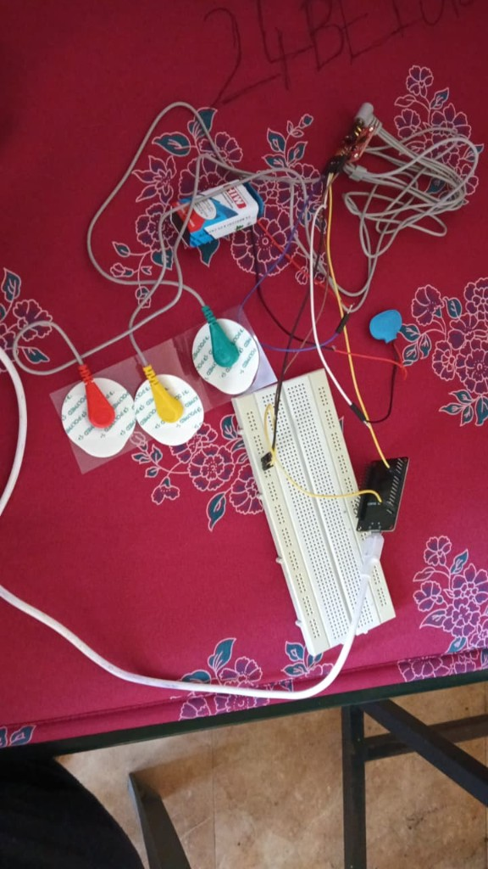
Fig. 2. Surface-EMG bench: snap electrodes, breadboard front end, and supply.
Acquisition is assigned to the NXP FRDM-MCXN236 in Fig. 3. The microcontroller is an Arm Cortex-M33 running at 150 MHz, with a single-precision floating-point unit and SIMD instructions [5]. Those instructions are multiply-accumulates, saturating arithmetic, and packed operations, which are the arithmetic of a real-time filter, an envelope detector, and a sample framer. The board also provides a high-speed USB device port, so framed audio can leave the chip without a separate interface converter. Whisper Small does not fit on this microcontroller. Recognition stays on the host. The board was chosen so the front-end arithmetic can sit next to the electrodes and the microphone, on a core built for that arithmetic, instead of shipping every sample to the host before any filtering.
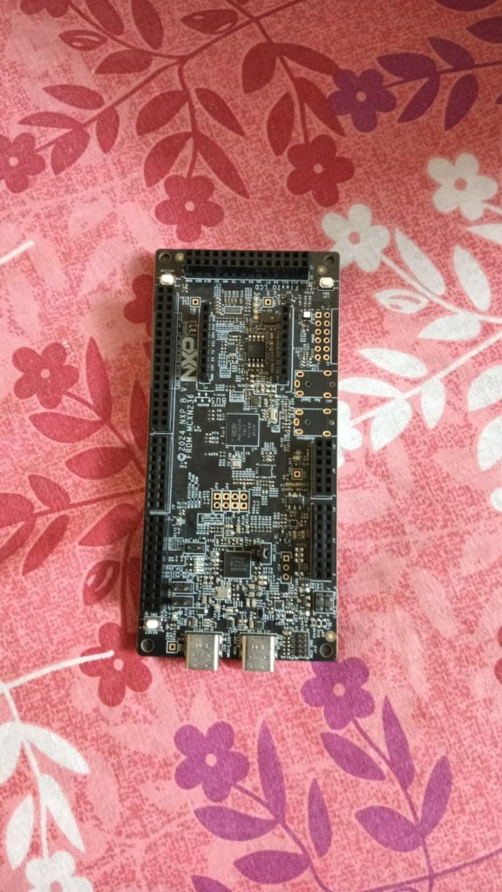
Fig. 3. NXP FRDM-MCXN236. The Cortex-M33 on this board includes a floating-point unit and SIMD instructions for front-end DSP.
III. THEORY
Dysarthria reduces the acoustic contrast listeners and recognizers use. On these corpora the unmodified English model has 17.02% word error on 1,556 control validation utterances and 106.64% on 911 dysarthric ones. On the held-out TORGO speakers the unmodified word error is 50.02% overall, 33.90% for moderate speech, and 73.74% for severe speech. Word error can exceed 100% when the hypothesis inserts more words than the reference contains. That unmodified score was measured before silence trimming, so it is not matched to the final front end.
Whisper consumes a log-mel spectrogram at 16 kHz and attends over a window of up to 30 seconds [3]. Retraining every weight on a few tens of thousands of dysarthric utterances would overwrite the model's general English. LoRA instead adds a low-rank change, ΔW = BA, in the layers that mix features, and leaves the pretrained weights fixed [4]. The adapter can shift the model toward slurred timing and weakened consonants while the rest of the network still decodes ordinary English. The checkpoint that is kept is the epoch with the lowest dysarthric validation word error. Control speech is the majority of the validation set, so the overall error would select a model that is already good at clear speech.
Audio is converted to 16 kHz mono. The high-pass filter cuts rumble below 80 Hz, under the band that carries most of the voice. Silero then scores each 512-sample block. Bursts shorter than 250 ms are dropped, 350 ms is kept before the detected onset, and an utterance is forced to end at 20 seconds. Dysarthric speech often contains a gap inside a word that is longer than ordinary silence, so an audio-only end-of-speech rule cuts too early or waits too long. Before the model, edge silence is removed at 30 dB below the peak, with 200 ms retained on each side, and the level is brought to −20 dBFS with the peak limited to 0.95. Level matching matters because a quiet recording otherwise looks like a different speaking style.
Surface EMG records the summed electrical activity of muscle fibers under the electrode. The spectrum of that voltage is not a speech spectrum. Formants are resonances of the vocal tract. EMG energy is the firing of motor units, concentrated well below the frequencies Whisper was trained on. Mapping one onto the other would invent acoustics the muscles did not produce. After a bandpass and a mains notch, the carrier is discarded. What is kept is the envelope and its slope on each channel, the coordination across channels, co-contraction when opposing muscles fire together, and modulation between 4 and 12 Hz. These traces are taken at about 20–50 Hz, the rate of speech gestures and the frame rate of the Whisper encoder.
Four decisions follow from that representation. A quiet gap in the waveform ends the utterance only when the muscle envelopes are also at rest. If the gesture is still active, the gap is a hold inside the word, and the utterance stays open. If EMG is absent, the fallback is 1,100 ms of acoustic silence. The buffer starts at EMG onset, which leads the sound by a short interval, so a weak first consonant is not clipped. Co-contraction, tremor-band modulation, and a high ratio of EMG energy to audio energy mark strain or a mouthed gesture with little voice. Those frames are treated more cautiously, and a silent interval with an active gesture is still passed to the recognizer. Channel coordination and closure timing rescore the five beams toward the lip or jaw gesture that occurred, which separates words whose acoustics have collapsed but whose facial gestures differ. The number of syllable-like pulses limits how many words the decoder may emit, which cuts insertions caused by breath and leftover silence.
Training runs for four epochs with batch size 4 and gradients accumulated over four steps. AdamW uses a learning rate of 1×10⁻⁴, weight decay 0.01, and gradient clipping at 1.0. The rate warms up for 200 updates and then follows a cosine down to one tenth of the base rate. Each draw picks one microphone from the utterance, then a speed of 0.9, 1.0, or 1.1, and masks the features with two frequency bands of up to 15 bins and two time bands of up to 30 frames. Sampling weights increase toward harder speech: 0.35 for control, 1.0 for high, 1.2 for mild, 1.5 for mid and moderate, 2.0 for low, and 2.5 for severe and very low. The point of the weights is that control speech would otherwise dominate every batch.
The corpora are TORGO [1] and UA-Speech [2]. Evaluation uses the TORGO head microphone and UA-Speech microphone M5. Speaker names include the corpus, so the two people labeled F03 are not the same person. Ten percent of the non-test utterances form the validation set, with seed 17. UA-Speech dysarthric block B3, together with 15% of the remaining dysarthric TORGO utterances, is split evenly into calibration and a held-out adaptation set. UA-Speech filenames store a word code. Digits and the radio alphabet are fixed. Other prompts were labeled by a majority vote of the same Whisper model on three intelligible control speakers. Twenty-seven uncommon-word codes did not agree and were omitted. A further adapter may be trained for 160 steps at 5×10⁻⁵ on one speaker. It is kept only when held-out error on that speaker falls.
IV. AUDIO FRONTEND
Audio is brought to 16 kHz mono before anything else is measured. A file recorded at another rate is resampled. A microphone that opens at a higher rate, commonly 48 kHz, is resampled onto the same grid. Live input is handled in 30 ms frames so the filter and the voice detector can run while the utterance is still arriving.
A one-pole high-pass removes rumble below 80 Hz. With sampling period dt and cutoff fc, the time constant is RC = 1/(2 π fc) and the coefficient is α = RC/(RC + dt). Each sample is updated as y[n] = α (y[n−1] + x[n] − x[n−1]). The filter keeps its state from one frame to the next, so a block boundary does not restart it. At 16 kHz and 80 Hz, α is about 0.969.
Voice activity is scored on the filtered signal. Silero reads 512-sample blocks, which is 32 ms at 16 kHz. A block is speech when its probability is at least 0.45. Bursts shorter than 250 ms are dropped, and 350 ms before the detected start is retained. An utterance is closed after 1,100 ms of detected silence, or at 20 s if the talker has not paused. When facial EMG is present, an active muscle gesture holds the utterance open through an acoustic gap. The 1,100 ms rule is the fallback once the muscle envelopes are at rest.
The cut utterance is then trimmed and leveled for Whisper. Power is computed on 20 ms frames stepped by 10 ms. Samples more than 30 dB below the peak frame power are treated as edge silence, and 200 ms is kept on each side of what remains. The root-mean-square level is scaled to −20 dBFS, a linear gain of 10^(−20/20) relative to full scale, and the peak is limited to 0.95 so that gain cannot clip. Anything longer than 30 s is cut to 30 s, which is the model window.
V. RESULTS
Error rates below are for the audio adapter. The EMG path is used at run time and is not part of these corpus scores. After four epochs, training loss fell from 0.828 to 0.162. Greedy dysarthric validation word error at the selected epoch is 23.73%. With five beams it is 24.16%. The very-low band on that validation set is 61.71% word error (218 utterances). Before silence trimming, the unmodified model scored 216.67% on the same band.
Table I is the speaker-independent test. Both speakers were absent from training, validation, and adaptation. Character error on all 951 utterances is 14.21% for the adapter and 35.57% for the unmodified model.
TABLE I
Held-out TORGO speakers. Unmodified scores predate silence trimming. Adapted scores use five-beam decoding.
Subset | N | Unmod. | Adapted
All held-out | 951 | 50.02 | 22.77
Moderate, F03 | 558 | 33.90 | 17.41
Severe, M02 | 393 | 73.74 | 30.65

Table II continues training for 160 steps on one UA-Speech speaker and scores clips held out from that step. Word error fell for the low and mid speakers. For the high speaker it stayed at 4.84% while character error fell from 1.80% to 1.05%. For the very-low speaker both rates rose.
TABLE II
Speaker adaptation, five-beam decoding, 160 steps, held-out clips. Rates are word error (%).
Speaker | Band | N | Before | After
M08 | High, 93% | 122 | 4.84 | 4.84
M05 | Mid, 58% | 126 | 31.78 | 30.23
M07 | Low, 28% | 118 | 47.97 | 40.65
M04 | Very low, 2% | 125 | 84.25 | 91.34

VI. CONCLUSION
On two TORGO speakers the adapter had never seen, word error fell from 50.02% to 22.77%, and from 73.74% to 30.65% on the severe speaker. The gain comes from a small update to Whisper, trained with extra weight on harder speech and selected by dysarthric validation error. Facial EMG is used where the waveform is ambiguous: it holds an utterance open through a muscular pause, starts the buffer at muscle onset, and breaks ties among beams when the lip and jaw gestures differ. It does not replace the acoustic model, and the tables above do not include it. The FRDM-MCXN236 is the acquisition board because its Cortex-M33 can run the filter, envelope, and framing arithmetic on the device. The recognizer itself stays on the host. The remaining errors are concentrated in very-low intelligibility: 61.71% word error on the validation band, and a speaker adapter that moved M04 from 84.25% to 91.34%.
REFERENCES
[1] F. Rudzicz, A. K. Namasivayam, and T. Wolff, "The TORGO database of acoustic and articulatory speech from speakers with dysarthria," Language Resources and Evaluation, vol. 46, pp. 523–541, 2012. https://doi.org/10.1007/s10579-011-9145-0
[2] H. Kim, M. Hasegawa-Johnson, A. Perlman, J. Gunderson, T. Huang, K. Watkin, and S. Frame, "Dysarthric speech database for universal access research," in Proc. Interspeech, 2008. https://www.isca-archive.org/interspeech_2008/kim08b_interspeech.html
[3] A. Radford, J. W. Kim, T. Xu, G. Brockman, C. McLeavey, and I. Sutskever, "Robust speech recognition via large-scale weak supervision," 2022, arXiv:2212.04356. https://arxiv.org/abs/2212.04356
[4] E. J. Hu, Y. Shen, P. Wallis, Z. Allen-Zhu, Y. Li, S. Wang, L. Wang, and W. Chen, "LoRA: Low-rank adaptation of large language models," 2021, arXiv:2106.09685. https://arxiv.org/abs/2106.09685
[5] NXP Semiconductors, "MCXN23x: Arm Cortex-M33 150 MHz microcontroller," data sheet. The core includes an FPU and SIMD. https://www.nxp.com/docs/en/data-sheet/MCXN23x.pdf
[6] Silero Team, "Silero VAD." Piper voice en_US-lessac-medium, Rhasspy. https://github.com/snakers4/silero-vad; https://github.com/rhasspy/piper

