**SWITCHER**

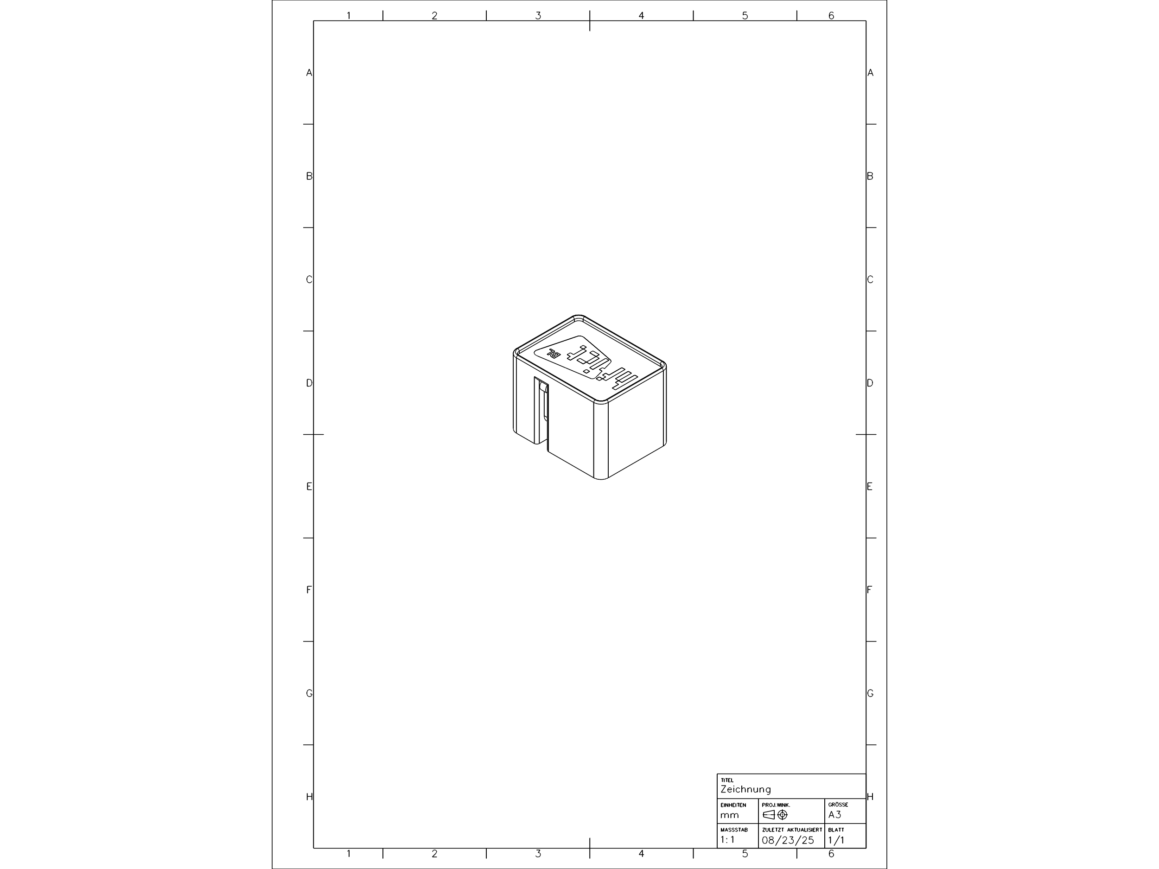

**Scan code for instructions**



https://github.com/VectorSix/HF-ICT_IoT_Switcher

