Tip and Tricks
Dialogs with Dialog Builder 6

Creation Date: | 11/2/2011
Author: | Vladislav Stanev

Summary

The Dialog Builder is a set of tools and object for Vectorworks that allows users to mock up and test layout manager dialogs in the environment of Vectorworks. Testing the dialog while designing is very important to reduce the problems caused by the short comings of the layout manager when laying out complex dialogs with lots of nested groups and alignments. Testing also helps ensuring the dialogs resize properly and behave correctly when localizers change string sizes.

Installing the Dialog Builder Tools

The Dialog Builder tools are part of the Debug Module plug-in found under Source/Plug-ins/Debug folder in mainline. Everyone can compile it but there is also a compiled version available at: http://developer.vectorworks.net/index.php?title=SDK:Dialog_Builder

Download the appropriate version and place it in the Vectorworks Plug-ins folder. It is much more useful to put the plug-ins into the user plug-ins folder. This way it would matter what build is used, the tools will always be there.

Also, on the same address there is a workspace file that contains just the Dialog Builder tools and menu commands. It should be copied into the user workspace folder too, so it would always have the workspace available to switch to when designing dialogs is required.

Basics of the Dialog Builder?

The dialog builder uses a layer in Vectorworks to represent a single dialog layout.

On the layer the user places Dialog Builder Control parametric objects to define the controls on the dialog layout.

The Dialog Builder Control object has a parameter called ‘type’ which can be used to change the layout manager control type. This also helps with the OIP when multiple controls are selected the user is able to change the parameters of them all at the same time.

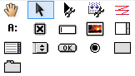
Tools are available to create a Dialog Builder Control with different type representing controls on the Vectorworks layout manager dialog.

Each Dialog Builder Control has two handles that define the relations of this control with the other controls on the dialog layout (similarly to how a Vectorworks layout manager dialogs is defined). Group like controls have an extra point to define the size of the group which is used to determine what controls will be included inside the group.

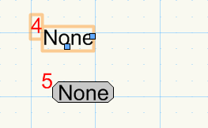
Right handle
Below handle
Control number

The user can get each handle and move it over to other control to define which control is on right or below the selected one:

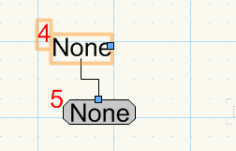
Right handle – there is no control on the right of #4
Below handle – below #4 is the control #5

Tools are provided to test run the dialog. Also, tools are used to export the VectorScript for the dialog that can be used directly inside Vectorworks. Also, a tool is available to automatically renumber the controls so the tab order is correct.

Running the Layout

A simple layout of two controls: static text and button look like this:

The user can use the ‘Run Tool’ to run the layout in Vectorworks

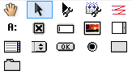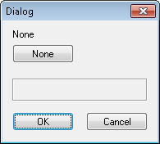

The tool has the following mode bar:

- Run Test Script – pressing this mode button will show the layout manager dialog generated by the Dialog Builder Controls.
- Reset – resets all Dialog Builder Controls on the layout.
- Layout Properties – allows defining the dialog title, resizability, help strings, and so on. See below for more details.
- This mode button group: ‘N’, ‘R’, and ‘old’ is used to randomize the localizable strings of the dialog builder controls.
  - ‘N’ will show the strings as they are entered in the controls
  - ‘R’ will randomize putting random number of the same character instead of the original string. This will simulate localizers changing the size of the strings. Each time the ‘Run Test Script’ is execute, a new set of random strings will be generated.
  - ‘old’ will preserve the same randomization allows the user to fix problems if they are found with ‘R’ mode.
- Next four buttons define tool modes:
  - Normal – testing dialogs.
  - Open – import previously exported layout from .vs or .xml file.
  - Save – export a .vs and .r files for the current layout.
  - VWFC – export SDK’s VWFC::VWDialog class for the current dialog.
- ‘Const’ – shows all constants used in the current dialog layout. This is used when existing dialog is being changed, and the constants need to be pasted back in the existing code of the dialog.

Dialog Builder Control

The dialog builder control has the following OIP:

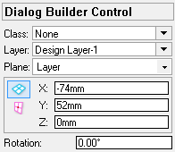 | The default parametric object parameters.
 | The type of the control. This is a list of all supported control types in the Vectorworks layout manager.
 | The control constant number. This value is used by the Layout Manager to control the tab order of the controls.
 | The control constant name. This is used when exporting the constants to VectorScript or C code.
 | Localizable string for the control. Depending on the control there might be a localizable value parameter as well.
 | Localizable string for the help.
 | Horizontal offset of the control for the Layout Manager.
 | Vertical offset of the control for the Layout Manager.
Alignment group of the control for the Layout Manager. This is used with the next two parameters to define how controls align.
Note: A single control can be in multiple groups at the same time. See the ‘Common Settings…’ button below.
 | Align edge for the specified align group.
 | Align mode for the specified align group.
 | Controls the visibility of the control. This is purely for dialog mock ups since the visibility is not part of the dialog creation, but part of the dialog handling.
 | Controls the enable status of the control. This is purely for dialog mock ups since the visibility is not part of the dialog creation, but part of the dialog handling.
 | The left binding of this control for the resizable dialog layouts.
 | The right binding of this control for the resizable dialog layouts.
 | The top binding of this control for the resizable dialog layouts.
 | The bottom binding of this control for the resizable dialog layouts.
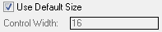 | Size of the text control. This parameter depends on the type of the control.  Note: The control width value could be numeric value prefixed by ‘#’. The dialog builder will make a variable for the controls with the same numbers. The variables will be initialized to the maximum width of all the controls in the group. This could be used for alignment of text fields for example.
 | Defines if the group control should show its frame. This parameter is available only for group controls.
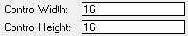 | Some controls have width and height parameters.
 | Only one control in the dialog layout can be specified as left. This control will be placed on the left side of the OK and Cancel buttons.
 | This text parameter defines VectorScript condition that will be used to create the control. This allows advanced control on the dialog layout.
 | Shows the common settings for the layout in a separate dialog. See b below for more details.
 | Defines presentation values for the control. This depends on the type of the control and it is purely for mocking puposes since this depends on the dialog handler.

Save the Layout in .vs and .r

The dialog builder can save the layout in .vs and .r files.

The .vs file will contain VectorScript procedure and a RUN command. The procedure will call the Vectorworks layout manager API to create the defined layout. It will also call resource functions to obtain the localizable resources.

The .r file will contain the resources for this layout dialog. A ‘TEXT’ resource will be included that reads the .vs file. Also it will contain ‘STR#’ resources for the localizable strings in the layout. See the layout properties for options about the indexes of these resources.

Very importantly, the .vs file will also contain a VectorScript commented section of an XML defining the layout. This is with the only purpose for the user to be able to import the layout back to the dialog builder and add corrections to the layout.

Note that if a .vs file is not created through the dialog builder, it will not be able to import it back.

Also, note that the user should not do any manual changes to the .vs and .r files. They always must be generated through the dialog builder to ensure consistency.

Layout Properties

The Layout Properties mode brings the settings dialog allowing the user to define the layout itself.

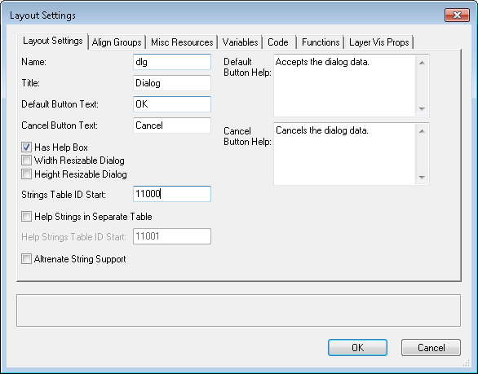
Layout Settings tag:
- Name – defines the name of the dialog. This is the string used in the code as a variable.
- Title – localizable string for the title of the dialog.
- Default Button Text – localizable string to appear on the default button.
- Cancel Button Text – localizable string to appear on the cancel button.
- Default Button Help – localizable string for the default button help.
- Cancel Button Help – localizable string for the cancel button help.
- Has Help Box – shows a group on the layout to display the help for the control under the mouse cursor.
- Width Resizable Dialog – option to allow the layout to be resized horizontally.
- Height Resizable Dialog – option to allow the layout to be resized vertically.
- String Table ID Start – this value is used for resource index for the ‘TEXT’ resource containing the VectorScript, and the ‘STR#’ resource that will contain the localizable strings of the layout.
- Help Strings in Separate Table – will generate another ‘STR#’ table for the help strings. If it is off then the help strings will be added to the String Table ID.
- Help String Table ID Start – if help string are to be in a separate table, this is its index.
- Alternate String Support – will generate mirror resource string tables for the localizable strings.

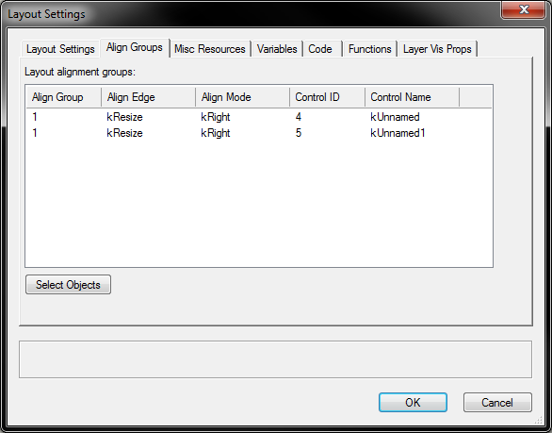
Align Groups tab lists all controls that have alignment groups assigned to them. This tab will allow the user to see what alignments groups are used and the controls associated with them.
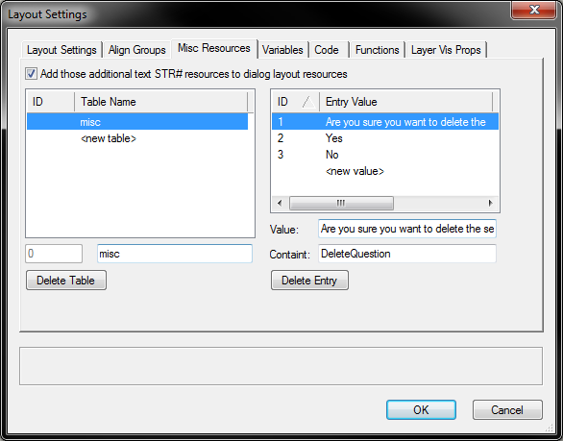
Mist Resources tab allows the user to add additional resources to the dialog layout resources. A check box controls weather it should create a new STR# resource for each table or it would just add the extra strings to the existing dialog resource.

Each resource string has a constant that will be used when generating theconstants for the layout. This way the code will not change when changes to the layout are made.
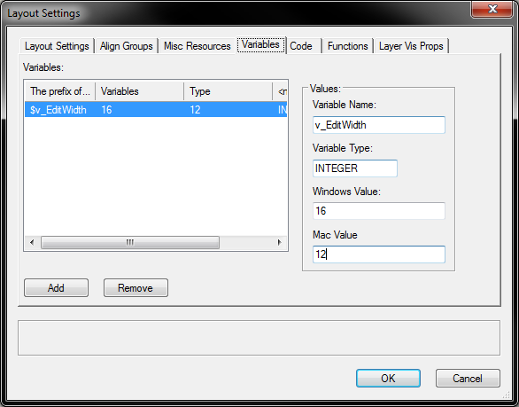
The Variables tab allows users to specify VectorScript variables that are initialized to different values for windows and mac. Every variable name can be used in any edit field when prefixed by ‘$’.

The Code and Functions tabs allows the user to inject VectorScript code into the layout and thus control the layout creation.
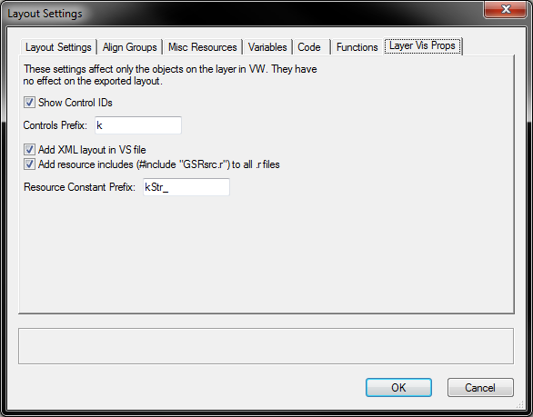
The Layer Vis Props tab specifies settings for the code generation:
- Show Control IDs – will display the control IDs as red numbers on the top left corner of the Dialog Builder Control object.
- Controls Prefix – prefix used when generating the code for the layout controls
- Add XMLlayout in VS file – this will insert the layout definition XML as a VectorScript comment in the .vs file. This allows the layout to be reimported back for changes. Recommended is that this option is always on.
- Add resource includes (#include “GSRsrc.r”) to all .r files – for plug-in development it is necessary to add the SDK resource to each .r file so each one is compilation unit for Rez.exe and the mac.
- Resource Constant Prefix – the prefix added to the constant for resource strings in the code. This is related to the Misc Resources tab.

Code Anatomy

The .vs file named with the name specified in the Layout Settings tag:
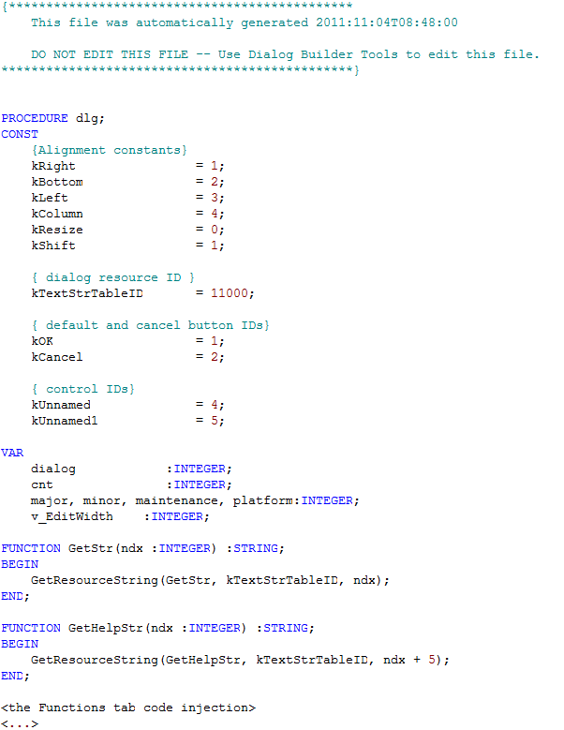
Alignment constants – always inserted by the Dialog Builder
List of the control IDs for the controls in the dialog layout.
The default control IDs for the standard OK and Cancel buttons.
The resource ID for the ‘STR#‘ resources of this dialog layout.
Variables to control the dialog creation. This is the place where the dialog builder places the variables. All of them are always prefixed with ‘v_’
Resource access functions for the labels and help strings. Label strings correspond to the control IDs. Since this code was generated with single STR# table, the help IDs are offset.
This is where the code injected from the Functions tab goes.

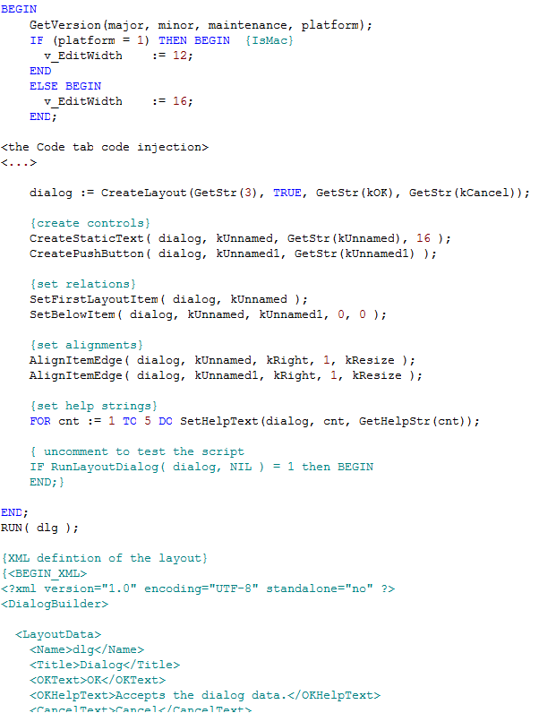
This is where the code injected from the Code tab goes. Note that at this time all variables and Functions are available.
This section is added only when there are variables to made sure they are initialized correctly.
The code that creates the layout. The code is composed of three sections:
- Create the controls
- Set relations between the controls
- Set alignment groups
- Set Help strings
This commented code can be uncommented if this layout is to be run as a document script for testing purposes.
This commented code can be uncommented if this layout is to be run as a document script for testing purposes.
The XML defining the layout used to recreate the layout when importing from the dialog builder.
Note this is VectorScript comment and this portion doesn’t do anything in Vectorworks.

The .r file, same name as the script file. Including this file in the resources is sufficient to add the creation Vectorscript and the necessary resources:
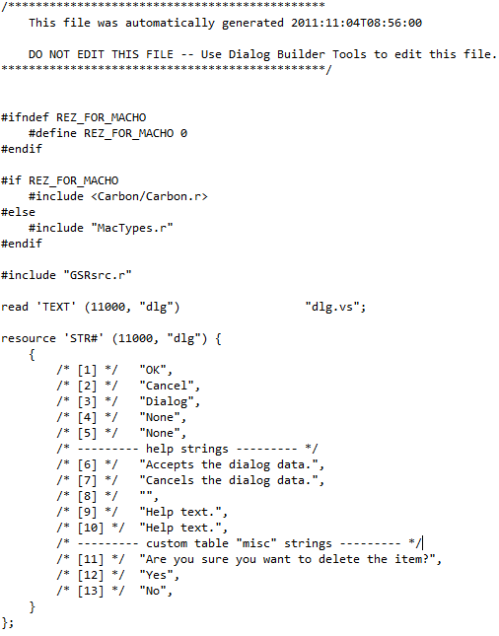
Include section to allow the .r files to be compiled independelty by Rez.exe and mac.
The STR# resource for the dialog. This is combined resource for the control labels, help texts and the additional resources.
If the settings dialog requires adding several resources, they will appear here. Usually the practice is to keep all resources into single table to reduce resource IDs conflicts in quick time.
Read the .vs file as TEXT resource. The resource ID comes from the settings dialog.

Code Anatomy

The constants are used as link between the code and the layout. This allows minimum changes to the code when the layout is updated or extended.

The constants generated by the tool look like this.

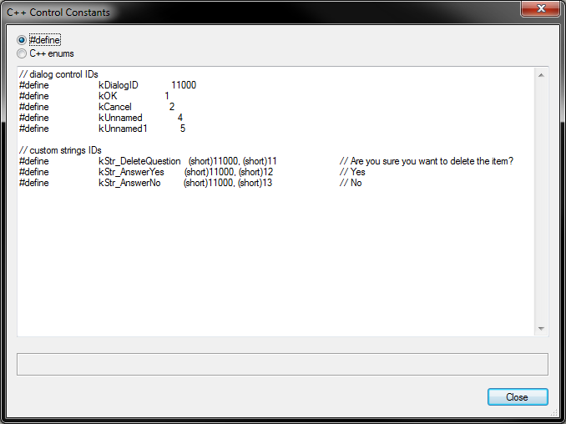
The dialog resource ID and the control IDs. The constant name comes from each Dialog Builder control parameter.
The additional string resources constants.

