Lab – Configuring Basic RIPv2

Topology
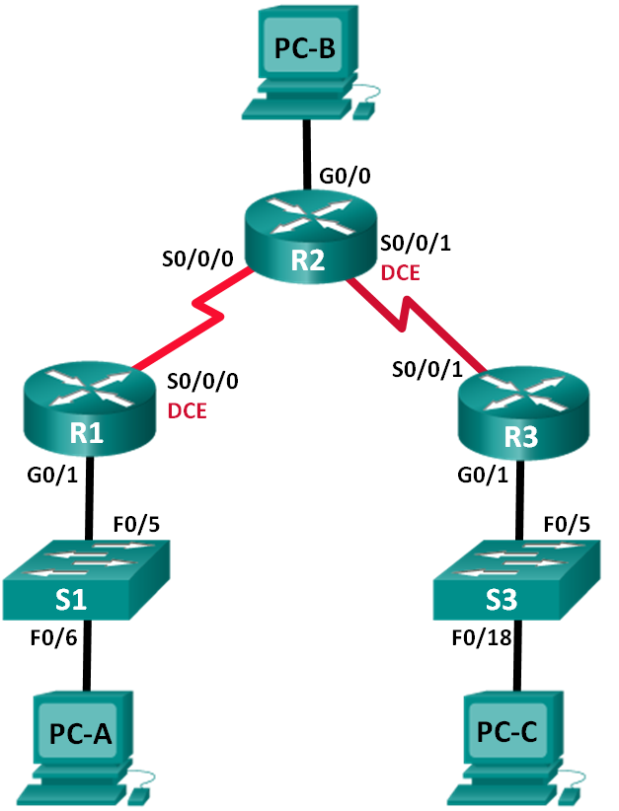
Addressing Table
Device | Interface | IP Address | Subnet Mask | Default Gateway
R1 | G0/1 | 172.30.10.1 | 255.255.255.0 | N/A
 | S0/0/0 (DCE) | 10.1.1.1 | 255.255.255.252 | N/A
R2 | G0/0 | 209.165.201.1 | 255.255.255.0 | N/A
 | S0/0/0 | 10.1.1.2 | 255.255.255.252 | N/A
 | S0/0/1 (DCE) | 10.2.2.2 | 255.255.255.252 | N/A
R3 | G0/1 | 172.30.30.1 | 255.255.255.0 | N/A
 | S0/0/1 | 10.2.2.1 | 255.255.255.252 | N/A
S1 | N/A | VLAN 1 | N/A | N/A
S3 | N/A | VLAN 1 | N/A | N/A
PC-A | NIC | 172.30.10.3 | 255.255.255.0 | 172.30.10.1
PC-B | NIC | 209.165.201.2 | 255.255.255.0 | 209.165.201.1
PC-C | NIC | 172.30.30.3 | 255.255.255.0 | 172.30.30.1
Objectives
Part 1: Build the Network and Configure Basic Device Settings
Part 2: Configure and Verify RIPv2 Routing
- Configure RIPv2 on the routers and verify that it is running.
- Configure a passive interface.
- Examine routing tables.
- Disable automatic summarization.
- Configure a default route.
- Verify end-to-end connectivity.
Background / Scenario
RIP version 2 (RIPv2) is used for routing of IPv4 addresses in small networks. RIPv2 is a classless, distance-vector routing protocol, as defined by RFC 1723. Because RIPv2 is a classless routing protocol, subnet masks are included in the routing updates. By default, RIPv2 automatically summarizes networks at major network boundaries. When automatic summarization has been disabled, RIPv2 no longer summarizes networks to their classful address at boundary routers.
In this lab, you will configure the network topology with RIPv2 routing, disable automatic summarization, propagate a default route, and use CLI commands to display and verify RIP routing information.

- Build the Network and Configure Basic Device Settings
In Part 1, you will set up the network topology and configure basic settings.

- Configure and Verify RIPv2 Routing
In Part 2, you will configure RIPv2 routing on all routers in the network and then verify that the routing tables are updated correctly. After RIPv2 has been verified, you will disable automatic summarization, configure a default route, and verify end-to-end connectivity.
  - Configure RIPv2 routing.
    - Configure RIPv2 on R1as the routing protocol and advertise the appropriate connected networks.
R1# config t
R1(config)# router rip
R1(config-router)# version 2
R1(config-router)# passive-interface g0/1
R1(config-router)# network 172.30.0.0
R1(config-router)# network 10.0.0.0
The passive-interface command stops routing updates out the specified interface. This process prevents unnecessary routing traffic on the LAN. However, the network that the specified interface belongs to is still advertised in routing updates that are sent out across other interfaces.
    - Configure RIPv2 on R3 and use the network statement to add the appropriate connected networks and prevent routing updates on the LAN interface.
    - Configure RIPv2 on R2 and use the network statements to add the appropriate connected networks. Do not advertise the 209.165.201.0 network.
Note: It is not necessary to make the G0/0 interface passive on R2 because the network associated with this interface is not being advertised.
  - Examine the current state of the network.
    - The status of the two serial links can quickly be verified using the show ip interface brief command on R2.
R2# show ip interface brief
Interface IP-Address OK? Method Status Protocol
Embedded-Service-Engine0/0 unassigned YES unset administratively down down
GigabitEthernet0/0 209.165.201.1 YES manual up up
GigabitEthernet0/1 unassigned YES unset administratively down down
Serial0/0/0 10.1.1.2 YES manual up up
Serial0/0/1 10.2.2.2 YES manual up up
    - Check connectivity between PCs.
From PC-A, is it possible to ping PC-B? _________ Why?
____________________________________________________________________________________
No, R2 is not advertising the route to PC-B.
From PC-A, is it possible to ping PC-C? _________ Why?
____________________________________________________________________________________
No, R1 and R3 do not have routes to the remote networks, and R2, incorrectly has two equal cost load balancing routes to the 172.30.0.0/16 subnet..
From PC-C, is it possible to ping PC-B? _________ Why?
____________________________________________________________________________________
No, R2 is not advertising the route to PC-B.
From PC-C, is it possible to ping PC-A? _________ Why?
____________________________________________________________________________________
No, R1 and R3 do not have routes to the remote networks, and R2, incorrectly has two equal cost loadbalancing routes to the 172.30.0.0/16 subnet..
    - Verify that RIPv2 is running on the routers.
You can use the debug ip rip, show ip protocols, and show run commands to confirm that RIPv2 is running. The show ip protocols command output for R1 is shown below.
R1# show ip protocols
Routing Protocol is "rip"
Outgoing update filter list for all interfaces is not set
Incoming update filter list for all interfaces is not set
Sending updates every 30 seconds, next due in 7 seconds
Invalid after 180 seconds, hold down 180, flushed after 240
Redistributing: rip
Default version control: send version 2, receive 2
Interface Send Recv Triggered RIP Key-chain
Serial0/0/0 2 2
Automatic network summarization is in effect
Maximum path: 4
Routing for Networks:
10.0.0.0
172.30.0.0
Passive Interface(s):
GigabitEthernet0/1
Routing Information Sources:
Gateway Distance Last Update
10.1.1.2 120
Distance: (default is 120)
When issuing the debug ip rip command on R2, what information is provided that confirms RIPv2 is running?
____________________________________________________________________________________
RIP: sending v2 updates to 224.0.0.9 via Serial 0/0/0 (10.1.1.2).
When you are finished observing the debugging outputs, issue the undebug all command at the privileged EXEC prompt.
When issuing the show run command on R3, what information is provided that confirms RIPv2 is running?
____________________________________________________________________________________
____________________________________________________________________________________
router rip
version 2

- he default route was configured (R2).
Router Interface Summary Table
Router Interface Summary
Router Model | Ethernet Interface #1 | Ethernet Interface #2 | Serial Interface #1 | Serial Interface #2
1800 | Fast Ethernet 0/0 (F0/0) | Fast Ethernet 0/1 (F0/1) | Serial 0/0/0 (S0/0/0) | Serial 0/0/1 (S0/0/1)
1900 | Gigabit Ethernet 0/0 (G0/0) | Gigabit Ethernet 0/1 (G0/1) | Serial 0/0/0 (S0/0/0) | Serial 0/0/1 (S0/0/1)
2801 | Fast Ethernet 0/0 (F0/0) | Fast Ethernet 0/1 (F0/1) | Serial 0/1/0 (S0/1/0) | Serial 0/1/1 (S0/1/1)
2811 | Fast Ethernet 0/0 (F0/0) | Fast Ethernet 0/1 (F0/1) | Serial 0/0/0 (S0/0/0) | Serial 0/0/1 (S0/0/1)
2900 | Gigabit Ethernet 0/0 (G0/0) | Gigabit Ethernet 0/1 (G0/1) | Serial 0/0/0 (S0/0/0) | Serial 0/0/1 (S0/0/1)
Note: To find out how the router is configured, look at the interfaces to identify the type of router and how many interfaces the router has. There is no way to effectively list all the combinations of configurations for each router class. This table includes identifiers for the possible combinations of Ethernet and Serial interfaces in the device. The table does not include any other type of interface, even though a specific router may contain one. An example of this might be an ISDN BRI interface. The string in parenthesis is the legal abbreviation that can be used in Cisco IOS commands to represent the interface.

