Q no. 1.1:- Install Jupyter notebook and run the first program and share the screenshot of the output.

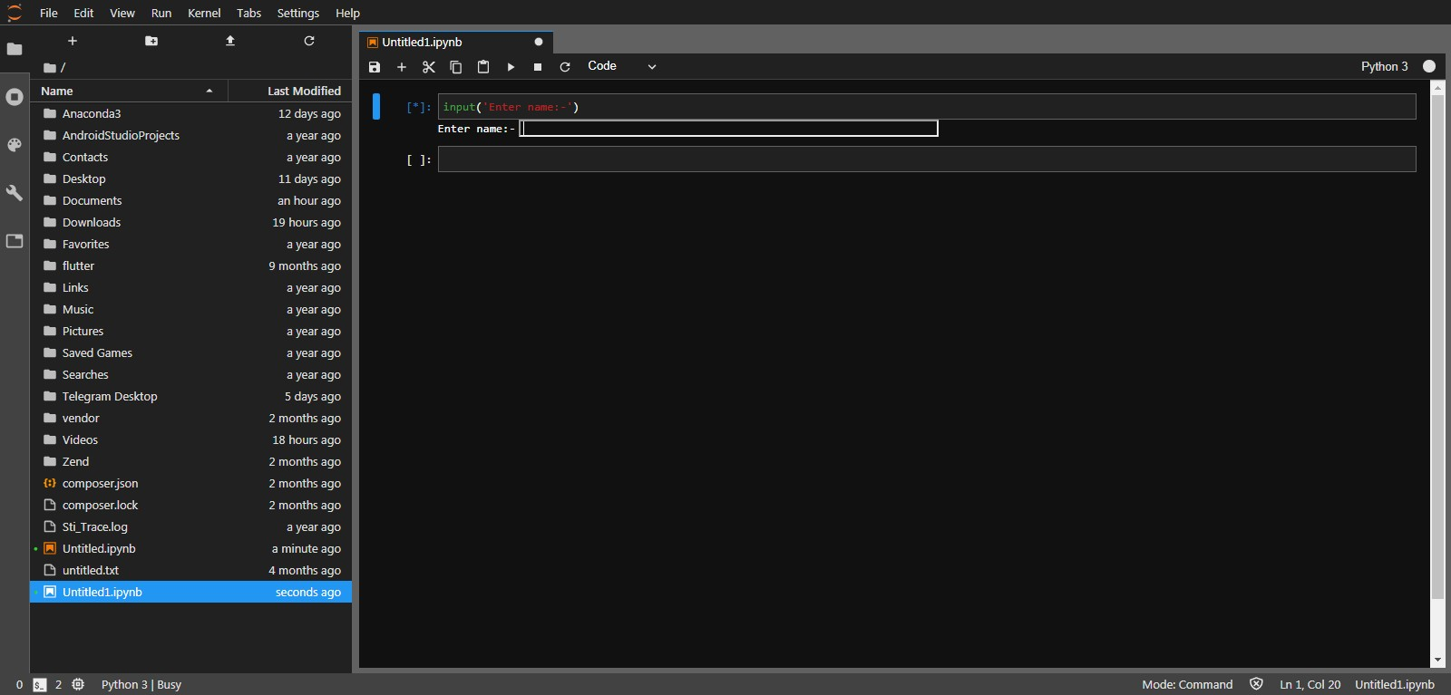

Input(‘Enter Name’)

Q no. 1.2:- Write a program which will find all such numbers which are divisible by 7 but are not a multiple

of 5, between 2000 and 3200 (both included). The numbers obtained should be printed in a

comma-separated sequence on a single line.

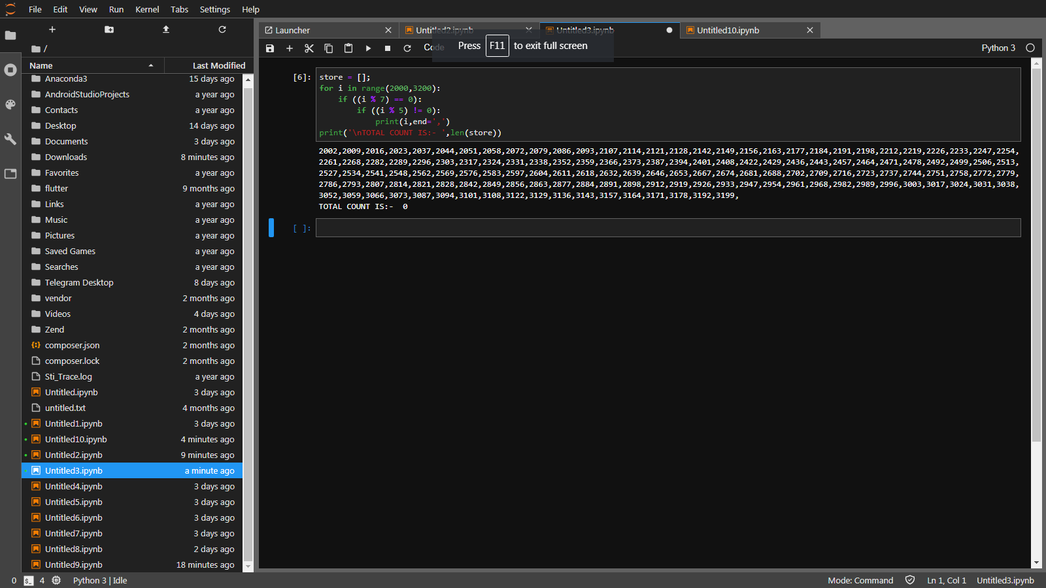

store = [];

for i in range(2000,3200):

if ((i % 7) == 0):

if ((i % 5) != 0):

print(i,end=',')

print('\nTOTAL COUNT IS:- ',len(store))

Q no.1.3:- Write a Python program to accept the user's first and last name and then getting them printed in

the the reverse order with a space between first name and last name.

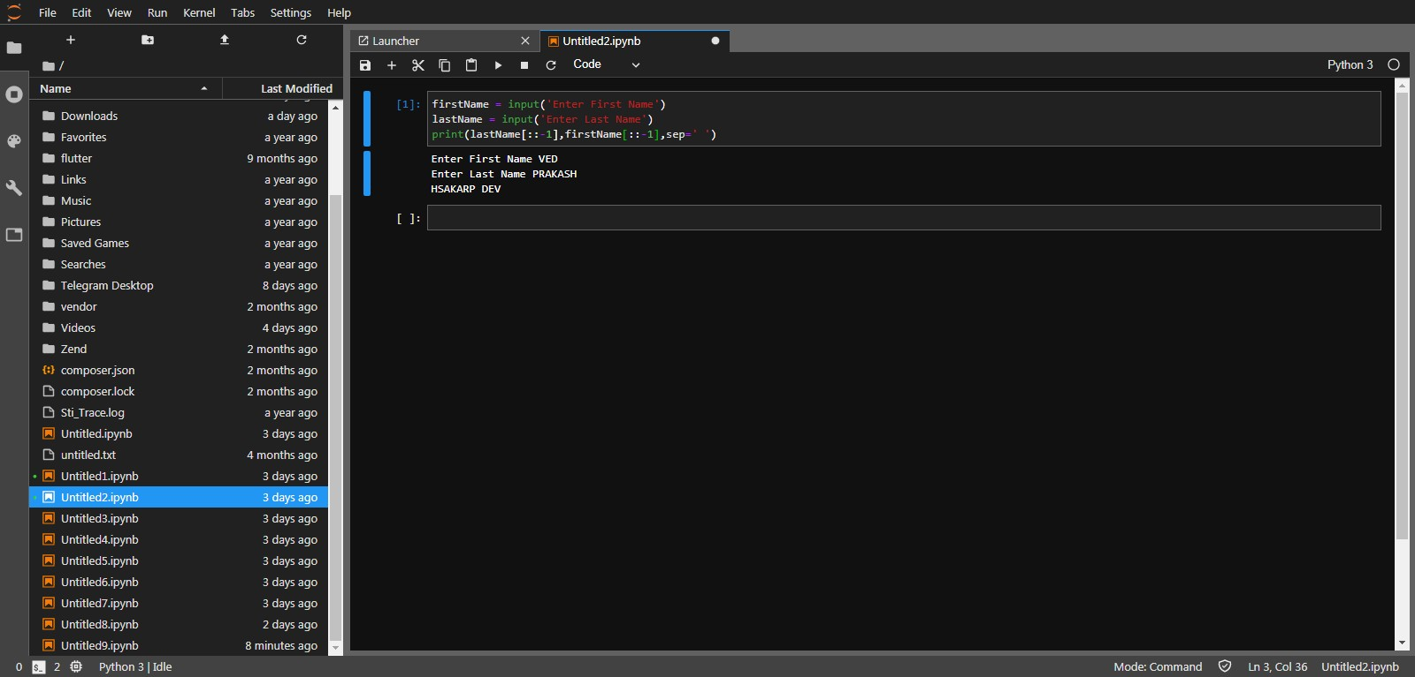

firstName = input('Enter First Name')

lastName = input('Enter Last Name')

print(lastName[::-1],firstName[::-1],sep=' ')

Q no.1.4:- Write a Python program to find the volume of a sphere with diameter 12 cm.

Formula: V=4/3 \* π \* r

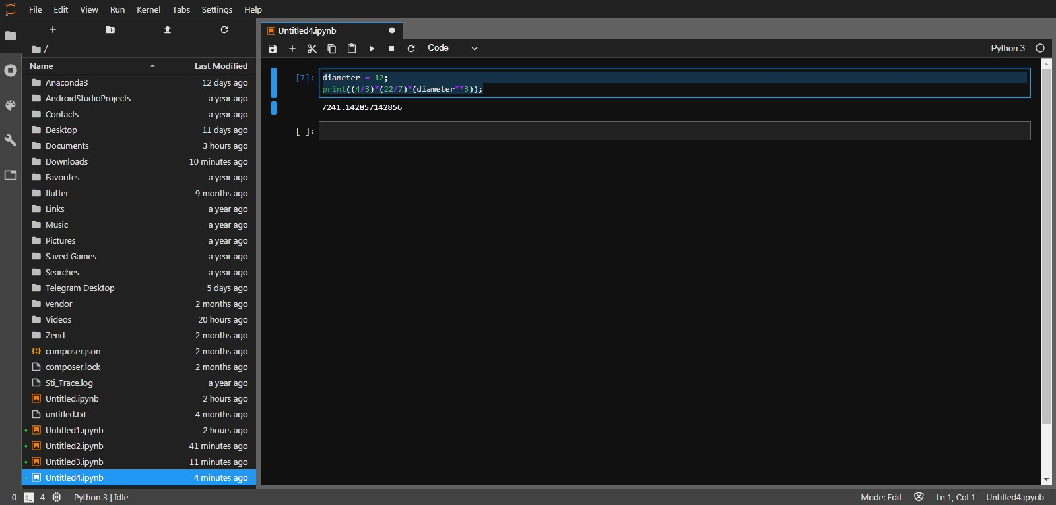

diameter = 12;

print((4/3)\*(22/7)\*(diameter\*\*3));

Q no. 2.1:- Write a program which accepts a sequence of comma-separated numbers from console and

generate a list.

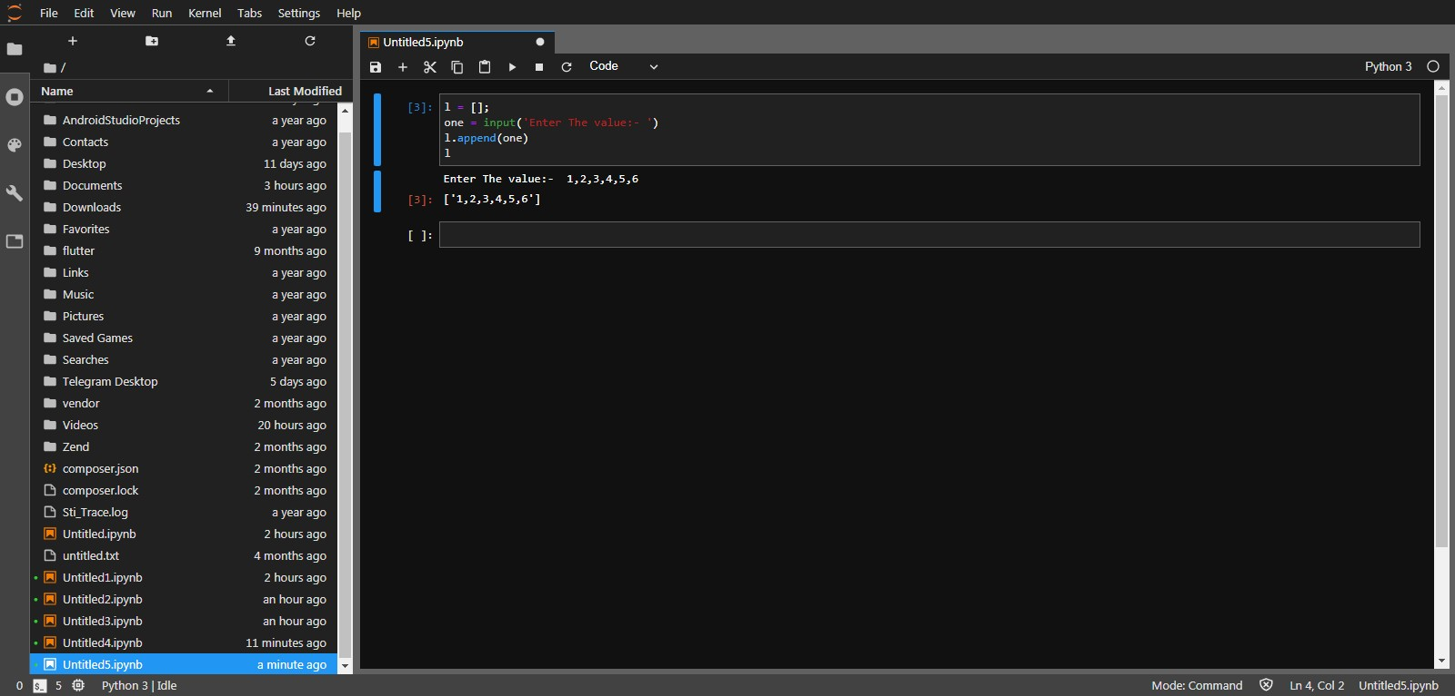

l = [];

one = input('Enter The value:- ')

l.append(one)

l

Q no 2.2:- Create the below pattern using nested for loop in Python.

\*

\* \*

\* \* \*

\* \* \* \*

\* \* \* \* \*

\* \* \* \*

\* \* \*

\* \*

\*

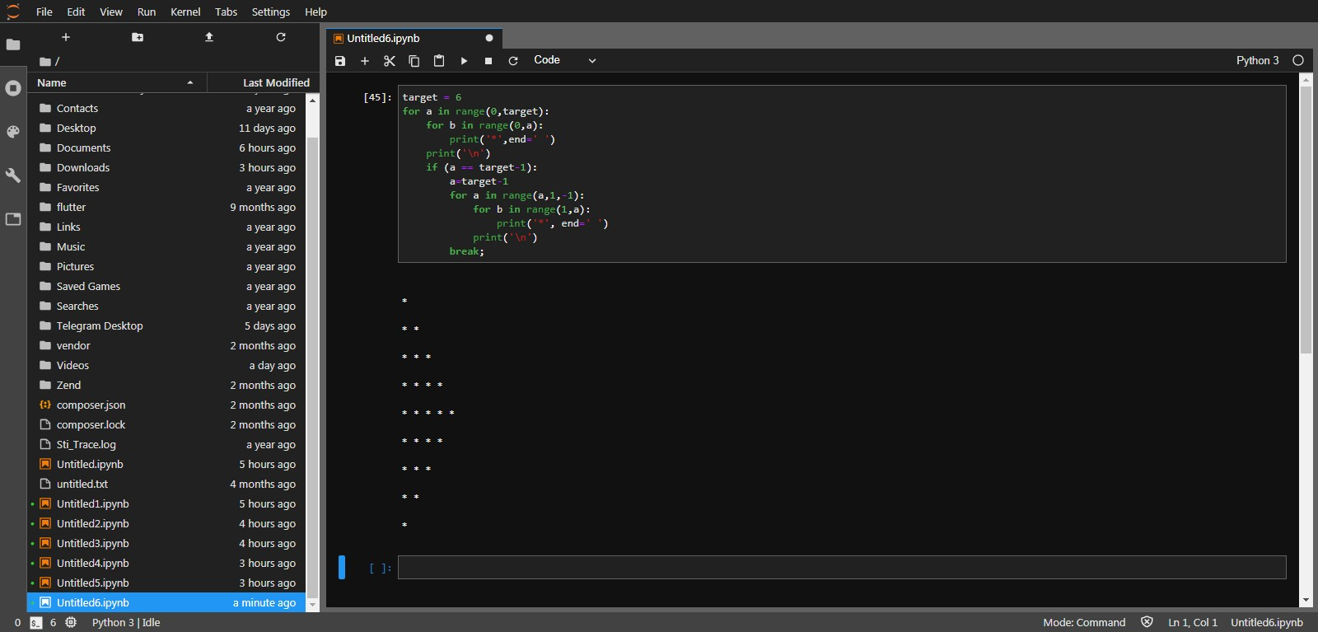

target = 6

for a in range(0,target):

for b in range(0,a):

print('\*',end=' ')

print('\n')

if (a == target-1):

a=target-1

for a in range(a,1,-1):

for b in range(1,a):

print('\*', end=' ')

print('\n')

break;

Q no 2.3:- Write a Python program to reverse a word after accepting the input from the user.

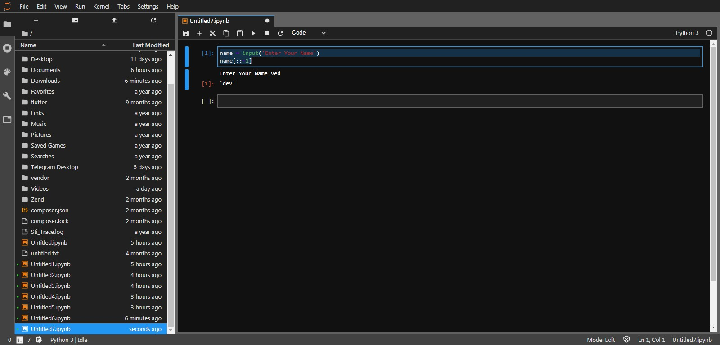

name = input('Enter Your Name')

name[::-1]

Q no 2.4:- Write a Python Program to print the given string in the format specified in the

​

sample output.

WE, THE PEOPLE OF INDIA, having solemnly resolved to constitute India into a

SOVEREIGN, SOCIALIST, SECULAR, DEMOCRATIC REPUBLIC and to secure to all

its citizens

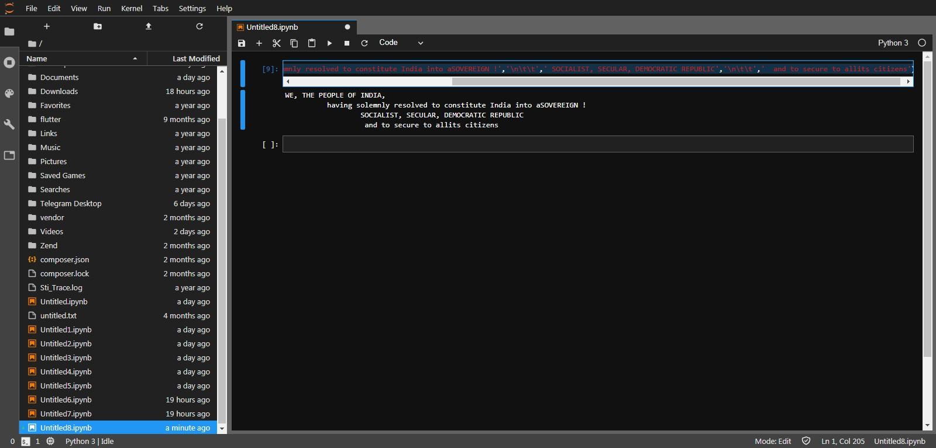

print('WE, THE PEOPLE OF INDIA,','\n\t',' having solemnly resolved to constitute India into aSOVEREIGN !','\n\t\t',' SOCIALIST, SECULAR, DEMOCRATIC REPUBLIC','\n\t\t',' and to secure to allits citizens')