Q no. 1.



Input(‘Enter Name’)

Q no. 2.

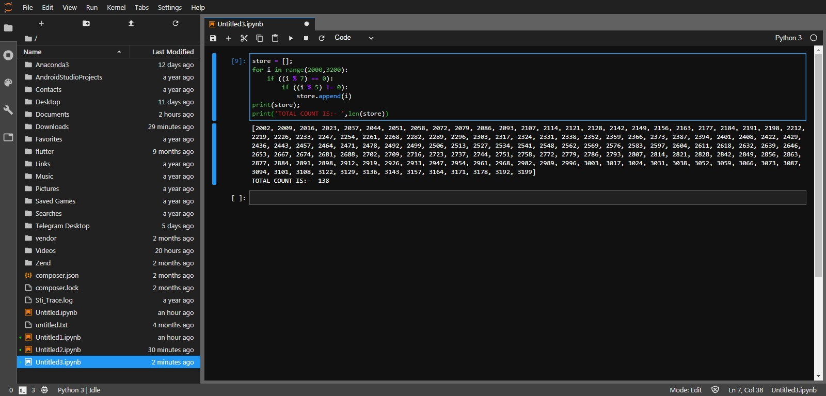

store = [];

for i in range(2000,3200):

if ((i % 7) == 0):

if ((i % 5) != 0):

store.append(i)

print(store);

print('TOTAL COUNT IS:- ',len(store))

Q no.3



firstName = input('Enter First Name')

lastName = input('Enter Last Name')

print(lastName,firstName,sep=' ')

Q no.4

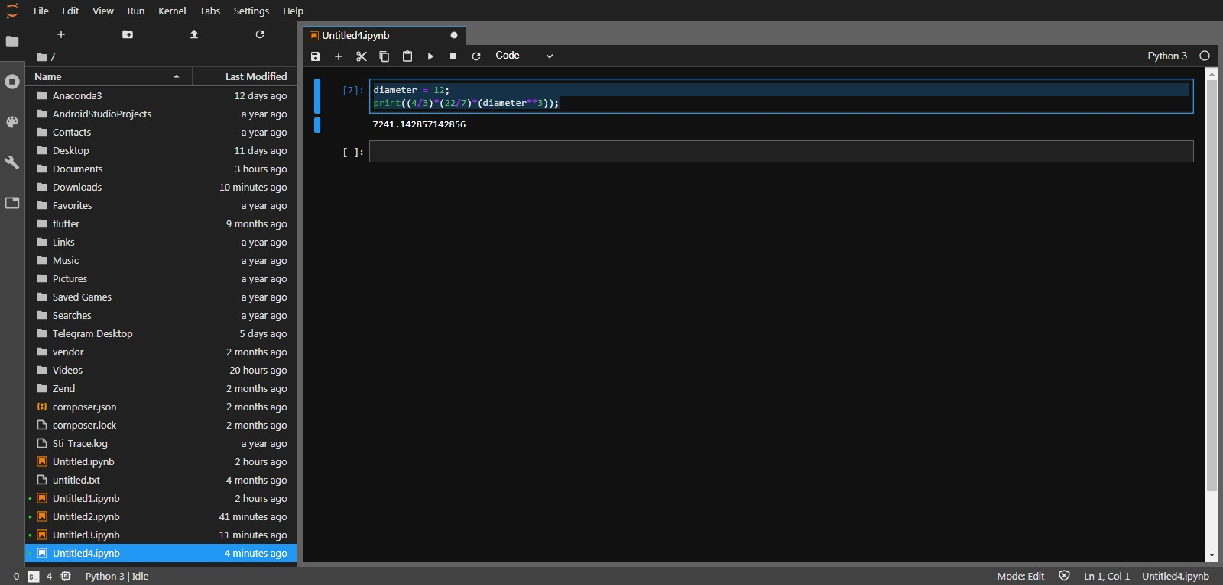

diameter = 12;

print((4/3)\*(22/7)\*(diameter\*\*3));