Q no. 1.1:-
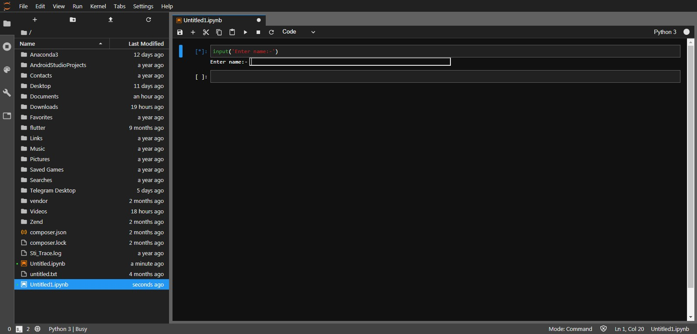
Input(‘Enter Name’)
Q no. 1.2:-
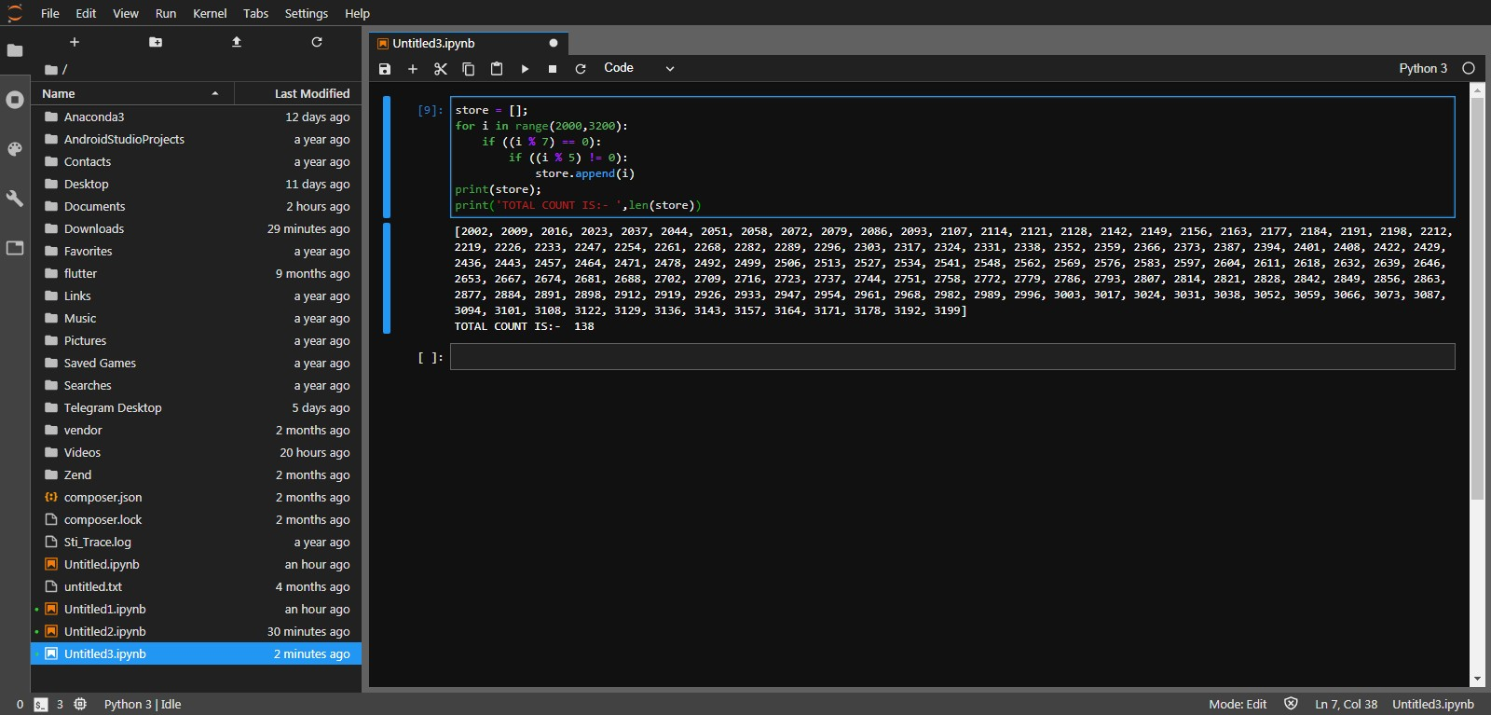
store = [];
for i in range(2000,3200):
if ((i % 7) == 0):
if ((i % 5) != 0):
store.append(i)
print(store);
print('TOTAL COUNT IS:- ',len(store))
Q no.1.3:-

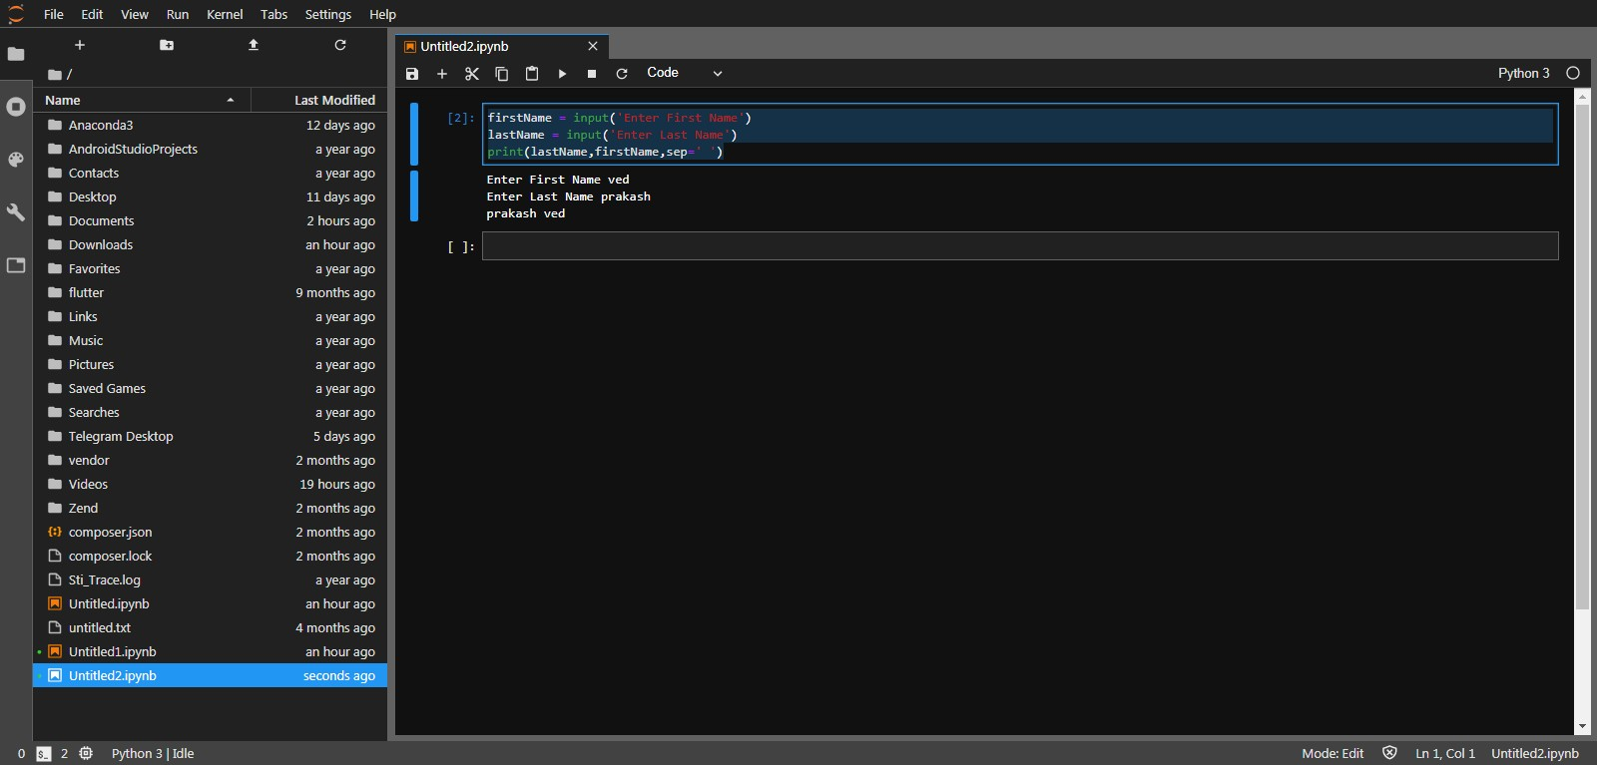
firstName = input('Enter First Name')
lastName = input('Enter Last Name')
print(lastName,firstName,sep=' ')
Q no.1.4:-
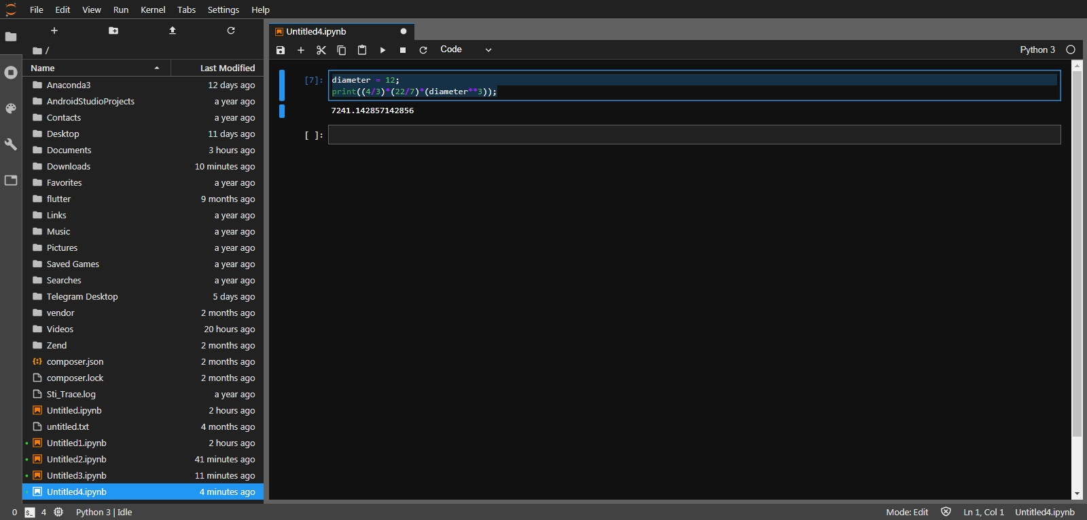
diameter = 12;
print((4/3)*(22/7)*(diameter**3));
Q no. 2.1:-
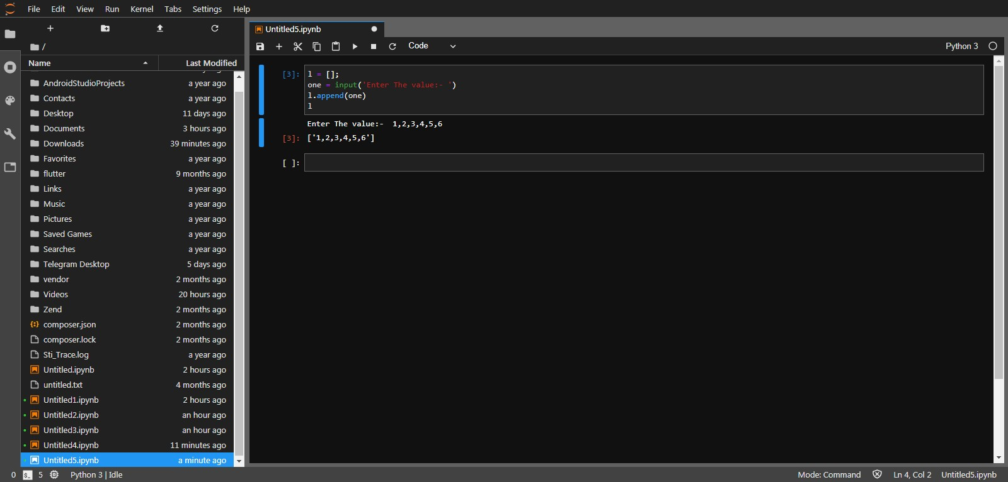
l = [];
one = input('Enter The value:- ')
l.append(one)
l
Q no 2.2:-
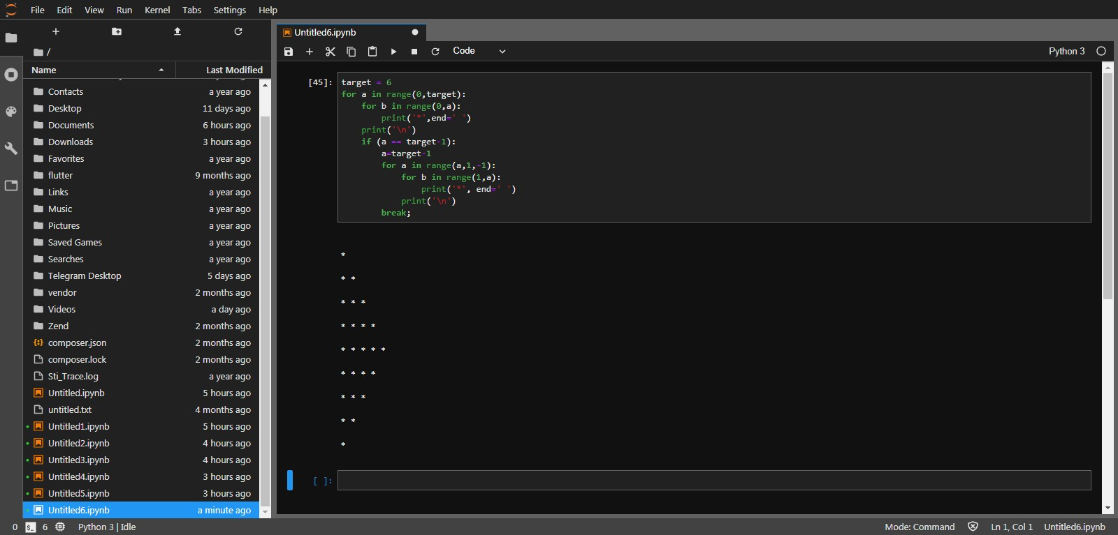
target = 6
for a in range(0,target):
for b in range(0,a):
print('*',end=' ')
print('\n')
if (a == target-1):
a=target-1
for a in range(a,1,-1):
for b in range(1,a):
print('*', end=' ')
print('\n')
break;
Q no 2.3:-
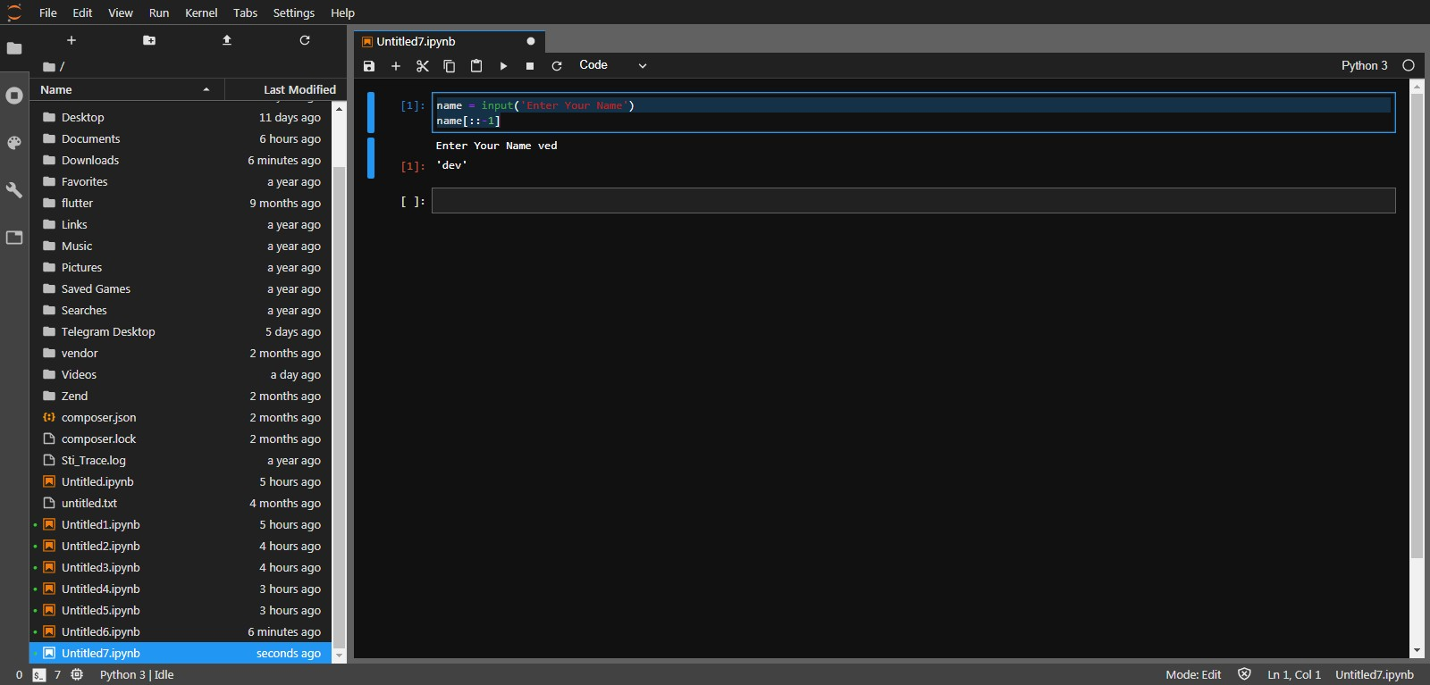
name = input('Enter Your Name')
name[::-1]
Q no 2.4:-
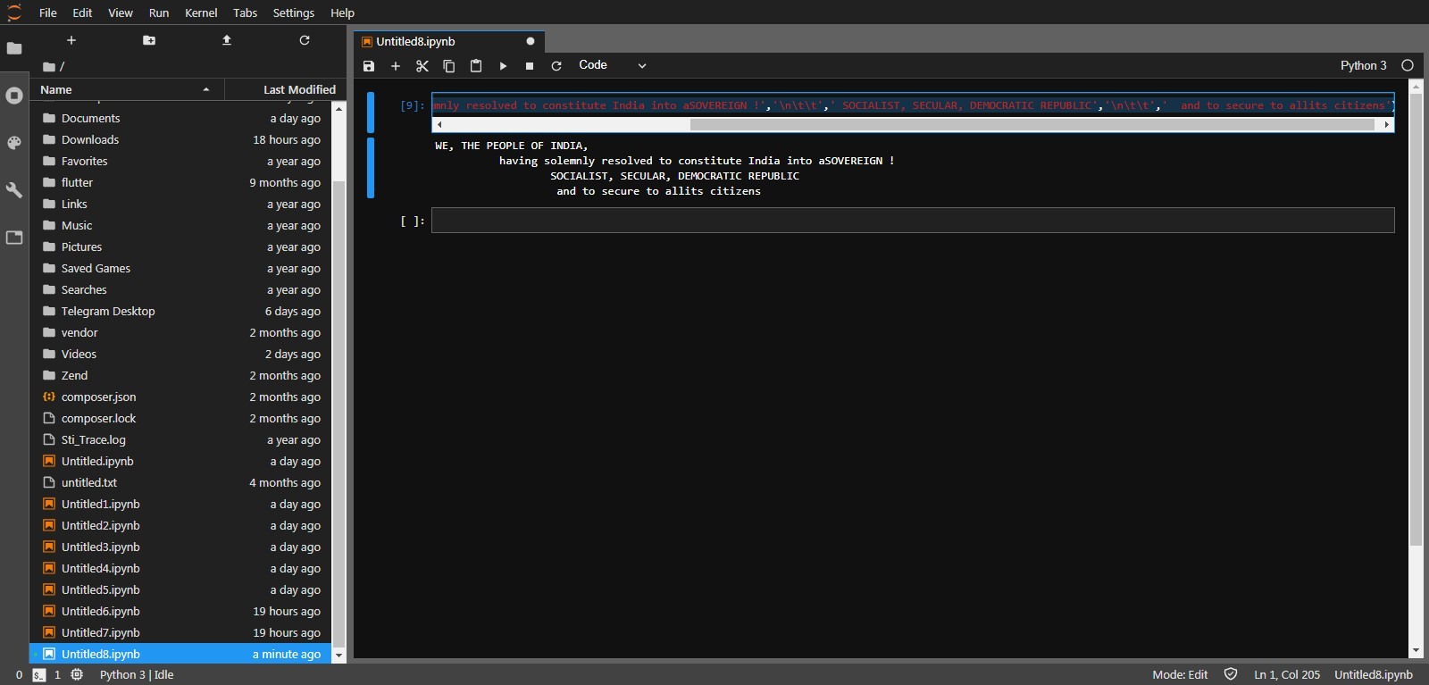
print('WE, THE PEOPLE OF INDIA,','\n\t',' having solemnly resolved to constitute India into aSOVEREIGN !','\n\t\t',' SOCIALIST, SECULAR, DEMOCRATIC REPUBLIC','\n\t\t',' and to secure to allits citizens')

