

Foundations of Programming
Assignment No. : 5
PROBLEM STATEMENT:
Write a program in C to perform basic matrix operations such as:
1. Addition of two matrices
2. Saddle point of a matrix
3. Inverse of a matrix
4. Magic square of a matrix

OBJECTIVE:
• To understand matrix representation in C using two-dimensional arrays.
• To implement various matrix operations using C programming.
• To develop logical thinking for solving matrix-based problems.

THEORY:
Matrix operations are widely used in engineering and scientific applications. Addition of matrices involves adding corresponding elements. A saddle point is an element that is the minimum in its row and maximum in its column. The inverse of a matrix exists only for square matrices with non-zero determinant. A magic square is a square matrix in which the sums of elements in each row, column, and diagonals are equal.

PLATFORM:
Linux

ALGORITHM:

Step 1: Start

Step 2: Declare variables

Integers: r, c, i, j, k

Matrices: A[10][10], B[10][10], Sum[10][10], Inv[10][10]

Other variables: min, max, flag

Step 3: Accept number of rows r and columns c from user

Step 4: Accept elements of matrix A

Repeat for i = 0 to r-1
Repeat for j = 0 to c-1
Read A[i][j]

Step 5: Accept elements of matrix B (for addition)

Repeat for i = 0 to r-1
Repeat for j = 0 to c-1
Read B[i][j]

Matrix Addition

Step 6: Perform addition of matrices

Repeat for i = 0 to r-1
Repeat for j = 0 to c-1
Sum[i][j] = A[i][j] + B[i][j]

Saddle Point

Step 7: Find saddle point of matrix A

For each row i
Set min = A[i][0], col_index = 0
Repeat for j = 1 to c-1
If A[i][j] < min
Set min = A[i][j], col_index = j

Set flag = 1
Repeat for k = 0 to r-1
If A[k][col_index] > min
Set flag = 0

If flag == 1
Display "Saddle Point = ", min

Inverse of Matrix

Step 8: Find inverse of matrix A (only if square matrix i.e., r == c)

Calculate determinant of matrix A

If determinant = 0
Display "Inverse not possible"

Else
Find adjoint of matrix
Divide each element of adjoint by determinant
Store result in Inv

Magic Square Check

Step 9: Check if matrix A is a magic square

If r != c
Display "Not a magic square"

Else
Calculate sum of first row and store in sum
Check sum of all rows, columns, and diagonals
If all sums are equal
Display "Magic Square"
Else
Display "Not a Magic Square"

Display Results

Step 10: Display results

Display resultant matrix Sum

Display saddle point (if any)

Display inverse matrix (if exists)

Display magic square result

Step 11: Stop

C PROGRAM: (Type C Program)

Flowchart:

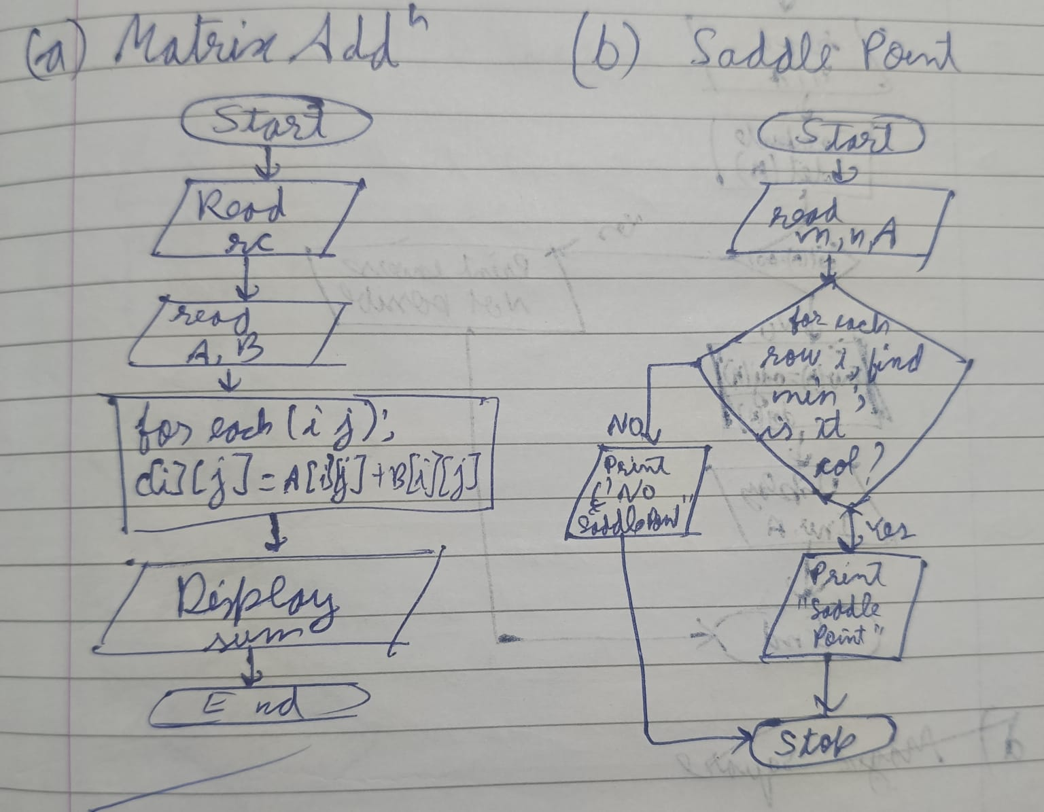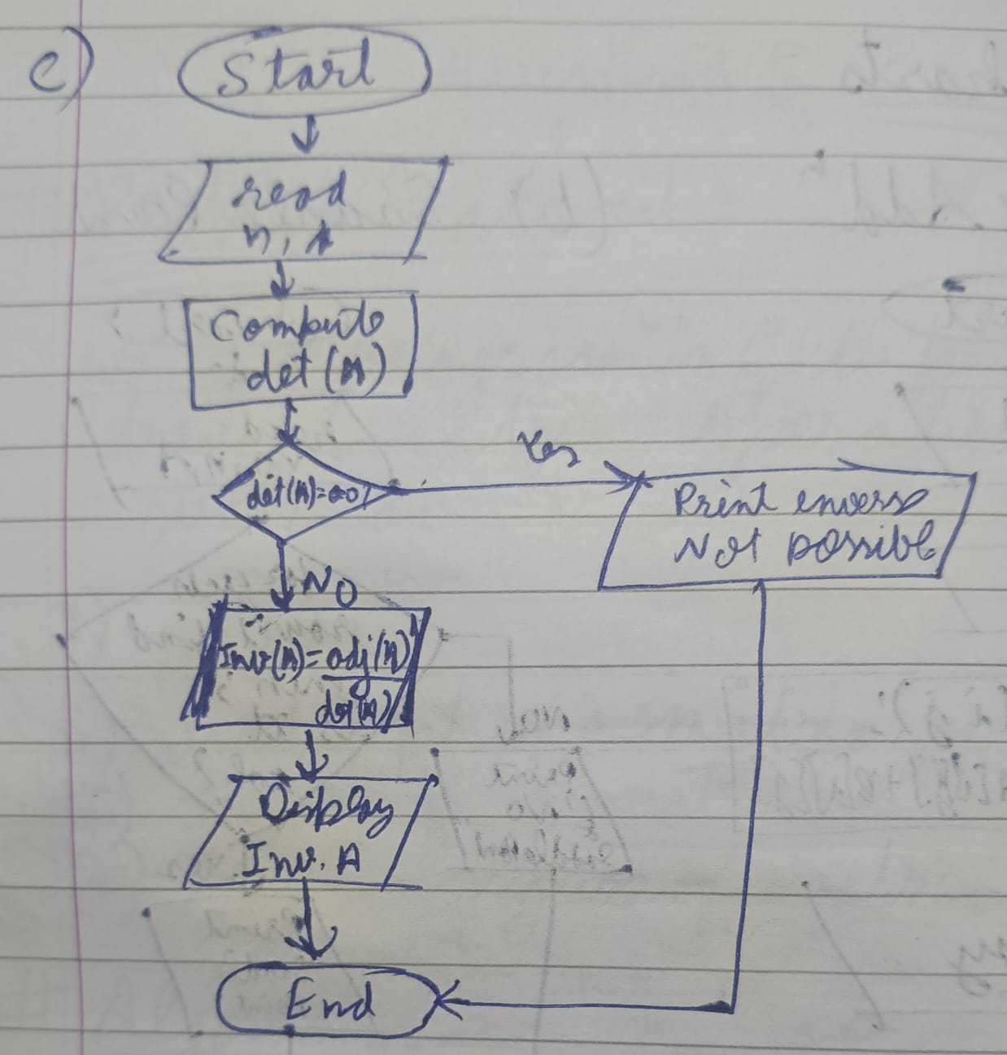
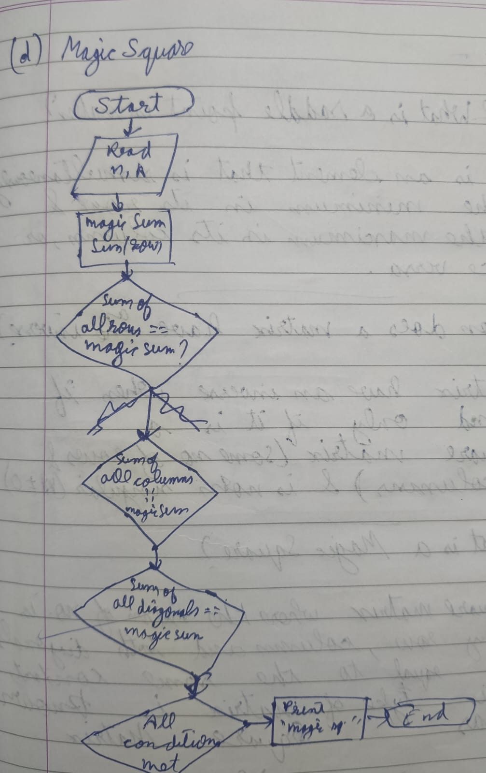

C Program:
#include <stdio.h>

// Function to find determinant (for 3x3 matrix only)
float determinant(int A[10][10], int n) {
float det = 0;

if (n == 2) {
det = (A[0][0]*A[1][1]) - (A[0][1]*A[1][0]);
}
else if (n == 3) {
det = A[0][0]*(A[1][1]*A[2][2] - A[1][2]*A[2][1])
- A[0][1]*(A[1][0]*A[2][2] - A[1][2]*A[2][0])
+ A[0][2]*(A[1][0]*A[2][1] - A[1][1]*A[2][0]);
}
return det;
}

int main() {
int A[10][10], B[10][10], Sum[10][10];
float Inv[10][10];
int r, c, i, j, k;

printf("Enter rows and columns: ");
scanf("%d %d", &r, &c);

// Input Matrix A
printf("Enter elements of Matrix A:\n");
for(i = 0; i < r; i++) {
for(j = 0; j < c; j++) {
scanf("%d", &A[i][j]);
}
}

// Input Matrix B
printf("Enter elements of Matrix B:\n");
for(i = 0; i < r; i++) {
for(j = 0; j < c; j++) {
scanf("%d", &B[i][j]);
}
}

// Matrix Addition
printf("\nMatrix Addition Result:\n");
for(i = 0; i < r; i++) {
for(j = 0; j < c; j++) {
Sum[i][j] = A[i][j] + B[i][j];
printf("%d ", Sum[i][j]);
}
printf("\n");
}

// Saddle Point
printf("\nSaddle Points:\n");
for(i = 0; i < r; i++) {
int min = A[i][0];
int col_index = 0;

for(j = 1; j < c; j++) {
if(A[i][j] < min) {
min = A[i][j];
col_index = j;
}
}

int flag = 1;
for(k = 0; k < r; k++) {
if(A[k][col_index] > min) {
flag = 0;
}
}

if(flag == 1) {
printf("%d\n", min);
}
}

// Inverse (only for 2x2 or 3x3)
if(r == c) {
float det = determinant(A, r);

if(det == 0) {
printf("\nInverse not possible (Determinant = 0)\n");
} else {
printf("\nInverse Matrix:\n");

if(r == 2) {
Inv[0][0] = A[1][1]/det;
Inv[0][1] = -A[0][1]/det;
Inv[1][0] = -A[1][0]/det;
Inv[1][1] = A[0][0]/det;
}

else if(r == 3) {
// Cofactor matrix (simplified)
Inv[0][0] = (A[1][1]*A[2][2] - A[1][2]*A[2][1])/det;
Inv[0][1] = -(A[0][1]*A[2][2] - A[0][2]*A[2][1])/det;
Inv[0][2] = (A[0][1]*A[1][2] - A[0][2]*A[1][1])/det;

Inv[1][0] = -(A[1][0]*A[2][2] - A[1][2]*A[2][0])/det;
Inv[1][1] = (A[0][0]*A[2][2] - A[0][2]*A[2][0])/det;
Inv[1][2] = -(A[0][0]*A[1][2] - A[0][2]*A[1][0])/det;

Inv[2][0] = (A[1][0]*A[2][1] - A[1][1]*A[2][0])/det;
Inv[2][1] = -(A[0][0]*A[2][1] - A[0][1]*A[2][0])/det;
Inv[2][2] = (A[0][0]*A[1][1] - A[0][1]*A[1][0])/det;
}

for(i = 0; i < r; i++) {
for(j = 0; j < c; j++) {
printf("%.2f ", Inv[i][j]);
}
printf("\n");
}
}
}

// Magic Square Check
if(r == c) {
int sum = 0, magic = 1;

for(j = 0; j < c; j++) {
sum += A[0][j];
}

// Check rows
for(i = 1; i < r; i++) {
int row_sum = 0;
for(j = 0; j < c; j++) {
row_sum += A[i][j];
}
if(row_sum != sum) magic = 0;
}

// Check columns
for(j = 0; j < c; j++) {
int col_sum = 0;
for(i = 0; i < r; i++) {
col_sum += A[i][j];
}
if(col_sum != sum) magic = 0;
}

// Diagonals
int d1 = 0, d2 = 0;
for(i = 0; i < r; i++) {
d1 += A[i][i];
d2 += A[i][r-i-1];
}

if(d1 != sum || d2 != sum) magic = 0;

if(magic)
printf("\nMatrix is a Magic Square\n");
else
printf("\nMatrix is NOT a Magic Square\n");
}

return 0;
}

INPUT:
Enter rows and columns: 2 2
Enter elements of Matrix A:
1 0
0 1
Enter elements of Matrix B:
2 0
0 2

Matrix Addition Result:
3 0
0 3

OUTPUT:
Result of matrix addition, saddle point, inverse, and magic square verification. 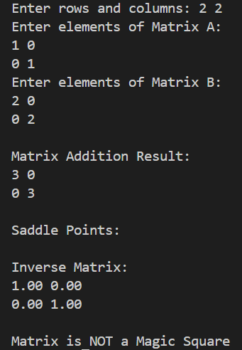

CONCLUSION:
Thus, we have learned how to perform basic matrix operations using C programming and understood their practical applications.

FAQs:
1. What is a saddle point in a matrix?
2. When does a matrix have an inverse?
3. What is a magic square?

