

Foundations of Programming

Assignment No. : 6
PROBLEM STATEMENT:Write a C function to compute the factorial of a number with and without recursion.

OBJECTIVE:

To demonstrate two different approaches for calculating the factorial of a number: iterative (non-recursive) and recursive, showcasing the versatility of problem-solving methods in programming.

THEORY:
- Explain the difference between the iterative and recursive approaches to calculating the factorial of a number.
- What is the base case in the recursive function for computing factorials, and why is it necessary?
- How does the program handle invalid input, such as negative numbers, and why is this important?
PLATFORM: Linux

ALGORITHM:
(Without Recursion)
Step 1: Start
Step 2: Declare variables n, i, fact as integers
Step 3: Accept the value of n from user
Step 4: Check if n < 0
If yes, display "Factorial not possible" and go to Step 8
Step 5: Initialize fact = 1
Step 6: Calculate factorial using loop
Repeat for i = 1 to n
fact = fact * i
Step 7: Display factorial
Step 8: Stop

(With Recursion)
Step 1: Start
Step 2: Declare variable n as integer
Step 3: Accept the value of n from user
Step 4: Check if n < 0
If yes, display "Factorial not possible" and go to Step 9
Step 5: Call recursive function fact(n)
Step 6: Define recursive function fact(n)
If n == 0 or n == 1
Return 1
Else
Return n * fact(n-1)
Step 7: Store returned value in result
Step 8: Display result
Step 9: Stop

FLOWCHART:
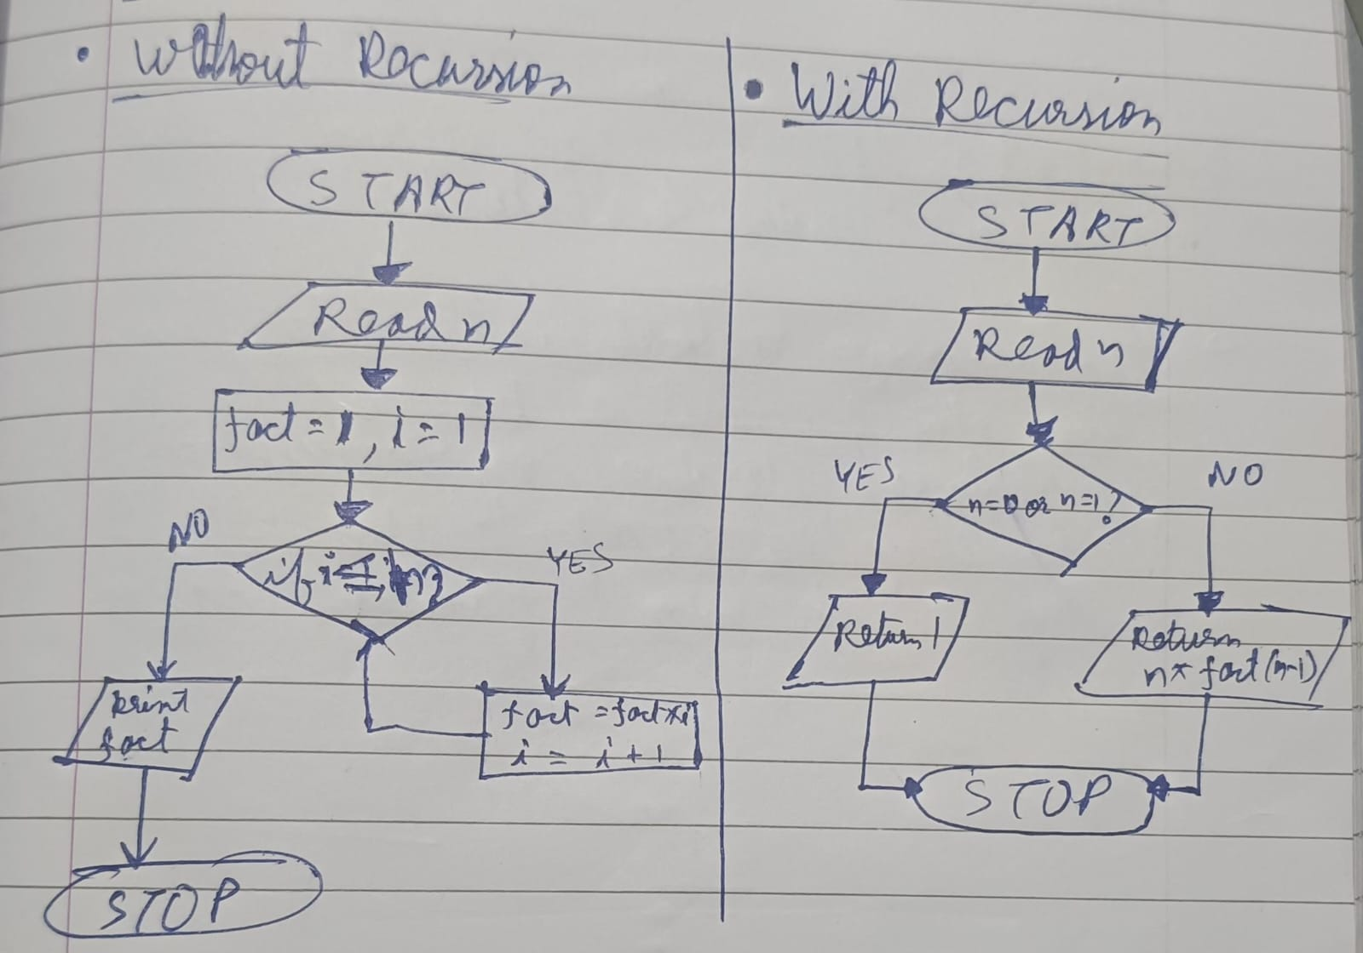

INPUT:
Enter a number: 10
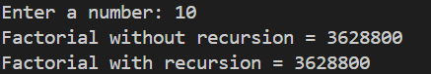
OUTPUT:

CONCLUSION: Thus, we have successfully executed factorial of a number with and without recursion.

FAQs:
1. What is the purpose of calculating factorial in programming?
2. What is the difference between recursive and non-recursive (iterative) methods?

