

Foundations of Programming

Assignment No.: 16
PROBLEM STATEMENT: To accept a list of N integers and partition the list into two sublists containing even and odd numbers.

OBJECTIVE:

- To understand how to work with arrays in C.
- To learn how to separate numbers based on conditions.
- To practice the use of loops and conditional statements.
- To display two different lists for even and odd numbers.

THEORY:
In C programming, arrays are used to store multiple values of the same data type. By using loops and conditional statements, it is possible to examine each element in the array and classify it based on certain conditions. In this program, the user enters N integers which are stored in an array. Each number is then checked using the modulus operator (%). If a number is divisible by 2, it is categorized as an even number; otherwise, it is an odd number. The program then displays two separate lists: one for even numbers and another for odd numbers.

PLATFORM: Linux
ALGORITM:
Step 1: Start
Step 2: Declare variables n, i as integers
Step 3: Declare arrays arr[100], even[100], odd[100]
Step 4: Declare counters e = 0, o = 0
Step 5: Accept number of elements n from user
Step 6: Accept n integers into array arr
Repeat for i = 0 to n-1
Read arr[i]

Partition into Even and Odd
Step 7: Separate numbers
Repeat for i = 0 to n-1
If arr[i] % 2 == 0
even[e] = arr[i]
e++
Else
odd[o] = arr[i]
o++

Display Result
Step 8: Display even numbers
Repeat for i = 0 to e-1
Print even[i]
Step 9: Display odd numbers
Repeat for i = 0 to o-1
Print odd[i]

Step 10: Stop
FLOWCHART:
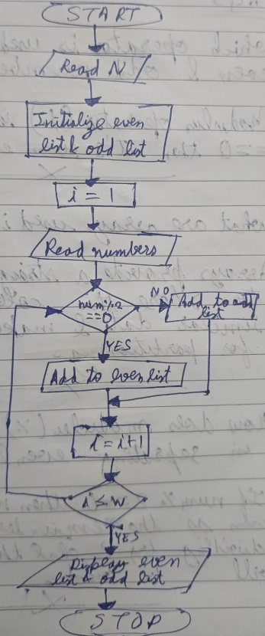
C CODE:
#include <stdio.h>

int main() {
int n, i;
int arr[100], even[100], odd[100];
int e = 0, o = 0;

printf("Enter number of elements: ");
scanf("%d", &n);

printf("Enter %d integers:\n", n);
for(i = 0; i < n; i++) {
scanf("%d", &arr[i]);
}

// Partition into even and odd
for(i = 0; i < n; i++) {
if(arr[i] % 2 == 0) {
even[e] = arr[i];
e++;
} else {
odd[o] = arr[i];
o++;
}
}

// Display even numbers
printf("\nEven numbers:\n");
for(i = 0; i < e; i++) {
printf("%d ", even[i]);
}

// Display odd numbers
printf("\nOdd numbers:\n");
for(i = 0; i < o; i++) {
printf("%d ", odd[i]);
}

return 0;
}

SAMPLE INPUT:
Enter number of elements: 5
Enter integers: 10 7 4 9 12
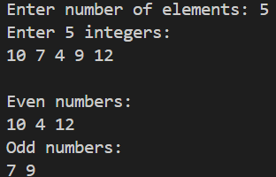
SAMPLE OUTPUT:
Even numbers are: 10 4 12
Odd numbers are: 7 9

CONCLUSION: Thus, the C program successfully accepts a list of integers and partitions them into two separate lists of even and odd numbers.

FAQs:
- Which operator is used to check even and odd numbers in C?
- Why are arrays used in this program?
- How does the modulus (%) operator help in separating even and odd numbers?

