

Foundations of Programming

Assignment No.: 17
PROBLEM STATEMENT: To accept the number of terms and find the sum of the sine series.

OBJECTIVE:

- To understand the concept of mathematical series in programming.
- To implement sine series using C programming.
- To practice loops and arithmetic operations.
- To learn the use of factorial and power calculations in C.

THEORY:
In mathematics, the sine function can be expressed as an infinite series called the Taylor series expansion. The sine series is represented as:
sin(x) = x − x^3/3! + x^5/5! − x^7/7! + ...

In this program, the user enters the value of x and the number of terms. The program calculates the sum of the sine series up to the specified number of terms using loops. Factorial and power operations are used to compute each term of the series.
PLATFORM: Linux

ALGORITHM:

Step 1: Start

Step 2: Declare variables
n, i, j, sign as integers
x, sum, term, power, fact as float

Step 3: Accept value of x (in radians) and number of terms n

Step 4: Initialize
sum = 0
sign = 1

Calculate Sine Series

Step 5: Repeat for i = 1 to n

Step 5.1: Calculate power x^(2i-1)
Set power = 1
Repeat for j = 1 to (2*i - 1)
power = power * x

Step 5.2: Calculate factorial (2i-1)!
Set fact = 1
Repeat for j = 1 to (2*i - 1)
fact = fact * j

Step 5.3: Calculate term
term = sign * (power / fact)

Step 5.4: Add term to sum
sum = sum + term

Step 5.5: Change sign
sign = -sign

Step 6: Display value of sine series (sum)

Step 7: Stop

FLOWCHART:

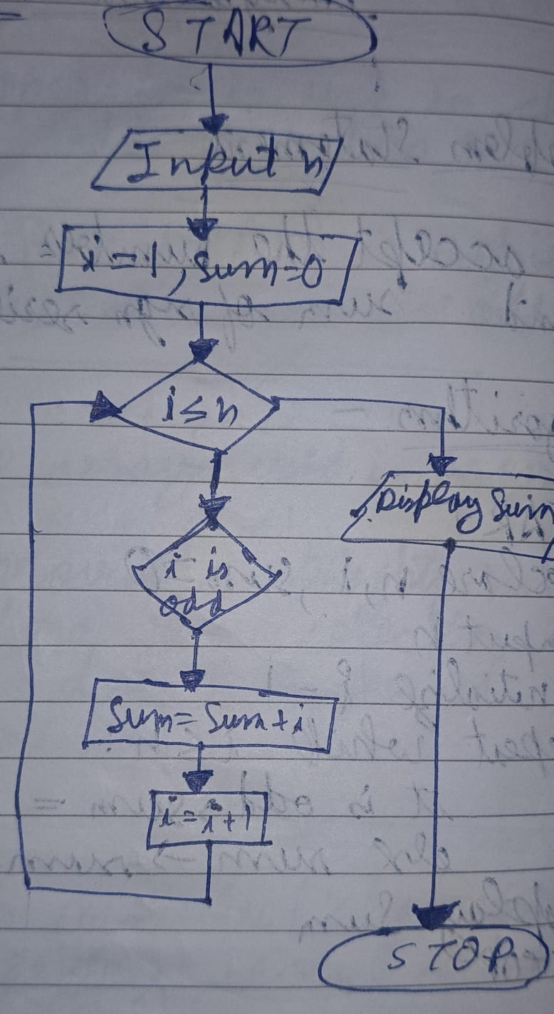

C CODE:
#include <stdio.h>

int main() {
int n, i, j, sign = 1;
float x, sum = 0, term, power, fact;

printf("Enter value of x (in radians): ");
scanf("%f", &x);

printf("Enter number of terms: ");
scanf("%d", &n);

for(i = 1; i <= n; i++) {

// Calculate power x^(2i-1)
power = 1;
for(j = 1; j <= (2*i - 1); j++) {
power *= x;
}

// Calculate factorial (2i-1)!
fact = 1;
for(j = 1; j <= (2*i - 1); j++) {
fact *= j;
}

// Calculate term
term = sign * (power / fact);

// Add to sum
sum += term;

// Change sign
sign = -sign;
}

printf("Sum of sine series = %f\n", sum);

return 0;
}

INPUT: Value of x and number of terms.

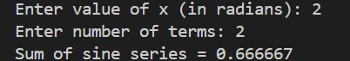
OUTPUT: Displays the sum of the sine series.

CONCLUSION: Thus, the C program successfully calculates the sum of the sine series for the given number of terms.

FAQs:
- What is a sine series in mathematics?
- Why is factorial used in the sine series?
- Why does the sine series have alternating signs?
- Which header file is required for power functions in C?
- How does increasing the number of terms affect accuracy?

