

Foundations of Programming

Assignment No.: 18
PROBLEM STATEMENT: Write a C program that accepts a string from the user and performs the following string operations: i) Calculate length of string ii) String reversal iii) Equality check of two strings iv) Check palindrome v) Check substring.

OBJECTIVE:

- To understand basic string operations in C.
- To learn how to manipulate strings using loops and functions.
- To perform comparison, reversal, and substring checking.
- To check whether a string is a palindrome.

THEORY:
In C programming, a string is a sequence of characters terminated by a null character ('\0'). Strings are commonly stored in character arrays. Various operations can be performed on strings such as calculating their length, reversing the characters, comparing two strings, checking whether a string is a palindrome, and finding a substring within another string. These operations can be implemented using loops and conditional statements or by using standard library functions from the string.h header file.
PLATFORM: Linux
ALGORITHM:
Step 1: Start
Step 2: Declare strings str1, str2, rev and integers i, len, flag
Step 3: Accept string str1 from user

(i) Length of String
Step 4: Initialize len = 0
Repeat while str1[i] != '\0'
Increment len

(ii) String Reversal
Step 5: Reverse string
Repeat for i = 0 to len-1
rev[i] = str1[len-i-1]
Set rev[len] = '\0'

(iii) Equality Check
Step 6: Accept second string str2
Step 7: Compare str1 and str2
If both strings are equal
Display "Strings are equal"
Else
Display "Strings are not equal"

(iv) Palindrome Check
Step 8: Compare str1 with rev
If equal
Display "Palindrome"
Else
Display "Not a palindrome"

(v) Substring Check
Step 9: Check if str2 is substring of str1
Search str2 inside str1 using loop
If found
Display "Substring found"
Else
Display "Substring not found"

Step 10: Display length and reversed string
Step 11: Stop
FLOWCHART:
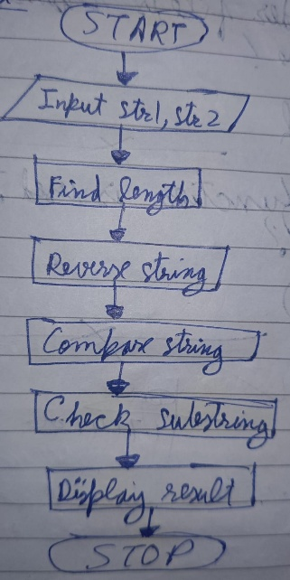
C CODE:
#include <stdio.h>
#include <string.h>

int main() {
char str1[100], str2[100], rev[100];
int i, len = 0, flag = 0;

printf("Enter first string: ");
scanf("%s", str1);

// (i) Length
while(str1[len] != '\0') {
len++;
}
printf("Length of string = %d\n", len);

// (ii) Reverse
for(i = 0; i < len; i++) {
rev[i] = str1[len - i - 1];
}
rev[len] = '\0';

printf("Reversed string = %s\n", rev);

// (iii) Equality check
printf("Enter second string: ");
scanf("%s", str2);

if(strcmp(str1, str2) == 0)
printf("Strings are equal\n");
else
printf("Strings are not equal\n");

// (iv) Palindrome check
if(strcmp(str1, rev) == 0)
printf("String is a palindrome\n");
else
printf("String is not a palindrome\n");

// (v) Substring check
if(strstr(str1, str2) != NULL)
printf("Substring found\n");
else
printf("Substring not found\n");

return 0;
}

INPUT: A string and another string for comparison and substring checking.
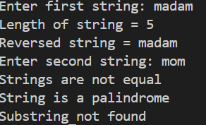

OUTPUT: Displays string length, reversed string, equality result, palindrome result, and substring check result.


CONCLUSION: Thus, the C program successfully performs different string operations such as length calculation, reversal, equality check, palindrome check, and substring detection.

FAQs:
- What is a string in C programming?
- Which header file is required for string functions?
- What function is used to find the length of a string?
- What is a palindrome string?
- Which function is used to check a substring in C?

