KIET Deemed To be University
Professional Elective
Devops
MSE-1

Name – Vedansh Mudgal
Branch – CSE
Sec – E
Semester – 5
Roll no: 2400290100342
Reg. No : 202401100200343

Submit the following:
- GitHub repository URL:
https://github.com/Ved07/github-skills-challenge/

- Pull request URL used to validate the workflows
Testing workflows by Ved07 · Pull Request #2 · Ved07/github-skills-challenge

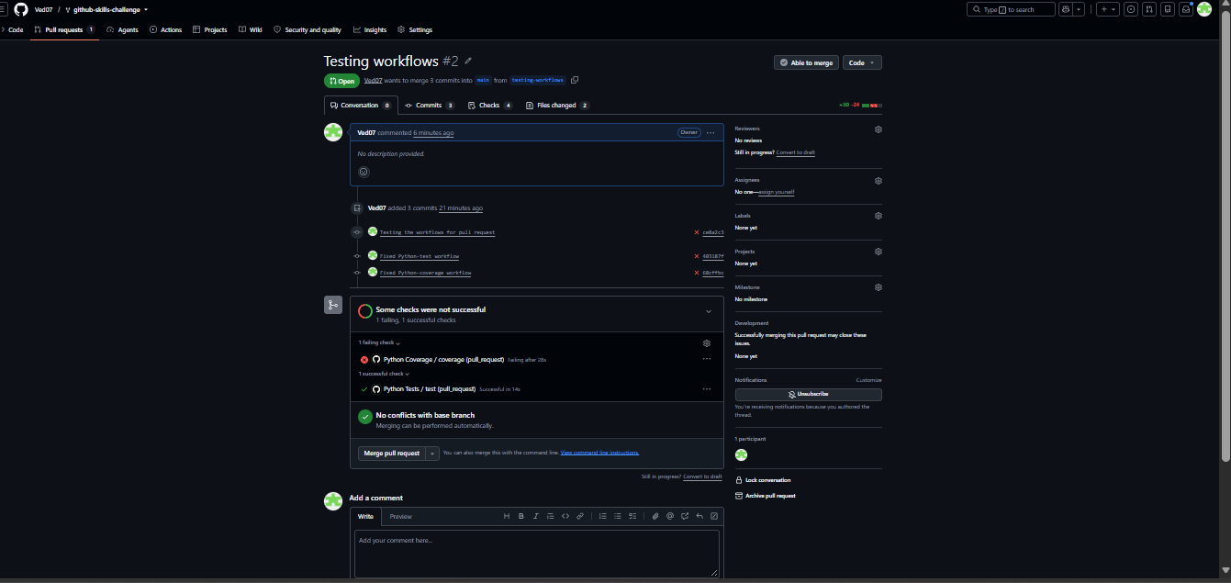
3. Screenshot showing the GitHub Actions workflows
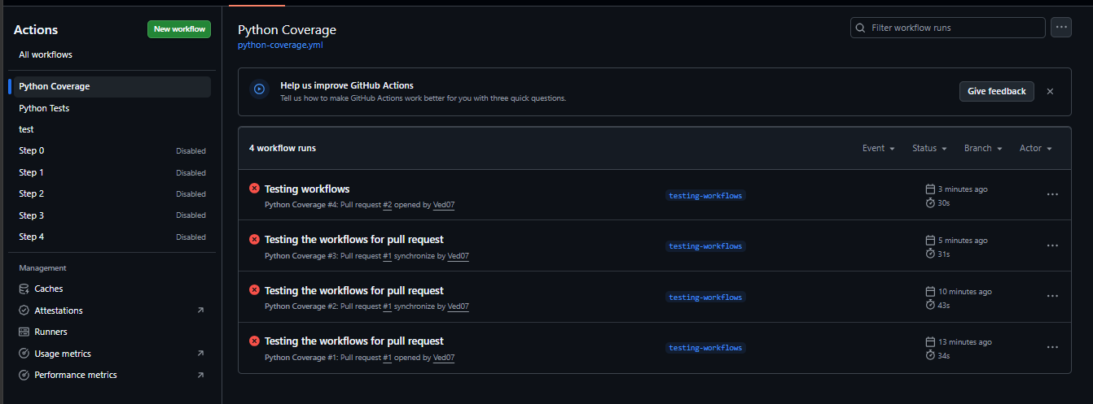

4. Screenshot showing a successful test workflow execution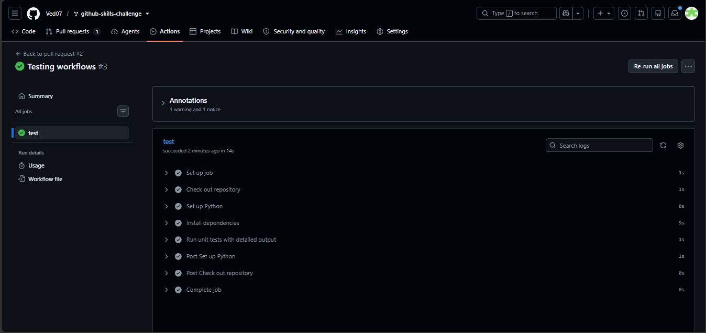
5. Screenshot showing the coverage result/comment on the pull request

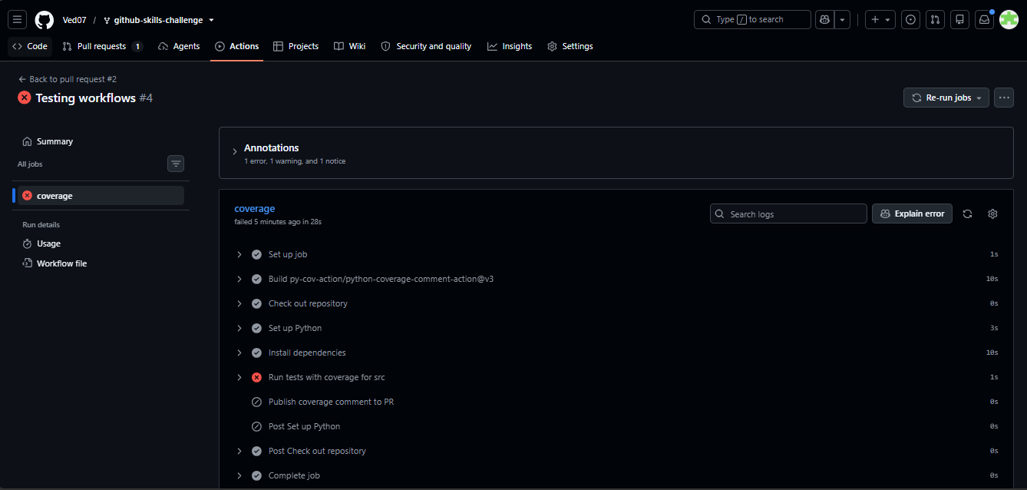
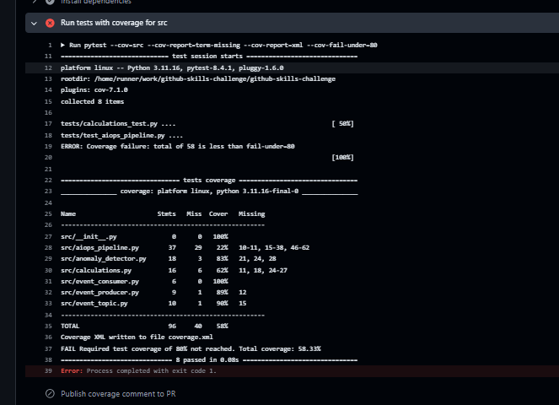

After Changing coverage percentage:
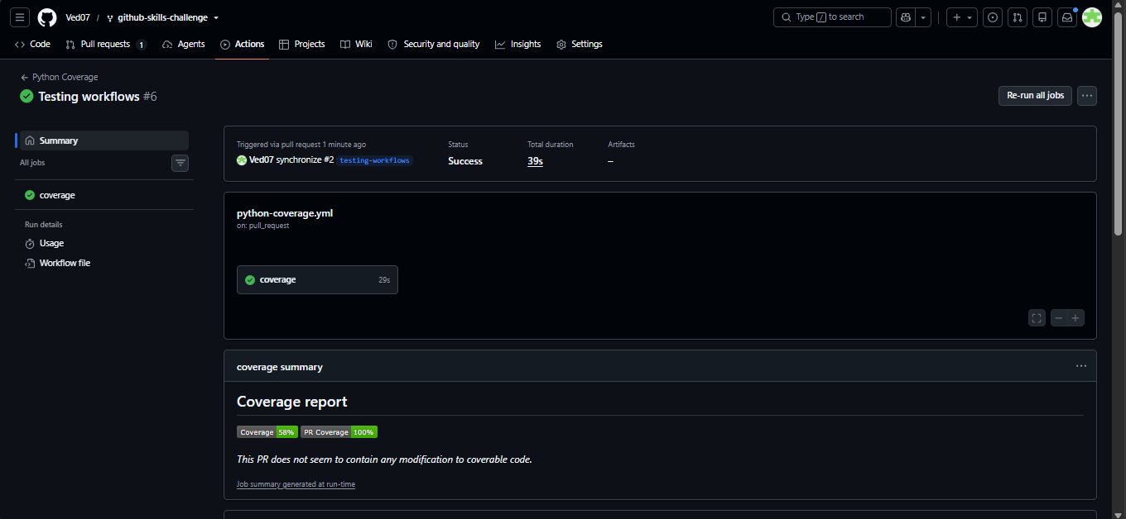

Pull request
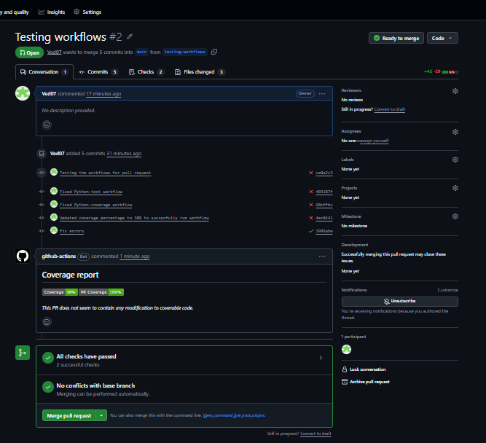

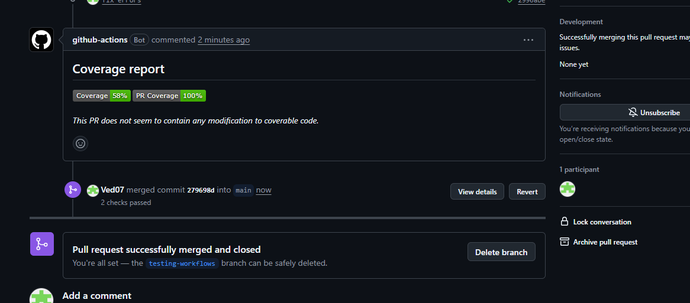
6. Screenshot showing the final repository/workflow files

