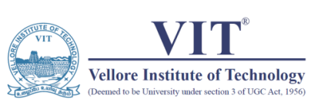OFFICE OF STUDENTS’ WELFARE

Event Report 2021

|  |  |  |  |  |  |  |
| --- | --- | --- | --- | --- | --- | --- |
| Club-Chapter Name | Indian Society for Technical Education (ISTE) | | | | | |
| Event Name | Technica | | | | No. of Participants | |
| Date | 09:04:2021 to 11:04:2021 | | | | Faculty | - |
| Venue/Online Platform | Online Event | | | | Students | 837 |
| Amount Spent If Any | - | | | | Externals | 75 |
| Event Completion Summary:  ISTE-VIT organised Technica, a 48-hour Hack-a-Thon. The hack was aimed at cultivating a technical temper among the student community and promoting healthy competition among peers. The hackathon commenced with an inauguration ceremony, followed by an ice breaker session. The second day began with the first round of reviews, followed by speaker sessions conducted by Ms. Saraswathy Ramamoorthy, Mr. Vaibhav Gupta and Mr. Suman Debnath. The final day started with the second round of reviews, followed by the judges round and finally the announcement of the winners . Overall, the event was successful and a good learning experience for all its participants. | | | | | | |
| Collaborating Agency/Club/Chapter/Others: | | | | | | |
| Photo | | | | | | |
|  | | |  | | | |
|  | |  |  |
| Student Coordinator | | Faculty Coordinator | Asst. Director SW | Director SW | | |
| Name: Saksham Jain | | Name: Sasikumar S |  |  | | |
| Reg. No.: 19BCE2399 | | Emp. ID: 10393 |  |  | | |