Assignment 3

Name: Vedant Sapkale

Roll no: TCOD29

Create following Tables

cust_mstr(cust_no,fname,lname)

add_dets(code_no,add1,add2,state,city,pincode)

Retrieve the address of customer Fname as 'xyz' and Lname as 'pqr’

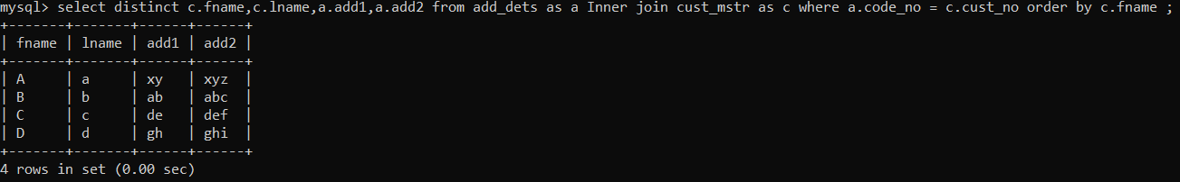

2.Create following Tables

cust_mstr(custno,fname,lname)

acc_fd_cust_dets(codeno,acc_fd_no) fd_dets(fd_sr_no,amt)

List the customer holding fixed deposit of amount more than 2000

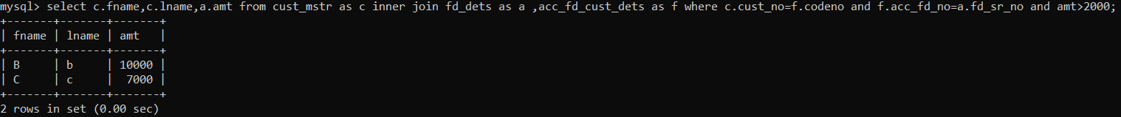

3. Create following Tables

emp_mstr(e_mpno,f_name,l_name,m_name,dept,desg,branch_no)

branch_mstr(name,b_no)

List the employee details along with branch names to which they belong

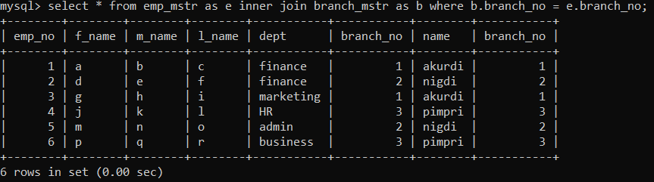

4. Create following Tables

emp_mstr(emp_no,f_name,l_name,m_name,dept)

cntc_dets(code_no,cntc_type,cntc_data)

List the employee details along with contact details using left outer join & right join

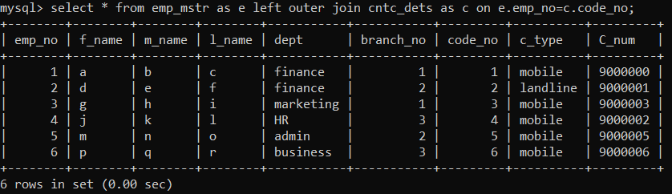

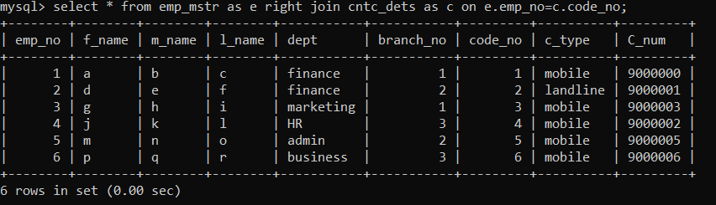

5. Create following Tables

cust_mstr(cust_no,fname,lname)

add_dets(code_no,pincode)

List the customer who do not have bank branches in their vicinity



6. a) Create view on customer and employee table by selecting any one column from each table

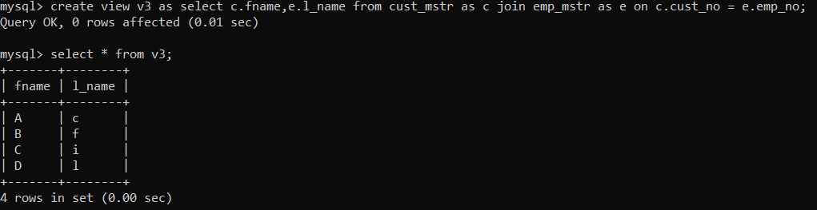

6. b) Create View on customer table by selecting any columns and perform insert update delete operations

6. c) Create updateable view on customer table by selecting any two columns and perform insert, update and delete operations.

