Assignment 9

Name: Vedant Sapkale.

Roll: TCOD29

db.createCollection('Student');

db.Student.insertMany([

{'Rno': '1', 'Name': 'Piyush', 'Class': 'TE COMP'},

{'Rno': '2', 'Name': 'Saee', 'Class': 'TE COMP'},

{'Rno': '3', 'Name': 'Atharva', 'Class': 'TE COMP'},

{'Rno': '4', 'Name': 'Bhushan', 'Class': 'TE COMP'},

{'Rno': '5', 'Name': 'Vedant', 'Class': 'TE COMP'},

{'Rno': '6', 'Name': 'Sahil', 'Class': 'TE COMP'}

]);

db.Student.find();

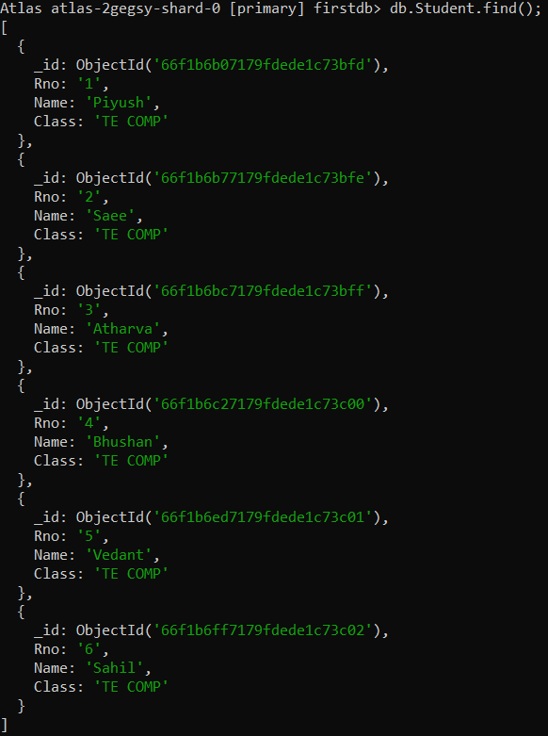

db.Student.find().pretty();

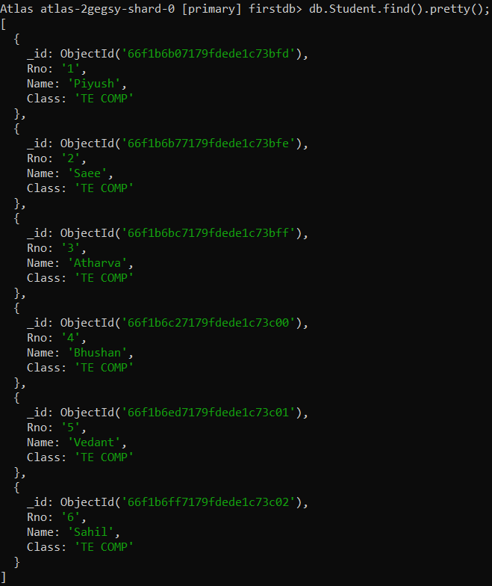

db.Student.update({'Name':'Sahil'},{$set: {'Name':'Vaibhavi'}});

db.Student.remove({'ADD':'MP'});

db.Student.find({$and:[{"Name":"Piyush"},{"Rno":"1"}]});

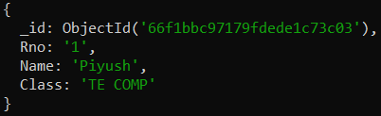

db.Student.find({$or:[{"Name":"Piyush"},{"Rno":"2"}]}).pretty();

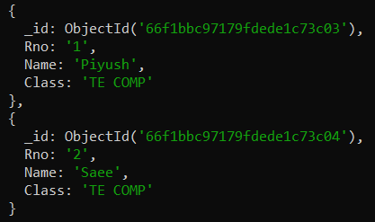

db.Student.find({$nor:[{"Name":"Piyush"},{" Rno":"2"}]}).pretty();

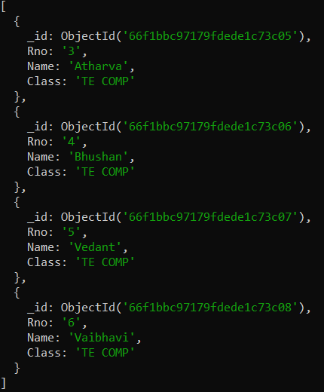

db.Student.find( {"Rno": { $eq:"5"}}).pretty();

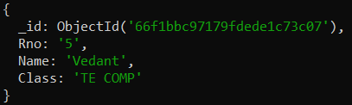

db.Student.find( {"Rno": { $gt:"5"}}).pretty();

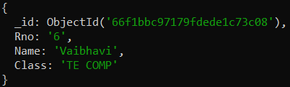

db.Student.find( {"Rno": { $gte:"5"}}).pretty();

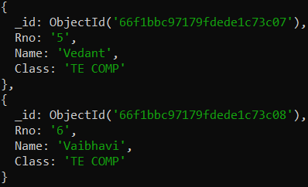

db.Student.find( {"Rno": { $lt:"2"}}).pretty();

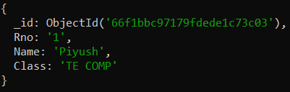

db.Student.find( {"Rno": { $lte:"2"}}).pretty();

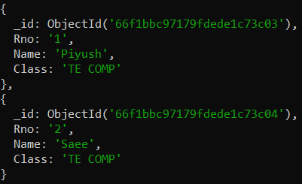

db.Student.find( {"Rno": { $lte:"5",$gt:"2"}}).pretty();

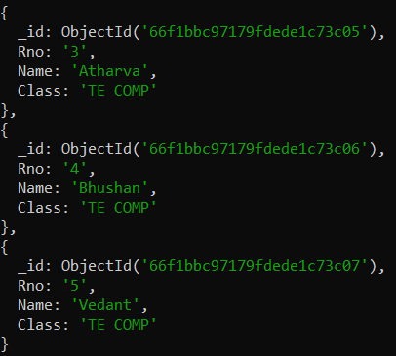

db.Student.update({'Name':'Sahil'},{$set: {'Name':'Vaibhavi'}});

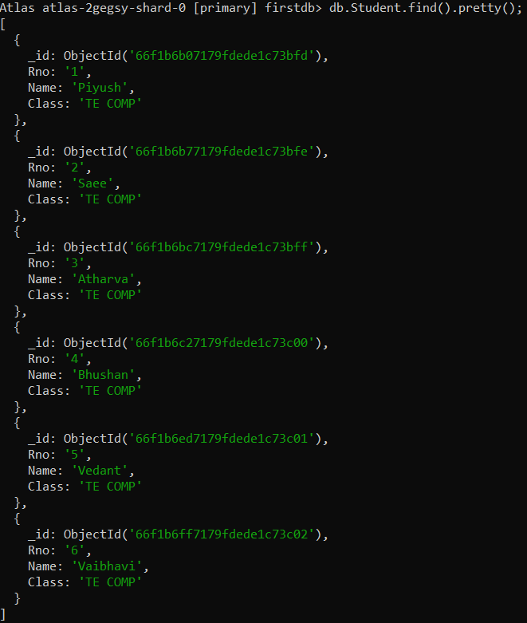

db.Student.remove({'Name':'Bhushan'},1)

