Assignment 10

Name: Vedant Sapkale.

Roll: TCOD29

db.Journal.aggregate([ { $group: { _id: "$book_id", totalAmount: { $sum: "$amt" } } } ]);

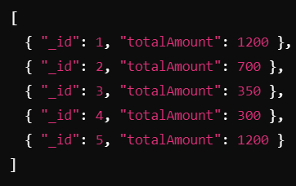

db.Journal.aggregate([{ $match: { status: "Available" } },{$group: {_id: "$book_id",availableCount: { $sum: 1 }}}]);

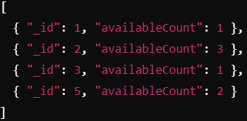

db.Journal.aggregate([ { $group: { _id: "$book_id", highestPrice: { $max: "$amt" } } } ]);

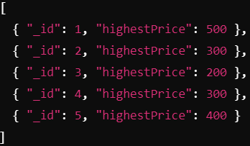

db.Journal.aggregate([ { $group: { _id: "$book_name", averageAmount: { $avg: "$amt" } } } ]);

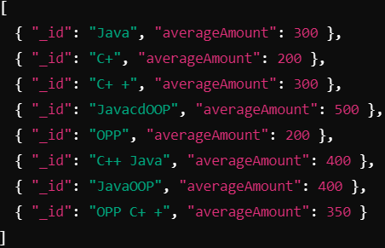

db.Journal.aggregate([ { $match: { status: "Not Available" } }, { $group: { _id: "$book_name" } } ]);

