Name: Shashwat Ved
Reg. No.: 230962200
Roll no.: 42

Lab4 - JQuery

Q1. Write a web page which contains table with 3 X 3 dimensions (fill some data) and one
image. Style the rows with alternate color. Move the table and image together from
right to left when button is clicked.

<!DOCTYPE html>
<html>
<head>
<title>Table and Image Animation</title>
<script src="jquery-4.0.0.min.js"></script>
<style>
.container {
position: relative;
}
table {
border-collapse: collapse;
width: 300px;
}
td {
border: 1px solid black;
padding: 10px;
}
tr:nth-child(even) {
background-color: #cce5ff;
}
tr:nth-child(odd) {
background-color: #e6ffe6;
}
img {
width: 150px;
}
</style>

<script>
$(document).ready(function(){
$("#moveBtn").click(function(){
$(".container").animate({left: "-=100px"}, "slow");
});
});
</script>
</head>

<body>
<button id="moveBtn">Move Left</button>

<div class="container">
<table>
<tr><td>A</td><td>B</td><td>C</td></tr>
<tr><td>D</td><td>E</td><td>F</td></tr>
<tr><td>G</td><td>H</td><td>I</td></tr>
</table>
<br>
<img src="cat.jpeg" alt="Sample Image">
</div>
</body>
</html>

Output:

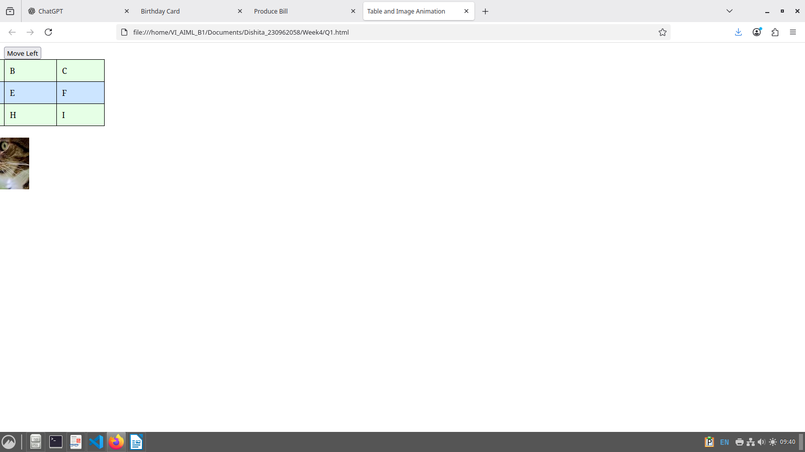
Q2. Design a calculator to perform basic arithmetic operations. Use textboxes and buttons
to design web page.

<!DOCTYPE html>
<html>
<head>
<title>Calculator</title>
<script src="jquery-4.0.0.min.js"></script>

<script>
$(document).ready(function(){
$(".btn").click(function(){
var a = parseFloat($("#num1").val());
var b = parseFloat($("#num2").val());
var op = $(this).val();
var result;

if(op == "+") result = a + b;
if(op == "-") result = a - b;
if(op == "*") result = a * b;
if(op == "/") result = a / b;

$("#result").val(result);
});
});
</script>
</head>

<body>
<input type="text" id="num1" placeholder="Enter 1st number">
<input type="text" id="num2" placeholder="Enter 2nd number"><br><br>

<input type="button" class="btn" value="+">
<input type="button" class="btn" value="-">
<input type="button" class="btn" value="*">
<input type="button" class="btn" value="/"><br><br>

Result: <input type="text" id="result" placeholder="Result">
</body>
</html>

Output:

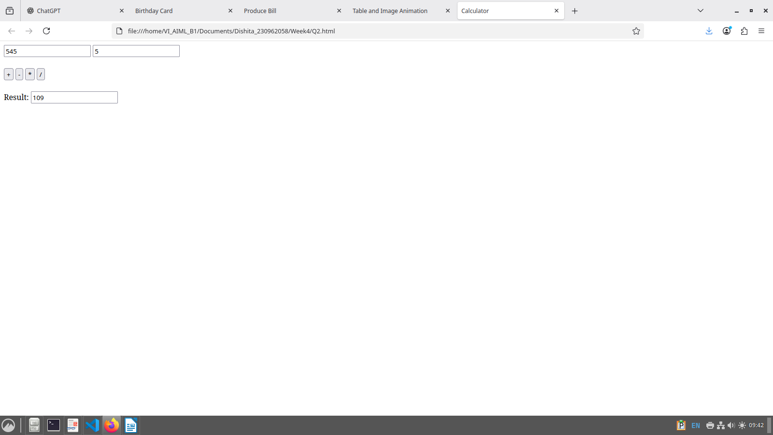
Q3. Create a web page to design a birthday card shown below.

<!DOCTYPE html>
<html>
<head>
<title>Birthday Card</title>
<script src="jquery-4.0.0.min.js"></script>

<style>
body {
font-family: Arial;
background-color: #f5f5f5;
}

.container {
width: 900px;
margin: 30px auto;
display: flex;
}

.controls {
width: 40%;
background-color: #fff8dc;
padding: 20px;
}

.controls label {
display: block;
margin-top: 10px;
font-weight: bold;
}

.controls input,
.controls select,
.controls textarea {
width: 90%;
margin-top: 5px;
}

.controls textarea {
height: 80px;
}

.controls button {
margin-top: 15px;
padding: 5px 15px;
}

.card {
width: 60%;
margin-left: 20px;
background-color: yellow;
border: 5px double black;
text-align: center;
padding: 20px;
}

.card h1 {
font-size: 28px;
}

.card img {
width: 200px;
margin-top: 20px;
}
</style>

<script>
$(document).ready(function(){
$("#update").click(function(){

$(".card").css("background-color", $("#bgcolor").val());
$(".card").css("font-family", $("#font").val());
$(".card h1").css("font-size", $("#fontsize").val() + "px");

var borderStyle = $("input[name='border']:checked").val();
if(borderStyle == "none") {
$(".card").css("border", "none");
} else {
$(".card").css("border", "5px " + borderStyle + " black");
}

$("#message").text($("#text").val());

if($("#pic").is(":checked")) {
$("#cake").show();
} else {
$("#cake").hide();
}
});
});
</script>
</head>

<body>

<div class="container">

<!-- LEFT PANEL -->
<div class="controls">

<label>Choose a background color:</label>
<select id="bgcolor">
<option value="yellow">Yellow</option>
<option value="pink">Pink</option>
<option value="lightblue">Light Blue</option>
</select>

<label>Choose a font:</label>
<select id="font">
<option value="Verdana">Verdana</option>
<option value="Arial">Arial</option>
<option value="Times New Roman">Times New Roman</option>
</select>

<label>Specify a numeric font size:</label>
<input type="text" id="fontsize" value="25">

<label>Choose a border style:</label>
<input type="radio" name="border" value="none"> None<br>
<input type="radio" name="border" value="double" checked> Double<br>
<input type="radio" name="border" value="solid"> Solid

<br><br>
<input type="checkbox" id="pic" checked> Add the Default Picture

<label>Enter the greeting text below:</label>
<textarea id="text">Happy Birthday, and many more</textarea>

<button id="update">Update</button>

</div>

<!-- RIGHT CARD -->
<div class="card">
<h1 id="message">Happy Birthday, and many more</h1>
<img id="cake" src="cake.jpeg" alt="Cake Image">
</div>

</div>

</body>
</html>

Output:

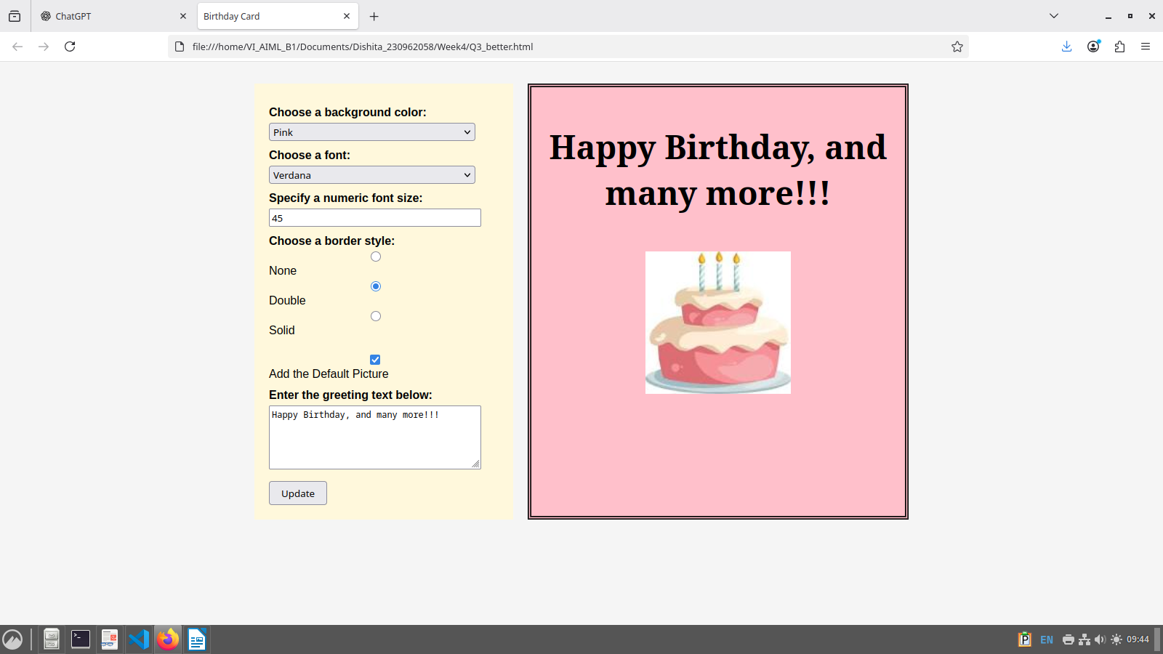
Q4. Design a webpage. The page contains:
• Dropdown list with HP, Nokia, Samsung, Motorola, Apple as items.
• Checkbox with Mobile and Laptop as items. Textbox where you enter quantity.
• There is a button with text as ‘Produce Bill’.
On Clicking Produce Bill button, alert should be displayed with total amount.

<!DOCTYPE html>
<html>
<head>
<title>Produce Bill</title>
<script src="jquery-4.0.0.min.js"></script>

<script>
$(document).ready(function(){
$("#bill").click(function(){
var price = 0;
var brand = $("#brand").val();
var qty = parseInt($("#qty").val());

if(brand == "HP") price = 50000;
if(brand == "Nokia") price = 20000;
if(brand == "Samsung") price = 30000;
if(brand == "Motorola") price = 25000;
if(brand == "Apple") price = 80000;

if($("#mobile").is(":checked")) price += 10000;
if($("#laptop").is(":checked")) price += 30000;

var total = price * qty;
alert("Total Amount = " + total);
});
});
</script>
</head>

<body>
Brand:
<select id="brand">
<option>HP</option>
<option>Nokia</option>
<option>Samsung</option>
<option>Motorola</option>
<option>Apple</option>
</select><br><br>

Products:
<input type="checkbox" id="mobile">Mobile
<input type="checkbox" id="laptop">Laptop<br><br>

Quantity:
<input type="text" id="qty"><br><br>

<button id="bill">Produce Bill</button>
</body>
</html>

Output:

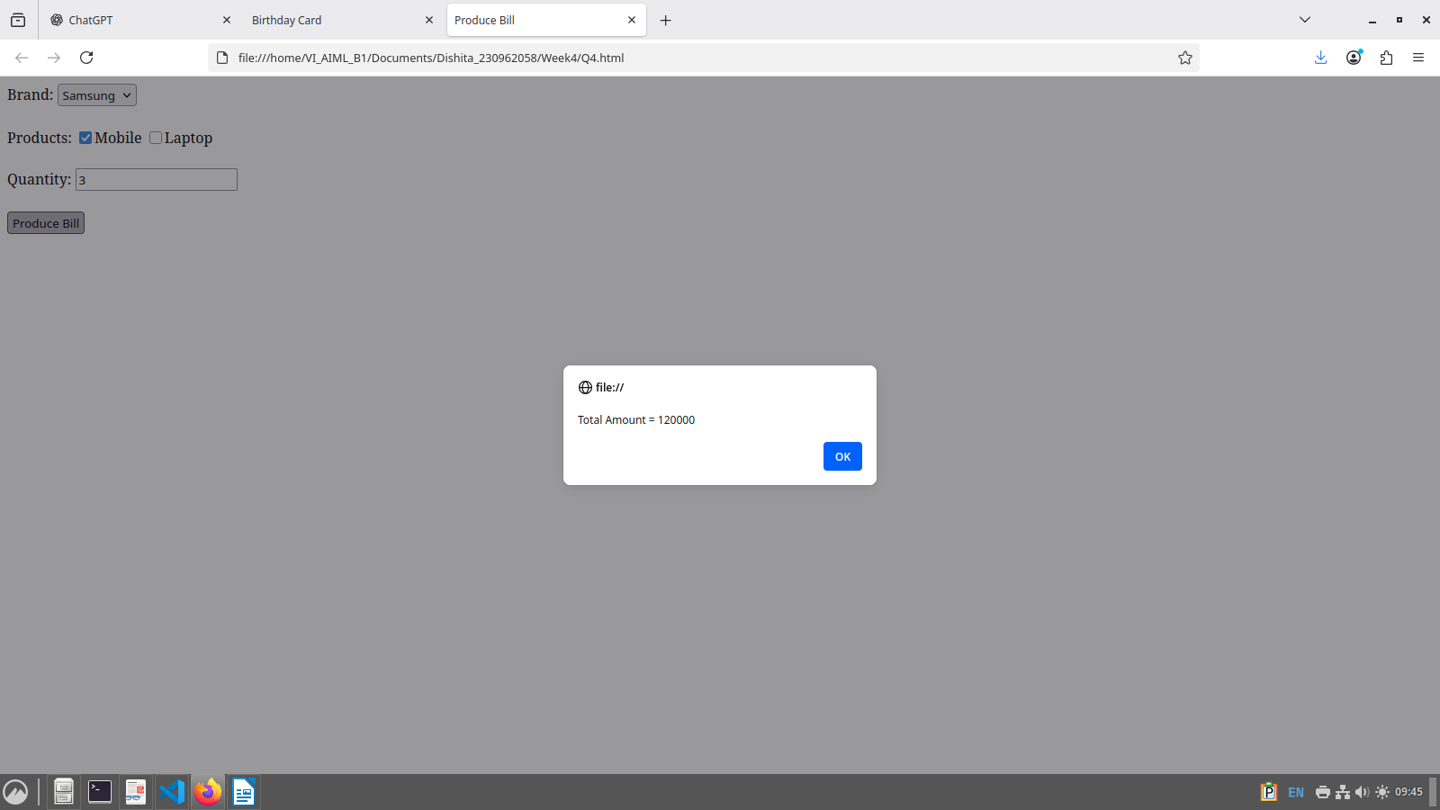
Additional Questions:

Q1. Implement the bouncing ball using animate() function.

<!DOCTYPE html>
<html>
<head>
<title>Bouncing Ball</title>
<script src="jquery-4.0.0.min.js"></script>

<style>
#ball {
width: 60px;
height: 60px;
background-color: red;
border-radius: 50%;
position: relative;
margin: 50px auto;
}
button {
display: block;
margin: auto;
padding: 8px 15px;
}
</style>

<script>
$(document).ready(function(){
$("#start").click(function(){
function bounce() {
$("#ball").animate({top: "200px"}, "slow")
.animate({top: "0px"}, "slow", bounce);
}
bounce();
});
});
</script>
</head>

<body>
<button id="start">Start Bouncing</button>
<div id="ball"></div>
</body>
</html>

Output:

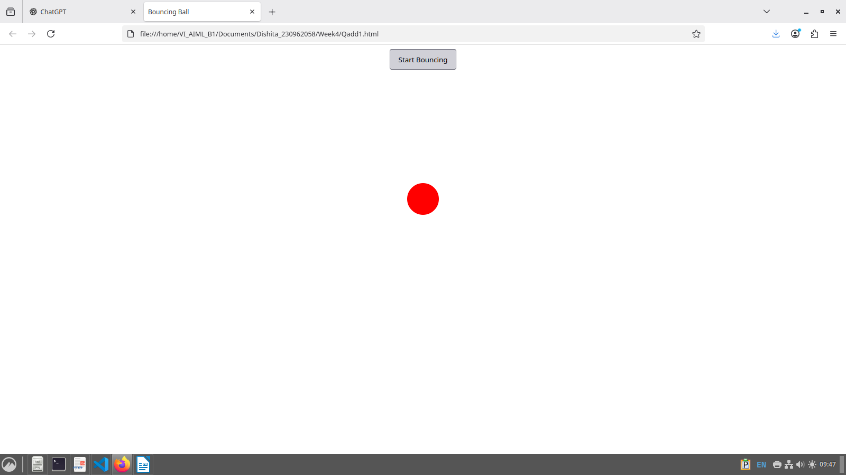
Q2. Write a web page which displays image and show the sliding text on the image.

<!DOCTYPE html>
<html>
<head>
<title>Sliding Text on Image</title>
<script src="jquery-4.0.0.min.js"></script>

<style>
.container {
width: 300px;
position: relative;
margin: 50px auto;
}
.container img {
width: 100%;
}
.text {
position: absolute;
bottom: -50px;
background: rgba(0,0,0,0.6);
color: white;
width: 100%;
text-align: center;
padding: 10px;
}
</style>

<script>
$(document).ready(function(){
$(".container").hover(
function(){
$(".text").animate({bottom: "0px"}, "slow");
},
function(){
$(".text").animate({bottom: "-50px"}, "slow");
}
);
});
</script>
</head>

<body>
<div class="container">
<img src="cat.jpeg" alt="Sample Image">
<div class="text">My cat</div>
</div>
</body>
</html>

Output:

