Data Science Laboratory
Project Report
On
“ML-Based Identifying Algorithmic Bidding Bots in Online Auction Systems”

Submitted By
Group No.22

Ryan Reji (5023164)
Ved Teredesai (5023166)
Eric Alhat (5022104)

Course Co-ordinator - Dr. Poonam Bari


Agnel Charities
Fr. C. Rodrigues Institute of Technology, Vashi
(An Autonomous Institute & Permanently Affiliated to University of Mumbai)
Sector 9A, Vashi, Navi Mumbai – 400703
Department of Information Technology
2025-2026

CERTIFICATE
This is to certify that the project entitled

“ML-Based Identifying Algorithmic Bidding Bots in Online Auction Systems”
Submitted By

Group No.22
Ryan Reji (5023164)
Ved Teredesai (5023166)
Eric Alhat (5022104)

In partial fulfillment in Third Year Information Technology for term work of the Semester VI - Data Science Lab Project- is approved.

External Examiner Internal Examiner

_________________ ________________

Course Coordinator Head of the Department

________________ ___________________

Date: -

Abstract
Online auction systems are widely used in digital commerce, but the presence of algorithmic bidding bots creates major challenges by causing unfair bidding practices, price manipulation, and reduced trust among genuine users. This project presents a machine learning-based approach for identifying algorithmic bidding bots using bidder behavioral analysis. Raw auction bid logs were processed to extract meaningful behavioral features such as bidding frequency, time differences, concurrent bidding activity, auction participation patterns, device usage, and IP behavior. Multiple machine learning models including Logistic Regression, Decision Tree, Random Forest, AdaBoost, and XGBoost were trained and evaluated using ROC-AUC and cross-validation. Since the dataset was highly imbalanced, techniques such as threshold tuning, class weighting, and SMOTE were applied to improve bot detection performance. Among all models, the threshold-optimized XGBoost classifier achieved the best results by significantly improving bot recall while maintaining strong overall performance. The final model was deployed using a desktop-based Tkinter application that classifies bidders as either “BOT DETECTED” or “HUMAN VERIFIED” along with a confidence score. The proposed system demonstrates that combining behavioral feature engineering with imbalance-aware machine learning techniques provides an effective solution for detecting fraudulent automated bidding behavior and improving fairness in online auction platforms.
Keywords: Machine Learning, XGBoost, Bot Detection, Online Auction System, Behavioral Analysis, Class Imbalance, Threshold Optimization, Fraud Detection

Contents
CHAPTER 1: INTRODUCTION | 1
1.1 Problem Definition | 1
1.2 Motivation | 1
1.3 Project Objective | 2
CHAPTER 2: LITERATURE SURVEY | 3
2.1 Literature Review | 3
CHAPTER 3: EXPLORATORY DATA ANALYSIS | 9
3.1 Introduction | 9
3.2 Dataset Overview | 9
3.3 Data Preprocessing and Feature Engineering | 12
3.4 Class Distribution Analysis | 16
3.5 Temporal Bidding Behaviour | 16
3.6 Bidding Activity Analysis | 18
3.7 Geographical and Device Behaviour | 19
3.8 Multivariate Feature Visualization | 20
3.9 Key Insights from Exploratory Data Analysis | 22
CHAPTER 4: METHODOLOGY AND MODEL EVALUATION | 25
4.1 Pipeline Overview | 25
4.2 Dataset Description | 26
4.3 Data Preprocessing | 26
4.4 Train-Test Split | 27
4.5 Handling Class Imbalance | 28
4.6 Classification Models | 29
4.7 Evaluation Metrics | 30
4.8 Implementation Environment | 31
CHAPTER 5: RESULT AND DISCUSSION | 32
5.1 Model Performance Comparison | 32
5.2 Hyperparameter Tuning Results | 34
5.3 Class Imbalance Handling and Threshold Optimization | 35
5.4 Final Model Evaluation | 37
5.5 Feature Importance Analysis | 38
5.6 Discussion | 40
CHAPTER 6: SYSTEM INTERFACE | 42
6.1 System Overview | 42
6.2 Implementation and Deployment | 43
6.3 System Interface and Prediction Process | 44
CHAPTER 7: CONCLUSION AND FUTURE SCOPE | 47
7.1 Conclusion | 47
7.2 Future Scope | 48
REFERENCES | 52

List of Figures
Figure No. | Caption | Page No.
Figure 3.1 | Class Imbalance Countplot - Humans vs Bots | 17
Figure 3.2 | Median Reaction Time within Auctions (Human vs Bot) | 17
Figure 3.3 | Proportion of Concurrent Bids | 18
Figure 3.4 | Distribution of Total Bids per User | 19
Figure 3.5 | Total Volume of Bids per User | 20
Figure 3.6 | Top 20 Countries by Total Bid Volume | 20
Figure 3.7 | Proportion of Users with Missing Country Data | 21
Figure 3.8 | Behavioral Ratios: Physical Constraints | 22
Figure 3.9 | PCA 2D Projection of Engineered Features | 23
Figure 4.1 | End-to-End Machine Learning Pipeline for Bot Detection | 26
Figure 5.1 | Threshold vs Precision, Recall and F1 Score | 36
Figure 5.2 | Confusion Matrices for Different Imbalance Handling | 37
Figure 5.3 | Final Confusion Matrix and Predicted Probability Distribution | 38
Figure 5.4 | XGBoost Feature Importance Graph | 39
Figure 6.1 | Bot Detection System Interface | 46

List of Tables
Table No. | Caption | Page No.
Table 2.1 | Comparative Analysis of Literature Survey | 6
Table 3.1 | Structure of the Train Dataset | 10
Table 3.2 | Summary Statistics of Train Dataset | 10
Table 3.3 | Structure of the Bids Dataset | 11
Table 3.4 | Missing Values in the Dataset | 11
Table 3.5 | Unique Values in Bids Dataset | 12
Table 3.6 | Basic Aggregated Features | 13
Table 3.7 | Temporal Features | 14
Table 3.8 | Missing Data Feature | 14
Table 3.9 | Behavioral Ratio Features | 15
Table 3.10 | Master Dataset Summary | 15
Table 4.1 | Train-Test Split Summary | 28
Table 4.2 | Imbalance Handling Comparison | 29
Table 5.1 | Initial Holdout AUC Scores | 32
Table 5.2 | 5-Fold Cross Validation AUC Scores | 33
Table 5.3 | Best Hyperparameters and Final AUC Scores | 34
Table 5.4 | Comparison of Imbalance Handling Methods | 36
Table 6.1 | Major Components of the Proposed System | 43
Table 6.2 | Software Tools Used | 44
Table 6.3 | Prediction Process | 45

CHAPTER 1: INTRODUCTION

1.1 Problem Definition
Online auction platforms are increasingly challenged by automated bidding bots that compete directly with human users by exploiting algorithmic speed, precision, and system latency. These bots can submit bids at extremely high frequencies, most notably through bid sniping, where bids are placed in the final milliseconds of an auction, leaving human participants unable to respond. Such behavior undermines fairness and transparency, as auction outcomes become driven by automation rather than genuine human demand. As a result, final prices are distorted, user trust deteriorates, and long-term participation declines, ultimately harming platform credibility and reputation. In addition to market imbalance, the high volume of automated requests generated by bots places significant strain on server infrastructure, increasing operational costs. This project addresses these challenges by focusing on the identification and classification of automated bidding bots versus human bidders using behavioral and temporal auction data. Instead of relying on one-time user verification, the approach emphasizes continuous monitoring and analysis of bidding patterns throughout the auction lifecycle to detect automation effectively..
1.2 Motivation
From a societal perspective, fairness in digital marketplaces is essential to ensure equal participation for all users, regardless of technical expertise or access to advanced tools. The unchecked use of bidding bots disrupts this balance by allowing automated agents to dominate auctions, systematically disadvantageous to human participants. From a business and platform standpoint, effective bot detection is crucial for maintaining user trust, preventing fraudulent or manipulative activity, reducing infrastructure strain caused by high-frequency automated requests, and preserving the integrity of auction pricing mechanisms. Platforms that fail to control automated bidding risk declining user engagement, distorted market outcomes, and long-term reputational harm. Academically, this problem represents a significant challenge in applied data science and machine learning. Unlike traditional classification tasks based on static attributes, detecting bidding bots requires analyzing dynamic behavioral patterns, temporal bidding sequences, and interaction-based features. This project advances beyond rule-based or CAPTCHA-style defenses by emphasizing continuous, data-driven behavioral monitoring through machine learning techniques.

1.3 Project Objective
The primary objectives of this project are:
- Identify automated bidding behavior
Detect bidders that exhibit non-human patterns such as extremely rapid bid placement, repetitive timing intervals, and simultaneous activity across multiple auctions.
- Classify bidders using machine learning
Develop a supervised machine learning model capable of accurately classifying bidders as either human or bot based on extracted behavioral features.
- Analyze temporal bidding patterns
Examine timestamp-based features to capture bid frequency, latency exploitation, and last-moment bidding behavior..
- Optimize model performance
Maximize detection accuracy while minimizing false positives to avoid incorrectly penalizing legitimate human user

CHAPTER 2: LITERATURE SURVEY

2.1 Literature Review
Auction fraud and shill bidding detection have evolved significantly over the past decade, progressing from rule-based scoring mechanisms to advanced machine learning and adaptive intelligent systems. As online marketplaces expanded in scale and complexity, fraudulent strategies became increasingly automated, coordinated, and dynamic. Consequently, detection methodologies shifted from static behavioral heuristics to scalable, data-driven models capable of handling imbalanced and large-scale datasets.
Early research primarily focused on supervised learning techniques to classify fraudulent bidders using engineered behavioral features. Anowar and Sadaoui [1] demonstrated that classifiers such as Support Vector Machines (SVM), Artificial Neural Networks (ANN), and Random Forest can achieve high recall when combined with hybrid resampling techniques like SMOTE-ENN to address class imbalance. Similarly, Ganguly and Sadaoui [2] employed hybrid sampling with SVM for end-of-auction fraud detection, emphasizing the importance of balanced datasets for reliable classification. Although these approaches achieved strong predictive performance, they relied heavily on offline labeling and post-auction analysis, limiting real-time intervention.
As fraud strategies became more coordinated, researchers began focusing on collusive and group-based detection. Trevathan and Read [3] enhanced the traditional Shill Score model to detect multi-seller collusion across auctions, recognizing that fraud often involves structured collaboration rather than isolated behavior. Graph-based methods further strengthened this direction. Fire et al. [4] showed that fraudulent bidders form tightly connected clusters within transaction networks, enabling detection through community detection techniques. Similarly, Bangcharoensap et al. [5] applied semi-supervised label propagation in auction graphs to uncover fraud rings with minimal labeled data. These approaches marked a transition from individual behavioral modeling to relational analysis. However, graph-based systems introduced computational complexity and scalability challenges when applied to large marketplaces.
To improve predictive accuracy, ensemble and hybrid models were introduced. Sabhita and Sarika [6] proposed a voting ensemble combining SVM, Random Forest, and Logistic Regression, achieving high classification accuracy through model aggregation. Abidi et al. [7] further fused SVM, ANN, and fuzzy logic into a real-time classifier, demonstrating superior performance compared to standalone models. While ensemble techniques improved generalization and robustness, they increased architectural complexity and reduced interpretability, posing challenges for practical deployment.
Neural network-based approaches also gained prominence due to their ability to capture nonlinear and high-dimensional patterns in bidding behavior. Anebo and Igbudu [8] applied feed-forward neural networks to model complex behavioral relationships, achieving competitive accuracy. Anebo and Ezebunwo [9] proposed a lightweight neural classifier with reduced architectural complexity, making it suitable for resource-constrained systems. However, neural models are often criticized for their black-box nature, which limits transparency in fraud-sensitive environments. To address this limitation, Souza et al. [10] introduced an evolving fuzzy neural network that integrates fuzzy logic reasoning with neural learning. By generating interpretable IF–THEN rules alongside adaptive learning, their model demonstrated that explainability and performance can be balanced within a unified framework.
Semi-supervised learning has also been explored to reduce reliance on labeled datasets. Elshaar and Sadaoui [11] proposed a semi-supervised framework that leverages both labeled and unlabeled auction data to improve fraud detection performance, demonstrating that partially labeled datasets can still produce reliable classification models.
Further research examined propagation-based techniques for identifying collusive groups within auction systems. Gerritse and van Wesenbeeck [12] proposed a bid score propagation mechanism that spreads suspicion scores across related bidders, enabling the detection of collusive bidding networks through iterative score updates.
More recently, adaptive and dynamic learning frameworks have been explored to address evolving fraud strategies. Static supervised models assume stable data distributions, whereas in practice, fraudsters continuously adapt their tactics. Wang et al. [13] proposed a multi-agent reinforcement learning (MARL) framework that models auctions as adversarial environments involving strategic interactions between honest and malicious bidders. By learning optimal strategies through interaction, the system adapts to evolving fraud patterns rather than relying solely on historical labels. Although conceptually powerful, reinforcement learning approaches require complex simulation environments and present interpretability challenges.
In contrast, Trevathan’s Live Shill Score (LSS) [14] emphasized operational practicality by dynamically computing fraud scores during ongoing auctions. Unlike traditional Shill Score models that operate post-auction, LSS enables real-time monitoring and immediate intervention. However, it remains rule-based and does not incorporate adaptive learning mechanisms, limiting its ability to respond to evolving strategies.
With the rapid growth of online marketplaces and access to massive transaction logs, large-scale behavioral and infrastructure-level feature engineering became increasingly important. Maan and Eswari [15] demonstrated that behavioral features such as bid frequency, timing irregularities, and participation spread can effectively distinguish automated bidders using Random Forest classifiers. Extending beyond behavioral signals, Sun et al. [16], in a Kaggle-based study, emphasized the importance of infrastructure-level features including IP diversity, URL access patterns, and device heterogeneity extracted from millions of bids. Their findings revealed that bots often exhibit structured access patterns distinct from human users. Building on this perspective, Gutierrez [17] reframed bot detection as a network inference problem by constructing bidder relationship graphs based on shared IPs, devices, and URLs. By computing centrality metrics such as PageRank and clustering coefficients, the study captured coordinated bot communities that traditional per-bidder models might overlook.
Finally, academic implementations have strengthened methodological rigor in this domain. Gu and Shi [18] developed a structured machine learning pipeline incorporating feature extraction, feature selection, cross-validation, and ablative analysis, achieving strong AUROC performance. Their work underscores the importance of systematic evaluation and careful pipeline design in developing reliable fraud detection systems.
Overall, the literature reveals a clear methodological evolution—from rule-based scoring and static supervised classification to ensemble learning, graph-based relational analysis, neuro-fuzzy systems, and adaptive reinforcement learning frameworks. While substantial progress has been made in improving detection accuracy and scalability, challenges remain in balancing interpretability, computational efficiency, adaptability, and real-time deployment in large-scale auction environments.
Table 2.1 presents a comparative analysis of the reviewed literature to highlight key contributions, identified problems, research gaps, and possible improvements. Each study is summarized based on its methodology, limitations, and scope for enhancement.
Table 2.1: Comparative Analysis of Literature Survey
Paper | Summary | Problem Identified | Research Gap | Proposed Improvement
[1] | ML models (SVM, ANN, RF) with SMOTE-ENN for fraud detection | Class imbalance handled but relies on offline labeling | No real-time detection | Integrate real-time fraud detection system
[2] | SVM with hybrid sampling for end-of-auction detection | Works only after auction ends | No live fraud monitoring | Develop real-time detection models
[3] | Enhanced Shill Score for detecting multi-seller collusion | Focused only on collusion scenarios | Limited general fraud detection | Combine with ML-based detection
[4] | Graph-based community detection identifies fraud clusters | Computationally expensive | Scalability issues for large datasets | Optimize graph-based models for large-scale systems
[5] | Semi-supervised graph label propagation detects fraud rings | Depends on graph structure quality | High computational cost | Efficient graph construction techniques
[6] | Ensemble model (SVM + RF + LR) improves accuracy | High model complexity | Reduced interpretability | Use explainable ensemble models
[7] | Fused classifier (SVM + ANN + fuzzy) for real-time detection | Very complex architecture | Difficult deployment | Simplify hybrid models for practical use
[8] | Feed-forward NN captures nonlinear bidding patterns | Black-box nature | Lack of interpretability | Integrate explainability techniques
[9] | Lightweight neural network for fraud classification | Lower accuracy than complex models | Limited scalability | Combine lightweight models with stronger features
[10] | Fuzzy neural network provides interpretable rules | Complex fuzzy setup | Requires tuning expertise | Automate fuzzy rule optimization
[11] | Semi-supervised learning reduces labeled data dependency | Depends on clustering accuracy | Not real-time | Combine with streaming data models
[12] | Score propagation detects collusive bidder groups | Computational overhead | No benchmark validation | Optimize propagation algorithms
[13] | MARL models dynamic interaction between bidders | Requires simulation environment | Hard to deploy & interpret | Hybrid adaptive + practical system
[14] | Live Shill Score enables real-time fraud scoring | Rule-based, no learning | No adaptability to evolving fraud | Combine with ML-based adaptive scoring
[15] | Behavioral features (timing, frequency) effective via RF | Limited to individual behavior | Ignores infrastructure patterns | Integrate behavioral + infrastructure features
[16] | Kaggle study uses IP, URL, device features for classification | Severe class imbalance not handled deeply | No real-time or deployment focus | Add imbalance handling + deployment system
[17] | Graph-based feature engineering (PageRank, clustering) captures bot networks | High computational cost | Not real-time scalable | Incremental graph updates + hybrid model
[18] | ML pipeline with feature selection & cross-validation (AUROC ~0.94) | No graph or infrastructure features | Limited feature diversity | Combine pipeline with graph + infra features

CHAPTER 3: EXPLORATORY DATA ANALYSIS

3.1 Introduction
Exploratory Data Analysis (EDA) is a crucial step in the data science pipeline that involves examining and summarizing datasets to understand their main characteristics before applying machine learning models. In the context of the Identifying bidding bots in our project, EDA helps identify patterns, anomalies, and behavioral differences between human bidders and automated bots in online auctions.
The primary objective of this EDA is to analyze bidding behavior using variables such as bidding frequency, time differences between bids, device usage, IP distribution, and geographical patterns. By exploring these features, we aim to gain insights into how bots behave differently from human users.
This analysis also helps in identifying missing values, outliers, and important features that may contribute to effective bot detection. The findings from the EDA stage guide the preprocessing steps and feature engineering required for building reliable classification models.

3.2 Dataset Overview
The Human vs Bot detection project uses the Facebook Recruiting: Human or Robot dataset [19],which contains information about bidders and their bidding activities in online auctions. The dataset consists of two primary files: train.csv and bids.csv. These datasets provide information about bidders, their accounts, and detailed bidding behavior during auctions.
The datasets were loaded into Python using the Pandas library for further preprocessing and analysis.

3.2.1 Train Dataset
The train dataset, as shown in Table 3.1, contains information about bidders and their associated labels indicating whether they are human or bot. Each record corresponds to a unique bidder.

Table 3.1: Structure of the Train Dataset
Column | Description
bidder_id | Unique identifier for each bidder
payment_account | Payment account associated with the bidder
address | Address identifier linked to the bidder
outcome | Target variable indicating whether the bidder is a bot (1) or human (0)
The summary statistics as in Table 3.2 shows that the Train dataset contains 2013 records and 4 attributes. The outcome column represents the classification label used for training machine learning models.
Table 3.2: Summary Statistics of Train Dataset
Statistic | Outcome
Count | 2013
Mean | 0.051
Standard Deviation | 0.220
Minimum | 0
Maximum | 1
The mean value indicates that only a small proportion of bidders are bots, showing that the dataset is highly imbalanced, with the majority being human bidders.

3.2.2 Bids Dataset
The bids dataset contains detailed information about every bid placed during the auctions. Structure of the bid can be seen in table 3.3.
Table 3.3: Structure of the Bids Dataset
Column | Description
bid_id | Unique identifier for each bid
bidder_id | Identifier linking the bid to a specific bidder
auction | Auction identifier
merchandise | Type of merchandise being auctioned
device | Device used to place the bid
time | Timestamp of the bid
country | Country from which the bid was placed
ip | IP address of the bidder
url | URL where the bid was placed
The dataset contains 7,656,334 bid records and 9 attributes, making it significantly larger than the train dataset. This dataset provides rich behavioral information such as bidding frequency, device usage, geographical location, and timing of bids, which are essential for distinguishing bots from human bidders.

3.2.3 Missing Values
Missing value analysis was performed to identify incomplete data in the datasets as shown in table 3.4.
Table 3.4: Missing Values in the Dataset
Dataset | Column | Missing Values
Train | All columns | 0
Bids | country | 8,859
The train dataset contains no missing values, while the bids dataset has missing values only in the country column, representing a small fraction of the total bid records.

3.2.4 Cardinality of Categorical Features
Several categorical variables in the bids dataset contain a large number of unique values (refer Table 3.5). High-cardinality features are important for understanding bidder behavior patterns.
Table 3.5: Unique Values in Bids Dataset
Feature | Number of Unique Values
auction | 15,051
merchandise | 10
device | 7,351
country | 199
ip | 2,303,991
url | 1,786,351
Features such as IP address, URL, and device show extremely high variability, which may help identify suspicious patterns associated with automated bidding behavior.

3.3 Data Preprocessing and Feature Engineering
Before performing exploratory data analysis and model development, several preprocessing and feature engineering steps were carried out to transform the raw bidding data into a structured bidder-level dataset. The goal of this process was to summarize large-scale bid-level information into meaningful behavioral features that could help differentiate human bidders from automated bots.

3.3.1 Data Cleaning
The original train dataset contained attributes such as payment_account and address. These columns were removed due to limited relevance.
After cleaning, only the relevant columns were retained, particularly:
- bidder_id – unique identifier for each bidder
- outcome – classification label indicating human (0) or bot (1)
The outcome variable was then merged with the bids dataset using bidder_id so that each bid could be associated with its corresponding label.

3.3.2 Bidder-Level Aggregation
Since the bids dataset contains millions of individual bid records, the data was aggregated at the bidder level to create a summarized dataset suitable for EDA and modeling (refer Table 3.6).
Several key aggregation features were computed:
Table 3.6: Basic Aggregated Features
Feature | Description
num_bids | Total number of bids placed by a bidder
num_auct | Number of unique auctions participated in
num_device | Number of unique devices used
num_country | Number of countries from which bids were placed
num_ip | Number of unique IP addresses used
num_url | Number of unique URLs used for bidding
These features capture the activity level and behavioral diversity of each bidder.

3.3.3 Temporal Behavioral Features
To analyze bidding patterns over time, the bids were first sorted by bidder ID and timestamp. The difference between consecutive bids (time_diff) was then calculated for each bidder.
From this, several temporal statistics were derived, shown in Table 3.7.
Table 3.7: Temporal Features
Feature | Description
mean_diff | Mean time difference between consecutive bids
median_diff | Median time difference between bids
min_diff | Minimum time gap between bids
num_concurrent_bids | Number of bids placed at the same timestamp
Bots often place bids extremely quickly or simultaneously, making these temporal features useful indicators of automated behavior.

3.3.4 Missing Data Feature
A feature (See Table 3.8) was also created to capture missing information related to bidder location.
Table 3.8: Missing Data Feature
Feature | Description
missing_country_bids | Number of bids where the country information is missing
This helps determine whether missing geographic data correlates with suspicious bidding behavior.

3.3.5 Behavioral Ratio Features
To further capture abnormal patterns in bidder behavior, several ratio-based features were engineered as shown in Table 3.9.
Table 3.9: Behavioral Ratio Features
Feature | Description
percent_concurrent_bids | Fraction of bids placed simultaneously
bids_per_device | Average number of bids per device
bids_per_url | Average number of bids per URL
ip_per_ctry | Number of IP addresses used per country
device_per_auct | Average number of devices used per auction
These ratios help reveal automated activity patterns, such as excessive bidding from the same device or rapid switching of IP addresses.

3.3.6 Final Master Dataset
After combining all engineered features, a master dataset was created for EDA and modeling.
The summary for the master dataset is shown in Table 3.10.
Table 3.10: Master Dataset Summary
Attribute | Value
Number of rows | 1984 bidders
Number of columns | 18 features
This dataset represents each bidder with a set of aggregated behavioral features, enabling efficient analysis of patterns that distinguish human bidders from bots.

3.4 Class Distribution Analysis
Class distribution analysis was performed to understand the proportion of human and bot bidders in the training dataset. The target variable outcome represents the class label, where 0 indicates a human bidder and 1 indicates a bot.
As shown in Figure 3.1, the dataset is highly imbalanced. Approximately 94.9% of the bidders are humans, while only 5.1% are bots. This indicates that bot accounts form a small minority within the dataset.
Such imbalance is common in fraud detection problems, where malicious or automated behavior occurs far less frequently than normal user activity. This imbalance must be considered during model development, as standard machine learning algorithms may otherwise become biased toward predicting the majority class.

3.5 Temporal Bidding Behaviour
Temporal features were analyzed to understand how quickly bidders react and how frequently they place simultaneous bids during auctions. These patterns are useful indicators for distinguishing human behavior from automated bot activity.
Figure 3.2 shows the median reaction time between consecutive bids for humans and bots. The results indicate that bot bidders generally have shorter reaction times, meaning they respond more quickly within auctions. Human bidders tend to have larger and more variable reaction times, reflecting natural delays in manual bidding.
Figure 3.3 presents the distribution of the proportion of concurrent bids, which represents bids placed at the same timestamp (zero-second gaps). The plot shows that bots tend to have a higher proportion of concurrent bids, whereas human bidders rarely place bids simultaneously.
These findings suggest that bots exhibit faster and more automated bidding patterns, while human bidders demonstrate slower and less synchronized behavior.
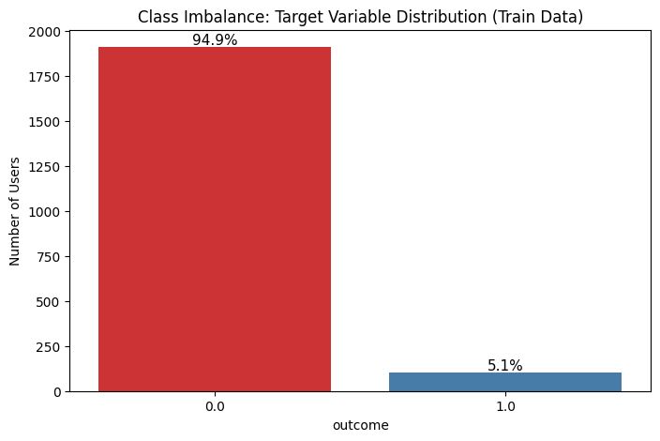
Figure 3.1: Class Imbalance countplot - Humans vs Bots
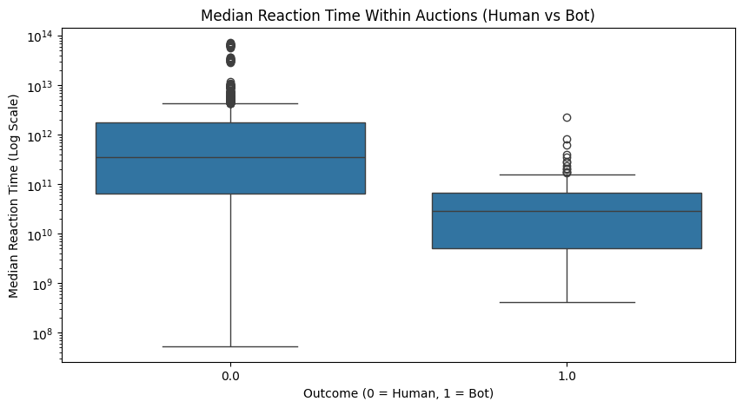
FIgure 3.2: Median Reaction Time within auctions (human vs bot)

3.6 Bidding Activity Analysis
The bidding activity of users was analyzed to understand how frequently bidders participate in auctions and whether bots exhibit different activity levels compared to human users.
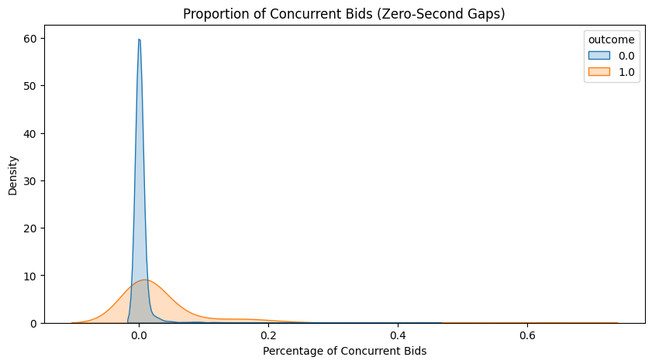
Figure 3.3: Proportion of Concurrent Bids
Figure 3.4 shows the distribution of total bids per user on a logarithmic scale. The distribution is highly right-skewed, indicating that most users place relatively few bids, while a small number of users place a very large number of bids. This heavy-tailed pattern is typical in auction environments where a few highly active participants dominate bidding activity.
Figure 3.5 compares the total volume of bids per user for humans and bots using a boxplot. The results show that bot accounts tend to place significantly more bids than human users. Bots also display a higher median number of bids and a wider range of bidding activity, suggesting more aggressive participation in auctions.
Overall, these results indicate that bots tend to generate higher bidding volumes, whereas most human bidders participate more moderately in auctions.

3.7 Geographical and Device Behaviour
Geographical and device-related features were analyzed to understand how bidders interact with the auction platform and whether bots demonstrate abnormal usage patterns.
Figure 3.4 shows the top countries by total bid volume. The results indicate that bidding activity is concentrated in a few countries, with India contributing the highest number of bids, followed by several other countries with significantly lower volumes. This suggests that auction participation is geographically uneven across the dataset.
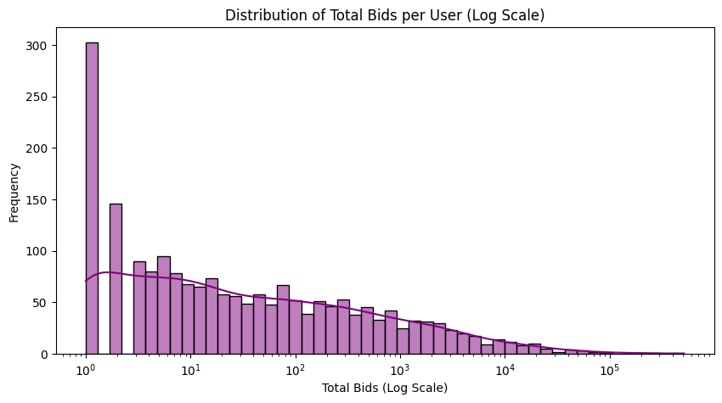
Figure 3.4: Distribution of Total Bids per User
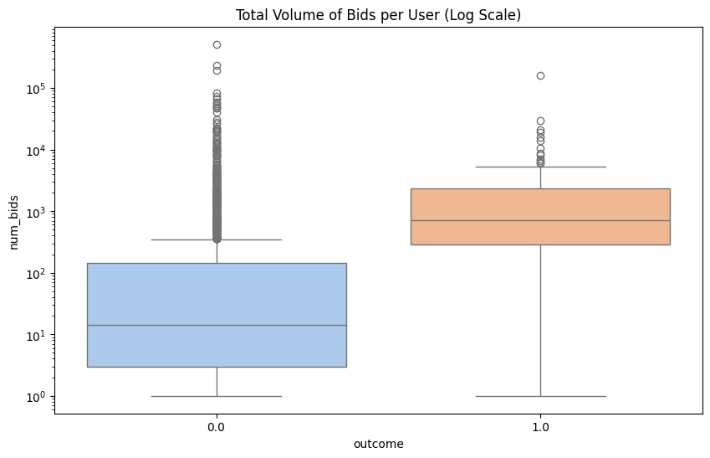
Figure 3.5: Total volume of bids per user

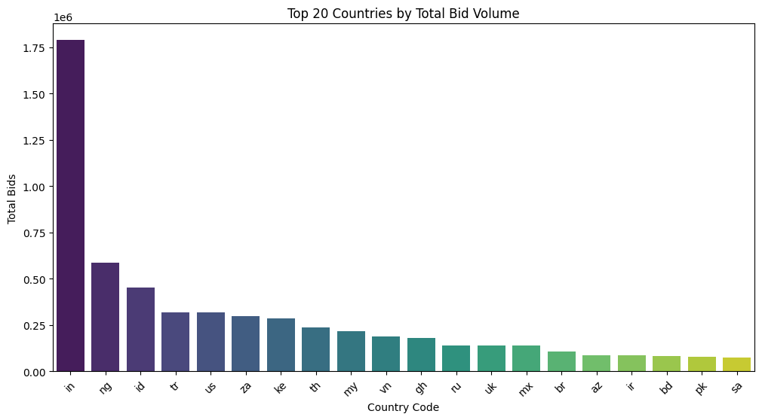
Figure 3.6: Top 20 Countries by Total Bid Volume
Figure 3.7 presents the proportion of users with missing country information. The analysis shows that bot accounts tend to have a higher proportion of missing country data compared to human users. Missing location information may indicate attempts to hide or obscure the true origin of bidding activity.
Figure 3.8 compares several behavioral ratio features, including bids per device, bids per URL, and IP addresses per country. Bots generally show higher values across these ratios, suggesting that automated bidders often generate more activity from the same device or URL and may use multiple IP addresses across locations.

3.8 Multivariate Feature Visualization
To analyze the relationships among the engineered features, Principal Component Analysis (PCA) was applied to reduce the high-dimensional feature space into two principal components for visualization.
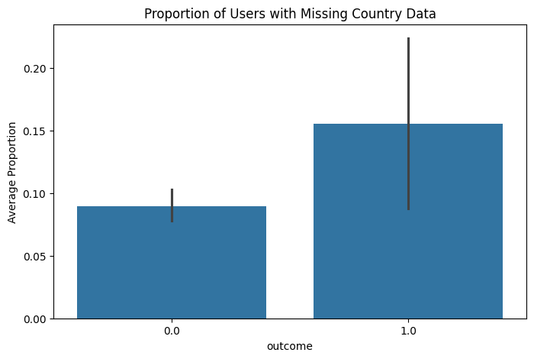
Figure 3.7: Proportion of Users with Missing Country Data
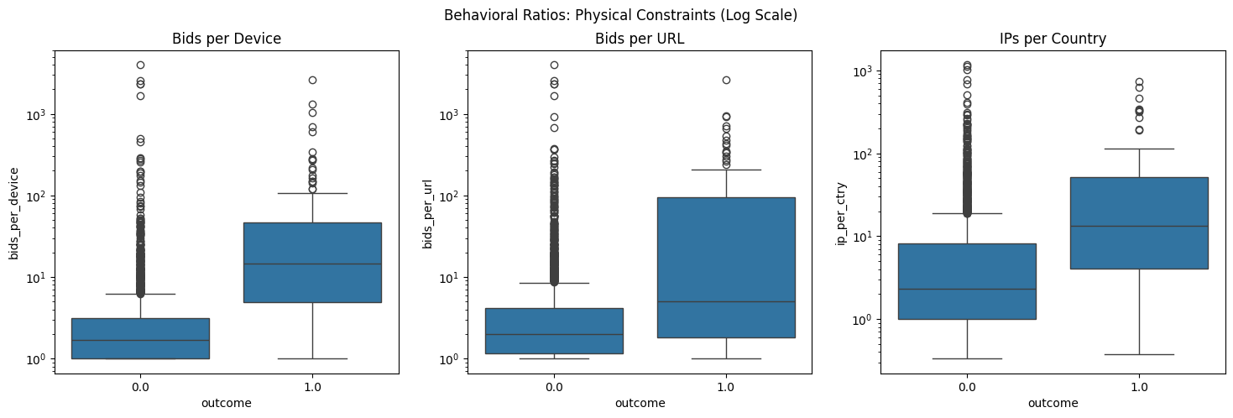
Figure 3.8: Behavioral Ratios: Physical Constraints
Figure 3.9 presents the 2D PCA projection of the engineered behavioral features. The plot reveals a high degree of overlap between human and bot behavioral profiles, indicating that the dataset is not linearly separable. This suggests that simple linear classification models may struggle to effectively distinguish between human and automated bidders.
By compressing multiple engineered features—including bidding frequency, IP density, device usage, and temporal ratios—into two principal components, the visualization shows that most bot bidders closely mimic human behavior patterns. As a result, both classes are concentrated within a dense central cluster, with only a few outliers appearing further from the main grouping.
This observation highlights the challenge of detecting sophisticated automated bidders, as bots are designed to imitate normal human activity to avoid detection.
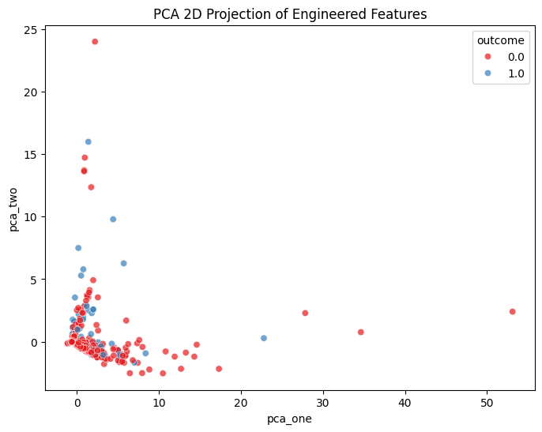
Figure 3.9: PCA 2D Projection of Engineered Features

3.9 Key Insights from Exploratory Data Analysis
The exploratory data analysis revealed several behavioral characteristics that help distinguish bot bidders from human users, while also highlighting the challenges associated with detecting sophisticated automated activity.
First, the dataset exhibits a significant class imbalance, with bot accounts representing only a small proportion of the total bidders. This imbalance is typical in fraud detection problems and must be considered during model development to avoid biased predictions toward the majority class.
Temporal analysis showed that bots generally exhibit faster reaction times and a higher proportion of concurrent bids, indicating automated bidding behavior. In contrast, human bidders tend to display larger and more variable time gaps between bids, reflecting natural human interaction with the auction platform.
The analysis of bidding activity further revealed that bots tend to generate higher bidding volumes, often participating in auctions more aggressively than human users. Additionally, geographical and device-based features indicated that bots frequently show higher ratios of bids per device, URL, and IP address, suggesting the use of automated scripts or multiple network sources.
However, the PCA visualization demonstrated a substantial overlap between human and bot behavioral profiles, indicating that bots often mimic human bidding patterns to avoid detection. This overlap suggests that the dataset is not easily separable using simple linear methods, and that more advanced machine learning models may be required to effectively identify automated bidders.
Overall, the insights obtained from EDA confirm that temporal behavior, bidding intensity, and network-based features are important indicators of automated activity, and they provide a strong foundation for building predictive models for bot detection.

CHAPTER 4: METHODOLOGY AND MODEL EVALUATION

4.1 Pipeline Overview
- The system follows a structured machine learning pipeline for detecting algorithmic bidding bots in online auction systems, starting from raw auction data and ending with real-time bidder classification.
- Raw auction bidding records are collected and converted into a structured dataset containing bidder activity such as bids, auctions, devices, IPs, and bidding intervals.
- Feature engineering is performed to extract meaningful behavioral features such as bidding frequency, time difference, concurrent bidding ratio, and device-to-auction patterns.
- Data preprocessing includes checking missing values, removing unnecessary columns, and preparing the final feature matrix. The target variable is defined as outcome, where 0 represents humans and 1 represents bots.
- The dataset is divided using train-test split with stratified sampling. Since the data is imbalanced, techniques such as threshold tuning, class weighting, and SMOTE are applied.
- Multiple models including Logistic Regression, Decision Tree, Random Forest, AdaBoost, and XGBoost are trained and compared using ROC-AUC and cross-validation. Hyperparameter tuning is also performed.
- The best-performing threshold-optimized XGBoost model is deployed using a Tkinter-based desktop application for real-time classification as “BOT DETECTED” or “HUMAN VERIFIED.”
The complete workflow is shown in Figure 4.1.
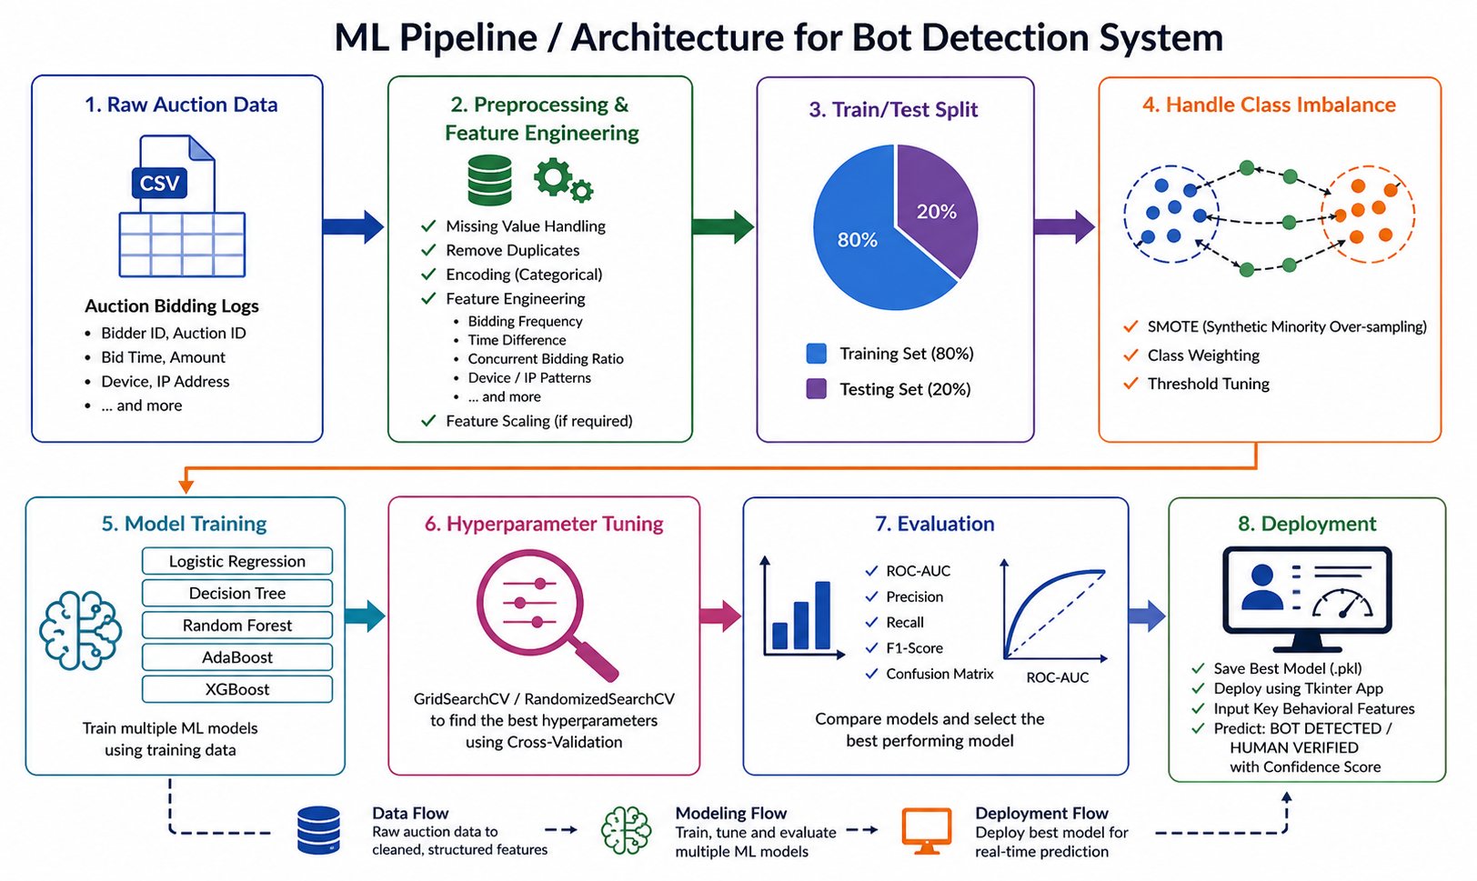
Figure 4.1: End-to-End Machine Learning Pipeline for Bot Detection System

4.2 Dataset Description

The dataset used for this project is based on online auction bidding records containing bidder behavior information such as bidding activity, auction participation, device usage, IP addresses, and time-based bidding patterns.

The raw dataset was processed to create the final behavioral dataset master_df, which contains engineered features used for machine learning classification. The final dataset consists of 2013 records and 34 columns.

The target variable used for classification is outcome, where 0 represents human bidders and 1 represents algorithmic bidding bots, making it a binary classification problem.

Important features include number of bids, number of auctions, unique devices, unique IPs, bidding time differences, concurrent bidding ratio, bids per auction, and bidding intensity patterns.

The dataset is highly imbalanced, with bot users forming only a small portion of the total records, which required imbalance handling techniques during model training and evaluation.

4.3 Data Preprocessing

The raw auction bidding dataset was processed to prepare it for machine learning model training. Since raw bidding records do not directly indicate whether a bidder is human or a bot, preprocessing was necessary to convert the data into a structured and usable format.

The first step involved removing unnecessary columns such as bidder identifiers that do not contribute to prediction. The target variable was defined as outcome, where 0 represents human bidders and 1 represents algorithmic bidding bots.

Feature engineering was then performed to create meaningful behavioral attributes from raw bid logs. Features such as bidding frequency, time differences between consecutive bids, number of concurrent bids, first and last bid patterns, bids per auction, bids per device, and percentage-based behavioral ratios were generated to capture bidder behavior.

Temporal features were created by calculating statistical measures such as mean, minimum, maximum, median, standard deviation, and interquartile range of bidding time differences. These features help identify abnormal bidding speed and repetitive automated behavior.

Missing values generated during feature creation were replaced with zero to maintain dataset consistency. The final processed dataset was stored as master_df, containing 2013 bidder records and 34 features ready for model training and evaluation.

4.4 Train-Test Split

After preprocessing, the dataset was divided into training and testing sets for model development and evaluation. An 80:20 split was used, where 80% of the data was used for training the models and 20% was reserved for final testing.

Stratified sampling was applied during the split to preserve the original class distribution of human users and bots in both training and testing datasets. This is important because the dataset is highly imbalanced, with bot users forming only a small percentage of the total records.

The training set was used for model training, cross-validation, and hyperparameter tuning, while the test set was kept separate for final model evaluation. This helps prevent data leakage and ensures reliable performance measurement.

The train-test split summary is shown in Table 4.1.

Table 4.1: Train-Test Split Summary
Dataset | Percentage | Purpose
Training Set | 80% | Model training and tuning
Testing Set | 20% | Final model evaluation

4.5 Handling Class Imbalance

The dataset used in this project is highly imbalanced, with bot users representing only around 5% of the total records. This creates a challenge because machine learning models tend to favor the majority class (human users), which increases the risk of false negatives where bots are incorrectly classified as humans.

To improve bot detection, three imbalance handling techniques were applied. The first method was threshold tuning, where the default classification threshold of 0.50 was reduced to an optimized value of approximately 0.09. This significantly improved bot recall without changing the model itself.

The second method was class weighting using the scale_pos_weight parameter in XGBoost, which assigns higher importance to the minority bot class during training.

The third method was SMOTE (Synthetic Minority Oversampling Technique), where synthetic bot samples were generated to balance the training dataset and im prove model learning.

Among all methods, threshold tuning provided the best balance between high bot recall and strong overall model performance.

The comparison of imbalance handling methods is shown in Table 4.2.

Table 4.2: Imbalance Handling Comparison
Method | Bot Recall | AUC
Default XGBoost | 0.286 | 0.9336
Threshold Tuning | 0.667 | 0.9336
Weighted XGBoost | 0.571 | 0.9339
SMOTE + XGBoost | 0.524 | 0.9256

4.6 Classification Models

To identify algorithmic bidding bots, multiple machine learning models were trained and compared. These models were selected to represent both simple baseline methods and advanced ensemble techniques capable of capturing complex behavioral patterns in bidder activity.

Logistic Regression
Logistic Regression was used as the baseline linear model. It predicts the probability of a bidder being a bot using a linear relationship between input features and the target variable. It is simple, fast, and useful for comparing the performance of more advanced models.

Decision Tree
Decision Tree is a non-linear model that splits data into decision rules based on feature values. It helps capture behavioral patterns more effectively than linear models and is easy to interpret, but it may overfit if not properly controlled.

Random Forest
Random Forest is an ensemble learning method that combines multiple decision trees and makes predictions based on majority voting. It reduces overfitting and improves generalization, making it highly effective for complex classification problems.

AdaBoost
AdaBoost is a boosting algorithm that improves performance by training multiple weak learners sequentially, where each new model focuses more on previously misclassified samples. It helps improve classification accuracy for difficult cases.

XGBoost
XGBoost is an advanced gradient boosting algorithm that provides high accuracy and efficient performance. It handles non-linear relationships well and performs strongly on imbalanced datasets, making it the best-performing model in this study.

All models were trained using the engineered behavioral features, while the target variable was outcome, where 0 represents human users and 1 represents bots. The models were compared using ROC-AUC and cross-validation, and XGBoost was selected for final deployment after threshold optimization.

4.7 Evaluation Metrics

Since the dataset is highly imbalanced, accuracy alone is not sufficient for evaluating model performance. Therefore, multiple evaluation metrics were used to properly measure the effectiveness of bot detection.

ROC-AUC (Receiver Operating Characteristic – Area Under Curve)
ROC-AUC was used as the primary evaluation metric. It measures the model’s ability to distinguish between human users and bots across different classification thresholds. A higher AUC indicates better classification performance.

Confusion Matrix
The confusion matrix helps analyze true positives, true negatives, false positives, and false negatives. It provides a clear understanding of how many bots were correctly detected and how many were missed.

Bot Recall
Bot recall was considered the most important metric in this project. It measures how many actual bots were correctly identified by the model. High recall is critical because missing bots can negatively affect auction fairness.

Precision
Precision measures how many users predicted as bots were actually bots. It helps reduce false alarms and ensures that genuine users are not incorrectly flagged too often.

F1-Score
F1-score provides a balance between precision and recall. It is useful when dealing with imbalanced datasets because it considers both bot detection and false positive control together.

These metrics provided a complete understanding of model performance and helped in selecting the final threshold-optimized XGBoost model.

4.8 Implementation Environment

The implementation of the proposed system was carried out using Python as the primary programming language due to its strong support for machine learning, data processing, and deployment.

Google Colab was used for data preprocessing, feature engineering, model training, cross-validation, hyperparameter tuning, and performance evaluation. It provided an efficient environment for experimentation using libraries such as Pandas, NumPy, Scikit-learn, XGBoost, Matplotlib, and Seaborn.

The final trained model was saved using the Joblib library in .pkl format as base_xgb_thresh_opt_model.pkl. This allowed the trained model to be loaded directly during deployment without repeating the training process.

For deployment, a desktop-based application was developed using Tkinter. The application accepts important bidder behavioral inputs such as bids, auctions, devices, IPs, and bidding intervals. It then performs prediction using the saved XGBoost model and displays the final result as either “BOT DETECTED” or “HUMAN VERIFIED” along with the confidence score.

CHAPTER 5: RESULT AND DISCUSSION

5.1 Model Performance Comparison
To identify the most suitable model for detecting algorithmic bidding bots, multiple machine learning models were trained and evaluated using the processed behavioral dataset. The models used in this study were Logistic Regression, Decision Tree, Random Forest, AdaBoost, and XGBoost.
The initial comparison was performed using the holdout validation method, where the dataset was divided into training and testing sets using an 80:20 split. The performance of each model was measured using ROC-AUC, which is suitable for imbalanced binary classification problems.
Among all models, Random Forest achieved the highest initial AUC score of 0.9455, followed closely by XGBoost with 0.9336 and AdaBoost with 0.9334. Logistic Regression and Decision Tree showed comparatively lower performance.
The initial holdout AUC comparison is shown in Table 5.1.

Table 5.1: Initial Holdout AUC Scores
Model | AUC Score
Logistic Regression | 0.7797
Decision Tree | 0.7563
Random Forest | 0.9455
AdaBoost | 0.9334
XGBoost | 0.9336
To further validate model stability and generalization, 5-Fold Cross Validation was performed using ROC-AUC as the scoring metric. This helped ensure that model performance was consistent across different training subsets.
Random Forest and XGBoost again showed the strongest performance, with mean cross-validation AUC scores of 0.9138 and 0.9132 respectively. AdaBoost also performed well, while Logistic Regression and Decision Tree showed lower stability and predictive performance.
Although Random Forest achieved the highest initial AUC, XGBoost was selected for final deployment because it performed consistently well, handled class imbalance more effectively, and responded better to threshold optimization.
The cross-validation results are shown in Table 5.2.

Table 5.2: 5-Fold Cross Validation AUC Scores
Model | Mean AUC | Standard Deviation
Logistic Regression | 0.7441 | 0.0472
Decision Tree | 0.6129 | 0.0677
Random Forest | 0.9138 | 0.0211
AdaBoost | 0.9101 | 0.0317
XGBoost | 0.9132 | 0.0227
Based on both holdout validation and cross-validation results, XGBoost was selected as the final model for further optimization and deployment.

5.2 Hyperparameter Tuning Results
After comparing the performance of multiple machine learning models, hyperparameter tuning was performed to improve model accuracy and generalization. Different tuning techniques such as GridSearchCV and RandomizedSearchCV were applied depending on the model complexity.
GridSearchCV was used for Logistic Regression, Decision Tree, Random Forest, and AdaBoost. For XGBoost, RandomizedSearchCV was used because of the larger parameter space and higher computational cost. The tuning process helped identify the best parameter combinations for each model based on ROC-AUC performance.
For Logistic Regression, the best parameters were found to be C = 0.01 and solver = lbfgs, but the improvement in AUC remained limited. Decision Tree showed significant improvement after tuning, especially by controlling tree depth and minimum samples required for splitting and leaf creation.
Random Forest was optimized using parameters such as number of estimators, maximum depth, and minimum sample split. Although it achieved strong performance, XGBoost provided better flexibility for handling imbalance and threshold optimization.
For AdaBoost, increasing the number of estimators and learning rate improved classification performance. However, XGBoost remained the most balanced and reliable model overall.
XGBoost was optimized using parameters such as learning rate, maximum depth, subsample ratio, column sampling ratio, and number of estimators. After tuning, it achieved a final AUC of 0.9371 and was selected as the best model for further imbalance handling and final deployment.
The best hyperparameters and final AUC scores are shown in Table 5.3.

Table 5.3: Best Hyperparameters and Final AUC Scores
Model | Best Parameters | Final AUC
Logistic Regression | C = 0.01, solver = lbfgs | 0.7797
Decision Tree | max_depth = 5, min_samples_leaf = 4, min_samples_split = 10 | 0.8915
Random Forest | n_estimators = 300, max_depth = 20 | 0.9360
AdaBoost | learning_rate = 1.0, n_estimators = 200 | 0.9167
XGBoost | learning_rate, max_depth, subsample, colsample_bytree optimized | 0.9371

5.3 Class Imbalance Handling and Threshold Optimization
The dataset used for this project is highly imbalanced, with bot users forming only a small portion of the total records. The bot ratio in both training and testing sets was approximately 5%, which makes bot detection challenging because machine learning models tend to favor the majority human class.
Initially, the base XGBoost model was evaluated using the default classification threshold of 0.50. Although the model achieved a strong AUC of 0.9336, the bot recall was only 0.286, meaning many bots were incorrectly classified as human users. This was not suitable for real-world auction fraud detection.
To improve bot detection, threshold tuning was applied. Instead of using the default threshold of 0.50, the classification threshold was reduced to the optimal value of 0.09. This significantly improved bot recall from 0.286 to 0.667 while maintaining the same AUC score of 0.9336. This made threshold tuning the most effective approach.
The second method used was Weighted XGBoost, where the scale_pos_weight parameter was applied to assign higher importance to the minority bot class during training. This improved bot recall to 0.571 with a slightly improved AUC of 0.9339.
The third method was SMOTE (Synthetic Minority Oversampling Technique), where synthetic bot samples were generated to balance the training data. Although SMOTE improved bot detection compared to the default model, the recall remained lower than threshold tuning, and the AUC slightly decreased to 0.9256.
Among all methods, threshold optimization on the base XGBoost model provided the best balance between bot recall and false positives, making it the final selected approach.
The comparison of all imbalance handling methods is shown in Table 5.4.

Table 5.4: Comparison of Imbalance Handling Methods
Model | AUC | False Negatives | True Positives | Bot Recall
Base XGBoost (0.50) | 0.9336 | 15 | 6 | 0.286
Base XGBoost (0.09) | 0.9336 | 7 | 14 | 0.667
Weighted XGBoost | 0.9339 | 9 | 12 | 0.571
SMOTE + XGBoost | 0.9256 | 10 | 11 | 0.524
The threshold optimization graph is shown in Figure 5.1, and the confusion matrix comparison of all strategies is shown in Figure 5.2.
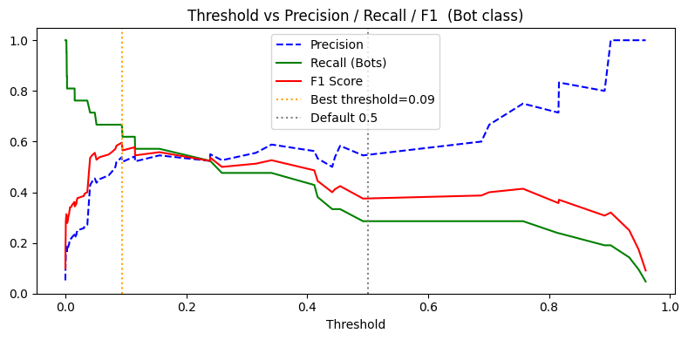
Figure 5.1: Threshold vs Precision, Recall and F1 Score
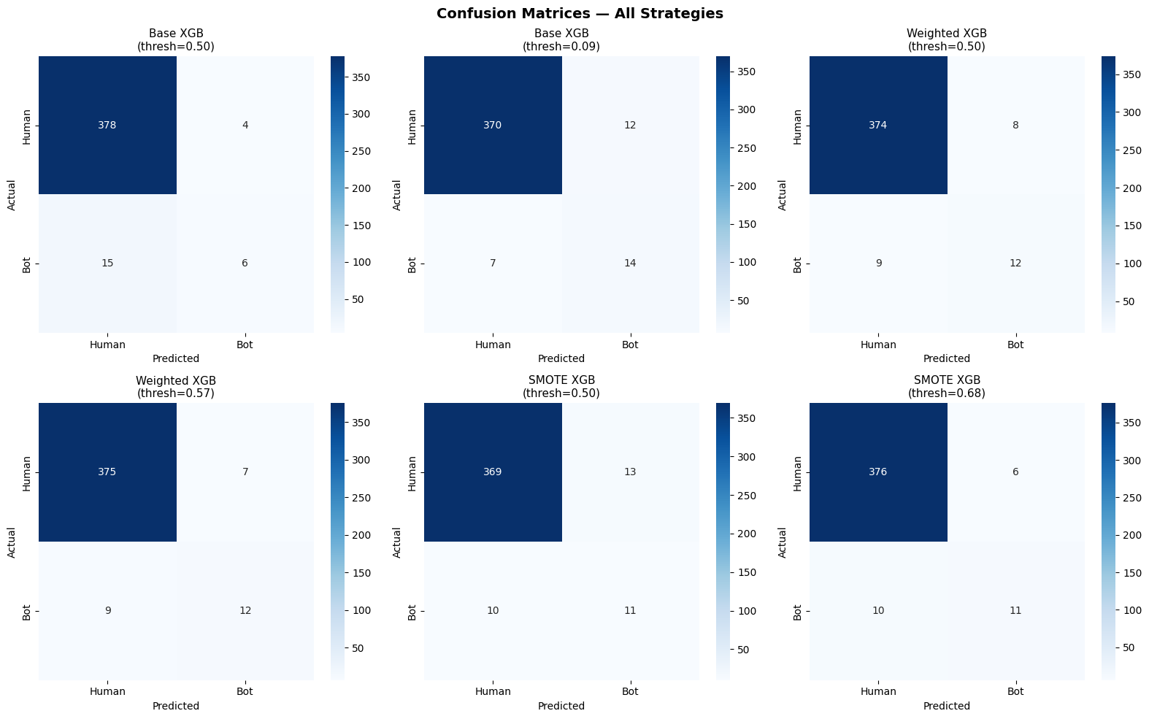
Figure 5.2: Confusion Matrices for Different Imbalance Handling Strategies

5.4 Final Model Evaluation
After applying hyperparameter tuning and class imbalance handling techniques, the final selected model was the threshold-optimized XGBoost classifier. This model was chosen because it provided the best balance between overall classification performance and bot detection capability.
The final model achieved an AUC score of 0.9336, indicating strong ability to distinguish between human users and algorithmic bidding bots. Since the dataset is highly imbalanced, special focus was placed on bot recall rather than overall accuracy.
Using the default threshold of 0.50, the model detected only 6 bots and missed 15 bots, resulting in a low bot recall of 0.286. After threshold optimization, the threshold was reduced to 0.09, which improved bot detection significantly. The model correctly identified 14 bots while reducing false negatives to 7, increasing bot recall to 0.667.
This improvement is important because undetected bots can negatively affect fairness in online auction systems. Although lowering the threshold slightly increased false positives, this trade-off is acceptable since detecting suspicious automated behavior is more important than occasional misclassification of genuine users.
The confusion matrix clearly shows that the model correctly classifies most human users while also improving bot detection after threshold tuning. This confirms that the selected model is suitable for practical fraud detection applications.
The predicted probability distribution further supports the model’s effectiveness. Human users are generally assigned lower bot probabilities, while actual bot users receive higher probability values. Some overlap exists between the two classes, which explains the remaining classification errors.
The final confusion matrix and predicted probability distribution are shown in Figure 5.3.
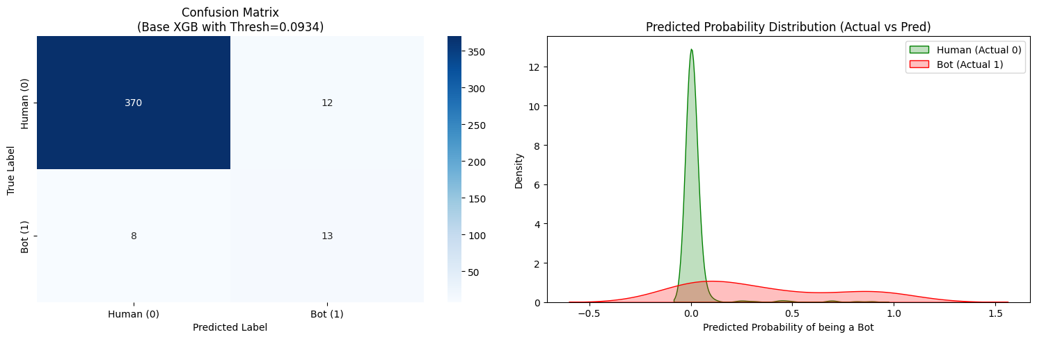
Figure 5.3: Final Confusion Matrix and Predicted Probability Distribution

5.5 Feature Importance Analysis
To understand which behavioral features contributed the most to bot detection, feature importance analysis was performed using the final XGBoost model. This helps explain why the model classifies certain bidders as bots and improves the interpretability of the system.
The feature importance graph shows that num_bids is the most influential feature in detecting algorithmic bidding bots. This indicates that the total number of bids placed by a bidder is a strong indicator of automated behavior, as bots tend to place a very large number of bids in a short period compared to normal human users.
The second important feature is bids_per_auct, which represents the average number of bids placed per auction. A high value suggests aggressive bidding behavior within fewer auctions, which is commonly seen in automated bidding systems.
Features such as num_ip, bids_per_device, and max_bids_in_auct also contributed significantly. Multiple IP addresses, unusually high bids per device, and excessive bidding in a single auction are strong behavioral patterns associated with bot activity.
Time-based features such as mean_diff and concurrent bidding features also help identify suspicious automated behavior, as bots usually place bids faster and more consistently than human users.
This analysis confirms that the selected features are meaningful and strongly related to bidder behavior, which improves the reliability of the prediction system. It also justifies why behavioral fingerprinting is effective for detecting algorithmic bidding bots.
The feature importance ranking is shown in Figure 5.4.
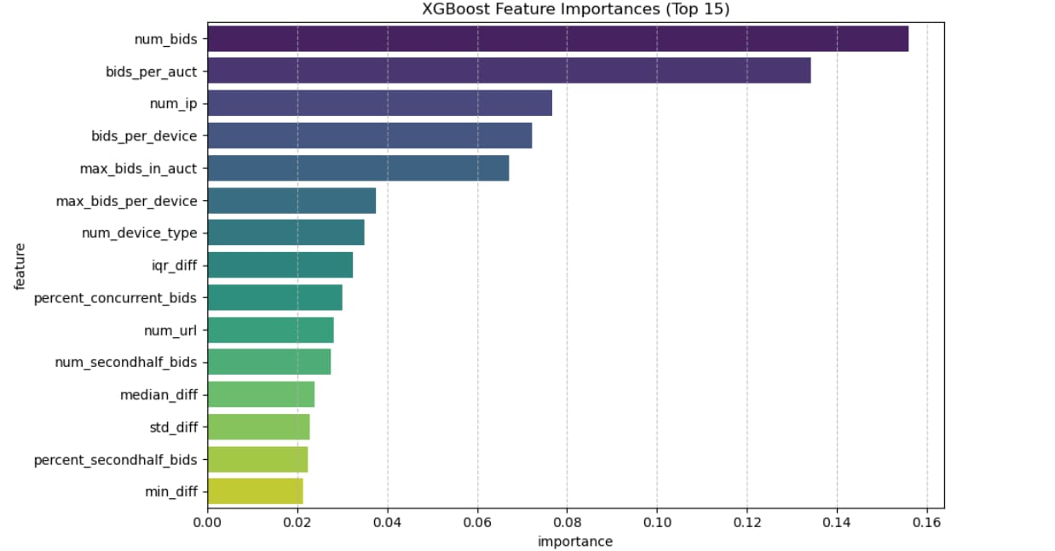
Figure 5.4: XGBoost Feature Importance Graph

5.6 Discussion
The experimental results show that machine learning can effectively identify algorithmic bidding bots by analyzing bidder behavior patterns. Among all the models tested, ensemble methods such as Random Forest, AdaBoost, and XGBoost performed significantly better than simpler models like Logistic Regression and Decision Tree. This is because bot behavior involves complex and non-linear patterns that are better captured by ensemble learning methods.
Although Random Forest achieved the highest initial holdout AUC score, XGBoost was selected as the final model because it provided more stable performance, better handling of class imbalance, and stronger improvement after threshold optimization. Its ability to work effectively with highly imbalanced data made it more suitable for this problem.
Threshold optimization proved to be more effective than both class weighting and SMOTE oversampling. By reducing the classification threshold from 0.50 to 0.09, bot recall increased from 0.286 to 0.667 without reducing the AUC score. This shows that improving the decision threshold can be more efficient than modifying the training dataset.
Bot recall was treated as the most important metric because missing a bot is more harmful than incorrectly flagging a human user. In online auction systems, undetected bots can manipulate prices, reduce fairness, and affect trust among genuine users. Therefore, reducing false negatives was given higher priority than minimizing false positives.
Although threshold tuning increased false positives slightly, this trade-off is acceptable in fraud detection systems. It is safer to review a few suspicious human users than to allow automated bots to continue manipulating auctions.
Feature importance analysis also supported the model’s decisions. Features such as total bids, bids per auction, IP usage, and bidding intensity were found to be strong indicators of bot behavior. This confirms that behavioral fingerprinting is an effective approach for identifying suspicious bidding patterns.
Overall, the results demonstrate that the proposed system is capable of providing reliable bot detection and can be practically used to improve fairness and transparency in online auction platforms.

CHAPTER 6: SYSTEM INTERFACE

6.1 System Overview
The proposed system is designed to identify algorithmic bidding bots in online auction systems by analyzing bidder behavior patterns using machine learning. The system takes behavioral input parameters from a bidder and predicts whether the bidder is a genuine human user or an automated bot.
The system is based on the XGBoost classifier trained using engineered behavioral features extracted from auction bidding data. Since the original dataset was highly imbalanced, threshold optimization was applied during model evaluation, and the final deployed model uses an optimized decision threshold of 0.09 instead of the default threshold of 0.50. This improves bot detection performance and reduces the chances of bots being misclassified as human users. The saved model file used for deployment is the threshold-optimized XGBoost model.
The deployed application is implemented using Python and Tkinter, providing a simple graphical user interface for user interaction. The system allows users to manually enter important behavioral parameters such as total bids, unique auctions, unique devices, unique IPs, mean time difference between bids, and concurrent bidding ratio.
These inputs are internally transformed into the complete feature vector required by the trained model. The model then calculates the probability of the bidder being a bot and compares it with the optimized threshold value to generate the final classification result.
If the predicted probability exceeds the threshold, the system displays “BOT DETECTED”; otherwise, it displays “HUMAN VERIFIED.” Along with the classification result, the confidence score is also shown to help users understand the prediction strength.
The major components of the system are summarized in Table 6.1.

Table 6.1: Major Components of the Proposed System
Component | Description
Input Layer | Accepts bidder behavioral inputs from the user
Feature Mapping | Converts manual inputs into the full engineered feature vector
ML Model | XGBoost classifier trained for bot detection
Threshold Logic | Uses optimized threshold value of 0.09 for final decision
Output Layer | Displays classification result and confidence score

6.2 Implementation and Deployment
The proposed bot detection system was implemented using Python due to its strong support for machine learning, data processing, and application development. The complete workflow includes feature engineering, model training, evaluation, model saving, and deployment through a desktop-based application.
Google Colab was used for preprocessing, feature engineering, model training, hyperparameter tuning, and performance evaluation. Libraries such as Pandas, NumPy, Scikit-learn, XGBoost, Matplotlib, and Seaborn were used during experimentation and model development.
The final selected model was the threshold-optimized XGBoost classifier, chosen for its strong bot detection capability and high recall for the minority bot class. The trained model was saved using the Joblib library in .pkl format as base_xgb_thresh_opt_model.pkl, allowing direct loading during deployment without retraining .
For deployment, a desktop-based application was developed using the Tkinter library. The saved model is loaded during system startup, and the application connects the trained classifier with user inputs to enable real-time prediction. This ensures smooth integration between model training and practical system usage.
The software tools used in implementation are summarized in Table 6.2.

Table 6.2: Software Tools Used
Tool / Library | Purpose
Python | Core programming language
Google Colab | Model training and experimentation
Pandas | Data preprocessing
NumPy | Numerical computation
Scikit-learn | Model evaluation and validation
XGBoost | Final classification model
Matplotlib | Graph generation
Seaborn | Statistical visualization
Joblib | Model saving and loading
Tkinter | Desktop application development

6.3 System Interface and Prediction Process
The deployed system allows users to classify bidders based on key behavioral inputs related to auction participation. Instead of requiring all engineered features manually, the system accepts only the most important behavioral values such as total bids, unique auctions, devices, IPs, mean time difference between bids, and concurrent bidding ratio.
These values are automatically converted into the complete feature vector required by the trained model. Additional derived features such as bidding ratios, activity intensity, and concurrency measures are generated internally to maintain consistency with the training dataset.
After feature preparation, the model calculates the probability of bot behavior using the predict_proba() function. The probability score is then compared with the optimized threshold value of 0.09 instead of the default threshold of 0.50. This improves bot detection performance and reduces false negatives.
Based on the prediction, the system displays either “BOT DETECTED” or “HUMAN VERIFIED” along with a confidence score. This allows users to interpret the result clearly and take further action if suspicious activity is detected.
The prediction workflow is summarized in Table 6.3.

Table 6.3: Prediction Process
Step | Description
Input Collection | User enters key behavioral values
Feature Generation | Remaining features are created automatically
Feature Mapping | Data is aligned with model training format
Probability Prediction | Bot probability is calculated using the trained model
Threshold Comparison | Probability is compared with threshold value of 0.09
Final Output | Classification result and confidence score are displayed
The graphical interface of the system is shown in Figure 6.1.
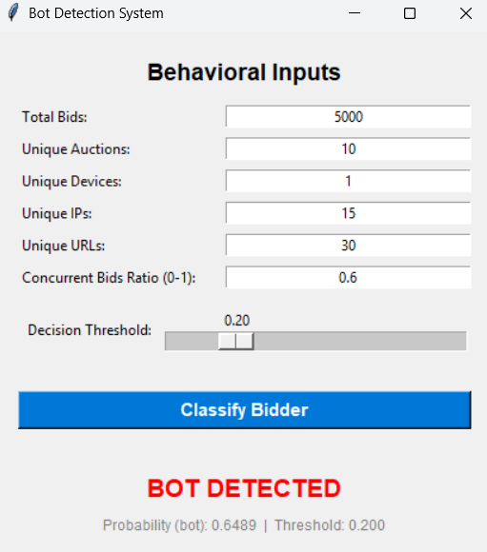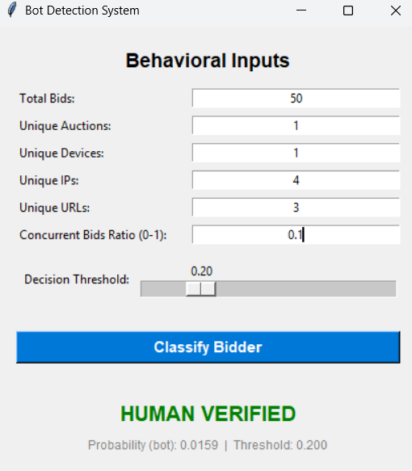
Figure 6.1: Bot Detection System Interface

CHAPTER 7: CONCLUSION AND FUTURE SCOPE
7.1 Conclusion
This project presents a machine learning-based approach for identifying algorithmic bidding bots in online auction systems using bidder behavioral analysis. The main objective was to detect automated bidding activity and improve fairness and transparency in digital auction platforms.
The study began with feature engineering, where raw auction bid logs were transformed into meaningful behavioral features such as bidding frequency, time differences, concurrent bidding activity, auction participation patterns, and device usage behavior. These features were used to create a behavioral fingerprint for each bidder.
Multiple machine learning models including Logistic Regression, Decision Tree, Random Forest, AdaBoost, and XGBoost were trained and evaluated using ROC-AUC and cross-validation. Among these, ensemble models performed better in capturing complex bidder behavior patterns.
Since the dataset was highly imbalanced, techniques such as threshold tuning, class weighting, and SMOTE were applied to improve bot detection. Threshold optimization on the XGBoost model produced the best results by significantly improving bot recall while maintaining strong overall performance.
The final model was deployed using a Tkinter-based desktop application, where users can enter key behavioral inputs and receive instant classification results as either “BOT DETECTED” or “HUMAN VERIFIED” along with a confidence score.
The project demonstrates that combining behavioral feature engineering with imbalance-aware machine learning techniques provides an effective solution for detecting fraudulent automated bidding behavior and supports fairer online auction systems.

7.2 Future Scope
Although the proposed system achieves strong performance in detecting algorithmic bidding bots, there are several areas where future improvements can enhance its effectiveness and scalability.
The current system uses manually entered behavioral values through a desktop-based application. Future work can focus on integrating the model directly with real-time online auction platforms so that bidder behavior can be monitored automatically without manual input.
The model can also be improved by training on larger and more diverse datasets collected from multiple auction platforms. This would help the system generalize better and improve detection of newer and more advanced bot strategies.
Web-based deployment can replace the desktop application to support large-scale usage and cloud accessibility. This would make the system more practical for enterprise-level deployment and allow monitoring of multiple users simultaneously.
Advanced techniques such as deep learning, anomaly detection, and adaptive learning models can also be explored to improve detection of highly sophisticated bots that mimic human bidding behavior.
Future research may also include real-time alert systems, fraud dashboards, and continuous model retraining to maintain effectiveness as bidding patterns change over time.

Mapping of POs, PSOs, and SDGs
Program Outcomes (POs)
- PO1 — Engineering Knowledge: Applies mathematical and statistical concepts including probability distributions, ROC-AUC metrics, SMOTE interpolation, and cross-validation, along with computing knowledge of supervised ML algorithms (Logistic Regression, Decision Tree, Random Forest, AdaBoost, XGBoost) to build the bidding bot detection pipeline.
- PO2 — Problem Analysis: Identifies and formulates the class imbalance problem inherent in fraud detection; reviews 18 research papers spanning rule-based scoring, graph-based methods, ensemble learning, and reinforcement learning; draws substantiated conclusions from model comparisons across five classifiers and three imbalance-handling strategies.
- PO3 — Design/Development of Solutions: Designs an end-to-end ML pipeline from raw bid log processing to behavioral feature engineering, and develops a Tkinter-based desktop application for real-time bot classification — addressing the real-world challenge of unfair automated bidding in online auction platforms.
- PO4 — Conduct Investigations of Complex Problems: Conducts systematic experiments with 5 classifiers, 2 hyperparameter tuning strategies (GridSearchCV and RandomizedSearchCV), and threshold optimization; interprets confusion matrices, bot recall, precision, F1-score, and AUC to provide valid and reproducible conclusions.
- PO5 — Engineering Tool Usage: Creates and applies Python-based tools including Pandas, NumPy, Scikit-learn, XGBoost, Matplotlib, Seaborn, Joblib, and Tkinter — recognising each tool's scope and limitations in the context of imbalanced binary classification and deployment.
- PO6 — The Engineer and The World: Evaluates the societal impact of algorithmic bot activity on fairness, user trust, and market integrity in digital auction platforms; findings are contextualised within economy, safety, and legal frameworks governing online commerce.
- PO7 — Ethics: Addresses ethical concerns around automated manipulation of auction systems; the project promotes transparency, fairness, and accountability in digital marketplaces in line with professional and societal values.
- PO9 — Communication: Produces a structured technical report covering literature review, EDA, methodology, results, and discussion; the deployed desktop application presents classification results and confidence scores in a format accessible to non-technical users.
- PO11 — Life-Long Learning: Independently explores techniques beyond standard coursework including threshold optimization, SMOTE oversampling, behavioral fingerprinting, and feature importance interpretability using XGBoost — demonstrating adaptability to emerging data science methods.
Program Specific Outcomes (PSOs)
- PSO1 — IT Solutions for Real-World Problems: Applies principles of algorithms, data preprocessing, and software engineering to design and develop a complete bot detection system — from raw auction data processing to a functional classification application — addressing a genuine problem in online commerce.
- PSO2 — Emerging Technologies: Applies advanced machine learning techniques including gradient boosting (XGBoost), synthetic oversampling (SMOTE), and threshold-based decision optimization to create an innovative solution for fraud detection in auction environments.
- PSO3 — Self-Learning and Research Attitude: Demonstrates independent research by surveying 18 peer-reviewed papers, identifying gaps in existing approaches, and implementing improvements through imbalance-aware modeling and behavioral feature engineering — reflecting continuous personal and professional development.
Sustainable Development Goals (SDGs)
- SDG 8 — Decent Work and Economic Growth: The project directly supports fair and transparent digital commerce by detecting automated bots that manipulate auction prices, thereby protecting genuine economic participation and the integrity of online marketplaces.
- SDG 9 — Industry, Innovation and Infrastructure: Contributes to innovation in digital platform infrastructure by developing an ML-based fraud detection system that improves the reliability and trustworthiness of online auction systems.
- SDG 10 — Reduced Inequalities: Addresses the unfair advantage gained by automated bidding bots over human users, promoting equal opportunity and fairer outcomes for all participants regardless of technical resources.
- SDG 16 — Peace, Justice and Strong Institutions: Supports the reduction of fraudulent and manipulative digital practices, contributing to more accountable, transparent, and just online platform governance.

REFERENCES
[1] M. A. Anowar and S. Sadaoui, “Detection of Auction Fraud in Commercial Sites,” Journal of Theoretical and Applied Electronic Commerce Research, vol. 15, no. 1, pp. 81–98, 2020. doi: 10.4067/S0718-18762020000100107.
[2] D. Ganguly and S. Sadaoui, “Online Detection of Shill Bidding Fraud Based on Machine Learning Techniques,” in Recent Trends and Future Technology in Applied Intelligence (IEA/AIE 2018), pp. 303–314, 2018. doi: 10.1007/978-3-319-92058-0_29.
[3] J. Trevathan and W. Read, “Detecting Collusive Shill Bidding,” in Proceedings of the 4th International Conference on Information Technology: New Generations (ITNG 2007), pp. 799–808, 2007. doi: 10.1109/ITNG.2007.74.
[4] M. Fire, R. Puzis, D. Kagan, and Y. Elovici, “Large-Scale Shill Bidder Detection in E-commerce,” in IDEAS 2023, pp. 79–86, 2023. doi: 10.1145/3589462.3589479.
[5] P. Bangcharoensap, H. Kobayashi, N. Shimizu, S. Yamauchi, and T. Murata, “Two Step graph-based semi-supervised Learning for Online Auction Fraud Detection,” in Machine Learning and Knowledge Discovery in Databases (ECML PKDD 2015), pp. 165–179, 2015. doi: 10.1007/978-3-319-23461-8_11.
[6] K. Sabhita and B. Sarika, "Shill Bidding Fraud Detection Using Hybrid Voting Ensemble," International Journal of Advanced Trends in Computer Science and Engineering, vol. 11, no. 3, pp. 434–441, 2025. doi:10.1109/ICSADL61749.2024.00027.
[7] W. U. H. Abidi, M. Daoud, B. Ihnaini, M. A. Khan, T. Alyas, A. Fatima, and M. Ahmad, “Real-Time Shill Bidding Fraud Detection Empowered With Fussed Machine Learning,” IEEE Access, vol. 9, pp. 113612–113621, 2021. doi: 10.1109/ACCESS.2021.3098628.
[8] N. P. Anebo and K. E. Igbudu, “Fraudulent Online Auction Bidders’ Detection System Using Neural Network,” International Journal of Neural Networks and Deep Learning, vol. 2, no. 2, pp. 1–14, 2025. doi: 10.34218/IJNNDL_02_02_001.
[9] A. Anebo and J. C. Ezebunwo, "Detection of Fraudulent Bidders in Auctions Using Artificial Neural Networks," International Journal of Scientific & Engineering Research, vol. 14, no. 1, pp. 401–409, 2023. doi:10.34218/IJNNDL_02_02_001.
[10] R. M. de Souza, L. A. Batista, and M. M. da Silva, “An Evolving Fuzzy Neural Network Based on Or-Type Logic Neurons for Identifying and Extracting Knowledge in Auction Fraud,” Mathematics, vol. 10, no. 20, art. 3872, 2022. doi: 10.3390/math10203872.
[11] S. Elshaar and S. Sadaoui, “Semi-supervised Classification of Fraud Data in Commercial Auctions,” Applied Artificial Intelligence, 2020. doi: 10.1080/08839514.2019.1691341.
[12] N. Majadi and J. Trevathan, “Detecting Collusive Seller Shill Bidding Using Social Network Analysis,” Journal of Information Systems Security, vol. 20, no. 2, pp. 111–139, 2024. doi: not available.
[13] Y. Wang, T. Zhang, and H. Liu, “Reinforcement Learning-Based Multi-Agent Fraud Detection in Online Bidding Environments,”in Proc. 2025 AAAI Conference on Artificial Intelligence, 2025. doi:10.1109/TWC.2020.3024860.
[14] N. Majadi and J. Trevathan, “Real-Time Detection of Shill Bidding in Online Auctions,” in Proceedings of the 51st Hawaii International Conference on System Sciences, pp. 100–108, 2018. doi:10.24251/HICSS.2018.482.
[15] A. Maan and B. R. Eswari, " Identification of Online Auction Bidding Robots Using Machine Learning" International Journal of Engineering and Advanced Technology (IJEAT), vol. 9, no. 4, pp. 567–571, 2020. (DOI: 0.1007/978-981-15-5258-8_25)
[16] X. Sun, Z. Li, M. Wang, H. Li, and B. Ma, "Bean Solution: Facebook Recruiting IV – Human or Robot?," Kaggle Report, 2015. [Online]. Available: https://github.com/crystalxs/Human-or-Robot. [Accessed: Feb. 22, 2026].
[17] P. Gutierrez, "Human or Robot, Becoming a Feature Engineer," Dataiku Blog, Jun. 9, 2015. [Online]. Available: https://blog.dataiku.com/2015/06/09/kaggle-feature-engineering. [Accessed: Feb. 22, 2026].
[18] X. Gu and S. Shi, "Human or Robot," Stanford University CS229 Project Report, 2017. [Online]. Available: https://cs229.stanford.edu/proj2017/final-reports/5161146.pdf. [Accessed: Feb. 22, 2026].
[19] Jim Dullaghan, John Costella, John_W, Meghan O'Connell, Rafael, Ruchi, RuchiVarshney, Sergey, Sofus Macskassy, and Wendy Kan. Facebook Recruiting IV: Human or Robot?. https://kaggle.com/competitions/facebook-recruiting-iv-human-or-bot, 2015. Kaggle. [Accessed: Feb. 23, 2026].

