Comparative Study of optimum Medical Diagnosis of Human Heart Disease Using Machine Learning Technique

To implement this project we have designed following modules
- User Sign Up: New users can create an account in the CardioLens application.
- User Login: Registered users can securely log in to the application.
- Dashboard: Displays an overview of the heart disease research platform, including dataset information and available functionalities.
- Upload Dataset: Allows users to upload a heart disease dataset for analysis and model development.
- Data Preprocessing: Processes the uploaded dataset by handling missing values, duplicate records, and preparing features for machine learning.
- Split Data: Divides the prepared dataset into training and testing sets for model development and evaluation.
- Train Models: Trains multiple machine learning algorithms, including Logistic Regression, Random Forest, Gradient Boosting, SVM, KNN, Decision Tree, and LDA, to predict heart disease.
- Model Evaluation: Evaluates the trained models using performance metrics such as accuracy, precision, recall, F1-score, sensitivity, specificity, and ROC-AUC.
- Model Comparison: Compares the performance of different machine learning algorithms using a results table and evaluation graphs.
- Manual Prediction: Allows users to enter patient-related feature values manually and obtain a heart disease prediction from the trained model.
- CSV Prediction: Enables users to upload a CSV file containing multiple records and generate predictions for each record.
- View Prediction Results: Displays the predicted class, prediction label, selected model, and probability score when provided by the model.
SCREEN SHOTS
To run project install python 3.11.9 and then install all packages given in requirements.txt file.
Now double click on ‘runWebServer.bat’ file to start python server and then will get below page
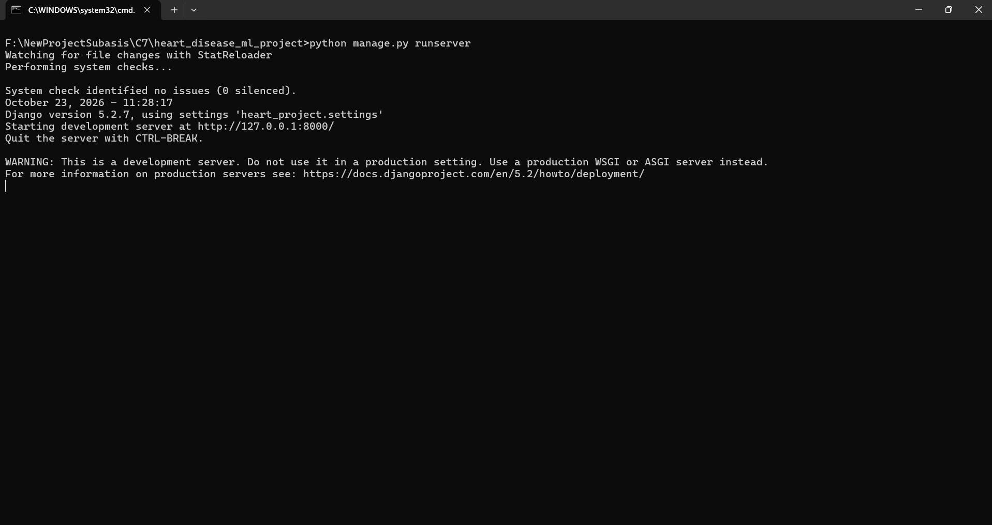
In above screen python server started and now open browser and enter URL as http://127.0.0.1:8000/ or http://127.0.0.1:8000/index.html and then press enter key to get below page
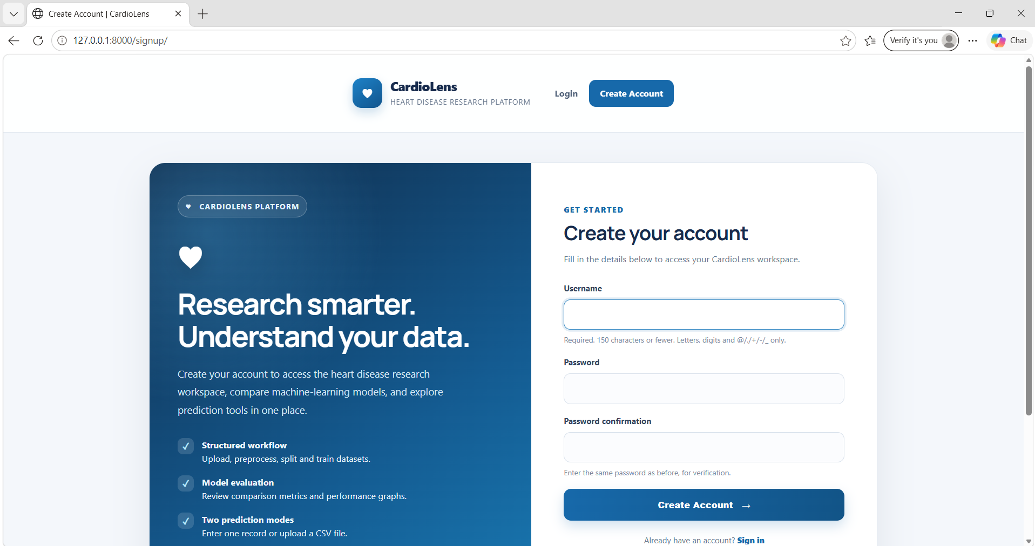
In above screen click on ‘Signup’ link to get below page
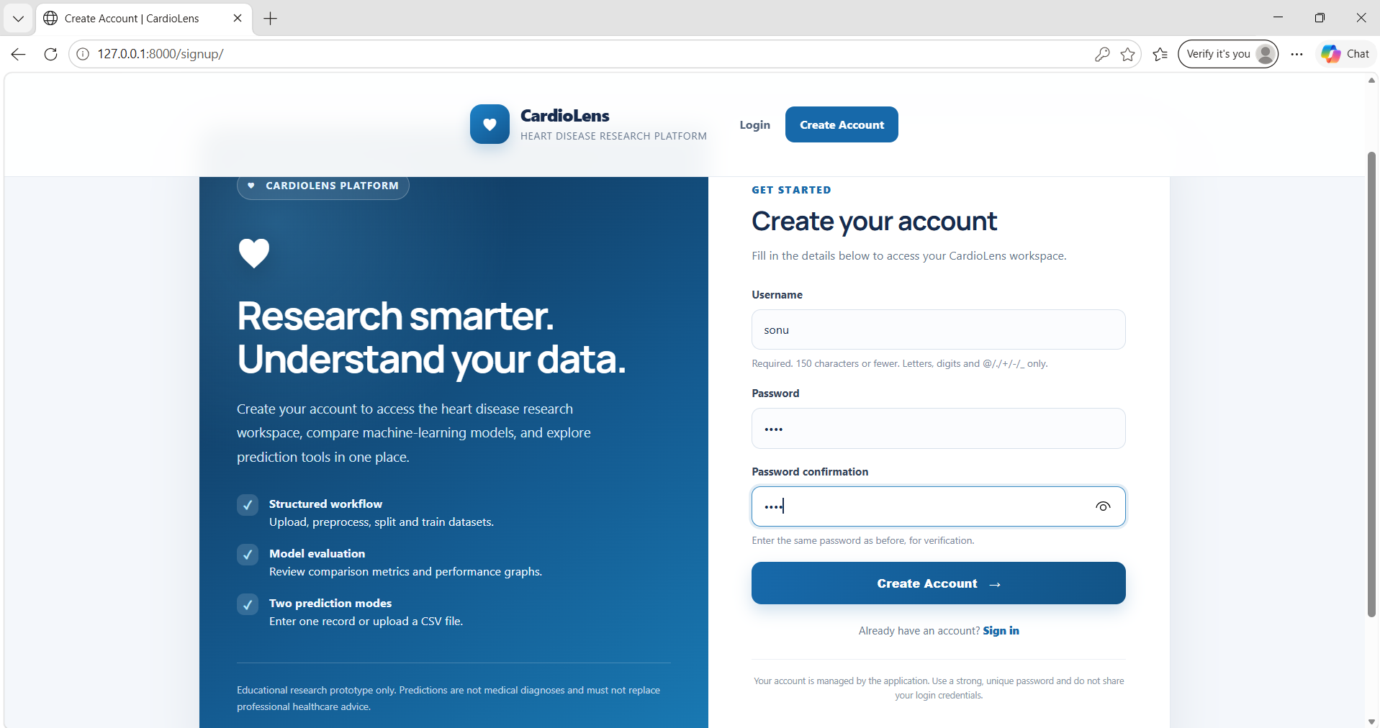
In above screen user entering sign up details and then press button to get below page
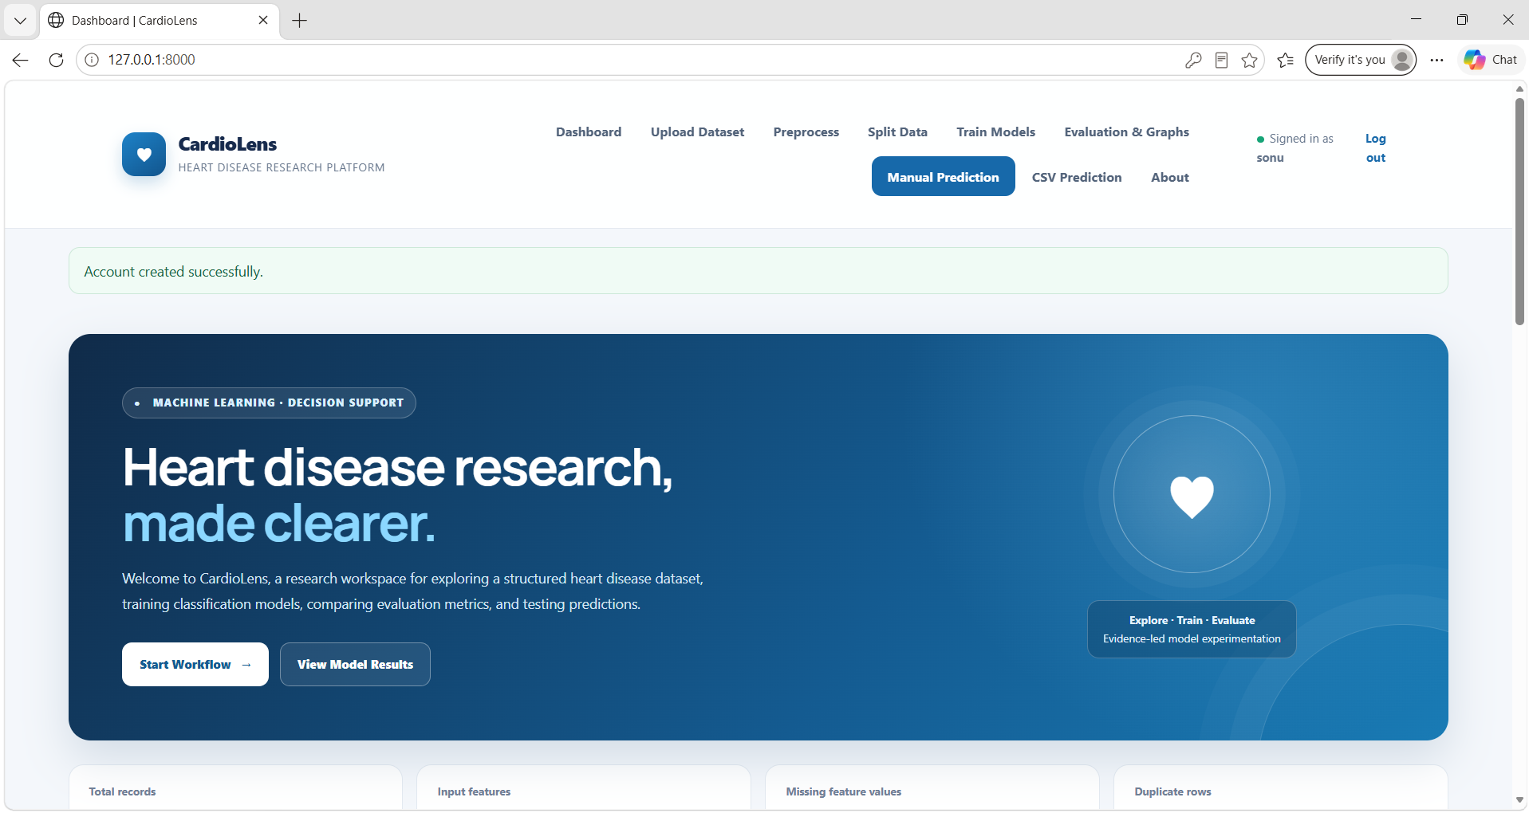In the above screen, user can click ‘Start Workflow’ to begin the heart disease prediction process.

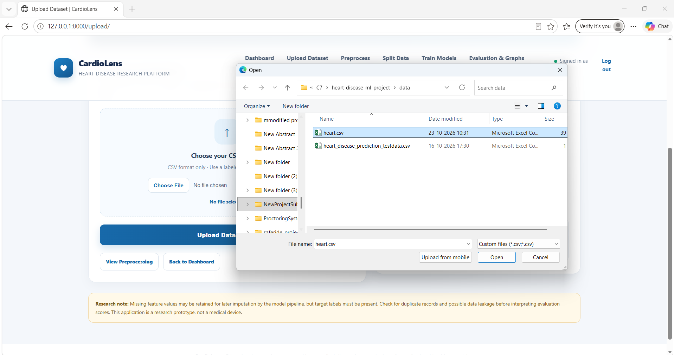
In above screen, user can upload dataset to get bellow page.
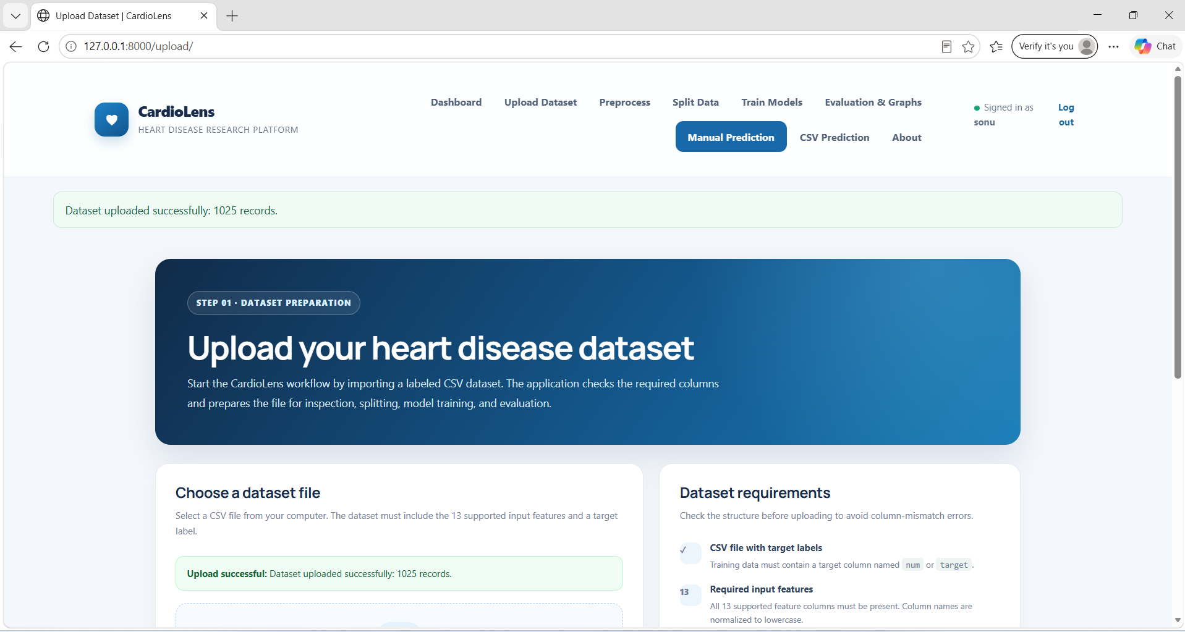
In above screen Dataset Uploaded and now click on ‘Preprocess’ to get bellow page.
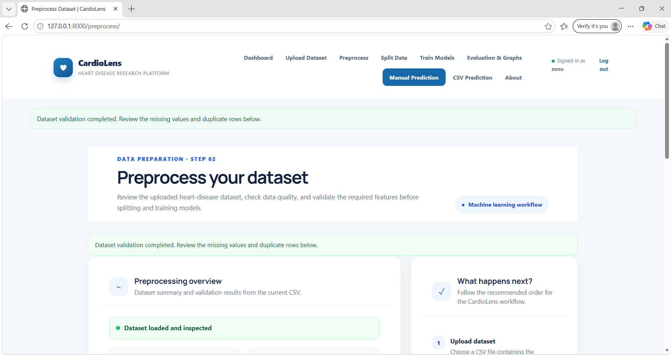
In above screen Dataset Preprocess completed and then click on ‘Split Dataset’ to get bellow page.
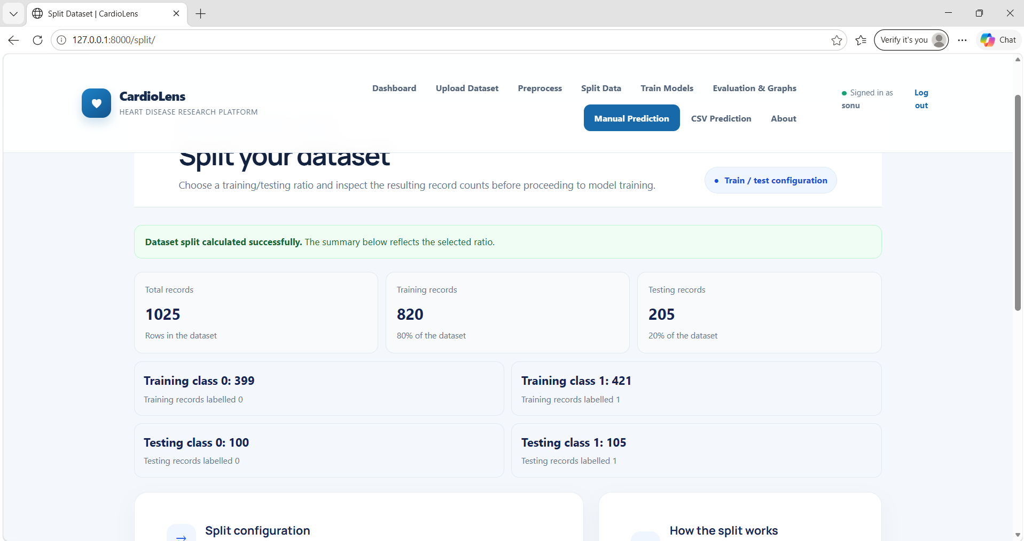
In above screen Split Dataset completed and then click on ‘Train Models’ to get bellow page.
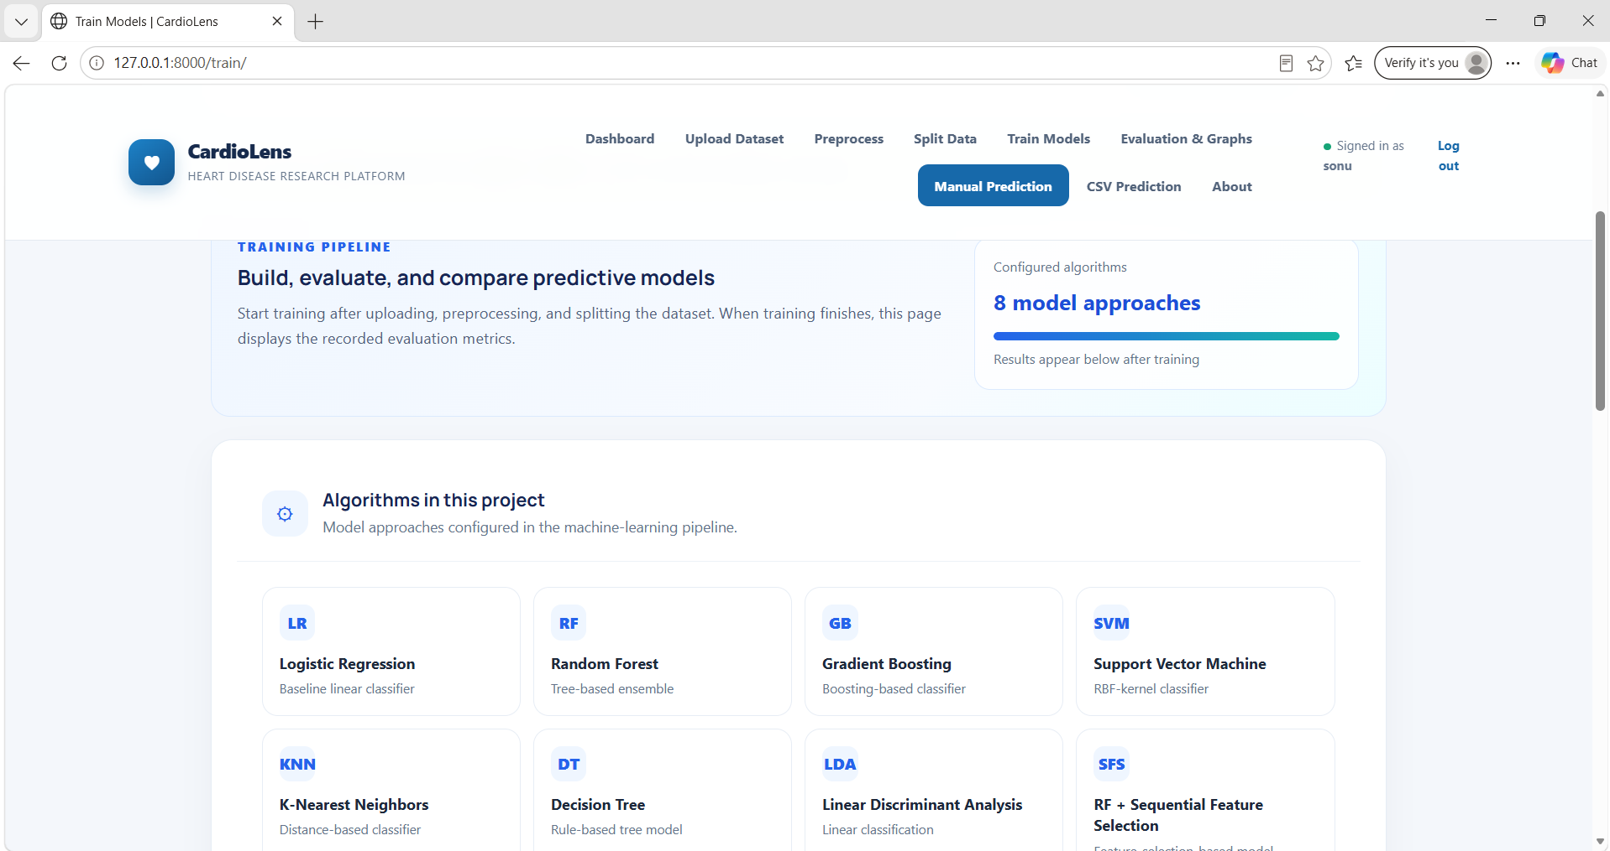
In above screen Model Training completed and then click on ‘Evaluation & Graphs’ to get bellow page.
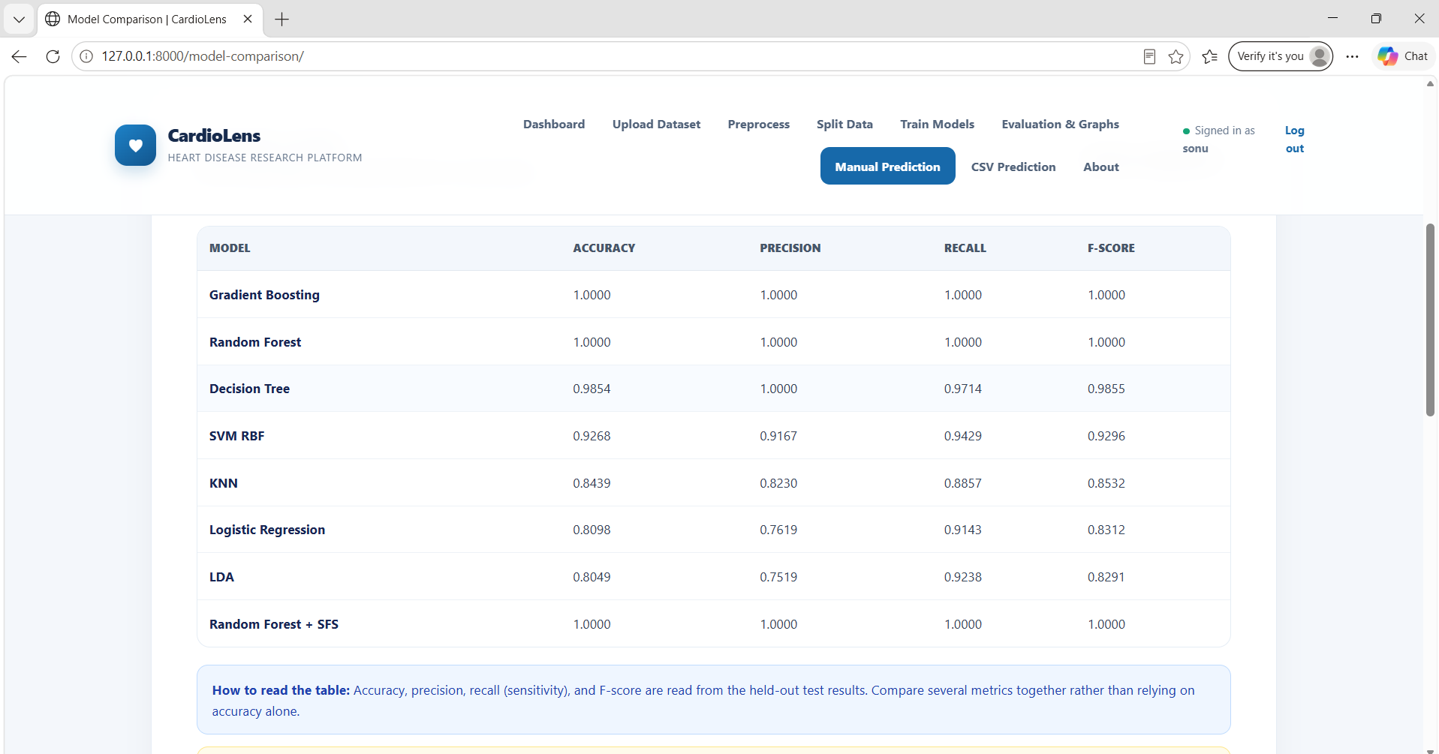
In above screen Model Evaluation completed and then in bellow page Model Performance Graph is there.
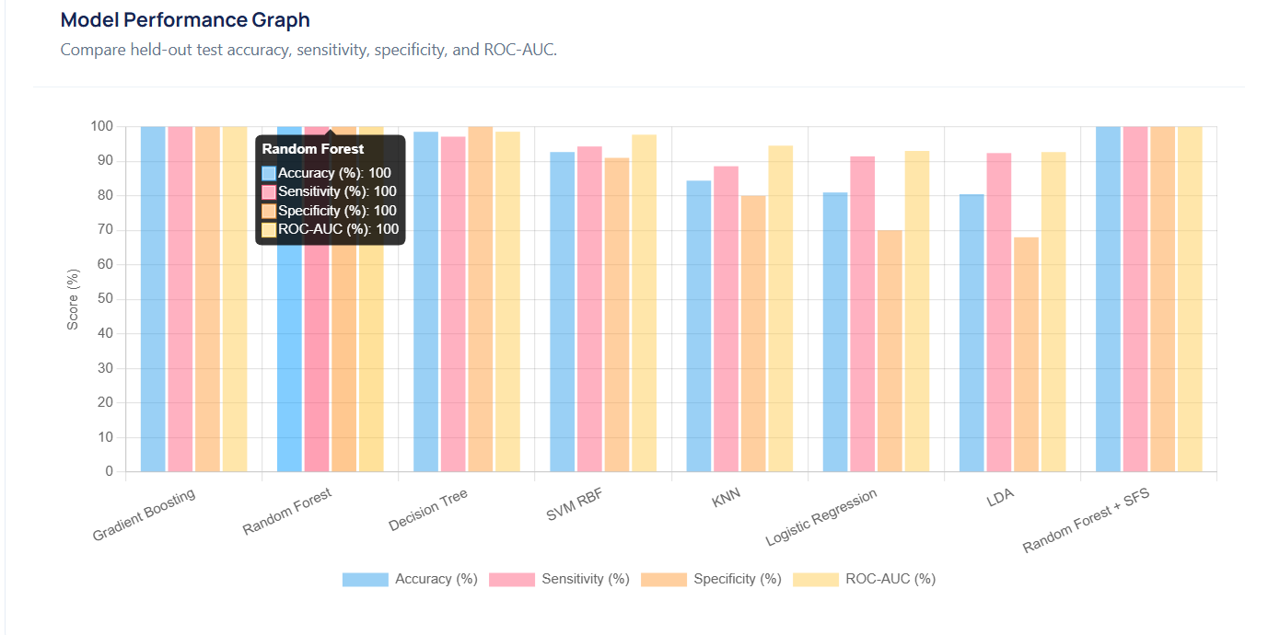
In above screen Model Performance Graph completed and then click on ‘Manual Prediction’ to get bellow page.
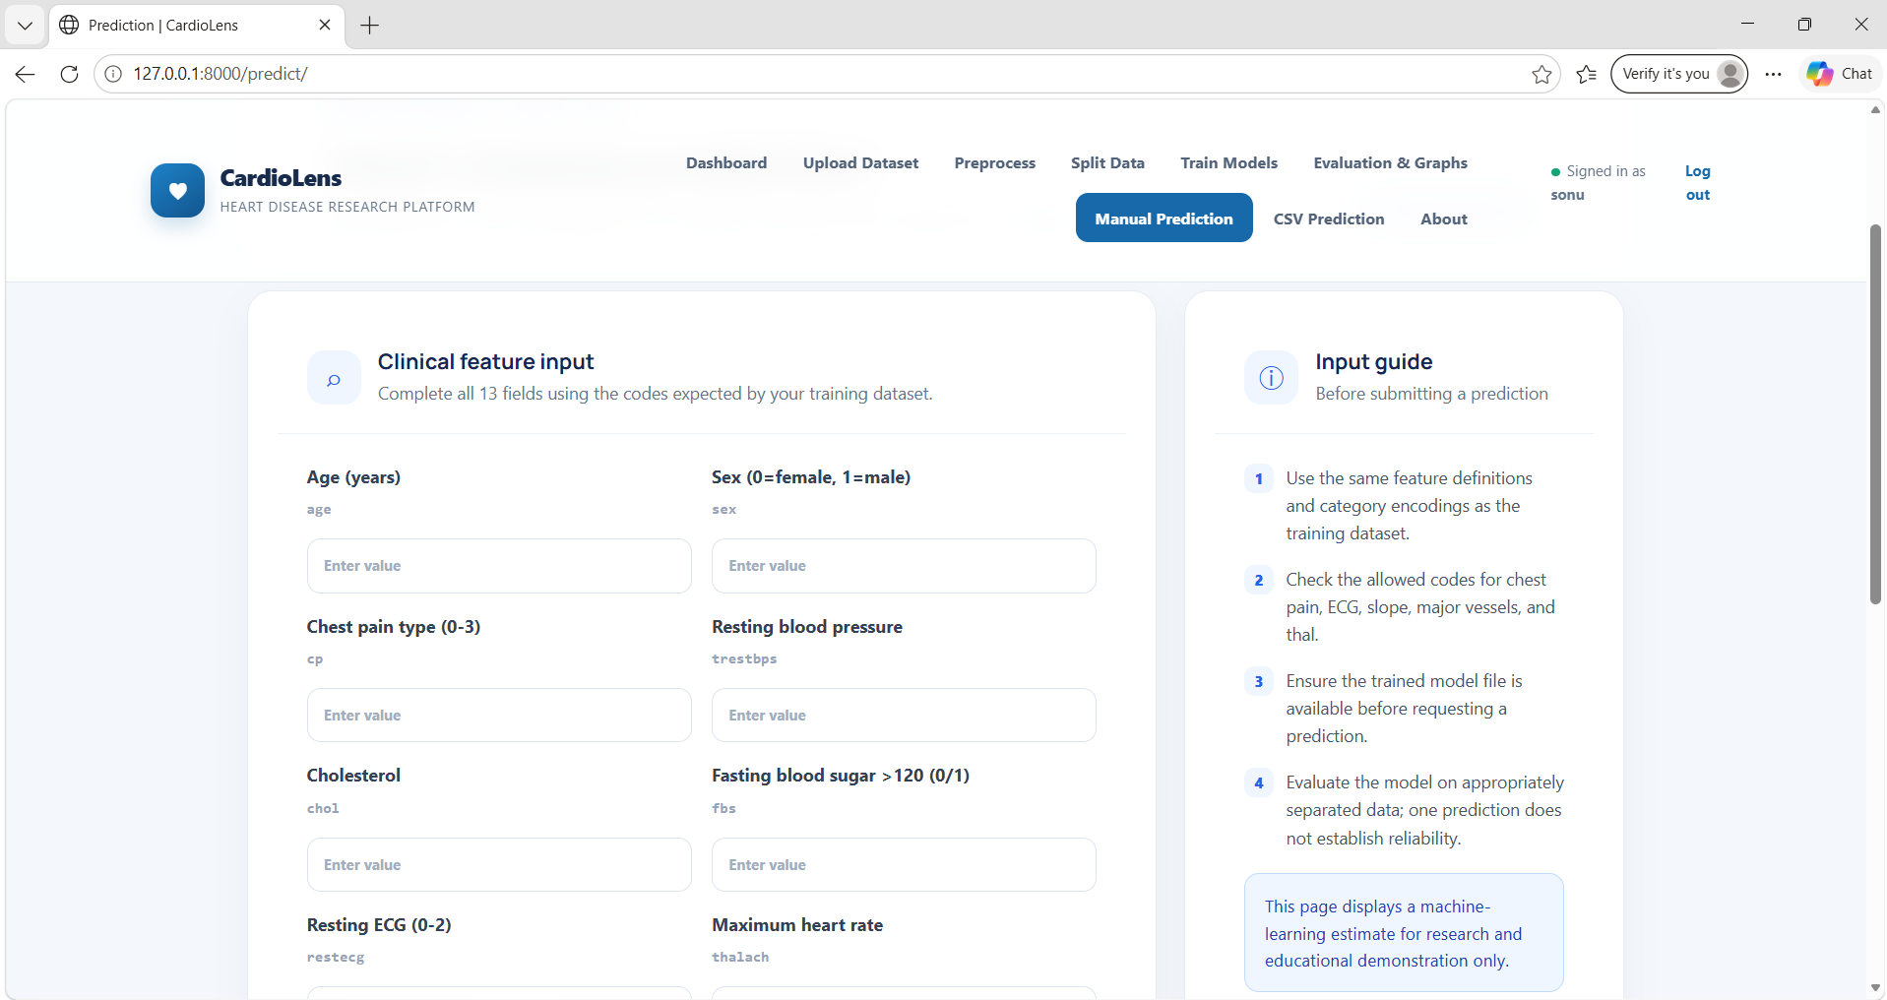
In above screen fill the above data and then click on ‘Estimate Model Output’ to get the prediction like below.
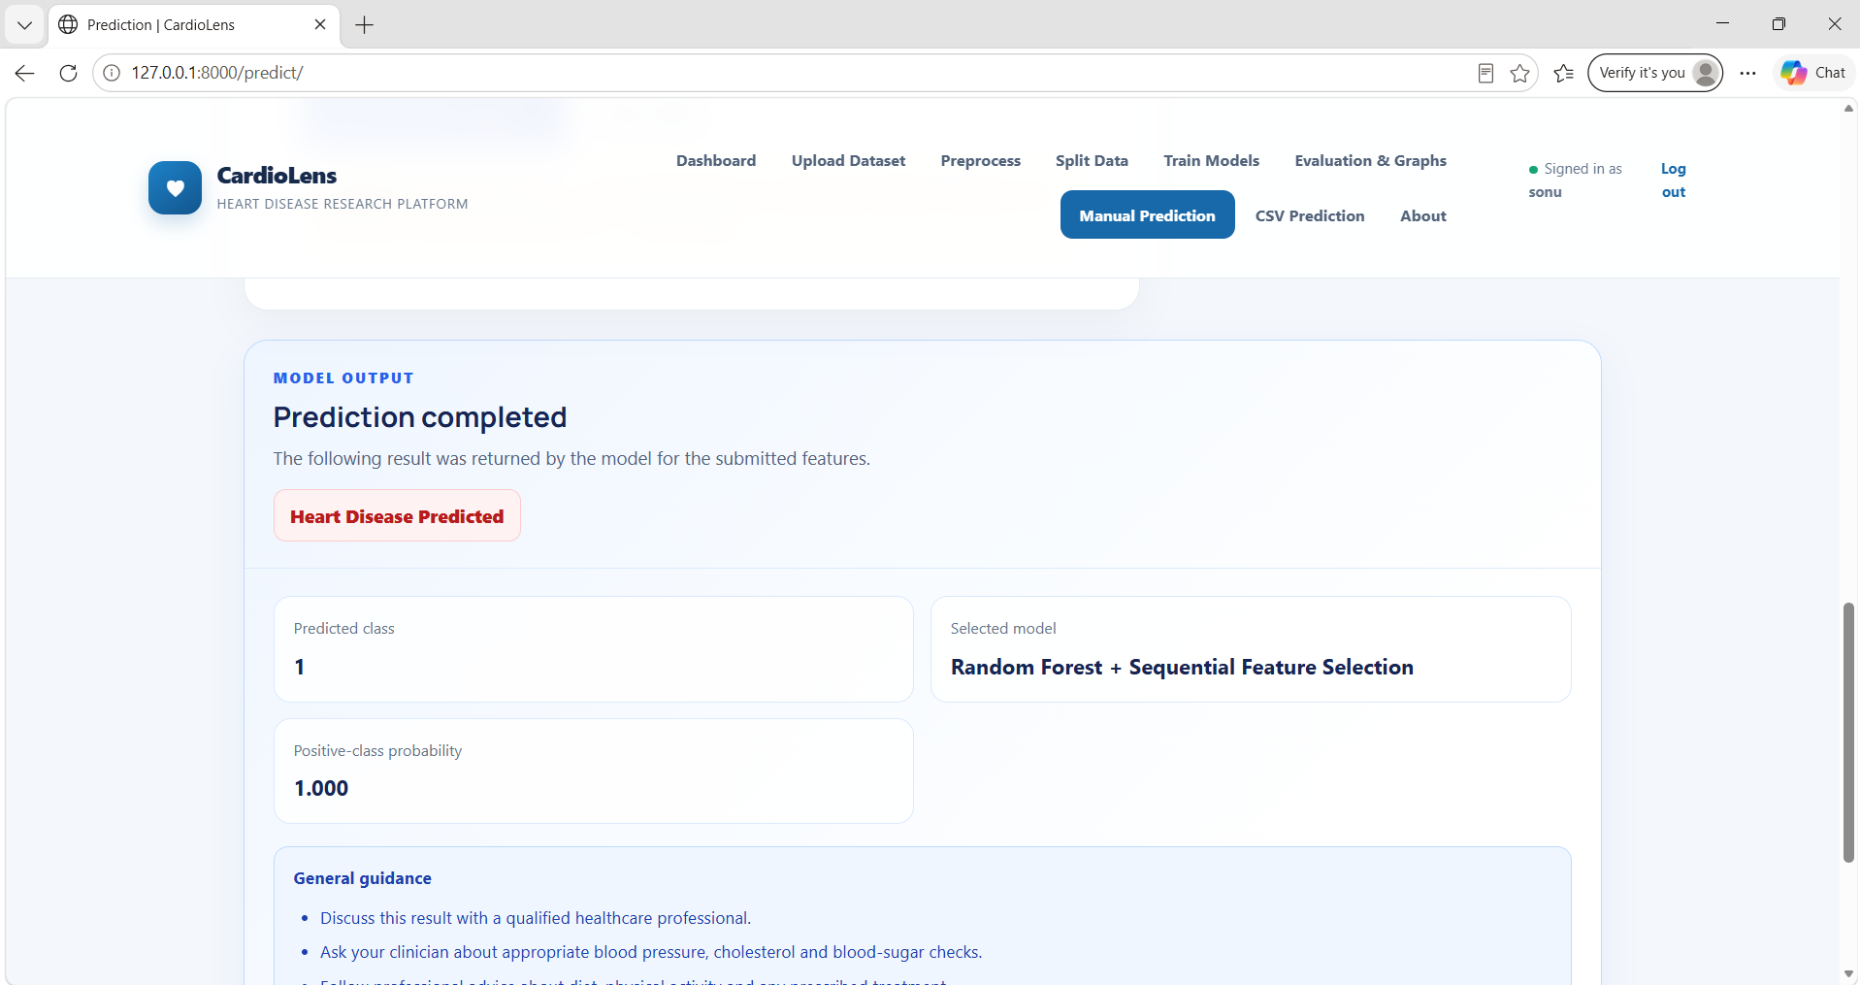
In above screen model predicted as Heart Disease Predicted and then click on ‘CSV Prediction’ to get bellow page.
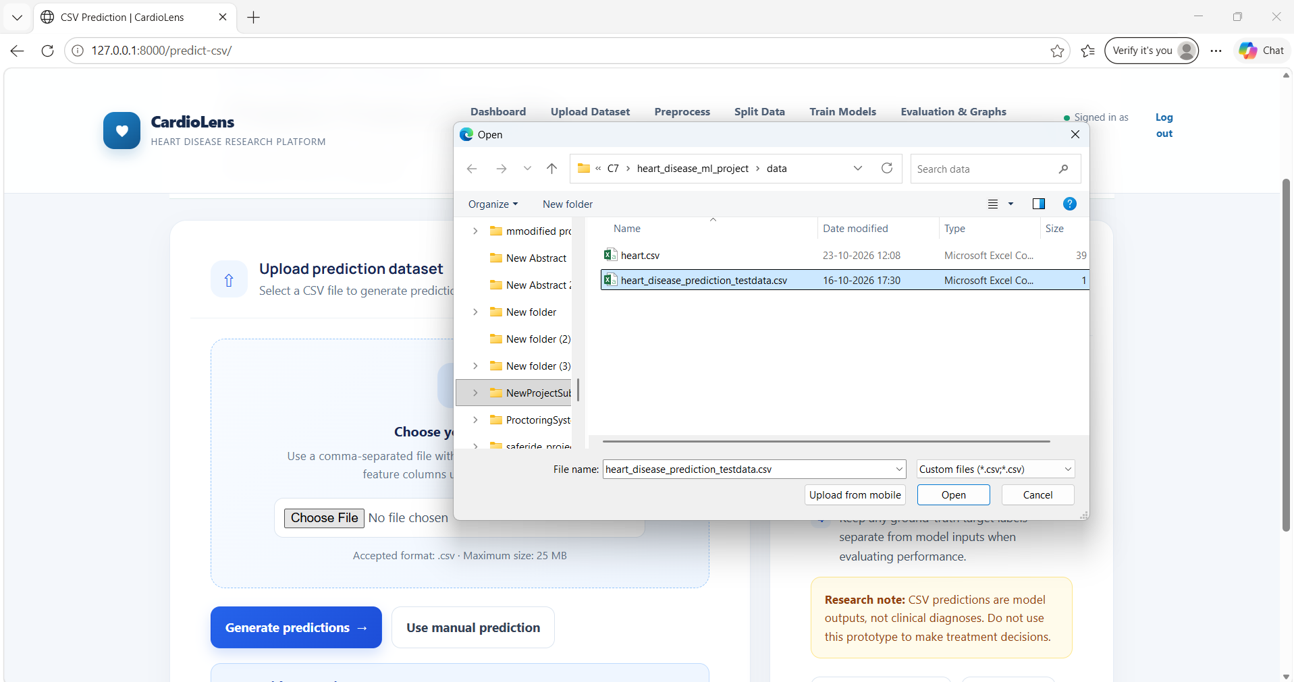
In above screen User can upload test data and then click on Generate Predictions to get below page
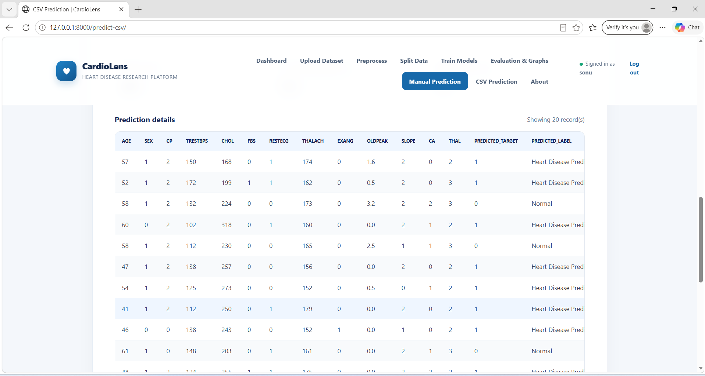
In above screen Model predicted from test data. Now you can follow above steps to run the project.

