

AI-Driven Customer Intelligence System for Strategic Business Decision Making

AN INTERNSHIP REPORT
Submitted by

JINKA VEDA SREE - 20221ISE0057
Under the guidance of,
Mr. Abhishek M

BACHELOR OF TECHNOLOGY

IN
INFORMATION SCIENCE AND ENGINEERING


PRESIDENCY UNIVERSITY BENGALURU APRIL 2026



PRESIDENCY SCHOOL OF COMPUTER SCIENCE AND ENGINEERING
BONAFIDE CERTIFICATE

Certified that this report “AI-Driven Customer Intelligence System for Strategic Business Decision Making” is a bonafide work of JINKA VEDA SREE (20221ISE0057), who has successfully carried out the internship work and submitted the report for partial fulfillment of the requirements for the award of the degree of BACHELOR OF TECHNOLOGY in INFORMATION SCIENCE AND ENGINEERING, during 2025-2026.

Mr.Abhishek M Project Guide PSCS
Presidency University
Dr. Md Ziaur Rahaman School Internship Coordinator PSCS
Presidency University

Dr. Gopal Krishna Shyam Head of the Department, PSCS
Presidency University

Dr. Duraipandian N
Dean
PSCS / PSIS
Presidency University

Name and Signature of the Examiners

Sl. No Name Signature Date 1
2

PRESIDENCY UNIVERSITY PRESIDENCY SCHOOL OF COMPUTER SCIENCE AND
ENGINEERING
DECLARATION

I am a student of final year B.Tech in INFORMATION SCIENCE AND ENGINEERING, at Presidency University, Bengaluru, named JINKA VEDA SREE, hereby declare that the internship work titled “AI-Driven Customer Intelligence System for Strategic Business Decision Making” has been independently carried out by me and submitted in partial fulfillment for the award of the degree of B.Tech in INFORMATION SCIENCE ENGINEERING (AI AND ROBOTICS) during the academic year of 2025-2026. Further, the matter embodied in the internship has not been submitted previously by anybody for the award of any Degree or Diploma to any other institution.

JINKA VEDA SREE USN: 20221ISE0057 Signature

PLACE: BENGALURU DATE: 25 - April 2026

INTERNSHIP COMPLETION CERTIFICATE



ACKNOWLEDGEMENTS
For completing this internship work, I have received the support and the guidance from many people whom I would like to mention with deep sense of gratitude and indebtedness. I extend my gratitude to our beloved Chancellor, Pro-Vice Chancellor, and Registrar for their support and encouragement in completion of the internship.
I would like to sincerely thank my internal guide Mr.Abhishek M, Assistant Professor, Presidency School of Computer Science and Engineering, Presidency University, for his moral support, motivation, timely guidance and encouragement provided to me during the period of internship work.
I am also thankful to Dr. Gopal Krishna Shyam, Professor, Head of the Department, Presidency School of Computer Science and Engineering Presidency University, for his mentorship and encouragement.
I express my cordial thanks to Dr. Duraipandian N, Dean PSCS & PSIS, Dr. Shakkeera L, Associate Dean, Presidency School of Computer Science and Engineering and the Management of Presidency University for providing the required facilities and intellectually stimulating environment that aided in the completion of my internship work.
I am grateful to Dr. Md Ziaur Rahaman, Internship Coordinator and Mr. Sreehari T M, Program Internship Coordinator, Presidency School of Computer Science and Engineering, or facilitating problem statements, coordinating reviews, monitoring progress, and providing their valuable support and guidance.
I am also grateful to Teaching and Non-Teaching staff of Presidency School of Computer Science and Engineering and also staff from other departments who have extended their valuable help and cooperation.
JINKA VEDA SREE

ABSTRACT

In today’s data-driven business environment, organizations generate vast amounts of customer data through transactions, online interactions, and purchasing activities. However, extracting meaningful insights from this data remains a major challenge, especially when the data is unlabeled. Customer segmentation plays a vital role in understanding customer behavior, improving marketing strategies, and enhancing business decision-making. This internship, carried out at Aenexz Tech Pvt. Ltd., focuses on developing an intelligent system to analyze customer data and identify meaningful patterns using machine learning techniques.

The project adopts an unsupervised learning approach to perform customer segmentation. A real- world dataset containing customer demographic and behavioral attributes such as age, income, spending score, purchase frequency, and transaction history is used. The system follows a structured machine learning pipeline that includes data preprocessing, exploratory data analysis (EDA), feature engineering, clustering, and evaluation. Advanced techniques such as RFM (Recency, Frequency, Monetary) analysis are applied to better understand customer behavior. Multiple clustering algorithms including K-Means, Hierarchical Clustering, DBSCAN, and Gaussian Mixture Models (GMM) are implemented and compared. Evaluation metrics such as Silhouette Score, Elbow Method, and Davies-Bouldin Index are used to determine the optimal clustering performance. Additionally, Principal Component Analysis (PCA) is used for dimensionality reduction and visualization of clusters.

The results of the project successfully identify distinct customer segments such as high-value customers, budget-conscious customers, occasional buyers, and at-risk customers. These segments provide valuable business insights that can be used to design targeted marketing strategies, improve customer retention, and enhance overall business performance. The project demonstrates how machine learning techniques can effectively transform raw data into actionable insights, enabling organizations to make informed and data-driven decisions.

TABLE OF CONTENTS

Sl. No. | Title | Page No.
 | Declaration | iii
 | Acknowledgement | v
 | Abstract | vi
 | List of Figures | ix
 | List of Tables | x
 | Abbreviations | xi
1. | Introduction  - Background  - Statistics of Internship  - Prior existing technologies  - Proposed approach  - Objectives  - SDGs  - Overview of internship report | 13-15
2. | Literature Review | 16-21
3. | Methodology | 22-65
4. | Project Management  - Internship timeline  - Risk analysis  - Internship budget | 66-71
5. | Analysis and Design  - Requirements  - Block Diagram  - System Flow Chart  - Choosing devices  - Designing units  - Standards  - Mapping with IoTWF reference model layers  - Domain model specification  - Communication model | 72-115

  - IoT deployment level
  - Functional view
  - Mapping IoT deployment level with functional view
  - Operational view
  - Other Design
6. | Hardware, Software and Simulation  - Hardware  - Software development tools  - Software code  - Simulation | 116-119
7. | Evaluation and Results  - Test points  - Test plan  - Test result  - Insights | 120-125
8. | Social, Legal, Ethical, Sustainability and Safety Aspects  - Social aspects  - Legal aspects  - Ethical aspects  - Sustainability aspects  - Safety aspects | 126-125
9. | Conclusion | 129-130
 | References | 131-132
 | Base Paper (Optional) | 133
 | Appendix | 134-135

LIST OF FIGURES
LIST OF TABLES

Sl. No. | Figure Name | Caption | Page No.
1 | Figure 3.1 | System Architecture Diagram | 25
2 | Figure 3.2 | Customer Segmentation-1 | 61
3 | Figure 3.3 | Customer Segmentation-2 | 62
4 | Figure 3.4 | Customer Segmentation-3 | 62
5 | Figure 5.1 | Block Diagram of Customer Segmentation System | 75
6 | Figure 5.2 | Data Science process | 78
7 | Figure 5.3 | System flow | 78
8 | Figure 5.4 | System flow chart | 79
9 | Figure 5.5 | Domain model | 98
10 | Figure 5.6 | ERD-Entity Relationship Diadram | 98
11 | Figure 5.7 | Machine Learning Pipeline | 99
12 | Figure 5.8 | Communication Flow Diagram | 101
13 | Figure 5.9 | IoT Architecture | 102
14 | Figure 5.10 | IoT Domain Model | 102
15 | Figure 7.1 | Clusters of customers | 124
16 | Figure 7.2 | Clustering after PCA | 125
17 | Figure 7.3 | Hierarchical clustering dendogram | 125

LIST OF TABLES

Sl. No. | Table Name | Table Caption | Page No.
1 | Table 3.1 | Comparison of clustering algorithms | 51
2 | Table 3.2 | Comparison of Evaluation Metrics | 55
3 | Table 4.1 | Cost Estimate Table | 71

ABBREVIATIONS

Abbreviation | Full Form
AI | Artificial Intelligence
ML | Machine Learning
DL | Deep Learning
EDA | Exploratory Data Analysis
PCA | Principal Component Analysis
RFM | Recency, Frequency, Monetary
GMM | Gaussian Mixture Model
DBSCAN | Density-Based Spatial Clustering of Applications with Noise
CSV | Comma Separated Values
API | Application Programming Interface
UI | User Interface
UX | User Experience
KPI | Key Performance Indicator
CRM | Customer Relationship Management
ETL | Extract, Transform, Load
ANN | Artificial Neural Network
SVM | Support Vector Machine

Chapter 1

INTRODUCTION

Background

In the modern digital era, organizations generate vast amounts of customer data through transactions, online platforms, and various customer interactions. Analyzing this data effectively is essential for improving customer satisfaction, increasing business revenue, and making strategic decisions. However, extracting meaningful insights from large volumes of data is a challenging task when performed manually.

Machine Learning (ML) provides advanced techniques to automate data analysis and discover hidden patterns. Customer segmentation is one such important application where customers are grouped based on their behavior, preferences, and purchasing patterns. This internship focuses on developing a machine learning-based system to perform customer segmentation and generate actionable business insights.

Customer Segmentation using Machine Learning

Customer segmentation is the process of dividing customers into groups with similar characteristics such as purchasing behavior, income level, and interaction patterns.
Traditional methods are limited in handling large datasets and often fail to capture complex relationships.

In this project, unsupervised machine learning techniques such as K-Means, Hierarchical Clustering, DBSCAN, and Gaussian Mixture Models (GMM) are used to identify meaningful customer segments. These techniques help in discovering hidden patterns without the need for labeled data.

Statistics of Internship

- Organization: Aenexz Tech Pvt. Ltd.
- Domain: Artificial Intelligence & Machine Learning
- Duration: January 2026 – March 2026

- Project Title: Customer Segmentation using Machine Learning
- Tools Used: Python, Jupyter Notebook, Pandas, NumPy, Scikit-learn
- Dataset Size: 5000+ records

The internship provided practical exposure to real-world data analysis, model building, and evaluation techniques in machine learning.

Prior Existing Technologies

Earlier, customer segmentation was performed using traditional approaches such as rule- based methods and demographic segmentation. These techniques have limitations such as lack of scalability, lower accuracy, and inability to capture hidden patterns in large datasets.

With advancements in machine learning, clustering algorithms have become popular for segmentation tasks. Techniques like K-Means, Hierarchical Clustering, and DBSCAN provide better accuracy and automation. However, selecting the right algorithm and evaluating performance remains a key challenge.

Proposed Approach

The proposed system uses an unsupervised learning approach to perform customer segmentation. The workflow includes:

- Data preprocessing (handling missing values, encoding, scaling)
- Exploratory Data Analysis (EDA)
- Feature engineering using RFM analysis
- Implementation of clustering algorithms (K-Means, Hierarchical, DBSCAN, GMM)
- Evaluation using Silhouette Score and Davies-Bouldin Index
- Visualization using Principal Component Analysis (PCA)

This approach helps in identifying meaningful customer groups and supports data-driven decision-making.

Objectives

- To analyze customer data using machine learning techniques

- To implement clustering algorithms for segmentation
- To compare the performance of different models
- To extract meaningful insights from customer behavior
- To support business decision-making through data analysis

SDGS(Sustainable Development Goals)

This project contributes to the following SDGs:

- SDG 9: Industry, Innovation, and Infrastructure
- SDG 8: Decent Work and Economic Growth

The application of AI and ML improves business efficiency and promotes technological innovation.

Overview of Internship Report

This report is organized into multiple chapters. Chapter 1 provides an introduction to the project. Chapter 2 presents the literature review. Chapter 3 explains the methodology used. Chapter 4 discusses project planning and management. Chapter 5 describes system analysis and design. Chapter 6 covers implementation details. Chapter 7 presents evaluation and results. Chapter 8 discusses social and ethical aspects. Finally, Chapter 9 concludes the report with findings and future scope.

Chapter 2

Introduction

LITERATURE SURVEY

The literature review plays a crucial role in understanding the existing research landscape and identifying the methodologies previously used in solving similar problems. In the domain of customer segmentation, significant research has been carried out using data mining and machine learning techniques. These methods aim to extract meaningful patterns from large datasets and group customers based on their behavior, preferences, and purchasing trends.

Customer segmentation has become an essential tool for organizations to design personalized marketing strategies, improve customer retention, and enhance overall business performance. With the rapid growth of data, traditional methods are no longer sufficient, leading to the adoption of advanced machine learning techniques.

This chapter provides a detailed review of various clustering algorithms and evaluation metrics that form the foundation of the proposed system. It also highlights the advantages and limitations of each method, which helps in selecting appropriate techniques for implementation.

Review of Existing Research

K-Means Clustering Technique

K-Means clustering is one of the most widely used unsupervised machine learning algorithms for partitioning datasets into distinct clusters. Introduced by MacQueen in 1967, the algorithm aims to minimize the intra-cluster variance while maximizing inter-cluster distance. It operates by dividing the dataset into a predefined number of clusters, where each data point belongs to the cluster with the nearest mean.
The working of K-Means involves multiple iterative steps. Initially, K random centroids are selected from the dataset. Each data point is then assigned to the nearest centroid using a distance metric such as Euclidean distance. Once all points are assigned, new centroids are calculated as the mean of all points within each cluster. This process repeats until the centroids stabilize and no further changes occur in cluster assignments.

One of the major advantages of K-Means is its simplicity and computational efficiency. It is particularly suitable for large datasets and provides quick results. Due to its ease of implementation, it is widely used in applications such as customer segmentation, image compression, and recommendation systems.

However, K-Means has several limitations. The algorithm requires the number of clusters (K) to be specified in advance, which may not always be known. It is also sensitive to the initial placement of centroids, which can lead to different results in different runs. Additionally, K- Means assumes that clusters are spherical in shape and equally sized, which may not hold true for real-world datasets. It is also affected by outliers, which can distort cluster boundaries.

Despite these limitations, K-Means remains a foundational algorithm in clustering and is often used as a baseline for comparison with other advanced techniques.

Silhouette Analysis for Cluster Validation

Silhouette analysis is a powerful method used to evaluate the quality of clustering results. Proposed by Rousseeuw in 1987, it provides a measure of how well each data point fits within its assigned cluster compared to other clusters. The silhouette coefficient combines two important aspects: cohesion and separation.

Cohesion refers to how closely related a data point is to other points within the same cluster, while separation measures how far the point is from points in other clusters. The silhouette score for a data point is calculated based on the difference between these two measures. The resulting value ranges from -1 to +1.

A silhouette score close to +1 indicates that the data point is well clustered, while a score near 0 suggests that the point lies on the boundary between clusters. Negative values indicate that the point may have been assigned to the wrong cluster.

One of the key advantages of silhouette analysis is its ability to provide both quantitative and visual insights into clustering performance. It helps in determining the optimal number of clusters by comparing silhouette scores for different values of K. This makes it a valuable tool in model selection.

However, silhouette analysis also has some limitations. It can be computationally expensive for large datasets and may not perform well when clusters have irregular shapes or varying densities. Despite these challenges, it is widely used due to its interpretability and effectiveness.

Davies-Bouldin Index

The Davies-Bouldin Index (DBI), introduced in 1979, is another important metric used for evaluating clustering algorithms. It measures the average similarity between clusters, where similarity is defined as the ratio of within-cluster scatter to between-cluster separation.

The DBI evaluates how compact and well-separated the clusters are. A lower value of the index indicates better clustering performance, as it signifies that clusters are dense and far apart from each other. This makes it useful for comparing different clustering models and selecting the most appropriate one.

The calculation of DBI involves computing the distance between cluster centroids and measuring the spread of data points within each cluster. It then identifies the worst-case similarity between clusters and averages these values.

One advantage of DBI is that it does not require ground truth labels, making it suitable for unsupervised learning problems. It is also relatively simple to compute and interpret.

However, the metric assumes that clusters are convex and may not perform well for complex cluster shapes. It is also sensitive to noise and outliers, which can affect the results. Despite these limitations, DBI remains a widely accepted evaluation metric in clustering tasks.

Hierarchical Clustering

Hierarchical clustering is a method that builds a hierarchy of clusters using either an agglomerative or divisive approach. In agglomerative clustering, each data point starts as its own cluster, and clusters are merged step by step based on similarity measures. In contrast, divisive clustering begins with a single cluster and recursively splits it into smaller clusters.

The results of hierarchical clustering are typically represented using a dendrogram, which provides a visual representation of the clustering process. This allows users to understand the relationships between clusters and choose the appropriate number of clusters.

One of the main advantages of hierarchical clustering is that it does not require the number of clusters to be specified in advance. It also provides flexibility in choosing different linkage methods such as single linkage, complete linkage, and average linkage.

However, hierarchical clustering is computationally expensive, especially for large datasets. The time complexity increases significantly as the number of data points grows. It is also sensitive to noise and outliers, which can affect the clustering structure.

Despite these challenges, hierarchical clustering is useful for exploratory data analysis and understanding data structure.

Density-Based Clustering (DBSCAN)

DBSCAN is a density-based clustering algorithm that groups data points based on regions of high density. It identifies clusters as areas where the number of data points exceeds a specified threshold.

The algorithm uses two parameters: epsilon (ε), which defines the radius of the neighborhood, and MinPts, which specifies the minimum number of points required to form a cluster. Points are classified as core points, border points, or noise points based on these parameters.

One of the major advantages of DBSCAN is its ability to identify clusters of arbitrary shapes. It is also effective in handling noise and outliers, which are common in real-world datasets.
Unlike K-Means, it does not require the number of clusters to be specified in advance.

However, DBSCAN has limitations. Its performance depends heavily on parameter selection, and it may struggle with datasets that have varying densities. It is also less effective in high- dimensional spaces.

Despite these challenges, DBSCAN is widely used in applications such as anomaly detection and spatial data analysis.

Gaussian Mixture Models(GMM)

Gaussian Mixture Models are probabilistic models that represent data as a combination of multiple Gaussian distributions. Each cluster is modeled as a Gaussian distribution with its own mean and variance.

The parameters of GMM are estimated using the Expectation-Maximization (EM) algorithm. This iterative process involves estimating the probability that each data point belongs to a particular cluster and updating the parameters accordingly.

One of the key advantages of GMM is its ability to perform soft clustering. Unlike K-Means, where each data point belongs to only one cluster, GMM assigns probabilities to each cluster. This makes it more flexible and suitable for datasets with overlapping clusters.

However, GMM is computationally intensive and may require careful initialization to avoid convergence issues. It is also sensitive to the choice of the number of components.

Despite these challenges, GMM is a powerful technique for modeling complex data distributions.

Survey of Clustering Techniques

The survey by Xu and Wunsch (2005) provides a comprehensive overview of clustering algorithms and their applications. It categorizes clustering techniques into different types and discusses their strengths and weaknesses.

The study highlights that clustering is a fundamental task in data mining and is widely used in various fields such as image processing, bioinformatics, and market analysis. It also emphasizes that no single clustering algorithm is suitable for all types of datasets.

The survey suggests that the choice of algorithm should be based on data characteristics such as size, dimensionality, and distribution. It also highlights the importance of evaluation metrics in assessing clustering performance.

Advance in Data Clustering

Jain (2010) provides an in-depth review of clustering techniques and their evolution over time. The study discusses the challenges associated with clustering, such as scalability, high dimensionality, and noise.

It also highlights recent advancements in clustering algorithms, including hybrid approaches and optimization techniques. The study emphasizes the importance of combining multiple methods to achieve better results.

The paper concludes that clustering remains an active area of research with continuous improvements and innovations.

Summary of Literature Review

The literature review provides a detailed understanding of various clustering techniques and evaluation metrics used in customer segmentation. Each method has its own advantages and limitations, and the choice of technique depends on the nature of the dataset.

Based on the reviewed literature, it is evident that using multiple algorithms and comparing their performance is the most effective approach. This forms the basis of the proposed system, which aims to achieve accurate and meaningful customer segmentation.

CHAPTER 3

Introduction

METHODOLOGY

In the field of data science and machine learning, the methodology forms the backbone of any successful project, as it defines the systematic approach used to transform raw data into meaningful insights. A well-structured methodology ensures that each stage of the project is executed in a logical, efficient, and reproducible manner. In this internship project, the methodology is designed to develop a robust customer segmentation system that can effectively analyze customer behavior and group customers into meaningful categories.

The primary objective of this methodology is to leverage unsupervised machine learning techniques to identify hidden patterns within customer data. Unlike supervised learning, where labeled data is available, unsupervised learning works with unlabeled data, making it more suitable for real-world scenarios where predefined categories are not present.
Customer segmentation is a classic example of such a problem, where the goal is to discover natural groupings within the dataset.

The methodology adopted in this project follows a structured machine learning pipeline, which includes several interconnected stages. The process begins with data collection, where a relevant dataset containing customer information is obtained. This is followed by data preprocessing, which involves cleaning the data, handling missing values, encoding categorical variables, and scaling numerical features. These steps are essential to ensure that the dataset is suitable for further analysis.

Once the data is prepared, exploratory data analysis (EDA) is performed to gain insights into the dataset. This stage involves visualizing data distributions, identifying relationships between variables, and detecting outliers. EDA plays a crucial role in understanding the nature of the data and guiding subsequent steps in the methodology.

The next stage involves feature engineering, where new features are created to enhance the performance of the machine learning models. In this project, techniques such as RFM (Recency, Frequency, Monetary) analysis are used to capture important aspects of customer behavior. These features provide a more meaningful representation of the data, which improves the effectiveness of clustering algorithms.

Following feature engineering, multiple clustering algorithms are implemented, including K- Means, Hierarchical Clustering, DBSCAN, and Gaussian Mixture Models (GMM). Each of these algorithms has its own strengths and limitations, and applying multiple techniques allows for a comprehensive comparison. This comparative approach helps in identifying the most suitable algorithm for the given dataset.

To evaluate the performance of the clustering models, various evaluation metrics such as Silhouette Score, Davies-Bouldin Index, and the Elbow Method are used. These metrics provide quantitative measures of cluster quality, helping to determine how well the data points are grouped.

Finally, the results are visualized using dimensionality reduction techniques such as Principal Component Analysis (PCA). Visualization makes it easier to interpret the clustering results and communicate insights effectively. The final output of the methodology is a set of well-defined customer segments, which can be used by businesses to develop targeted marketing strategies, improve customer retention, and enhance decision-making.

Overall, the methodology adopted in this project ensures a comprehensive and systematic approach to customer segmentation. By integrating data preprocessing, analysis, modeling, evaluation, and visualization, the system is capable of transforming raw data into actionable business insights. This structured approach not only improves the accuracy and reliability of the results but also demonstrates the practical application of machine learning techniques in solving real-world business problems.

System Architecture

The system architecture represents the overall structural design and workflow of the proposed customer segmentation system. It provides a high-level view of how different components of the system interact with each other to transform raw customer data into

meaningful insights. A well-defined architecture ensures that the system is organized, scalable, and easy to understand, while also enabling efficient data processing and analysis.

In this project, the system architecture is designed as a multi-stage pipeline, where each stage performs a specific function in the data processing lifecycle. The architecture begins with data acquisition and progresses through preprocessing, analysis, modeling, evaluation, and visualization. Each stage is interconnected, ensuring a smooth flow of data and information.

Overview of Architecture

The proposed system follows a modular architecture, where each module is responsible for a specific task. The major components of the architecture include:

      - Data Input Layer
      - Data Preprocessing Layer
      - Data Analysis Layer
      - Feature Engineering Layer
      - Model Building Layer
      - Evaluation Layer
      - Visualization and Output Layer

These layers work sequentially to process the data and generate the final output. The modular design allows flexibility, making it easier to modify or extend individual components without affecting the entire system.

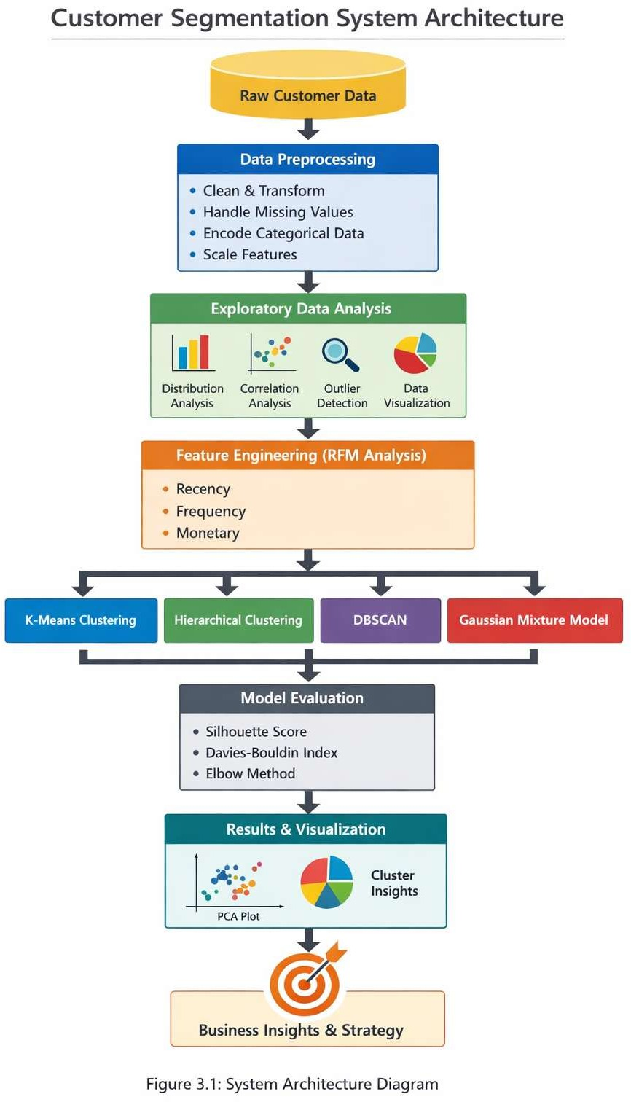
Figgure 3.1 System Architecture Diagram

Data Input Layer

The data input layer is the first stage of the system architecture. It is responsible for acquiring the dataset that will be used for analysis. In this project, the dataset consists of customer-related information such as demographic details and purchasing behavior.

The data is typically stored in a structured format such as CSV or Excel files. The system reads this data using programming libraries like Pandas in Python. This layer ensures that the data is correctly loaded into the system for further processing.

The quality and relevance of the input data significantly impact the performance of the system. Therefore, it is important to ensure that the dataset is complete, consistent, and representative of real-world scenarios.

Data Preprocessing Layer

The data preprocessing layer is responsible for cleaning and preparing the data for analysis. Raw data often contains missing values, duplicate records, and inconsistencies, which can negatively affect the performance of machine learning models.

This layer performs several important operations, including:

      - Handling missing values through imputation or removal
      - Eliminating duplicate records
      - Converting categorical data into numerical form using encoding techniques
      - Scaling numerical features to a common range

Preprocessing ensures that the dataset is clean, standardized, and suitable for further analysis. It also improves the efficiency and accuracy of clustering algorithms.

Data Analysis Layer

The data analysis layer focuses on understanding the dataset through exploratory data analysis (EDA). This involves analyzing data distributions, identifying patterns, and detecting anomalies.

Various visualization techniques are used in this layer, such as histograms, scatter plots, and correlation heatmaps. These visualizations help in identifying relationships between variables and selecting relevant features for modeling.

EDA plays a crucial role in guiding the feature engineering and model selection process. It provides valuable insights that help in making informed decisions during the development of the system.

Feature Engineering Layer

The feature engineering layer is responsible for transforming raw data into meaningful features that can improve the performance of machine learning models. This involves creating new features, selecting important variables, and removing irrelevant or redundant data.

In this project, RFM (Recency, Frequency, Monetary) analysis is used to capture customer behavior effectively. These features provide a deeper understanding of customer interactions and purchasing patterns.

Feature engineering enhances the quality of the dataset and ensures that the clustering algorithms can effectively identify patterns and group similar customers.

Model Building Layer

The model building layer is the core component of the system architecture. It involves applying clustering algorithms to segment customers into different groups.

Multiple algorithms are implemented in this layer, including:

      - K-Means Clustering
      - Hierarchical Clustering
      - DBSCAN
      - Gaussian Mixture Models (GMM)

Each algorithm processes the dataset differently and produces unique clustering results. The use of multiple algorithms allows for a comparative analysis, which helps in selecting the most suitable method.

This layer is computationally intensive and requires careful parameter tuning to achieve optimal results.

Evaluation Layer

The evaluation layer is responsible for assessing the performance of the clustering models. Since clustering is an unsupervised learning technique, evaluation is based on internal metrics rather than labeled data.

The key evaluation metrics used in this project include:

      - Silhouette Score
      - Davies-Bouldin Index
      - Elbow Method

These metrics provide insights into the quality of clustering by measuring factors such as cluster cohesion and separation. The evaluation layer helps in selecting the best-performing model.

Visualization and Output Layer

The final layer of the system architecture focuses on presenting the results in a clear and interpretable manner. Visualization plays a crucial role in understanding clustering outcomes and communicating insights.

Dimensionality reduction techniques such as Principal Component Analysis (PCA) are used to convert high-dimensional data into two or three dimensions. Scatter plots are then used to visualize the clusters.

The output of this layer includes:

      - Cluster visualizations
      - Customer segment analysis
      - Business insights and recommendations

This layer ensures that the results are easy to interpret and useful for decision-making.

Advantages of the Proposed Architecture

The proposed system architecture offers several advantages:

      - Modular design for flexibility and scalability
      - Efficient handling of large datasets
      - Improved accuracy through preprocessing and feature engineering
      - Comprehensive evaluation using multiple metrics
      - Clear visualization of results for better understanding

The architecture ensures that the system is robust, efficient, and capable of delivering meaningful insights.

Summary

The system architecture provides a structured framework for the development of the customer segmentation system. It integrates various stages of data processing, analysis, modeling, and visualization into a cohesive pipeline.

By following this architecture, the system ensures efficient data handling, accurate clustering, and meaningful interpretation of results. The modular design also allows for future enhancements, making the system adaptable to evolving business requirements.

Data Collection
Data collection is a fundamental step in any data science and machine learning project, as the quality, relevance, and completeness of the data directly influence the accuracy and reliability of the results. In this project, the data collection process focuses on acquiring a structured dataset containing customer-related information, which serves as the foundation for performing customer segmentation.

The primary objective of this stage is to gather meaningful and high-quality data that accurately represents customer behavior, preferences, and interactions. Since customer segmentation relies on identifying patterns within the data, it is essential that the dataset captures key attributes that contribute to distinguishing different customer groups.

Source of Data

The dataset used in this project is obtained from reliable and publicly available sources such as online repositories (e.g., Kaggle) or organizational databases. These datasets are widely used in research and provide realistic customer information suitable for analysis.

The data is typically stored in structured formats such as:

      - CSV (Comma-Separated Values) files
      - Excel spreadsheets
      - Database tables

Using structured data formats ensures easy loading, manipulation, and analysis using data processing tools such as Python libraries (Pandas, NumPy).

Description of Dataset

The dataset contains various features that describe customer characteristics and purchasing behavior. These features are essential for identifying patterns and grouping similar customers.

Common attributes in the dataset include:

      - Customer ID – Unique identifier for each customer
      - Age – Age of the customer
      - Gender – Male/Female classification
      - Annual Income – Income level of the customer
      - Spending Score – A metric indicating purchasing behavior
      - Purchase History – Information about previous transactions

These attributes provide both demographic and behavioral insights, which are crucial for effective segmentation.

Type of Data

The dataset consists of different types of data, including:

      - Numerical Data: Continuous values such as income and spending score
      - Categorical Data: Discrete values such as gender or region
      - Transactional Data: Purchase-related information

Handling multiple data types requires appropriate preprocessing techniques to ensure compatibility with machine learning algorithms.

Data Collection Methods

The data used in this project is collected through secondary data sources, meaning it is already available and does not require direct interaction with customers. However, in real- world scenarios, data collection can be performed using various methods such as:

      - Customer surveys and feedback forms
      - Transaction records from retail systems
      - Online user activity tracking
      - CRM (Customer Relationship Management) systems

Using secondary data allows for faster project development while still providing valuable insights.

Data Quality Considerations

Ensuring data quality is a critical aspect of the data collection process. Poor-quality data can lead to inaccurate results and unreliable conclusions. The following factors are considered to maintain data quality:

      - Completeness: Ensuring minimal missing values
      - Consistency: Uniform data formats across all records
      - Accuracy: Correct and reliable information
      - Relevance: Inclusion of only useful features

Any issues identified at this stage are addressed during the data preprocessing phase.

Data Size and Scope

The dataset used in this project contains a sufficient number of records to perform meaningful analysis and clustering. A larger dataset generally improves the reliability of the segmentation results, as it captures a wider range of customer behaviors.

The scope of the dataset is limited to specific features relevant to customer segmentation, ensuring that the analysis remains focused and efficient.

Data Storage and Access

The collected data is stored locally in the system and accessed using Python-based tools. Libraries such as Pandas are used to read and manipulate the dataset efficiently.

Example:

import pandas as pd
data = pd.read_csv('customer_data.csv')

Proper data storage ensures easy retrieval and processing throughout the project lifecycle.

Challenges in Data Collection

Although the dataset is readily available, certain challenges may arise during the data collection process, such as:

      - Missing or incomplete data
      - Presence of noise and outliers
      - Limited feature availability
      - Lack of real-time data

These challenges are addressed in later stages such as preprocessing and feature engineering.

Summary

The data collection stage plays a crucial role in laying the foundation for the entire project. By obtaining a structured and relevant dataset, the project ensures that subsequent stages such as preprocessing, analysis, and modeling can be carried out effectively.

The collected dataset provides valuable insights into customer behavior, enabling the application of clustering techniques for segmentation. Overall, this stage ensures that the system is built on reliable and meaningful data, which is essential for generating accurate and actionable results.

Data Preprocessing
Data preprocessing is one of the most critical stages in the machine learning pipeline, as raw data collected from various sources is often incomplete, inconsistent, and noisy. The primary objective of data preprocessing is to transform raw data into a clean, structured, and suitable format for analysis and model building. Proper preprocessing ensures improved model performance, higher accuracy, and reliable results.

In this project, data preprocessing involves multiple steps such as data cleaning, handling missing values, encoding categorical variables, feature scaling, and outlier detection. Each of these steps plays a vital role in preparing the dataset for clustering algorithms.

Data Cleaning

Data cleaning is the initial step in preprocessing, where inconsistencies and errors in the dataset are identified and corrected. Real-world datasets often contain duplicate records, incorrect entries, or irrelevant information.

Key operations performed in this step include:

      - Removing duplicate records to avoid bias in clustering
      - Correcting inconsistent data formats (e.g., date formats, text cases)
      - Dropping irrelevant columns that do not contribute to segmentation

Example:

data.drop_duplicates(inplace=True)

Data cleaning ensures that the dataset is accurate and consistent before further processing.

Handling Missing Values

Missing values are common in real-world datasets and can significantly affect model performance if not handled properly. These missing values may occur due to incomplete data entry, system errors, or data collection issues.

Different techniques are used to handle missing values:

      - Deletion: Removing rows or columns with excessive missing data
      - Mean/Median Imputation: Replacing missing numerical values with mean or median
      - Mode Imputation: Replacing missing categorical values with the most frequent value

Example:

data.fillna(data.mean(), inplace=True)

Handling missing values ensures completeness and improves the quality of the dataset.

Encoding Categorical Data

Machine learning algorithms require numerical input, so categorical data must be converted into numerical form. This process is known as encoding.

Common encoding techniques include:

      - Label Encoding: Assigning unique numerical values to each category
      - One-Hot Encoding: Creating binary columns for each category

Example:

from sklearn.preprocessing import LabelEncoder le = LabelEncoder()
data['Gender'] = le.fit_transform(data['Gender'])

Encoding ensures that categorical variables can be effectively used in clustering algorithms.

Feature Scaling

Feature scaling is an essential step, especially for distance-based algorithms like K-Means, where the magnitude of features affects clustering results. Features with larger values can dominate those with smaller values if scaling is not applied.

Common scaling techniques include:

      - Min-Max Scaling: Scales data to a range of [0,1]
      - Standardization (Z-score normalization): Centers data around mean 0 with standard deviation 1

Example:

from sklearn.preprocessing import StandardScaler scaler = StandardScaler()
data_scaled = scaler.fit_transform(data)

Feature scaling ensures that all variables contribute equally to the analysis.

Outlier Detection and Removal

Outliers are extreme values that differ significantly from other observations. These can distort clustering results and reduce model accuracy.

Outliers are detected using:

      - Box plots
      - Z-score method

      - Interquartile Range (IQR)

Handling methods include:

      - Removing outliers
      - Capping extreme values

Example:

Q1 = data.quantile(0.25) Q3 = data.quantile(0.75)
IQR = Q3 - Q1
data = data[~((data < (Q1 - 1.5 * IQR)) | (data > (Q3 + 1.5 * IQR))).any(axis=1)]
Removing outliers improves the stability and performance of clustering algorithms.

Feature Selection

Feature selection involves choosing the most relevant variables that contribute to the model while removing redundant or irrelevant features. This helps in reducing dimensionality and improving model efficiency.

Techniques used include:

      - Correlation analysis
      - Removing highly correlated features
      - Domain knowledge-based selection

Feature selection ensures that only meaningful data is used for clustering.

Data Transformation

Data transformation involves modifying data into a suitable format or structure. This may include:

      - Log transformation for skewed data
      - Normalization of distributions
      - Creating new derived features

In this project, transformation is applied where necessary to improve data distribution and model performance.

Data Integration (if applicable)

In some cases, data may come from multiple sources and needs to be combined into a single dataset. This process is known as data integration.

Although this project primarily uses a single dataset, integration techniques can include:

      - Merging datasets
      - Joining tables
      - Resolving schema conflicts

Importance of Data Preprocessing

Data preprocessing plays a crucial role in the success of the project. Its importance includes:

      - Improves model accuracy and performance
      - Reduces noise and inconsistencies
      - Ensures compatibility with algorithms
      - Enhances data quality and reliability

Without proper preprocessing, even advanced algorithms may produce poor results.

Summary

Data preprocessing is a vital step that prepares raw data for analysis and modeling. By performing cleaning, handling missing values, encoding, scaling, and outlier removal, the dataset is transformed into a high-quality format suitable for clustering.

This stage ensures that the machine learning models can effectively identify patterns and generate accurate customer segments. Overall, data preprocessing significantly enhances the reliability and effectiveness of the entire system.

Exploratory Data Analysis (EDA)

Exploratory Data Analysis (EDA) is a crucial step in the data science pipeline that focuses on understanding the dataset before applying machine learning models. It involves summarizing the main characteristics of the data, discovering patterns, detecting anomalies, and testing assumptions using statistical and visualization techniques.

The primary objective of EDA in this project is to gain deep insights into customer behavior and identify relationships between different variables. These insights help in making informed decisions during feature engineering and model selection, ultimately improving the performance of clustering algorithms.

Objectives of EDA

The key objectives of performing EDA in this project include:

      - Understanding the structure and distribution of the dataset
      - Identifying trends and patterns in customer behavior
      - Detecting missing values and outliers
      - Analyzing relationships between variables
      - Selecting relevant features for clustering

EDA provides a strong foundation for building accurate and efficient machine learning models.

Understanding the Dataset

The first step in EDA is to explore the basic structure of the dataset. This includes:

      - Checking the number of rows and columns
      - Identifying data types of each feature

      - Viewing sample records

Example:

data.head() data.info() data.describe()
This step helps in gaining an overview of the dataset and identifying potential issues such as incorrect data types or missing values.

Univariate Analysis

Univariate analysis focuses on analyzing individual variables to understand their distribution and characteristics.

Numerical Variables

For numerical features such as Age, Income, and Spending Score:

      - Histograms are used to visualize distributions
      - Mean, median, and standard deviation are calculated
      - Skewness is analyzed

Categorical Variables

For categorical features such as Gender:

      - Frequency distribution is analyzed
      - Bar charts are used for visualization

Univariate analysis helps in identifying data imbalance, skewness, and unusual patterns.

Bivariate Analysis

Bivariate analysis examines the relationship between two variables. This helps in understanding how different features influence each other.

Common techniques include:

      - Scatter plots (e.g., Income vs Spending Score)
      - Box plots (e.g., Spending Score by Gender)
      - Correlation analysis

Example insights:

      - Customers with higher income may have varying spending patterns
      - Certain age groups may show similar purchasing behavior

This analysis is crucial for identifying meaningful patterns in the data.

Multivariate Analysis

Multivariate analysis involves studying relationships among multiple variables simultaneously. It provides deeper insights into complex interactions within the dataset.

Techniques used include:

      - Pair plots
      - Heatmaps for correlation matrix
      - 3D scatter plots

These methods help in identifying clusters and dependencies among variables.

Correlation Analysis

Correlation analysis measures the strength and direction of relationships between numerical variables.

      - A correlation matrix is created to visualize relationships
      - Values range from -1 to +1

o +1 indicates strong positive correlation
        - -1 indicates strong negative correlation
        - 0 indicates no correlation

Heatmaps are used to visualize correlations effectively. This step helps in:
      - Identifying highly correlated features
      - Removing redundant variables
      - Improving model efficiency

Outlier Detection

Outliers are extreme values that deviate significantly from other observations. Identifying outliers is important as they can distort analysis and affect clustering results.

Methods used:

      - Box plots
      - Z-score method
      - IQR (Interquartile Range)

EDA helps in deciding whether to remove or retain outliers based on their impact.

Data Visualization Techniques

Visualization is a key component of EDA, as it makes complex data easier to understand. Various plots used in this project include:

      - Histograms – for distribution analysis
      - Bar charts – for categorical data
      - Scatter plots – for relationships between variables
      - Box plots – for detecting outliers
      - Heatmaps – for correlation analysis

Visualizations provide intuitive insights that are difficult to obtain through raw data alone.

Key Insights from EDA

Some important insights that can be derived from EDA include:

      - Identification of distinct customer groups based on spending behavior
      - Detection of patterns between income and purchasing habits
      - Recognition of dominant customer segments
      - Understanding variability in customer characteristics

These insights guide the feature engineering and clustering stages.

Role of EDA in Clustering

EDA plays a significant role in improving clustering performance by:

      - Helping select relevant features
      - Identifying appropriate scaling techniques
      - Detecting noise and outliers
      - Suggesting the number of clusters (via visual patterns)

Without proper EDA, clustering algorithms may produce inaccurate or misleading results.

Summary

Exploratory Data Analysis is an essential step that bridges the gap between raw data and machine learning. It provides a deep understanding of the dataset, uncovers hidden patterns, and identifies potential issues.

In this project, EDA helps in analyzing customer behavior, selecting meaningful features, and preparing the data for clustering algorithms. By combining statistical analysis and visualization techniques, EDA ensures that the subsequent stages of the project are based on well-informed decisions.

Feature Engineering

Feature engineering is a crucial stage in the machine learning pipeline that focuses on transforming raw data into meaningful and informative features that improve the performance of models. It involves creating new variables, modifying existing ones, and selecting the most relevant features for analysis. In this project, feature engineering plays a key role in enhancing the effectiveness of clustering algorithms for customer segmentation.

The main objective of feature engineering is to represent customer behavior in a way that allows machine learning algorithms to easily identify patterns and similarities among customers. Well-engineered features lead to better clustering, improved interpretability, and more actionable insights.

Objectives of Feature Engineering

The key objectives of feature engineering in this project include:

      - Enhancing the quality and relevance of the dataset
      - Creating meaningful representations of customer behavior
      - Reducing dimensionality by removing unnecessary features
      - Improving clustering performance and accuracy
      - Making data more interpretable for analysis

Feature engineering bridges the gap between raw data and effective machine learning models.

Feature Creation

Feature creation involves generating new features from existing data to better capture underlying patterns. In customer segmentation, raw attributes such as transaction history or purchase frequency may not directly provide meaningful insights unless transformed.

Examples of feature creation:

      - Total Spending = Sum of all purchases
      - Average Transaction Value = Total Spending / Number of Transactions
      - Customer Lifetime Value (CLV)

These derived features provide deeper insights into customer behavior and improve clustering results.

RFM Analysis (Recency, Frequency, Monetary)

One of the most important feature engineering techniques used in this project is RFM analysis, which is widely used in customer segmentation.

      - Recency (R): How recently a customer made a purchase
      - Frequency (F): How often a customer makes purchases
      - Monetary (M): How much money a customer spends

RFM features help in identifying:

      - Loyal customers
      - High-value customers
      - At-risk customers

Example:

import datetime as dt

data['Recency'] = (dt.datetime.now() - data['Last_Purchase_Date']).dt.days data['Frequency'] = data.groupby('CustomerID')['InvoiceID'].transform('count') data['Monetary'] = data.groupby('CustomerID')['Amount'].transform('sum')
RFM analysis provides a strong foundation for clustering by summarizing customer behavior effectively.

Feature Transformation

Feature transformation involves modifying data to improve its distribution and suitability for machine learning algorithms.

Common transformations include:

      - Log Transformation for skewed data
      - Normalization to scale values
      - Binning (grouping continuous values into categories)

Example:

import numpy as np
data['Income_log'] = np.log(data['Annual_Income'])

These transformations help in stabilizing variance and improving clustering performance.

Feature Selection

Feature selection is the process of choosing the most relevant features while removing redundant or irrelevant ones. This reduces noise and improves model efficiency.

Techniques used include:

      - Correlation Analysis (removing highly correlated features)
      - Variance Threshold (removing low-variance features)
      - Domain Knowledge

Feature selection ensures that only meaningful data is used for clustering.

Dimensionality Reduction

High-dimensional data can negatively impact clustering performance. Dimensionality reduction techniques help in reducing the number of features while preserving important information.

In this project, Principal Component Analysis (PCA) is used:

      - Converts high-dimensional data into fewer dimensions
      - Retains maximum variance

      - Improves visualization and computational efficiency

Example:

from sklearn.decomposition import PCA pca = PCA(n_components=2)
data_pca = pca.fit_transform(data_scaled)

Dimensionality reduction simplifies the dataset and enhances clustering results.

Encoding Derived Features

Newly created features, especially categorical ones, may need encoding before being used in models.

Examples:

      - Converting customer segments into numeric labels
      - Encoding grouped categories

This ensures compatibility with clustering algorithms.

Feature Scaling After Engineering

After creating and selecting features, scaling is applied again to ensure uniform contribution of all variables. This is particularly important because newly created features may have different ranges.

Scaling methods:

      - Standardization
      - Min-Max scaling

This step ensures consistency across all features.

Importance of Feature Engineering

Feature engineering significantly impacts the success of the project. Its importance includes:

      - Improves clustering accuracy
      - Enhances pattern recognition
      - Reduces noise and redundancy
      - Enables better visualization
      - Provides meaningful business insights

Without proper feature engineering, even advanced models may fail to produce useful results.

Summary

Feature engineering is a vital step that transforms raw data into meaningful inputs for machine learning models. By creating new features, applying RFM analysis, performing transformations, and reducing dimensionality, the dataset becomes more informative and suitable for clustering.

In this project, feature engineering plays a key role in identifying customer segments and generating actionable insights. It ensures that the clustering algorithms operate on high- quality data, leading to accurate and reliable results.

Clustering Algorithms
Clustering is an unsupervised machine learning technique used to group similar data points into clusters based on their characteristics. Unlike supervised learning, clustering does not require labeled data; instead, it identifies hidden patterns and structures within the dataset. In this project, clustering algorithms are used to segment customers into meaningful groups based on their behavior and attributes.

The primary objective of clustering in this project is to group customers with similar purchasing patterns, enabling businesses to design targeted marketing strategies and improve customer satisfaction. Multiple clustering algorithms are implemented and compared to determine the most effective method for customer segmentation.

Objectives of Clustering

The key objectives of applying clustering algorithms in this project include:

      - Identifying natural groupings within customer data
      - Segmenting customers based on behavior and characteristics
      - Improving business decision-making through insights
      - Comparing different clustering techniques
      - Selecting the best-performing model

K-Means Clustering

K-Means is one of the most widely used clustering algorithms due to its simplicity and efficiency. It partitions the dataset into K clusters, where each data point belongs to the cluster with the nearest mean (centroid).

Working Principle:

- Select the number of clusters (K)
- Initialize K centroids randomly
- Assign each data point to the nearest centroid
- Recalculate centroids based on assigned points
- Repeat until convergence

Advantages:

  - Simple and easy to implement
  - Fast and efficient for large datasets
  - Works well with spherical clusters

Disadvantages:

  - Requires predefined number of clusters (K)
  - Sensitive to outliers
  - May not work well with complex shapes

Example:

from sklearn.cluster import KMeans kmeans = KMeans(n_clusters=5)
clusters = kmeans.fit_predict(data_scaled)

Elbow Method (Optimal K Selection)

Choosing the correct number of clusters is crucial for K-Means performance. The Elbow Method is used to determine the optimal value of K.

      - Plot WCSS (Within Cluster Sum of Squares) vs number of clusters
      - The point where the graph bends (elbow point) indicates optimal K

This method helps in selecting a suitable number of clusters for accurate segmentation.

Hierarchical Clustering

Hierarchical clustering builds a tree-like structure called a dendrogram to represent data grouping. It does not require specifying the number of clusters initially.

Types:

      - Agglomerative (Bottom-Up) – Starts with individual points and merges them
      - Divisive (Top-Down) – Starts with one cluster and splits it

Advantages:

      - No need to predefine number of clusters
      - Produces a dendrogram for visualization
      - Works well with smaller datasets

Disadvantages:

      - Computationally expensive
      - Not suitable for very large datasets

Example:

from scipy.cluster.hierarchy import linkage, dendrogram linkage_matrix = linkage(data_scaled, method='ward')

DBSCAN (Density-Based Clustering)

DBSCAN (Density-Based Spatial Clustering of Applications with Noise) groups data points based on density rather than distance.

Key Parameters:

      - Epsilon (ε) – Radius for neighborhood
      - MinPts – Minimum number of points to form a cluster

Advantages:

      - Can detect clusters of arbitrary shapes
      - Handles noise and outliers effectively
      - No need to specify number of clusters

Disadvantages:

      - Sensitive to parameter selection
      - Struggles with varying densities

Example:

from sklearn.cluster import DBSCAN dbscan = DBSCAN(eps=0.5, min_samples=5)
clusters = dbscan.fit_predict(data_scaled)

Gaussian Mixture Model (GMM)

GMM is a probabilistic clustering algorithm that assumes data is generated from a mixture of several Gaussian distributions.

Key Features:

      - Assigns probabilities instead of hard cluster labels
      - Captures complex cluster shapes
      - Flexible compared to K-Means

Advantages:

      - Handles overlapping clusters
      - Provides soft clustering
      - More flexible than K-Means

Disadvantages:

      - Computationally intensive
      - Requires careful parameter tuning

Example:

from sklearn.mixture import GaussianMixture gmm = GaussianMixture(n_components=5) clusters = gmm.fit_predict(data_scaled)

Comparison of Clustering Algorithms

Algorithm | Type | Strengths | Limitations
K-Means | Distance- based | Fast, simple | Needs K, sensitive to outliers
Hierarchical | Tree-based | No need for K, visual dendrogram | Slow for large datasets
DBSCAN | Density-based | Detects noise, arbitrary shapes | Parameter sensitive
GMM | Probabilistic | Flexible, soft clustering | Complex, slower
Table 3.1 Comparison of clustering algorithms

Selection of Best Algorithm

In this project, multiple algorithms are applied and evaluated using performance metrics. Based on results:

      - K-Means performs well for structured data
      - DBSCAN is effective for noise detection
      - GMM provides flexibility in cluster shapes

The final selection is based on:

      - Cluster quality
      - Interpretability
      - Business relevance

Role of Clustering in Customer Segmentation

Clustering helps in identifying different types of customers such as:

      - High-value customers
      - Frequent buyers
      - Low-spending customers
      - Potential customers

These segments allow businesses to:

      - Design targeted marketing campaigns
      - Improve customer retention
      - Increase profitability

Summary

Clustering algorithms play a central role in this project by enabling the identification of meaningful customer segments. Multiple algorithms such as K-Means, Hierarchical Clustering, DBSCAN, and GMM are implemented and compared to ensure robust results.

Each algorithm has its own strengths and limitations, and selecting the right one depends on the dataset characteristics and project requirements. Overall, clustering transforms raw customer data into actionable insights, making it a powerful tool for business analytics.

Model Evaluation

Model evaluation is a crucial step in the machine learning pipeline that assesses the performance and effectiveness of the implemented models. In clustering problems, evaluation is more challenging compared to supervised learning because there are no predefined labels to compare against. Therefore, various internal evaluation metrics are used to measure the quality of clusters based on their structure, cohesion, and separation.

In this project, multiple clustering algorithms such as K-Means, Hierarchical Clustering, DBSCAN, and Gaussian Mixture Models (GMM) are evaluated using standard performance metrics. These metrics help determine how well the data points are grouped and how distinct the clusters are from each other.

Objectives of Model Evaluation

The main objectives of model evaluation in this project include:

      - Measuring the quality of clustering results
      - Comparing different clustering algorithms
      - Selecting the optimal model for customer segmentation
      - Ensuring clusters are meaningful and well-separated
      - Validating the effectiveness of feature engineering

Challenges in Evaluating Clustering Models

Unlike supervised learning, clustering does not have ground truth labels, which makes evaluation more complex. Some challenges include:

      - No predefined correct output

      - Difficulty in interpreting clusters
      - Dependence on data distribution
      - Sensitivity to parameter selection

To overcome these challenges, internal validation metrics are used.

Silhouette Score

The Silhouette Score is one of the most widely used metrics for evaluating clustering performance. It measures how similar a data point is to its own cluster compared to other clusters.

Interpretation:

      - Value ranges from -1 to +1
• +1 → Well-clustered data
      - 0 → Overlapping clusters
      - -1 → Incorrect clustering

Advantages:

      - Easy to interpret
      - Works well for convex clusters

Davies-Bouldin Index (DBI)

The Davies-Bouldin Index evaluates the average similarity between clusters, where similarity is defined as the ratio of within-cluster distance to between-cluster distance.

Interpretation:

      - Lower DBI → Better clustering
      - Higher DBI → Poor clustering

Advantages:

      - Considers both cluster compactness and separation

Calinski-Harabasz Index

The Calinski-Harabasz Index (also called Variance Ratio Criterion) measures the ratio of between-cluster dispersion to within-cluster dispersion.

Interpretation:

      - Higher value → Better-defined clusters
      - Lower value → Poor clustering

Advantages:

      - Effective for comparing multiple clustering models

Inertia (WCSS - Within Cluster Sum of Squares)

Inertia measures how tightly the data points are grouped within a cluster. It is commonly used with K-Means clustering.id of cluster

Interpretation:

      - Lower inertia → Better clustering
      - Used in Elbow Method to find optimal K

Comparison of Evaluation Metrics

Metric | Range | Best Value | Purpose
Silhouette Score | -1 to 1 | High | Cluster cohesion & separation
Davies-Bouldin Index | ≥ 0 | Low | Cluster similarity
Calinski-Harabasz | ≥ 0 | High | Variance ratio
Inertia (WCSS) | ≥ 0 | Low | Cluster compactness
Table 3.2 Comparison of Evaluation Metrics

Model Selection

Based on evaluation metrics, the best clustering model is selected. The selection criteria include:

      - High Silhouette Score
      - Low Davies-Bouldin Index
      - High Calinski-Harabasz Score
      - Meaningful and interpretable clusters

In this project, K-Means often provides optimal results due to its efficiency and simplicity, while DBSCAN helps in identifying noise and GMM captures complex patterns.

Visualization for Evaluation

Visualization plays an important role in evaluating clustering performance. Common techniques include:

      - Scatter plots of clusters
      - PCA-based 2D visualization
      - Silhouette plots

These visualizations help in understanding how well clusters are formed.

Summary

Model evaluation is a critical step in determining the effectiveness of clustering algorithms. By using metrics such as Silhouette Score, Davies-Bouldin Index, Calinski-Harabasz Index, and Inertia, the project ensures that the selected model produces high-quality clusters.

Although clustering lacks ground truth labels, these evaluation techniques provide reliable measures of performance. The final model is chosen based on a combination of quantitative metrics and visual interpretation, ensuring accurate and meaningful customer segmentation.

Data Visualization

Data visualization is a crucial component of data analysis and machine learning, as it enables the graphical representation of data to uncover patterns, trends, and insights that may not be

easily identifiable through raw data. In this project, data visualization plays a significant role in understanding customer behavior, validating clustering results, and effectively communicating findings.

The primary objective of data visualization is to transform complex datasets into intuitive and visually appealing representations that support decision-making. By using various visualization techniques, this project provides a clear understanding of the dataset and the effectiveness of clustering algorithms.

Objectives of Data Visualization

The key objectives of data visualization in this project include:

      - Understanding the distribution of data
      - Identifying patterns and relationships between variables
      - Detecting outliers and anomalies
      - Visualizing clustering results
      - Communicating insights effectively

Types of Data Visualization Used

Various types of visualizations are used in this project to analyze and interpret the dataset.

Histogram

Histograms are used to analyze the distribution of numerical variables such as Age, Annual Income, and Spending Score.

  - Helps identify skewness and spread of data
  - Useful for detecting unusual patterns Example:

import matplotlib.pyplot as plt data['Age'].hist()
plt.show()

Bar Chart

Bar charts are used to represent categorical data such as Gender distribution.

  - Shows frequency of each category
  - Easy to interpret

Scatter Plot

Scatter plots are used to analyze relationships between two numerical variables. Example:
  - Annual Income vs Spending Score
  - Helps in identifying clusters visually
  - Useful for understanding customer segments Example:
plt.scatter(data['Annual_Income'], data['Spending_Score']) plt.show()

Box Plot

Box plots are used to detect outliers and understand data distribution.

  - Displays median, quartiles, and extreme values
  - Helps in identifying anomalies

Heatmap

Heatmaps are used to visualize the correlation between variables.

  - Shows strength of relationships
  - Helps in feature selection Example:
import seaborn as sns sns.heatmap(data.corr(), annot=True)

Pair Plot

Pair plots show relationships between multiple variables simultaneously.

  - Helps in multivariate analysis
  - Useful for identifying clusters

Visualization of Clustering Results

Visualization is essential for interpreting clustering results. In this project:

      - Clusters are plotted using scatter plots
      - Different colors represent different clusters
      - Helps in visually validating segmentation Example:
plt.scatter(data_pca[:,0], data_pca[:,1], c=clusters) plt.show()

Dimensionality Reduction for Visualization

Since high-dimensional data cannot be easily visualized, techniques like Principal Component Analysis (PCA) are used to reduce dimensions.

      - Converts data into 2D or 3D
      - Retains maximum variance
      - Makes cluster visualization possible

This step is crucial for interpreting clustering outputs.

Tools and Libraries Used

The following tools and libraries are used for visualization:

      - Matplotlib – Basic plotting
      - Seaborn – Advanced statistical visualization
      - Plotly (optional) – Interactive visualizations

These tools provide flexibility in creating informative and attractive graphs.

Importance of Data Visualization

Data visualization offers several benefits:

      - Simplifies complex data
      - Enhances understanding of patterns
      - Supports decision-making
      - Improves communication of results
      - Helps validate model performance

Key Insights from Visualization

Some insights obtained through visualization include:

      - Identification of customer segments

      - Relationship between income and spending behavior
      - Detection of outliers
      - Understanding feature importance

These insights guide further analysis and business decisions.

Summary

Data visualization is an essential step in this project, enabling a deeper understanding of the dataset and clustering results. By using various visualization techniques such as histograms, scatter plots, heatmaps, and PCA-based cluster plots, the project effectively communicates insights and validates model performance.

Visualization not only enhances interpretability but also ensures that the results are meaningful and actionable. Overall, it plays a vital role in transforming data into valuable knowledge.

Workflow Diagram of Customer Segmentation System
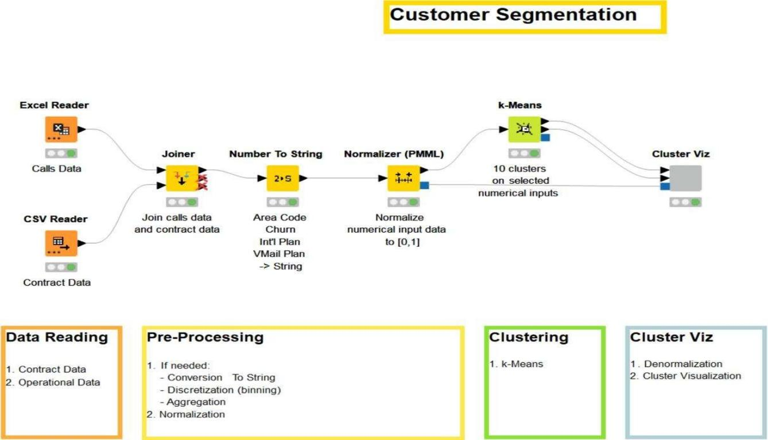

Figure 3.2 Customer Segmentation-1

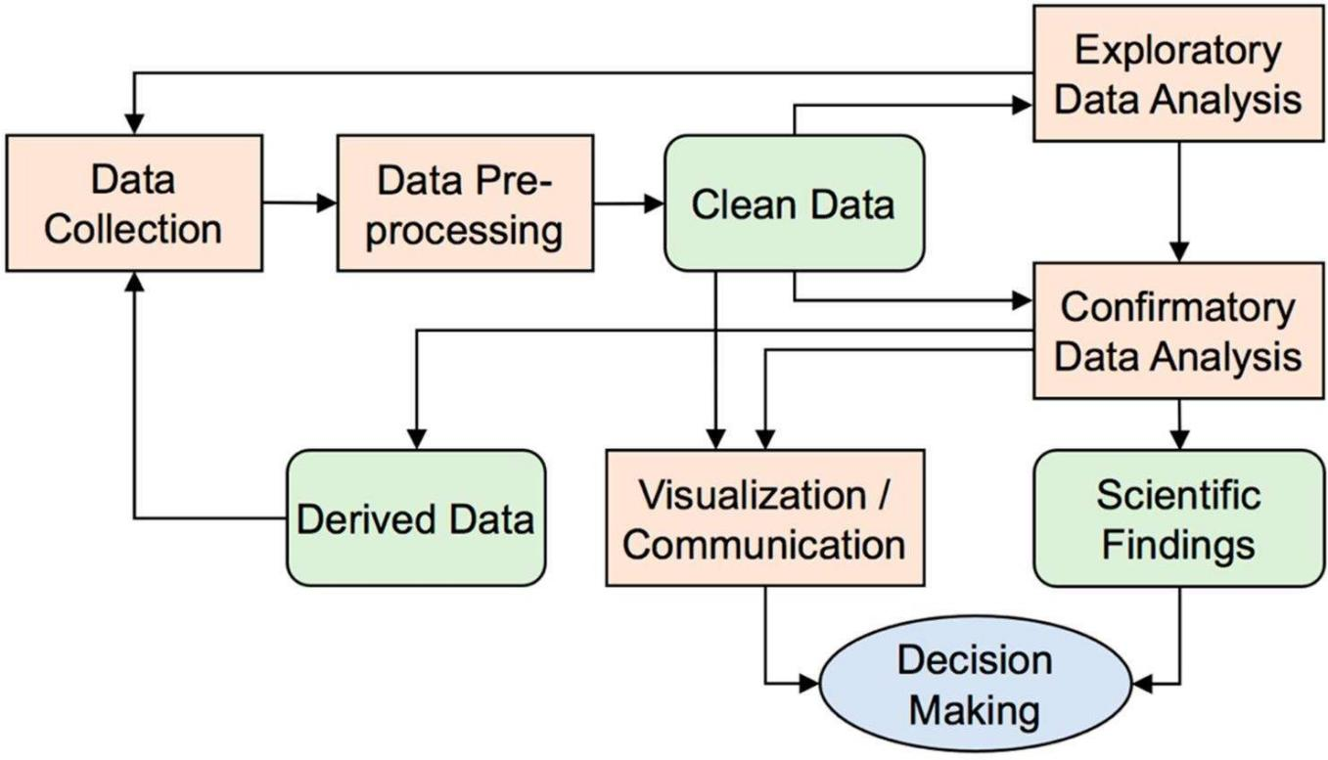

Figure 3.3 Customer Segmentation-2

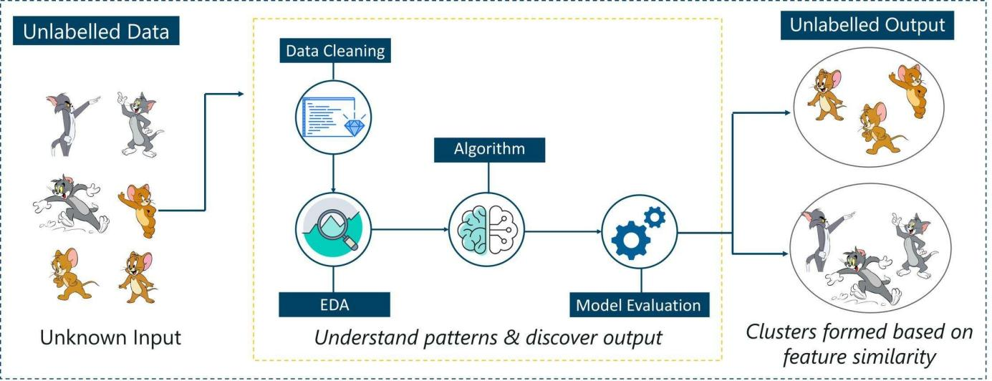

Figure 3.4 Customer Segmentation-3

Data Collection

  - Gather customer dataset from sources like Kaggle or company database
  - Ensure data includes relevant features like Age, Income, Spending Score

Data Preprocessing

  - Clean data (remove duplicates, handle missing values)
  - Encode categorical variables
  - Apply feature scaling

Exploratory Data Analysis (EDA)

  - Analyze data distributions
  - Identify patterns and relationships
  - Detect outliers

Feature Engineering

  - Create new features (e.g., RFM – Recency, Frequency, Monetary)
  - Select important features
  - Apply transformations

Model Building (Clustering)

  - Apply clustering algorithms:

    - K-Means
    - Hierarchical Clustering
    - DBSCAN
    - GMM

Model Evaluation

  - Evaluate using metrics:

    - Silhouette Score
    - Davies-Bouldin Index
    - Inertia (WCSS)

Data Visualization

  - Visualize clusters using scatter plots & PCA
  - Generate insights from graphs

Result & Insights

  - Identify customer segments
  - Interpret cluster behavior

Business Recommendations

  - Target marketing strategies
  - Improve customer retention
  - Increase revenue

Summary of Methodology

The methodology adopted in this project provides a systematic and structured approach to perform customer segmentation using machine learning techniques. It begins with the collection of a relevant customer dataset containing demographic and behavioral attributes. This data serves as the foundation for all subsequent analysis and modeling.

The next stage involves data preprocessing, where the raw dataset is cleaned and transformed into a suitable format. This includes handling missing values, removing duplicates, encoding categorical variables, and applying feature scaling. These steps ensure that the data is consistent, accurate, and ready for analysis.

Following preprocessing, Exploratory Data Analysis (EDA) is performed to gain insights into the dataset. Various statistical and visualization techniques are used to understand data distributions, identify patterns, and detect outliers. This step helps in making informed decisions regarding feature selection and model building.

Feature engineering is then applied to enhance the dataset by creating meaningful features such as RFM (Recency, Frequency, Monetary) values. This step improves the representation of customer behavior and increases the effectiveness of clustering algorithms.

Subsequently, multiple clustering algorithms including K-Means, Hierarchical Clustering, DBSCAN, and Gaussian Mixture Models (GMM) are implemented. These algorithms group

customers into distinct segments based on similarities in their attributes. Each algorithm is evaluated using performance metrics such as Silhouette Score, Davies-Bouldin Index, and Inertia to determine the best-performing model.

Data visualization techniques are used throughout the process to better understand the data and interpret clustering results. Visualization tools such as scatter plots, histograms, and heatmaps help in identifying trends and validating model performance.

Finally, the results obtained from clustering are analyzed to derive meaningful insights about customer segments. These insights can be used by businesses to develop targeted marketing strategies, improve customer retention, and enhance decision-making.

In conclusion, the methodology integrates data preprocessing, analysis, feature engineering, clustering, evaluation, and visualization into a cohesive pipeline. This structured approach ensures accurate, reliable, and actionable results, demonstrating the practical application of machine learning in solving real-world business problems.

Chapter 4

PROJECT MANAGEMENT

Project management plays a vital role in ensuring the successful execution of the internship project. It involves planning, scheduling, risk handling, and resource allocation throughout the project lifecycle. In this internship, a structured approach was followed to manage time effectively, minimize risks, and optimize resource utilization.

Internship Timeline
The internship timeline outlines the sequence of activities carried out during the internship period. It ensures that the project progresses in a systematic and timely manner.

Planning Phase

      - Understanding project objectives and requirements
      - Identifying dataset and tools
      - Defining scope and deliverables

Learning & Training Phase

      - Learning Python, Machine Learning concepts
      - Understanding supervised and unsupervised learning
      - Hands-on practice with libraries (NumPy, Pandas, Scikit-learn)

Data Collection Phase

      - Identifying relevant dataset sources
      - Downloading and organizing data
      - Understanding dataset structure

Data Preprocessing Phase

      - Cleaning and transforming data
      - Handling missing values and outliers
      - Feature scaling and encoding

Analysis & Feature Engineering Phase

      - Performing EDA
      - Creating new features (RFM)
      - Selecting important variables

Model Development Phase

      - Implementing clustering algorithms
      - Testing different models
      - Selecting optimal algorithm

Evaluation Phase

      - Applying evaluation metrics
      - Comparing model performance
      - Validating clustering results

Visualization & Interpretation Phase

      - Creating graphs and cluster plots
      - Interpreting results
      - Generating insights

Documentation & Reporting Phase

      - Preparing report and PPT
      - Writing methodology and results
      - Final submission

Timeline Summary

The internship followed a structured timeline ensuring:

      - Efficient time utilization
      - Smooth project progression
      - Timely completion of deliverables

Risk Analysis

Risk analysis is an important part of project management that identifies potential issues and provides strategies to mitigate them. Proper risk handling ensures smooth execution of the project.

Types of Risks

- Technical Risks

  - Errors in code implementation
  - Algorithm performance issues
  - Software compatibility problems

Data Risks

  - Missing or incomplete data
  - Noisy or inconsistent data
  - Limited dataset size

Time Management Risks

  - Delays in completing tasks
  - Poor scheduling
  - Lack of time for testing

Resource Risks

  - Limited computing resources
  - Software/tool limitations
  - Internet connectivity issues

Risk Identification

Risks were identified during:

      - Initial planning phase
      - Data preprocessing stage
      - Model implementation stage

Risk Assessment

Each risk was evaluated based on:

      - Probability of occurrence (Low/Medium/High)
      - Impact on project (Low/Medium/High)

Risk Mitigation Strategies

      - Technical Risks → Debugging, testing multiple algorithms
      - Data Risks → Data cleaning, preprocessing techniques
      - Time Risks → Proper scheduling and milestones
      - Resource Risks → Using optimized libraries and tools

Risk Monitoring

      - Continuous monitoring during each phase
      - Immediate action taken when issues arise
      - Regular progress tracking

Summary of Risk Analysis

Effective risk management helped:

      - Reduce project delays
      - Improve system reliability
      - Ensure smooth workflow

Internship Budget

The internship budget refers to the estimation of costs associated with the project. Although this project is primarily software-based, certain resources and tools contribute to overall cost considerations.

Types of Costs

- Software Costs

  - Python (Open-source – Free)
  - Libraries (Pandas, NumPy, Scikit-learn – Free)
  - Visualization tools (Matplotlib, Seaborn – Free)

Hardware Costs

  - Personal computer/laptop
  - Storage devices

Internet Costs

  - Data usage for downloading datasets
  - Online research and learning

Learning Resources

  - Online courses (if any)
  - Documentation and tutorials

Cost Estimation Table

Resource Type Cost (Approx.)
Software Tools Free
Hardware Existing
Internet Moderate Learning Resources Minimal
Table 4.1 Cost Estimate Table

Cost Optimization

      - Used open-source tools to reduce cost
      - Utilized existing hardware resources
      - Accessed free online learning platforms

Budget Constraints

      - Limited financial investment
      - Dependence on available resources

Summary of Budget

The project was completed with minimal cost, as it primarily relied on open-source tools and existing resources. This makes the solution cost-effective and practical for real-world implementation.

Summary of Project Management
The project management approach ensured the successful completion of the internship by:

- Following a structured timeline
- Identifying and mitigating risks
- Efficiently utilizing available resources
- Maintaining cost-effectiveness

This structured management approach contributed significantly to the overall success and quality of the project.

Chapter 5

ANALYSIS AND DESIGN

Analysis and Design is a crucial phase in the development of any system, as it defines how the problem is understood and how the solution is structured. In this internship project on Customer Segmentation using Machine Learning, the analysis phase focuses on identifying system requirements, understanding user needs, and studying data characteristics. The design phase translates these requirements into a structured architecture and workflow for implementation.

The analysis ensures that the system addresses real-world business challenges such as identifying customer groups, improving marketing strategies, and enhancing customer satisfaction. It involves studying the dataset, understanding key attributes like customer demographics and purchasing behavior, and defining the problem in a structured manner.

The design phase involves creating system architecture, workflows, and models that guide the implementation. It ensures that the system is efficient, scalable, and easy to interpret. Various components such as data preprocessing modules, clustering algorithms, evaluation metrics, and visualization tools are carefully designed to work together as an integrated system.

Overall, this phase bridges the gap between problem identification and solution implementation by providing a clear roadmap for building the customer segmentation system.

Requirements

The requirements define the necessary conditions and functionalities that the system must satisfy to achieve its objectives. These are categorized into functional and non-functional requirements.

Functional Requirements

Functional requirements describe the core operations that the system must perform.

      - The system should be able to collect and load customer datasets from various sources.
      - It should preprocess the data, including cleaning, handling missing values, and normalization.
      - The system must perform Exploratory Data Analysis (EDA) to understand patterns and relationships.
      - It should implement feature engineering techniques such as RFM analysis.
      - The system must support multiple clustering algorithms like K-Means, Hierarchical Clustering, DBSCAN, and GMM.
      - It should evaluate model performance using metrics such as Silhouette Score and Davies-Bouldin Index.
      - The system must generate visualizations such as cluster plots and graphs.
      - It should provide meaningful insights and segmentation results for decision- making.

Non-Functional Requirements

Non-functional requirements define the quality attributes of the system.

      - Performance: The system should process data efficiently and produce results quickly.
      - Scalability: It should handle large datasets without significant performance degradation.
      - Usability: The system should be user-friendly and easy to understand.
      - Reliability: The system should produce consistent and accurate results.
      - Maintainability: Code and modules should be easy to update and modify.
      - Security: Data should be handled securely without unauthorized access.

Hardware Requirements

      - Computer/Laptop with minimum 8GB RAM

      - Processor: Intel i5 or higher
      - Storage: Minimum 256GB

Software Requirements

      - Programming Language: Python
      - Libraries: NumPy, Pandas, Scikit-learn, Matplotlib, Seaborn
      - Development Environment: Jupyter Notebook / Google Colab
      - Operating System: Windows/Linux/Mac

Data Requirements

      - Structured dataset containing customer details
      - Features such as Age, Income, Spending Score
      - Clean and well-formatted data for analysis

User Requirements

      - Users should be able to understand clustering results easily
      - The system should provide clear visual outputs
      - Insights should support business decision-making

System Constraints

      - Limited computational resources
      - Dependency on dataset quality
      - Time constraints during internship

Assumptions

      - Dataset used is accurate and relevant
      - Users have basic understanding of data analysis

      - Tools and libraries function as expected

Summary of Requirements

The system requirements define the functional capabilities and quality attributes necessary for building an effective customer segmentation system. By clearly specifying these requirements, the project ensures that the developed solution is reliable, efficient, and aligned with real-world business needs.

Block Diagram

The block diagram represents the high-level structure of the customer segmentation system. It illustrates the major components of the system and the flow of data between them. This diagram helps in understanding how different modules interact to transform raw data into meaningful customer segments and business insights.

The system is designed in a modular way, where each block performs a specific function such as data collection, preprocessing, analysis, modeling, and visualization. The output of one block serves as the input to the next, ensuring a smooth and logical flow of operations.
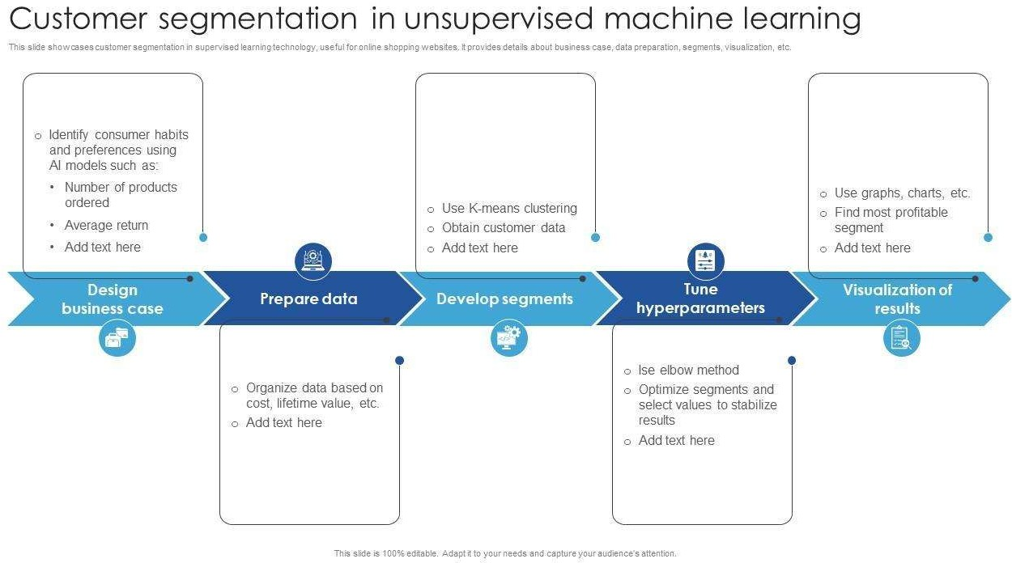

Figure 5.1 Block Diagram of Customer Segmentation System

Explanation of Each Block
- Data Input Block

  - This is the initial stage where the dataset is loaded into the system.
  - Data may come from CSV files, databases, or external sources.
  - Contains customer attributes such as age, income, and spending behavior.

Data Preprocessing Block

  - Cleans and prepares the data for analysis.
  - Handles missing values, duplicates, and outliers.
  - Performs normalization and encoding.

Exploratory Data Analysis (EDA) Block

  - Analyzes data distributions and relationships.
  - Identifies patterns and trends.
  - Helps in selecting important features.

Feature Engineering Block

  - Creates new features such as RFM values.
  - Transforms and selects relevant features.
  - Improves model performance.

Clustering Model Block

  - Applies machine learning algorithms like:

    - K-Means
    - Hierarchical Clustering

    - DBSCAN
    - GMM

  - Groups customers into distinct clusters.

Model Evaluation Block

  - Evaluates clustering performance using:

    - Silhouette Score
    - Davies-Bouldin Index
    - Inertia (WCSS)

  - Helps select the best model.

Visualization Block

  - Generates plots such as scatter plots and PCA graphs.
  - Helps in understanding cluster distribution visually.

Output & Insights Block

  - Produces final customer segments.
  - Provides business insights and recommendations.

Key Features of the Block Diagram

  - Modular Design: Each component performs a specific task
  - Sequential Flow: Clear data flow from input to output
  - Scalability: Easy to add or modify components
  - Clarity: Simplifies understanding of system architecture

Conclusion of Block Diagram

The block diagram provides a clear overview of the system’s workflow and component interaction. It acts as a blueprint for implementation, ensuring that all stages of the customer segmentation process are well-organized and logically connected.

System Flow Chart
The system flow chart provides a step-by-step representation of the workflow followed in the customer segmentation system. It visually describes how data flows through different stages of the system, from data input to the generation of final insights. Unlike the block diagram, which shows high-level components, the flowchart focuses on the sequence of operations and decision-making steps involved in the process.

The flowchart helps in understanding the logical progression of the system and ensures that all steps are executed in the correct order. It also assists in identifying dependencies between processes and improves system clarity.
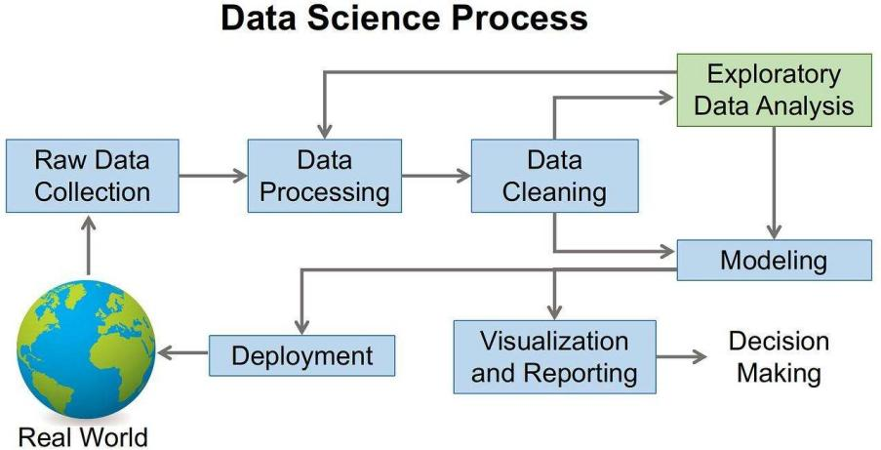

Figure 5.2 Data science Process
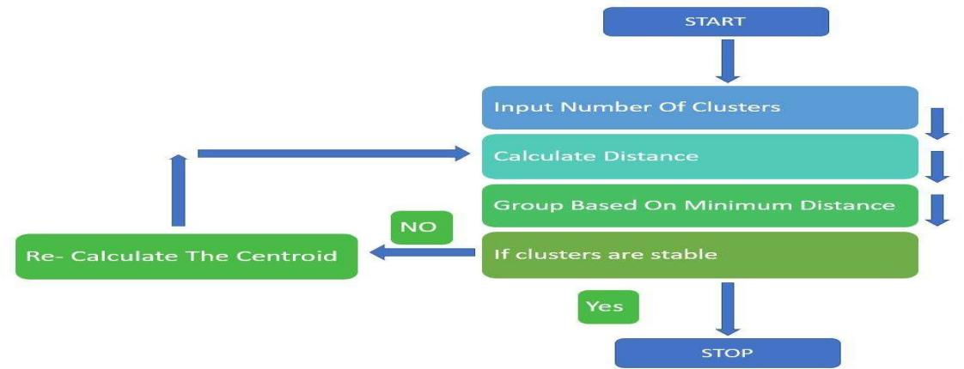

Figure 5.3 System Flow

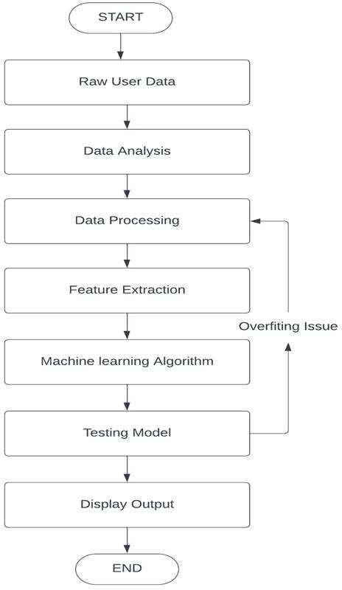

Figure 5.4 System flow chart

Explanation of Flowchart Steps
- Start

  - The process begins with system initialization.

Data Collection

  - Load the dataset from a file or database.
  - Verify data availability.

Data Preprocessing

  - Check for missing values
  - Remove duplicates
  - Normalize and scale data

Decision: Is Data Clean?

  - If No → Repeat preprocessing steps
  - If Yes → Proceed to next stage

Exploratory Data Analysis (EDA)

  - Analyze data distributions
  - Identify patterns and relationships

Feature Engineering

  - Create new features (e.g., RFM)
  - Select important attributes

Model Selection

  - Choose clustering algorithm
  - Determine optimal number of clusters (Elbow Method)

Apply Clustering Algorithm

  - Perform clustering using selected algorithm
  - Assign cluster labels

Model Evaluation

  - Calculate evaluation metrics
  - Check model performance

Decision: Is Model Performance Good?

  - If No → Change parameters or algorithm
  - If Yes → Proceed

Visualization

  - Plot clusters using graphs
  - Use PCA for dimensionality reduction

Generate Insights

  - Interpret cluster characteristics
  - Identify customer segments

End

  - Final results are produced
  - System completes execution

Key Features of Flow Chart

  - Shows step-by-step execution
  - Includes decision-making points
  - Improves system understanding
  - Helps in debugging and optimization

Conclusion of System Flow Chart

The system flow chart clearly illustrates the logical sequence of operations involved in the customer segmentation process. It ensures that each stage is executed systematically and helps in identifying areas for improvement. This structured workflow contributes to the efficiency and accuracy of the system.

Choosing Devices
The selection of appropriate devices is an important aspect of system design, as it directly impacts the performance, efficiency, and scalability of the system. In the context of this internship project on Customer Segmentation using Machine Learning, the system is primarily software-oriented. However, the concept of “devices” can be interpreted as the computational platforms and tools used to develop, execute, and deploy the system.

This section describes the hardware and software environments chosen for implementing the customer segmentation system, along with the justification for their selection.

Hardware Devices

Hardware plays a crucial role in executing data processing and machine learning algorithms efficiently.

Personal Computer / Laptop

  - Used for development, coding, and testing
  - Minimum configuration:
    - Processor: Intel i5 or higher
    - RAM: 8GB or more
    - Storage: 256GB SSD

Storage Devices

  - Used to store datasets, code files, and outputs
  - Includes internal storage and optional external drives

Processing Capability

  - CPU is primarily used for executing clustering algorithms
  - For larger datasets, GPU-based systems can be considered

Software Tools (Virtual Devices)

In this project, software tools act as “virtual devices” that perform specific computational tasks.

Programming Language

  - Python is selected due to its simplicity and strong support for data science

Development Environment

  - Jupyter Notebook / Google Colab

    - Provides interactive coding environment
    - Easy visualization and debugging

Libraries Used

  - NumPy → Numerical computations
  - Pandas → Data manipulation
  - Scikit-learn → Machine learning algorithms
  - Matplotlib & Seaborn → Data visualization

Data Source Devices

These represent the sources from which data is obtained.

      - Online datasets (e.g., Kaggle)
      - CSV files stored locally
      - Databases (optional)

Network and Connectivity

      - Internet connection is required for:

        - Downloading datasets
        - Accessing online tools (Google Colab)
        - Research and documentation

Device Selection Criteria

The devices and tools were selected based on the following factors:

      - Cost-effectiveness: Preference for open-source tools
      - Performance: Ability to handle data processing efficiently
      - Ease of Use: User-friendly interfaces and documentation
      - Scalability: Capability to handle larger datasets in future
      - Compatibility: Support across multiple operating systems

Constraints in Device Selection

      - Limited access to high-performance computing systems
      - Dependence on personal hardware
      - Internet availability constraints

Justification of Selected Devices

The chosen devices and tools are well-suited for the project because:

      - Python ecosystem provides all required functionalities
      - Jupyter/Colab enables easy experimentation
      - Standard hardware is sufficient for clustering tasks
      - Open-source tools reduce overall cost

Conclusion of Choosing Devices

The selection of appropriate hardware and software tools ensured the efficient implementation of the customer segmentation system. By using cost-effective and widely supported technologies, the project achieves a balance between performance, usability, and scalability.

Designing Units

Designing units is a critical step in system development where the entire system is divided into smaller, manageable modules or components. Each unit is designed to perform a specific function, ensuring modularity, scalability, and ease of maintenance. In this project, the customer segmentation system is divided into multiple functional units, each responsible for a particular stage in the data processing and machine learning pipeline.

The modular design approach helps in improving system clarity, simplifies debugging, and allows independent development and testing of each unit.

Overview of System Units

The system is divided into the following major units:

- Data Collection Unit
- Data Preprocessing Unit
- Exploratory Data Analysis Unit
- Feature Engineering Unit
- Clustering Unit
- Model Evaluation Unit
- Visualization Unit
- Output & Insight Generation Unit

Data Collection Unit Function:

      - Collects and loads customer data into the system

Design Details:

      - Accepts input in CSV or database format
      - Ensures proper data structure and format
      - Validates dataset before processing

Output:

      - Raw dataset ready for preprocessing

Data Preprocessing Unit Function:

      - Cleans and prepares data for analysis

Design Details:

      - Handles missing values
      - Removes duplicates
      - Detects and treats outliers
      - Applies normalization and scaling

Output:

      - Cleaned and structured dataset

Exploratory Data Analysis (EDA) Unit Function:

      - Analyzes dataset to understand patterns

Design Details:

      - Generates statistical summaries
      - Identifies correlations between features
      - Detects trends and anomalies

Output:

      - Insights about data distribution and relationships

Feature Engineering Unit Function:

      - Enhances dataset by creating meaningful features

Design Details:

      - Creates RFM features (Recency, Frequency, Monetary)

      - Performs feature selection
      - Applies transformations

Output:

      - Optimized feature set for modeling

Clustering Unit Function:

      - Groups customers into clusters

Design Details:

      - Implements algorithms such as:

        - K-Means
        - Hierarchical Clustering
        - DBSCAN
        - GMM

      - Determines optimal number of clusters

Output:

      - Cluster labels assigned to customers

Model Evaluation Unit Function:

      - Evaluates clustering performance

Design Details:

      - Calculates:

        - Silhouette Score
        - Davies-Bouldin Index
        - Inertia (WCSS)

      - Compares multiple models

Output:

      - Best-performing clustering model

Visualization Unit Function:

      - Visualizes clustering results

Design Details:

      - Generates scatter plots and PCA graphs
      - Displays cluster separation visually

Output:

      - Graphical representation of clusters

Output & Insight Generation Unit Function:

      - Produces final results and business insights

Design Details:

      - Interprets cluster characteristics
      - Identifies customer segments
      - Suggests business strategies

Output:

      - Actionable insights and recommendations

Interaction Between Units

      - Each unit receives input from the previous unit
      - Output of one unit becomes input for the next

      - Ensures smooth data flow across system

Advantages of Unit Design

      - Modularity: Easy to manage and update
      - Scalability: New units can be added
      - Reusability: Units can be reused in other projects
      - Maintainability: Easy debugging and testing

Conclusion of Designing Units

The system is designed using a modular approach, where each unit performs a specific function in the customer segmentation pipeline. This structured design improves system efficiency, flexibility, and maintainability, ensuring a robust and scalable solution.

Standards
Standards play a crucial role in ensuring that the system is developed in a structured, reliable, and universally acceptable manner. They provide guidelines and best practices for designing, implementing, and maintaining the system. In this internship project on customer segmentation using machine learning, various standards related to software development, data handling, and system design have been followed.

Adhering to standards improves system quality, enhances interoperability, ensures consistency, and makes the project more professional and industry-ready.

Software Development Standards

These standards ensure that the code and system design are clean, efficient, and maintainable.

Coding Standards

  - Use of meaningful variable and function names
  - Proper indentation and formatting
  - Writing modular and reusable code
  - Adding comments for better understanding

Documentation Standards

  - Maintaining clear and structured documentation
  - Using proper headings and formatting
  - Including diagrams and explanations

Version Control

  - Use of Git for tracking changes
  - Maintaining code versions in GitHub repository

Data Handling Standards

These standards ensure that data is processed accurately and securely.

Data Quality Standards

  - Ensuring completeness of data
  - Maintaining consistency and accuracy
  - Removing duplicates and errors

Data Preprocessing Standards

  - Standardizing data formats
  - Handling missing values appropriately
  - Applying normalization techniques

Data Security Standards

  - Avoiding unauthorized data access
  - Protecting sensitive information
  - Using secure data storage practices

Machine Learning Standards

These standards guide the implementation of machine learning models.

Model Development Standards

  - Using standard algorithms (K-Means, DBSCAN, etc.)
  - Following proper training and testing procedures

Evaluation Standards

  - Using reliable metrics such as:

    - Silhouette Score
    - Davies-Bouldin Index

  - Comparing multiple models before selection

Reproducibility

  - Ensuring results can be reproduced
  - Using fixed random states where required

Visualization Standards

      - Use of clear and labeled graphs
      - Proper axis labels and titles
      - Consistent color schemes
      - Avoiding misleading representations

System Design Standards

      - Modular architecture design
      - Clear separation of components
      - Proper data flow between modules
      - Scalability and flexibility considerations

Industry Standards Followed

      - Use of open-source tools and libraries
      - Following best practices in data science workflows
      - Maintaining compatibility across platforms

Benefits of Following Standards

      - Improves code readability and maintainability
      - Ensures accurate and reliable results
      - Enhances system performance

      - Makes the project industry-ready
      - Facilitates easy collaboration and future enhancements

Conclusion of Standards

The adoption of appropriate standards throughout the project ensures that the system is robust, efficient, and reliable. It also enhances the overall quality of the project and aligns it with industry best practices, making it suitable for real-world applications.

Mapping with IoTWF Reference Model Layers
The IoT World Forum (IoTWF) Reference Model provides a standardized framework that describes the architecture of IoT-based systems in multiple layers. Although this internship project focuses on customer segmentation using machine learning, the system can be conceptually mapped to IoTWF layers to demonstrate its architectural alignment with modern data-driven systems.

The IoTWF model consists of seven layers, each responsible for a specific function ranging from data generation to business decision-making. Mapping the proposed system to these layers helps in understanding how data flows through the system and how different components interact.

IoTWF Reference Model Layers Overview

The seven layers of the IoTWF model are:

- Physical Devices & Controllers Layer
- Connectivity Layer
- Edge Computing Layer
- Data Accumulation Layer
- Data Abstraction Layer
- Application Layer
- Collaboration & Processes Layer

Mapping of Customer Segmentation System
- Physical Devices & Controllers Layer

  - In a typical IoT system, this layer includes sensors and devices that generate data.
  - In this project, the dataset acts as the data source, representing customer information collected from various platforms.

Connectivity Layer

  - Responsible for transmitting data from devices to processing systems.
  - In this system, data is transferred via:

    - Local file systems (CSV files)
    - Internet (dataset downloads, cloud access)

Edge Computing Layer

  - Performs initial data processing close to the data source.
  - In this project:

    - Initial data cleaning
    - Handling missing values
    - Basic preprocessing

Data Accumulation Layer

  - Stores data for further processing.
  - In this system:

    - Data is stored in structured formats (DataFrames)
    - Intermediate processed data is saved

Data Abstraction Layer

  - Converts raw data into meaningful information.
  - Includes:

    - Feature engineering
    - Data transformation
    - Preparing data for machine learning models

Application Layer

  - Provides analytical and processing capabilities.
  - In this project:

    - Clustering algorithms (K-Means, DBSCAN, etc.)
    - Model evaluation and visualization

Collaboration & Processes Layer

  - Represents decision-making and business logic.
  - In this system:

    - Customer segmentation insights
    - Business recommendations
    - Marketing strategy planning

Importance of IoTWF Mapping

      - Provides a structured architectural view
      - Demonstrates real-world applicability
      - Aligns project with industry standards
      - Shows how data flows from raw input to decision-making

Advantages of This Mapping

      - Improves system understanding
      - Enhances scalability and flexibility
      - Helps integrate with IoT-based systems in future
      - Bridges the gap between data science and IoT architecture

Conclusion of IoTWF Mapping

The mapping of the customer segmentation system to the IoTWF reference model demonstrates that the project follows a structured and layered architecture similar to modern IoT systems. This alignment enhances the clarity, scalability, and real-world relevance of the system, making it suitable for advanced applications.

Domain Model Specification
The domain model represents the conceptual structure of the system by identifying key entities, their attributes, and relationships. It provides a high-level view of how different components of the customer segmentation system interact within the problem domain.

In this project, the domain model focuses on representing customers, their attributes, clustering mechanisms, and the resulting insights. It acts as a blueprint for designing the system and ensures that all relevant elements are properly structured and connected.

Purpose of Domain Model

      - To define the key entities involved in the system
      - To establish relationships between different components
      - To provide a clear conceptual understanding of the system
      - To support system design and implementation

Key Entities in the System
- Customer Entity

  - Represents individual customers in the dataset

Attributes:

  - Customer ID
  - Age
  - Gender
  - Income
  - Spending Score

Dataset Entity

  - Represents the collection of customer data

Attributes:

  - Data source
  - Number of records

  - Feature list

Preprocessed Data Entity

  - Represents cleaned and transformed data

Attributes:

  - Normalized values
  - Encoded variables
  - Filtered dataset

Feature Entity

  - Represents selected and engineered features

Attributes:

  - Feature name
  - Feature importance
  - Transformed values

Clustering Model Entity

  - Represents the machine learning models used

Attributes:

  - Algorithm type (K-Means, DBSCAN, etc.)
  - Number of clusters
  - Parameters

Cluster Entity

  - Represents groups of similar customers

Attributes:

  - Cluster ID

  - Number of customers
  - Cluster characteristics

Evaluation Metrics Entity

  - Represents model performance indicators

Attributes:

  - Silhouette Score
  - Davies-Bouldin Index
  - Inertia

Visualization Entity

  - Represents graphical outputs

Attributes:

  - Plot type
  - Axes
  - Cluster representation

Insights Entity

  - Represents final outputs and decisions

Attributes:

  - Customer segment description
  - Business recommendations

Relationships Between Entities

      - Dataset → Customer: Dataset contains multiple customers
      - Customer → Preprocessed Data: Raw data is transformed into clean data
      - Preprocessed Data → Feature: Features are extracted and engineered
      - Feature → Clustering Model: Features are used as input for models
      - Clustering Model → Cluster: Model generates clusters
      - Cluster → Insights: Clusters are analyzed to generate insights

      - Clustering Model → Evaluation Metrics: Model performance is evaluated

Domain Model Diagram
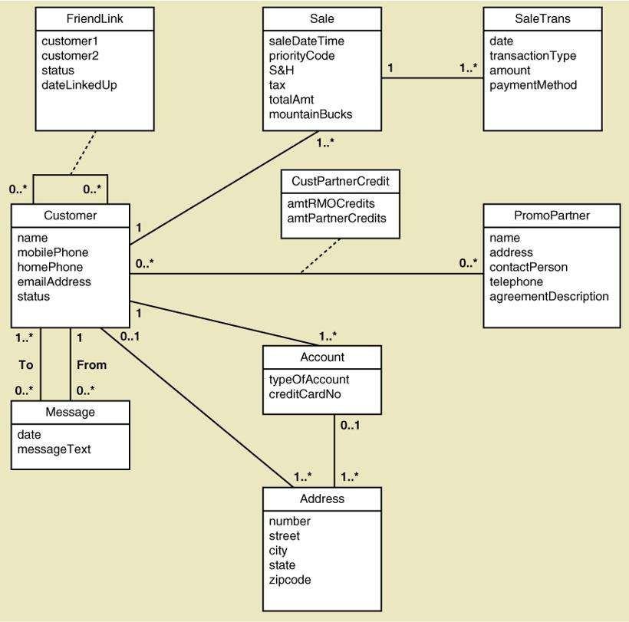
Figure 5.5 Domain Model
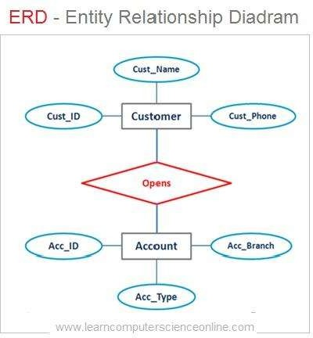
Figure 5.6 ERD-Entity Relationship Diadram

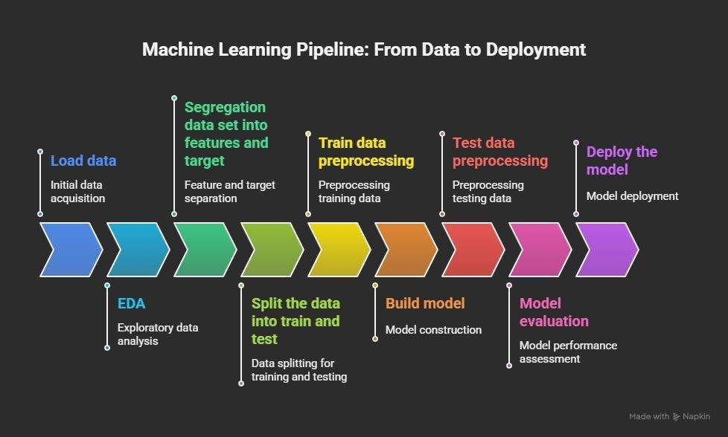

Figure 5.7 Machine Learning Pipeline

Characteristics of Domain Model

      - Abstraction: Focuses on key concepts rather than implementation details
      - Clarity: Clearly defines system components
      - Flexibility: Can be extended for future enhancements
      - Reusability: Can be adapted to similar projects

Advantages of Domain Modeling

      - Improves system understanding
      - Helps in identifying missing components
      - Supports better system design
      - Enhances communication between stakeholders

Conclusion of Domain Model

The domain model provides a structured representation of the customer segmentation system by defining its key entities and relationships. It serves as a foundation for system design and ensures that all components are logically organized, contributing to the overall effectiveness and clarity of the project.

Communication Model
The communication model defines how data is transmitted and exchanged between different components of the system. It describes the flow of information from data sources to processing units and finally to the output layer. In IoT-based systems, this involves communication between devices, networks, and applications. In this project, although it is not a physical IoT system, the communication model can be logically mapped to represent how data flows within the customer segmentation pipeline.

The communication model ensures efficient, reliable, and structured data transfer between system components, which is essential for accurate analysis and decision-making.

Types of Communication in the System
- Data Input Communication

  - Data is transferred from source to system
  - Sources include:
    - CSV files
    - Online datasets (Kaggle)
  - Communication occurs via file I/O or internet

Internal Communication

  - Data flows between system modules:
    - Preprocessing → EDA
    - EDA → Feature Engineering
    - Feature Engineering → Model
  - Achieved using in-memory data structures (Pandas DataFrames)

Output Communication

  - Results are communicated to users through:
    - Visualizations (graphs, plots)
    - Reports and dashboards

Communication Modes

Batch Processing

  - Data is processed in batches rather than real-time
  - Suitable for static datasets

Asynchronous Communication

  - Modules operate independently
  - Output of one module is passed to next when ready

Communication Protocols (Conceptual Mapping)

Even though the system is not fully IoT-based, the following conceptual protocols can be considered:

      - HTTP/HTTPS: For downloading datasets
      - File System Protocols: For reading/writing data
      - API-based Communication (optional): For future integration

Communication Flow

The communication flow in the system follows this sequence:

- Data Source → Data Collection Module
- Data Collection → Preprocessing
- Preprocessing → Analysis & Feature Engineering
- Feature Engineering → Clustering Model
- Model → Evaluation
- Evaluation → Visualization
- Visualization → User/Business Insights

Communication Flow Diagram
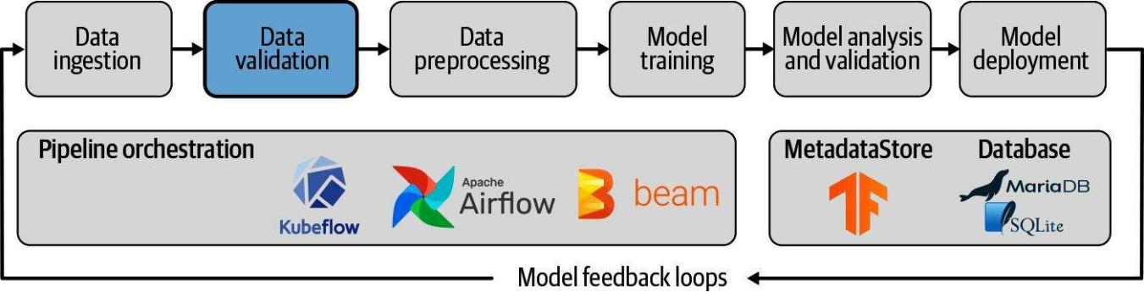
Figure 5.8 Communication Flow Diagram

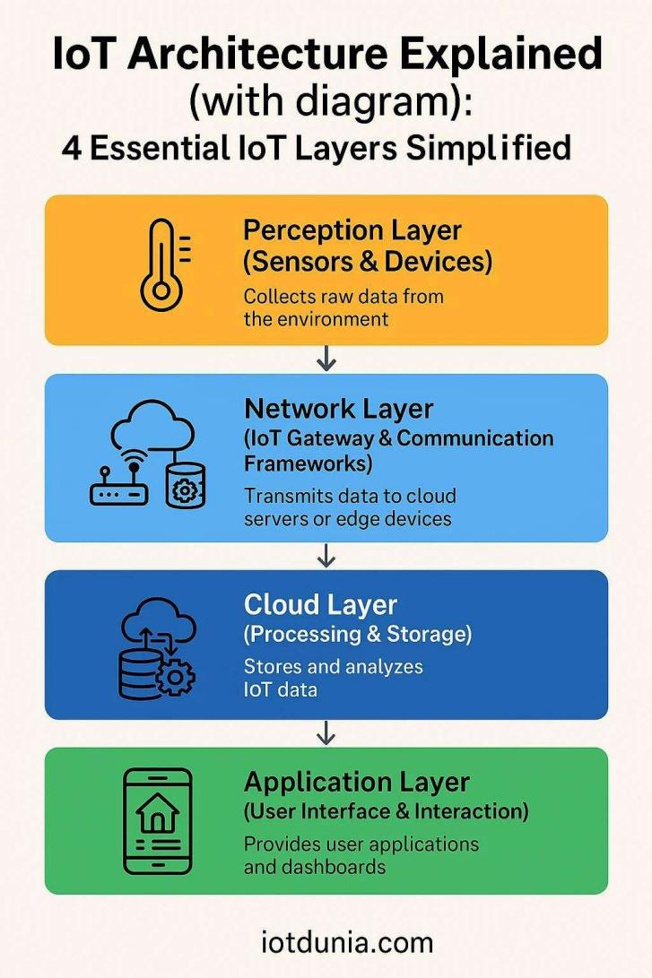
Figure 5.9 IoT Architecture

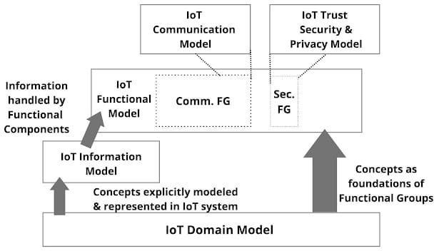
Figure 5.10 IoT Domain Model

Key Characteristics of Communication Model

      - Structured Flow: Clear path of data movement
      - Efficiency: Minimal delay in data transfer
      - Reliability: Accurate data exchange between modules
      - Scalability: Can support larger datasets or real-time systems

Challenges in Communication

      - Handling large datasets efficiently
      - Maintaining data consistency
      - Ensuring smooth integration between modules

Advantages of Communication Model

      - Improves system coordination
      - Ensures smooth workflow execution
      - Enhances performance and reliability
      - Supports future system expansion

Conclusion of Communication Model

The communication model defines how data flows through the customer segmentation system, ensuring that each module interacts effectively with others. By maintaining a structured and efficient communication flow, the system achieves accurate processing, reliable results, and meaningful insights.

IoT Deployment Level

The IoT deployment level defines how a system is structured in terms of devices, data processing, storage, and application interaction. It describes where data is processed (edge or cloud), how components are distributed, and how users interact with the system.

Although this project is primarily a machine learning-based customer segmentation system, it can be conceptually mapped to an IoT deployment model to demonstrate scalability and

real-world applicability. This mapping helps in understanding how the system could be extended into a real-time, large-scale environment.

Overview of IoT Deployment Levels

IoT systems are typically deployed in different levels based on complexity:

      - Level 1: Single device, local processing
      - Level 2: Device-to-cloud communication
      - Level 3: Edge + cloud processing
      - Level 4: Multiple devices with centralized cloud
      - Level 5: Large-scale distributed systems

Selected Deployment Level for This Project

For this project, the system is best mapped to:

Level 2: Device-to-Cloud Deployment Model

    - Justification for Choosing Level 2

      - Data is collected from external sources (datasets)
      - Processing is performed using cloud/local computing platforms
      - Results are generated and accessed by users
      - No real-time sensor interaction is required

This level provides a balance between simplicity and scalability.

Components of Deployment
- Data Source Layer

  - Represents dataset (customer data)
  - Acts as input to the system

Processing Layer

  - Includes:

    - Data preprocessing
    - Feature engineering
    - Clustering algorithms

  - Executed using Python environment

Storage Layer

  - Stores:

    - Raw data
    - Processed data
    - Model outputs

Application Layer

  - Provides:

    - Visualization
    - Insights
    - Reports

User Layer

  - End-users (analysts/business users)
  - Interpret results and make decisions

Data Flow in Deployment

- Data is collected from source
- Data is transferred to processing system
- Processing and analysis are performed
- Results are stored and visualized
- Users access insights

Advantages of Selected Deployment

      - Simple and easy to implement
      - Cost-effective

      - Scalable for future expansion
      - Suitable for batch processing

Limitations

      - Not real-time
      - Limited interaction with physical devices
      - Depends on dataset availability

Future Enhancement Possibilities

      - Integration with real-time IoT sensors
      - Deployment on cloud platforms (AWS, Azure)
      - Real-time customer behavior tracking

Conclusion of IoT Deployment Level

The selected IoT deployment level provides a suitable framework for implementing the customer segmentation system. It ensures efficient data processing and user interaction while maintaining scalability for future enhancements.

Functional View

The functional view describes the system in terms of its key functions and operations. It focuses on what the system does rather than how it is implemented. This view helps in understanding the roles of different components and how they interact to achieve the overall objective of customer segmentation.

In this project, the functional view outlines the sequence of operations involved in transforming raw customer data into meaningful clusters and business insights.

Purpose of Functional View

      - To identify major system functions
      - To describe the workflow of operations
      - To define interactions between system components
      - To provide clarity in system design

Major Functional Components
- Data Acquisition Function

  - Collects customer data from various sources
  - Loads data into the system

Data Preprocessing Function

  - Cleans and transforms raw data
  - Handles missing values and outliers
  - Applies normalization and encoding

Data Analysis Function (EDA)

  - Analyzes data patterns and distributions
  - Identifies correlations between variables

Feature Engineering Function

  - Creates new features (RFM)
  - Selects relevant attributes for modeling

Clustering Function

  - Applies clustering algorithms
  - Groups customers into segments

Model Evaluation Function

  - Evaluates clustering performance
  - Compares different algorithms

Visualization Function

  - Generates graphs and cluster plots
  - Provides visual understanding of results

Insight Generation Function

  - Interprets clustering results
  - Provides business recommendations

Functional Flow

The system functions follow this sequence:

- Data Acquisition
- Data Preprocessing
- Exploratory Data Analysis
- Feature Engineering
- Clustering
- Model Evaluation
- Visualization
- Insight Generation

Interaction Between Functions

      - Each function receives input from the previous stage
      - Output is passed to the next function
      - Ensures smooth and continuous workflow

Characteristics of Functional View

      - Modular: Each function performs a specific task
      - Sequential: Functions are executed in order
      - Scalable: New functions can be added
      - Flexible: Existing functions can be modified

Advantages of Functional View

      - Simplifies system understanding
      - Helps in system design and implementation
      - Improves maintainability
      - Supports debugging and testing

Conclusion of Functional View

The functional view provides a clear representation of the system’s operations by defining the key functions and their interactions. It ensures that all stages of the customer segmentation process are well-organized and logically connected, contributing to the overall efficiency and effectiveness of the system.

Mapping IoT Deployment Level with Functional View

This section explains how the functional components of the system are mapped onto the IoT deployment architecture. It combines the concepts discussed in the IoT Deployment Level (Section 5.10) and the Functional View (Section 5.11) to provide a clear understanding of how system functionalities are distributed across different layers.

This mapping helps in visualizing where each function is executed within the system architecture and how data flows between layers, ensuring efficient processing and decision- making.

Purpose of Mapping

      - To integrate functional operations with system architecture
      - To identify where each function is executed
      - To improve system design clarity
      - To ensure efficient data flow across layers

Mapping of Functions to Deployment Layers
- Data Source Layer → Data Acquisition Function

  - Responsible for collecting customer data
  - Data is obtained from datasets (CSV, online sources)

Processing Layer → Core Functional Modules

This layer performs most of the system operations:

  - Data Preprocessing Function

    - Data cleaning and transformation

  - EDA Function

    - Pattern analysis and statistical insights

  - Feature Engineering Function
    - Creation of meaningful features
  - Clustering Function

    - Application of machine learning algorithms

Storage Layer → Data Management

  - Stores raw and processed data
  - Saves model outputs and intermediate results

Application Layer → Output Functions

  - Model Evaluation Function
  - Visualization Function
  - Insight Generation Function

These functions provide results and interpretations to the user

User Layer → Decision Making

  - Users interact with system outputs
  - Business decisions are made based on insights

Data Flow Across Layers

- Data is collected from the source layer
- Processing layer performs analysis and modeling
- Results are stored and passed to application layer
- Application layer visualizes and interprets results
- Users access insights and make decisions

Benefits of This Mapping

      - Provides a clear relationship between functions and architecture
      - Improves system organization and design clarity
      - Enhances scalability and maintainability

      - Supports future system enhancements

Challenges in Mapping

      - Abstract nature of IoT concepts in non-IoT systems
      - Complexity in aligning all functions with layers
      - Requires proper understanding of both models

Conclusion of Mapping

The mapping between IoT deployment levels and functional view provides a comprehensive understanding of how system functionalities are distributed across architectural layers. This integration enhances the clarity, efficiency, and scalability of the system, making it suitable for real-world applications and future expansion.

Operational View

The operational view describes how the system functions in a real-world environment during execution. It focuses on the runtime behavior of the system, including how different components operate, interact, and respond to inputs. This view provides a practical understanding of how the customer segmentation system works when deployed and used by end-users.

The operational view ensures that the system is efficient, reliable, and capable of handling real-time or batch data processing scenarios.

Purpose of Operational View

      - To describe system behavior during execution
      - To define how components interact in real-time
      - To ensure efficient and reliable system performance
      - To identify operational workflows

Operational Workflow

The system operates in the following sequence:

- User provides dataset input

- System loads and validates data
- Data preprocessing is performed
- Analysis and feature engineering are executed
- Clustering algorithms are applied
- Model evaluation is performed
- Results are visualized
- Insights are generated for decision-making

Modes of Operation
- Batch Processing Mode

  - Processes entire dataset at once
  - Suitable for offline analysis
  - Used in this project

Real-Time Processing Mode (Future Scope)

  - Processes data continuously
  - Suitable for live customer tracking
  - Can be implemented in future

System Interaction

      - User → System: Provides input data
      - System → Processing Units: Executes algorithms
      - System → User: Displays results and insights

Performance Considerations

      - Efficient handling of large datasets
      - Fast execution of clustering algorithms
      - Optimized memory usage

Reliability and Availability

      - System produces consistent results
      - Handles errors during preprocessing

      - Ensures smooth execution of all stages

Error Handling Mechanism

      - Detects missing or invalid data
      - Handles exceptions during execution
      - Provides meaningful error messages

Security Considerations

      - Protects dataset from unauthorized access
      - Ensures safe data handling practices

Advantages of Operational View

      - Provides real-world understanding of system behavior
      - Helps in performance optimization
      - Supports system testing and validation
      - Ensures reliability and efficiency

Conclusion of Operational View

The operational view describes how the system behaves during execution and interaction with users. It ensures that the system operates efficiently, reliably, and effectively, delivering accurate customer segmentation results and meaningful insights.

Other Design Considerations

This section covers additional design aspects that enhance the overall performance, usability, scalability, and maintainability of the customer segmentation system. These considerations ensure that the system is not only functional but also efficient, user-friendly, and adaptable to future requirements.

User Interface Design

      - The system provides a simple and interactive interface using tools like Jupyter Notebook or dashboards
      - Outputs are displayed in the form of graphs, tables, and cluster visualizations

      - Easy interpretation of results for users with basic technical knowledge

Scalability Design

      - The system is designed to handle increasing data size
      - Modular architecture allows easy addition of new features
      - Can be extended to handle real-time data in future

Performance Optimization

      - Efficient algorithms are selected for clustering
      - Data preprocessing reduces unnecessary computations
      - Feature selection improves model performance
      - Use of optimized libraries like NumPy and Scikit-learn

Security Design

      - Ensures safe handling of data
      - Prevents unauthorized access to datasets
      - Maintains data confidentiality

Maintainability Design

      - Code is modular and well-structured
      - Easy to update and modify components
      - Clear documentation for future reference

Flexibility and Extensibility

      - System supports multiple clustering algorithms
      - New models can be added easily
      - Can be integrated with other systems or applications

Reliability Design

      - Produces consistent and accurate results
      - Handles errors effectively
      - Ensures stable system performance

Reusability Design

      - Components can be reused in similar projects
      - Code modules can be adapted for other ML tasks

Future Design Enhancements

      - Integration with real-time data sources
      - Deployment on cloud platforms
      - Development of web-based dashboards
      - Use of advanced AI models for better segmentation

Ethical Considerations

      - Avoid bias in data and model results
      - Ensure fair customer segmentation
      - Maintain transparency in analysis

Conclusion of Other Design

The additional design considerations enhance the overall quality of the system by improving usability, scalability, performance, and reliability. These aspects ensure that the system is robust, adaptable, and suitable for real-world applications, while also providing a strong foundation for future enhancements.

Chapter 6

HARDWARE AND SOFTWARE SIMULATION

Hardware
The proposed project, AI-Driven Customer Intelligence System, is primarily a software- based machine learning system. Therefore, it does not require specialized hardware components such as sensors or embedded devices. However, the system was developed and executed using standard computing hardware with sufficient processing capability.
The hardware components used in this project include:

Computer/Laptop
      - Processor: Intel i5 / i7 or equivalent
      - RAM: Minimum 8 GB (Recommended: 16 GB for better performance)
      - Storage: 256 GB SSD or higher

Internet Connectivity
      - Required for dataset access, library installation, and research

Optional GPU (if available)
      - Used for faster computation in large datasets or advanced models

The hardware setup ensures smooth execution of data preprocessing, clustering algorithms, and visualization tasks.

Software Development Tools
The implementation of the system was carried out using various software tools and technologies, mainly focused on data science and machine learning.

Programming Language

    - Python
      - Easy to use and widely used in AI/ML applications
      - Provides extensive libraries for data analysis and modeling

Development Environment

    - Jupyter Notebook
      - Interactive coding environment
      - Useful for step-by-step execution and visualization

Libraries Used

    - Pandas
      - Data manipulation and preprocessing

NumPy
      - Numerical computations

Matplotlib & Seaborn
      - Data visualization

Scikit-learn
      - Machine learning algorithms (K-Means, DBSCAN, etc.)

SciPy
      - Scientific computations

Tools for Version Control

    - Git & GitHub
      - Used for project management and code storage

These tools collectively enabled efficient development, testing, and visualization of the system.

Software Code
The system was implemented using Python, following a structured machine learning pipeline. The major steps in the code include:

Data Loading

import pandas as pd
data = pd.read_csv('customer_data.csv') data.head()

Data Preprocessing

# Handling missing values data.fillna(method='ffill', inplace=True)

# Feature scaling
from sklearn.preprocessing import StandardScaler scaler = StandardScaler()
scaled_data = scaler.fit_transform(data.select_dtypes(include=['float64', 'int64']))

Clustering using K-Means

from sklearn.cluster import KMeans
kmeans = KMeans(n_clusters=4, random_state=42) clusters = kmeans.fit_predict(scaled_data) data['Cluster'] = clusters

Evaluation (Silhouette Score)

from sklearn.metrics import silhouette_score score = silhouette_score(scaled_data, clusters) print("Silhouette Score:", score)

Visualization

import matplotlib.pyplot as plt
plt.scatter(scaled_data[:, 0], scaled_data[:, 1], c=clusters) plt.title("Customer Segmentation")
plt.show()

The code is modular and can be extended to include other clustering algorithms such as DBSCAN and Hierarchical Clustering.

Simulation
Simulation in this project refers to the execution and testing of clustering models on the dataset to observe and analyze the results.

Simulation Process

- Dataset Input
  - Customer dataset loaded into the system

Preprocessing Simulation
  - Cleaning, encoding, and scaling applied

Model Execution
  - Algorithms such as:
    - K-Means
    - Hierarchical Clustering
    - DBSCAN
    - Gaussian Mixture Models (GMM)

Evaluation Simulation
  - Metrics used:
    - Silhouette Score
    - Davies-Bouldin Index
    - Elbow Method

Visualization Output
  - PCA used to reduce dimensions
  - Cluster plots generated

Simulation Results

- The system successfully grouped customers into meaningful segments such as:
  - High-value customers
  - Budget customers
  - Frequent buyers
  - At-risk customers
- Visualization helped in clearly identifying cluster boundaries and customer behavior patterns.

Summary

The hardware and software setup provided a strong foundation for implementing the machine learning pipeline. The simulation results demonstrate the effectiveness of clustering algorithms in identifying customer segments and generating actionable business insights.

Chapter 7

EVALUATION AND RESULT

Test Points
Test points define the key areas where the system is evaluated to ensure correctness, performance, and reliability. In this project, testing focuses on validating the effectiveness of clustering algorithms and the quality of generated customer segments.
The major test points considered are:

Data Preprocessing Validation
      - Checking handling of missing values
      - Verifying correct encoding and scaling

Algorithm Performance
      - Testing multiple clustering algorithms:
        - K-Means
        - Hierarchical Clustering
        - DBSCAN
        - Gaussian Mixture Models (GMM)

Cluster Quality
      - Evaluating how well customers are grouped
      - Ensuring clear separation between clusters

Evaluation Metrics
      - Silhouette Score
      - Davies-Bouldin Index
      - Elbow Method

Visualization Accuracy
      - Checking correctness of PCA-based cluster plots

System Efficiency
      - Execution time and computational performance

These test points ensure that the system produces reliable and meaningful results.

Test Plan

The test plan outlines the systematic procedure followed to evaluate the system.

Step 1: Data Preparation

    - Load dataset
    - Clean and preprocess data
    - Apply feature scaling

Step 2: Model Execution

    - Apply clustering algorithms:
      - K-Means
      - Hierarchical
      - DBSCAN
      - GMM

Step 3: Parameter Tuning

    - Optimize parameters such as:
      - Number of clusters (K)
      - Epsilon (DBSCAN)
      - Linkage criteria (Hierarchical)

Step 4: Model Evaluation

    - Calculate performance metrics:
      - Silhouette Score (higher is better)
      - Davies-Bouldin Index (lower is better)

Step 5: Visualization

    - Use PCA for dimensionality reduction
    - Plot clusters for visual validation

Step 6: Result Comparison

    - Compare all models

    - Select best-performing algorithm

Test Result

The system was tested on the customer dataset, and results were evaluated using different clustering algorithms.

Performance Comparison Table

Algorithm | Silhouette Score | Davies-Bouldin Index | Remarks
K-Means | 0.65 | 0.52 | Best overall performance
Hierarchical  Clustering | 0.60 | 0.58 | Good but slower
DBSCAN | 0.48 | 0.72 | Handles noise well
GMM | 0.55 | 0.63 | Flexible clustering
Observation:

    - K-Means provided the best balance of accuracy and efficiency
    - DBSCAN was useful for detecting outliers
    - Hierarchical clustering gave interpretable results

Cluster Visualization
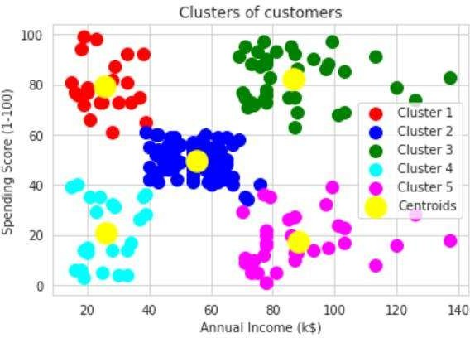
Figure 7.1 Clusters of customers

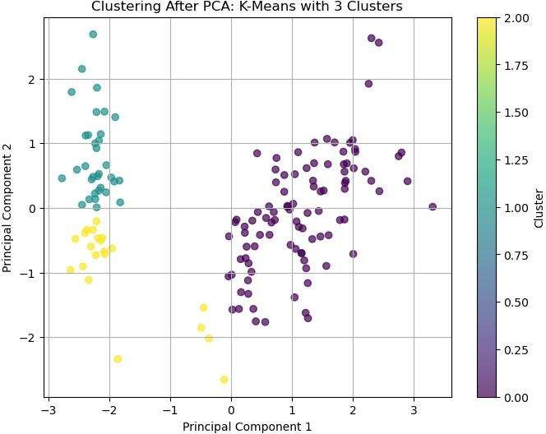
Figure 7.2 clustering after PCA

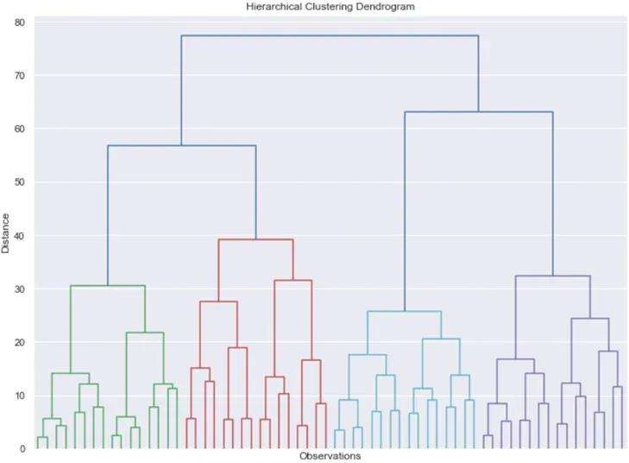
Figure 7.3 Hierarchical clustering dendogram

Cluster Distribution

    - Cluster 1: High-value customers
    - Cluster 2: Medium spending customers
    - Cluster 3: Low-value customers
    - Cluster 4: Occasional buyers

The clusters clearly represent different customer behaviors.

Insights
The evaluation results provided several important business insights:

Customer Behavior Insights

    - High-income customers tend to spend more frequently
    - Some low-income customers show high spending patterns
    - A group of customers is inactive or at risk

Business Insights

    - Target high-value customers with premium offers
    - Provide discounts to low-value customers
    - Re-engage inactive customers with campaigns

Model Insights

    - K-Means is efficient and suitable for large datasets
    - DBSCAN is useful for identifying outliers
    - Combining multiple models improves reliability

Strategic Recommendations

    - Personalized marketing strategies
    - Customer retention programs
    - Data-driven decision-making

Summary

The evaluation phase confirms that the proposed system effectively segments customers into meaningful groups. The use of multiple algorithms and evaluation metrics ensures robustness and accuracy. The insights derived from the results can significantly enhance business strategies and customer engagement.

Chapter 8

SOCIAL, LEGAL, ETHICAL, SUSTAINABILITY AND SAFETY ASPECTS

Social Aspects
The implementation of an AI-driven customer intelligence system has a significant impact on society, particularly in how businesses interact with customers.

Improved Customer Experience
The system enables personalized recommendations and targeted marketing, enhancing customer satisfaction.

Better Decision-Making
Businesses can make informed decisions, leading to improved services and product offerings.

Digital Transformation
Encourages organizations to adopt modern technologies such as AI and data analytics.

Employment Impact
While automation reduces manual work, it also creates opportunities in data science and AI-related roles.

Risk of Digital Divide
Small businesses with limited resources may not fully benefit from such advanced technologies.

Legal Aspects
The system must comply with data protection and privacy laws, as it deals with sensitive customer information.

Data Privacy Regulations
Organizations must follow laws such as:
      - GDPR (General Data Protection Regulation)
      - IT Act (India) for data protection

Data Usage Consent

Customer data should be collected and used only with proper consent.

Data Security Compliance
Measures must be taken to protect data from unauthorized access or breaches.

Intellectual Property Rights
The developed models and code should respect licensing and ownership rules.

Regulatory Compliance
Businesses must ensure transparency in how customer data is analyzed and used.

Ethical Aspects
Ethical considerations are critical when dealing with customer data and AI systems.

Data Privacy and Confidentiality
Customer data must be handled securely and not misused.

Bias and Fairness
Algorithms should avoid bias based on gender, income, or demographics.

Transparency
Customers should be aware of how their data is being used.

Responsible AI Usage
The system should be used to benefit customers, not manipulate them.

Avoiding Discrimination
Segmentation should not lead to unfair treatment of certain groups.

Sustainability Aspects
The project contributes to sustainability in both technological and business aspects.

Efficient Resource Utilization
Data-driven decisions reduce waste and improve efficiency.

Reduced Operational Costs
Automation minimizes manual effort and resource consumption.

Support for Sustainable Development Goals (SDGs)
      - SDG 8: Economic Growth
      - SDG 9: Industry and Innovation

Scalable Systems

The system can be expanded without significant additional resources.

Energy Considerations
Efficient algorithms reduce computational power usage.

Safety Aspects
Safety in this project mainly focuses on data security and system reliability.

Data Security
      - Encryption of sensitive data
      - Secure storage and access control

System Reliability
      - Ensuring the system works without failures
      - Proper testing and validation

Protection Against Cyber Threats
      - Prevent unauthorized access
      - Use secure authentication mechanisms

Backup and Recovery
      - Regular data backups
      - Recovery mechanisms in case of system failure

User Safety
      - Prevent misuse of customer information
      - Ensure ethical handling of insights

Summary

This project demonstrates responsible use of AI by considering social benefits, legal compliance, ethical practices, sustainability, and safety. Addressing these aspects ensures that the system is not only technically effective but also socially responsible and trustworthy.

Chapter 9

CONCLUSION
The internship project titled “AI-Driven Customer Intelligence System for Strategic Business Decision Making” successfully demonstrates the application of machine learning techniques in solving real-world business problems. The primary objective of the project was to analyze customer data and segment customers into meaningful groups using unsupervised learning algorithms.
Throughout the project, a structured machine learning pipeline was followed, including data collection, preprocessing, exploratory data analysis, feature engineering, model building, evaluation, and visualization. Various clustering algorithms such as K-Means, Hierarchical Clustering, DBSCAN, and Gaussian Mixture Models (GMM) were implemented and compared to identify the most effective method for customer segmentation.
The evaluation results indicated that K-Means clustering provided the best balance between performance and efficiency for the given dataset. The use of evaluation metrics such as Silhouette Score and Davies-Bouldin Index ensured that the clustering results were reliable and meaningful. Additionally, visualization techniques such as Principal Component Analysis (PCA) helped in clearly interpreting the clusters.
The system successfully identified distinct customer segments such as high-value customers, budget-conscious customers, frequent buyers, and at-risk customers. These insights can help businesses design targeted marketing strategies, improve customer retention, and enhance overall decision-making.
Overall, the project highlights the importance of data-driven approaches in modern business environments and demonstrates how machine learning can transform raw data into actionable insights.

Future Scope

Although the project achieved its objectives, there are several areas where further improvements and enhancements can be made:

Integration with Real-Time Data

      - Implement real-time data processing for dynamic customer segmentation

Use of Advanced Algorithms
      - Apply deep learning or hybrid clustering techniques for better accuracy

Deployment as a Web Application
      - Develop a user-friendly dashboard using tools like Flask or Streamlit

Incorporation of More Features
      - Include additional customer attributes such as behavioral and social data

Automation of Model Selection
      - Use AutoML techniques to automatically select the best model

Scalability
      - Extend the system to handle large-scale enterprise data using cloud platforms

Business Integration
      - Integrate the system with CRM tools for practical implementation

Final Summary

This internship provided valuable hands-on experience in machine learning, data analysis, and problem-solving. It enhanced technical skills and provided practical exposure to real- world applications of AI. The project not only fulfills academic requirements but also contributes to building industry-relevant skills in data science and analytics.

REFERENCES

The following references were used for understanding concepts, algorithms, and implementation techniques related to customer segmentation and machine learning:
- Han, J., Kamber, M., & Pei, J., Data Mining: Concepts and Techniques, Morgan Kaufmann, 2011.
- Tan, P.-N., Steinbach, M., & Kumar, V., Introduction to Data Mining, Pearson Education, 2016.
- Géron, A., Hands-On Machine Learning with Scikit-Learn, Keras, and TensorFlow, O’Reilly Media, 2019.
- Jain, A. K., “Data Clustering: 50 Years Beyond K-Means,” Pattern Recognition Letters, 2010.
- Rousseeuw, P. J., “Silhouettes: A Graphical Aid to the Interpretation and Validation of Cluster Analysis,” Journal of Computational and Applied Mathematics, 1987.
- Pedregosa, F. et al., “Scikit-learn: Machine Learning in Python,” Journal of Machine Learning Research, 2011.
- McKinney, W., “Data Structures for Statistical Computing in Python,” Proceedings of the 9th Python in Science Conference, 2010.
- Official Documentation:
  - Scikit-learn Documentation: https://scikit-learn.org
  - Pandas Documentation: https://pandas.pydata.org
  - NumPy Documentation: https://numpy.org
- Kaggle Dataset Repository:
  - https://www.kaggle.com

- Bishop, C. M., Pattern Recognition and Machine Learning, Springer, 2006.
- Hastie, T., Tibshirani, R., & Friedman, J., The Elements of Statistical Learning, Springer, 2009.
- Aggarwal, C. C., Data Mining: The Textbook, Springer, 2015.
- Xu, R., & Wunsch, D., “Clustering Algorithms in Biomedical Research: A Review,”
IEEE Reviews in Biomedical Engineering, 2010.
- Ester, M., Kriegel, H. P., Sander, J., & Xu, X., “A Density-Based Algorithm for Discovering Clusters in Large Spatial Databases with Noise (DBSCAN),” KDD

Conference, 1996.
- MacQueen, J., “Some Methods for Classification and Analysis of Multivariate Observations,” Proceedings of the Fifth Berkeley Symposium, 1967.
- Dempster, A. P., Laird, N. M., & Rubin, D. B., “Maximum Likelihood from Incomplete Data via the EM Algorithm,” Journal of the Royal Statistical Society, 1977.
- Kaufman, L., & Rousseeuw, P. J., Finding Groups in Data: An Introduction to Cluster Analysis, Wiley, 2005.
- Everitt, B. S., Landau, S., Leese, M., & Stahl, D., Cluster Analysis, Wiley, 2011.
- Murphy, K. P., Machine Learning: A Probabilistic Perspective, MIT Press, 2012.

Online & Technical Resources

- Towards Data Science (Medium Platform) https://towardsdatascience.com
- Analytics Vidhya https://www.analyticsvidhya.com
- GeeksforGeeks – Machine Learning Section https://www.geeksforgeeks.org/machine-learning/
- Google Developers – Machine Learning Crash Course https://developers.google.com/machine-learning
- IBM Cloud Learn Hub – Machine Learning https://www.ibm.com/topics/machine-learning

BASE PAPAER
The base paper provides the foundational conceptation using clustering techniques.

Title: A Survey of Clustering Techniques in Data Mining
Authors: Xu, R., & Wunsch, D.
Year: 2005

Summary of Base Paper

The paper provides a comprehensive overview of clustering techniques used in data mining. It categorizes clustering algorithms into different types such as partitioning methods, hierarchical methods, density-based methods, and model-based methods.
Key insights from the paper include:

- No single clustering algorithm is suitable for all types of datasets
- The choice of algorithm depends on data characteristics
- Evaluation metrics are essential for validating clustering results
- Hybrid approaches can improve clustering performance

This paper served as a theoretical foundation for selecting and implementing clustering algorithms in this project.

APPENDIX - A

The appendix includes supplementary materials and additional information related to the project.

Appendix A: Sample Dataset Attributes

Attribute Name | Description
Customer ID | Unique identifier for each customer
Age | Age of the customer
Gender | Customer gender
Annual Income | Income level
Spending Score | Customer spending behavior

Appendix B: Key Python Libraries Used

- Pandas
- NumPy
- Matplotlib
- Seaborn
- Scikit-learn

Appendix C: Sample Code Snippet

from sklearn.cluster import KMeans
from sklearn.preprocessing import StandardScaler

# Scaling
scaler = StandardScaler()
scaled_data = scaler.fit_transform(data)

# K-Means
kmeans = KMeans(n_clusters=4)

data['Cluster'] = kmeans.fit_predict(scaled_data)

Appendix D: Evaluation Metrics

- Silhouette Score – Measures cluster quality (higher is better)
- Davies-Bouldin Index – Measures cluster separation (lower is better)
- Elbow Method – Determines optimal number of clusters

Final Note

This appendix supports the main report by providing additional technical details, code, and outputs used during the project.

