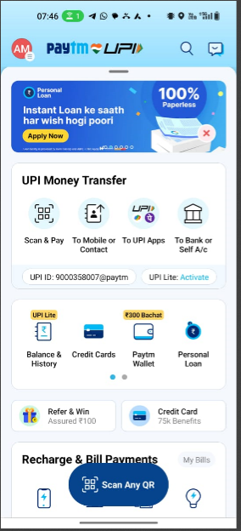

**Step-1 Create Java Project**



**Step- 2 Create base or root package**

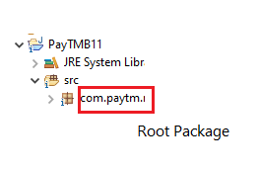

**Step-3 Create the class MoneyTransfer.java**

3.1 First create another package **moneytransfer** under root package (**com.paytm**) and then add a MoneyTransfer class in the **com.paytm.moneytransfer** package

3.2 Add the methods inside the MoneyTransfer class

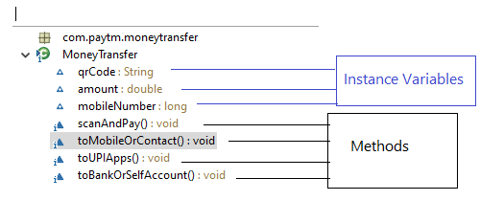

**Step-4 Create a test class TestPayTM.java to test our above objects.**