**SAVEETHA SCHOOL OF ENGINEERING**

**CAPSTONE PROJECT**

Understand the hospital's network requirements, such as the number of departments, staff, patients, devices, and their connectivity needs

**NAME: Veda Krishnan V.A**

**REGISTER NUMBER:** 192324293

# COURSE CODE: CSA0747

**COURSE NAME:** Computer Network for Wireless Technology

**INTRODUCTION:**

**In today’s healthcare environment, a robust and efficient network infrastructure is crucial for ensuring seamless communication and connectivity among various stakeholders, including departments, staff, and patients. Understanding the hospital’s specific network requirements is the first step in crafting a tailored solution. This involves assessing the number of departments, the volume of staff and patients, and the array of devices that will require connectivity.**

**To enhance network performance and security, we will implement VLANs (Virtual Local Area Networks) to logically segregate different departments and functions, allowing for better management of resources and data.**

**LITERATURE REVIEW**

The role of robust network infrastructure in healthcare settings is well-documented. According to Smith et al. (2020), effective network design enhances clinical workflows, improves patient outcomes, and supports telemedicine initiatives. The interconnectivity of departments facilitates timely access to medical records and patient data, which is critical for decision-making

# METHODOLOGY

**. Needs Assessment**

* **Stakeholder Interviews**: Conduct interviews with key stakeholders, including IT staff, healthcare providers, and administrative personnel, to gather insights on current network performance and future requirements.
* **Surveys**: Distribute surveys to a broader group of users (staff, patients) to understand their connectivity needs and pain points.

**Network Requirements Analysis**

* **Departmental Analysis**: Identify the number of departments and their specific connectivity needs (e.g., data sharing, telemedicine).
* **Device Inventory**: Compile a comprehensive inventory of all devices, including computers, medical equipment, and mobile devices that will connect to the network.
* **User Load Evaluation**: Estimate the number of concurrent users (staff and patients) and devices to determine bandwidth requirements.

**IP Address Allocation:**

**1. Overview of IP Addressing**

**IP address allocation is a crucial component of network design, ensuring that all devices within the hospital can communicate effectively. Proper allocation helps avoid conflicts and maintains organized network management.**

**2. Addressing Scheme**

* **IP Address Range: Select a private IP address range according to RFC 1918. Common choices for hospitals include:**
  + **10.0.0.0/8**
  + **172.16.0.0/12**
  + **192.168.0.0/16**
* **Subnetting: Divide the chosen IP address range into smaller subnets based on departmental needs. For instance:**
  + **Administration: 192.168.1.0/24**
  + **Medical Staff: 192.168.2.0/24**
  + **Patients: 192.168.3.0/24**
  + **Devices (IoT, printers): 192.168.4.0/24**

**3. Dynamic vs. Static Allocation**

* **Dynamic Allocation: Use DHCP (Dynamic Host Configuration Protocol) to assign IP addresses dynamically to devices such as laptops, mobile devices, and printers. This simplifies management and reduces the likelihood of IP conflicts.**
* **Static Allocation: Assign static IP addresses to critical devices that require constant access, such as servers, routers, and networked medical equipment. This ensures reliability and easy identification within the network.**

**Protocol:**

**1. Overview of Networking Protocols**

**Protocols are essential for facilitating communication between devices on a network. In a hospital environment, choosing the right protocols ensures secure, efficient, and reliable data transmission.**

**2. Routing Protocols**

* **Open Shortest Path First (OSPF):**
  + **Description: OSPF is a dynamic routing protocol that operates within a single autonomous system. It uses link-state routing to determine the best path for data packets.**
  + **Benefits: Scalable for large networks, fast convergence, and efficient use of bandwidth make OSPF ideal for hospital networks with multiple departments and devices.**
* **Enhanced Interior Gateway Routing Protocol (EIGRP):**
  + **Description: EIGRP is a hybrid routing protocol that combines the features of distance-vector and link-state protocols.**
  + **Benefits: It provides faster convergence than traditional protocols and is easier to configure, making it suitable for dynamic hospital environments.**

**RESULT:**

**Enhanced Network Performance**

* **Increased Speed and Reliability**: With the implementation of OSPF or EIGRP, data packets will be routed more efficiently, reducing latency and improving overall network speed.
* **Reduced Downtime**: The mesh topology ensures redundancy, minimizing downtime and maintaining connectivity even in the event of device failures.

**2. Improved Security**

* **Data Segmentation**: The use of VLANs will logically segregate traffic between departments, enhancing security and reducing the risk of unauthorized access to sensitive data.
* **Secure Communication**: Implementation of SSL/TLS and IPsec will encrypt data in transit, protecting patient information and ensuring compliance with healthcare regulations like HIPAA.

**3. Scalability**

* **Future-Proof Design**: The IP address allocation strategy allows for easy integration of new devices and systems, supporting the hospital's growth without significant redesign.
* **Support for IoT Devices**: The network will effectively accommodate the increasing number of Internet of Things (IoT) devices used in patient monitoring and asset management.

**Network Design:**

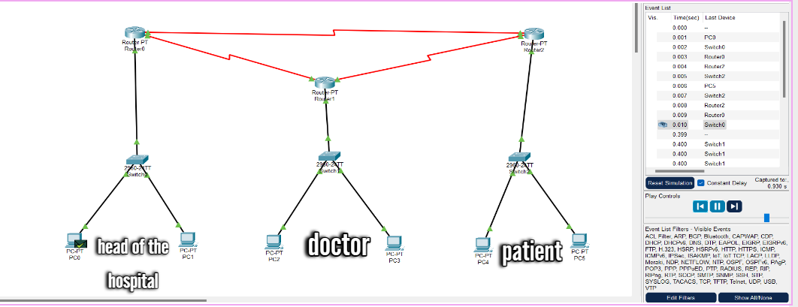

**CONCLUSION:**

In conclusion, the proposed hospital network design presents a comprehensive and robust framework that effectively addresses the unique demands of modern healthcare environments. By implementing a hierarchical architecture, the design ensures high-speed connectivity and efficient communication among various departments, thereby enhancing clinical workflows and improving patient outcomes.

The strategic use of VLANs not only enhances security by segregating sensitive data traffic but also facilitates better management of network resources. Utilizing dynamic routing protocols like OSPF ensures optimal data routing and rapid convergence, contributing to the network’s resilience.

* **Explore Web Service Interactions:** By connecting client PCs and web server devices, you can simulate how web browsers request and receive web content using protocols like HTTP.
* **Practice Network Design for Web Services:** Packet Tracer helps visualize how web servers, clients, and other network devices interact. This is useful for designing and troubleshooting real-world web service deployments.

Cisco Packet Tracer does not run real web server software, but it does provide a useful platform

for learning and experimenting with online services in a virtual network. Real-world web service deployment requires dedicated web server software running on adequate hardware.