Rmarkdown_example

Veda

2023-04-01

# **R Markdown**

It has three types of content which include text, code chunks and YAML metadata which build Rmarkdown. Code chunk can be run without interference from text. Multiple code chunks and of different programming languages like Python and SQL can also be included in the same document. The result of the code run can also be seen in the form of out put along with explanation in the same document. The R code and output from following code chunks will normally appear in the produced content because the code chunk in this instance sets the default “echo” option to “TRUE.” This code chunk may not be included in the output due to the ‘include=FALSE’ parameter.

## *Dataset* ‘pressure’

The following code loads data of dataset ‘pressure’, summarizes the dataset and plots the relationship between temperature in degrees celsius and mercury pressure in mm of Hg.

library(datasets)  
data(pressure)  
summary(pressure)

## temperature pressure   
## Min. : 0 Min. : 0.0002   
## 1st Qu.: 90 1st Qu.: 0.1800   
## Median :180 Median : 8.8000   
## Mean :180 Mean :124.3367   
## 3rd Qu.:270 3rd Qu.:126.5000   
## Max. :360 Max. :806.0000

plot(pressure, xlab = "Temperature (deg C)",  
 ylab = "Pressure (mm of Hg)",  
 main = "pressure data: Vapor Pressure of Mercury")

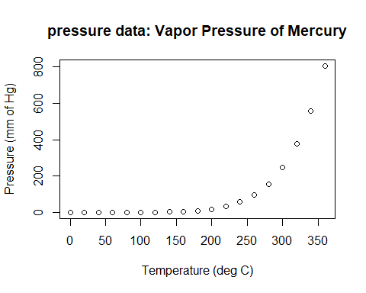

plot(pressure, xlab = "Temperature (deg C)", log = "y",  
 ylab = "Pressure (mm of Hg)",  
 main = "pressure data: Vapor Pressure of Mercury")

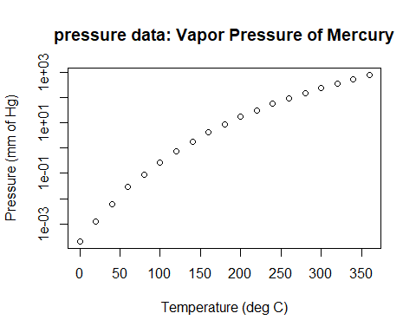

## *Dataset* ‘quakes’

The following code loads data and creates a scatter plot of data of earthquakes in Fiji.

library(datasets)  
data(quakes)  
pairs(quakes, main = "Fiji Earthquakes, N = 1000",col=rainbow(12), cex.main = 1.5, pch = ".")

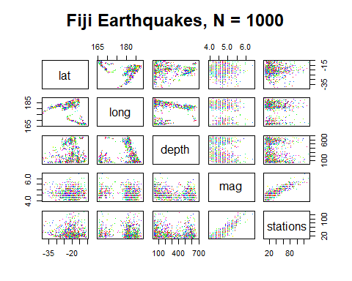

## Matrices

The matrices ‘A’ and ‘B’ are created and ‘transpose’ function is implemented to them. Two vectors ‘a’ and ‘b’ are created and multiplied with matrices.

A = matrix(1:10, nrow=10)  
B = matrix(1:10, nrow=10)  
A

## [,1]  
## [1,] 1  
## [2,] 2  
## [3,] 3  
## [4,] 4  
## [5,] 5  
## [6,] 6  
## [7,] 7  
## [8,] 8  
## [9,] 9  
## [10,] 10

#Transpose A and B  
t(A)

## [,1] [,2] [,3] [,4] [,5] [,6] [,7] [,8] [,9] [,10]  
## [1,] 1 2 3 4 5 6 7 8 9 10

t(B)

## [,1] [,2] [,3] [,4] [,5] [,6] [,7] [,8] [,9] [,10]  
## [1,] 1 2 3 4 5 6 7 8 9 10

#create two vectors (a and b)  
a = c(1:5)  
b = c(1:10)  
#multiply matrices by vectors  
X = a*A  
Y = b*B  
X

## [,1]  
## [1,] 1  
## [2,] 4  
## [3,] 9  
## [4,] 16  
## [5,] 25  
## [6,] 6  
## [7,] 14  
## [8,] 24  
## [9,] 36  
## [10,] 50

Y

## [,1]  
## [1,] 1  
## [2,] 4  
## [3,] 9  
## [4,] 16  
## [5,] 25  
## [6,] 36  
## [7,] 49  
## [8,] 64  
## [9,] 81  
## [10,] 100

## Python

The following code chunk is in Python language and it prints Hello, World from 1 to 10.

for i in range(1,11):  
 print("Hello, World%d" % i)

## Hello, World1  
## Hello, World2  
## Hello, World3  
## Hello, World4  
## Hello, World5  
## Hello, World6  
## Hello, World7  
## Hello, World8  
## Hello, World9  
## Hello, World10

After saving the file, select knit to HTML, which will result in an HTML document containing all the information of YAML metadata, text, code chunks and output which will make it easier to view the output of different kinds of data set in one file.