**Module#4 Programming structure in R assignment**

**Creating Boxplot and Histogram**

**The names of 5 variables in the dataset are as follows:**

‘Frequency’,‘BP’, ‘First’, ‘Second’, ‘FinalDecision’

1.    "0.6","103","bad","low","low”  
2.     "0.3","87","bad","low","high”  
3.     "0.4","32","bad","high","low”  
4.      "0.4","42","bad","high","high"  
5.     "0.2","59","good","low","low”  
6.      "0.6","109","good","low","high”  
7.     "0.3","78","good","high","low”  
8.      "0.4","205","good","high","high”  
9.      "0.9","135",”NA","high","high"  
10.    "0.2","176", “bad","high","high”

**Conversion of the following data into code and obtaining data.frame from it:**

**>**Freq <- c(0.6,0.3,0.4,0.4,0.2,0.6,.3,0.4,0.9,0.2)  
# frequency of hospital visits by patients during 12 month period  
**>**BP <- c(103,87,32,43,59,109,78,205,135,178) # blood pressure of each individual patient   
**>**First <- c(1,1,1,1,0,0,0,0,NA,1)# first doctor evaluation of BP, where 1=bad and 0=good  
**>**Second <- c(0,0,1,1,0,0,1,1,1,1) # second and final evaluation of BP, where 0=low and 1=high  
**>**Final <- c(0,1,0,1,0,1,0,1,1,1)  
**>**hospital.df <- data.frame(Freq,BP,First,Second,Final) # contain everything under hospital data.frame.

Frequency BP First Second Final

1 0.6 103 1 0 0

2 0.3 87 1 0 1

3 0.4 32 1 1 0

4 0.4 42 1 1 1

5 0.2 59 0 0 0

6 0.6 109 0 0 1

7 0.3 78 0 1 0

8 0.4 205 0 1 1

9 0.9 135 NA 1 1

10 0.2 176 1 1 1

**Find the mean of the final decision and BP rating using code:**

> mean(Final)

[1] 0.6

> mean(BP)

[1] 102.6

**Plot side-by-side histograms and boxplot of each variable using (boxplot (x, ...)) and histogram ((hist(x, ...)) and implementing code ‘par(mfrow=c(1,5))’ to create a matrix of plots in one plotting space along with it.**

> par(mfrow=c(1,5))

> hist(hospital.df$BP,col= "green",main="Histogram of the BP variable")

> hist(hospital.df$Frequency,col="red",main="Histogram of the Frequency variable")

> hist(hospital.df$First,col="purple",main="Histogram of the First variable")

> hist(hospital.df$Second,col="yellow",main="Histogram of the Second variable")

> hist(hospital.df$Final,col="brown",main="Histogram of the Final variable")

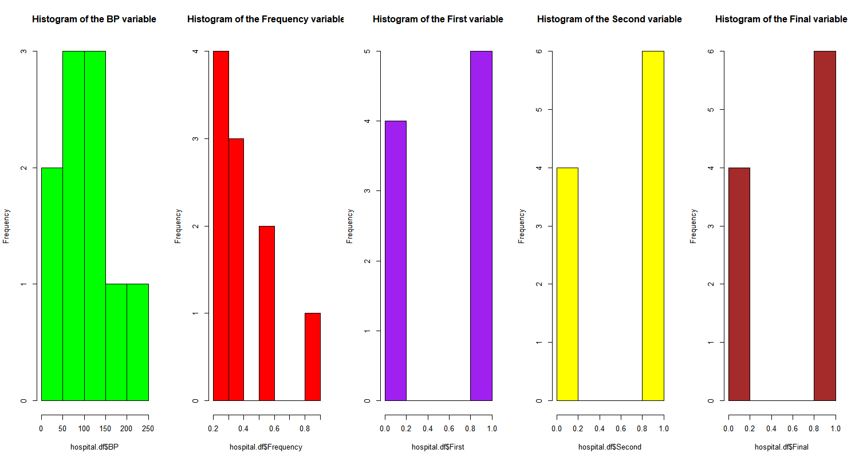

> par(mfrow=c(1,5))

> boxplot(hospital.df$BP,col= "green",main="boxplot of the BP variable")

> boxplot(hospital.df$Frequency,col="red",main="boxplot of the Frequency variable")

> boxplot(hospital.df$First,col="purple",main="boxplotof the First variable")

> boxplot(hospital.df$Second,col="yellow",main="boxplot of the Second variable")

> boxplot(hospital.df$Final,col="brown",main="boxplot of the Final variable")

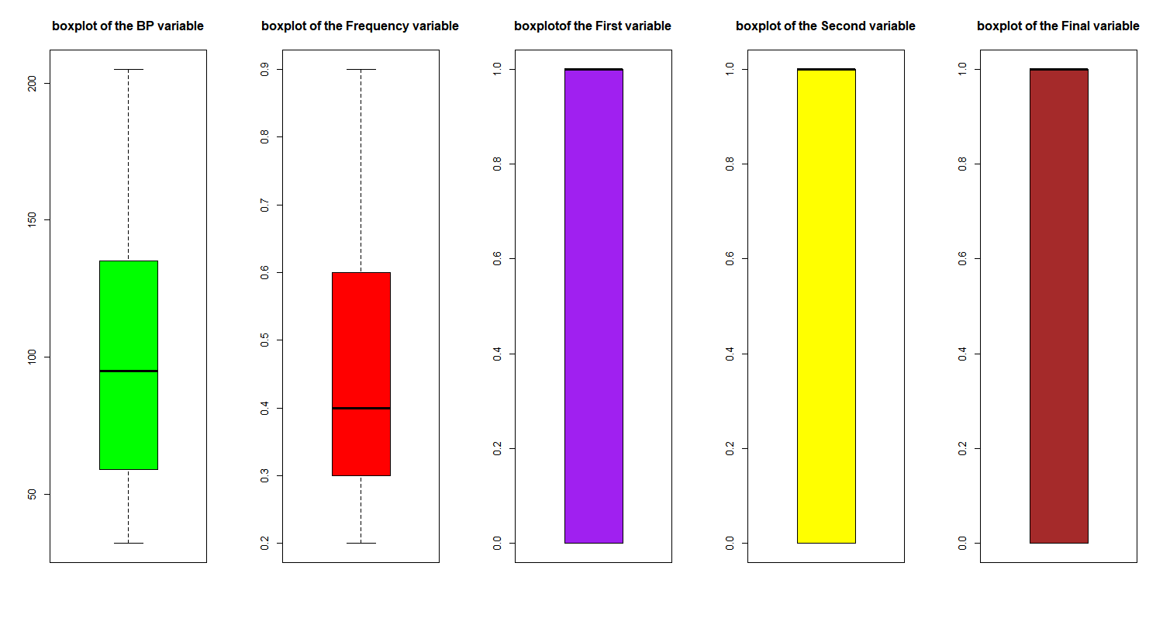

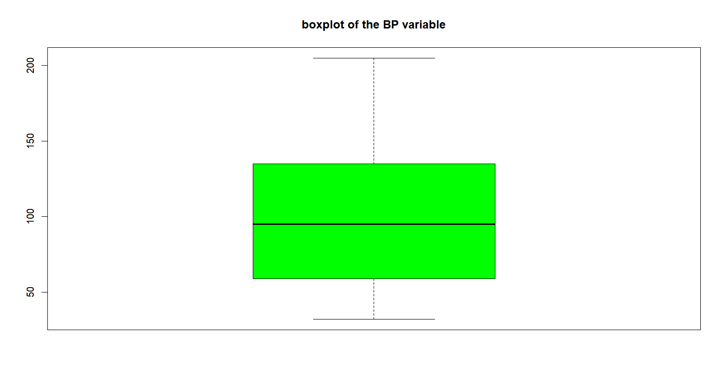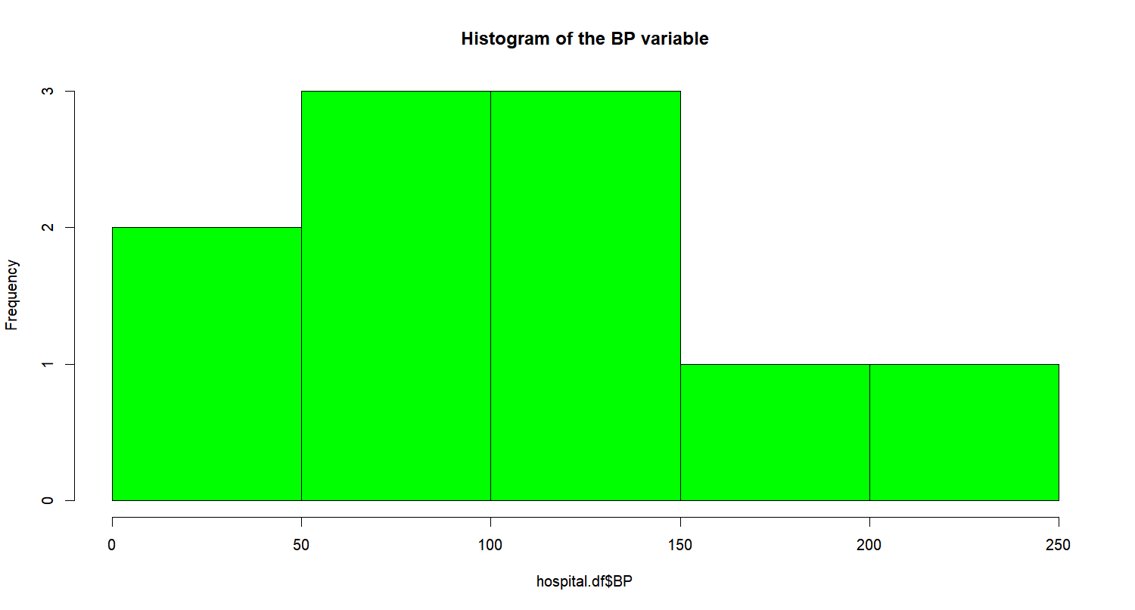

**Results regarding patient’s** **Blood Pressure:**

**From the histogram and boxplot created, it can be observed that most of the patient’s blood pressure is in the range of 59 to 140 and other patients blood pressure lies in the lies below 50 and above 140. Mean of the patient’s blood pressure is 102.6. Lower Quartile range is 59. Upper quartile range is 140. Mean of the final decision ratings is 0.6.**