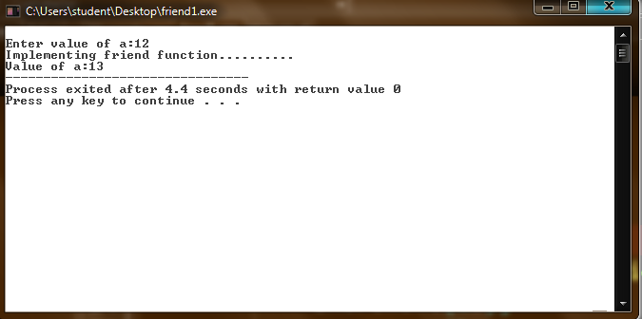

#include<iostream>

using namespace std;

class A{

public:

int a;

void friend increment();

void input(){

cout<<endl<<"Enter value of a:";

cin>>a;

}

void output()

{

cout<<endl<<"Value of a:"<<a;

}

};

void increment(A \*a)

{

a->a++;

}

int main(){

A a;

a.input();

cout<<"Implementing friend function..........";

increment(&a);

a.output();

return 0;

}

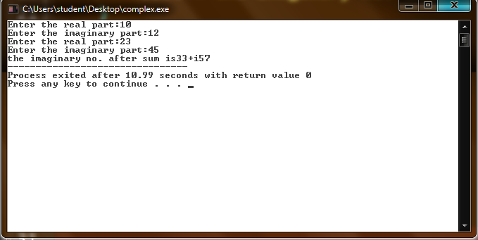

#include<iostream>

#include<conio.h>

using namespace std;

class complex

{

float i,j;

float a,b;

public:

void insert()

{

cout<<"Enter the real part:";

cin>>i;

cout<<"Enter the imaginary part:";

cin>>j;

}

complex add(complex \*x,complex \*y)

{

a=x->i+y->i;

b=x->j+y->j;

cout<<"the imaginary no. after sum is"<<a<<"+i"<<b;

}

};

int main()

{

complex c1,c2,c3;

c1.insert();

c2.insert();

c3=c3.add(&c1,&c2);

return 0;

}



#include<iostream>

using namespace std;

class B;

class A {

public:

int a;

void input(){

cout<<endl<<"Enter value of a:";

cin>>a;

}

friend class B;

void output()

{

cout<<endl<<"Value of a:"<<a;

}

};

class B{

public:

void increment(A \*a)

{

a->a++;

}

};

int main(){

A a;

a.input();

cout<<"Implementing friend class..........";

B b;

b.increment(&a);

a.output();

return 0;

}