1.1

Name: Hero MotoCorp

Type: Large-cap (Globally, it ranks among the largest two-wheeler manufacturers)

Manufacturing based company…

Export: **Globally Active**

<https://www.seair.co.in/indian-trader/hero-motocorp-limited.aspx>

– Product changes made between domestic and global market**

1.2

Owner: Pawan Munjal

CEO: Niranjan Gupta

Others:

* Dr Pawan Munjal: Executive Chairman and Whole-Time Director. He is a renowned corporate leader in India who champions growth, technological innovations, and socio-economic progress.
* Dr Brijmohan Lall Munjal: Chairman Emeritus.
* Niranjan Kumar Gupta: Chief Executive Officer.
* Vivek Anand: Chief Financial Officer.
* Sanjay Bhan: Chief Business Officer, Head (Global Business).
* Mike Clarke: Chief Operating Officer.
* Reema Jain: Chief Information & Digital Officer.

1.3

Employee Count: ~ 10k

Gender ratio: Over the past five years, Hero MotoCorp, the world's largest manufacturers of motorcycles and scooters, has increased women’s participation in the workforce from 2% to 10%. Going forward, the automotive giant looks to increase its women workforce to 30% by 2030, and boost its leadership diversity to 25% from 8% over the next two years by adopting a pragmatic approach to attracting, retaining and nurturing female talent within the organisation.

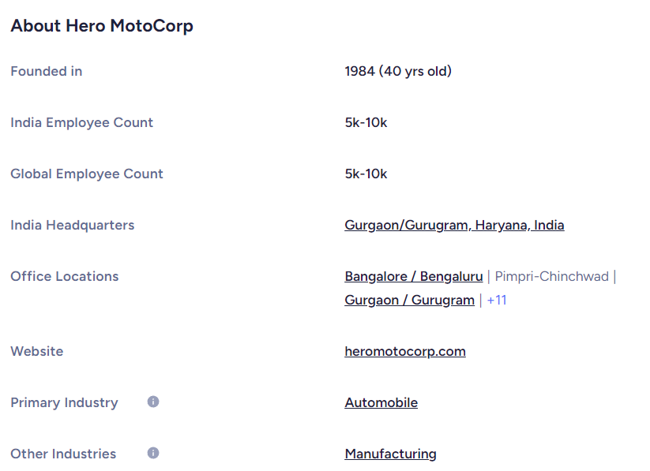

9,225 (of which 512 are women) skilled technical employees. Almost 24,741 non-technical unskilled labour.

1.4

Hero MotoCorp does job analysis internally (Company is involved).

Job analysis:

Type of job:

* Plant operations and services: Majority of jobs offered are related to manufacturing, production activities and maintenance.
* Sales: Customer service, dealerships and sales strategy.
* R&D: Research, development, product design and engineering.
* IT: Information technology, software development and digital transformation.
* Strategic Sourcing and Supply: Managing suppliers and distributors and their logistics.
* HR: The job most closely related to Industrial Psychology: Talent management, recruitment, and employee welfare programs.

These types of roles align Hero MotoCorp with a multinational manufacturing corporation.

Job analysis is done regularly as a part of their human resource and operational strategy.

1.5 Recruitment and selection:

56% of recruitment is campus recruitment (external). 24% by recruitment agencies (external), 10% from company website. 10% from internal sources (employee referral) and other sources.

Selection process is moderate. Employees find good work culture.

1.6

The training & development team at Hero Corporate has developed content and trained over 10,000+ employees in the Automotive & Manufacturing Industries in India. The cell arranges for world-class speakers and experts in various areas of economy to address different groups of individuals. This provides a platform for inter-disciplinary learning, brain-storming as well as knowledge creation and sharing. The key success factor for the ongoing Training & Development cell at Hero Corporate is to understand the need of the hour at both ends of the spectrum. At the board-level, video based and class room teaching methods for a variety of topics ranging from quality management, benchmarking to personality management programmes is used across the group for senior professionals. The shop-floor level initiatives across various ancillaries and manufacturing companies in the Manufacturing network have created uniformity in understanding as well as horizontal deployment of best practices across companies. Peer-to-Peer learning as well as inter-company learning have been encouraged through several programmes. Some of the training programmes being run by the training & development team are: Time management, Supervisory development, Kaizen, Train-the-Technical Trainer, Auditing for ISO 9002, 7QC tools, TS16949 awareness, FMEA, APQP Training, Self-Development Workshops, MSA, Positive Attitude, Conflict Management, Personal Effectiveness, Lateral Thinking, Creativity & Innovation etc.

1.7 <https://www.ijcms2015.co/file/2020/vol-5-issue-1/aijra-vol-5-issue-1-01.pdf>

Refer to this pdf.

1.8 Rules and Regulations: <https://www.heromotocorp.com/en-in/rules-and-regulations.html>

(Employee specific rules*)

1.9 Psychologist:

<https://www.linkedin.com/in/dr-kamal-karamchandani-76b13618/?originalSubdomain=in>

* 1. The company emphasizes career growth, employee wellbeing, competitive compensation, leaves, mental health assistance, career progression plans, and offers inclusive policies such as flexible working hours and health benefits, including child care and fertility assistance.

Also refer to WE CARE.pdf



**2**

* Refer rules and regulations link above.
* Refer Annual report in the group.