Project Documentation: Global Malnutrition Trends (1983–2019)

1. Project Overview
This Power BI project aims to analyze global malnutrition trends from 1983 to 2019, focusing on key indicators such as underweight, overweight, stunting, and their relationship with income classification. The dataset focuses on children under five years of age and provides critical insights into how economic status and geographical location contribute to malnutrition disparities globally.

2. Data Sources
The analysis is based on a dataset including the following major metrics:
- Count of Under-5 Population: 152
- Sum of Underweight Individuals: 14.29K (14,290)
- Sum of Survey Sample (N): 343M (343,000,000)
These data points were visualized using Power BI to explore trends, patterns, and insights.

3. Key Findings & Insights
✅ Underweight & Overweight Insights
- A total of 14,290 underweight individuals were recorded.
- The second income classification group had the highest count of overweight individuals (over 2000 cases).
✅ Stunting vs. Income Classification
- There's a strong inverse correlation between income level and stunting:
- Low-income groups (Classification 0) had the highest stunting rates.
- High-income groups (Classification 3) had minimal stunting rates.
✅ Country-specific Trends
- Venezuela had the highest overweight count, followed by:
- Vietnam
- Zimbabwe
- Zambia
- Yemen

4. Visualizations
The dashboard consists of several interactive visual elements:
📊 KPIs (Key Performance Indicators)
- Displaying:
- Total U5 population (152)
- Underweight count (14.29K)
- Survey sample size (343M)
📊 Stacked Column & Line Chart
Title: Sum of LDC, LIFD, LLDC/SID2 and Average of Stunting by Income
- X-axis: Income Classification (0 to 3)
- Y-axis (left): Developmental classifications (LDC, LIFD, LLDC/SID2)
- Y-axis (right): Average stunting
- Insight: Higher development levels correspond to lower stunting rates.
📊 Ribbon Chart
Title: Sum of Overweight by Country
- Highlights top countries with high overweight cases.
📊 Area Chart
Title: Sum of Underweight and Overweight by Income Classification
- Visual comparison of both malnutrition types across income classes.

5. Design & Interactivity
The dashboard uses:
- Consistent pastel color themes for clarity and differentiation.
- Multiple chart types for multi-dimensional analysis.
- Logical layout for KPI cards, charts, and highlights.
- Interactive slicers/filters (optional for future enhancement).

6. Tools Used
- Data Visualization: Microsoft Power BI
- Design Principles: Clarity, consistency, audience-focused layout

7. Future Scope
- Adding filters by region or country for deeper exploration.
- Including year-wise trend analysis for time-series insights.
- Exploring other factors influencing malnutrition (e.g., education, healthcare).
- Integration with real-time data sources for live updates.

8. Limitations
- Under-5 population count of 152 seems to represent a subset or sample, not the global figure.
- The analysis currently covers a limited number of countries in overweight statistics, not a complete global representation.

9. Dashboard
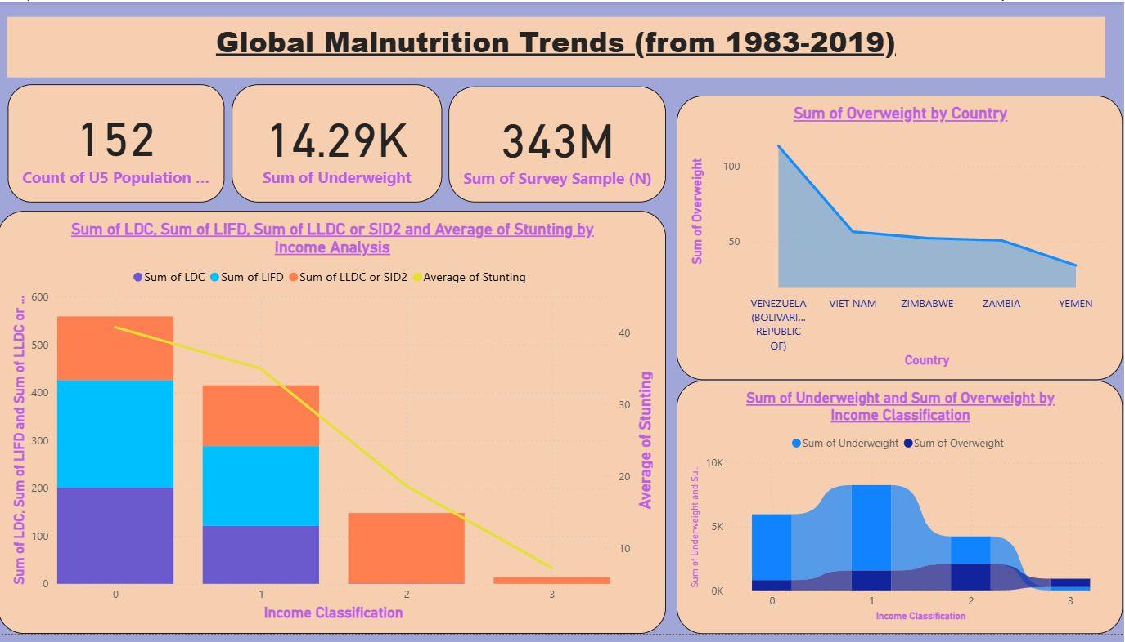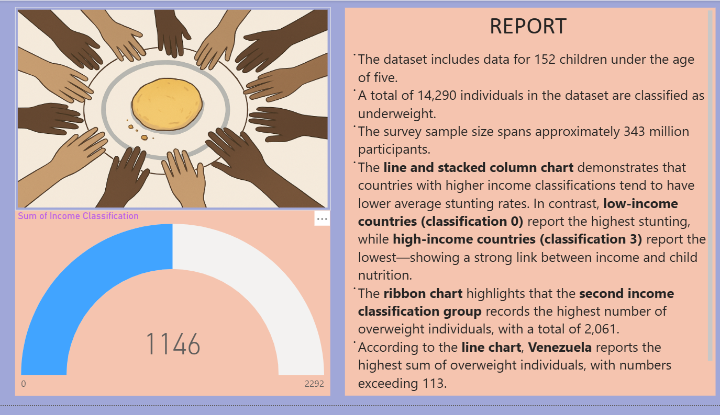

10. Created By
Vishal Singh Chauhan
CSE(Data Science), ABES Engineering College

