|  |  |
| --- | --- |
| Email:  vedang_shinde_it@modoerncoe.edu.in  LinkedIn: https://www.linkedin.com/in/vedang-shinde-759a90297  Contact: 8624090755 Address:  Sadashiv Peth , Pune - 411042 | RAJNISH KUMAR  To secure a responsible career opportunity to fully utilize my training and skills, while making a significant contribution to the success of the company.  **EDUCATION**  B.Tech, Information Technology & Engineering  Modern College of Engineering , Pune  Senior Secondary Examination XII - HSC  Fergusson College ,Pune. |

Secondary Examination X - SSC

PES Modern High School Pune,

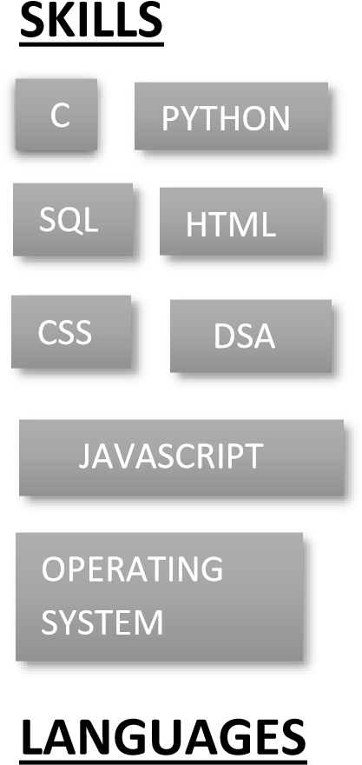

# CERTIFICATES

Accenture Developer Program:

Completed Virtual developer program "Accenture"

Enterprises-Grade Artificial Intelligence from IBM:

Online learning experience concept, methods, and tools related to Artificial Intelligence.

Aws Academy Graduate badge from Amazon:

Certification of Completion “AWS Academy”

Cyber Security Certification from Skill Up

Certificate of Completion “Skill Up”

# TOOLS

Marathi , English ,Hindi and German VS Code, IntelliJ, Eclipse

**INTERESTS**



To learn new

Technologies



Cooking



Ready to be

part of GD’s

# COURSEWORK

Design and Analysis Of Algorithms , Oops

**PERSONAL PROJECTS**

* Desktop Voice Assistant(04/2022-Present)

AI Based Desktop Voice Assistant Using Python

* Canteen Website for College (12/2022)

Using HTML, CSS, JavaScript, and Bootstrap.

* IC-TAC-TOE Game (05/2022)