1. Install the Selenium IDE extension in your Chrome or Firefox browser and confirm it appears in your browser toolbar.
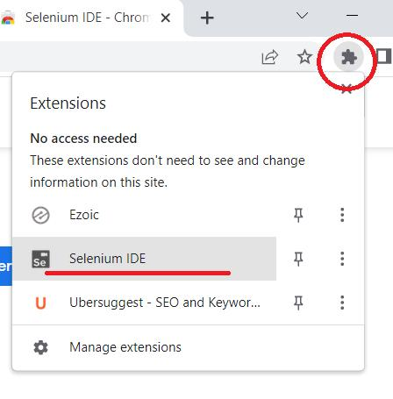
Ans:

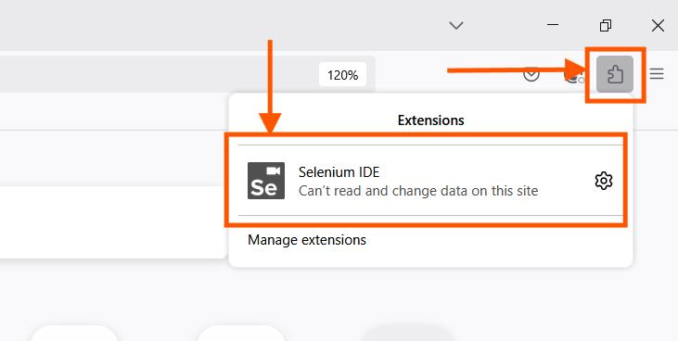

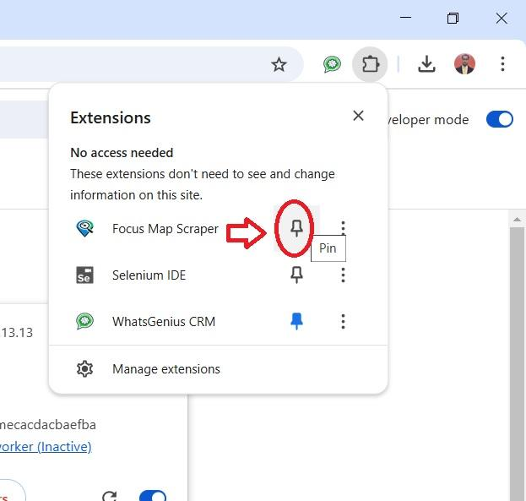

2. Use Selenium IDE to record a test case that opens the Flipkart homepage, searches for 'headphones', and clicks on the first product link.
Ans:

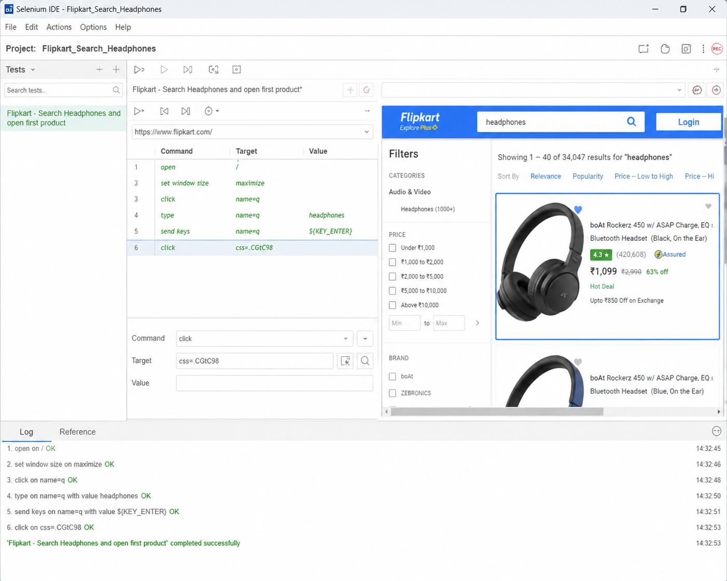

3. With Selenium IDE, record a test that logs into Instagram's web login page using any dummy credentials and verifies that an error message appears. Look for a 'verify text' or 'assert' command to check for the error.
Ans:

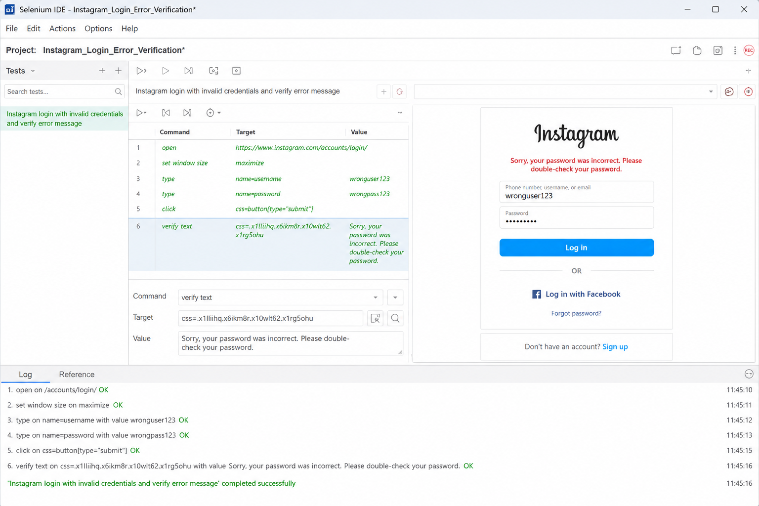

4. Install Katalon Recorder and record a test that opens Zomato, enters 'pizza' in the search bar, and captures a screenshot after the results load. Use the screenshot command provided by the tool.
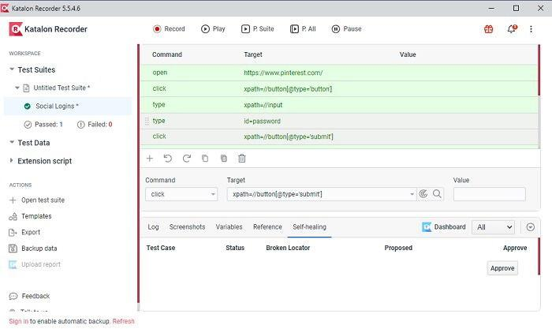
Ans:

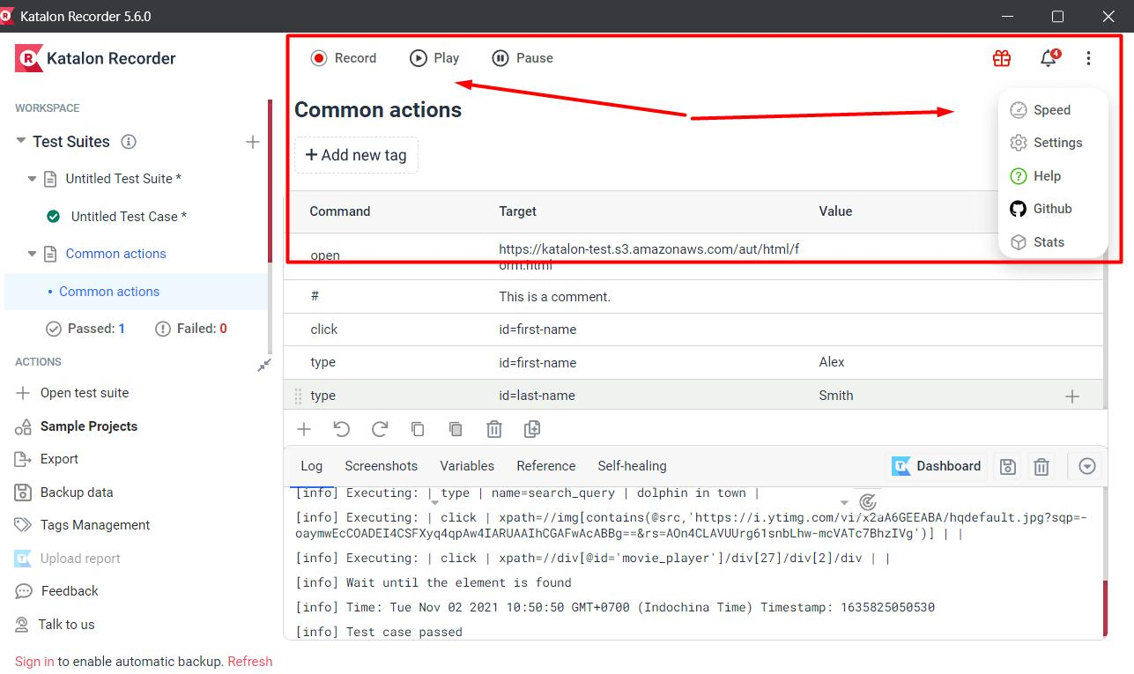

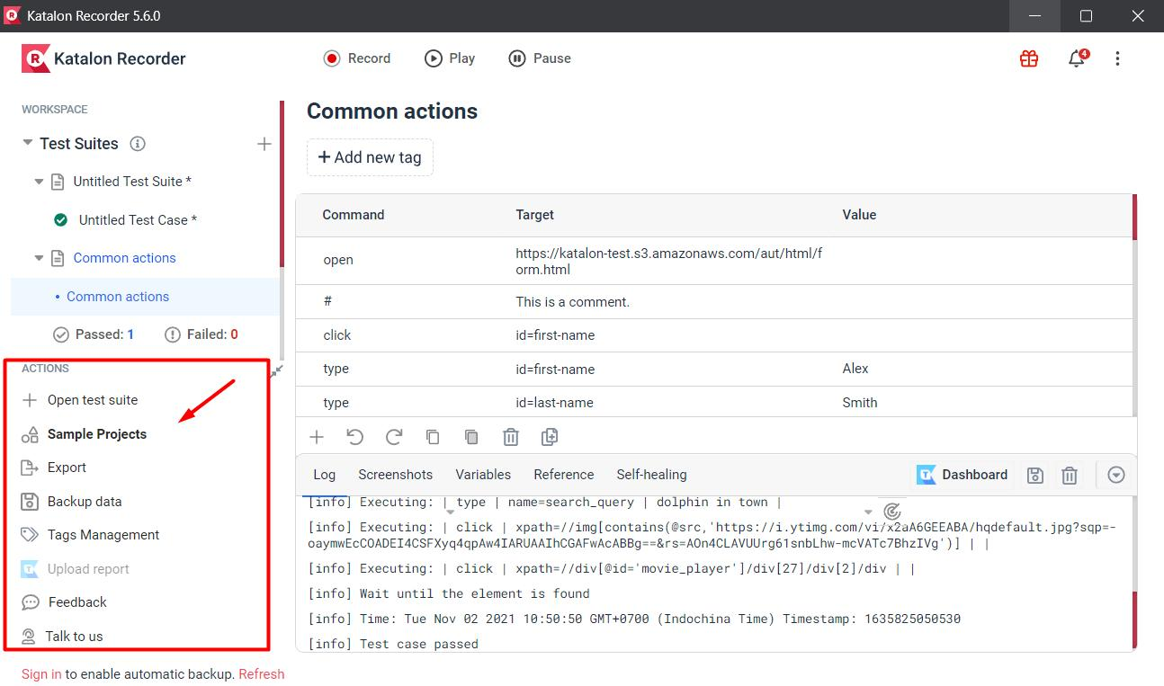

5. List 3 types of website tasks that non-programmers can automate using Selenium IDE or Katalon Recorder, and for each, briefly explain one limitation they might face with no-code automation.
Ans:
