1.Sign up for a free Jira account, create a new project named 'Food Delivery App QA', and add a sample bug titled 'Order status not updating after payment'.
Ans:
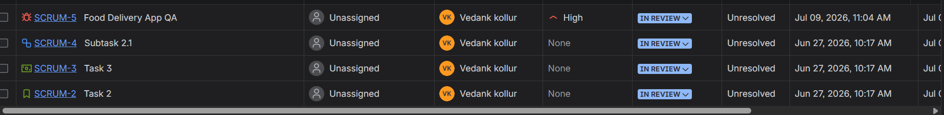
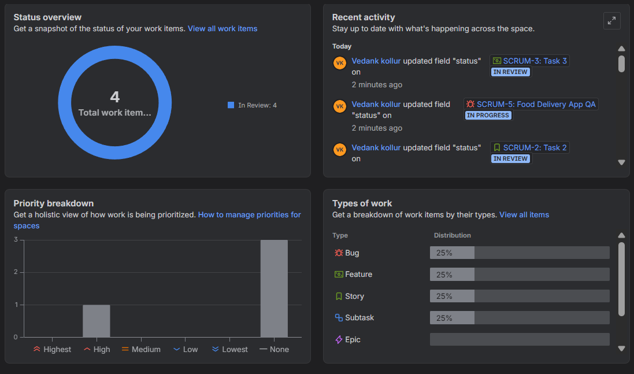

2. Fill out a defect report in Jira for a bug you found in any app you use daily (like Zomato, Flipkart, or Paytm), using all main fields: Summary, Description, Steps to Reproduce, Expected Result, Actual Result, Severity, and Priority. Use a real or imagined bug, but make the details specific and realistic.
Ans:
Defect Report
Application: Zomato
Summary:
Order tracking status is not updating after the delivery partner picks up the order.
Description:
When a user places a food order and the delivery partner picks it up, the order tracking status remains stuck on “Preparing Order” instead of changing to “Out for Delivery”. This creates confusion for users about the actual delivery progress.
Steps to Reproduce:
- Open the Zomato app.
- Log in with a valid account.
- Select a restaurant and place an order.
- Complete the payment process.
- Wait until the delivery partner picks up the order.
- Check the order tracking status.
Expected Result:
The order status should update automatically to “Out for Delivery” once the delivery partner picks up the order.
Actual Result:
The order status remains “Preparing Order” even after the delivery partner has picked up the order.
Severity:
Medium
Priority:
High
3. Given these three bugs found in a movie ticket booking app: (1) Payment fails for UPI, (2) Movie poster image is blurry, (3) App crashes if you book more than 10 tickets at once — classify each bug as High/Medium/Low Severity and High/Medium/Low Priority, and justify your choices.
Ans:
Bug | Severity | Priority | Justification
1. Payment fails for UPI | High | High | This directly blocks users from completing ticket purchases using a major payment method. It has a significant business impact (lost revenue) and should be fixed as soon as possible.
2. Movie poster image is blurry | Low | Low | The issue affects the visual quality of the app but does not prevent users from browsing movies or booking tickets. It has minimal impact on functionality.
3. App crashes if you book more than 10 tickets at once | High | Medium | An application crash is a serious functional defect, so the severity is high. However, if booking more than 10 tickets is an uncommon scenario or exceeds the typical number of tickets users purchase, the priority may be medium since it affects fewer users. (If the app officially supports bookings above 10 tickets and many users rely on it, the priority could reasonably be considered high.)

4. Draw the complete bug life cycle for a typical defect in Jira, labeling each stage (for example: New, Assigned, In Progress, Fixed, Retest, Closed, Reopened) and describing what happens at each step.You can use a simple flowchart tool or draw and scan a diagram, but your answer must include both the diagram and brief descriptions.
Ans:
+-------+
| New |
+-------+
|
v
+-----------+
| Assigned |
+-----------+
|
v
+---------------+
| In Progress |
+---------------+
|
v
+---------+
| Fixed |
+---------+
|
v
+---------+
| Retest |
+---------+
/ \
Pass / \ Fail
v v
+---------+ +-----------+
| Closed | | Reopened |
+---------+ +-----------+
|
v
+-----------+
| Assigned |
+-----------+
|
v
(Cycle repeats)

Stage | Description
New | The tester identifies a defect and logs it in Jira with details such as summary, description, steps to reproduce, severity, priority, screenshots, and environment.
Assigned | The bug is assigned to a developer (or development team) for investigation and resolution.
In Progress | The developer analyzes the issue, identifies the root cause, and starts working on the fix.
Fixed | The developer implements the fix, tests it locally, and changes the status to Fixed (or Resolved) for QA verification.
Retest | The tester verifies the fix in the testing environment by executing the relevant test cases and checking that the defect no longer occurs.
Closed | If the defect is successfully fixed and no related issues remain, the tester marks the bug as Closed.
Reopened | If the defect still exists or the fix is incomplete, the tester reopens the bug and assigns it back to the developer. The workflow then repeats until the issue is resolved.

5. Download a sample defect template from the internet (or use a template provided in class), and fill it out for a bug you noticed in any social media app (like Instagram or WhatsApp), making sure to include Severity and Priority fields.
Ans:
Sample Defect Report
Defect ID: BUG-001
Project/Application: Instagram (Mobile App)
Module: Stories
Bug Title: App crashes when adding multiple GIF stickers to an Instagram Story
Reported By: [pushkar]
Reported Date: 14 July 2026
Environment:
- Device: Android 14
- App Version: Latest available version
- Network: Wi-Fi
Severity: High
Priority: High
Status: New
Description
The Instagram app crashes when a user adds multiple GIF stickers to a Story and attempts to publish it.
Steps to Reproduce
- Open the Instagram app.
- Tap Your Story to create a new story.
- Select a photo from the gallery.
- Add several GIF stickers (approximately 8–10).
- Tap Your Story to post the story.
Expected Result
The story should be uploaded successfully without any issues.
Actual Result
The application closes unexpectedly (crashes), and the story is not uploaded.
Frequency
Intermittent (occurs several times during testing).
Severity Justification
High – The crash prevents users from completing an important feature (posting Stories), affecting the core functionality of the app.
Priority Justification
High – Story posting is a frequently used feature, so the issue should be resolved quickly to minimize user impact.
Attachments
- Screenshot of the crash (if available)
- Screen recording (optional)
- Device logs (if available)
Assigned To
Development Team
Comments
Issue requires investigation of the Story editor's handling of multiple GIF sticker elements.

