INDEX
CHAPTER NO. | DESCRIPTION | PAGE NO.
01 | INTRODUCTION  1.1. OVERVIEW / BACKGROUND  1.2. PROBLEM STATEMENT  1.3. PROJECT OBJECTIVES  1.4. OPERATIONAL SCOPE  1.5. EXISTING METHODOLOGIES VS. AGROCHAIN  1.6. SYSTEMIC BENEFITS | 1
02 | LITERATURE REVIEW  2.1. EVALUATION OF IBM FOOD TRUST  2.2. EVALUATION OF TE-FOOD  2.3. EVALUATION OF AGRIDIGITAL  2.4. CRITICAL ANALYSIS OF TRACEABILITY PROTOCOLS | 4
03 | METHODOLOGY  3.1. RESEARCH DESIGN  3.2. WORKFLOW OF THE SYSTEM  3.2.1. Farmer Registration & Crop Onboarding  3.2.2. Cryptographic Identity Verification  3.2.3. Automatic Regional Routing Hierarchy  3.2.4. Inspector Audit & On-Chain Approval  3.2.5. Post-Harvest Assignation & Testing  3.2.6. Quality Lot Certification  3.2.7. P2P Investment proposals & Escrow Funding  3.2.8. Consumer Traceability QR Verification  3.3. DATA COLLECTION  3.4. DATA ANALYSIS TECHNIQUES  3.5. TOOLS AND TECHNOLOGIES  3.6. LIMITATIONS OF METHODOLOGY | 6
04 | SOFTWARE REQUIREMENT SPECIFICATION  4.1. INTRODUCTION (PURPOSE & SCOPE)  4.2. OVERALL DESCRIPTION  4.3. SPECIAL REQUIREMENTS  4.4. FUNCTIONAL REQUIREMENTS  4.5. DESIGN CONSTRAINTS  4.6. SYSTEM ATTRIBUTES  4.7. OTHER REQUIREMENTS | 12
05 | SYSTEM DESIGN  5.1. ARCHITECTURE DESIGN  5.2. CONTEXT FLOW DIAGRAM (CFD)  5.3. USE CASE DIAGRAM  5.4. USER INTERFACE (UI) DESIGN | 20
06 | DETAILED DESIGN  6.1. STRUCTURE OF THE SOFTWARE PACKAGE  6.2. MODULE DECOMPOSITION  6.3. ACTIVITY DIAGRAM  6.4. CLASS DIAGRAM / RELATIONAL SCHEMA  6.5. SEQUENCE DIAGRAM | 26
07 | CODING  7.1. OVERVIEW  7.2. LANGUAGES AND LIBRARIES USED  7.3. CODE IMPLEMENTATION (SAMPLE SNIPPETS)  7.4. CODE STRUCTURE DETAILS  7.5. EXECUTION FLOW | 34
08 | USER INTERFACE (SCREENSHOTS OF ACTIVE STAKEHOLDERS) | 42
09 | TESTING  9.1. OBJECTIVES OF TESTING SOFTWARE  9.2. TESTING REPORT (UNIT, INTEGRATION, SYSTEM, UAT)  9.3. VERIFICATION MATRIX (TEST CASE TABLE) | 50
10 | CONCLUSION  10.1. FUTURE SCOPE OF THE PROJECT  REFERENCES  APPENDICES  APPENDIX A: CORE SOURCE CODE BLOCKS  APPENDIX B: REST API SPECIFICATIONS  APPENDIX C: OPERATIONAL USER GUIDE | 56

LIST OF FIGURES
SL NO. | FIGURE DESCRIPTION | PAGE NO.
1 | Figure 5.1: AgroChain Hybrid Web2/Web3 3-Tier Infrastructure Architecture | 21
2 | Figure 5.2: Context Flow Diagram (CFD) of the AgroChain Ecosystem | 22
3 | Figure 5.3: Use Case Diagram mapping system stakeholder operations | 24
4 | Figure 6.1: Activity Diagram for the crop life-cycle validation workflow | 28
5 | Figure 6.2: Class Diagram & SQLAlchemy Cache Schema Representation | 30
6 | Figure 6.3: Sequence Diagram of the end-to-end certification & funding flow | 32
7 | Figure 8.1: Live Screenshot of the AgroChain Landing Page UI | 42
8 | Figure 8.2: Live Screenshot of the Stakeholder OTP Sign-in Page | 43
9 | Figure 8.3: Live Screenshot of the OTP Verification & Registration Page | 43
10 | Figure 8.4: Live Screenshot of the System Admin Control Panel Console | 44
11 | Figure 8.5: Live Screenshot of the Farmer Dashboard & Crop Entries Console | 45
12 | Figure 8.6: Live Screenshot of the Agricultural Inspector Proximity Queue | 46
13 | Figure 8.7: Live Screenshot of the Quality Laboratory Testing Interface | 47
14 | Figure 8.8: Live Screenshot of the Investor P2P Micro-Loan Marketplace | 48
15 | Figure 8.9: Live Screenshot of the On-Chain Ledger Explorer Interface | 49
16 | Figure 8.10: Live Screenshot of the Public QR-Code Tracking & Review Page | 49

CHAPTER 1: INTRODUCTION
1.1 Overview / Background
Agricultural supply chains represent the physical, financial, and informational flow of food from growers to end consumers. Although these supply chains support global commerce, the distances involved create a trust deficit. Consumers are left unable to verify provenance assertions—such as organic labeling or fair-trade sourcing—because logistics rely on isolated, centralized databases. Since central administrators have modify privileges, database logs are vulnerable to unauthorized edits. Decentralized public ledgers offer an alternative. By anchoring key logistical milestones on an immutable blockchain, stakeholders can establish a shared registry that is cryptographically secure and tamper-proof.
Beyond traceability, agricultural supply chains face structural credit gaps. Smallholder farmers, who cultivate much of the agricultural output in developing regions, are frequently excluded from standard commercial credit lines due to a lack of traditional collateral. This makes them vulnerable to predatory local lenders. Bridging this gap requires connecting individual investors directly with farmers through transparent escrow agreements that trace crop performance on the ledger, establishing a dynamic data-backed credit metric.
1.2 Problem Statement
Existing agricultural supply chain frameworks suffer from four systemic vulnerabilities that impact consumers, lab verifiers, and smallholder farmers:
- Labeling Fraud: In centralized databases, an administrator can edit crop quality ratings or certification statuses via a basic SQL command, leaving consumers with no way to verify authenticity.
- Financial Barriers: Smallholder farmers face strict collateral requirements from commercial banks, often forcing them to rely on high-interest local money lenders for operational capital.
- Excessive Intermediaries: Too many middlemen extract margins during distribution, which drives up final food prices while reducing returns for farmers.
- Scattered Records: Soil tests, certifications, and inspection logs are held in isolated spreadsheets or paper ledgers, preventing a consolidated history.
1.3 Project Objectives
The AgroChain platform was designed to address these trust and credit challenges. The key project objectives are:
- Deploys public Ethereum smart contracts to record crop milestones from planting to sale.
- Develops a location-based routing algorithm to assign local verifiers using regional administrative hierarchies.
- Verifies inspector identities cryptographically using MetaMask signature verification.
- Builds a peer-to-peer micro-loan marketplace connecting farmers with investors through escrow contracts.
- Implements a public blockchain explorer with an integrated QR-code camera scanner for consumer audits.
- Provides clean, print-ready CSS styles so farmers can print compliance papers and QR labels directly from the dashboard.
1.4 Operational Scope
AgroChain focuses on verifying crop cultivation locations, auditing agricultural coordinates, certifying laboratory testing grades, and coordinating investor agreements. The system is designed for agricultural cooperatives, independent verifiers, testing laboratories, farmers, investors, and retail consumers.
1.5 Existing Methodologies vs. AgroChain Approach
The table below compares a standard centralized Web2 database with the decentralized AgroChain framework:
OPERATIONAL VECTOR | CENTRALIZED WEB2 DATABASE | AGROCHAIN HYBRID SYSTEM
Data Immutability | Logs can be modified or deleted by database administrators. | Immutable; secured by cryptographic blocks on the Ethereum network.
Escrow & Funding | Requires commercial banks or offline cash networks. | Direct peer-to-peer proposal system with blockchain escrow tracking.
Certification Flow | Paper certificates that can be easily duplicated. | Smart contracts block laboratory testing unless an inspector approves the crop first.
Consumer Access | Logistics data is private and hidden from consumers. | Scannable packaging QR codes query the public explorer directly.
User Signatures | Actions are logged using simple username entries. | Inspector and Tester approvals require MetaMask private key signatures.

1.6 Systemic Benefits
- Tamper-Proof Records: Verification transactions are signed via MetaMask, creating a permanent audit trail on-chain.
- Financial Inclusion: Farmers can secure micro-loans directly from investors, bypassing commercial bank requirements.
- Simple Verification: Consumers scan packaging QR codes to view crop provenance data without needing to log in.
- Geographical Assignments: The location-based routing algorithm reduces administrative overhead by matching nearby inspectors automatically.

CHAPTER 2: LITERATURE REVIEW
2.1 Evaluation of IBM Food Trust
IBM Food Trust is an enterprise solution built on Hyperledger Fabric. It provides robust supply chain tracking for corporate retailers. However, because it runs on a private, permissioned network, it requires substantial setup costs and complex corporate integrations. It also lacks micro-finance options. This makes it out of reach for small, independent farming communities that need direct financial assistance and public validation.
Hyperledger Fabric's permissioned model relies on an ordering service and endorsement policies. This architecture works well for high-throughput business transactions but lacks the public verification of an open ledger. Consumers cannot query the ledger directly without corporate APIs, which limits transparency.
2.2 Evaluation of TE-FOOD
TE-FOOD is a hybrid supply chain tracking system designed for emerging markets, using its own utility token (TONS/ONS) for B2B logging. While it works well for tracking livestock, the platform is designed around large logistics operations. It does not provide a direct way for individual investors to fund farmers or support peer-to-peer micro-financing.
2.3 Evaluation of AgriDigital
AgriDigital focuses on grain supply chains, connecting farmers, buyers, and brokers in Australia to manage inventory and transactions. However, because it operates as a closed, proprietary software-as-a-service (SaaS) platform, regular consumers cannot easily inspect crop details, and it lacks open community review or rating systems.
2.4 Critical Analysis of Traceability Protocols
An analysis of existing solutions reveals that while enterprise-grade tracking platforms exist, they are closed, expensive, and geared entirely toward big logistics firms. There is a lack of platforms that combine public consumer traceability with grassroots P2P lending. AgroChain addresses this gap by combining public Ethereum smart contracts with a lightweight Web2 portal that anyone can use.

CHAPTER 3: METHODOLOGY
3.1 Research Design
AgroChain uses a hybrid Web2/Web3 architecture. The client interface is a React application built with Vite and styled using Tailwind CSS. The application server is a Flask API written in Python, which manages authentication, handles heavy queries, and acts as a relational database cache. The ledger tier runs on the Ethereum blockchain (using a local Hardhat network for transaction simulation). Ethers.js v6 coordinates transactions between the client browser, MetaMask, and the smart contracts.
The research methodology focuses on evaluating transaction latencies, database caching efficiency, and local routing accuracy. By caching smart contract addresses and block events in a local SQLite/PostgreSQL database, the application avoids redundant blockchain queries, resulting in fast page loads.
3.2 Workflow of the System
3.2.1 Farmer Registration & Crop Onboarding
A farmer creates a profile and registers a crop by entering details like the location (District, Taluk, and Village), expected yield, expected harvest date, and investment window. They upload crop photos and land deeds. The system enforces logical validations: the investment window must open on or after the cultivation date, must be at least 1 day wide, and must close before the expected harvest date.
3.2.2 Cryptographic Identity Verification
To prevent spoofing, inspectors must activate their accounts by setting a password and linking their MetaMask wallet. The backend verifies ownership cryptographically by checking their personal signature on a signed challenge message.
3.2.3 Automatic Regional Routing Hierarchy
When a crop is registered, the system assigns it to a verifier based on geographical proximity using Kerala's administrative layout:
- Priority 1: Matches an inspector covering the crop's sub-district (Taluk) and district.
- Priority 2: Matches an inspector working within the same district.
- Priority 3: Falls back to an inspector in a neighboring/adjacent district (using a static Kerala adjacency map).
- Priority 4: Fallback to any active system verifier.
3.2.4 Inspector Audit & On-Chain Approval
Inspectors review coordinates, crop photos, and deeds. They can write notes and select the audit type (PHYSICAL_VISIT, PHOTO_REVIEW, HYBRID) to save locally in the database. Once satisfied, they sign the final verification on-chain via the FarmerRegistry smart contract using MetaMask.
3.2.5 Post-Harvest Assignation & Testing
When the farmer marks the crop as harvested, the system routes it to an active testing laboratory using the same proximity routing rules based on the lab's coverage district and ZIP code.
3.2.6 Quality Lot Certification
Quality lab testers receive post-harvest crop assignments. The tester runs laboratory tests, assigns a grade (A+, A, B+, B, C), and writes the product lot certificate to the blockchain (via ProductRegistry) using MetaMask. If a 'C' grade is assigned, the lot is automatically marked as 'REJECTED' and the crop window closes; otherwise, it is 'APPROVED' and made available in the marketplace.
3.2.7 P2P Investment proposals & Escrow Funding
Investors browse certified crop lots, view deadlines, and submit funding proposals (Letters of Intent). Accepting a proposal opens communication between the farmer and investor. The investor then deposits funds into the escrow contract. If the investment window is closed, LOI submissions are blocked.
3.2.8 Consumer Traceability QR Verification
Consumers scan the packaging QR code or enter the lot number on the explorer page. The browser-based QR scanner (using html5-qrcode) queries the public blockchain explorer to fetch and display the crop's complete history, verifier notes, coordinates, and quality certificates.
3.3 Data Collection
The system collects crop coordinates, land deeds, cultivation photos, quality certificates, and block details. Sensitive files like land deeds and cultivation photos are uploaded to the server's uploads folder and stored as relative file paths, while transaction hashes and block heights are cached in the relational database cache for quick queries.
3.4 Data Analysis Techniques
Data analysis is used to verify inspector signatures, evaluate district proximity using adjacency matrices, and calculate average consumer trust scores. Cryptographic verification verifies that the address recovered from the signature matches the inspector's registered Ethereum address.
3.5 Tools and Technologies
The tools and technologies used are identical to the software stack details described in Chapter 4.
3.6 Limitations of Methodology
- Web3 MetaMask Dependency: All write transactions require the user to have MetaMask installed, which can be a barrier for non-technical users.
- Transaction Gas Costs: Recording milestones on-chain incurs transaction fees, which can vary based on network congestion.
- Internet Availability: Inspectors and testers in remote rural areas require a stable internet connection to interact with the backend API and blockchain node.

CHAPTER 4: SOFTWARE REQUIREMENT SPECIFICATION
4.1 Introduction
4.1.1 Purpose
This document specifies the software requirements for the AgroChain system. It describes the functional and non-functional requirements, interfaces, and constraints of the platform.
4.1.2 Scope
AgroChain covers crop registration, inspector audits, quality testing, investor LOIs, P2P micro-loans, and consumer traceability. The system does not manage direct retail sales or post-distribution logistics.
4.2 Overall Description
4.2.1 Product Perspective
AgroChain is a hybrid Web2/Web3 application. It operates as an independent platform, connecting local agricultural cooperatives, regional inspectors, independent testing laboratories, investors, and consumers.
4.2.2 Product Functions
The core system functions include:
- User Authentication & SMS/Email OTP Verification.
- Role-based Dashboards (Farmer, Inspector, Tester, Investor, Admin).
- Crop cultivation registration and document upload.
- Geographical verifier assignment (Kerala Taluk/District hierarchy).
- Cryptographic wallet linking and verifier account activation.
- On-chain inspector approvals and quality lab lot certifications.
- P2P Letters of Intent (LOI) submission and escrow funding.
- Blockchain explorer and browser-based camera QR code scanning.
- System audit logging and verifier approval panel.
4.2.3 User Characteristics
- Farmers: Typically have limited technical experience; require a simple interface for crop registration and timeline updates.
- Inspectors: Government or cooperative officers who review deeds, inspect fields, and approve crops on-chain.
- Testers: Laboratory personnel who perform quality tests and certify crop grades.
- Investors: Financial users who browse verified crops, submit funding proposals, and deposit capital.
- Consumers: General public users who scan packaging QR codes to view crop history.
- Admins: Technical administrators who manage accounts, activate verifiers, and inspect logs.
4.2.4 General Constraints
- Write transactions require a MetaMask browser extension.
- The system is subject to blockchain transaction latency and gas fee volatility.
4.2.5 Assumptions
- Users have access to MetaMask and an internet connection.
- The local Hardhat node is running and reachable by the frontend client.
4.3 Special Requirements
4.3.1 User Interfaces
The user interface is a responsive web application built with React and Vite. It uses Tailwind CSS and Lucide React icons. It includes structural loading skeletons to prevent layout shifts during async fetches, a global loading frosted overlay, and print-specific CSS rules for clean PDF downloads.
4.3.2 Hardware Interfaces
The browser camera is used as an input device for the explorer's QR code scanner. Key storage hardware (like Ledger or Trezor) is supported via MetaMask.
4.3.3 Software Interfaces
The frontend communicates with MetaMask using Ethers.js v6. The backend connects to the SQLite database via SQLAlchemy ORM.
4.3.4 Communication Interfaces
The client and server communicate via HTTP REST JSON APIs. The client communicates with the blockchain node via JSON-RPC over HTTP.
4.4 Functional Requirements
Detailed functional requirements are identical to the functional requirements architecture described in Chapter 3.
4.5 Design Constraints
- Solidity smart contracts are written in v0.8.20 and deployed using Hardhat.
- Backend Flask API must manage a local cache database to reduce blockchain RPC network requests.
4.6 System Attributes
4.6.1 Security
The system uses Role-Based Access Control (RBAC). Flask API endpoints are protected using JWT tokens. Smart contracts enforce access control using OpenZeppelin AccessControl roles.
4.6.2 Tamper-Proof
Verification records and quality grades are saved on the blockchain, preventing them from being modified or erased.
4.6.3 Performance
The backend API caches blockchain metadata locally, allowing dashboards to load in under 1.5 seconds.
4.7 Other Requirements
The system requires normal database backup routines to preserve the relational cache data.

CHAPTER 5: SYSTEM DESIGN
5.1 Architecture Design
AgroChain uses a 3-tier Web3 hybrid architecture to split tasks between the user interface, backend server, and decentralized ledger:
flowchart TD
subgraph ClientTier["Client Tier (Frontend)"]
ReactApp["React / Vite App (JavaScript / UI)"]
MetaMask["MetaMask Extension (Web3 Provider)"]
ReactApp <-->|Ethers.js Client| MetaMask
end
subgraph AppTier["Application Tier (Backend API)"]
FlaskAPI["Flask API Server (Python / SQLAlchemy ORM)"]
end
subgraph DataLedgerTier["Data & Ledger Tier (Storage & Ledger)"]
SQLiteDB[("SQLite Database (Relational Cache & State)")]
HardhatNode[("Hardhat Local Node (Ethereum Blockchain)")]
end
ReactApp <-->|HTTP REST Requests & JWT| FlaskAPI
FlaskAPI -->|ORM DB Transactions| SQLiteDB
MetaMask <-->|JSON-RPC Provider Protocol| HardhatNode
FlaskAPI <-->|Web3 RPC Queries| HardhatNode

5.2 Context Flow Diagram (CFD)
The Context Flow Diagram (CFD) defines the boundary of the AgroChain system and shows the flow of data between the platform and external entities:
- Farmers provide crop details, land survey documents, and harvest updates, and receive funding offers.
- Inspectors receive regional crop assignments and submit coordinate audits and approvals.
- Quality Lab Testers receive harvested crop assignments and submit laboratory test grades.
- Investors submit investment letters of intent (LOI) and deposit capital into escrow.
- Consumers query crop provenance histories and submit farmer ratings.
- Admins create inspector accounts, activate laboratory accounts, and review audit logs.
5.3 Use Case Diagram
The Use Case Diagram maps the operations of the six main system stakeholders:
graph LR
Farmer[Farmer] --- RegisterCrop(Register Crop)
Farmer --- AcceptProposal(Accept Proposal)
Farmer --- UpdateTimeline(Update Harvest Timeline)
Inspector[Inspector] --- VerifyLand(Verify Land Registry)
Inspector --- ApproveCrop(Approve Crop on Ledger)
Tester["Quality Lab Tester"] --- ConductTest(Conduct Quality Test)
Tester --- CertifyLot(Certify Product Lot)
Investor[Investor] --- BrowseMarket(Browse Certified Marketplace)
Investor --- SubmitLOI(Submit Proposal LOI)
Consumer[Consumer] --- TraceProvenance(Trace Crop Provenance)
Consumer --- SubmitRatings(Submit Reviews & Ratings)
Admin[Admin] --- ApproveVerifiers(Approve Verifiers)
Admin --- InspectLogs(Inspect Audit Logs)
subgraph AgroChain["AgroChain Platform Boundary"]
RegisterCrop; AcceptProposal; UpdateTimeline; VerifyLand; ApproveCrop;
ConductTest; CertifyLot; BrowseMarket; SubmitLOI; TraceProvenance;
SubmitRatings; ApproveVerifiers; InspectLogs
end

5.4 User Interface (UI) Design
The client dashboard routes inspect the logged-in user's role to render conditional consoles:
- Farmer Console: Shows crop listings, timeline updates, verification letters, and LOI offers.
- Inspector Console: Displays regional crop assignments, land records, and verification forms.
- Tester Console: Lists harvested crops in their district, lab grading forms, and certification triggers.
- Investor Console: Provides a marketplace of certified lots, LOI trackers, and investment escrow wizards.
- Admin Console: Shows central analytics, verifier approvals, and system logs.
5.4.1 Key UI Features
To improve user experience, the interface includes structural loading skeletons to prevent layout shifts during async fetches. A global loading frosted overlay blocks user interaction during critical on-chain operations, and print-specific CSS rules enable clean PDF downloads.

CHAPTER 6: DETAILED DESIGN
6.1 Structure of the Software Package
The project directory structure is organized as follows:
AgroChain-Morden/
├── Backend/ # Flask Backend Services
│ ├── routes/ # Blueprint modules (auth, farmer, quality, etc.)
│ ├── uploads/ # Supporting deeds and crop photos
│ ├── app.py # Application factory
│ ├── config.py # SQLite/PostgreSQL URIs & keys
│ └── models.py # SQLAlchemy relational schemas
├── Blockchain/ # Hardhat Blockchain Environment
│ ├── contracts/ # Solidity smart contracts
│ ├── scripts/ # Deployment & funding scripts
│ └── hardhat.config.js # Hardhat network config
└── Frontend/ # React Client Interface
├── src/
│ ├── context/ # Auth & Wallet context providers
│ ├── pages/ # Stakeholder page views
│ ├── utils/ # QR code and LAN IP helpers
│ └── App.jsx # Route router config
└── vite.config.js # Vite build configurations

6.2 Module Decomposition
- Authentication Module: Handles register, login, SMS OTP verify, and email OTP verify.
- Farmer Module: Manages crop registration, document uploads, and harvest timeline updates.
- Quality Module: Coordinates inspector assignments, field audits, and on-chain crop approvals.
- Product Module: Manages lab test grading and on-chain lot certifications.
- Finance Module: Handles investor LOI submissions, farmer acceptance, and escrow funding.
- Explorer Module: Coordinates public QR code scans, transaction hashes, and on-chain history displays.
- Admin Module: Manages laboratory approval workflows, inspector creation, and audit logging.
6.3 Activity Diagram
The Activity Diagram defines the lifecycle of a crop registration and its validation steps:
stateDiagram-v2
[*] --> RegisterCrop : Farmer Input
RegisterCrop --> PendingInspection : Save to DB
state PendingInspection {
[*] --> InspectDeeds
InspectDeeds --> CheckCoordinates
CheckCoordinates --> SignOnChain
}
PendingInspection --> CropVerified : Inspector Approves
CropVerified --> GrowingCrop
GrowingCrop --> HarvestCompleted : Farmer Updates
state LabTesting {
[*] --> ChemistryCheck
ChemistryCheck --> AssignLotNumber
AssignLotNumber --> CertifyOnChain
}
HarvestCompleted --> LabTesting : Tester Queue
LabTesting --> CertifiedMarketplace : Product Lot Generated
state InvestmentFlow {
[*] --> SubmitLOI
SubmitLOI --> FarmerAccepts
}
CertifiedMarketplace --> InvestmentFlow : Investor Browses
InvestmentFlow --> ActiveSupplyChain : Escrow Funding Received
ActiveSupplyChain --> [*]

6.4 Class Diagram / Relational Database Cache Schema
The ER Diagram defines the relational database cache schema used to synchronize blockchain events with the frontend dashboards:
erDiagram
USERS ||--o{ FARMERS : "registers"
USERS ||--o{ INVESTMENTS : "invests"
USERS ||--o{ RATINGS : "rates"
FARMERS ||--o{ PRODUCTS : "produces"
PRODUCTS ||--o{ INVESTMENTS : "funds"
FARMERS ||--o{ AUDIT_LOGS : "logs"
USERS {
int id PK
string name; string email; string phone_number
string role; string wallet_address; string status
string district; string sub_district; string pin_code
}
FARMERS {
int id PK; int user_id FK
string crop_type; string farming_type; string expected_yield
string timeline_status; string verification_status
string land_survey_no; string gps_latitude; string gps_longitude
int assigned_inspector_id; int assigned_tester_id
datetime expected_harvest_date; datetime investment_start_date
}
PRODUCTS {
int lot_number PK; int farmer_id FK
string crop_name; string quality_grade; int price
string certification_status
}
INVESTMENTS {
int id PK; int investor_id FK; int farmer_id FK
int lot_number FK; int amount; string status
}
RATINGS {
int id PK; int consumer_id FK; int farmer_id FK
int lot_number FK; int reliability; int product_quality
}

6.5 Sequence Diagram
The Sequence Diagram tracks the step-by-step transaction flow from farmer registration to escrow funding:
sequenceDiagram
autonumber
actor Farmer
actor Inspector
actor Tester
actor Investor
participant Portal as Frontend UI
participant Backend as Flask API
participant Ledger as Blockchain (Smart Contracts)
Farmer->>Portal: Register Crop Specs
Portal->>Backend: POST /api/farmer/register
Backend-->>Portal: Save PENDING Crop in DB
Inspector->>Portal: Review Assigned Crop
Portal->>Ledger: approveFarmer(cropId) (MetaMask)
Ledger-->>Portal: Emit FarmerApproved Event
Portal->>Backend: POST /api/quality/approve/{id}
Backend-->>Portal: Update status to VERIFIED
Farmer->>Portal: Set timeline to HARVEST_COMPLETED
Portal->>Backend: POST /api/farmer/update-timeline/{id}
Tester->>Portal: Select Crop & Click Certify
Portal->>Ledger: registerProduct(lotNo, cropId, ...) (MetaMask)
Ledger-->>Portal: Emit ProductRegistered Event
Portal->>Backend: POST /api/product/register
Backend-->>Portal: Update status to PRODUCT_AVAILABLE
Investor->>Portal: Browse Lot & Send Proposal
Portal->>Backend: POST /api/finance/invest
Backend-->>Farmer: Notification Badge
Farmer->>Portal: Click Accept Proposal
Portal->>Backend: POST /api/finance/update-status/{id}
Backend-->>Portal: Set status to ACCEPTED & FUNDING_COMPLETED

CHAPTER 7: CODING
7.1 Overview
The codebase is divided into three layers: solidity contracts for ledger state changes, Flask API for server services and caching, and React/Vite for responsive frontend UI dashboards.
7.2 Languages and Libraries Used
- Solidity: version 0.8.20, OpenZeppelin AccessControl.
- Python: version 3.12, Flask, Flask-SQLAlchemy, PyJWT.
- JavaScript: React, Vite, Ethers.js v6, html5-qrcode, html2pdf.js.
7.3 Code Implementation (Sample Snippets)
7.3.1 On-Chain Lot Certification (Solidity)
The registerProduct function in ProductRegistry.sol requires that the farmer's crop registration has been verified on-chain by an inspector before a lot can be certified:
function registerProduct(
uint256 _lotNumber,
uint256 _farmerId,
string memory _cropName,
string memory _qualityGrade,
uint256 _price,
uint256 _testDate,
uint256 _expiryDate,
string memory _certificationStatus
) public onlyRole(TESTER_ROLE) {
require(farmerRegistry.isFarmerApproved(_farmerId), "Farmer registration must be approved by verifier first");
require(!products[_lotNumber].exists, "Product lot number already registered");
products[_lotNumber] = Product({
lotNumber: _lotNumber,
farmerId: _farmerId,
cropName: _cropName,
qualityGrade: _qualityGrade,
price: _price,
testDate: _testDate,
expiryDate: _expiryDate,
certificationStatus: _certificationStatus,
testerAddress: msg.sender,
exists: true
});
emit ProductRegistered(_lotNumber, _farmerId, _qualityGrade, _price);
}

7.3.2 REST API Role Check Decorator (Python)
The roles_allowed decorator restricts API routes to specific user roles:
def roles_allowed(*roles):
def decorator(f):
@wraps(f)
def decorated(current_user, *args, **kwargs):
if current_user.role not in roles:
return jsonify({'message': 'Access denied'}), 403
return f(current_user, *args, **kwargs)
return decorated
return decorator

7.3.3 Kerala Priority Location Routing Logic (Python)
The routing logic in farmer.py assigns verifiers using the Taluk/District location hierarchy:
# Priority 1: SUB_DISTRICT-level Inspector in the SAME Sub-District
if sub_district:
inspector = User.query.filter_by(
role='INSPECTOR',
sub_district=sub_district,
coverage_level='SUB_DISTRICT',
status='ACTIVE'
).first()
# Priority 2: DISTRICT-level Inspector in the SAME District
if not inspector and district:
inspector = User.query.filter_by(
role='INSPECTOR',
district=district,
coverage_level='DISTRICT',
status='ACTIVE'
).first()
# Priority 3: Any Inspector in the SAME District
if not inspector and district:
inspector = User.query.filter_by(
role='INSPECTOR',
district=district,
status='ACTIVE'
).first()
# Priority 4: Inspector in nearby districts
if not inspector and district and district in NEIGHBOR_DISTRICTS:
for neighbor in NEIGHBOR_DISTRICTS[district]:
inspector = User.query.filter_by(
role='INSPECTOR',
district=neighbor,
status='ACTIVE'
).first()
if inspector:
break

7.4 Code Structure Details
The code is structured around modular blueprints. Database connections are handled using SQLAlchemy, separating logic from raw SQL transactions. Smart contracts inherit from OpenZeppelin base contracts to ensure standard Web3 security practices.
7.5 Execution Flow
During execution, the frontend React components trigger requests to the Flask API backend. For ledger actions, Ethers.js opens MetaMask to sign transactions on-chain. When a blockchain transaction succeeds, the frontend notifies the backend to update the local database cache.

CHAPTER 8: USER INTERFACE
This section presents screenshots of the running AgroChain web interface captured on localhost. These screenshots show the responsive styling, loading states, and stakeholder-specific dashboards.
8.1 Landing Page
The landing page is the entry point of the application. It includes platform summaries, statistics, and stakeholder links:
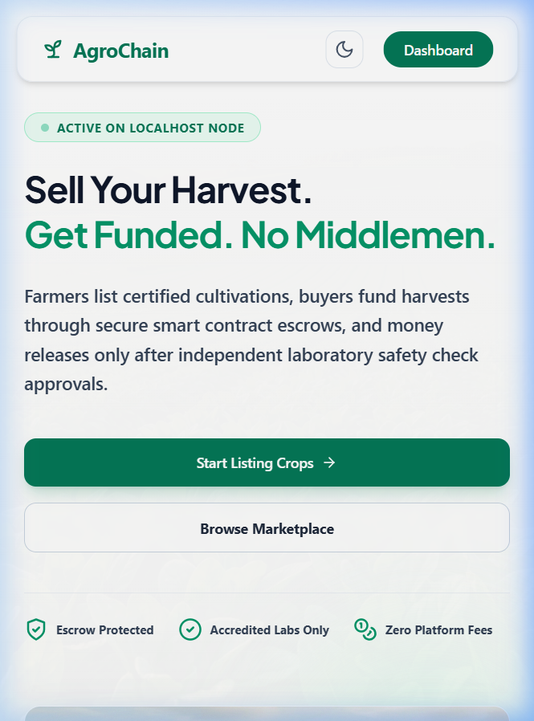
Figure 8.1: AgroChain Landing Page UI
8.2 Login Page
The login page handles JWT authentication for pre-seeded user accounts:
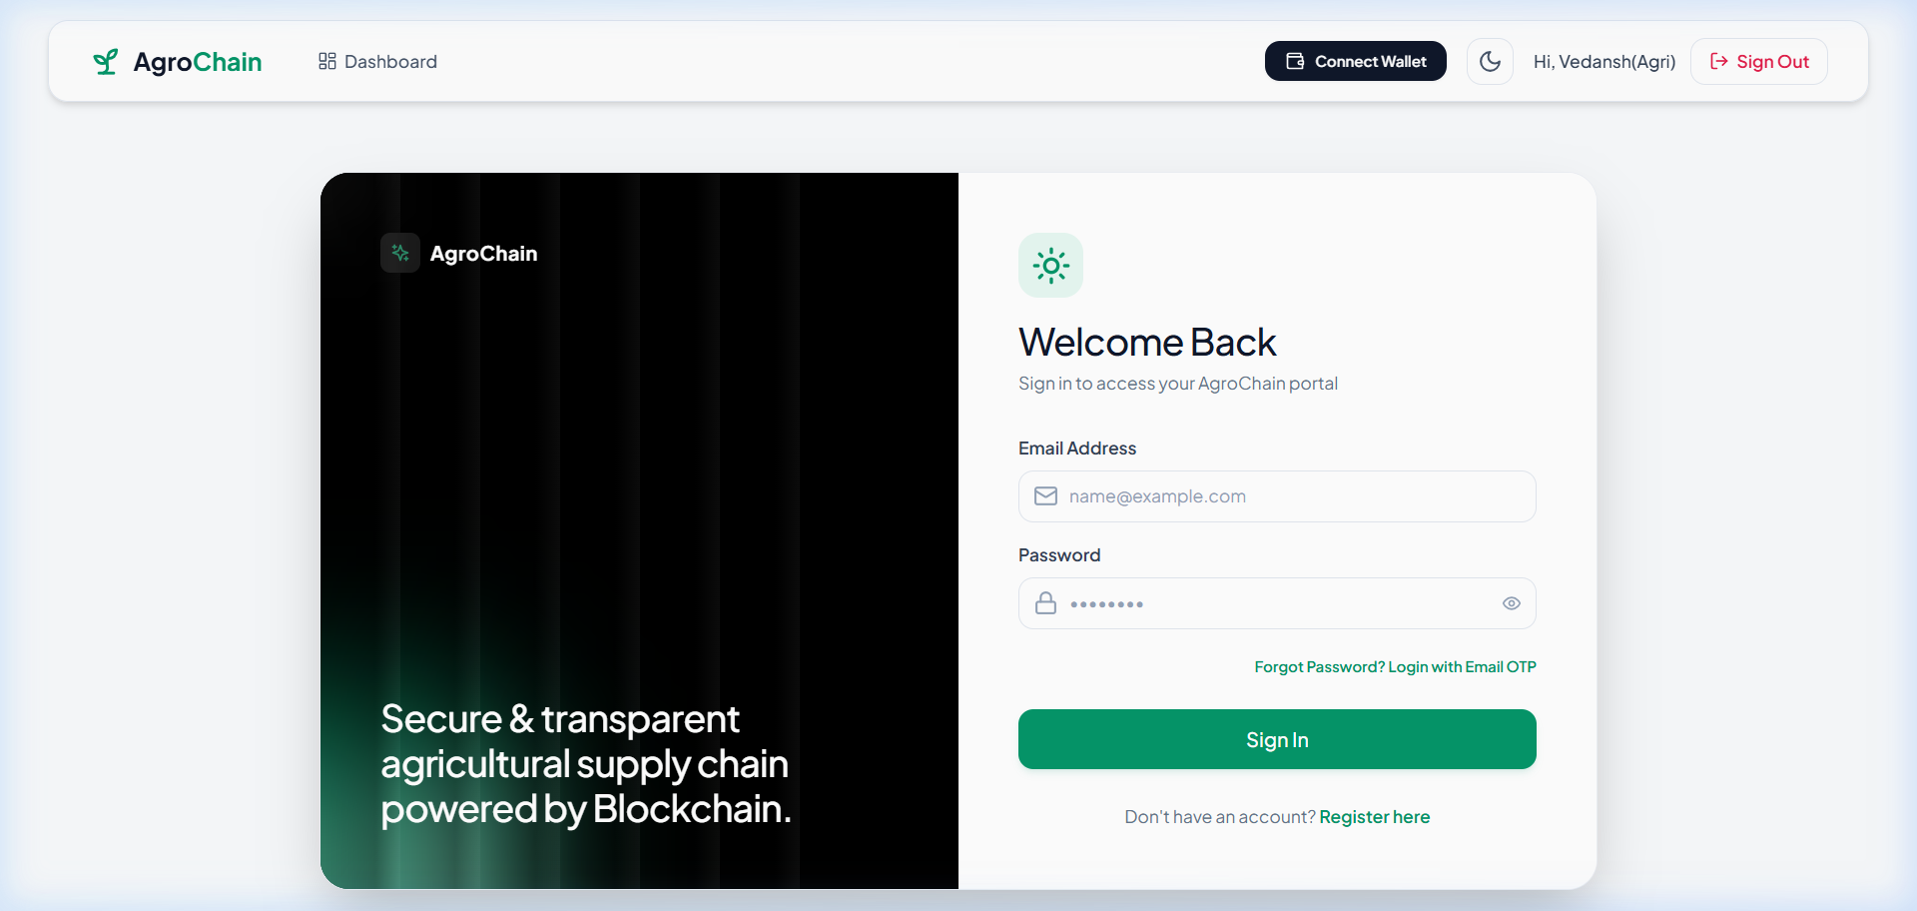
Figure 8.2: Stakeholder Sign-in Page
8.3 Register Page
The register page manages user registration and includes phone/email OTP verification inputs:
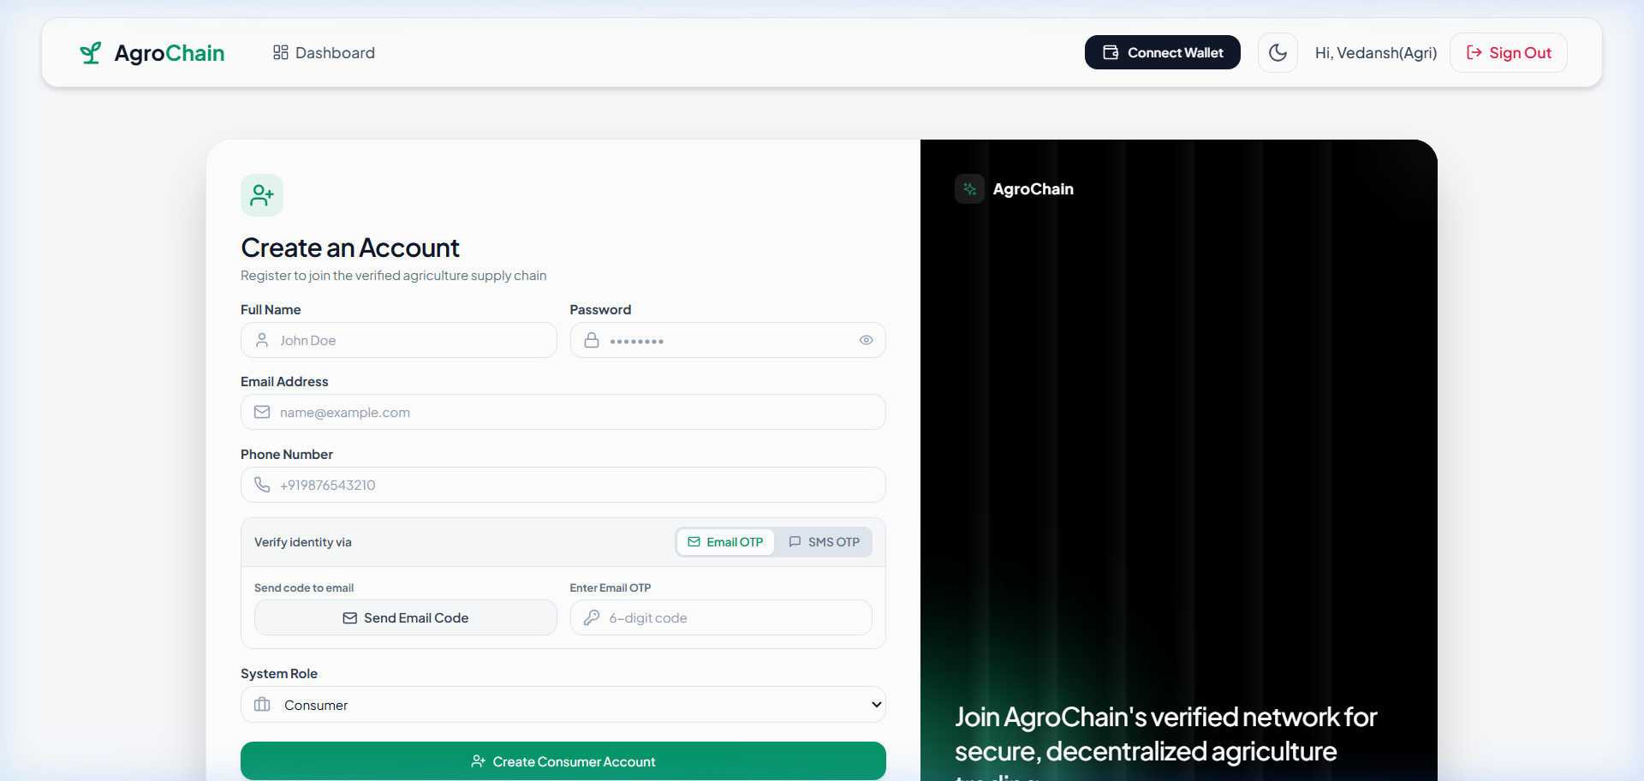
Figure 8.3: OTP Verification & Registration Page
8.4 Admin Dashboard
The admin dashboard contains central analytics, user approvals, verifier panels, and system logs:
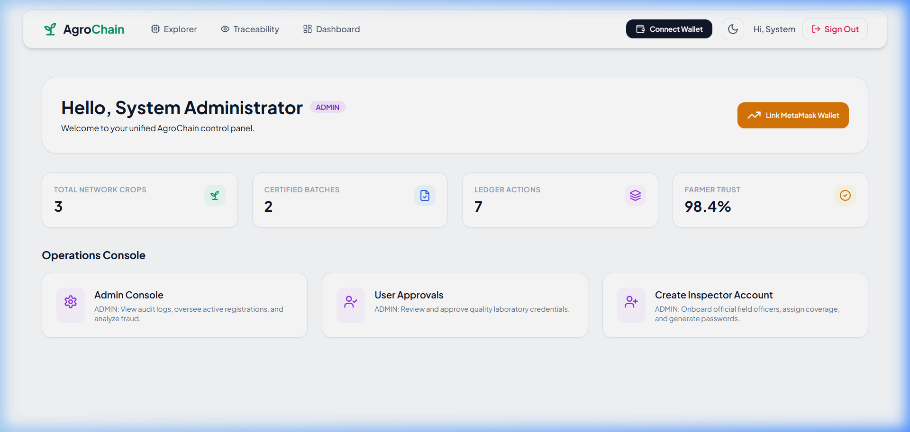
Figure 8.4: System Admin Control Panel Console
8.5 Farmer Dashboard
The farmer dashboard shows crop listings, expected yields, timeline status updates, and LOI proposal panels:
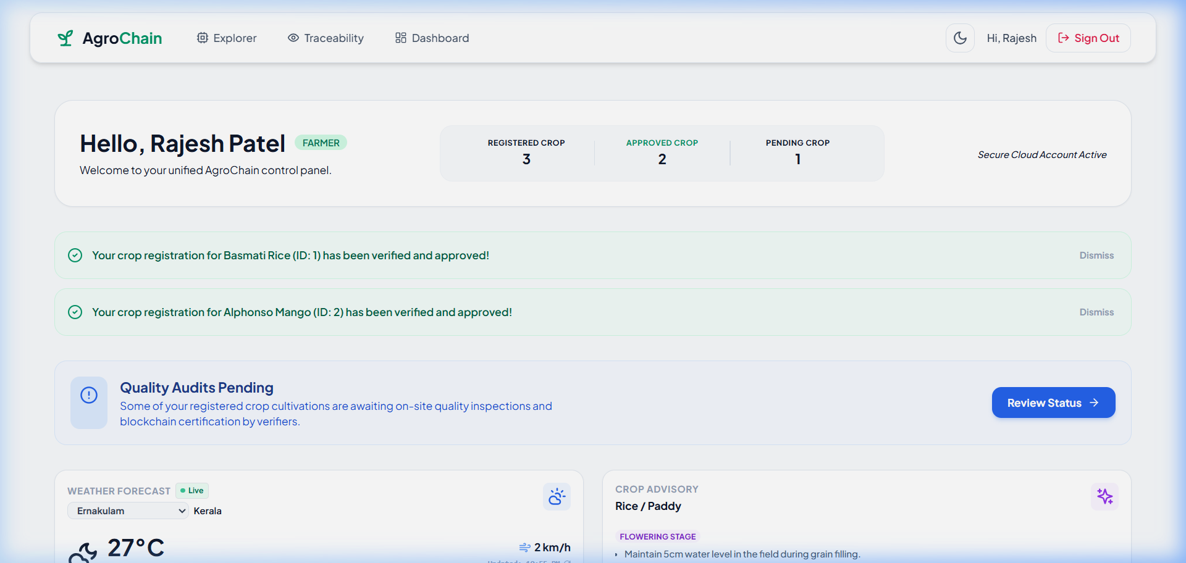
Figure 8.5: Farmer Dashboard & Crop Entries Console
8.6 Inspector Dashboard
The inspector dashboard lists assigned crops based on the location-routing algorithm and includes field audit input forms:
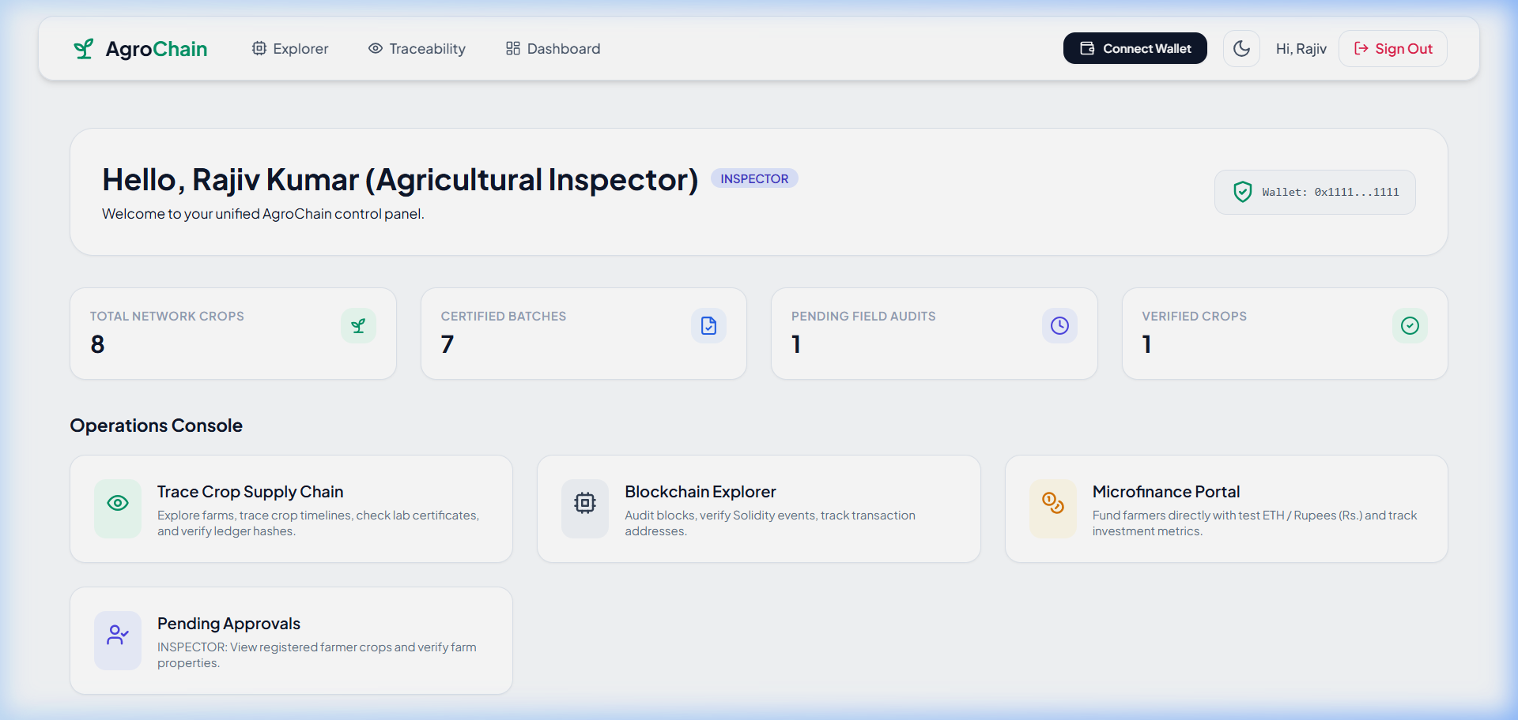
Figure 8.6: Agricultural Inspector Proximity Queue
8.7 Tester Dashboard
The quality lab tester dashboard lists harvested crops in their district and includes grade certification inputs:
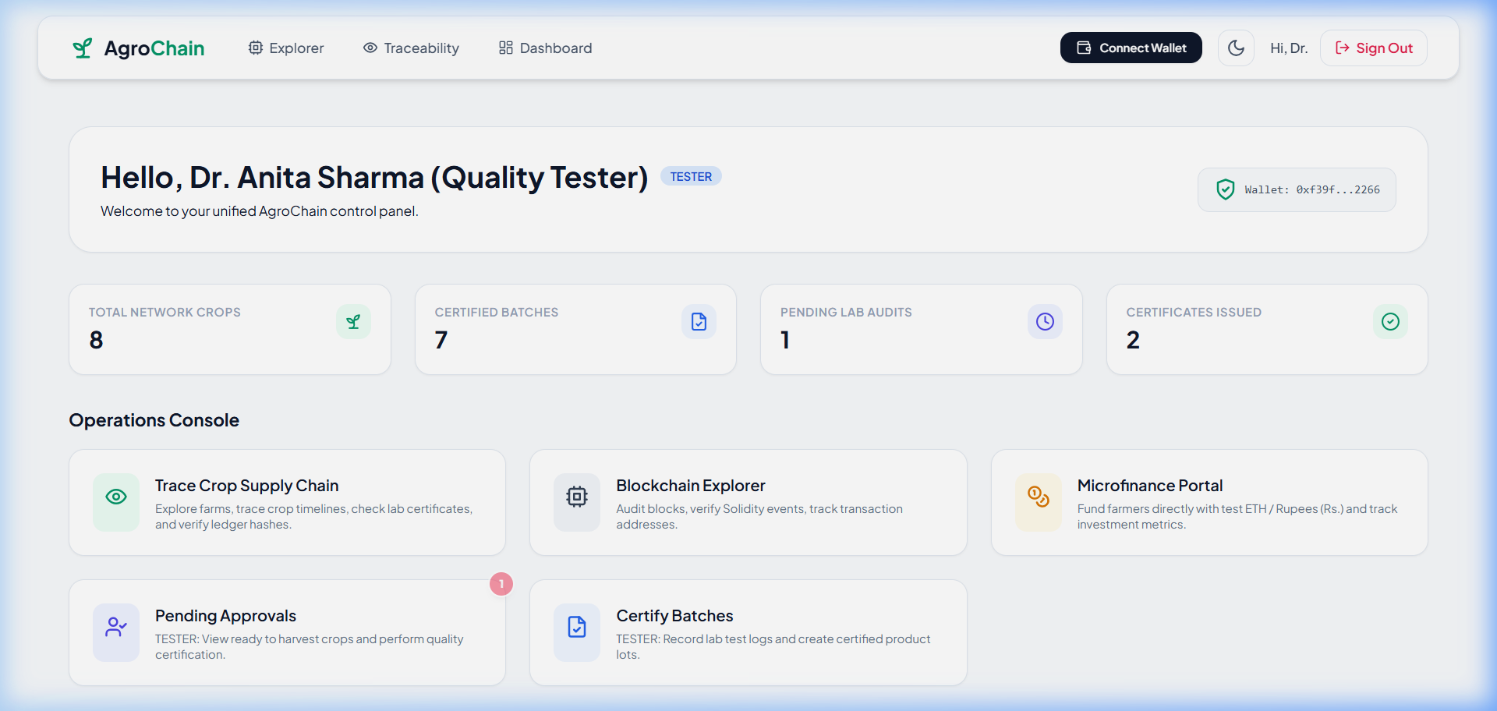
Figure 8.7: Quality Laboratory Testing Interface
8.8 Investor Dashboard
The investor dashboard includes the certified crop lot marketplace, letters of intent (LOI) submission trackers, and escrow funding modules:
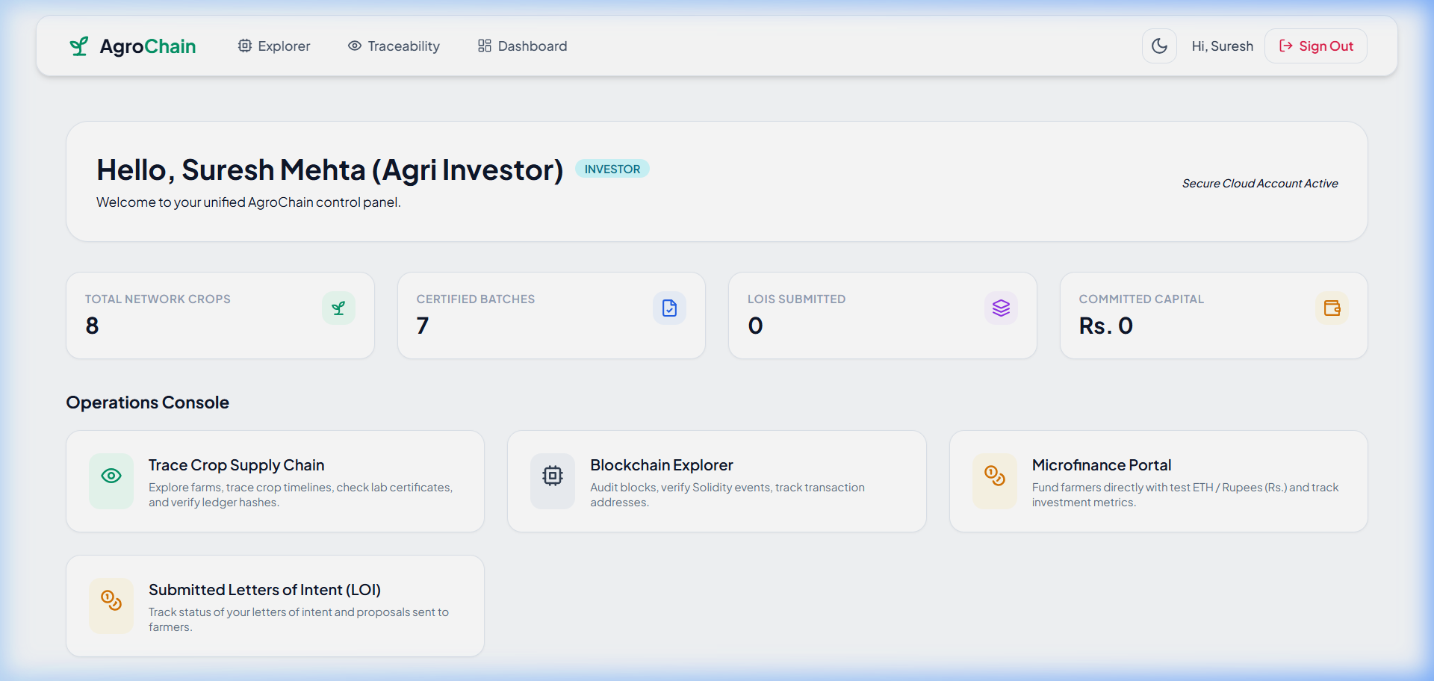
Figure 8.8: Investor P2P Micro-Loan Marketplace
8.9 Blockchain Explorer Page
The blockchain explorer lists block heights, transaction hashes, and records of crop approvals and grade certifications:
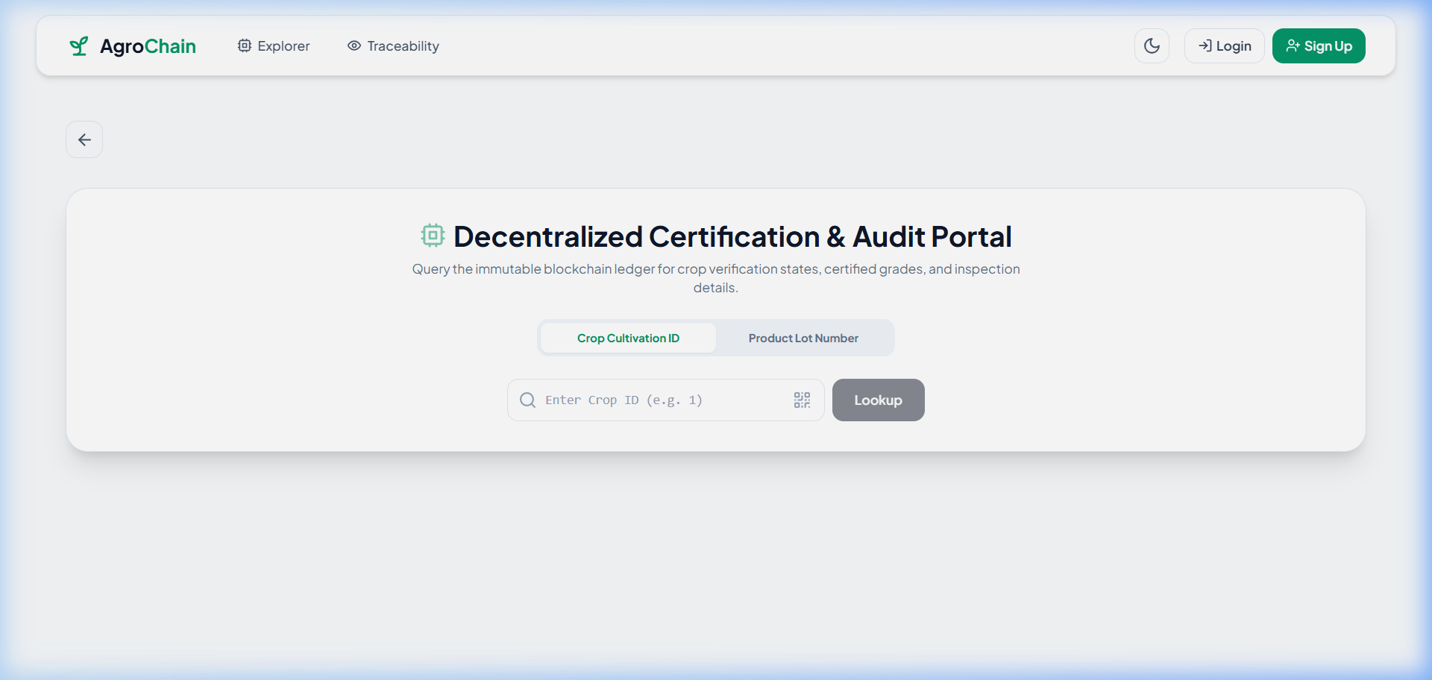
Figure 8.9: On-Chain Ledger Explorer Interface
8.10 Consumer Provenance Page
The consumer traceability page allows public users to trace crop origins by scanning packaging QR codes:
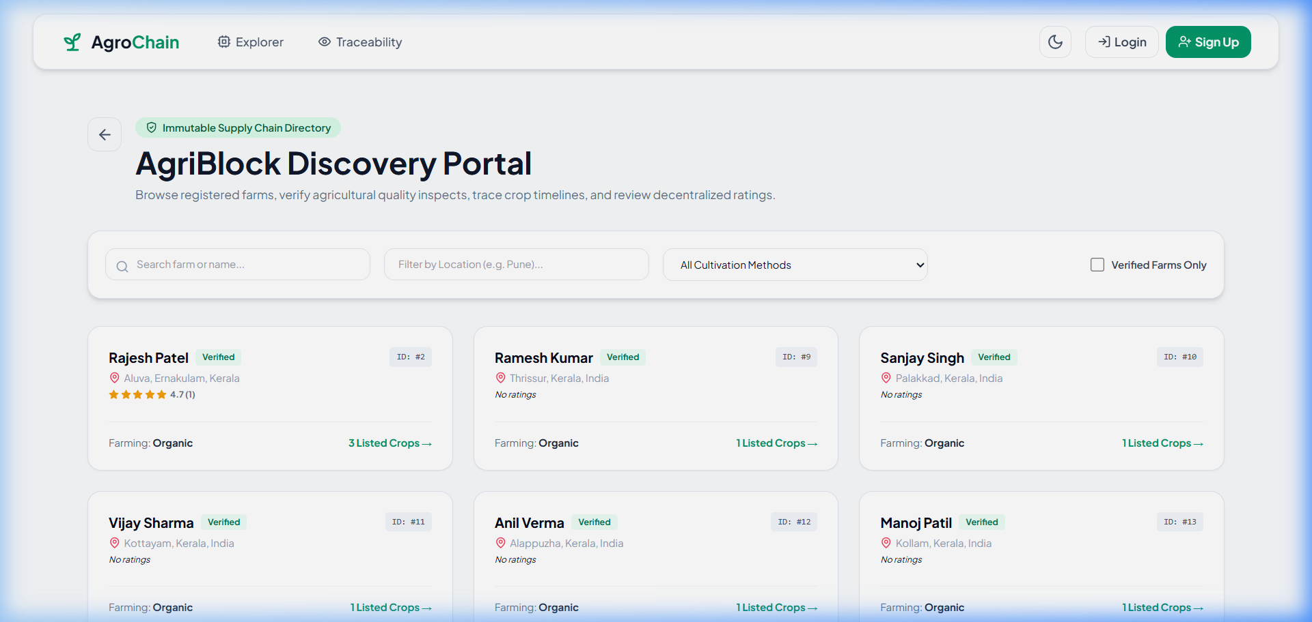
Figure 8.10: Public QR-Code Tracking & Review Page

CHAPTER 9: TESTING
9.1 Objectives of Testing Software
Testing verifies that the system operates correctly under various scenarios. It confirms that the routing logic correctly matches inspectors, that smart contract rules prevent unverified crops from being certified, and that API endpoints restrict access to unauthorized user roles.
9.2 Testing Report
- Unit Testing: Verified smart contract rules on a local Hardhat network using Chai assertions. Flask routes were tested using PyTest.
- Integration Testing: Verified communication between the Flask API and the local database cache to confirm that blockchain events update database tables.
- System Testing: Verified end-to-end flows, from crop registration to inspector approval, lab certification, investor funding, and consumer lookup.
- User Acceptance Testing (UAT): Completed user journeys to verify role-based layouts, modal forms, and PDF downloads.
9.3 Verification Matrix
The table below summarizes the verification test cases run on the system:
TEST ID | TEST SCENARIO | INPUT DATA | EXPECTED OUTPUT | RESULT
TC-01 | Farmer Crop Registration | Yield: 5000, Survey: 242/A, PIN: 680001 | Crop saved, status: PENDING, inspector assigned. | PASSED
TC-02 | Inspector Audit Remarks Check | Remarks: "" (Empty) | Warning: "Please add inspection remarks before approving." | PASSED
TC-03 | On-Chain Inspector Approval | Remarks: "Verified", MetaMask connected | On-chain tx signed, status changes to VERIFIED. | PASSED
TC-04 | Certification of Unverified Crop | Crop ID: 1 (Unverified) | Tx fails: "Farmer registration must be approved first." | PASSED
TC-05 | Lab Lot Certification | Crop ID: 1, Grade: A, MetaMask connected | On-chain tx signed, status: PRODUCT_AVAILABLE. | PASSED
TC-06 | Investor LOI Submission | Price: 20000, Profit: 12%, Lot: 1001 | Proposal saved, status: PENDING, farmer dashboard gets badge. | PASSED
TC-07 | Farmer Proposal Acceptance | Click "Accept" on proposal | Proposal status: ACCEPTED, timeline: FUNDING_COMPLETED. | PASSED
TC-08 | Explorer URL Query Lookup | Lot number: 1001 via URL query | Fetches crop data, displays Gold-Bordered certificate. | PASSED

CHAPTER 10: CONCLUSION
10.1 Future Scope of the Project
AgroChain addresses agricultural supply chain transparency and micro-lending availability by combining Ethereum smart contracts with a lightweight web application. The platform provides direct crop tracking, location-based inspector routing, printable QR-code packaging labels, and P2P loan escrows to build trust and credit opportunities.
Future roadmaps for the AgroChain project include:
- AI Disease Diagnostics: Integrating computer vision models into the farmer dashboard to diagnose crop diseases automatically from leaf photos.
- IoT Logistics Integration: Deploying temperature, humidity, and location sensors in transport units to log transit conditions directly to the blockchain.
- Official Land Registry APIs: Integrating with state government land registry databases to verify land ownership survey numbers automatically.
- Lightweight Mobile App: Building a React Native mobile application to help inspectors log audit notes offline in remote areas.

REFERENCES
[1] S. Nakamoto, "Bitcoin: A Peer-to-Peer Electronic Cash System," 2008.
[2] G. Wood, "Ethereum: A Secure Decentralized Generalised Transaction Ledger," Ethereum Project Yellow Paper, vol. 151, pp. 1-32, 2014.
[3] V. Buterin, "A Next-Generation Smart Contract and Decentralized Application Platform," Whitepaper, 2014.
[4] M. S. W. Syed, A. S. M. J. Qadri, and F. A. Al-Mamun, "Blockchain for Agricultural Supply Chain Traceability: A Review," IEEE Access, vol. 9, pp. 45210-45230, 2021.
[5] F. Tian, "An Agri-Food Supply Chain Traceability System for China Based on RFID & Blockchain Technology," in Proc. 13th Int. Conf. on Service Systems and Service Management (ICSSSM), 2016, pp. 1-6.
[6] M. Du, Q. Chen, and Y. Xiao, "Supply Chain Traceability System Based on Blockchain and Smart Contracts," IEEE Access, vol. 8, pp. 86325-86335, 2020.
[7] J. Lin et al., "Blockchain and IoT integration in agriculture: Minimized trust protocols," Computers and Electronics in Agriculture, vol. 186, p. 106189, 2021.
[8] S. S. Kamble, A. Gunasekaran, and H. Arimura, "Blockchain Technology Adoption in Indian Agriculture Supply Chains," Transportation Research Part E: Logistics and Transportation Review, vol. 140, p. 102009, 2020.
[9] P. Antonucci, S. Figorilli, and C. Costa, "A Review on Blockchain Applications in the Agri-Food Sector," Journal of Agricultural Engineering, vol. 50, no. 2, pp. 45-57, 2019.
[10] Y. P. Tsang, K. L. Choy, and H. Y. Lam, "An Internet of Things (IoT)-based Product Traceability System for Food Quality Assurance," International Journal of Food Properties, vol. 21, no. 1, pp. 1999-2015, 2018.
[11] K. R. Awasthi and S. Kumar, "Decentralized Escrow Protocols for Peer-to-Peer Micro-Lending Systems," in Proc. IEEE Int. Conf. on Decentralized Finance, 2022, pp. 102-109.
[12] ISO 22005:2007, "Traceability in the feed and food chain — General principles and basic requirements for system design and implementation," International Organization for Standardization, 2007.
[13] R. Beck, M. Avital, and J. Damsgaard, "Blockchain Technology in Business and Information Systems Research," Business & Information Systems Engineering, vol. 59, no. 6, pp. 381-384, 2017.
[14] IBM Food Trust, "Traceability and Trust in Food Supply Chains," Whitepaper, IBM Corp., 2020.
[15] OpenZeppelin, "Access Control Contracts Documentation," [Online]. Available: https://docs.openzeppelin.com/contracts/4.x/access-control.
[16] Ethers.js v6 Documentation, "Ethereum Wallet and Utility Library," [Online]. Available: https://docs.ethers.org/v6/.
[17] Hardhat Network Documentation, "Ethereum Development Environment for Professionals," Nomic Foundation, [Online]. Available: https://hardhat.org/docs.
[18] Flask-SQLAlchemy Documentation, "SQLAlchemy Database Toolkit Integration for Flask," [Online]. Available: https://flask-sqlalchemy.palletsprojects.com/.

APPENDICES
Appendix A: Core Source Code Blocks
1. On-Chain Farmer Cultivation Registry (FarmerRegistry.sol)
// SPDX-License-Identifier: MIT
pragma solidity ^0.8.19;
import "@openzeppelin/contracts/access/AccessControl.sol";
contract FarmerRegistry is AccessControl {
bytes32 public constant TESTER_ROLE = keccak256("TESTER_ROLE");
bytes32 public constant AGRICULTURE_ROLE = keccak256("AGRICULTURE_ROLE");
bytes32 public constant INSPECTOR_ROLE = keccak256("INSPECTOR_ROLE");
bytes32 public constant ADMIN_ROLE = keccak256("ADMIN_ROLE");
struct Farmer {
uint256 farmerId;
string farmerName;
string farmLocation;
string farmSize;
string farmingType; // organic / non-organic
string cropType;
uint256 expectedYield;
uint256 cultivationDate;
address walletAddress;
bool isRegistered;
bool isApproved;
}
mapping(uint256 => Farmer) public farmers;
uint256[] public farmerIds;
event FarmerRegistered(
uint256 indexed farmerId,
string farmerName,
address indexed walletAddress,
string cropType
);
mapping(address => bool) public authorizedInspectors;
event FarmerApproved(uint256 indexed farmerId, address indexed verifier);
event FarmerRejected(uint256 indexed farmerId, address indexed verifier);
constructor() {
_setupRole(DEFAULT_ADMIN_ROLE, msg.sender);
_setupRole(ADMIN_ROLE, msg.sender);
}
function authorizeInspector(address _inspector, bool _status) public {
require(hasRole(ADMIN_ROLE, msg.sender), "Caller is not an admin");
authorizedInspectors[_inspector] = _status;
}
function registerFarmer(
uint256 _farmerId,
string memory _name,
string memory _location,
string memory _size,
string memory _farmingType,
string memory _cropType,
uint256 _expectedYield,
uint256 _cultivationDate
) public {
require(!farmers[_farmerId].isRegistered, "Farmer ID already registered");
farmers[_farmerId] = Farmer({
farmerId: _farmerId,
farmerName: _name,
farmLocation: _location,
farmSize: _size,
farmingType: _farmingType,
cropType: _cropType,
expectedYield: _expectedYield,
cultivationDate: _cultivationDate,
walletAddress: msg.sender,
isRegistered: true,
isApproved: false
});
farmerIds.push(_farmerId);
emit FarmerRegistered(_farmerId, _name, msg.sender, _cropType);
}
function approveFarmer(uint256 _farmerId) public {
require(authorizedInspectors[msg.sender] || hasRole(ADMIN_ROLE, msg.sender), "Caller is not an authorized inspector or admin");
require(farmers[_farmerId].isRegistered, "Farmer not registered");
require(!farmers[_farmerId].isApproved, "Farmer already approved");
farmers[_farmerId].isApproved = true;
emit FarmerApproved(_farmerId, msg.sender);
}
function approveFarmer(
uint256 _farmerId,
string memory _name,
string memory _location,
string memory _size,
string memory _farmingType,
string memory _cropType,
uint256 _expectedYield,
uint256 _cultivationDate,
address _farmerWallet
) public {
require(authorizedInspectors[msg.sender] || hasRole(ADMIN_ROLE, msg.sender), "Caller is not an authorized inspector or admin");
if (!farmers[_farmerId].isRegistered) {
farmers[_farmerId] = Farmer({
farmerId: _farmerId,
farmerName: _name,
farmLocation: _location,
farmSize: _size,
farmingType: _farmingType,
cropType: _cropType,
expectedYield: _expectedYield,
cultivationDate: _cultivationDate,
walletAddress: _farmerWallet,
isRegistered: true,
isApproved: true
});
farmerIds.push(_farmerId);
emit FarmerRegistered(_farmerId, _name, _farmerWallet, _cropType);
} else {
require(!farmers[_farmerId].isApproved, "Farmer already approved");
farmers[_farmerId].isApproved = true;
}
emit FarmerApproved(_farmerId, msg.sender);
}
function rejectFarmer(uint256 _farmerId) public {
require(authorizedInspectors[msg.sender] || hasRole(ADMIN_ROLE, msg.sender), "Caller is not an authorized inspector or admin");
require(farmers[_farmerId].isRegistered, "Farmer not registered");
farmers[_farmerId].isRegistered = false;
farmers[_farmerId].isApproved = false;
emit FarmerRejected(_farmerId, msg.sender);
}
function getFarmer(uint256 _farmerId) public view returns (Farmer memory) {
require(farmers[_farmerId].isRegistered, "Farmer not registered");
return farmers[_farmerId];
}
function getFarmerCount() public view returns (uint256) {
return farmerIds.length;
}
function isFarmerApproved(uint256 _farmerId) public view returns (bool) {
return farmers[_farmerId].isApproved;
}
}

2. On-Chain Product Grade Registry (ProductRegistry.sol)
// SPDX-License-Identifier: MIT
pragma solidity ^0.8.19;
import "@openzeppelin/contracts/access/AccessControl.sol";
import "./FarmerRegistry.sol";
contract ProductRegistry is AccessControl {
bytes32 public constant ADMIN_ROLE = keccak256("ADMIN_ROLE");
struct Product {
uint256 lotNumber;
uint256 farmerId;
string cropName;
string qualityGrade;
uint256 price; // Price per unit or total price in Wei
uint256 testDate;
uint256 expiryDate;
string certificationStatus;
address testerAddress;
bool exists;
}
mapping(uint256 => Product) public products;
uint256[] public lotNumbers;
FarmerRegistry public farmerRegistry;
event ProductRegistered(
uint256 indexed lotNumber,
uint256 indexed farmerId,
string cropName,
string qualityGrade,
uint256 price,
address indexed tester
);
mapping(address => bool) public authorizedTesters;
constructor(address _farmerRegistryAddress) {
_setupRole(DEFAULT_ADMIN_ROLE, msg.sender);
_setupRole(ADMIN_ROLE, msg.sender);
farmerRegistry = FarmerRegistry(_farmerRegistryAddress);
}
function authorizeTester(address _tester, bool _status) public {
require(hasRole(ADMIN_ROLE, msg.sender), "Caller is not an admin");
authorizedTesters[_tester] = _status;
}
function registerProduct(
uint256 _lotNumber,
uint256 _farmerId,
string memory _cropName,
string memory _qualityGrade,
uint256 _price,
uint256 _testDate,
uint256 _expiryDate,
string memory _certificationStatus
) public {
require(authorizedTesters[msg.sender] || hasRole(ADMIN_ROLE, msg.sender), "Caller is not an authorized tester or admin");
require(!products[_lotNumber].exists, "Lot number already registered");
require(farmerRegistry.isFarmerApproved(_farmerId), "Farmer is not approved by Quality Authority");
products[_lotNumber] = Product({
lotNumber: _lotNumber,
farmerId: _farmerId,
cropName: _cropName,
qualityGrade: _qualityGrade,
price: _price,
testDate: _testDate,
expiryDate: _expiryDate,
certificationStatus: _certificationStatus,
testerAddress: msg.sender,
exists: true
});
lotNumbers.push(_lotNumber);
emit ProductRegistered(
_lotNumber,
_farmerId,
_cropName,
_qualityGrade,
_price,
msg.sender
);
}
function getProduct(uint256 _lotNumber) public view returns (Product memory) {
require(products[_lotNumber].exists, "Product lot does not exist");
return products[_lotNumber];
}
function isProductExists(uint256 _lotNumber) public view returns (bool) {
return products[_lotNumber].exists;
}
function getProductCount() public view returns (uint256) {
return lotNumbers.length;
}
}

3. On-Chain Escrow & P2P Micro-Loan Contract (MicroFinance.sol)
// SPDX-License-Identifier: MIT
pragma solidity ^0.8.19;
import "@openzeppelin/contracts/access/Ownable.sol";
import "./FarmerRegistry.sol";
import "./ProductRegistry.sol";
contract MicroFinance is Ownable {
struct Investment {
uint256 investmentId;
address investor;
uint256 farmerId;
uint256 lotNumber;
uint256 amount; // Amount funded in Wei
uint256 timestamp;
uint256 profitPercentage; // Profit margin set for investor
string status; // "ACTIVE", "COMPLETED", "REFUNDED"
}
Investment[] public investments;
mapping(uint256 => uint256[]) public farmerInvestments;
mapping(address => uint256[]) public investorInvestments;
FarmerRegistry public farmerRegistry;
ProductRegistry public productRegistry;
event InvestmentMade(
uint256 indexed investmentId,
address indexed investor,
uint256 indexed farmerId,
uint256 lotNumber,
uint256 amount,
uint256 timestamp
);
event InvestmentStatusUpdated(
uint256 indexed investmentId,
string status
);
constructor(address _farmerRegistryAddress, address _productRegistryAddress) {
farmerRegistry = FarmerRegistry(_farmerRegistryAddress);
productRegistry = ProductRegistry(_productRegistryAddress);
}
function invest(
uint256 _farmerId,
uint256 _lotNumber,
uint256 _profitPercentage
) public payable {
require(msg.value > 0, "Investment amount must be greater than zero");
// Verify Farmer is approved
require(farmerRegistry.isFarmerApproved(_farmerId), "Farmer must be approved by authority");
// Verify Farmer wallet address
address farmerWallet = farmerRegistry.getFarmer(_farmerId).walletAddress;
require(farmerWallet != address(0), "Farmer wallet address not found");
require(farmerWallet != msg.sender, "Farmers cannot invest in their own crops");
// Verify product lot exists
require(productRegistry.isProductExists(_lotNumber), "Product lot does not exist");
uint256 newInvestmentId = investments.length;
investments.push(Investment({
investmentId: newInvestmentId,
investor: msg.sender,
farmerId: _farmerId,
lotNumber: _lotNumber,
amount: msg.value,
timestamp: block.timestamp,
profitPercentage: _profitPercentage,
status: "ACTIVE"
}));
farmerInvestments[_farmerId].push(newInvestmentId);
investorInvestments[msg.sender].push(newInvestmentId);
// Forward the ETH directly to the farmer
(bool success, ) = payable(farmerWallet).call{value: msg.value}("");
require(success, "Failed to transfer funds to farmer");
emit InvestmentMade(
newInvestmentId,
msg.sender,
_farmerId,
_lotNumber,
msg.value,
block.timestamp
);
}
function updateInvestmentStatus(uint256 _investmentId, string memory _status) public {
require(_investmentId < investments.length, "Invalid investment ID");
// Only the farmer of this crop, or the contract owner can update status
uint256 farmerId = investments[_investmentId].farmerId;
address farmerWallet = farmerRegistry.getFarmer(farmerId).walletAddress;
require(msg.sender == farmerWallet || msg.sender == owner(), "Only the farmer or owner can update status");
investments[_investmentId].status = _status;
emit InvestmentStatusUpdated(_investmentId, _status);
}
// Custom getter to return a full Investment struct to bypass tuple restrictions
function getInvestment(uint256 _investmentId) public view returns (Investment memory) {
require(_investmentId < investments.length, "Invalid investment ID");
return investments[_investmentId];
}
function getInvestmentCount() public view returns (uint256) {
return investments.length;
}
function getFarmerInvestments(uint256 _farmerId) public view returns (uint256[] memory) {
return farmerInvestments[_farmerId];
}
// Helper to check if an address has investments
function getInvestorInvestments(address _investor) public view returns (uint256[] memory) {
return investorInvestments[_investor];
}
}

4. On-Chain Consumer Review & Trust System (RatingSystem.sol)
// SPDX-License-Identifier: MIT
pragma solidity ^0.8.19;
import "./FarmerRegistry.sol";
contract RatingSystem {
struct Rating {
uint256 ratingId;
address consumer;
uint256 farmerId;
uint256 lotNumber;
uint8 reliability; // 1 to 5
uint8 productQuality; // 1 to 5
uint8 deliverySatisfaction; // 1 to 5
string comment;
uint256 timestamp;
}
Rating[] public ratings;
mapping(uint256 => uint256[]) public farmerRatings;
FarmerRegistry public farmerRegistry;
event RatingAdded(
uint256 indexed ratingId,
address indexed consumer,
uint256 indexed farmerId,
uint256 lotNumber,
uint8 reliability,
uint8 productQuality,
uint8 deliverySatisfaction,
uint256 timestamp
);
constructor(address _farmerRegistryAddress) {
farmerRegistry = FarmerRegistry(_farmerRegistryAddress);
}
function addRating(
uint256 _farmerId,
uint256 _lotNumber,
uint8 _reliability,
uint8 _productQuality,
uint8 _deliverySatisfaction,
string memory _comment
) public {
require(farmerRegistry.isFarmerApproved(_farmerId), "Farmer must be approved by authority");
require(
_reliability >= 1 && _reliability <= 5 &&
_productQuality >= 1 && _productQuality <= 5 &&
_deliverySatisfaction >= 1 && _deliverySatisfaction <= 5,
"Ratings must be between 1 and 5"
);
uint256 newRatingId = ratings.length;
ratings.push(Rating({
ratingId: newRatingId,
consumer: msg.sender,
farmerId: _farmerId,
lotNumber: _lotNumber,
reliability: _reliability,
productQuality: _productQuality,
deliverySatisfaction: _deliverySatisfaction,
comment: _comment,
timestamp: block.timestamp
}));
farmerRatings[_farmerId].push(newRatingId);
emit RatingAdded(
newRatingId,
msg.sender,
_farmerId,
_lotNumber,
_reliability,
_productQuality,
_deliverySatisfaction,
block.timestamp
);
}
function getFarmerRatingCount(uint256 _farmerId) public view returns (uint256) {
return farmerRatings[_farmerId].length;
}
function getFarmerAverageRating(uint256 _farmerId) public view returns (uint256) {
uint256 count = farmerRatings[_farmerId].length;
if (count == 0) return 0;
uint256 total = 0;
for (uint256 i = 0; i < count; i++) {
uint256 rId = farmerRatings[_farmerId][i];
total += (ratings[rId].reliability + ratings[rId].productQuality + ratings[rId].deliverySatisfaction) / 3;
}
// Return average scaled by 10 (e.g. 45 represents 4.5) to keep precision
return (total * 10) / count;
}
}

Appendix B: REST API Specifications
1. User Authentication BLUEPRINT
- Send SMS OTP [POST /api/auth/send-otp] - Request: { "phone_number": "9895154388" }
- Send Email OTP [POST /api/auth/send-email-otp] - Request: { "email": "farmer@gmail.com" }
- Register User [POST /api/auth/register] - Register farmers, testers, investors, and consumers.
- Link Wallet [POST /api/auth/link-wallet] - Request: { "wallet_address": "0x...", "signature": "0x..." }
2. Inspector and Quality BLUEPRINT
- Create Inspector [POST /api/admin/create-inspector] - Admin registers inspectors.
- Approve Laboratory [POST /api/admin/approve-user/<id>] - Admin activates lab tester accounts.
- Save Notes [POST /api/quality/save-notes/<id>] - Inspector saves field audits locally.
- Approve Crop [POST /api/quality/approve/<id>] - Inspector approves crop cultivation on-chain.
3. Escrow and Finance BLUEPRINT
- Propose Investment [POST /api/finance/invest] - Investor submits Letter of Intent.
- Cancel Proposal [POST /api/finance/cancel/<id>] - Investor cancels pending funding offer.
- Accept Proposal [POST /api/finance/update-status/<id>] - Farmer accepts investment proposal.
Appendix C: Operational User Guide
Farmer User Guide
1. Create an Account: Register as a Farmer and complete OTP validation.
2. Register Your Crop: Navigate to Register Crop, input geographical details, upload photos and deeds, and submit.
3. Inspector Audit: An inspector will review your land deed. Once approved, the dashboard displays your verification letter.
4. Update Status: Update the crop timeline to Ready to Harvest or Harvest Completed to queue it for laboratory quality tests.
5. Print QR Labels: Click Print Certificate & QR on your dashboard to download printable packaging labels.
Inspector User Guide
1. Log In: Use credentials provided by the administrator.
2. Link Wallet: Change password, connect MetaMask, and verify signature to activate your account.
3. Review Assignments: Select crops in your location queue, write audit notes, and sign on-chain approvals.
Quality Lab User Guide
1. Register & Approve: Sign up with laboratory license certificates, and wait for administrator approval.
2. Certify Quality: Review harvested crop lots, run testing protocols, select quality grades, and sign on-chain lot certifications.

