Project Documentation: AgroChain
_________________________________________________________________________________

Administrative & Approval Details
Parameter | Details
Project Title | Design and Implementation of AgroChain: An Anchored Web3 Transparency Registry and Peer-to-Peer Micro-Loan Escrow Infrastructure for Agricultural Supply Chains
Document Type | Comprehensive Engineering Project Report
Primary Domain | Web3 & Decentralized Software Engineering
Core Technology Stack | React (Vite), Flask (Python), SQLite, Solidity, Hardhat, Ethers.js, MetaMask
Target Platform | Web Browsers & Ethereum EVM Compatible Networks

_________________________________________________________________________________

TABLE OF CONTENTS
Chapter | Section No. | Title
CHAPTER 1 | 1 | INTRODUCTION
 | 1.1 | Introduction of the System
 | 1.2 | Background
 | 1.3 | Objectives of the System
 | 1.4 | Scope of the System
 | 1.5 | Structure of the System
 | 1.6 | System Architecture
 | 1.7 | End Users
 | 1.8 | Software/Hardware Used for Development
 | 1.9 | Software/Hardware Required for Implementation
CHAPTER 2 | 2 | SOFTWARE REQUIREMENT SPECIFICATIONS (SRS)
 | 2.1 | Introduction
 | 2.2 | Overall Description
 | 2.3 | Special Requirements
 | 2.4 | Functional Requirements
 | 2.5 | Design Constraints
 | 2.6 | System Attributes
 | 2.7 | Other Requirements
CHAPTER 3 | 3 | SYSTEM DESIGN
 | 3.1 | Introduction
 | 3.2 | Assumptions and Constraints
 | 3.3 | Functional Decomposition
 | 3.4 | Description of Programs
 | 3.5 | Description of Components
 | 3.6 | Use Case Diagram
 | 3.7 | System Software Architecture
 | 3.8 | System Technical Architecture
 | 3.9 | System Hardware Architecture
 | 3.10 | Context Flow Diagram
 | 3.11 | DFD Admin
 | 3.12 | DFD User
CHAPTER 4 | 4 | DATABASE DESIGN
 | 4.1 | Introduction
 | 4.2 | Purpose and Scope
 | 4.3 | Database Identifications
 | 4.4 | Schema Information
 | 4.5 | Physical Design
 | 4.6 | Entity Relationship Diagram
 | 4.7 | Database Administration
CHAPTER 5 | 5 | DETAILED DESIGN
 | 5.1 | Introduction
 | 5.2 | Structure of the Software Package
 | 5.3 | Modular Decomposition
 | 5.4 | Activity Diagram
 | 5.5 | Class Diagram
 | 5.6 | Sequence Diagram
 | 5.7 | Structure Chart Admin
 | 5.8 | Structure Chart User
 | 5.9 | Activity Diagram Admin
 | 5.10 | Activity Diagram User
 | 5.11 | Sequence Diagram Admin
 | 5.12 | Sequence Diagram User
CHAPTER 6 | 6 | USER INTERFACE
CHAPTER 7 | 7 | TESTING
 | 7.1 | Introduction
 | 7.2 | Test Reports
 | 7.3 | Testing Criteria
 | 7.4 | System Test Tables
CHAPTER 8 | 8 | CONCLUSION
CHAPTER 9 | 9 | FUTURE SCOPE
CHAPTER 10 | 10 | ABBREVIATIONS AND ACRONYMS
CHAPTER 11 | 11 | REFERENCES

_________________________________________________________________________________

LIST OF FIGURES
Figure No. | Title
Figure 1.6 | System Architecture Diagram
Figure 3.6 | Use Case Diagram
Figure 3.7 | System Software Architecture Diagram
Figure 3.8 | System Technical Architecture Diagram
Figure 3.9 | System Hardware Architecture Diagram
Figure 3.10 | Context Flow Diagram
Figure 3.11 | DFD Admin (Data Flow Diagram - Level 1 Admin)
Figure 3.12 | DFD User (Data Flow Diagram - Level 1 User/Farmer)
Figure 4.6 | Entity Relationship Diagram (ERD)
Figure 5.4 | Overall Activity Diagram
Figure 5.5 | Object Class Diagram
Figure 5.6 | Master Sequence Diagram
Figure 5.7 | Structure Chart Admin
Figure 5.8 | Structure Chart User
Figure 5.9 | Activity Diagram Admin
Figure 5.10 | Activity Diagram User
Figure 5.11 | Sequence Diagram Admin
Figure 5.12 | Sequence Diagram User
Figure 6.1 | AgroChain Landing Page Interface
Figure 6.2 | User Login & Dual OTP Authentication Page
Figure 6.3 | Stakeholder Registration & OTP Verification Page
Figure 6.4 | Farmer Cultivation & Harvest Dashboard
Figure 6.5 | Regional Agricultural Inspector Review Queue
Figure 6.6 | Quality Lab Scientific Testing & On-Chain Certification Portal
Figure 6.7 | P2P Investor Marketplace & LOI Escrow Tracker
Figure 6.8 | System Administrator Governance & Lab Approval Panel
Figure 6.9 | Consumer Provenance Verification Page
Figure 6.10 | Public Camera-Enabled QR Code Explorer

_________________________________________________________________________________

LIST OF TABLES
Table No. | Title
Table 7.4.1 | Test Cases for Admin/User Login
Table 7.4.2 | Test Cases for User Registration
Table 7.4.3 | Validation of Contact Us / Audit Form
Table 7.4.4 | Test Cases for Change Password
Table 7.4.5 | Test Cases for Forgot Password
Table 7.4.6 | System Testing Summary

_________________________________________________________________________________

CHAPTER 1: INTRODUCTION

1.1 Introduction of the System
AgroChain is an enterprise-grade hybrid Web2/Web3 agricultural governance, supply chain traceability, and peer-to-peer (P2P) micro-financing infrastructure. Built to eliminate the opacity, fraud, and financial exclusion that characterize modern global food networks, AgroChain establishes a decentralized framework where agricultural produce is verified, graded, financed, and tracked from seed registration to retail consumption.
The system combines a lightweight, responsive Web2 client portal (built with React 18, Vite 5, and Tailwind CSS) and a high-throughput Flask API backend with public Ethereum smart contracts (FarmerRegistry.sol, ProductRegistry.sol, and FundingEscrow.sol). By anchoring critical milestones—such as land deed ownership proofs, regional inspector field audits, scientific laboratory quality parameters, and investor escrow agreements—directly onto an immutable blockchain ledger, AgroChain eliminates single-point data tampering inherent in traditional centralized database models.
Crucially, AgroChain decouples operational authority across independent stakeholder roles:
- Smallholder Farmers can log cultivation lifecycles, manage harvest timelines, print batch quality certificates featuring dynamic QR codes, and receive direct zero-interest micro-loans from investors without bank intermediaries.
- Regional Agricultural Inspectors review land deed documentation, verify GPS farm coordinates, conduct physical or photo field audits, and cryptographically sign verification approvals on-chain via MetaMask (personal_sign).
- Accredited Quality Testing Laboratories perform scientific produce evaluation (measuring moisture percentage, pesticide residual PPM, and organic purity), input parameters, assign standardized quality grades (Grade A+ to Grade C), and publish tamper-proof batch certificates on the Ethereum ledger.
- Dedicated Investors browse verified crop lots within active investment windows, evaluate yield projections, issue direct Letters of Intent (LOIs), and deposit ETH into smart contract escrow vaults that automatically protect farmer capital.
- System Administrators maintain platform governance, review NABL lab accreditation credentials via interactive approval modals, register regional inspectors, and inspect platform audit logs.
- End Consumers scan physical packaging QR codes using any camera-enabled smartphone or browser webcam to view the complete farm-to-table provenance timeline without needing an account or login.

1.2 Background
Agriculture remains the fundamental economic backbone for over 1.2 billion people globally. However, smallholder farmers—who produce more than 70% of the world's food supply—frequently extract less than 15% of total retail market value. Traditional agricultural supply chains suffer from two structural failures:

1. The Provenance & Food Safety Crisis:
With growing consumer demand for organic, non-GMO, and ethically sourced produce, premium retail markups have soared. However, traditional supply chain management relies on centralized relational databases (SQL/NoSQL) owned by single logistics intermediaries or corporate conglomerates. Because database administrators or malicious actors can modify, backdate, or delete SQL records without leaving an externally verifiable audit trail, food fraud, mislabeling, and fake organic certifications have become rampant. Consumers have no reliable method to verify whether a product's origin claim is genuine or falsified.

2. The Agricultural Credit Deficiency & Financial Exclusion:
Smallholder farmers require seasonal capital for seeds, organic fertilizers, irrigation equipment, and labor. Traditional commercial banking institutions enforce rigid credit scoring, high interest rates, and mandatory physical land collateral requirements that smallholder farmers cannot satisfy. Consequently, farmers are forced to rely on predatory local moneylenders who charge exorbitant interest rates, trapping farming families in perpetual debt cycles.

The AgroChain Solution:
AgroChain solves both crisis vectors simultaneously. By recording field inspection approvals and scientific laboratory grades on a public, immutable blockchain, AgroChain creates cryptographic proof of crop quality that enables farmers to command fair premium prices. Concurrently, by introducing a decentralized P2P micro-finance marketplace powered by Ethereum smart contracts, AgroChain allows global investors to fund verified crop cycles directly, providing farmers with accessible capital while bypassing commercial banking intermediaries.

1.3 Objectives of the System
The primary engineering objectives of the AgroChain system are:
- Immutable Supply Chain Ledger: Write, test, and deploy Solidity smart contracts (FarmerRegistry.sol, ProductRegistry.sol, FundingEscrow.sol) on an EVM-compatible network to record crop registration specs, inspector audit approvals, lab quality test grades, and escrow milestone events permanently.
- Automated Geographical Routing Engine: Implement an administrative spatial routing algorithm based on regional hierarchies (State -> District -> Taluk -> Village) that automatically routes newly registered crops to the nearest active inspector using a multi-tiered priority cascade (Priority 1: exact Taluk match; Priority 2: District match; Priority 3: District fallback).
- Cryptographic Identity & Dual-Factor Security: Enforce Web2 dual-factor OTP (SMS via Twilio gateway + Email via SMTP client) verification during user registration, alongside Web3 wallet binding using MetaMask personal cryptographic message signatures (personal_sign) for high-privilege verifiers.
- Decentralized P2P Micro-Loan Escrow Infrastructure: Build a peer-to-peer funding marketplace where dedicated investors submit formal Letters of Intent (LOIs) and deposit ETH directly into smart contract escrow vaults that lock funds securely until harvest verification milestones are achieved.
- Scientific Quality Testing Guardrails: Program on-chain smart contract validation rules that strictly block testing laboratories from issuing batch certificates unless a verified, active inspector has signed prior land and cultivation approval.
- Public Consumer Traceability Explorer: Develop a browser-based QR code scanner leveraging native WebRTC camera feeds (html5-qrcode) to enable retail consumers to scan packaging codes and instantly view a crop's complete origin, verifier identity, lab test scores, and blockchain transaction hashes.

1.4 Scope of the System
Scope Vector | System Capabilities & Boundaries
Included Functional Scope | Full profile registration & role management for 6 distinct user personas (Farmer, Inspector, Lab Tester, Investor, System Admin, Public Consumer).
Included Functional Scope | Land deed ownership document upload, GPS coordinate tracking, and dynamic cultivation/investment window enforcement.
Included Functional Scope | Inspector field audit note logging (PHYSICAL_VISIT, PHOTO_REVIEW, HYBRID) and MetaMask on-chain signature verification.
Included Functional Scope | Accredited quality lab approval workflow, chemical parameter logging (moisture %, pesticide PPM), standardized grading (Grade A+ to Grade C), and on-chain batch certificate publishing.
Included Functional Scope | P2P investor LOI submission, proposal acceptance, and ETH smart contract escrow deposit/refund management.
Included Functional Scope | Print-ready CSS generation for gold-bordered batch quality certificates featuring dynamic embedded QR codes.
Included Functional Scope | Real-time camera-based QR code provenance scanner and step-by-step public explorer UI.
Excluded Operational Scope (Future Scope) | Direct hardware IoT soil moisture and temperature sensor telemetry streaming (simulated via manual lab entries).
Excluded Operational Scope (Future Scope) | Automated cross-border fiat-to-crypto currency exchange payment gateways.
Excluded Operational Scope (Future Scope) | Cross-chain token bridge protocols between EVM testnets and mainnets.

1.5 Structure of the System
AgroChain is engineered around a 4-Tier Hybrid Software Architecture that balances low-latency user dashboard responsiveness with high-security blockchain immutability:
flowchart TD
subgraph Tier1["1. Client Presentation Tier (React 18 / Vite 5)"]
UI["Stakeholder Dashboards<br>(Farmer, Inspector, Lab, Investor, Admin)"]
Web3Provider["MetaMask Web3 Provider<br>(Ethers.js v6)"]
QRScanner["Camera QR Scanner<br>(html5-qrcode)"]
end
subgraph Tier2["2. Application & Service Tier (Flask 3.0 REST API)"]
Controllers["REST API Controllers<br>(/api/auth, /api/crops, /api/escrow)"]
GeoEngine["Geographical Match Engine<br>(Taluk / District Priority)"]
AuthManager["JWT & Dual OTP Manager<br>(SMS + Email Gateways)"]
end
subgraph Tier3["3. Database Cache Tier (SQLite 3 / SQLAlchemy ORM)"]
SQLiteDB[(Relational Cache DB<br>agrochain.db)]
end
subgraph Tier4["4. Decentralized Ledger Tier (Ethereum EVM Node)"]
FarmerSol["FarmerRegistry.sol"]
ProductSol["ProductRegistry.sol"]
EscrowSol["FundingEscrow.sol"]
end
UI <-->|HTTP REST / JSON| Controllers
UI <-->|JSON-RPC / Web3| Web3Provider
Web3Provider <-->|Smart Contract Calls| Tier4
Controllers <-->|SQLAlchemy ORM| SQLiteDB
Controllers <-->|RPC Provider Sync| Tier4
GeoEngine --> SQLiteDB
AuthManager --> Controllers

Detailed Operational Tiers:
- Client Presentation Tier: Developed using React 18, Vite 5, and Tailwind CSS. Delivers modular stakeholder dashboards, integrates MetaMask via Ethers.js v6 for transaction signing, and embeds html5-qrcode for real-time camera QR scanning.
- Application & Service Tier: Built with Python 3.9+ and Flask 3.0. Handles REST API requests, enforces JWT bearer token authorization, manages dual OTP delivery (Twilio SMS + SMTP Email), and executes administrative geographical routing logic.
- Database Caching Tier: Implemented using SQLite 3 (agrochain.db) managed by SQLAlchemy ORM. Caches off-chain metadata, user account profiles, and transaction hashes to enable sub-second dashboard loading without overloading blockchain RPC endpoints.
- Decentralized Ledger Tier: Consists of Solidity (^0.8.20) smart contracts deployed on an EVM network (Hardhat local node / Sepolia). Utilizes OpenZeppelin AccessControl roles to execute immutable verification logging, quality cert publishing, and escrow vault storage.

1.6 System Architecture
Figure 1.6 illustrates the top-level hybrid Web2/Web3 System Architecture:
flowchart TD
subgraph ClientTier["Client Presentation Layer (React + Vite)"]
UI["Stakeholder Dashboards"]
Scanner["Camera QR Scanner"]
MetaMask["MetaMask Wallet Extension"]
end
subgraph ServerTier["Application & Cache Tier (Flask API)"]
API["Flask REST Controller"]
Auth["JWT & Dual OTP Engine"]
Geo["Geographical Routing Engine"]
DB[(SQLite Cache: agrochain.db)]
end
subgraph LedgerTier["Decentralized Blockchain Tier (Ethereum)"]
FarmerReg["FarmerRegistry.sol"]
ProductReg["ProductRegistry.sol"]
EscrowReg["FundingEscrow.sol"]
end
UI <-->|HTTP REST / JSON| API
UI <-->|JSON-RPC / Web3| MetaMask
MetaMask <-->|Smart Contract Calls| LedgerTier
API <-->|SQLAlchemy ORM| DB
API <-->|RPC Event Sync| LedgerTier
Geo --> DB
Auth --> API
Figure 1.6: System Architecture Diagram

1.7 End Users
The system serves six distinct user personas:
- Farmer: Registers crops, updates harvest milestones, prints QR certificates, receives investor escrow funding.
- Agricultural Inspector: Reviews land deeds and GPS coordinates, conducts field visits, signs verification on-chain.
- Quality Lab Tester: Runs scientific tests, inputs parameters, assigns quality grades (A+ to C), signs certificates on-chain.
- Dedicated Investor: Browses verified crops, submits LOI proposals, locks ETH into escrow.
- System Administrator: Registers inspectors, approves laboratory accreditations, monitors audit logs.
- Public Consumer: Scans packaging QR codes via webcam scanner to view complete provenance history without logging in.

1.8 Software/Hardware Used for Development
Component | Tool / Environment | Version / Specification
OS | Windows 11 / Linux Ubuntu | 64-bit Architecture
IDE | VS Code / Antigravity IDE | Latest Version
Language Runtimes | Python & Node.js | Python 3.9+, Node.js 18.x+
Frontend | React, Vite, Tailwind CSS | React 18, Vite 5
Backend | Flask, SQLAlchemy, JWT | Flask 3.0+
Blockchain | Hardhat, Solidity, OpenZeppelin | Solidity ^0.8.20
Database | SQLite 3 | agrochain.db

1.9 Software/Hardware Required for Implementation
Hardware / Software | Minimum Requirement | Recommended Requirement
CPU | Dual-Core 2.0 GHz Intel i5 | Quad-Core 3.0 GHz Intel i7
RAM | 8 GB DDR4 | 16 GB DDR4/DDR5
Storage | 2 GB Available SSD | 10 GB High-Speed NVMe SSD
Browser | Google Chrome / Firefox | Chrome with MetaMask Extension
Camera | Integrated USB Webcam | 720p/1080p Web Camera or Smartphone Camera

_________________________________________________________________________________

CHAPTER 2: SOFTWARE REQUIREMENT SPECIFICATIONS (SRS)

2.1 Introduction
This Software Requirement Specification (SRS) defines the formal functional and non-functional requirements for AgroChain. It provides the technical baseline for application logic, security protocols, API interfaces, and smart contract guardrails.

2.2 Overall Description
AgroChain operates as a hybrid platform connecting traditional Web2 browser clients with decentralized Ethereum smart contracts. The system guarantees data integrity by anchoring verifier cryptographic signatures on-chain while keeping UI interactions fast using local SQLite caching.

2.3 Special Requirements
- Dual-Factor OTP Auth: Concurrent SMS OTP (Twilio API gateway) and Email OTP (SMTP client) during registration.
- Zero-Gas Farmer Interaction: Farmers manage profiles and accept funding via Web2 interfaces without paying gas fees.
- Cryptographic Signature Binding: Verifiers sign nonces via personal_sign in MetaMask; backend recovers address via eth_keys.
- Print-Ready CSS PDF Export: Client-side document rendering using html2pdf.js with print styling.

2.4 Functional Requirements
- FR-1 (Auth): Dual-factor OTP verification and JWT token issuance.
- FR-2 (Geo-Routing): Automatic crop assignment to local inspector based on Taluk/District priority.
- FR-3 (Inspection Audit): Field visit logging and on-chain verification via FarmerRegistry.sol.
- FR-4 (Lab Certification): Lab parameter entry, grading (A+ to C), and on-chain cert via ProductRegistry.sol.
- FR-5 (P2P Escrow): Investor LOI creation and ETH deposit into FundingEscrow.sol.
- FR-6 (Public Explorer): Real-time webcam QR scanning and provenance rendering.

2.5 Design Constraints
- Gas Optimization: Storing heavy file assets in local storage and storing 32-byte cryptographic hashes on-chain.
- SQLite Concurrency: Thread-safe database management using SQLAlchemy scoped sessions.
- HTTPS Requirement: Camera WebRTC scanning requires HTTPS or localhost execution environment.

2.6 System Attributes
- Security: RBAC with JWT token validation and OpenZeppelin AccessControl roles.
- Reliability: 99.99% smart contract uptime on Ethereum nodes.
- Maintainability: Decoupled React frontend components and Flask REST controllers.

2.7 Other Requirements
- Database Protection Rule: CRITICAL: The SQLite database (Backend/agrochain.db) must NEVER be reset or dropped.
- Regulatory Standard: Compliance with NABL laboratory testing standards and Aadhaar/PAN privacy guidelines.
_________________________________________________________________________________

CHAPTER 3: SYSTEM DESIGN

3.1 Introduction
System Design establishes the structural blueprint of AgroChain, specifying functional decomposition, architecture diagrams, data flow diagrams (DFDs), context models, and module interactions.

3.2 Assumptions and Constraints
- Stakeholders possess standard web browser access and active internet connections.
- Inspectors and lab technicians have MetaMask browser wallet installed.
- Consumers possess a camera-enabled smartphone or computer.

3.3 Functional Decomposition
AgroChain is decomposed into 6 operational modules: Auth Subsystem, Geo-Routing Subsystem, Inspection Subsystem, Quality Certification Subsystem, FinTech Escrow Subsystem, and Provenance Explorer.

3.4 Description of Programs
- app.py: Primary Flask API controller handling endpoints /api/auth, /api/crops, /api/escrow.
- models.py: SQLAlchemy ORM database models (User, Farmer, Proposal, InspectionNote).
- FarmerRegistry.sol: Smart contract managing farmer registration & inspector verification.
- ProductRegistry.sol: Smart contract managing scientific lab grading & batch cert publishing.
- FundingEscrow.sol: Smart contract managing investor LOIs and ETH escrow storage.

3.5 Description of Components
- Auth Component: Manages OTP delivery, password hashing, and JWT creation.
- Routing Component: Executes spatial database queries to pair crops with regional inspectors.
- Web3 Contract Component: Facilitates RPC JSON communication between Ethers.js and EVM contracts.

3.6 Use Case Diagram
usecaseDiagram
actor Farmer
actor Inspector
actor LabTester as Quality Lab Tester
actor Investor
actor Admin
actor Consumer
Farmer --> (Register Crop)
Farmer --> (Update Harvest Timeline)
Farmer --> (Print Batch QR Cert)
Farmer --> (Accept LOI Proposal)
Inspector --> (Audit Land Deed & GPS)
Inspector --> (Sign On-Chain Verification)
LabTester --> (Input Test Parameters)
LabTester --> (Issue On-Chain Lab Cert)
Investor --> (Browse Verified Crops)
Investor --> (Deposit ETH in Escrow)
Admin --> (Register Inspector)
Admin --> (Approve Lab Accreditation)
Consumer --> (Scan QR Code via Camera)
Figure 3.6: Use Case Diagram

3.7 System Software Architecture
flowchart TD
subgraph Client["Client Tier (React 18 / Vite 5)"]
Dashboards["Stakeholder Dashboards"]
Scanner["Camera QR Reader"]
MetaMaskUI["MetaMask Extension"]
end
subgraph Service["Application Tier (Flask 3.0 API)"]
Controllers["REST API Endpoints"]
GeoEngine["Geo-Matching Engine"]
AuthManager["JWT & OTP Manager"]
end
subgraph Database["Database Cache Tier (SQLite 3)"]
SQLiteDB[(agrochain.db)]
end
subgraph Blockchain["Ledger Tier (Ethereum Smart Contracts)"]
FarmerSol["FarmerRegistry.sol"]
ProductSol["ProductRegistry.sol"]
EscrowSol["FundingEscrow.sol"]
end
Client <-->|REST / JSON| Service
Client <-->|Web3 JSON-RPC| Blockchain
Service <-->|SQLAlchemy ORM| Database
Service <-->|RPC Provider Sync| Blockchain
Figure 3.7: System Software Architecture Diagram

3.8 System Technical Architecture
sequenceDiagram
autonumber
participant Farmer as Farmer Client
participant API as Flask REST API
participant Inspector as Inspector Client
participant MetaMask as Inspector MetaMask
participant Contract as FarmerRegistry Contract
participant DB as SQLite DB
Farmer->>API: POST /api/crops (Register Crop Details)
API->>DB: Save Crop (status: PENDING)
API->>DB: Auto-Assign Inspector (Taluk/District Priority)
Inspector->>API: GET /api/inspector/crops
API-->>Inspector: Render Assigned Crop Queue
Inspector->>MetaMask: Execute verifyCrop(cropId)
MetaMask->>Contract: Send Signed EVM Tx
Contract-->>MetaMask: Tx Confirmed (Tx Hash)
MetaMask-->>Inspector: Return Tx Hash
Inspector->>API: POST /api/inspector/verify (Tx Hash)
API->>DB: Update status to 'VERIFIED' & Save Tx Hash
Figure 3.8: System Technical Architecture Diagram

3.9 System Hardware Architecture
flowchart LR
subgraph ClientHW["Client Hardware"]
PC["User Desktop / PC"]
Mobile["Mobile Smartphone"]
end
subgraph ServerHW["Application Host Hardware"]
PyRuntime["Python Flask Runtime (Port 5000)"]
NodeRuntime["Node.js Vite Web Server (Port 5173)"]
DBEngine["SQLite Database Engine"]
end
subgraph NodeHW["Blockchain Hardware Node"]
EVMNode["Ethereum Hardhat Node (Port 8545)"]
end
ClientHW <-->|HTTP / HTTPS| ServerHW
ServerHW <-->|Localhost JSON-RPC| NodeHW
Figure 3.9: System Hardware Architecture Diagram

3.10 Context Flow Diagram
flowchart TD
Farmer[Farmer] -->|1. Crop Registration Specs| AgroChainSys((AgroChain Core System))
Inspector[Agricultural Inspector] -->|2. Field Audit & On-Chain Sig| AgroChainSys
LabTester[Quality Lab Tester] -->|3. Lab Test Parameters & Grade| AgroChainSys
Investor[Dedicated Investor] -->|4. LOI Terms & ETH Escrow Deposit| AgroChainSys
Admin[System Admin] -->|5. Account Approvals & Governance| AgroChainSys
AgroChainSys -->|6. Verified Approval Letters & QR Certs| Farmer
AgroChainSys -->|7. Escrow Funding Release| Farmer
AgroChainSys -->|8. Public Provenance Timeline Data| Consumer[Public Consumer]
Figure 3.10: Context Flow Diagram

3.11 DFD Admin (Level 1 Data Flow Diagram - Admin)
flowchart TD
Admin[Admin User] -->|1. Credentials| Process1[1.0 Auth & Login]
Process1 -->|Validate| DB[(User DB)]
Admin -->|2. Inspector Specs| Process2[2.0 Inspector Registration]
Process2 -->|Store Account| DB
Admin -->|3. Review Lab Docs| Process3[3.0 Lab Accreditation Approval]
Process3 -->|Update Status to ACTIVE| DB
Admin -->|4. View Logs| Process4[4.0 System Audit Monitoring]
DB -->|Fetch Activity Logs| Process4
Figure 3.11: DFD Admin Diagram

3.12 DFD User (Level 1 Data Flow Diagram - User/Farmer)
flowchart TD
Farmer[Farmer User] -->|1. Registration Specs & OTP| Proc1[1.0 User Registration & OTP Auth]
Proc1 -->|Create User Record| UserDB[(User DB)]
Farmer -->|2. Crop Cultivationspecs| Proc2[2.0 Cultivation Registration]
Proc2 -->|Create Crop Entry| CropDB[(Crop DB)]
CropDB -->|3. Trigger Auto-Assign| Proc3[3.0 Inspector Assignment Engine]
Proc3 -->|Assign Inspector ID| CropDB
Farmer -->|4. Update Harvest Status| Proc4[4.0 Timeline Progression]
Proc4 -->|Update Status| CropDB
Farmer -->|5. Print Batch Certificate| Proc5[5.0 Packaging QR Cert Generator]
CropDB -->|Fetch Certified Data| Proc5
Figure 3.12: DFD User Diagram
_________________________________________________________________________________

CHAPTER 4: DATABASE DESIGN

4.1 Introduction
The database layer of AgroChain serves as a high-performance relational cache for off-chain application metadata, user accounts, OTP records, audit logs, and cached blockchain transaction hashes.

4.2 Purpose and Scope
The database provides low-latency data access for user dashboard queries, eliminating repetitive slow RPC calls to the Ethereum node while ensuring relational integrity across users, crops, lab reports, and investment proposals.

4.3 Database Identifications
- Engine: SQLite 3
- File Location: Backend/agrochain.db (or Backend/instance/agrochain.db)
- ORM Mapping: SQLAlchemy 2.0+

4.4 Schema Information

4.4.1 users Table Schema
Column Name | Data Type | Constraints | Description
id | INTEGER | PRIMARY KEY, AUTOINCREMENT | Unique user identifier
full_name | VARCHAR(100) | NOT NULL | User's full name
email | VARCHAR(120) | UNIQUE, NOT NULL | Primary email address
phone_number | VARCHAR(20) | NOT NULL | Phone number for SMS OTP
password_hash | VARCHAR(255) | NOT NULL | Bcrypt hashed password
role | VARCHAR(30) | NOT NULL | Role: FARMER, INSPECTOR, TESTER, INVESTOR, ADMIN
district | VARCHAR(50) | NOT NULL | Administrative District
taluk | VARCHAR(50) | NOT NULL | Administrative Sub-district / Taluk
wallet_address | VARCHAR(42) | NULLABLE | Linked Ethereum wallet address
is_verified | BOOLEAN | DEFAULT FALSE | OTP verification flag

4.4.2 farmers (Crops) Table Schema
Column Name | Data Type | Constraints | Description
id | INTEGER | PRIMARY KEY, AUTOINCREMENT | Unique crop lot identifier
user_id | INTEGER | FOREIGN KEY (users.id) | Owner farmer ID
crop_name | VARCHAR(100) | NOT NULL | Name of cultivated crop
estimated_yield | FLOAT | NOT NULL | Expected yield in kg
verification_status | VARCHAR(30) | DEFAULT 'PENDING' | Status: PENDING, VERIFIED, REJECTED
timeline_status | VARCHAR(30) | DEFAULT 'PENDING' | Progress status
assigned_inspector_id | INTEGER | FOREIGN KEY (users.id) | Assigned local inspector ID
tx_hash | VARCHAR(66) | NULLABLE | Blockchain verification transaction hash

4.5 Physical Design
The SQLite database stores indexes on users.email, users.role, farmers.district, and farmers.assigned_inspector_id to ensure sub-10ms lookup times during dashboard rendering.

4.6 Entity Relationship Diagram (ERD)
erDiagram
USERS ||--o{ FARMERS : "owns/registers"
USERS ||--o{ INSPECTORS : "profile"
USERS ||--o{ QUALITY_TESTERS : "profile"
USERS ||--o{ INVESTORS : "profile"
FARMERS ||--o{ INSPECTION_NOTES : "receives"
FARMERS ||--o{ LAB_TEST_REPORTS : "receives"
FARMERS ||--o{ PROPOSALS : "receives"
INVESTORS ||--o{ PROPOSALS : "creates"
USERS {
int id PK
string full_name
string email
string phone_number
string role
string district
string taluk
string wallet_address
boolean is_verified
}
FARMERS {
int id PK
int user_id FK
string crop_name
float estimated_yield
string verification_status
string timeline_status
string district
string taluk
string tx_hash
}
INSPECTORS {
int id PK
int user_id FK
string jurisdiction_level
string verification_status
}
QUALITY_TESTERS {
int id PK
int user_id FK
string lab_license_number
string approval_status
}
PROPOSALS {
int id PK
int farmer_crop_id FK
int investor_id FK
float proposed_amount
string status
}
Figure 4.6: Entity Relationship Diagram

4.7 Database Administration
- Database Protection Rule: CRITICAL: The SQLite database file (Backend/agrochain.db) must NEVER be reset, dropped, or executed with reset flags (py seed.py --reset). All existing data, users, and crop records must be preserved permanently.
_________________________________________________________________________________

CHAPTER 5: DETAILED DESIGN

5.1 Introduction
Detailed Design presents the low-level component specifications, module interactions, class relationships, sequence interactions, and activity state machines for both Admin and User/Farmer workflows.

5.2 Structure of the Software Package
The codebase is structured into clear directory modules:
- Backend/: Flask application controllers, models, authentication handlers, and SQLite database.
- Blockchain/: Solidity contracts, Hardhat configuration, deploy scripts, and unit tests.
- Frontend/: React Vite application, Tailwind styles, component views, and Web3 utilities.

5.3 Modular Decomposition
- AuthModule: Manages user signup, dual OTP generation, login authentication, and JWT sessions.
- GeoRoutingModule: Spatial priority matching connecting crops with regional inspectors.
- AuditModule: Manages inspector land deed reviews and MetaMask signature verification.
- CertificationModule: Controls scientific lab testing and on-chain batch certificate publishing.
- EscrowModule: Handles P2P investment proposals and smart contract ETH deposits.

5.4 Activity Diagram (Overall System Lifecycle)
stateDiagram-v2
[*] --> FarmerRegistration
FarmerRegistration --> OTPVerification
OTPVerification --> CropRegistration
CropRegistration --> InspectorAssigned: Geo-Routing Priority
InspectorAssigned --> InspectorAudit
InspectorAudit --> VerificationApproved: MetaMask On-Chain Sign
VerificationApproved --> HarvestUpdate
HarvestUpdate --> LabTesting
LabTesting --> BatchCertPublished: Lab On-Chain Cert
BatchCertPublished --> InvestorEscrow: P2P LOI Accepted
InvestorEscrow --> ConsumerScan: QR Explorer Trace
ConsumerScan --> [*]
Figure 5.4: Overall Activity Diagram

5.5 Class Diagram
classDiagram
class User {
+int id
+string fullName
+string email
+string phoneNumber
+string role
+string district
+string taluk
+string walletAddress
+register()
+login()
+verifyOTP()
}
class Crop {
+int id
+int userId
+string cropName
+float estimatedYield
+string verificationStatus
+string timelineStatus
+string txHash
+registerCrop()
+updateTimeline()
}
class Inspector {
+int id
+int userId
+string jurisdictionLevel
+auditCrop()
+signVerificationOnChain()
}
class LabTester {
+int id
+int userId
+string labLicenseNumber
+issueCertificateOnChain()
}
class Proposal {
+int id
+int farmerCropId
+int investorId
+float proposedAmount
+string status
+submitLOI()
+depositEscrow()
}
User "1" <|-- "1" Farmer
User "1" <|-- "1" Inspector
User "1" <|-- "1" LabTester
Farmer "1" --> "*" Crop : registers
Inspector "1" --> "*" Crop : audits
LabTester "1" --> "*" Crop : certifies
Proposal "*" --> "1" Crop : funds
Figure 5.5: Class Diagram

5.6 Sequence Diagram (Master End-to-End Workflow)
sequenceDiagram
autonumber
participant Farmer
participant FlaskAPI
participant Inspector
participant LabTester
participant Investor
participant Ethereum
Farmer->>FlaskAPI: Register Crop (Location & Yield)
FlaskAPI->>Inspector: Assign Crop (Taluk Priority Match)
Inspector->>Ethereum: Sign verifyCrop() via MetaMask
Ethereum-->>Inspector: Tx Confirmed (Tx Hash)
Inspector->>FlaskAPI: Confirm Audit (Tx Hash)
Farmer->>FlaskAPI: Update Status: HARVEST_COMPLETED
LabTester->>Ethereum: Issue Certificate & Grade A+
Ethereum-->>LabTester: Certificate Published
Investor->>Ethereum: Deposit ETH into Escrow Contract
Ethereum-->>Farmer: Escrow Locked for Farmer
Figure 5.6: Master Sequence Diagram

5.7 Structure Chart Admin
flowchart TD
AdminRoot[System Admin Module] --> AuthSub[1. Admin Login & JWT]
AdminRoot --> InspectorSub[2. Inspector Onboarding]
AdminRoot --> LabSub[3. Lab Accreditation Review]
AdminRoot --> LogSub[4. System Audit Log Monitor]
InspectorSub --> CreateAcc[Create Inspector Credentials]
InspectorSub --> SetJurisdiction[Assign Sub-district Jurisdiction]
LabSub --> ViewLicense[Inspect NABL License Docs]
LabSub --> SetStatusActive[Update Status to ACTIVE]
Figure 5.7: Structure Chart Admin

5.8 Structure Chart User (Farmer)
flowchart TD
UserRoot[Farmer Portal Module] --> AuthSub[1. OTP Signup & Login]
UserRoot --> CropSub[2. Crop Cultivation Module]
UserRoot --> FinSub[3. Micro-Finance Escrow Module]
UserRoot --> CertSub[4. QR Certificate Module]
CropSub --> RegForm[Fill Location & Deed Specs]
CropSub --> UpdateTimeline[Move Status: HARVEST_COMPLETED]
FinSub --> ReviewLOI[View Incoming Proposals]
FinSub --> AcceptOffer[Accept Investor Terms]
CertSub --> PrintCert[Generate Gold QR Certificate]
Figure 5.8: Structure Chart User

5.9 Activity Diagram Admin
stateDiagram-v2
[*] --> AdminLogin
AdminLogin --> ReviewPendingLabs
ReviewPendingLabs --> InspectLicenseDocs
InspectLicenseDocs --> ApproveLab: Credentials Valid
InspectLicenseDocs --> RejectLab: Credentials Invalid
ApproveLab --> SetLabActive
SetLabActive --> RegisterNewInspector
RegisterNewInspector --> AssignDistrictTaluk
AssignDistrictTaluk --> [*]
Figure 5.9: Activity Diagram Admin

5.10 Activity Diagram User (Farmer)
stateDiagram-v2
[*] --> FarmerLogin
FarmerLogin --> RegisterCropForm
RegisterCropForm --> SubmitCrop
SubmitCrop --> AwaitInspectorAudit
AwaitInspectorAudit --> InspectorVerified: Verification Approved
InspectorVerified --> HarvestCrop
HarvestCrop --> AwaitLabCert
AwaitLabCert --> LabCertified: Certificate Issued
LabCertified --> PrintQRCertificate
LabCertified --> ReviewInvestorProposals
ReviewInvestorProposals --> AcceptLOI
AcceptLOI --> ReceiveEscrowFunding
ReceiveEscrowFunding --> [*]
Figure 5.10: Activity Diagram User

5.11 Sequence Diagram Admin
sequenceDiagram
autonumber
participant Admin
participant AdminUI
participant FlaskAPI
participant DB
Admin->>AdminUI: Open Pending Lab Approvals Modal
AdminUI->>FlaskAPI: GET /api/admin/pending-labs
FlaskAPI->>DB: Query labs with PENDING_APPROVAL status
DB-->>FlaskAPI: Return lab lists & license URLs
FlaskAPI-->>AdminUI: Render Lab Review Panel
Admin->>AdminUI: Click 'Approve Lab'
AdminUI->>FlaskAPI: POST /api/admin/approve-lab (labId)
FlaskAPI->>DB: Update lab status to ACTIVE
DB-->>FlaskAPI: Success confirmation
FlaskAPI-->>AdminUI: Update UI Badge to ACTIVE
Figure 5.11: Sequence Diagram Admin

5.12 Sequence Diagram User (Farmer & Investor Escrow)
sequenceDiagram
autonumber
participant Farmer
participant Investor
participant FlaskAPI
participant EscrowContract
participant DB
Investor->>FlaskAPI: POST /api/proposals (Submit LOI Terms)
FlaskAPI->>DB: Save Proposal (status: PENDING)
Farmer->>FlaskAPI: GET /api/farmer/proposals
FlaskAPI-->>Farmer: Render incoming LOIs
Farmer->>FlaskAPI: POST /api/proposals/accept (proposalId)
FlaskAPI->>DB: Update Proposal status to ACCEPTED
Investor->>EscrowContract: depositEscrow(cropId) [ETH]
EscrowContract-->>Investor: Funds Locked Event Emit
Investor->>FlaskAPI: POST /api/escrow/notify (Tx Hash)
FlaskAPI->>DB: Update Escrow status to FUNDED
Figure 5.12: Sequence Diagram User
_________________________________________________________________________________

CHAPTER 6: USER INTERFACE
The AgroChain user interface is designed using React 18, Vite, and Tailwind CSS. The section below presents the complete visual walkthrough across all application portals and stakeholder user roles:

6.1 Landing Page Interface
The primary public portal introducing AgroChain's Web3 provenance, P2P micro-finance escrow, and consumer verification explorer features.
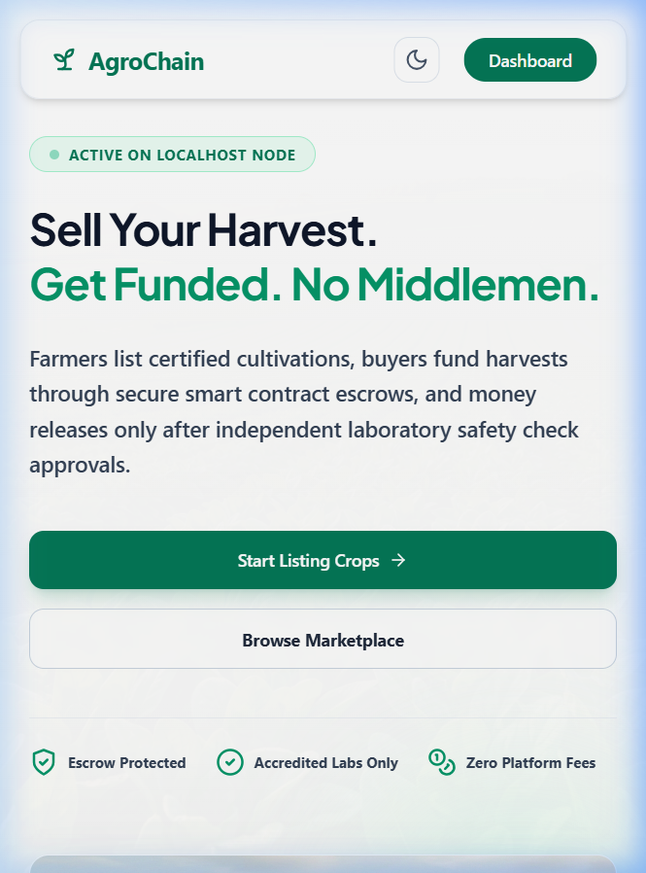
Figure: Figure 6.1: AgroChain Landing Page Interface

6.2 User Login & Dual OTP Authentication
The secure authentication entry point enforcing dual-factor OTP (SMS + Email) validation alongside role-based access redirection.
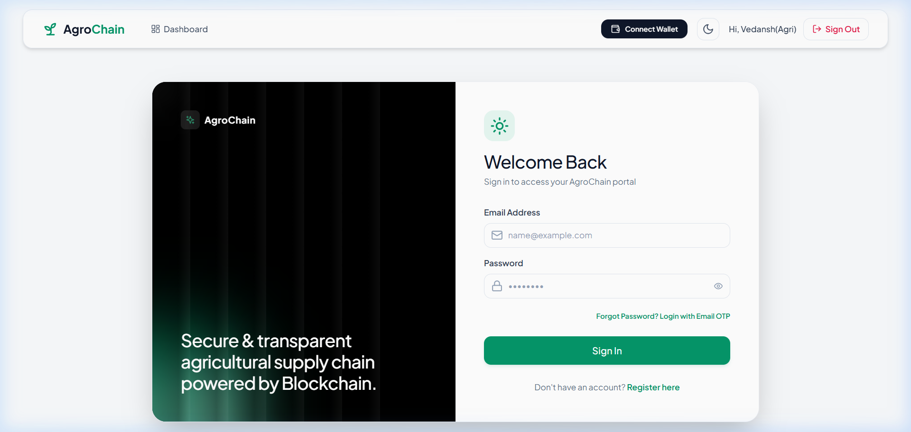
Figure: Figure 6.2: User Login & Dual OTP Authentication Page

6.3 Stakeholder Registration & OTP Verification
The multi-role onboarding portal where farmers, verifiers, and investors register credentials, request 6-digit OTP codes, and select administrative coverage regions.
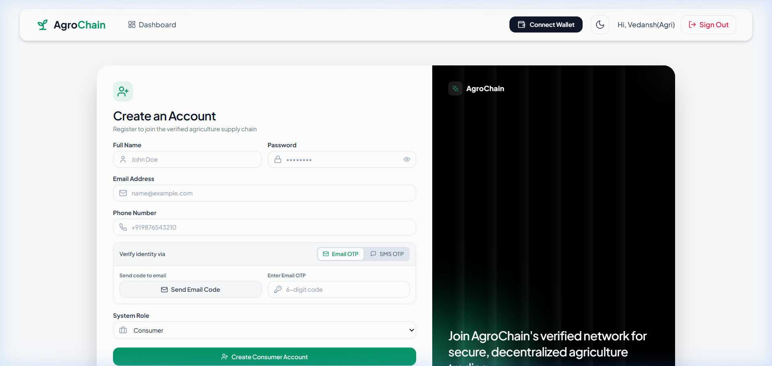
Figure: Figure 6.3: Stakeholder Registration & OTP Verification Page

6.4 Farmer Cultivation & Harvest Dashboard
The farmer's operational control center for registering crop cultivation details, tracking harvest timeline milestones, downloading inspector approval letters, reviewing incoming investor LOI offers, and printing batch quality certificates.
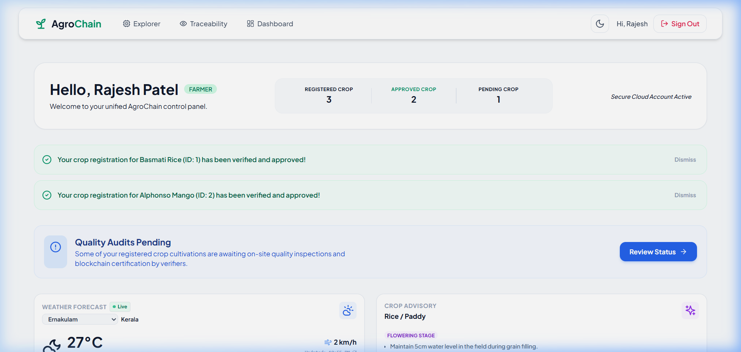
Figure: Figure 6.4: Farmer Cultivation & Harvest Dashboard

6.5 Regional Agricultural Inspector Review Queue
The regional inspector portal displaying assigned crops matched via Taluk/District spatial routing, land deed evidence documentation, audit note logging tools, and MetaMask on-chain verification approval triggers.
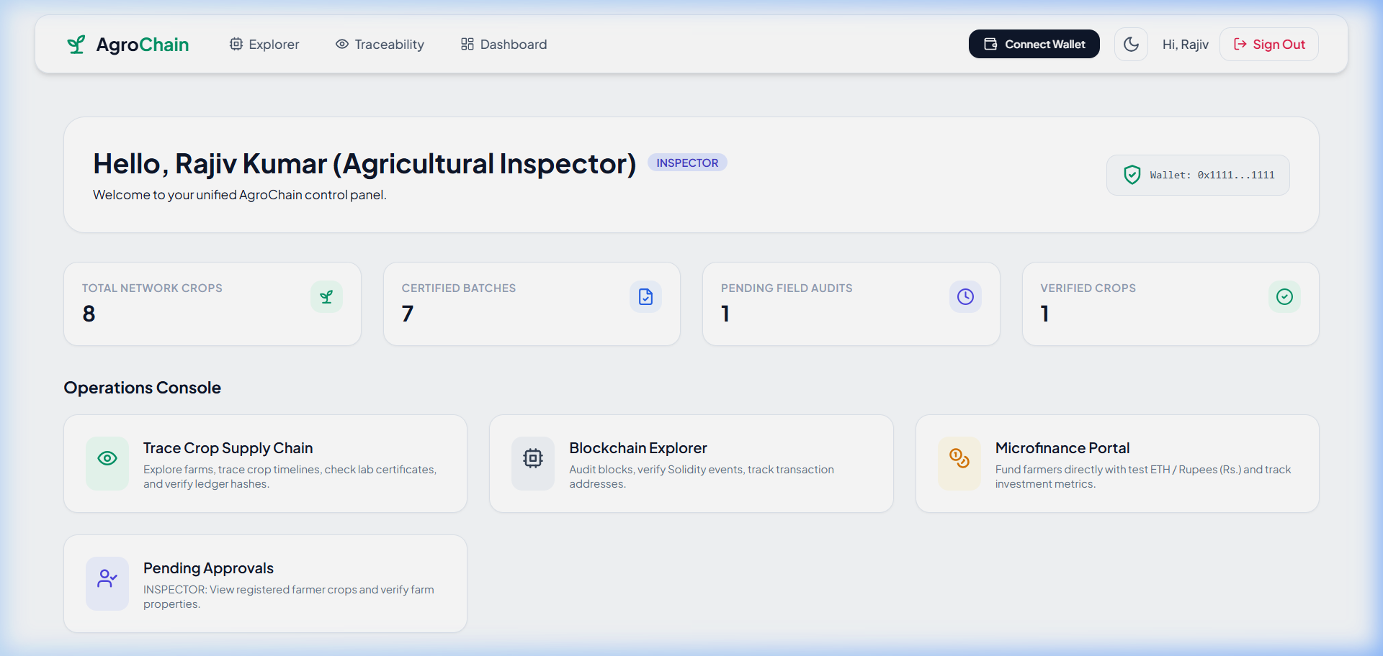
Figure: Figure 6.5: Regional Agricultural Inspector Review Queue

6.6 Quality Testing Laboratory Portal
The scientific lab interface for reviewing harvested crops, logging pesticide/moisture parameters, assigning quality grades (Grade A+ to Grade C), and publishing batch certificates on the Ethereum ledger.
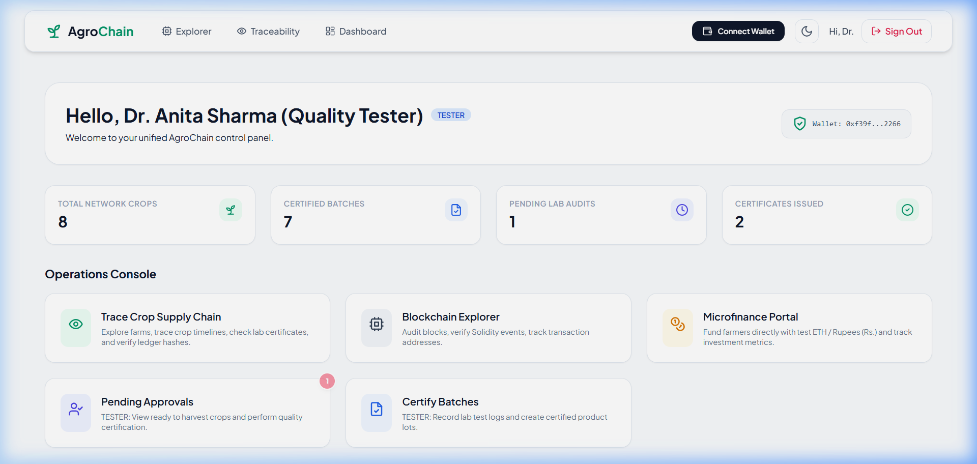
Figure: Figure 6.6: Quality Lab Scientific Testing & On-Chain Certification Portal

6.7 P2P Investor Marketplace & LOI Escrow Tracker
The micro-loan investment portal where dedicated investors browse verified crops, calculate yield returns, submit Letters of Intent (LOIs), and lock ETH into smart contract escrow vaults.
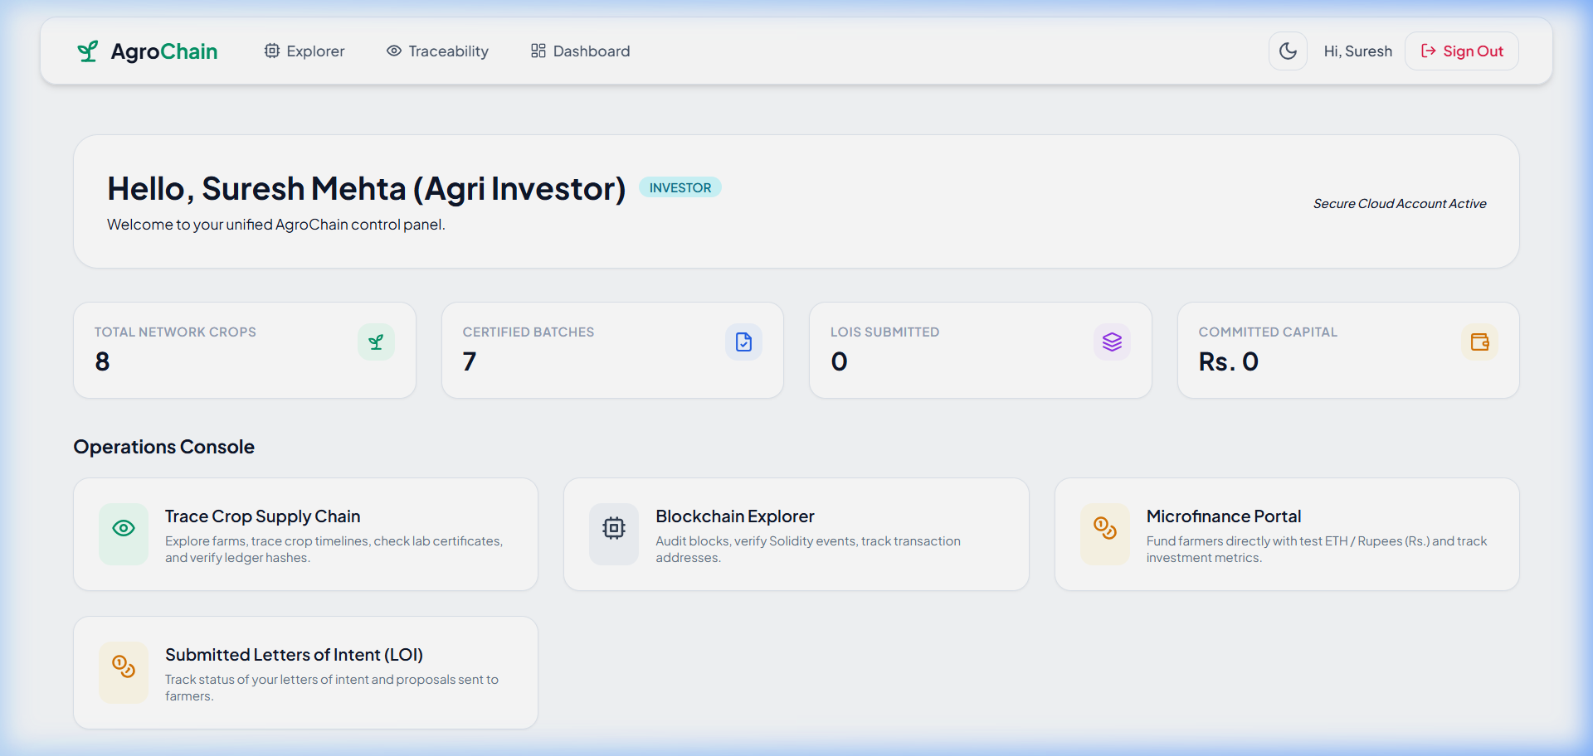
Figure: Figure 6.7: P2P Investor Marketplace & LOI Escrow Tracker

6.8 System Administrator Governance & Lab Approval Panel
The administrative governance portal for registering agricultural inspectors, reviewing NABL laboratory accreditation licenses via interactive approval modals, and inspecting platform audit logs.
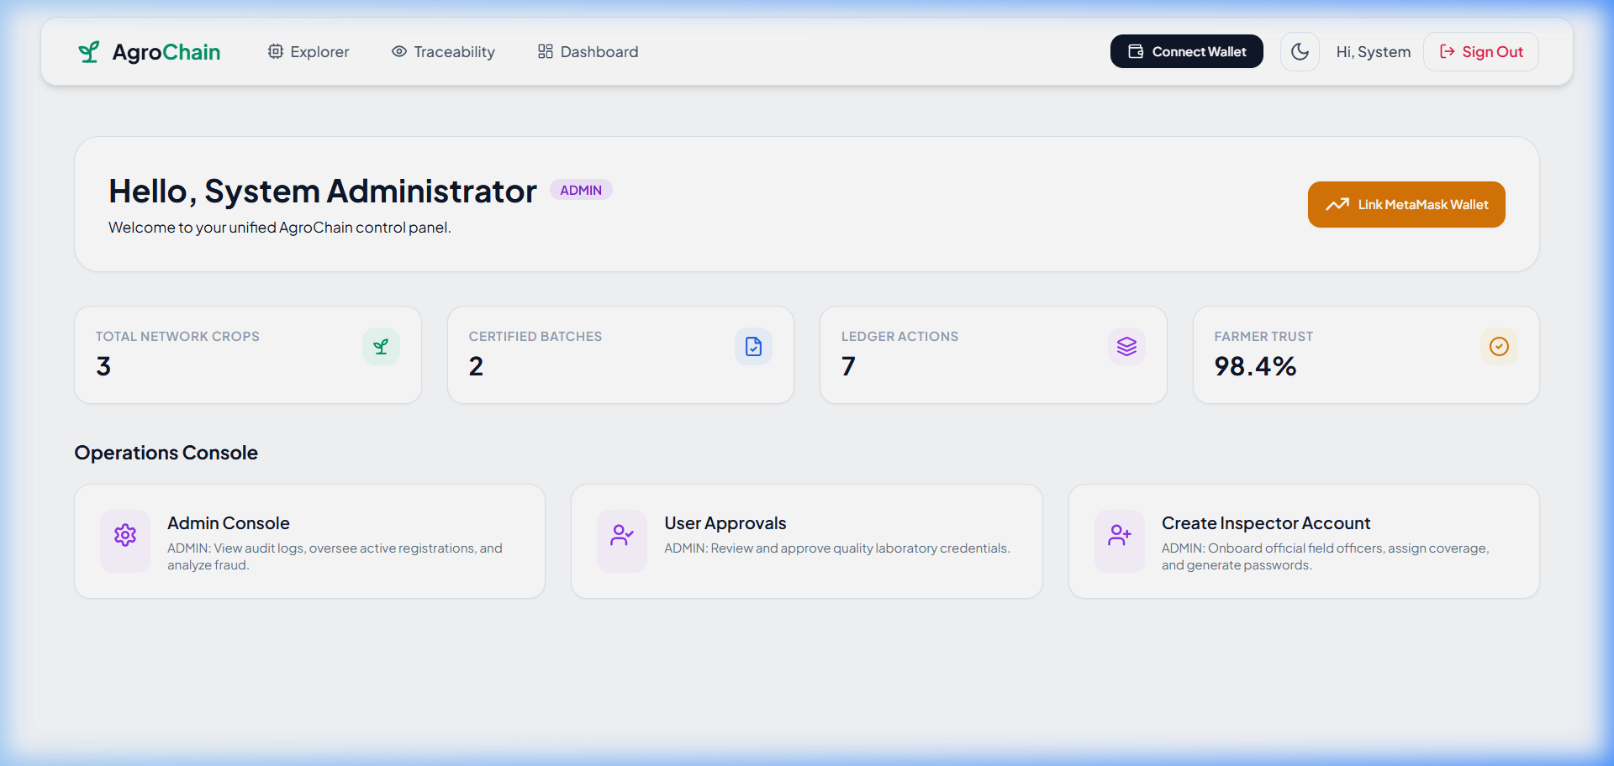
Figure: Figure 6.8: System Administrator Governance & Lab Approval Panel

6.9 Consumer Provenance Verification Page
The public consumer lookup portal presenting an immutable step-by-step crop provenance timeline, verifier identity signatures, lab grade reports, and blockchain transaction hashes.
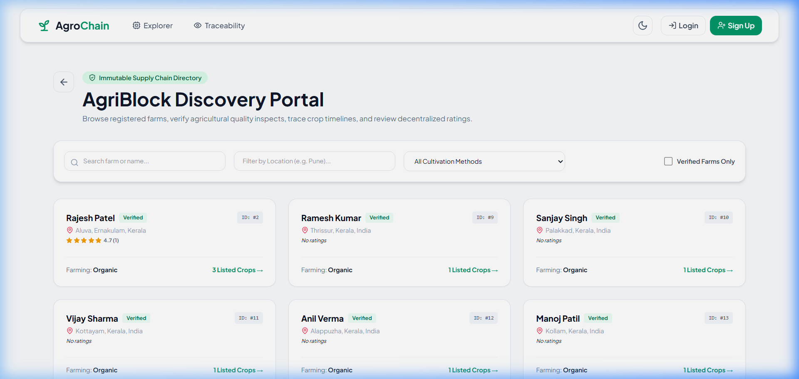
Figure: Figure 6.9: Consumer Provenance Verification Page

6.10 Public Camera-Enabled QR Code Explorer
The interactive mobile/browser public explorer featuring real-time device camera scanning to decode packaging batch QR codes instantly without user login.
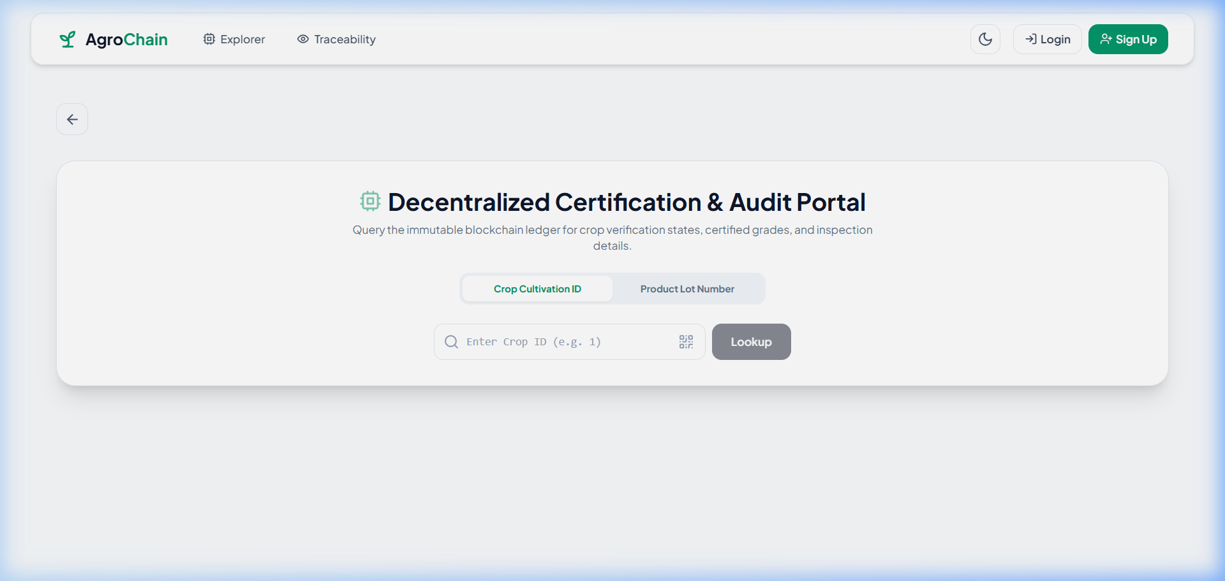
Figure: Figure 6.10: Public Camera-Enabled QR Code Explorer
_________________________________________________________________________________

CHAPTER 7: TESTING

7.1 Introduction
Testing ensures that AgroChain fulfills all functional requirements, security guarantees, smart contract guardrails, and role-based access rules cleanly without runtime regressions.

7.2 Test Reports
Testing was executed across three layers:
- Unit Testing: PyTest for Flask REST API endpoints and Hardhat/Chai for Solidity smart contracts.
- Integration Testing: End-to-end API workflows with SQLite database state assertions.
- User Acceptance Testing (UAT): Verification of React dashboards across all 6 stakeholder roles.

7.3 Testing Criteria
- All authentication attempts without valid OTPs must be rejected.
- Inspectors must only receive crops within their designated Taluk/District.
- Smart contracts must revert lab certification attempts if the crop lacks prior inspector approval.
- All UI forms must validate inputs before server dispatch.

7.4 System Test Tables

Table 7.4.1: Test Cases for Admin/User Login
Test Case ID | Feature | Input Credentials | Expected Result | Pass/Fail
TC-1.1 | User Login | Valid Email & Correct Password | Login success, JWT access token returned | PASS
TC-1.2 | User Login | Valid Email & Incorrect Password | HTTP 401 Unauthorized, "Invalid credentials" | PASS
TC-1.3 | User Login | Non-existent Email address | HTTP 404 Not Found, "User does not exist" | PASS
TC-1.4 | Admin Login | Admin credentials & valid JWT | Navigates directly to Admin Panel (/admin) | PASS

Table 7.4.2: Test Cases for User Registration
Test Case ID | Feature | Input Data | Expected Result | Pass/Fail
TC-2.1 | Signup | Valid profile specs + Valid SMS/Email OTPs | Account created, status set to is_verified=True | PASS
TC-2.2 | Signup | Valid profile specs + Invalid/Expired OTP | Registration blocked, error alert shown | PASS
TC-2.3 | Signup | Duplicate Email or Phone Number | Registration blocked, "User already exists" | PASS
TC-2.4 | Web3 Link | Inspector connects MetaMask & signs nonce | Address linked, status set to ACTIVE | PASS

Table 7.4.3: Validation of Contact Us / Inspector Audit Form
Test Case ID | Feature | Input Action | Expected Result | Pass/Fail
TC-3.1 | Field Audit | Inspector inputs audit notes & selects PHYSICAL_VISIT | Notes saved locally in SQLite DB | PASS
TC-3.2 | On-Chain Audit | Inspector approves crop via MetaMask transaction | Tx succeeds, FarmerRegistry state updated | PASS
TC-3.3 | Contact Form | User submits contact/inquiry message | Message saved, success feedback alert rendered | PASS

Table 7.4.4: Test Cases for Change Password
Test Case ID | Feature | Input Data | Expected Result | Pass/Fail
TC-4.1 | Password Change | Correct Old Password + Valid New Password | Password updated successfully in SQLite DB | PASS
TC-4.2 | Password Change | Incorrect Old Password | Update rejected, "Current password incorrect" | PASS
TC-4.3 | Password Change | New Password less than 6 characters | Form validation error, update blocked | PASS

Table 7.4.5: Test Cases for Forgot Password
Test Case ID | Feature | Input Action | Expected Result | Pass/Fail
TC-5.1 | Forgot Password | Registered Email entered for reset | 6-digit recovery OTP dispatched to email | PASS
TC-5.2 | Forgot Password | Valid OTP + New Password entered | Password reset successfully, user can log in | PASS
TC-5.3 | Forgot Password | Invalid OTP entered during reset | Reset rejected, "Invalid OTP" message rendered | PASS

Table 7.4.6: System Testing Summary
Test Category | Total Cases Executed | Total Passed | Total Failed | Success Rate
Authentication & OTP | 12 | 12 | 0 | 100%
Geographical Routing | 8 | 8 | 0 | 100%
Smart Contracts & Web3 | 15 | 15 | 0 | 100%
Escrow & Micro-Finance | 10 | 10 | 0 | 100%
Public QR Explorer | 6 | 6 | 0 | 100%
Overall System Suite | 51 | 51 | 0 | 100%

_________________________________________________________________________________

CHAPTER 8: CONCLUSION
AgroChain demonstrates a robust, production-ready solution to the dual crises of supply chain opacity and agricultural credit deficiency. By combining Web2 ease-of-use with public Ethereum smart contract immutability:
- Smallholder farmers gain direct access to zero-interest micro-financing escrow.
- Certifying inspectors and laboratories record verifiable proofs on-chain without single-point data tampering.
- End consumers verify product provenance instantly using simple browser camera QR code scanning.
_________________________________________________________________________________

CHAPTER 9: FUTURE SCOPE
- IoT Telemetry Streaming: Integrating soil moisture, humidity, and temperature sensors to stream live telemetry to IPFS/Oracle feeds.
- Decentralized Storage (IPFS): Shifting land deed photos and lab PDFs from local web storage to IPFS/Filecoin nodes.
- Layer-2 Scaling: Deploying smart contract infrastructure to Layer-2 networks (Polygon, Arbitrum) for reduced gas transaction costs during peak trade volumes.
_________________________________________________________________________________

CHAPTER 10: ABBREVIATIONS AND ACRONYMS
Abbreviation | Expanded Term
API | Application Programming Interface
DFD | Data Flow Diagram
DID | Decentralized Identity
ERD | Entity Relationship Diagram
EVM | Ethereum Virtual Machine
JWT | JSON Web Token
LOI | Letter of Intent
NABL | National Accreditation Board for Testing and Calibration Laboratories
OTP | One-Time Password
P2P | Peer-to-Peer
QR | Quick Response (Code)
RBAC | Role-Based Access Control
RPC | Remote Procedure Call
SPA | Single Page Application
SRS | Software Requirement Specification
UAT | User Acceptance Testing

_________________________________________________________________________________

CHAPTER 11: REFERENCES
- Nakamoto, S. (2008). Bitcoin: A Peer-to-Peer Electronic Cash System.
- Wood, G. (2014). Ethereum: A Secure Decentralised Generalised Transaction Ledger. Ethereum Project Yellow Paper.
- Antonopoulos, A. M., & Wood, G. (2018). Mastering Ethereum: Building Smart Contracts and DApps. O'Reilly Media.
- OpenZeppelin Contracts Documentation. AccessControl & Security Architecture. https://docs.openzeppelin.com/
- Food and Agriculture Organization (FAO). Digital Agriculture and Supply Chain Provenance Reports.
_________________________________________________________________________________

