C Programming Project Report
Rhythm Game


- Course: Programming in C (B.Tech 1st Semester)
- Course Code:
- Submitted By: Vedansh Rawat, 590027560
- Submitted To: Mohsin Furkh Dar, SoCS
- Date of Submission: 02/12/2025

Problem Statement

Rhythm games are popular interactive applications that test a player’s timing and reaction skills.
Modern rhythm games use graphical engines and audio syncing, but the goal of this project is to implement a simplified terminal-based rhythm game using only the basic C programming concepts taught in the first semester.

The problem is to design a playable, interactive 4-lane rhythm game inside a console window, where falling notes must be hit at the correct time using the keyboard (A, S, D, F keys). The game should read level data from text files, process input in real-time, detect timing accuracy, update score, and display a clear end-of-level summary.

Objective of the Project
The primary objectives of the Rhythm Game project are:
- To design an interactive terminal-based game using fundamental C programming concepts.
- To implement file handling for loading level data.
- To use structures and arrays to store and manage falling notes.
- To refresh and update the screen in real-time using ANSI escape sequences.
- To implement timing using Sleep() for controlling note fall speed.
- To capture keyboard input (A, S, D, F keys) using non-blocking methods.
- To calculate and display score based on accurate hits.
- To detect end of level when all notes have fallen.
- To present results (score + combo or hits).
10. To create a simple main menu that allows selecting difficulty or viewing instructions.

Software and Tools Used

Compiler: GCC (MinGW-w64)
IDE: Visual Studio Code
Operating System: Windows 10
Libraries: stdio.h, string.h, stdlib.h, conio.h (for non-blocking input), windows.h (sleep), ANSI escape codes.
Other Tools: Terminal, Command Prompt
File Types: .txt (for level designs)

Algorithm
1. Start Program
- Display Main Menu (Start Game, Select Difficulty, Instructions, Exit).
- Take user input.
2. Select Song File
- Based on difficulty, load easy.txt, medium.txt, or hard.txt.
3. Load Level Data
- Open text file.
- Read each line (beat) into a 2D array beats[][].
- Store total number of beats.
4. Initialize Game Variables
- Clear grid
- Set noteCount = 0, score = 0, combo = 0, currentBeat = 0.
5. Start Game Loop
The loop repeats until:
- All notes have spawned.
- All active notes are gone.
Inside loop:
a. Spawn Notes
- Every beatInterval, read beats[currentBeat].
- Convert characters to notes:
  - A → lane 0
  - S → lane 1
  - D → lane 2
  - F → lane 3
b. Update Note Positions
- Move each active note downward by increasing its row.
c. Clear Grid
- Reset all characters to blank (' ').
d. Redraw Notes on Grid
- Place 'O' in the appropriate row/column.
e. Draw Screen
- Use printf("\033[2J\033[H") to clear + rewrite.
f. Read Keyboard Input
- Check if user pressed A/S/D/F.
- Detect if timed correctly (within perfect row ±1).
g. Update Score
- If hit:
  - score += 100
- If miss:
  - score += 0
h. Timing Control
- Use Sleep(200) (200ms per frame).
6. End Condition
Exit loop when:
- currentBeat >= totalBeats
AND
- No active notes remain.
7. Show Results
- Print final score and combo.
- Return to main menu.
8. Exit Program

FLOWCHART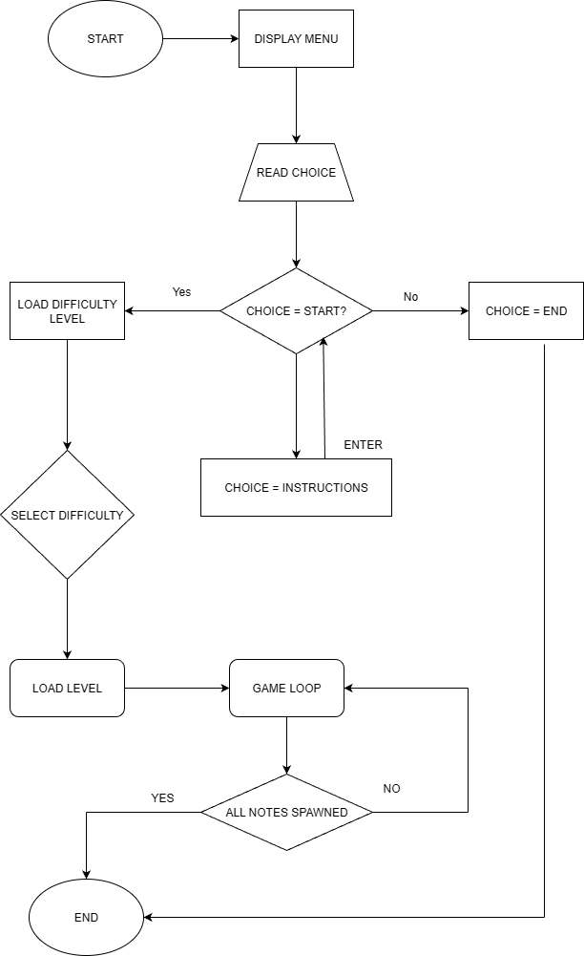
Screenshots

Main Menu: 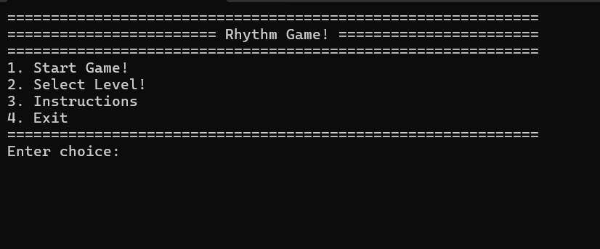
Instructions: 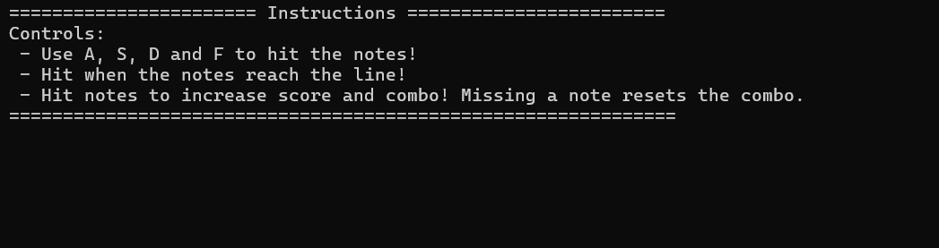

Game running:
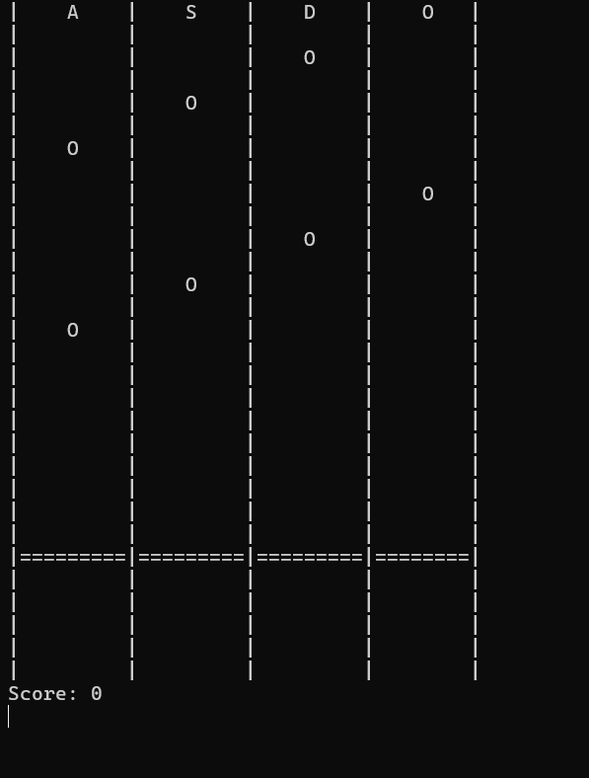

Conclusion

This project successfully demonstrates the application of fundamental C programming concepts to create an interactive rhythm game in a terminal environment. The use of structures, arrays, functions, and file handling enabled efficient note management and level loading. The project also provided practical experience with real-time input handling and terminal screen updates.
Overall, the project improved understanding of modular programming, data processing, file systems, and game loops. Despite being text-based, the final result is functional, enjoyable, and showcases creativity within first-semester constraints.

