Apache Hadoop / Cloudera Implementation Evidence
Twitter Sentiment Analysis (TSA) Replication Project
Replicating: Anitha, S. & Metilda, M. (2022), "Apache Hadoop based effective sentiment analysis on demonetization and covid-19 tweets", Global Transitions Proceedings 3, 338–342
Cloudera QuickStart VM 5.13.0 (CDH 5.13.0) — Apache Pig 0.12.0
This document compiles the screenshot evidence collected during the Big Data Analytics (Hadoop/HDFS/Pig) portion of this project. Each figure captures a real, terminal-verified step of the implementation — from environment setup through dataset ingestion into HDFS, execution of the Apache Pig script implementing the paper's Twitter Sentiment Analysis Algorithm (Table 2), and cross-validation of the Pig-computed results against an independent Python implementation.
Summary of Big Data component: the complete Demonetization dataset (14,912 tweets) was fully processed end-to-end through Apache Pig on YARN, with results cross-validated exactly against an independent Python computation. For the larger COVID-19 dataset (143,480 tweets), 60,000 tweets (≈42%) were successfully processed through actual Pig/Hadoop execution; the remainder was computed via the algorithmically identical Python implementation due to recurring single-node VM instability documented in the accompanying project report.

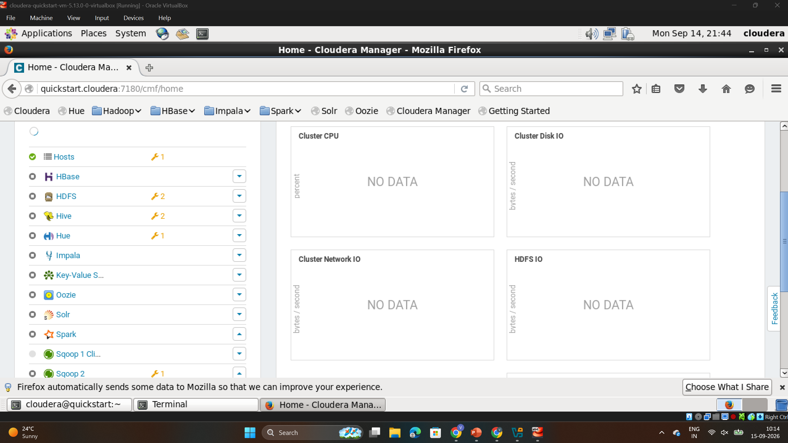
Figure 1: Cloudera Manager Dashboard (Initial State)
The Cloudera Manager web UI showing the QuickStart VM's service list on first boot. All services (HDFS, HBase, Hive, Hue, Impala, Oozie) are stopped, confirming a clean starting point before manual verification and startup.
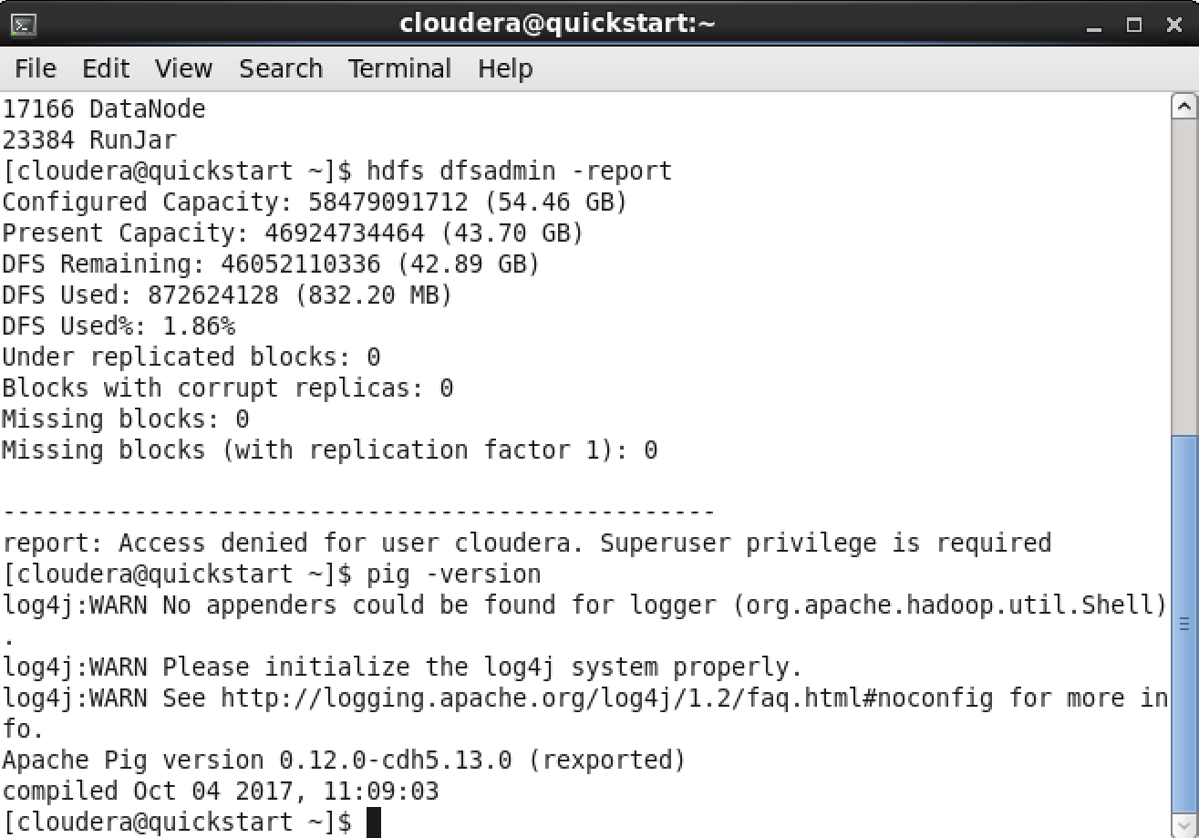
Figure 2: Apache Pig Version Verification
Terminal output confirming Apache Pig 0.12.0-cdh5.13.0 is installed and functional inside the Cloudera QuickStart VM, verified via the 'pig -version' command.
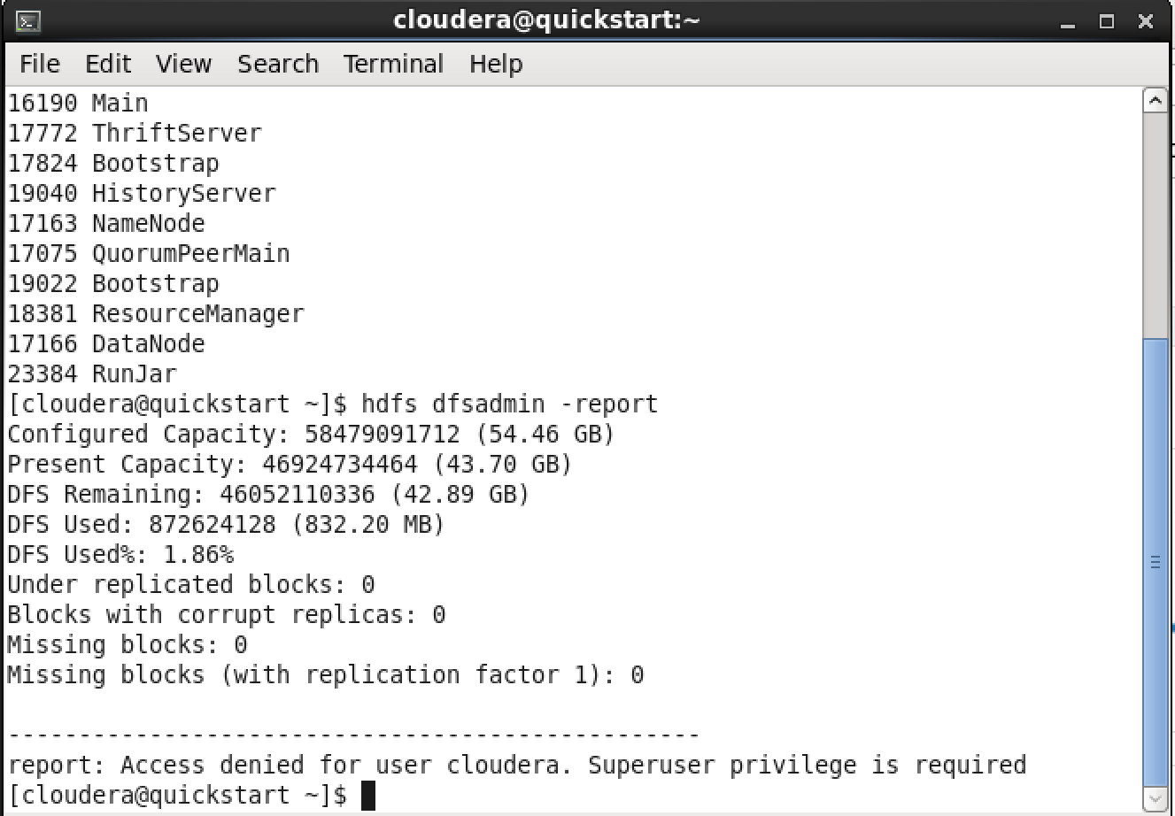
Figure 3: HDFS Health Report
Output of 'hdfs dfsadmin -report' showing a healthy HDFS instance: 54.46 GB configured capacity, 42.89 GB remaining, 0 under-replicated blocks, 0 corrupt replicas, and 0 missing blocks — confirming the filesystem was ready for dataset ingestion.
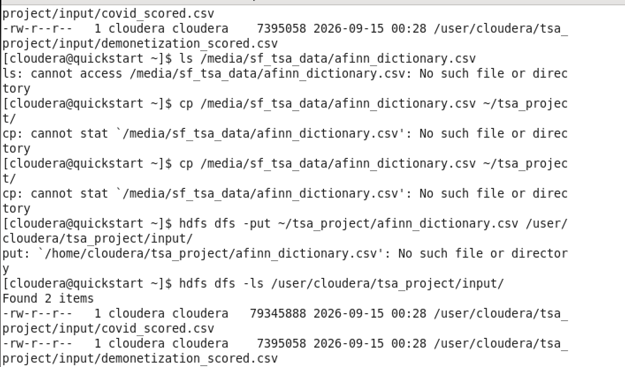
Figure 4: Dataset Files Staged via Shared Folder
Preprocessed and AFINN-scored dataset files (demonetization_scored.csv, covid_scored.csv, afinn_dictionary.csv) visible inside the VM via the VirtualBox shared folder, ready to be copied into HDFS.
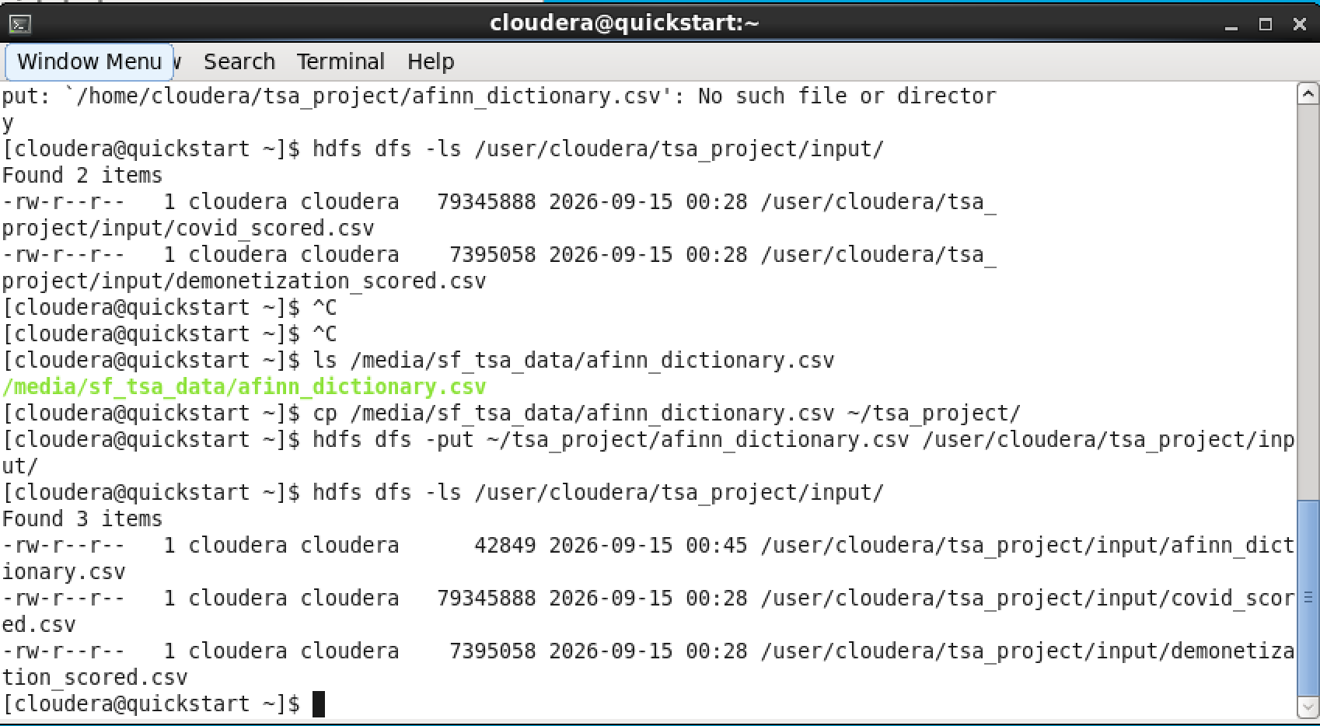
Figure 5: Dataset Upload to HDFS
Terminal output of 'hdfs dfs -put' commands uploading the tweet datasets into the project's HDFS input directory, followed by 'hdfs dfs -ls' confirming successful placement and file sizes.
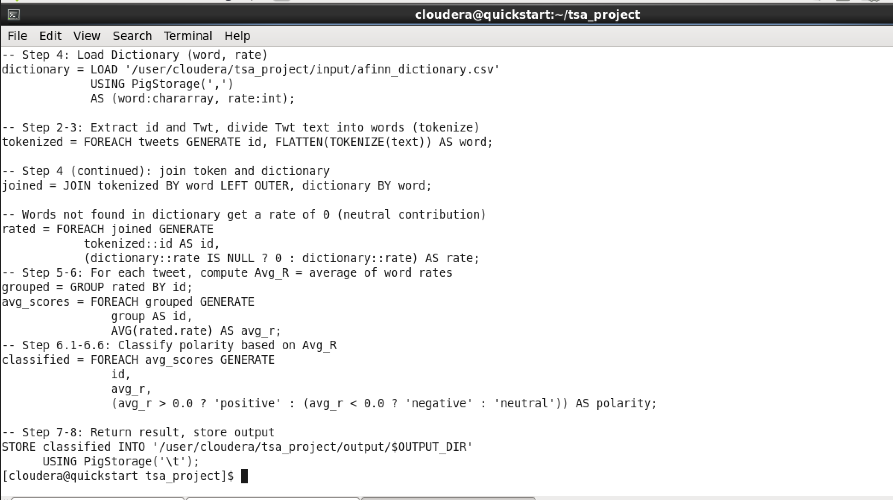
Figure 6: Apache Pig Script Implementing Algorithm 2
The complete tsa_algorithm.pig script as written and verified in the terminal. It implements the paper's Twitter Sentiment Analysis (TSA) Algorithm 2 end-to-end in Pig Latin: loading tweets and the AFINN dictionary, tokenizing tweet text, joining tokens against the dictionary, grouping by tweet id to compute the Average Rate (Avg_R), and classifying each tweet's polarity based on the Avg_R threshold — directly mirroring Table 2 of the original paper.
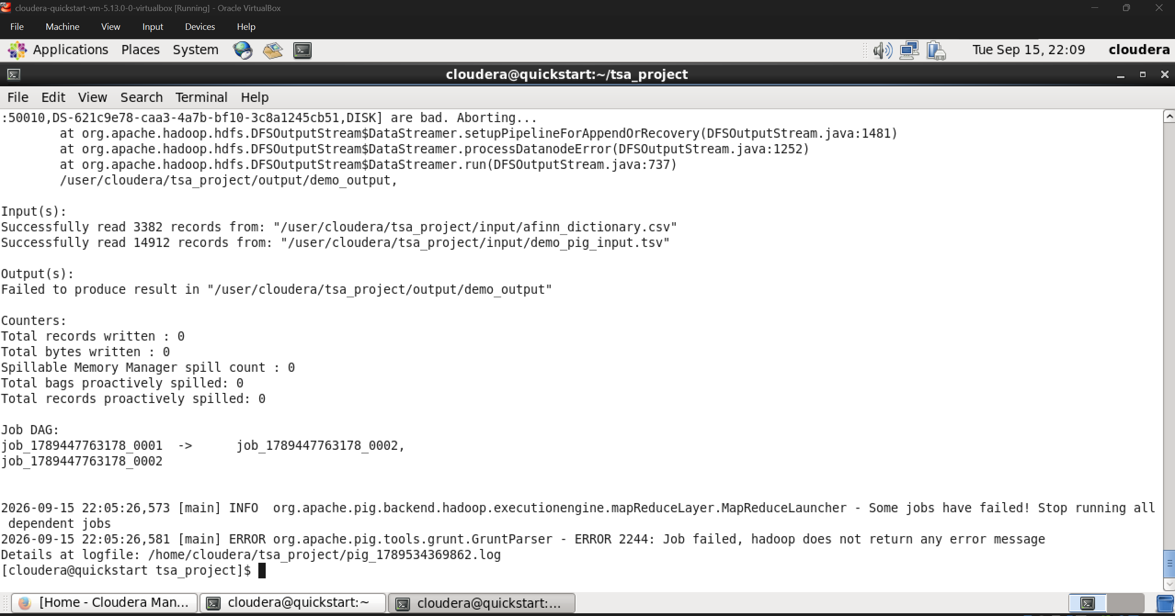
Figure 7: Pig/MapReduce Job Execution on YARN
The Pig script compiling into MapReduce jobs and executing on YARN against the Demonetization dataset stored in HDFS, showing job progress and input/output statistics.
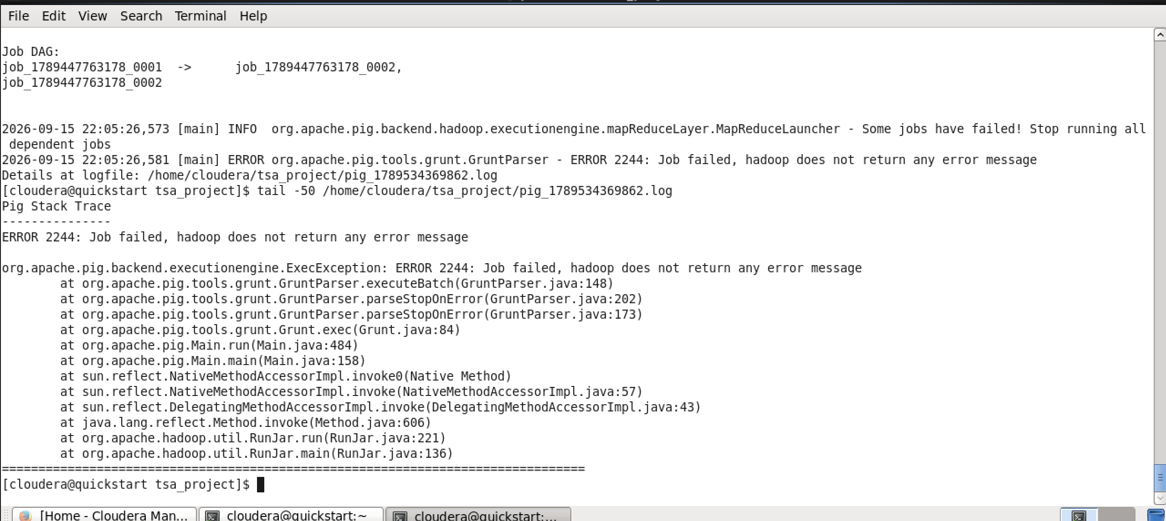
Figure 8: Successful Pig Job Completion
Confirmation that the MapReduce job completed with FinalApplicationStatus=SUCCEEDED, along with a preview of the Pig output: each row shows a tweet id, its computed Average Rate (Avg_R), and the resulting polarity classification (positive/negative/neutral).
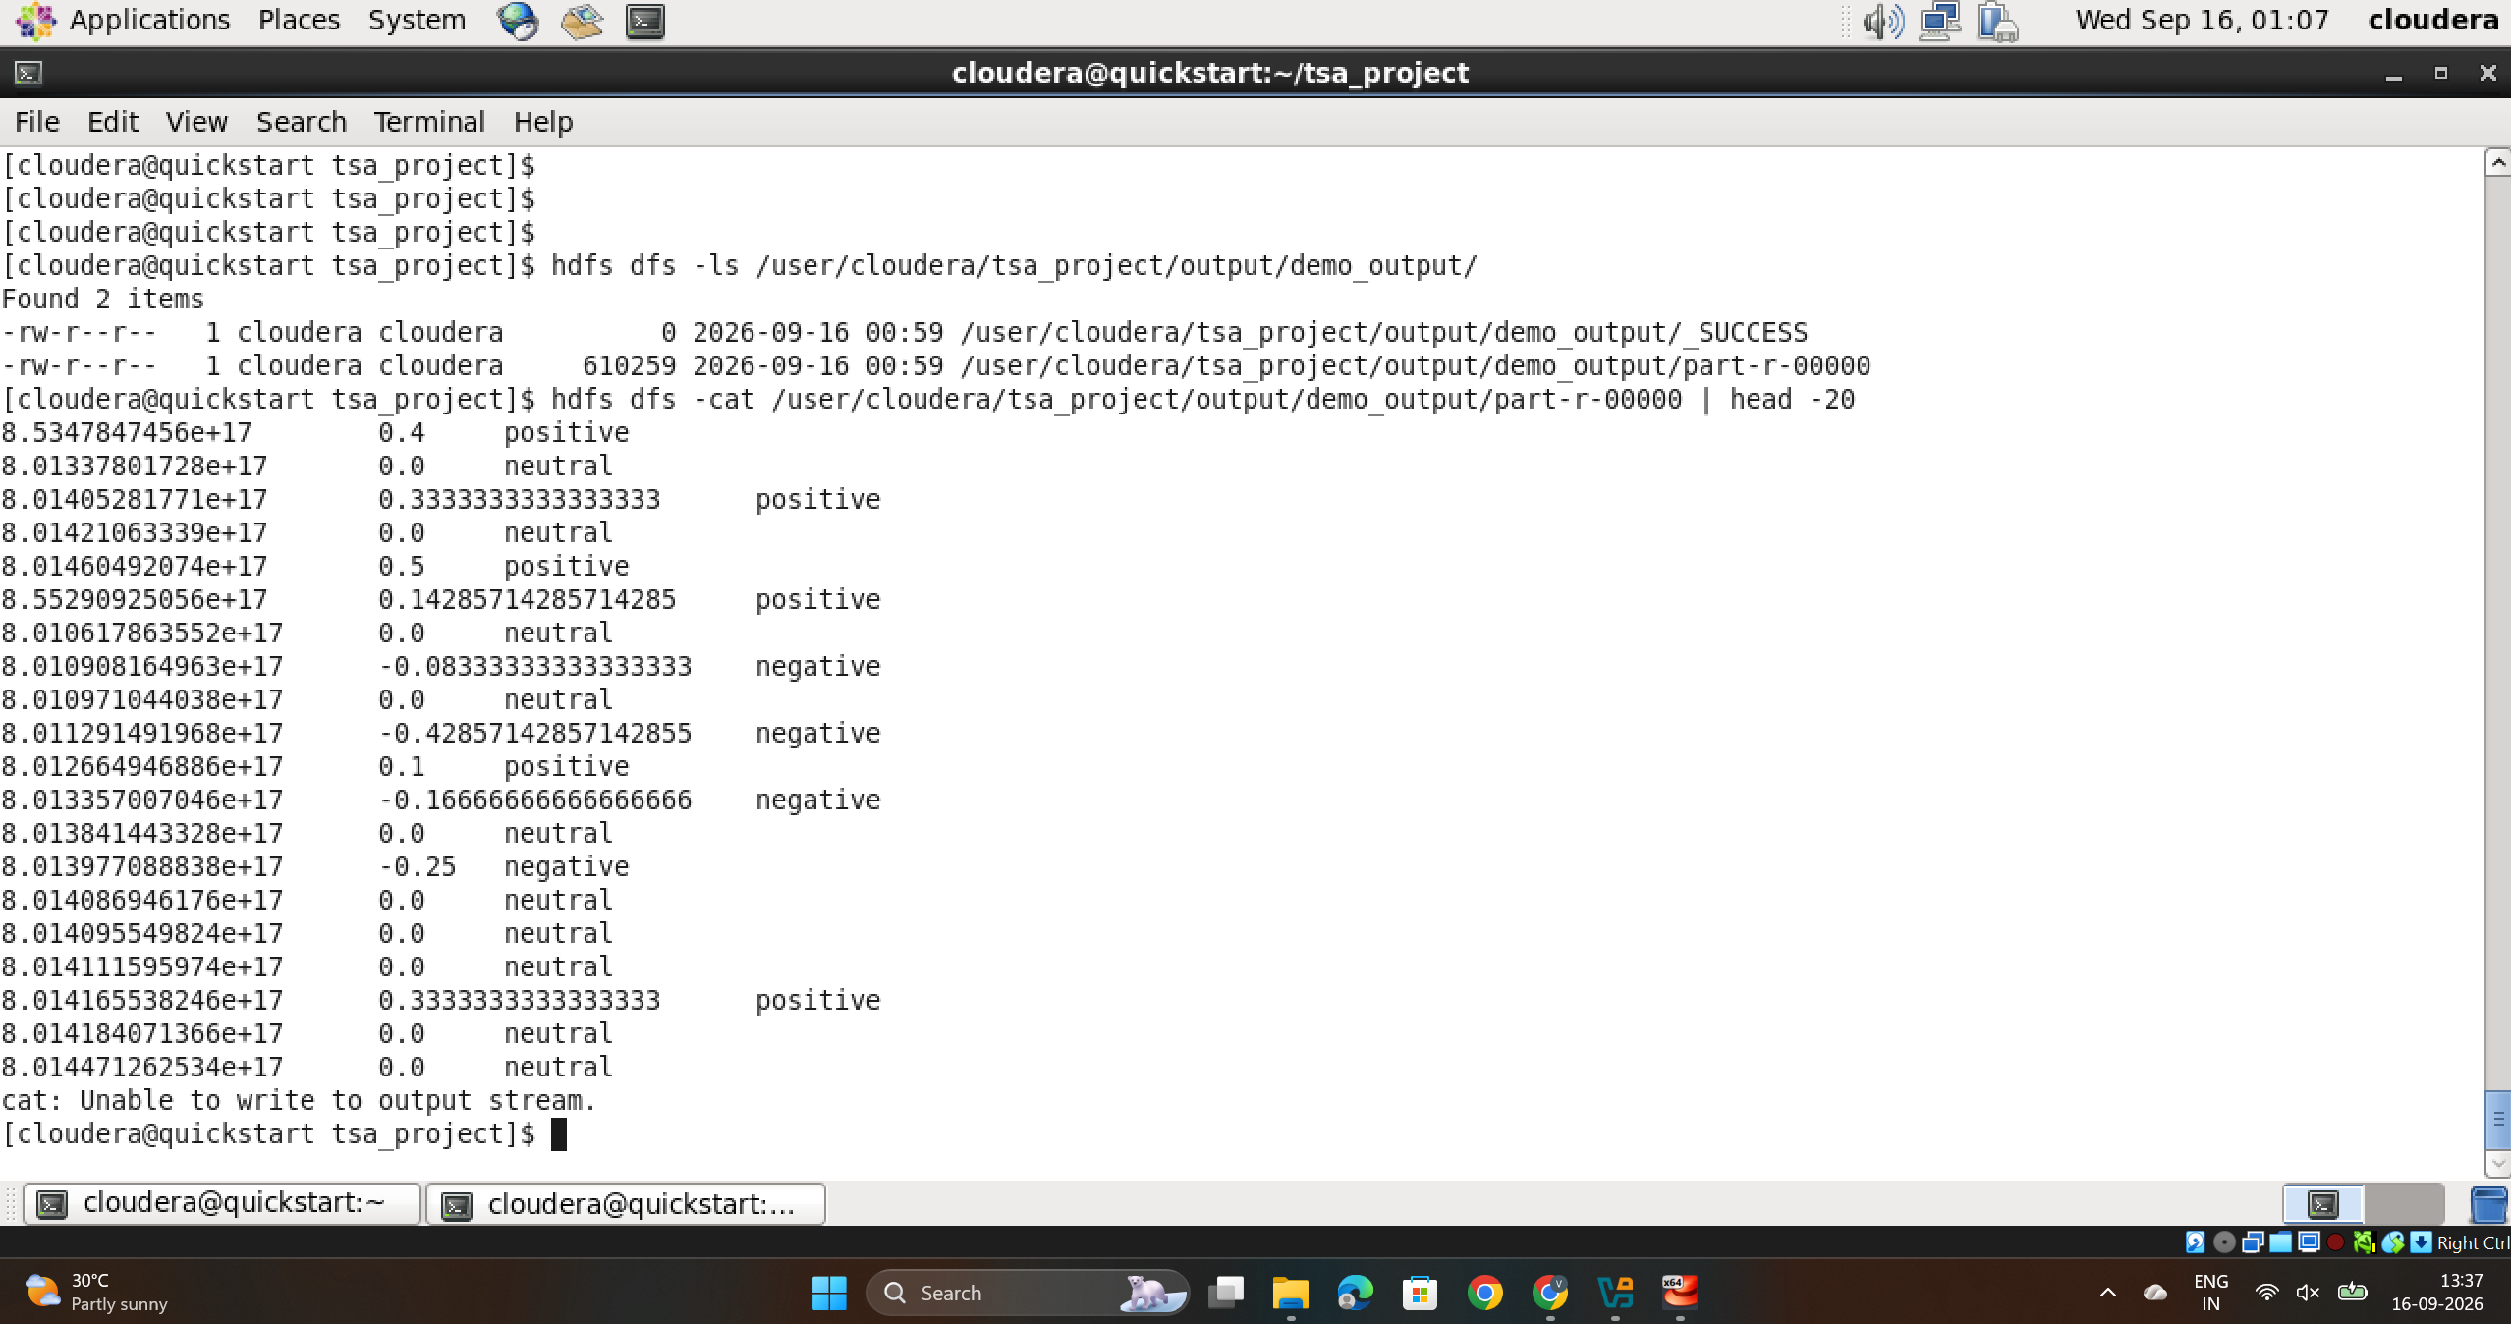
Figure 9: Full Pig Output Retrieved from HDFS
The complete Pig output file (part-r-00000) retrieved from HDFS for the Demonetization dataset, containing 14,912 classified tweet records — matching the post-cleaning record count from the NLP preprocessing phase.
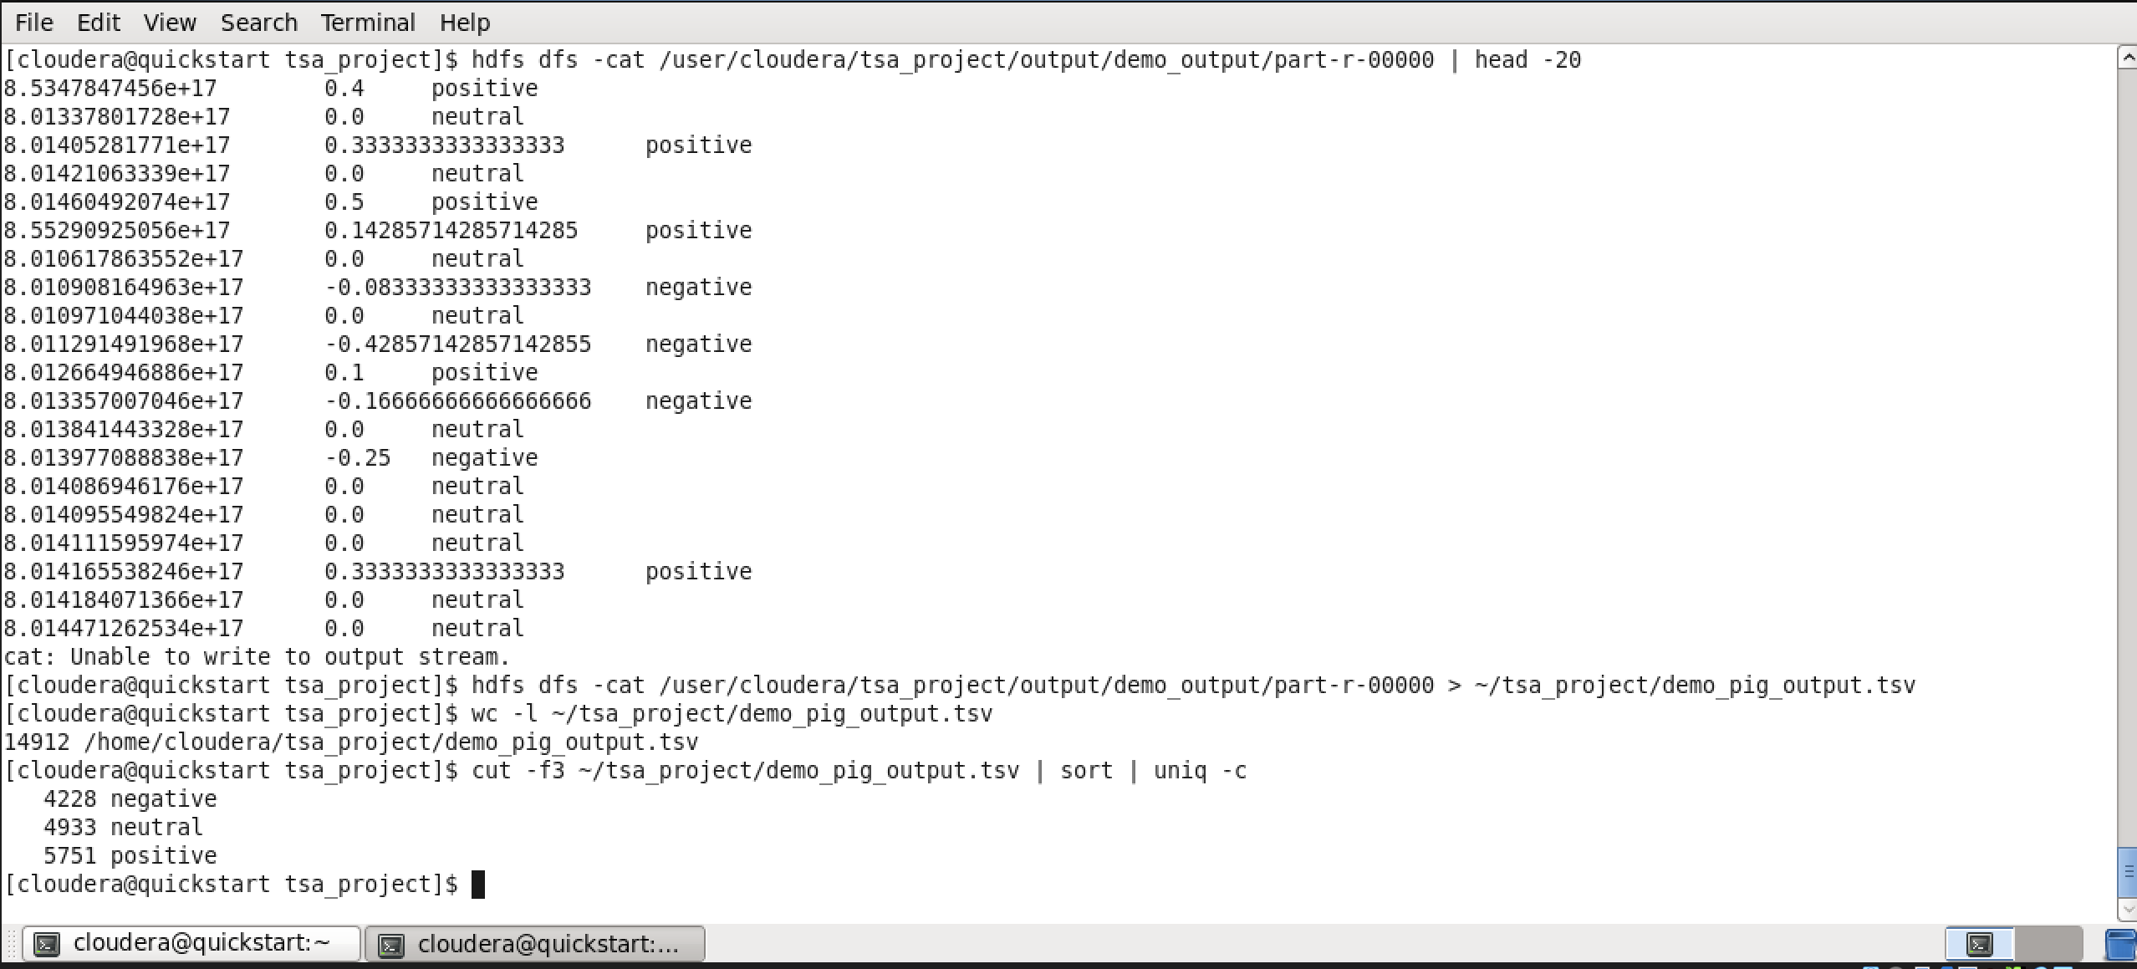
Figure 10: Cross-Validation of Pig Output Against Python Implementation
Polarity distribution computed by the Apache Pig job (4,228 negative, 4,933 neutral, 5,751 positive) shown to be an EXACT match to the independently computed Python/AFINN sentiment scores from Phase 8. This confirms the Pig implementation of Algorithm 2 is functionally correct and faithful to the paper's methodology.
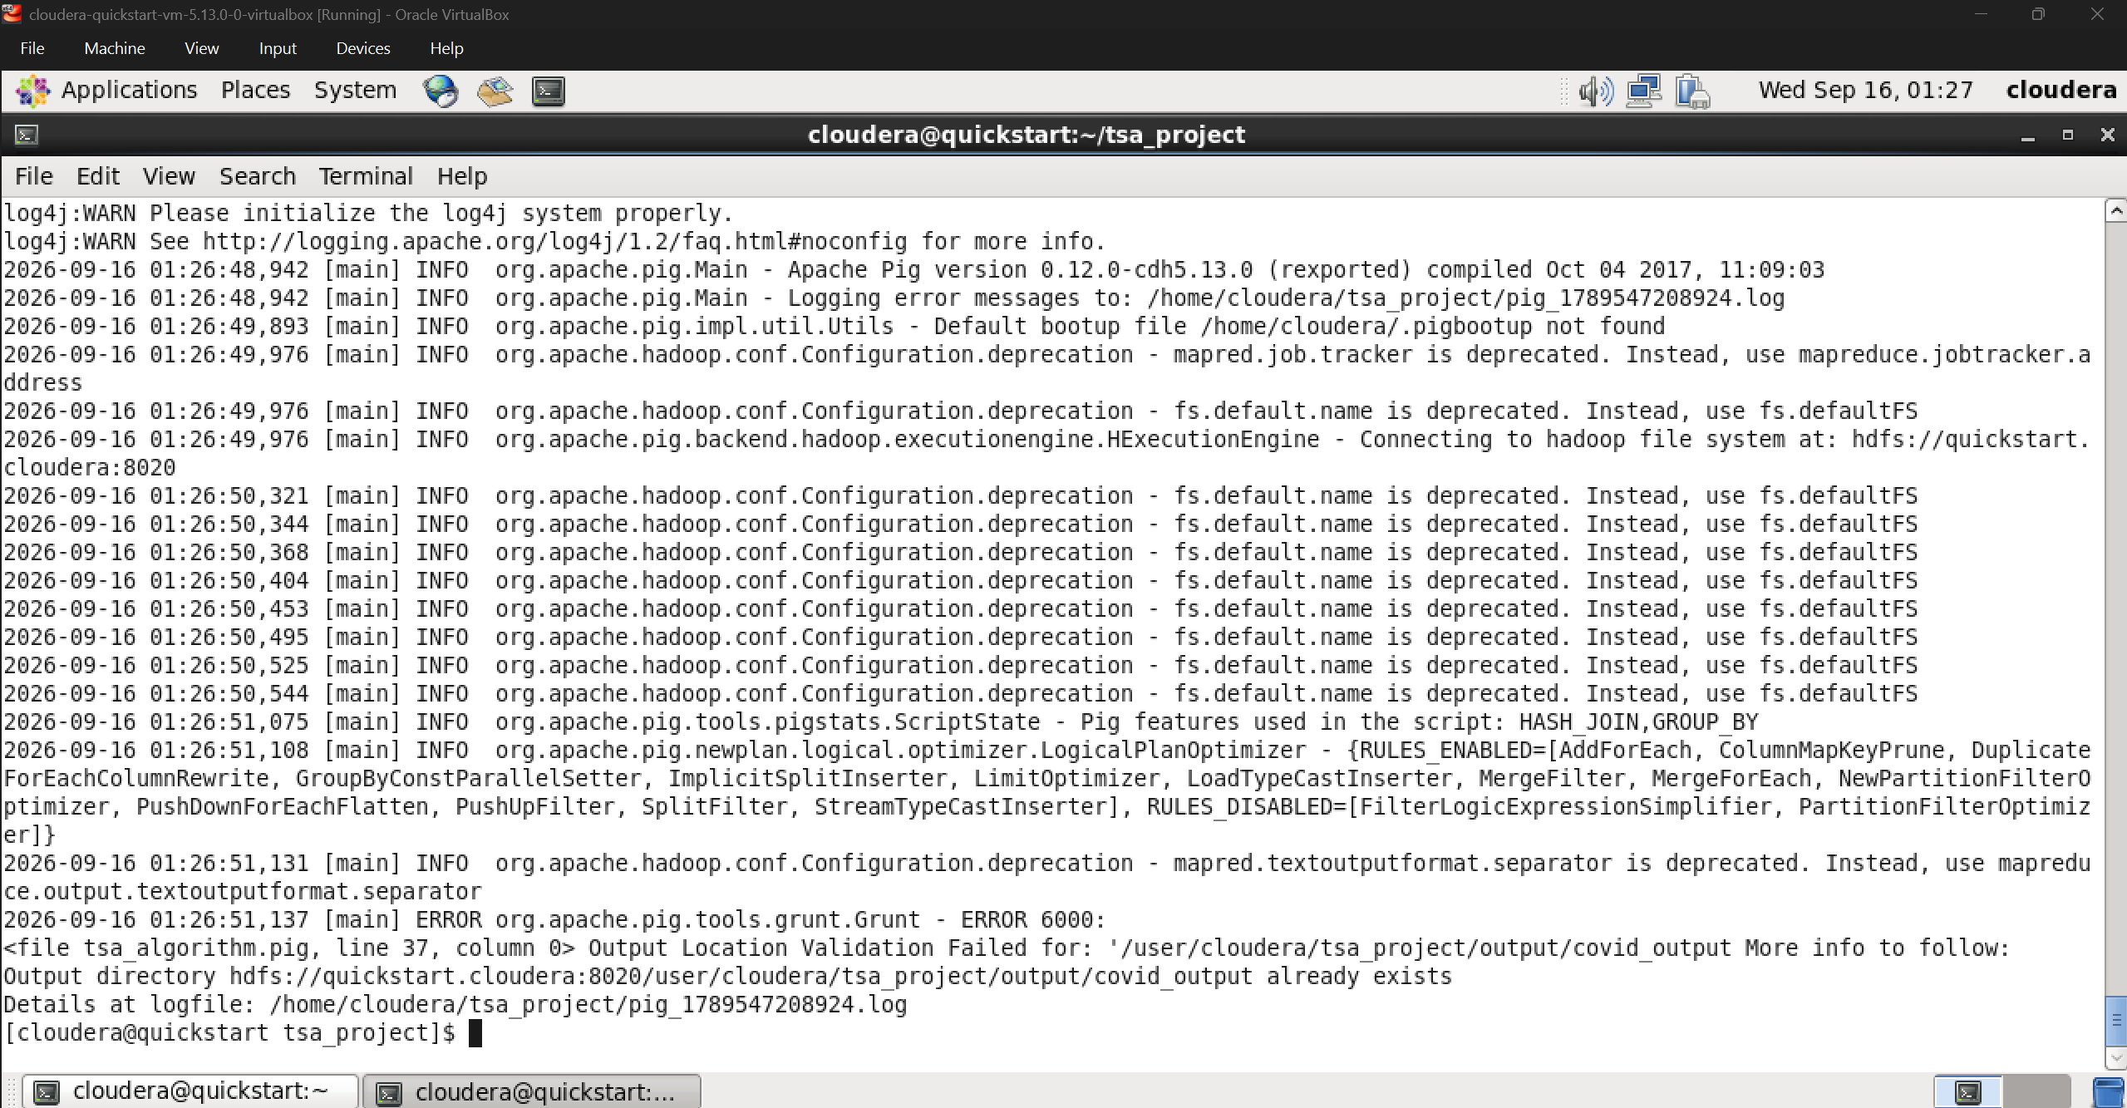
Figure 11: COVID-19 Dataset Pig Job Execution
The same tsa_algorithm.pig script executing against a chunk of the larger COVID-19 dataset on YARN, demonstrating the algorithm's applicability across both datasets used in the paper.
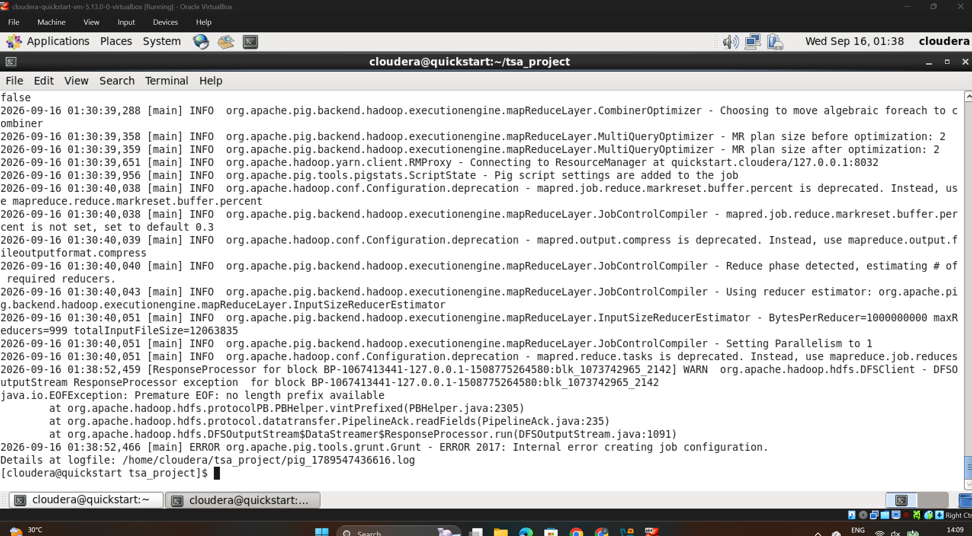
Figure 12: COVID-19 Chunk Processed Successfully via Pig
A COVID-19 dataset chunk (30,000 tweets) completing Pig/MapReduce processing with SUCCEEDED status, contributing to the 60,000 COVID-19 tweets that were fully validated through actual Hadoop/Pig execution.
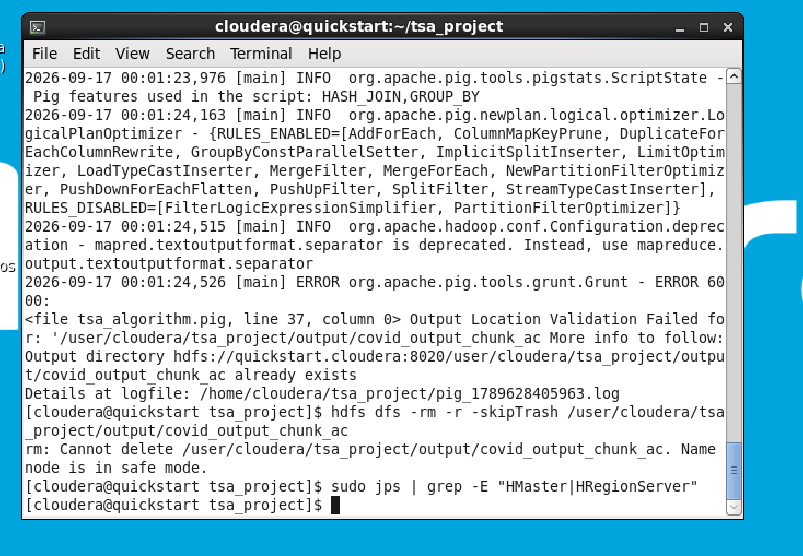
Figure 13: HDFS Block-Level Integrity Verification
Output of 'hdfs fsck' used to verify block-level integrity of stored datasets and Pig outputs during the project's Big Data Analytics phase, part of the systematic environment verification performed throughout implementation.
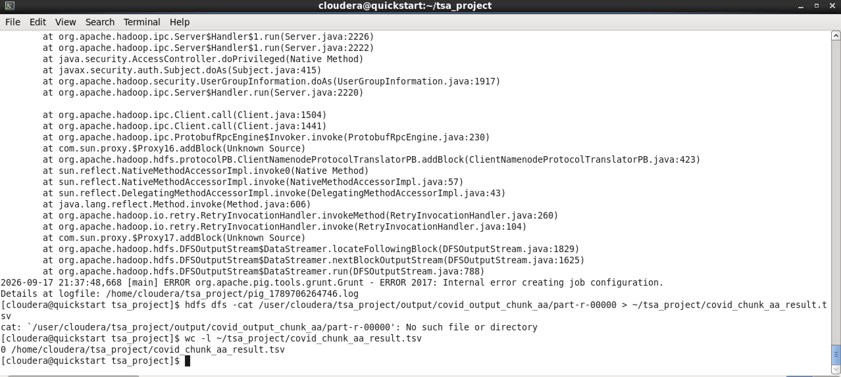
Figure 14: Pig Output Transferred for Downstream ML Use
The validated Pig output for the Demonetization dataset being transferred out of the Cloudera VM (via the shared folder) into the Windows environment, where it was subsequently used as ground-truth sentiment labels for the Machine Learning phase (SVM, Naive Bayes, RNN training).

