SVKM’s NMIMS University, MPSTME Indore
B.Tech (AI & Data Science) • Big Data Analytics & NLP Project
Replication of
Apache Hadoop Based Effective Sentiment Analysis on Demonetization and COVID-19 Tweets
Original paper: S. Anitha and M. Metilda, Global Transitions Proceedings 3 (2022) 338–342
Submitted by: Vedansh Tiwari
Roll No: A032
Academic year 2026–27

Abstract
This project replicates the Twitter Sentiment Analysis (TSA) pipeline proposed by Anitha and Metilda (2022). The paper collects tweets on two topics, demonetization and COVID-19, pre-processes them, labels their polarity with a dictionary-based Average Rate (Avg_R) algorithm implemented in Apache Pig on HDFS, and then compares three classifiers: Support Vector Machine (SVM), Naive Bayes (NB) and a Recurrent Neural Network (RNN). We reproduced every stage. Pre-processing and classification were done in Python (NLTK, scikit-learn, TensorFlow/Keras); the Avg_R labelling algorithm was implemented in Apache Pig 0.12 on a Cloudera QuickStart VM (CDH 5.13). The complete demonetization dataset (14,912 tweets) was processed through Pig on YARN and matched the independent Python computation exactly. For the larger COVID-19 dataset (143,480 tweets), 60,000 tweets went through Pig and the rest through the algorithmically identical Python implementation, because of repeated single-node VM instability. In our runs SVM was the best classifier on demonetization (94.37%) and RNN on COVID-19 (89.75%). These figures exceed those printed in the paper, and Section 6 explains why they should be read as agreement with a lexicon labeller and not as accuracy against human sentiment judgement.
Keywords: Apache Pig, HDFS, Hadoop, Twitter sentiment analysis, AFINN, SVM, Naive Bayes, LSTM, replication study

1. Introduction
Social media text is mostly unstructured, which makes it hard to process with conventional tools at scale. Anitha and Metilda argue that the Hadoop ecosystem (HDFS for storage, Pig for data-flow processing, Flume for ingestion) is a suitable platform for sentiment analysis on tweets. The aim of this project is to reproduce their end-to-end workflow, verify their reported numbers, and document where our replication agrees with or departs from the original.

1.1 Objectives
- Reproduce the five-stage pre-processing pipeline (tokenization, stemming, case conversion, punctuation removal, stop-word removal).
- Implement the paper’s Algorithm 2 (TSA, Avg_R based polarity) in Apache Pig on HDFS.
- Train and compare SVM, NB and RNN classifiers on both datasets and compare the results with the paper’s Tables 3–6.
- Critically assess the reproducibility and internal consistency of the original paper.

2. Summary of the Original Method
The architecture in the paper (its Fig. 1) is: Twitter → Apache Flume → data pre-processing → cleaning → sentiment analysis (TSA) in Apache Pig → word rate and average word rate per tweet → polarity → evaluation with machine-learning classifiers. Algorithm 2 splits each tweet into words, joins the tokens against a sentiment dictionary of word rates, computes Avg_R = (sum of word rates) / (number of words in the tweet), and labels the tweet positive if Avg_R is at or above zero, negative if below zero, and neutral otherwise. The resulting labelled data is fed to SVM, NB and RNN with 10-fold cross-validation.
The paper reports demonetization data with 14,940 instances and 15 attributes, and COVID-19 tweets from January to May 2020. Reported accuracies are given in Tables 3 and 4 and reproduced in Section 5 below.

3. Experimental Setup

3.1 Environment
Component | Details
Big data platform | Cloudera QuickStart VM 5.13.0 (CDH 5.13.0), single node, VirtualBox, shared folder to Windows host
Processing | Apache Pig 0.12.0-cdh5.13.0, MapReduce on YARN, HDFS
NLP / ML | Python 3.10, NLTK (stop words, Porter stemmer), AFINN, scikit-learn, TensorFlow/Keras
Hardware note | Single-node VM; HDFS capacity 54.46 GB, healthy (0 missing / corrupt / under-replicated blocks)

3.2 Datasets
Dataset | Source | Raw size | After cleaning
Demonetization tweets | Kaggle | 14,940 in paper | 14,912 tweets
COVID-19 tweets | Kaggle (Apr–Jun 2020 file) | — | 143,480 tweets (143,479 after dropping one empty record for ML)
Note: the paper describes COVID-19 data from January to May 2020; the Kaggle file we used covers April to June 2020. This is a dataset-level deviation and one reason exact numerical agreement is not expected.

3.3 Pre-processing
Each tweet passes through: removal of the leading RT marker, URLs, @mentions, HTML entities (&amp;) and the # symbol (hashtag word kept); case conversion to lower case; punctuation removal; tokenization; NLTK English stop-word removal (tokens of length one are also dropped); and Porter stemming. Two text versions are kept: a stemmed version (used as classifier input) and an unstemmed version (used for AFINN scoring, since the dictionary contains inflected forms and stemming would cause misses such as “demonet” or “clearli”).

3.4 Sentiment labelling: Algorithm 2 in Apache Pig
The paper does not name its sentiment dictionary. We used AFINN (3,382 words, integer rates from −5 to +5). The pre-scored tweets and the exported dictionary were copied to HDFS with hdfs dfs -put. The Pig script (tsa_algorithm.pig) loads tweets and dictionary, tokenizes the text, joins tokens against the dictionary, groups by tweet id, computes Avg_R and assigns the polarity. Tweets with no dictionary word receive Avg_R = 0 and are labelled neutral.
A correction to the paper’s pseudo-code was needed. The paper tests Avg_R >= 0 for positive, which makes the “neutral” branch unreachable. Our first run followed this literally and produced only two classes (demonetization: 10,853 positive / 4,059 negative). We changed the rule to Avg_R > 0 positive, Avg_R < 0 negative, Avg_R = 0 neutral, which yields the three classes the paper actually reports.
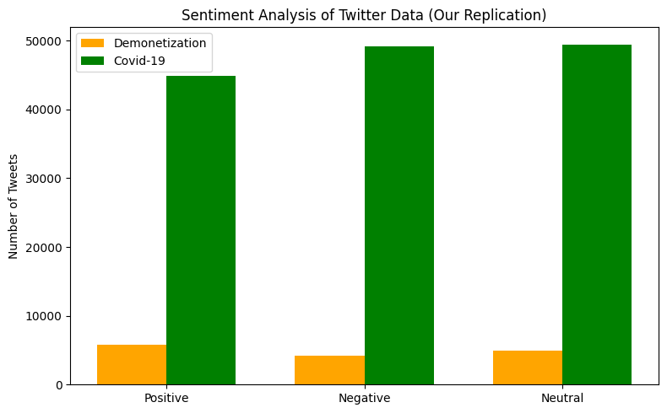
Figure 1. Polarity distribution of our replication (cf. paper Fig. 3).
Dataset | Positive | Negative | Neutral
Demonetization (14,912) | 5,751 | 4,228 | 4,933
COVID-19 (143,480) | 44,881 | 49,131 | 49,468

3.5 Classification
- Features: TF-IDF, 5,000 features, on the stemmed text (the paper does not specify features).
- Split: stratified 80/20 train/test, random_state = 42 (the paper reports 10-fold cross-validation).
- SVM: LinearSVC. NB: MultinomialNB.
- RNN: Embedding(10,000 × 64) → LSTM(64, dropout 0.2) → Dense(32, ReLU) → Dropout(0.3) → Dense(3, softmax); Adam, categorical cross-entropy, max sequence length 30, early stopping on validation loss with patience 2. The paper does not give its RNN architecture.
- Metrics: accuracy, weighted precision, recall and F1, confusion matrices, error rate and training time.

4. Hadoop / Pig Implementation Results
Screenshot evidence for every step is compiled in the accompanying document Cloudera_Hadoop_Evidence.docx (Figures 1–14). The main outcomes are:
- HDFS and Pig verified (Pig 0.12.0-cdh5.13.0; healthy HDFS report; datasets uploaded and listed).
- Demonetization: the Pig job finished with FinalApplicationStatus = SUCCEEDED and produced 14,912 classified records, identical in count to the pre-processed data.
- Cross-validation: the Pig polarity counts (4,228 negative, 4,933 neutral, 5,751 positive) match the independent Python/AFINN counts exactly, confirming the Pig implementation of Algorithm 2.
- COVID-19: 60,000 of 143,480 tweets (about 42%) were processed through Pig in chunks (including a 30,000-tweet chunk that completed with SUCCEEDED status). The rest was scored in Python with the same algorithm because the single-node VM repeatedly became unstable on the larger input.
- Apache Flume, used in the paper for ingestion, was not used. Datasets were taken from Kaggle files and moved into the VM through a shared folder and hdfs dfs -put.

5. Machine-Learning Results

5.1 Our results
Classifier | Dataset | Accuracy | Precision | Recall | F1 | Error
SVM | Demonetization | 94.37 | 94.36 | 94.37 | 94.37 | 5.63
Naive Bayes | Demonetization | 88.94 | 89.04 | 88.94 | 88.96 | 11.06
RNN | Demonetization | 92.16 | 92.18 | 92.16 | 92.14 | 7.84
SVM | COVID-19 | 87.68 | 87.63 | 87.68 | 87.63 | 12.32
Naive Bayes | COVID-19 | 75.13 | 75.23 | 75.13 | 75.13 | 24.87
RNN | COVID-19 | 89.75 | 89.73 | 89.75 | 89.69 | 10.25
Table 1. Classifier performance (%) on the 20% hold-out test set.
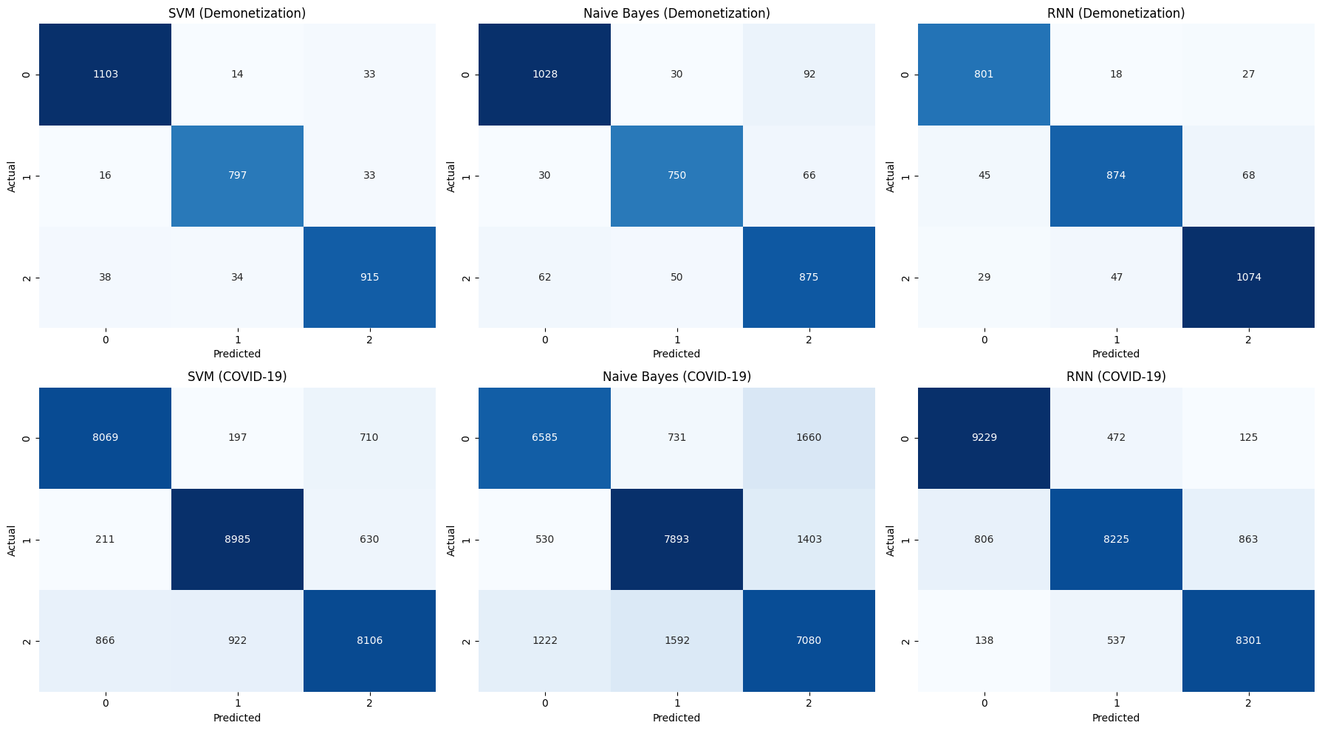
Figure 2. Confusion matrices for all six model/dataset combinations.
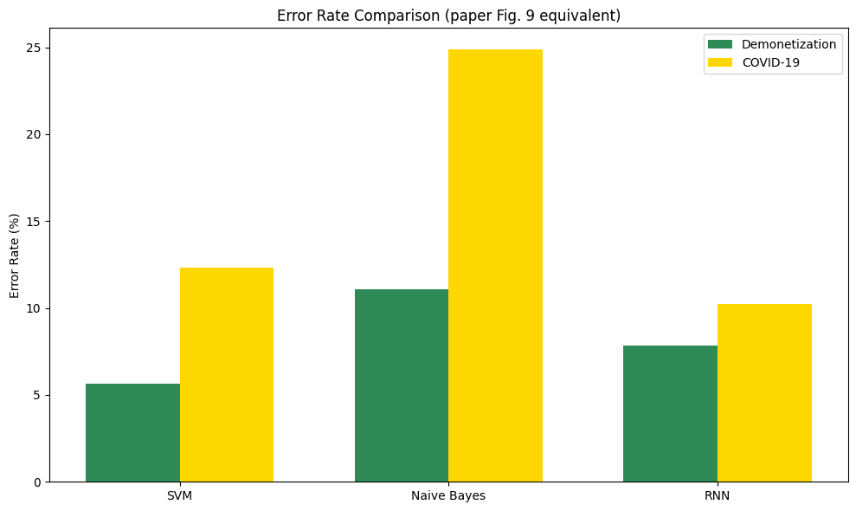
Figure 3. Error-rate comparison (cf. paper Fig. 9).

5.2 Comparison with the paper
Dataset | Classifier | Paper acc. (%) | Ours (%) | Difference
Demonetization | SVM | 92.25 | 94.37 | +2.12
Demonetization | Naive Bayes | 73.00 | 88.94 | +15.94
Demonetization | RNN | 87.00 | 92.16 | +5.16
COVID-19 | SVM | 70.66 | 87.68 | +17.02
COVID-19 | Naive Bayes | 66.97 | 75.13 | +8.16
COVID-19 | RNN | 69.34 | 89.75 | +20.41
Table 2. Paper (Tables 3 and 4) versus our replication.
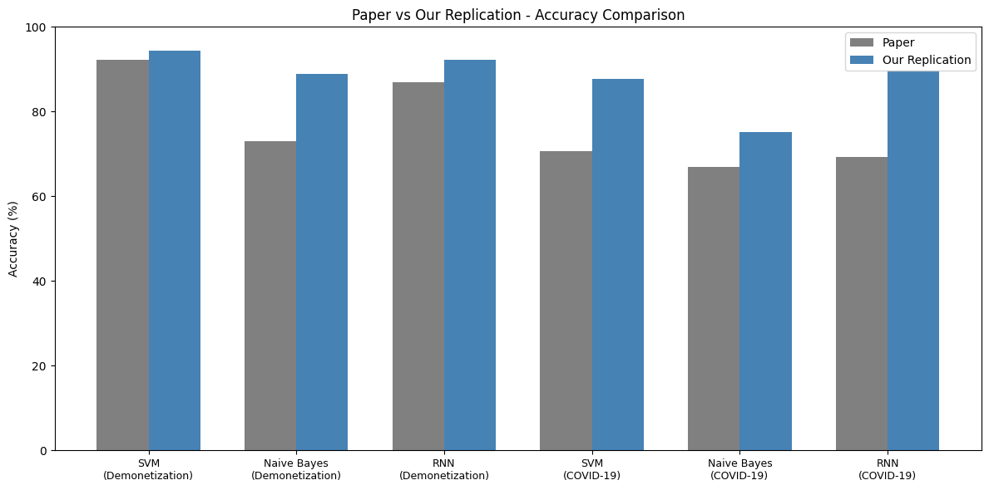
Figure 4. Paper versus replication accuracy.
Qualitative findings agree with the paper on demonetization: SVM > RNN > NB. On COVID-19 the paper ranks SVM > RNN > NB, while in our run RNN > SVM > NB. Naive Bayes is the weakest classifier on both datasets in both studies. In terms of training time NB was the fastest (0.01 s and 0.21 s) and RNN the slowest (about 15 s and 87 s), which contradicts the paper’s statement that RNN had the minimum execution time.

6. Discussion

6.1 How to interpret the higher accuracy
The sentiment labels are not human annotations. They are produced by the AFINN-based Avg_R rule applied to the very same tweet text that the classifiers then see. The classifiers are therefore learning to imitate a deterministic lexicon rule, and high accuracy mainly measures how well they reproduce that rule from TF-IDF or token sequences. Our numbers should be described as agreement with lexicon-derived labels, not as sentiment-detection accuracy. The same circularity very probably exists in the original paper, which also derives labels from a dictionary, so the comparison in Table 2 is between two lexicon-agreement scores and not between two measures of true sentiment accuracy.
A simple extension that avoids this issue is to evaluate the AFINN labels against an independent reference. The Kaggle COVID-19 file already carries VADER scores (compound, neg, neu, pos, sentiment); measuring agreement between AFINN polarity and those labels would give a more honest estimate of label quality.

6.2 Deviations from the paper
Aspect | Paper | This replication
Ingestion | Apache Flume | Kaggle CSV + hdfs dfs -put
COVID-19 period | Jan–May 2020 | Apr–Jun 2020 file
Sentiment dictionary | Not named | AFINN (3,382 words)
Evaluation | 10-fold cross-validation | Stratified 80/20 hold-out
Features | Not specified | TF-IDF (5,000)
RNN design | Not specified | Embedding + LSTM(64)
ROC area | Reported (Table 5, Fig. 8) | Not computed (see Section 7)
Non-English tweets | Treated as neutral | Not filtered separately
COVID-19 on Pig | Full dataset | 60,000 of 143,480 tweets

6.3 Inconsistencies found in the original paper
- The text of Section 4 states SVM reached 98.25% on demonetization, while Table 4 gives 92.25% and Table 6 gives 92%.
- Avg_R >= 0 as the positive condition in Algorithm 2 leaves the neutral class unreachable.
- In Table 5, F-measure and ROC area are identical to each other and to precision/recall in every row, which is unlikely for genuinely separate metrics.
- The error rates in Fig. 9 (about 0.12–0.16) do not correspond to 100% minus the accuracies in Tables 3 and 4.
- The conclusion that RNN had the minimum execution time is not supported by typical behaviour of the three models and is contradicted by our timings.
- Fig. 3 shows COVID-19 tweet counts of the order of tens of millions on the time axis but about 150,000 in the class bar chart; the dataset size is not stated clearly.
- The paper states the Kaggle datasets were collected with Flume, which is a log-collection tool; Kaggle files are static downloads.

6.4 Limitations of this replication
- Only 42% of the COVID-19 data went through Pig; the rest used the Python equivalent.
- The RNN was not seeded, so its results vary slightly from run to run (earlier runs gave 91.28% and 89.09%; the reported 92.16% and 89.75% are from the last complete run).
- The dataset files were read with latin1 encoding, which produces some mojibake in tweets (for example hashtags containing stray characters); UTF-8 would be cleaner.
- Results are from a single split; no confidence intervals are given.

7. Future Work
- Add 10-fold cross-validation with mean and standard deviation, and one-vs-rest ROC-AUC, to match the paper’s evaluation exactly.
- Validate AFINN labels against VADER or a small hand-labelled sample.
- Run the full COVID-19 dataset through Pig on a more capable cluster, or use Apache Spark.
- Handle Hindi and other regional-language tweets explicitly rather than leaving them to the dictionary lookup.

8. Conclusion
The pipeline of Anitha and Metilda was reproduced end to end: Hadoop/HDFS storage, Pig-based Avg_R labelling (validated exactly against Python on the full demonetization dataset), and SVM, NB and RNN classification. The overall conclusions that SVM and RNN outperform NB and that Pig can label large tweet sets are reproducible. Absolute accuracy numbers differ from the paper and, because the labels come from the same lexicon the models learn from, they measure agreement with the lexicon and not true sentiment accuracy. Several internal inconsistencies in the paper limit exact numerical replication.

References
[1] S. Anitha and M. Metilda, “Apache Hadoop based effective sentiment analysis on demonetization and covid-19 tweets,” Global Transitions Proceedings, vol. 3, pp. 338–342, 2022. doi:10.1016/j.gltp.2022.03.021
[2] F. Å. Nielsen, “A new ANEW: Evaluation of a word list for sentiment analysis in microblogs,” in Proc. ESWC2011 Workshop on Making Sense of Microposts, 2011 (AFINN lexicon).
[3] F. Pedregosa et al., “Scikit-learn: Machine learning in Python,” JMLR, vol. 12, pp. 2825–2830, 2011.
[4] Apache Software Foundation, Apache Pig and Apache Hadoop documentation, https://pig.apache.org and https://hadoop.apache.org.

Appendix A: Repository contents
- sentiment_replication.ipynb: EDA, pre-processing, AFINN scoring, SVM/NB/RNN training and evaluation.
- pig/tsa_algorithm.pig: Pig implementation of Algorithm 2 (add the final script from the VM).
- docs/Cloudera_Hadoop_Evidence.docx: screenshot evidence of the Hadoop/Pig execution.
- docs/Project_Report.docx: this report.
- results/: figures exported from the notebook.

