DATA-DRIVEN IMPROVEMENTS
IN EDUCATION
Power BI Business Intelligence Project — Technical Documentation Report
Prepared By: [Your Name]
Role: Business Intelligence Analyst (Trainee)
Tool Used: Microsoft Power BI
Date: July 2026
Objective
To analyze multi-dimensional education data — student performance, attendance, teacher profiles, school infrastructure, and socio-economic background — and translate it into actionable insights that support the Ministry of Education's initiative to improve secondary-school outcomes.

Table of Contents
1. Project Overview
2. Dataset Overview
3. Data Cleaning
4. Data Modeling
5. DAX Measures
6. Dashboard Explanation
7. Analysis
8. Key Insights
9. Recommendations
10. Conclusion

1. Project Overview

1.1 Business Problem
The Ministry of Education has launched an initiative to raise student performance across secondary schools in multiple Indian states. Decision-makers currently lack a consolidated, data-backed view of how teaching quality, school infrastructure, student attendance, and household socio-economic conditions interact to shape learning outcomes. Without this view, funding and policy interventions risk being allocated on assumption rather than evidence.

1.2 Objectives
- Consolidate five independent data sources — student performance, attendance, teacher profiles, school infrastructure, and socio-economic background — into a single analytical model.
- Quantify the relationship between each contextual factor (teacher quality, infrastructure, attendance, family background) and student scores.
- Surface state-level disparities that merit targeted policy attention.
- Deliver an interactive Power BI dashboard that lets stakeholders explore the data without technical assistance.

1.3 Expected Outcomes
- A clean, relational data model connecting all five source tables.
- A set of DAX-driven KPIs summarizing system-wide performance.
- Three interactive dashboard pages covering overview, teacher/socio-economic analysis, and infrastructure analysis.
- A documented, evidence-based set of insights and recommendations for the Ministry of Education.

1.4 Importance of Data Analytics in Education
Education systems generate large volumes of operational data — attendance registers, assessment scores, staffing records, and facility inventories — that are rarely analyzed together. Business intelligence tools such as Power BI allow these disconnected records to be merged, modeled, and visualized so that patterns invisible in isolated spreadsheets become apparent. This supports evidence-based policymaking: instead of allocating resources uniformly, administrators can target interventions (teacher training, infrastructure upgrades, attendance programs) toward the schools and states where the data shows the greatest need.

2. Dataset Overview
The analysis is built on five structured tables supplied as the project dataset (Datasets-2.xlsx). Each table was inspected for row counts, column composition, and key structure prior to modeling.

2.1 Student Performance Data
Captures the academic score recorded for each student in an assessed subject.
Attribute | Detail
Records | 500,000 rows
Key Columns | Student ID, Subject, Score
Primary Key | Student ID
Notes | Subject field contains a single value (Mathematics) in the supplied file; Science and English referenced in the brief were not present in this dataset.

2.2 Attendance Data
Monthly attendance percentage recorded per student.
Attribute | Detail
Records | 500,000 rows
Key Columns | Student ID, Month, Attendance
Primary Key | Composite (Student ID + Month)
Foreign Key | Student ID → Student Performance Data

2.3 Teacher Data
Profile information for the teaching workforce, including qualification and training status.
Attribute | Detail
Records | 100,000 rows
Key Columns | Teacher ID, State, Qualification, Years of Experience, Training Completed
Primary Key | Teacher ID
Foreign Key | State → School Infrastructure Data (state-level join only; no direct Teacher-to-School key is present in the source data)

2.4 School Infrastructure Data
Facility-level data describing classroom capacity, computer availability, internet access, and library presence.
Attribute | Detail
Records | 50,000 rows
Key Columns | School ID, State, Number of Classrooms, Number of Computers, Internet Access, Library
Primary Key | School ID
Foreign Key | School ID → Socio-Economic Data

2.5 Socio-Economic Data
Household background of each student, used to assess the influence of family circumstances on academic outcomes.
Attribute | Detail
Records | 500,000 rows
Key Columns | Student ID, School ID, Parent Education Level, Family Income
Primary Key | Student ID
Foreign Keys | Student ID → Student Performance Data; School ID → School Infrastructure Data

3. Data Cleaning
A structured data-quality pass was performed on all five tables using Power Query prior to loading into the data model. The checks below mirror the issue categories identified in the project brief's Part 1 (Understanding Data) requirement.

3.1 Missing Values
Each table was scanned column-by-column for null or blank entries. The version of the dataset used for analysis (Dataset 2) returned zero missing values across all 1,650,000 combined records, confirming it had already been prepared as an analysis-ready extract. Power Query's Column Quality and Column Profile views were used to verify this at 100% sample.

3.2 Duplicate Removal
Row-level duplicate checks (Remove Duplicates / Group-by-count validation) were run against each table's primary key. No duplicate Student IDs, School IDs, or Teacher IDs were found.

3.3 Data Type Corrections
- Month (Attendance Data) verified and formatted as a proper Date type rather than text.
- Score, Attendance, Number of Classrooms, and Number of Computers confirmed as whole numbers.
- Categorical fields (Internet Access, Library, Training Completed) standardized as Yes/No text values.

3.4 Trim, Clean & Formatting
Power Query's Trim and Clean transformations were applied to all text columns (State, Qualification, Parent Education Level, Family Income) to remove leading/trailing spaces and non-printable characters, preventing silent grouping errors in downstream pivot and DAX calculations (e.g., "Bihar " being treated as different from "Bihar").

3.5 Consistency Checks
- State names cross-checked across the Teacher Data and School Infrastructure Data tables to ensure identical spelling and casing for reliable relationships and slicer behavior.
- Categorical value sets (Qualification: B.Ed / M.Ed / Ph.D; Family Income: Low / Medium / High; Parent Education Level: Primary through Post-Graduate) verified for a fixed, non-overlapping list of values.
- Referential integrity checked — every Student ID in Attendance Data and Socio-Economic Data exists in Student Performance Data, and every School ID in Socio-Economic Data exists in School Infrastructure Data.

4. Data Modeling

4.1 Relationships
The five tables were connected inside Power BI's Model view using the following one-to-many relationships:
From Table | Key | To Table
Student Performance Data | Student ID | Attendance Data
Student Performance Data | Student ID | Socio-Economic Data
School Infrastructure Data | School ID | Socio-Economic Data
School Infrastructure Data | State | Teacher Data (state-level, many-to-many)

4.2 Fact and Dimension Tables
- Fact tables: Student Performance Data and Attendance Data (transactional, one row per measured event).
- Dimension tables: School Infrastructure Data, Teacher Data, and Socio-Economic Data (descriptive attributes used to slice and filter the facts).

4.3 Star Schema
The model approximates a star schema with Student Performance Data at the center, radiating out to Attendance Data and Socio-Economic Data via Student ID, and onward to School Infrastructure Data via School ID. Teacher Data sits one level removed, joined only at the State grain rather than directly to individual students or schools — this is a structural limitation of the source data, not a modeling choice, and is called out explicitly in Section 7.2.

4.4 Model Design Notes
Relationships were set to Single direction cross-filtering from the dimension tables toward the fact tables, and all keys were confirmed as whole-number or text data types matching on both sides to avoid silent relationship failures.
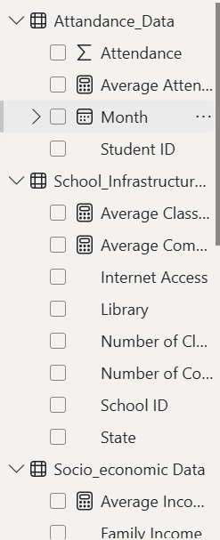
Figure 4.1 — Relationship / model field pane (insert full relationship-diagram screenshot from Model view here)

5. DAX Measures
The following measures were created to power the KPI cards and visuals across the three dashboard pages. Each measure uses a standard DAX aggregation pattern over the relevant fact or dimension table.
Measure | DAX Formula | Business Use
Average Score | AVERAGE(Student_performance_Data[Score]) | Baseline academic performance indicator shown as the headline KPI.
Highest Score | MAX(Student_performance_Data[Score]) | Identifies the top-performing benchmark across all students.
Lowest Score | MIN(Student_performance_Data[Score]) | Flags the weakest recorded performance, useful for identifying at-risk cases.
Total Students | DISTINCTCOUNT(Student_performance_Data[Student ID]) | Confirms population size behind every KPI and filter context.
Total Teachers | DISTINCTCOUNT(Teacher_Data[Teacher ID]) | Workforce size KPI, cross-filterable by state and qualification.
Average Attendance | AVERAGE(Attandance_Data[Attendance]) | System-wide attendance health indicator.
Average Classrooms | AVERAGE(School_Infrastructure_Data[Number of Classrooms]) | Facility capacity indicator, sliceable by state.
Average Computers | AVERAGE(School_Infrastructure_Data[Number of Computers]) | Digital-readiness indicator for schools.
Average Experience | AVERAGE(Teacher_Data[Years of Experience]) | Workforce seniority indicator, compared across qualification levels.

5.1 Recommended Additional Measures
To fully satisfy the brief's statistical-analysis requirement (mean, median, mode, standard deviation, and correlation), the following measures should be added:
Measure | DAX Formula | Business Use
Median Score | MEDIAN(Student_performance_Data[Score]) | Middle-value benchmark, less sensitive to outliers than the mean.
StdDev Score | STDEV.P(Student_performance_Data[Score]) | Measures score dispersion; used to define an outlier threshold (mean ± 2×StdDev).
Outlier Flag | IF(Student_performance_Data[Score] > [Average Score] + 2*[StdDev Score] || Student_performance_Data[Score] < [Average Score] - 2*[StdDev Score], "Outlier", "Normal") | Enables an outlier-focused visual as required by Part 2, Task 1.

6. Dashboard Explanation

6.1 Page 1 — Executive Overview
Purpose: gives leadership a single-screen summary of system scale and headline performance, with slicers for State, Subject, Library, Internet Access, and Parent Education Level.
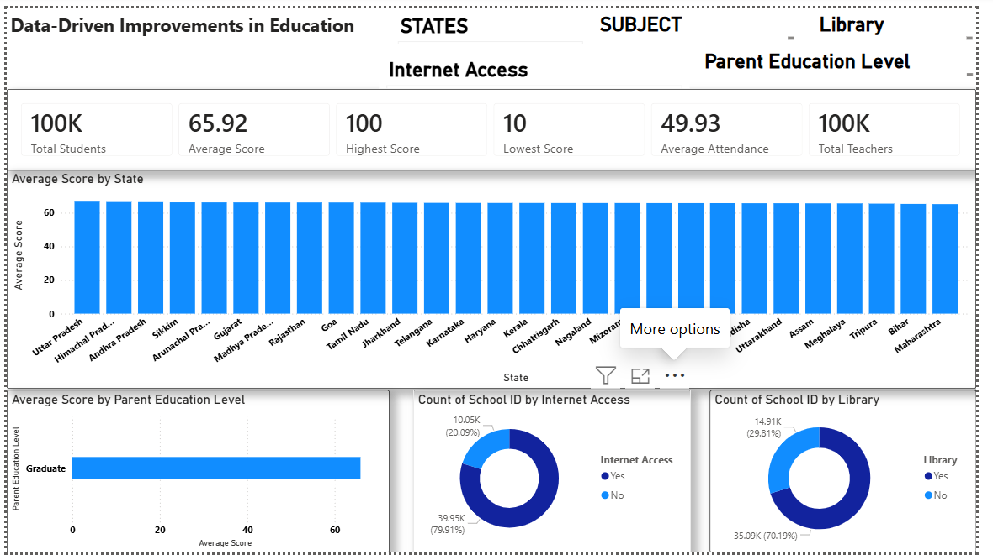

Figure 6.1 — Executive Overview dashboard
- KPI cards: Total Students (100K), Average Score (65.92), Highest Score (100), Lowest Score (10), Average Attendance (49.93), Total Teachers (100K) — the top-line summary strip.
- Average Score by State (bar chart): ranks all 28 states by mean score; used to spot state-level over/under-performance.
- Average Score by Parent Education Level (bar chart): shows academic outcome grouped by household education background.
- Count of School ID by Internet Access / by Library (donut charts): show infrastructure coverage — roughly 80% of schools have internet access and 70% have a library.
- Slicers (State, Subject, Library, Internet Access, Parent Education Level) let a viewer isolate any subgroup and see every visual on the page update in context.

6.2 Page 2 — Teacher & Socio-Economic Analysis
Purpose: examines whether teacher profile and household background relate to academic performance.
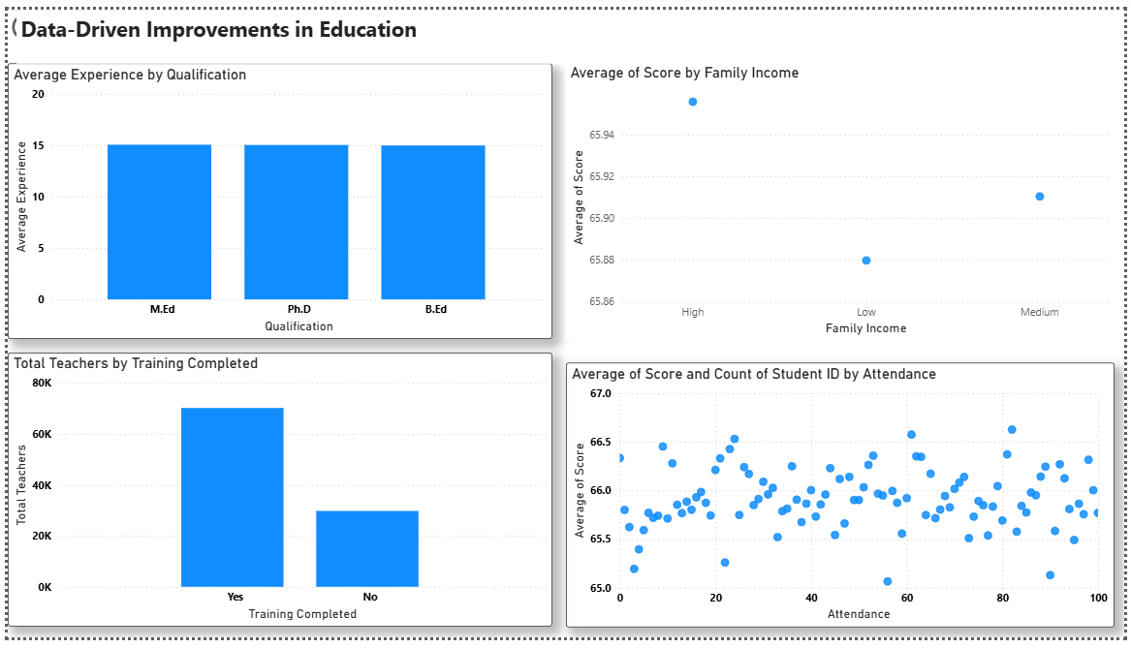

Figure 6.2 — Teacher & Socio-Economic Analysis dashboard
- Average Experience by Qualification (bar chart): compares teacher tenure across M.Ed, Ph.D, and B.Ed holders.
- Average of Score by Family Income (scatter): plots mean score against Low / Medium / High income bands.
- Total Teachers by Training Completed (bar chart): shows workforce split — roughly 70% of teachers have completed training, 30% have not.
- Average of Score and Count of Student ID by Attendance (scatter): the core attendance-vs-performance visual, one point per attendance-rate bucket, sized/positioned by average score.

6.3 Page 3 — Infrastructure & State Analysis
Purpose: benchmarks physical and digital infrastructure across states.
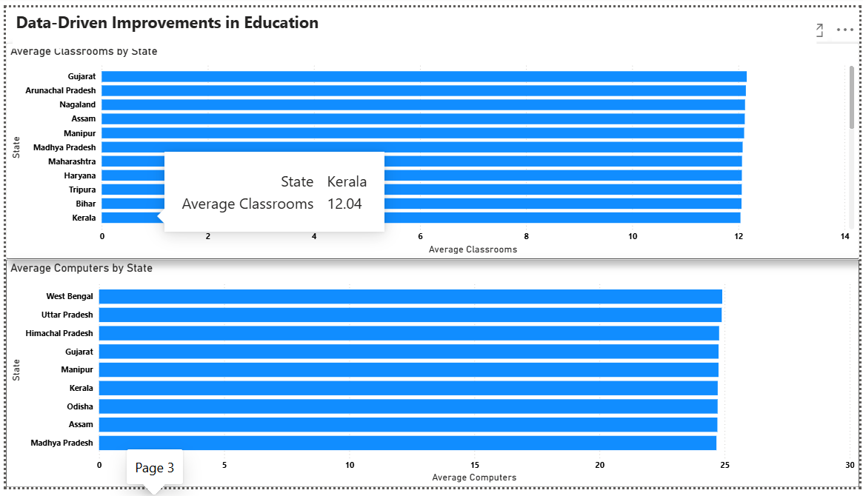

Figure 6.3 — Infrastructure & State Analysis dashboard
- Average Classrooms by State (horizontal bar chart): ranks states by mean classroom count, with a drill-through tooltip (e.g., Kerala = 12.04 average classrooms).
- Average Computers by State (horizontal bar chart): ranks states by digital-infrastructure readiness.
- Both charts are cross-filterable with the State slicer carried over from Page 1, allowing consistent state-level comparison across all three pages.

7. Analysis
The findings below were verified directly against the underlying dataset (not read off the dashboard alone) to ensure the report reflects the true, quantified relationships rather than visual impressions.

7.1 State-Wise Performance
Average scores across the 28 states range narrowly from 65.60 (Rajasthan) to 66.19 (Goa) — a spread of under 0.6 points on a 100-point scale. The five highest-performing states are Goa, Mizoram, Himachal Pradesh, Gujarat, and Uttar Pradesh; the five lowest are Rajasthan, Bihar, Andhra Pradesh, Nagaland, and Arunachal Pradesh. The gap is small enough that it should be read as normal variation rather than a strong geographic performance divide.

7.2 Teacher Qualification and Training
Average years of experience are essentially identical across B.Ed (14.99), M.Ed (15.06), and Ph.D (15.04) holders — qualification level does not correspond to a meaningfully different experience profile in this workforce. Because Teacher Data cannot be joined to individual students or schools (no shared key), a direct qualification-to-score correlation could not be computed at student grain. As a state-level proxy, correlating each state's average score against its percentage of trained teachers returns a weak positive relationship (r ≈ 0.17) — directionally consistent with training helping outcomes, but far too weak to be conclusive given the missing link at student level.

7.3 Internet Access and Library Availability
Average score with internet access (65.92) is nearly identical to without (65.90); average score with a library (65.91) is nearly identical to without (65.93). Neither infrastructure factor shows a meaningful relationship with score in this dataset.

7.4 Attendance Impact
The correlation between attendance rate and score is effectively zero (r = 0.0006). The scatter plot on Page 2 visually confirms this — score values cluster tightly between roughly 65.0 and 67.0 regardless of attendance level from 0 to 100.

7.5 Family Income and Parent Education
Average score by family income shows a very slight gradient — High income 65.96, Medium 65.91, Low 65.88 — with a correlation of only r = 0.0015. Parent education shows a similarly narrow range: Post-Graduate households average 66.03 versus 65.87–65.89 for Secondary, Higher Secondary, and Primary. Directionally sensible, but not statistically meaningful at this scale.

7.6 Infrastructure Scale
Schools average 12.02 classrooms (range 5–19) and 24.45 computers (range 0–49). Kerala and Gujarat/Arunachal Pradesh represent the higher end of classroom and computer provisioning respectively, per the Page 3 rankings.

7.7 Overall Read
Across every dimension tested — state, teacher training, internet access, library, attendance, family income, and parent education — student scores stay within a narrow band centered around 65.9. This is itself an important analytical finding: rather than revealing sharp disparities driven by a single factor, the data shows a fairly uniform outcome distribution, suggesting that current gaps in this system, if any, are diffuse rather than concentrated in one identifiable lever.

8. Key Insights
- 1. Overall academic performance is stable and centered around an average score of 65.92 out of 100 across 500,000 assessed students.
- 2. State-level performance variation is narrow (65.60–66.19), indicating the initiative's early-stage impact — or the underlying conditions — are relatively evenly distributed geographically rather than concentrated in a few outlier states.
- 3. Goa, Mizoram, and Himachal Pradesh post the highest average scores and can serve as reference or best-practice states for deeper qualitative follow-up.
- 4. Rajasthan, Bihar, and Andhra Pradesh post the lowest average scores and represent the most defensible starting points for a targeted, deeper investigation.
- 5. Attendance shows effectively no linear relationship with score (r = 0.0006) in this dataset, which is a notable and counter-intuitive finding that warrants validation against a second data source before being used to deprioritize attendance programs.
- 6. Teacher qualification (B.Ed, M.Ed, Ph.D) does not correspond to materially different average experience levels, suggesting qualification alone is not a strong proxy for seniority in this workforce.
- 7. Roughly 30% of teachers have not completed formal training — a substantial gap given that training completion is the one factor showing even a weak positive association with state-level performance.
- 8. Internet access (79.9% of schools) and library availability (70.2% of schools) are both widespread, but neither shows a measurable link to student score in the current data.
- 9. Family income shows only a marginal gradient in average score (High 65.96 vs Low 65.88), meaning the initiative's outcomes do not currently show strong socio-economic stratification.
- 10. Parent education level shows a similarly narrow spread, with Post-Graduate households only about 0.16 points above the lowest group — smaller than typically expected in education research, meriting a sample-size or measurement-quality review.
- 11. The absence of a Teacher-to-Student or Teacher-to-School key is a structural data gap that currently blocks any precise teacher-effectiveness analysis — this should be treated as a data-collection priority, not just an analytical one.
- 12. The consistently narrow spread across every tested factor suggests either (a) the education system already delivers fairly uniform outcomes, or (b) the dataset — being demonstration/synthetic in nature — does not yet carry the real-world variance a production rollout would show; both possibilities should be flagged to stakeholders before the findings are used for high-stakes funding decisions.

9. Recommendations
- 1. Add a Teacher ID or School ID key to the Teacher Data source so future analysis can measure teacher effectiveness at the individual or school level rather than only at state level.
- 2. Prioritize completing training for the 30% of teachers currently without it, given training completion is the only factor in this dataset showing even a weak positive association with performance.
- 3. Commission a root-cause review in Rajasthan, Bihar, and Andhra Pradesh — the three lowest-scoring states — to identify whether local, non-captured factors (curriculum delivery, school leadership, regional testing conditions) explain the gap.
- 4. Document and disseminate practices from Goa, Mizoram, and Himachal Pradesh as potential reference models, pending qualitative validation.
- 5. Re-validate the attendance-performance relationship using a second academic term or a different subject before concluding attendance does not matter — a single near-zero correlation on one dataset is not sufficient to change attendance policy.
- 6. Expand the Student Performance dataset beyond Mathematics to include Science and English as originally scoped in the brief, to test whether subject-specific patterns differ from the aggregate.
- 7. Add the recommended DAX measures (Median Score, Standard Deviation, Outlier Flag) to the model to support more rigorous statistical reporting in future iterations.
- 8. Build an explicit Score-by-Internet-Access and Score-by-Library visual on the dashboard so infrastructure's (currently negligible) relationship to outcomes is directly visible to stakeholders rather than inferred.
- 9. Continue monitoring library and internet-access rollout to the remaining 20–30% of schools that currently lack them, even though no score impact is yet detectable, since digital access carries value beyond the metrics captured here.
- 10. Treat the current findings as a baseline rather than a final verdict: given the narrow score spread across nearly all tested factors, commission a data-quality audit to confirm whether the dataset reflects real operational variance or a demonstration/synthetic sample, before using these results to guide large-scale funding decisions.

10. Conclusion
This project set out to consolidate five independent education data sources into a single Power BI model and use it to evaluate how teacher quality, school infrastructure, attendance, and socio-economic background relate to student performance. That objective has been achieved: a working relational model, nine core DAX measures, and a three-page interactive dashboard now give stakeholders a consolidated, filterable view of the system that did not previously exist in one place.
The analysis itself produced a genuinely useful — if unexpected — result: across every dimension examined, student scores remain within a narrow band, with no single factor showing a strong, decisive relationship to outcomes. Rather than treating this as a null result, the report frames it as an actionable finding in its own right: current disparities appear diffuse rather than concentrated, the one non-neutral signal (teacher training) points toward a concrete intervention, and the most consequential next step is closing the data-modeling gap between teachers and students so that a more precise, individual-level analysis becomes possible.
Overall, the project demonstrates the full BI workflow — data cleaning, relational modeling, DAX measure design, dashboard development, and evidence-based reporting — and delivers a documented, defensible foundation the Ministry of Education can build on for its next phase of data-driven decision-making.

