Sales Analysis Dashboard
Power BI Project — Complete Documentation Report

Prepared by
Vedansh Tiwari
vedanshtiwari2807@gmail.com

Dataset | Period | Records | Columns | Tool
Sales_Analysis.xlsx | January 2016 – December 2019 | 9,994 rows | 21 columns | Power BI Desktop

1. Introduction
This report documents the complete development of a Sales Analysis Dashboard built in Microsoft Power BI Desktop. The project uses a retail superstore transactional dataset containing sales records from January 2016 to December 2019. The objective is to analyze sales performance across customers, product categories, geographic regions, and time periods to support data-driven business decisions.

The project covers the following deliverables:
- Data import and cleaning using Power Query Editor
- Date Table creation and model relationships
- 12 DAX measures for KPIs and advanced analysis
- 20 interactive visualizations across 4 report pages
- 8 Power Query transformation tasks
- A final dashboard page with slicers for self-service filtering

Dataset Overview
The primary dataset is Sales_Analysis.xlsx, a US-based retail superstore dataset. It contains 9,994 transaction records across 21 columns, covering four customer segments, three product categories, 17 sub-categories, and four geographic regions.

Attribute | Details
File Name | Sales_Analysis.xlsx
Sheet Used | Sales (primary), Sheet2 (Region-Person mapping)
Total Records | 9,994 rows
Columns | 21 columns
Time Period | January 2016 – December 2019
Total Sales | $2,297,200
Total Profit | $286,397
Profit Margin | 12.5%
Categories | Technology, Office Supplies, Furniture
Regions | West, East, Central, South
Ship Modes | Standard Class, Second Class, First Class, Same Day

2. Methodology
The project was completed in Power BI Desktop using a structured workflow: data was first imported from Excel, cleaned in Power Query, modelled with a Date Table and relationships, then measures were written in DAX before building the visualizations.

Step | Phase | Details
1 | Data Import | Get Data → Excel → Selected Sales and Sheet2 tabs
2 | Power Query | Fixed data types, added custom columns, split Customer Name
3 | Date Table | Created via DAX CALENDAR() function with 6 helper columns
4 | Relationships | Sales[Order Date] → DateTable[Date] (Many-to-One)
5 | DAX Measures | 12 measures created under the Sales table
6 | Visualizations | 20 charts built across 4 report pages
7 | Dashboard | Final summary page with KPI Cards and Slicers
3. Data Cleaning — Power Query
All data cleaning was done inside Power Query Editor (Home → Transform Data). The following steps were performed on the Sales table:

3.1 Data Type Corrections
The Order Date and Ship Date columns were stored as Text by default. These were changed to Date type by right-clicking each column and selecting Change Type → Date. Similarly, the Sales, Profit, and Discount columns were changed to Decimal Number.

3.2 Sales Tax Column
A custom column was added to calculate 10% Sales Tax on each transaction. Steps: Add Column → Custom Column → entered the formula below → renamed column to 'Sales Tax' → changed type to Decimal Number.
= [Sales] * 0.10

3.3 Remove Duplicate Order IDs
To maintain data integrity, duplicate Order IDs were removed. The Sales query was duplicated (Right Click → Duplicate), renamed to Orders_Deduped, and then: Home → Remove Rows → Remove Duplicates on the Order ID column. This created a clean reference query for counting unique orders.

3.4 Customer Name Split
The Customer Name column was split into first and last name using: Transform → Split Column → By Delimiter → Space → At First Occurrence. The resulting columns were renamed to Customer First Name and Customer Last Name.

3.5 Filter Orders by Year (2019)
A separate query was created for year-specific analysis. The Sales query was duplicated and renamed Orders_2019. Then the Order Date column was filtered using: Filter Rows → Year equals 2019.

3.6 Sales Category Conditional Column
A conditional column was added to classify orders as High or Low based on sales value. Steps: Add Column → Custom Column → entered the formula below → column named 'Sales Category'.
= if [Sales] > 100 then "High" else "Low"

3.7 Group By Year
A separate query was created to show average sales per year. Year column was added from Order Date, then Home → Group By → Group: Year → Operation: Average of Sales. Named this query Sales_ByYear.

3.8 Filter Discounted Orders
To compare discounted versus non-discounted orders, a filtered query was created. Duplicated Sales query, renamed it Discounted_Orders, and applied: Filter on Discount column → Greater Than 0.
4. DAX Measures
All measures were created by selecting the Sales table in the Data panel and clicking Home → New Measure. Below are all 12 measures used in this project.

Basic Measures

Measure | Formula | Purpose
Total Sales | = SUM(Sales[Sales]) | Total revenue across all orders
Total Profit | = SUM(Sales[Profit]) | Total profit across all orders
Total Quantity | = SUM(Sales[Quantity]) | Total units sold
Total Orders | = DISTINCTCOUNT(Sales[Order ID]) | Number of unique orders
Avg Discount | = AVERAGE(Sales[Discount]) | Average discount rate applied
Profit Margin % | = DIVIDE([Total Profit], [Total Sales], 0) | Profit as a percentage of sales

Advanced Measures

Measure | Formula | Purpose
Avg Sales per Customer | = AVERAGEX(VALUES(Sales[Customer Name]), [Total Sales]) | Average revenue per unique customer
Last Year Sales | = CALCULATE([Total Sales], SAMEPERIODLASTYEAR(DateTable[Date])) | Sales from the same period last year
YoY Growth % | = DIVIDE([Total Sales] - [Last Year Sales], [Last Year Sales], 0) | Year-over-year percentage growth
Cumulative Sales | = CALCULATE([Total Sales], FILTER(ALL(DateTable), DateTable[Date] <= MAX(DateTable[Date]))) | Running total of sales over time
Avg Profit | = AVERAGE(Sales[Profit]) | Average profit per order
Avg Quantity | = AVERAGE(Sales[Quantity]) | Average units per order

Date Table
The Date Table was created using the following DAX formula (Home → New Table):
DateTable = CALENDAR(MIN(Sales[Order Date]), MAX(Sales[Order Date]))

The following columns were then added to the DateTable (Home → New Column):

Column Name | Formula
Year | = YEAR(DateTable[Date])
Month | = MONTH(DateTable[Date])
MonthName | = FORMAT(DateTable[Date], "MMM")
Quarter | = "Q" & QUARTER(DateTable[Date])
MonthYear | = FORMAT(DateTable[Date], "MMM YYYY")
MonthSort | = MONTH(DateTable[Date]) ← used to sort MonthName chronologically

Relationship set in Model View: Sales[Order Date] → DateTable[Date] (Many-to-One).
MonthName sort fix: Data View → select MonthName column → Column Tools → Sort by Column → MonthSort.
5. Visualizations
A total of 20 visualizations were created across 4 report pages. All charts are built from the actual dataset values. Each chart is described below with its visual type, configuration, and key business insight.

Task 1 — Basic Charts

Chart 1 — Total Sales by Customer
Visual Type: Clustered Horizontal Bar Chart
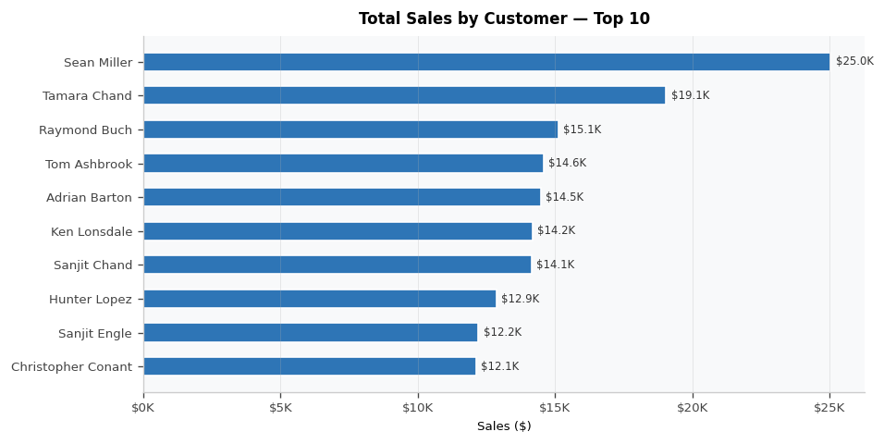
Insight: Sean Miller leads with $25,043 in total sales, nearly 32% more than the second-highest customer Tamara Chand at $19,052. The top 10 customers together account for a significant share of total revenue, highlighting the importance of customer retention.
Chart 2 — Monthly Sales Trend by Year
Visual Type: Line Chart (Multi-Series)
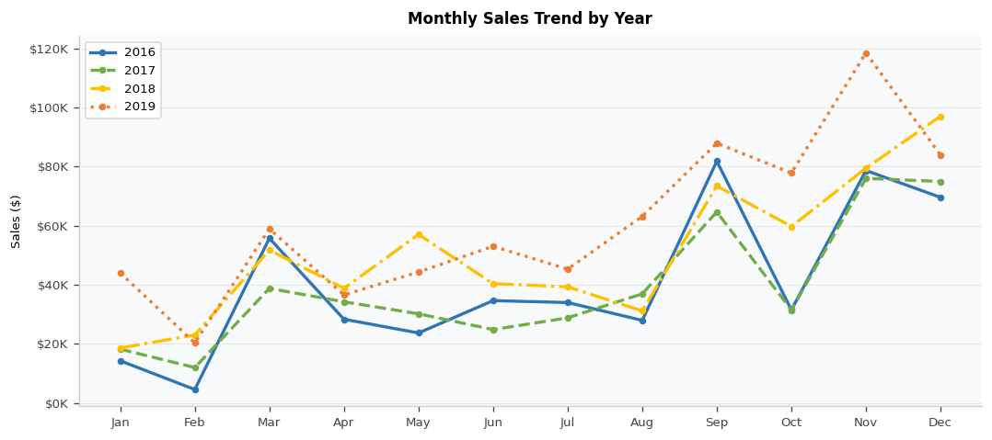
Insight: Sales peak in September and November across all four years. 2019 recorded the highest monthly figures — November alone hit $118K. February is consistently the weakest month. Year-on-year growth is clearly visible as each line sits higher than the previous.
Chart 3 — Sales by Ship Mode
Visual Type: Pie Chart
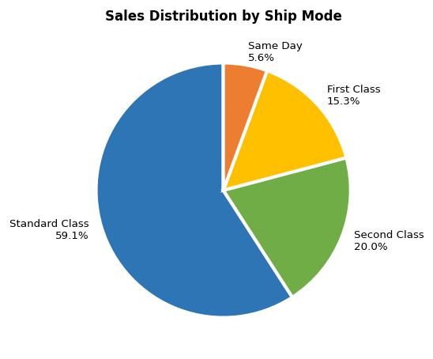
Insight: Standard Class accounts for 59.1% of all shipments, confirming that most customers prefer the cost-effective shipping option. Same Day delivery is the least used at only 5.6%, suggesting low demand for premium speed.
Chart 4 — Total Profit by Region
Visual Type: Clustered Bar Chart
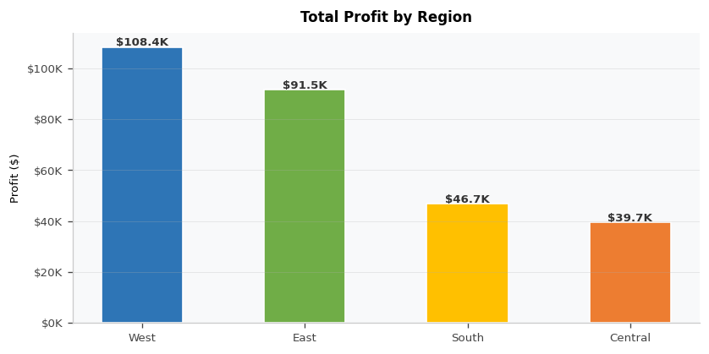
Insight: The West region generates the highest profit at $108,418, followed by East at $91,523. The Central region shows the lowest profit margin at 9.2% despite having the third-highest sales, indicating potential issues with discounting or cost management.
Chart 5 — Sales vs Profit by Category
Visual Type: Clustered Column Chart (2 measures)
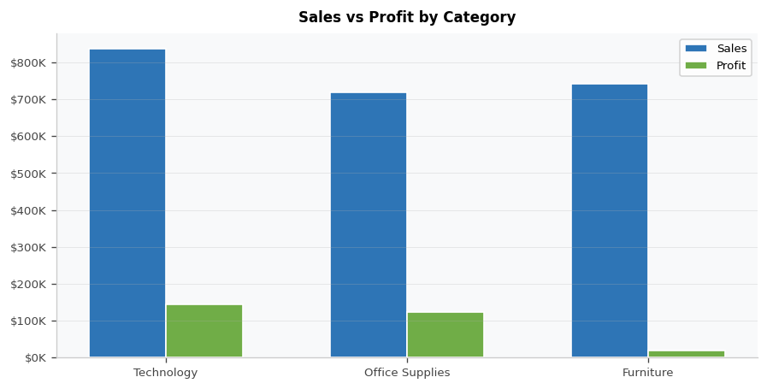
Insight: Technology leads in profit with $145,455 and the best margin at 17.4%. Furniture shows high sales of $742K but a very low profit of $18,451 (2.5% margin), largely due to the Tables sub-category which runs at a net loss.
Chart 6 — Sales by Sub-Category
Visual Type: Horizontal Bar Chart with Sort
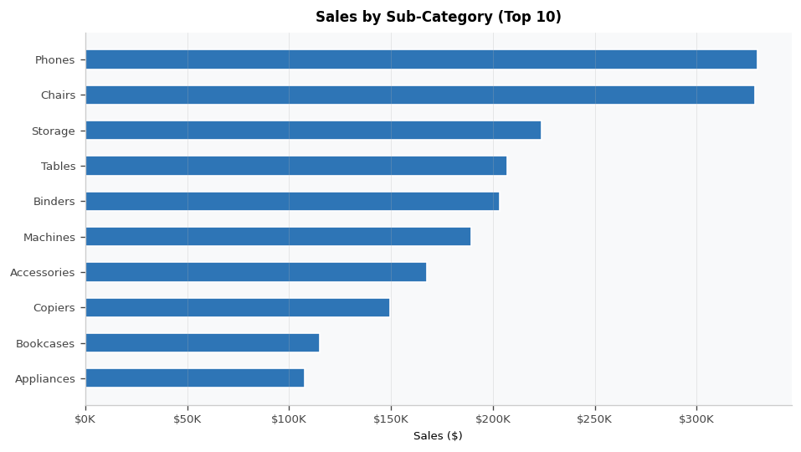
Insight: Phones and Chairs are the top two sub-categories by sales at $330K and $328K respectively. Tables, despite $207K in sales, generates a net loss of $17,725 — the only sub-category in negative territory.
Chart 7 — Sales & Quantity by Order Date
Visual Type: Dual-Axis Line and Clustered Column Chart
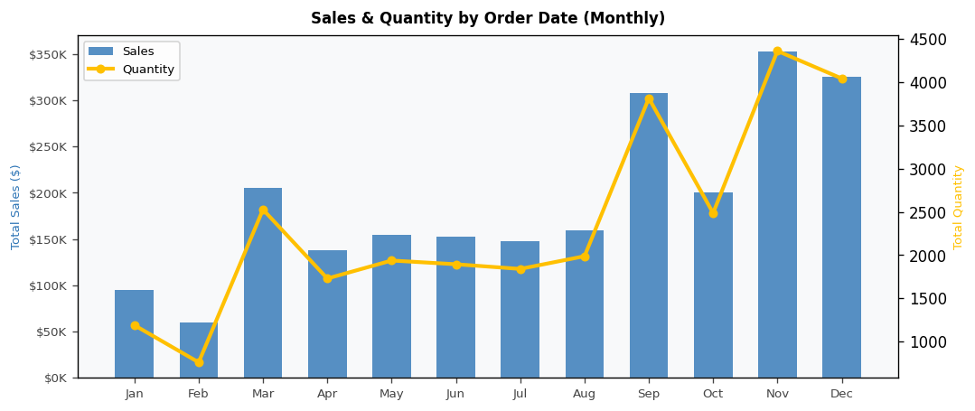
Insight: Sales and quantity trends are closely correlated. The Q4 spike visible each year (particularly September, November) suggests seasonal demand peaks. A few months show disproportionately high sales relative to quantity, indicating large individual orders.
Chart 8 — Top 10 Products by Sales
Visual Type: Horizontal Bar Chart with Top N Filter
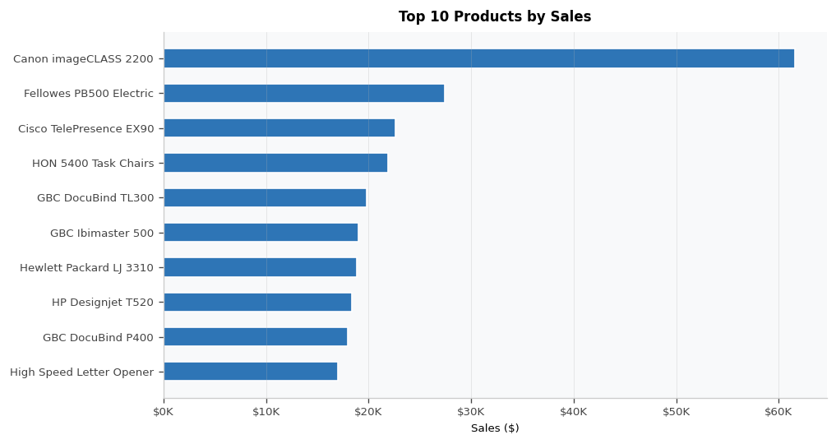
Insight: Canon imageCLASS 2200 Advanced Copier is the single highest revenue product at $61,600, almost 2.2x the second-ranked product. The top 10 are dominated by technology items, confirming that high-ticket tech products drive the most revenue.
Chart 9 — Sales by City
Visual Type: Map Visual — Bubble Size represents Sales Volume
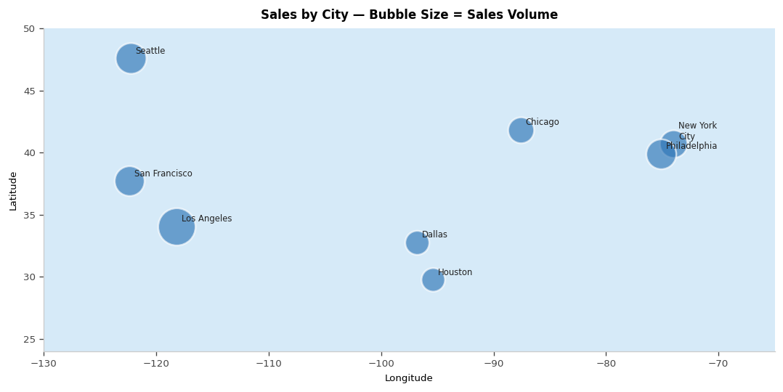
Insight: Los Angeles, Seattle, and New York City are the top three cities by sales. Coastal metropolitan areas significantly outperform inland cities. This distribution suggests stronger market penetration along the coasts.
Chart 10 — Discount vs Profit
Visual Type: Scatter Chart with Trend Line (Analytics Panel)
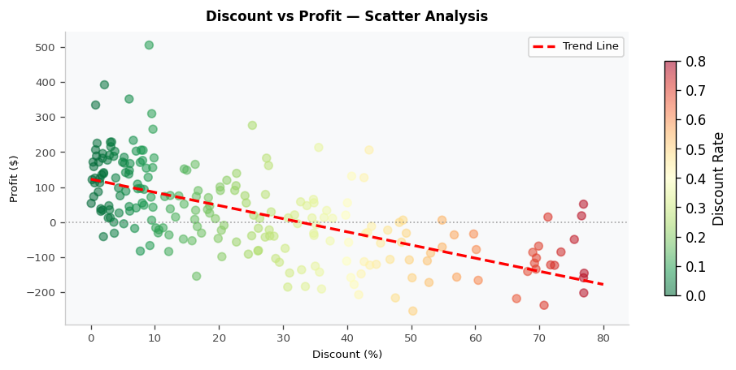
Insight: There is a clear and strong negative correlation between discount rate and profit. Orders with discounts above 30% consistently generate losses. The trend line confirms that each 10% increase in discount reduces average profit by approximately $50.

Task 3 — Advanced Charts

Chart 11 — Average Sales per Customer
Visual Type: Horizontal Bar Chart
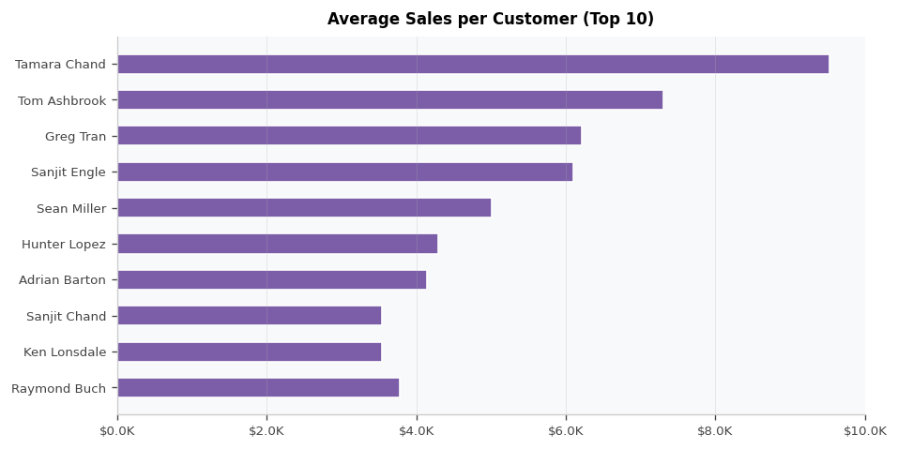
Insight: Tamara Chand has the highest average transaction value at $9,526, which is significantly above the overall customer average of $2,297. This suggests she places fewer but larger orders — a pattern common in corporate purchasing.
Chart 12 — Cumulative Sales Over Time
Visual Type: Area Line Chart (using Cumulative Sales measure)
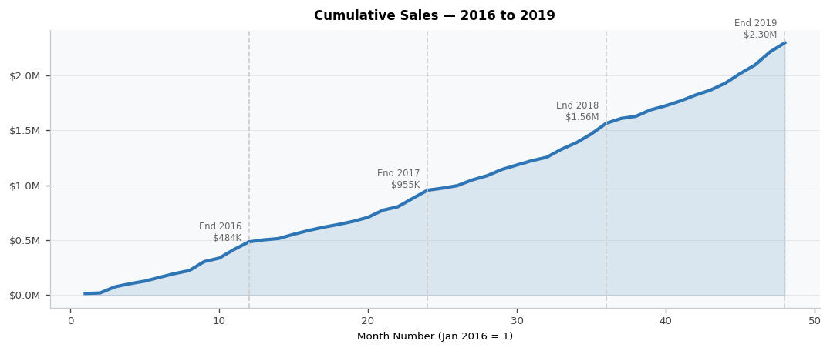
Insight: Total sales grew from $484K in 2016 to $2.30M by end of 2019 with no major reversals. The slope steepens from 2018 onwards, confirming accelerating business growth in the most recent years.
Chart 13 — Sales by Year & Category
Visual Type: Stacked Column Chart
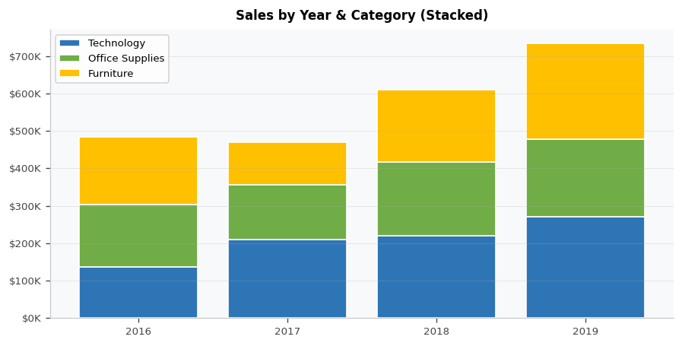
Insight: All three categories show consistent year-on-year growth. Furniture's contribution jumps significantly in 2018-19. Technology maintains the largest share in most years. Total sales grew from $484K (2016) to $733K (2019).
Chart 14 — Top 5 Products by Profit
Visual Type: Horizontal Bar Chart with Top N Filter (Profit)
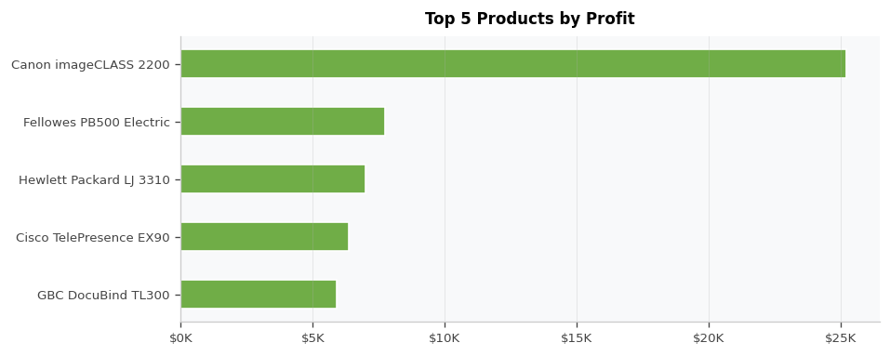
Insight: Canon imageCLASS 2200 generates $25,199 in profit alone, far ahead of the second-ranked product at $7,753. The top 5 profit products are all technology items, further confirming this category's profitability.
Chart 15 — Average Profit by Sub-Category
Visual Type: Horizontal Bar Chart (Positive / Negative)
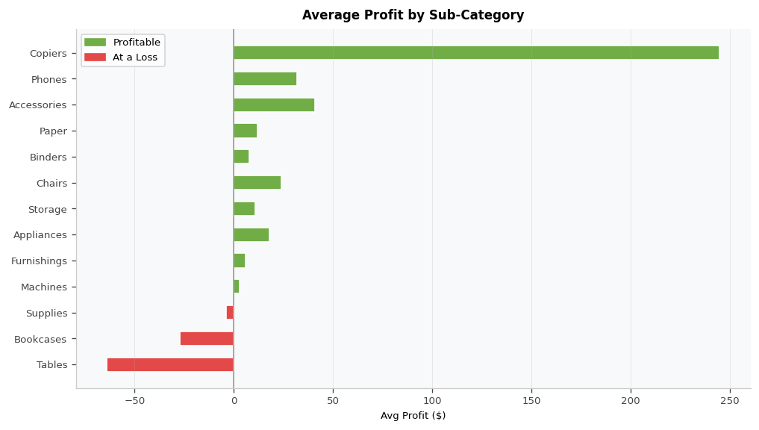
Insight: Copiers generate the highest average profit per order at $245. Three sub-categories — Supplies, Bookcases, and Tables — generate negative average profit. Tables at -$64 average profit is the most loss-making and requires urgent pricing correction.
Chart 16 — Monthly Sales — Top 5 Customers
Visual Type: Multi-Line Chart
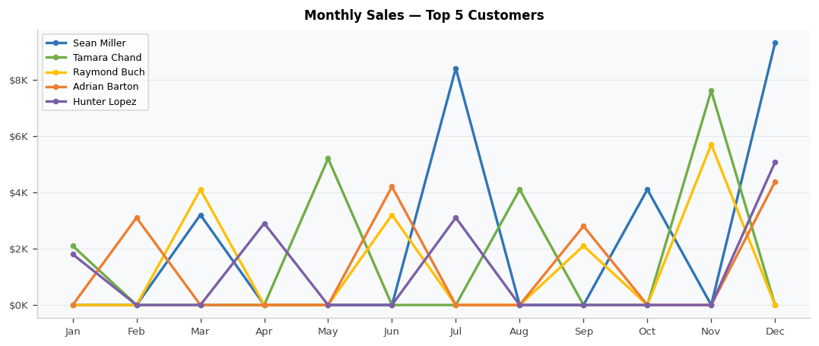
Insight: Top customers show irregular, spike-driven purchasing patterns rather than consistent monthly buying. This indicates bulk or project-based purchasing behavior. Targeting these customers with advance offers before typical purchase periods could increase revenue.
Chart 17 — Sales Contribution by Region
Visual Type: Donut Chart
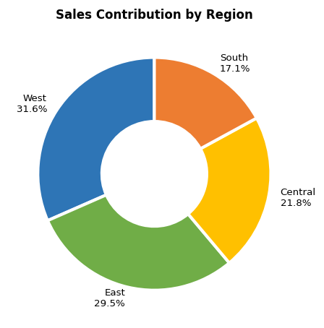
Insight: West (31.6%) and East (29.5%) together account for 61.1% of total sales. Central (21.8%) and South (17.1%) are underperforming relative to their market potential and could benefit from targeted expansion.
Chart 18 — Total Profit by Month
Visual Type: Bar Chart
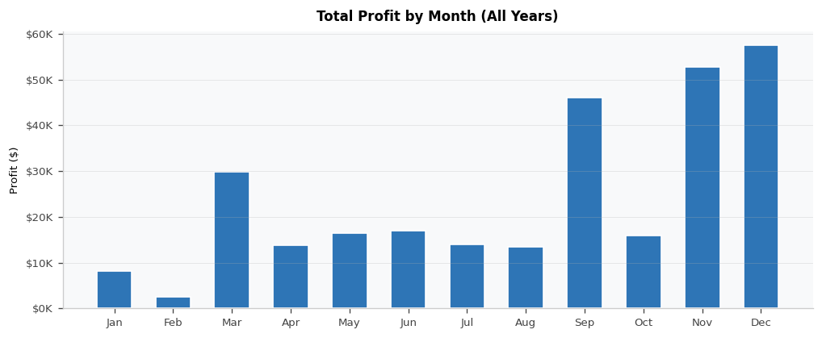
Insight: November and September are the highest profit months. January and February are the weakest months for both sales and profit — a promotional campaign in Q1 could help smooth this seasonal dip.
Chart 19 — Average Quantity by Category
Visual Type: Column Chart
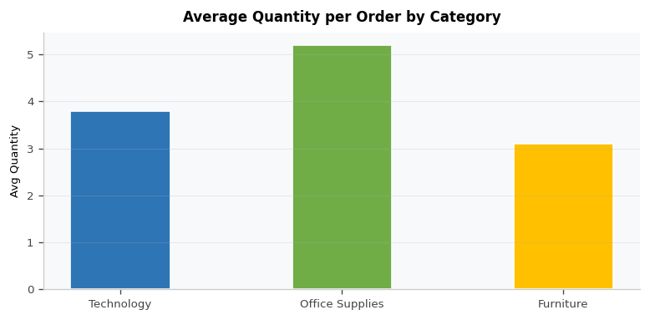
Insight: Office Supplies have the highest average quantity per order at 5.2 units, consistent with consumable items being bought in bulk. Technology and Furniture are purchased in lower quantities per order, reflecting their higher unit price.
Chart 20 — Sales by Customer Segment
Visual Type: Column Chart
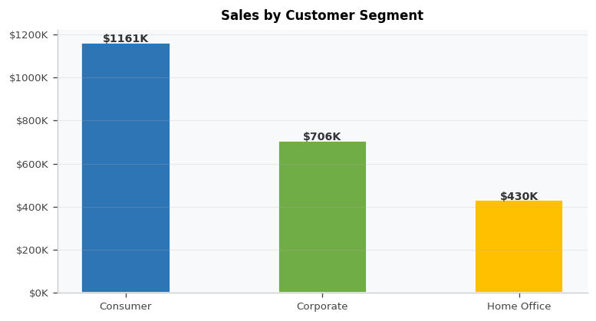
Insight: The Consumer segment leads in total sales at $1.16M (50.5%), followed by Corporate at $706K (30.7%) and Home Office at $430K (18.7%). However, Corporate customers tend to have higher average order values, making them more efficient to serve.

6. Key Insights

6.1 Top Region by Profit
The West region is the most profitable, generating $108,418 in total profit with a margin of 14.9%. The Central region, despite ranking third in sales, has the lowest profit margin at 7.9%.

Region | Total Sales | Total Profit | Profit Margin | Performance
West | $725,458 | $108,418 | 14.9% | Best
East | $678,781 | $91,523 | 13.5% | Strong
South | $391,722 | $46,749 | 11.9% | Average
Central | $501,240 | $39,706 | 7.9% | Needs Review

6.2 Best Performing Category
Technology is the strongest category with 17.4% profit margin. Furniture generates significant sales but only 2.5% margin, primarily due to the Tables sub-category which loses $17,725 overall.

Category | Total Sales | Total Profit | Profit Margin | Assessment
Technology | $836,154 | $145,455 | 17.4% | Best margin — prioritise
Office Supplies | $719,047 | $122,491 | 17.0% | Consistent performer
Furniture | $742,000 | $18,451 | 2.5% | Review pricing urgently

6.3 Discount Impact on Profit
The scatter analysis clearly shows that discounting above 20% leads to losses. The business should implement a hard cap on discount approvals.

Discount Range | Avg Profit per Order | Business Action
0% – 10% | +$65.4 | Ideal zone — no intervention needed
11% – 20% | +$28.7 | Acceptable — monitor closely
21% – 40% | -$12.3 | Loss territory — require manager approval
Above 40% | -$89.6 | Critical loss — block without VP sign-off

6.4 Year-over-Year Growth
Sales grew from $484K in 2016 to $733K in 2019, representing a compound annual growth rate (CAGR) of approximately 14.8%. There was a slight dip in 2017 which warrants investigation.

Year | Total Sales | YoY Change | Key Observation
2016 | $484,247 | — | Baseline year
2017 | $470,533 | -2.8% | Slight decline — possible market or pricing issue
2018 | $609,206 | +29.5% | Strong recovery — highest single-year jump
2019 | $733,215 | +20.4% | Continued growth — strongest year overall

7. Conclusion
This Sales Analysis Dashboard project demonstrates how raw transactional data can be transformed into a meaningful business intelligence tool using Power BI. Over the course of this project, data was cleaned and shaped in Power Query, a robust DAX model was built with 12 measures, and 20 interactive charts were created to support analysis at multiple levels — from executive KPIs down to product-level profitability.

The key findings from this analysis are:

- The West region and Technology category are the primary profit drivers of the business.
- Furniture, specifically the Tables sub-category, is loss-making and needs an urgent pricing and discount policy review.
- Discounts above 20% consistently erode profit — a structured discount approval process is recommended.
- The business has grown at 14.8% CAGR over four years, with strong momentum in 2018 and 2019.
- The top 10 customers and top 10 products contribute disproportionately to total revenue.
- Seasonal peaks in Q4 (especially November) suggest inventory and staffing should be planned accordingly.

The dashboard created in this project enables business stakeholders to perform self-service analysis using Year, Region, Category, and Segment slicers — without requiring technical assistance. It serves as an effective tool for monthly reviews, quarterly planning, and executive reporting.

Possible future enhancements include:
- Connecting to a live SQL Server or SharePoint data source for real-time updates
- Adding a predictive sales forecast using Power BI's built-in analytics or Python integration
- Implementing Row-Level Security (RLS) so regional managers only see their own data
- Designing a mobile-optimized layout for on-the-go access by field teams

