***Admin Login***

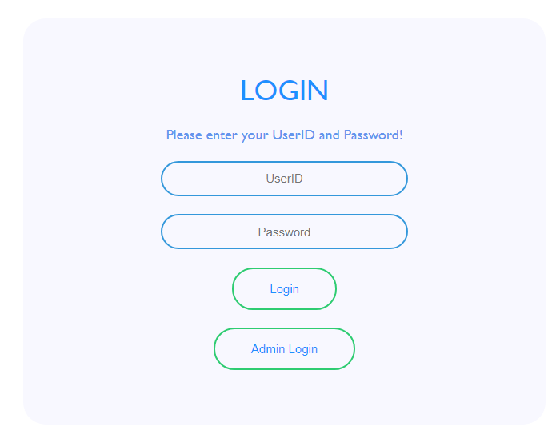

admin_page()

|  |  |
| --- | --- |
| **Method** | **Description** |
| FoodIndex_new: admin_page() | On clicking the “**Admin Login**” button, **admin_page()** function is called and it renders the **admin_login.html** file; redirects to **Admin Login** page |

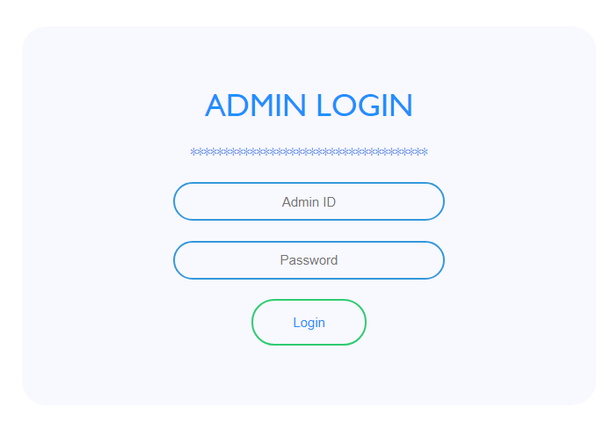

admin_login()

|  |  |
| --- | --- |
| **Method** | **Description** |
| FoodIndex_new: admin_login() | On clicking the “**Login**” button, **admin_login()** function is called. If the Admin Id or Password is wrong, an error message is shown: “Invalid Admin or Password”; if the data is correct, it renders the **fm_table.html** file. |

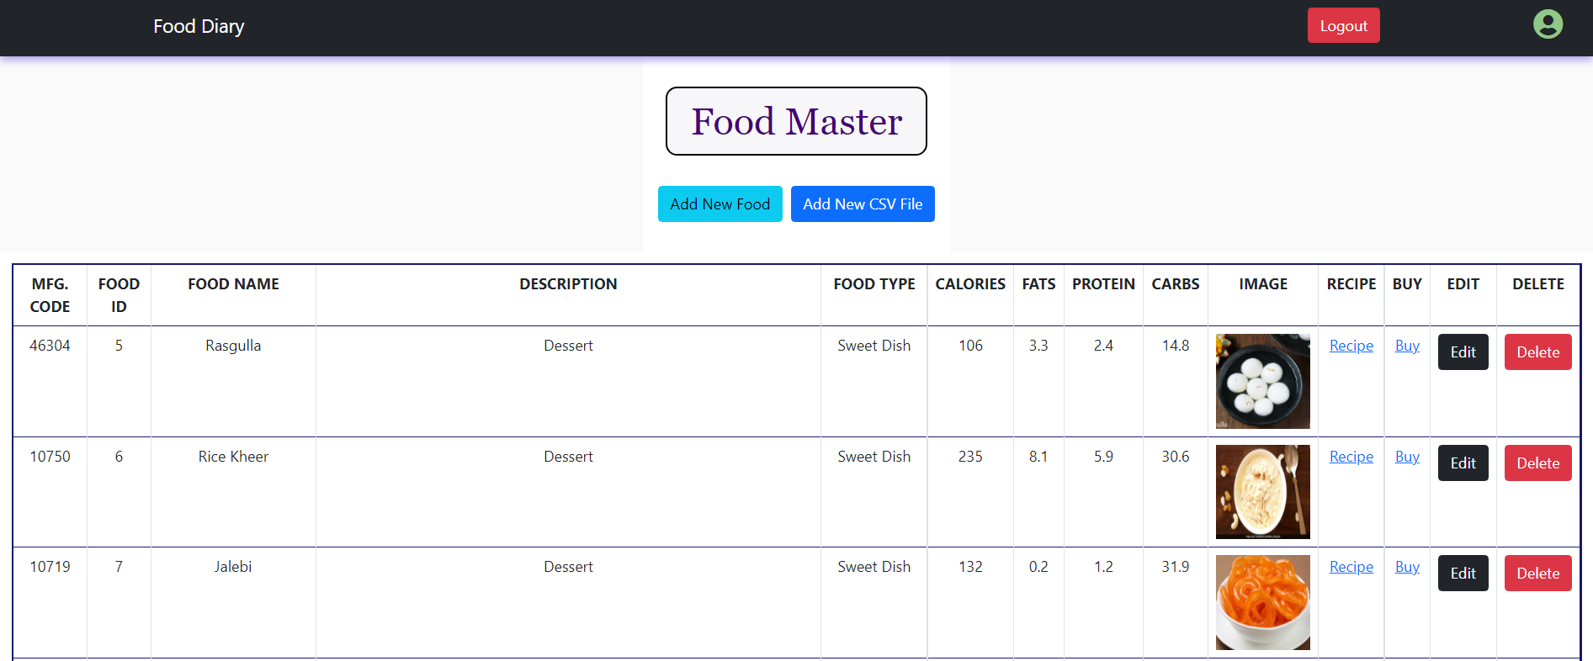

xyz()

add_food()

|  |  |
| --- | --- |
| **Method** | **Description** |
| Food Master Table | After successful login to admin page, the food master table appears which contains data fetched from MySQL central database. |
| “Add New Food” Button:-  FoodIndex_new: add_food() | When “**Add New Food**” is clicked, the webpage is rendered to **add_food.html** file, from which a new individual food item can be added into the database. |
| “Add New CSV File” Button:-  FoodIndex_new: xyz() | When “**Add New CSV File**” is clicked, the webpage is rendered to **upload_file.html** file, from which food items can be batch uploaded into database. |
| “Edit” button:  FoodIndex_new: update_food() | When “**Edit**” button is clicked, it renders **update_form.html** file and redirects to webpage through which the details of the food item can be modified. |
| “Delete” button:  FoodIndex_new: delete_food() | When “**Delete**” button is clicked, it deletes that item from the database. |
| “Recipe” button | On hovering over “**Recipe**”, the link to recipe can be found. |
| “Buy” button | On hovering over “**Buy**”, the link to purchase the food item can be found. |

***Add Food Item Manually***

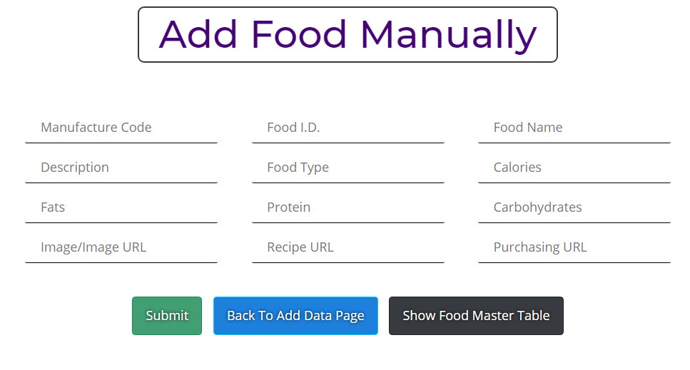

|  |  |
| --- | --- |
| **Method** | **Description** |
| “Add Food Manually” | When “**Add New Food**” is clicked on **Food Master Table**, this webpage is shown. Several input fields are shown. |
| “**Submit**” button:- FoodIndex_new: getdata() | When **Submit** button is called, **getdata()** function is called and the data is added into the database. Identifies data from unique **Food ID**; if duplicate is entered, it throws a warning. |
| “**Back To Add Data Page**”:- FoodIndex_new: xyz() | When **Back To Add Data Page** button is pressed, it redirects to the webpage for csv batch upload. |
| “**Show Food Master Table**”:- FoodIndex_new(): base_table() | When “**Show Food Master Table”** is pressed, it redirects to **Food Master Table.** |

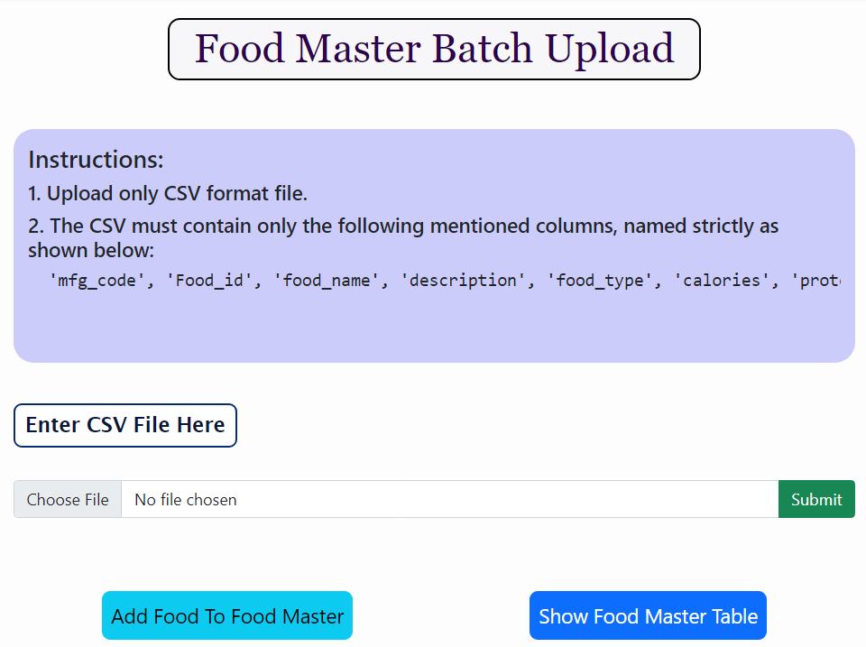***CSV Batch Upload***

|  |  |
| --- | --- |
| **Method** | **Description** |
| “Batch Upload” | When “**Add New CSV File**” is clicked on **Food Master Table**, this webpage is shown. Several input fields are shown. |
| “Submit” button:- FoodIndex_new: file_to_db() | When **Submit** button is called, **file_to_db()** function is called and the file is added into the database. Identifies data from unique **Food ID**; if duplicate is present in file, it throws a warning. |
| “Add Food”:- FoodIndex_new: addfood() | When **Add Food** button is pressed, it redirects to the webpage for adding individual item. |
| “Show Food Master Table”:- FoodIndex_new(): base_table() | When “**Show Food Master Table”** is pressed, it redirects to **Food Master Table.** |

***Update Food Details***

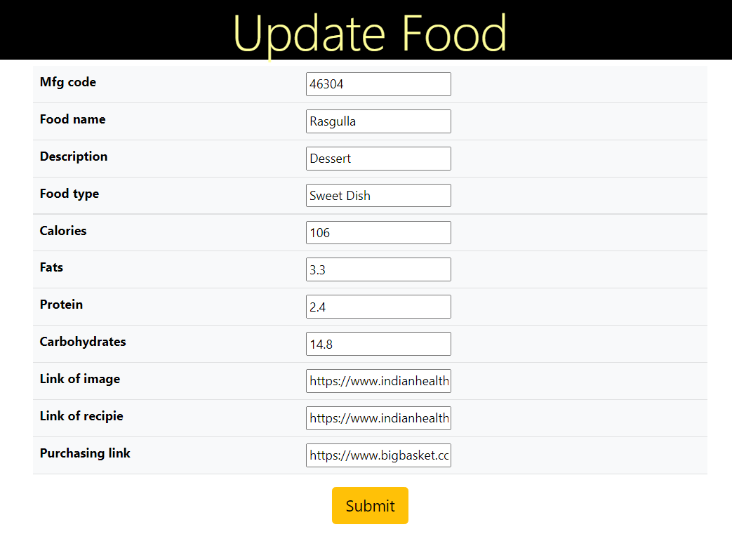

|  |  |
| --- | --- |
| **Method** | **Description** |
| “Update Food”:  Update_form.html | When “**Edit**” is clicked on **Food Master Table**, this webpage is shown by rendering update_form.html. Several input fields are shown.  All the fields which are allowed to modify can be modified from here. |
| “Submit” button:-  FoodIndex_new: update_food() | When “**Submit**” is clicked, the new data gets updates in the database and is immediately reflected in the **Food Master Table.** The food master table is rendered after submit. |

***Calories Analysis***

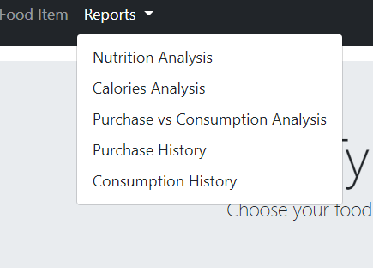

|  |  |
| --- | --- |
| **Method** | **Description** |
| Reports dropdown>>Calories Analysis  Home_app_new: userfoodlogchart() | Redirects to the **User Food Log Charts.**  The webpage has date inputs which shows calories consumption from dates recorded in database. |

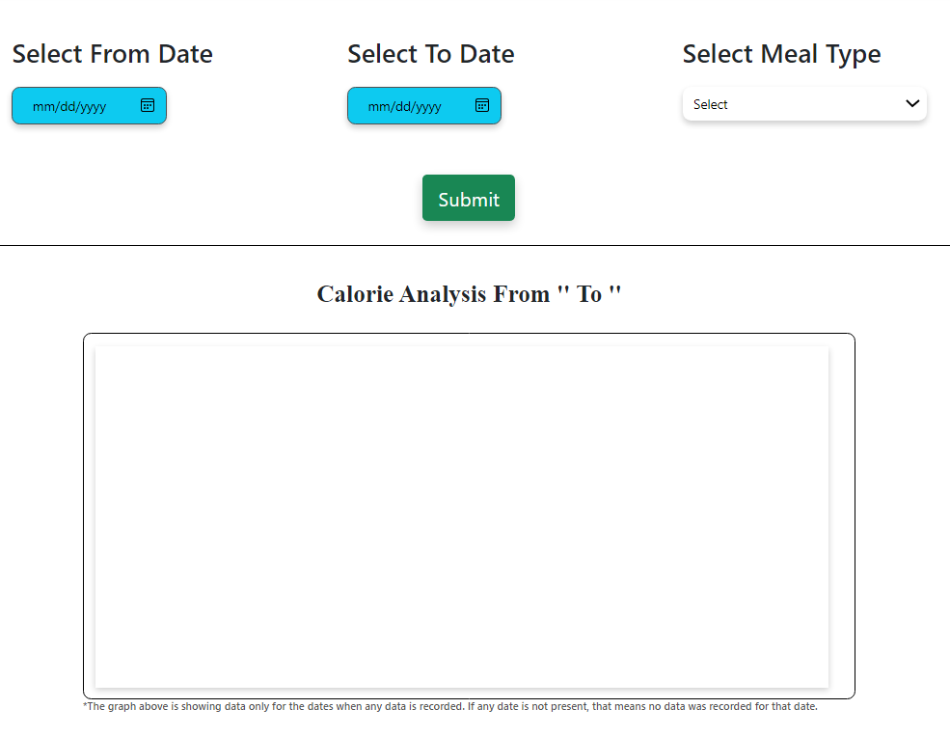

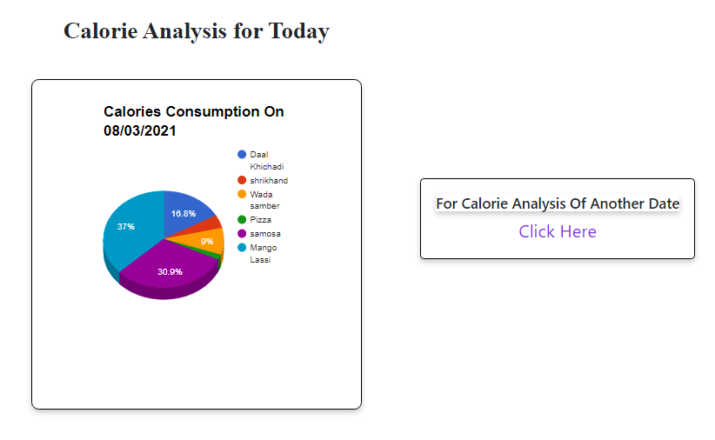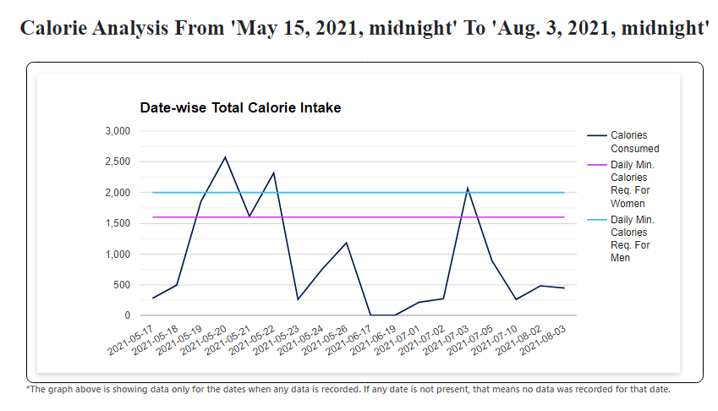

***Date-wise Calorie Analysis***

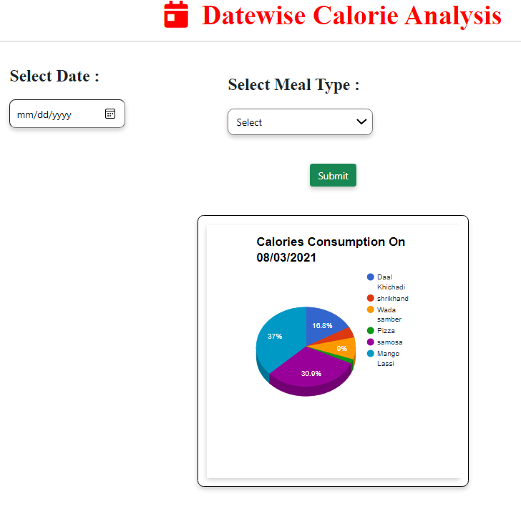

|  |  |
| --- | --- |
| **Method** | **Description** |
| “Submit” button: Home_app_new: userfoodlogchart()  userfoodlogchart.html | **Userfoodlogchart()** accepts input from “**Select From Date**”, “**Select To Date**” and “**Select Meal Type**”; when “**Submit**” button is pressed, a **line graph** is shown representing the calories consumption between the selected date range and selected meal type. Comparison with average calorie consumption for men and women is also shown. |
| “Calories Analysis for Today”:- Home_app_new: userfoodlogchart()  userfoodlogchart.html | In this block, a pie chart is shown which shows the distribution of calories consumed in present day divided between the consumed items. |
| “Calories Analysis of Another Date”:-  Home_app_new: otherdayanalysis()  Userdate_form.html | When “**Click Here**” is clicked, **userdate_form.html** is rendered and **Other Day Analysis** page is shown. It has **Select Date** input and **Select Meal Type** input. |
| “Submit” button: Home_app_new: otherdayanalysis()  userdate_form.html | **Otherdayanalysis()** function takes  **Select Date** input and **Select Meal Type** input and shows a **pie-chart** which shows the distribution of calories between the food consumed on the particular date. |

***Consume Comparison***

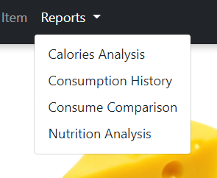

consumeComparison()

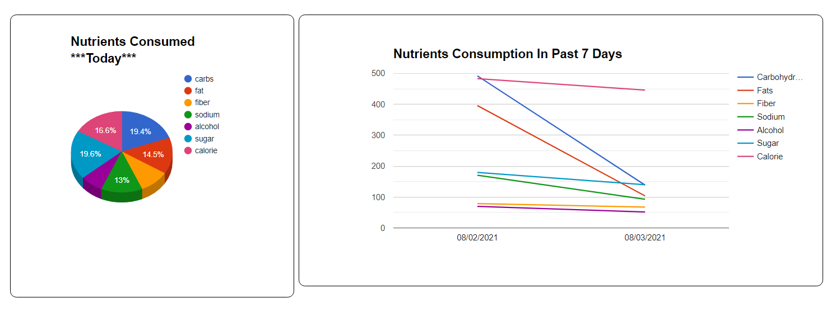

|  |  |
| --- | --- |
| **Method** | **Description** |
| Reports dropdown>>Consume Comparison  Home_app_new: consumeComparison()  consumeComparison.html | Redirects to the **Consume Comparison** page**.**  This page shows 2 analysis graphs. First graph is a **pie-chart** which shows distribution of quantities of nutrients consumed in **present day**. Second graph is a **line chart** which shows various **line graphs** representing nutrients consumed in the **recorded dates within the past 7 days.** |

***Purchase Comparison***

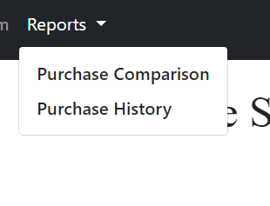

purchaseComparison()

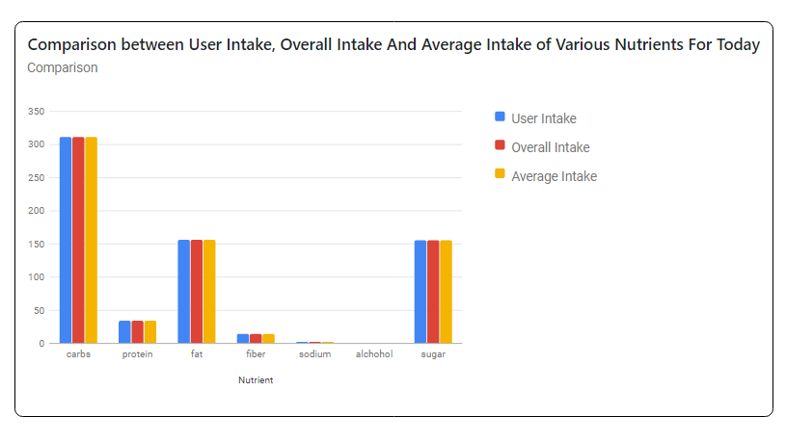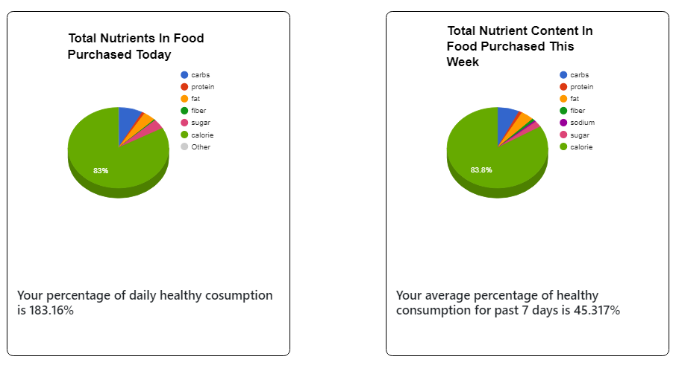

|  |  |
| --- | --- |
| **Method** | **Description** |
| Purchase Items>>Reports>>**Purchase Comparison**  **Home_app_new: purchaseComparison()**  **purchaseComparison.html** | When **Purchase Comparison** is clicked, it calls the **purchaseComparison()** function which renders the **purchaseComparison.html** file and redirects to Purchase Comparison page. This page has 3 graphs:   1. **Pie-chart** that shows nutrient wise distribution of food items purchased today. 2. **Pie-chart** that shows nutrient based distribution of food items purchased in last 7 recorded days. 3. A **bar graph** that shows comparison b/w **User Intake**, **Overall Intake** and **Average Intake** of nutrients for that particular day. |

----------------------------------------------------------------------------------------------------------------------------------------------------------------

***Add Food To Pancare Database***

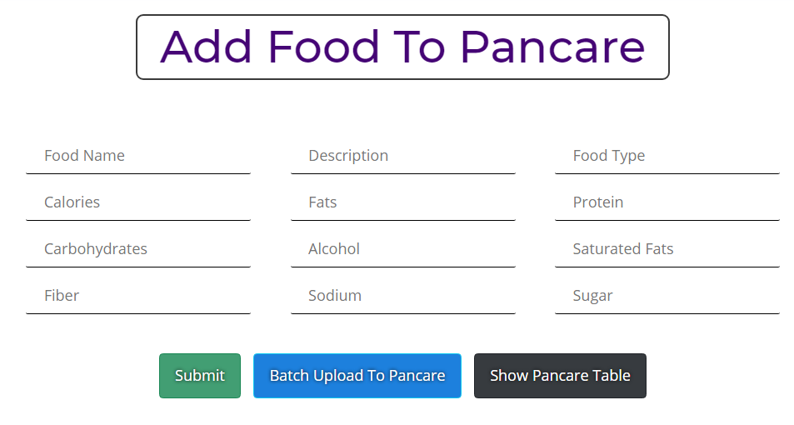

|  |  |
| --- | --- |
| **Method** | **Description** |
| **foodtopanadmin(), foodtopanadmin.html** | On filling the above fields. And clicking the Submit button, function Adds individual food to **Pan-care** |
| **csvtopanadminloader(), csvtopanadmin.html** | **“Batch Upload To Pancare”** >>redirects to batch upload page |

-----------------------------------------------------------------------------------------------------------------------------------------------------------------***Batch Upload Data into Pancare Database***

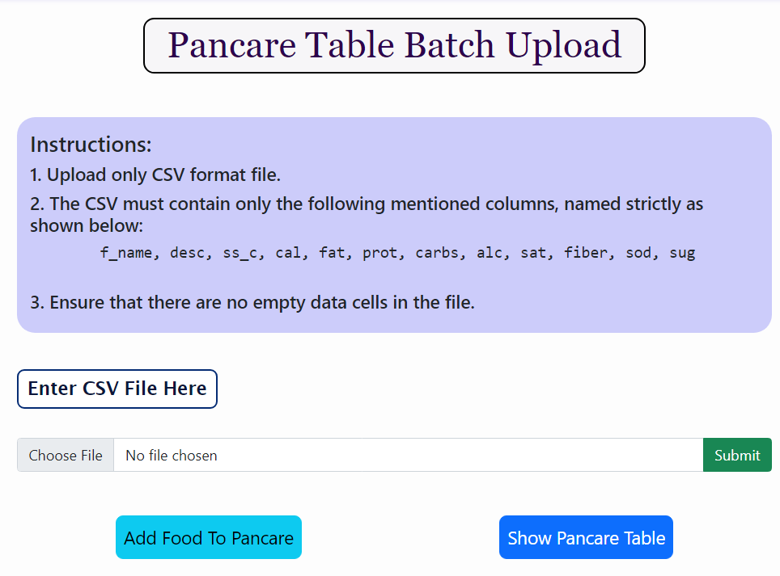

|  |  |
| --- | --- |
| **Method** | **Description** |
| **foodtopanadmin(), foodtopanadmin.html** | On clicking the **Submit** button, function batch uploads food to **Pan-care** |
| **“Add Food to Pancare”** | Redirects to individual add food page |
| **“Show Pancare Table”** | Redirects to Pancare table |

***Purchase Items Table***

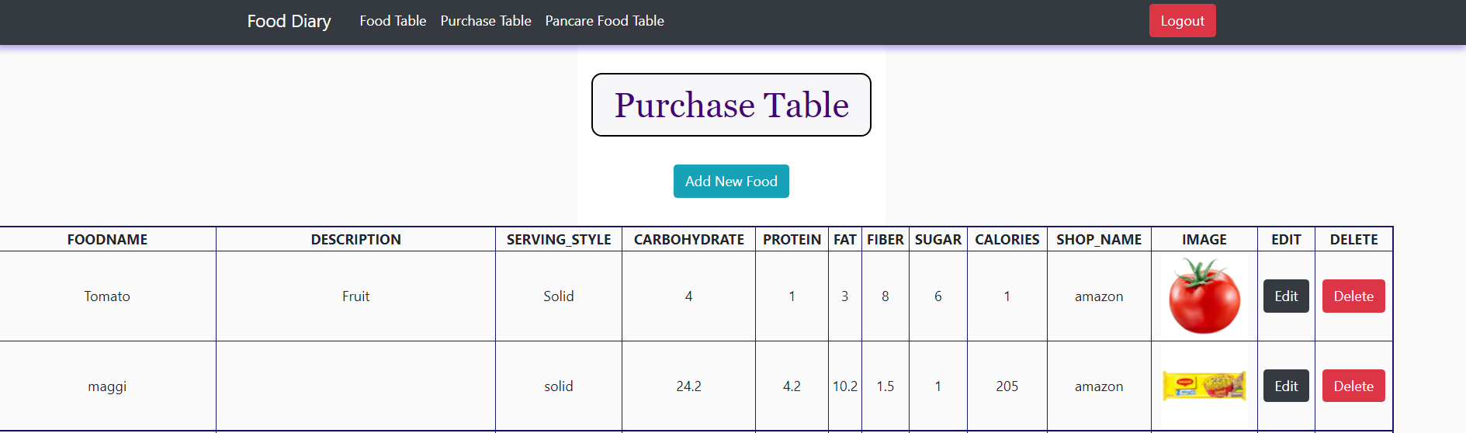

***Add Food To Purchase Items Table***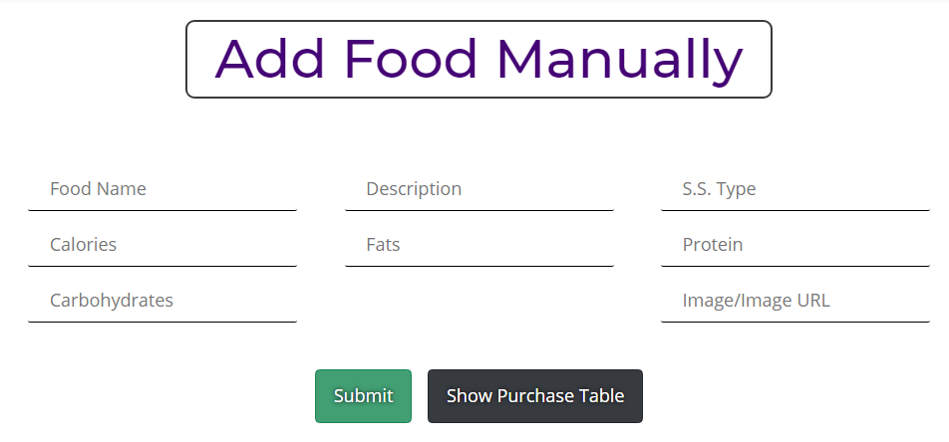

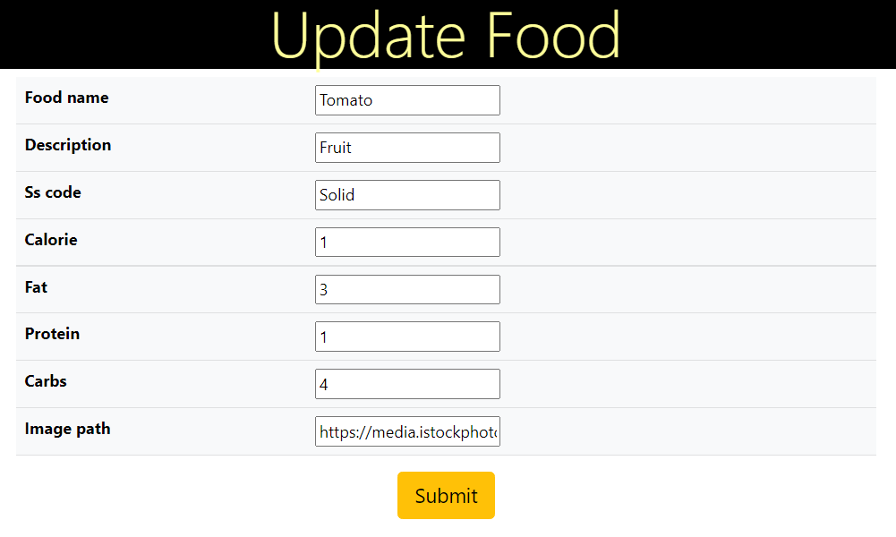

|  |  |
| --- | --- |
| **Method** | **Description** |
| **“Add New Food”: addpurchasefood(), addpurchasefood.html** | Redirects to a form to add food to purchase table, |
| **update_purchase_food() update_purchase_food.html** | Redirects to a form to update food items in purchase table, |
| **delete_purchase_food():** | delete food item from purchase table |