*Name:* Vedanshi Maulikbhai Dungarani

*Roll No:* 1017

*Div:* A

Question 1.

**CSS Selectors**

<!DOCTYPE html>

<html lang="en">

<head>

    <meta charset="UTF-8">

    <meta name="viewport" content="width=device-width, initial-scale=1.0">

    <link rel="stylesheet" href="style.css">

    <title>CSS Selectors</title>

</head>

<body>

    <header>

        <h1 class="main-title">Welcome to my website</h1>

    </header>

    <section>

        <h2>About Us</h2>

        <p>This is a paragraph about our website.</p>

        <p class="highlight">This paragraph is highlighted</p>

    </section>

    <footer id="unique-footer">

        <p>&copy; 2025 my website</p>

    </footer>

</body>

</html>

*CSS*

/* Universal Selector */

* {

    box-sizing: border-box;

}

/* Type Selector */

body {

    font-family: Arial, sans-serif;

    margin: 0;

    padding: 0;

}

h2 {

    text-align: center;

}

/* Class Selector */

.main-title {

    color: #333;

    text-align: center;

}

/* ID Selector */

#unique-footer {

    background-color: #f1f1f1;

    text-align: center;

    padding: 10px;

}

.highlight {

    background-color: yellow;

}

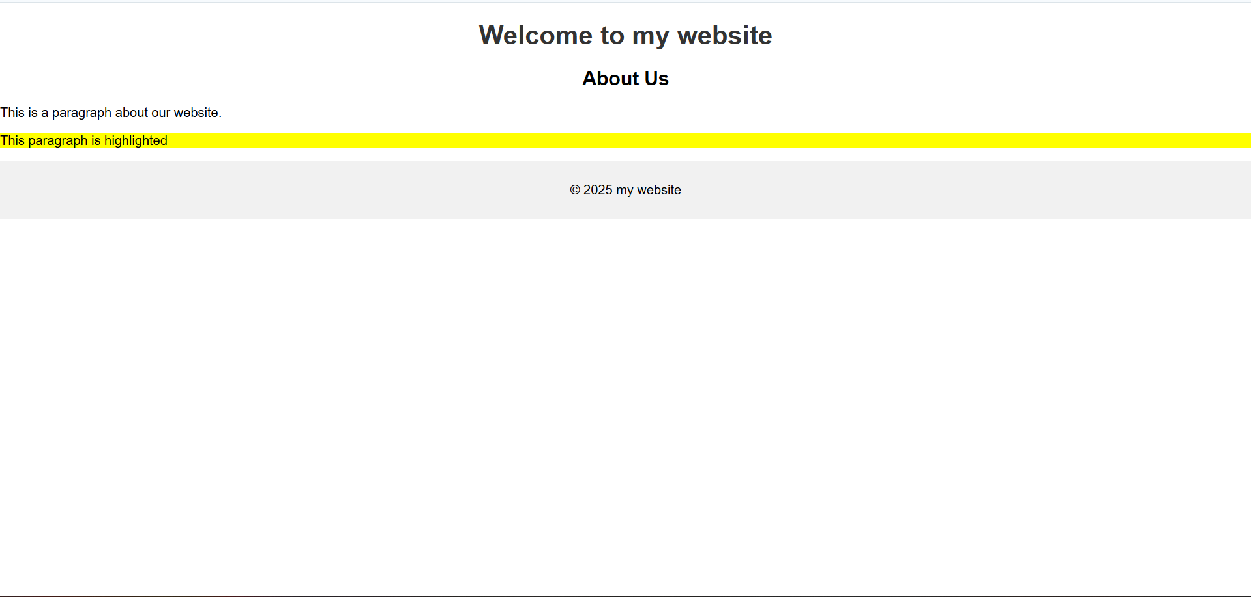

Question 2.

**CSS Box Model**

<!DOCTYPE html>

<html lang="en">

<head>

    <meta charset="UTF-8">

    <meta name="viewport" content="width=device-width, initial-scale=1.0">

    <link rel="stylesheet" href="Q2.css">

    <title>Box model</title>

</head>

<body>

    <div class="box">

        <h1>This is a heading</h1>

        <p>This is a paragraph inside the box model example. It demonstrates how margin, border, padding, and content work together.</p>

    </div>

</body>

</html>

CSS

body {

    font-family: Arial, sans-serif;

    background-color: #f0f0f0;

  margin: 0;

    padding: 20px;

}

.box {

    margin: 20px;

    border: 5px solid #007bff;

    padding: 15px;

    background-color: #ffffff;

    box-shadow: 0 4px 8px black;

}

h1 {

    color: #333;

}

p {

    color: #666;

}

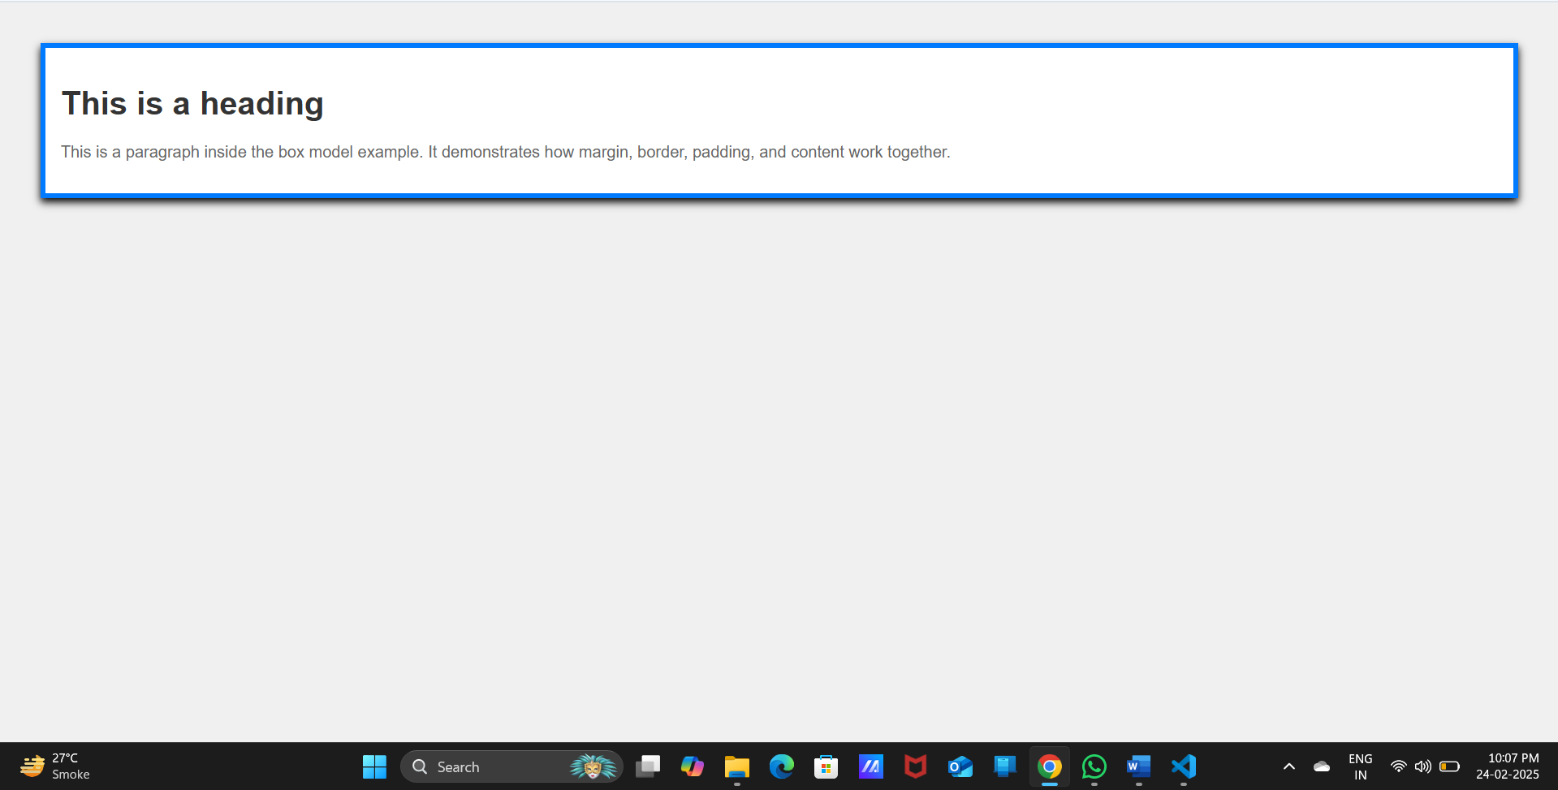

Question 3.

**Registration form**

<!DOCTYPE html>

<html lang="en">

<head>

    <meta charset="UTF-8">

    <meta name="viewport" content="width=device-width, initial-scale=1.0">

    <link rel="stylesheet" href="Q3.css">

    <title>Registration Form</title>

</head>

<body>

    <div class="container">

        <h2>Registration Form</h2>

        <form action="#" method="post">

            <label for="name">Name:</label>

            <input type="text" id="name" name="name">

            <label for="email">Email:</label>

            <input type="email" id="email" name="email">

            <div class="gender-group">

                <h3>Gender:</h3>

                <label>

                    <input type="radio" name="gender" value="male"> male

                </label>

                <label>

                    <input type="radio" name="gender" value="female"> Female

                </label>

                <label>

                    <input type="radio" name="gender" value="other"> Other

                </label>

            </div>

            <div class="interests-group">

                <h3>Interests:</h3>

                <label>

                    <input type="checkbox" name="interests"  value="reading"> Reading

                </label>

                <label>

                    <input type="checkbox" name="interests"  value="music"> Music

                </label>

                <label>

                    <input type="checkbox" name="interests"  value="sports"> Sports

                </label>

                <label>

                    <input type="checkbox" name="interests"  value="travel"> Travel

                </label>

            </div>

            <input type="submit" value="Submit">

            <input type="reset" value="Reset">

        </form>

    </div>

</body>

</html>

*CSS*

body {

    font-family: Arial, sans-serif;

    background-color: #f0f0f0;

    margin: 0;

    padding: 20px;

}

.container {

    max-width: 400px;

    margin: auto;

    background-color: #ffffff;

    padding: 20px;

    border-radius: 5px;

    box-shadow: 0 2px 5px black;

}

h2 {

    text-align: center;

    color: #333;

}

label {

    display: block;

    margin: 10px 0 5px;

}

input[type="text"],

input[type="email"] {

    width: 95%;

    padding: 10px;

    margin-bottom: 15px;

    border: 1px solid #ccc;

    border-radius: 4px;

}

.gender-group, .interests-group {

    border: 1px solid #ccc;

    border-radius: 4px;

    padding: 10px;

    margin-bottom: 15px;

}

.gender-group h3,

.interests-group h3 {

    font-weight: bold;

    margin-bottom: 10px;

}

input[type="submit"],

input[type="reset"] {

    background-color: #007BFF;

    color: white;

    border: none;

    padding: 10px 15px;

    border-radius: 4px;

    cursor: pointer;

    margin-right: 10px;

}

input[type="submit"]:hover,

input[type="reset"]:hover {

    background-color: #0056b3;

}

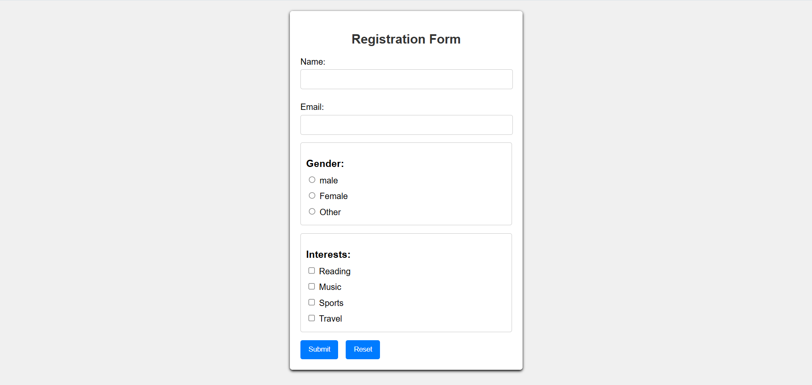

Question 4.

**Flexbox**

<!DOCTYPE html>

<html lang="en">

<head>

    <meta charset="UTF-8">

    <meta name="viewport" content="width=device-width, initial-scale=1.0">

    <link rel="stylesheet" href="Q4.css">

    <title>Flexbox</title>

</head>

<body>

    <div class="container">

        <div class="item">Item 1</div>

        <div class="item">Item 2</div>

        <div class="item">Item 3</div>

    </div>

</body>

</html>

CSS

body {

    font-family: Arial, sans-serif;

    background-color: #f0f0f0;

    margin: 0;

    padding: 20px;

}

.container {

    width: 80px;

    height: 200px;

    padding: 20px;

    border: 2px solid #007bff;

    margin: 20px auto;

    display: flex;

    justify-content: space-between;

    background-color: #ffffff;

}

.item {

    flex: 1;

    margin: 0 10px;

    padding: 20px;

    background-color: #007bff;

    color: white;

    text-align: center;

    border-radius: 5px;

}

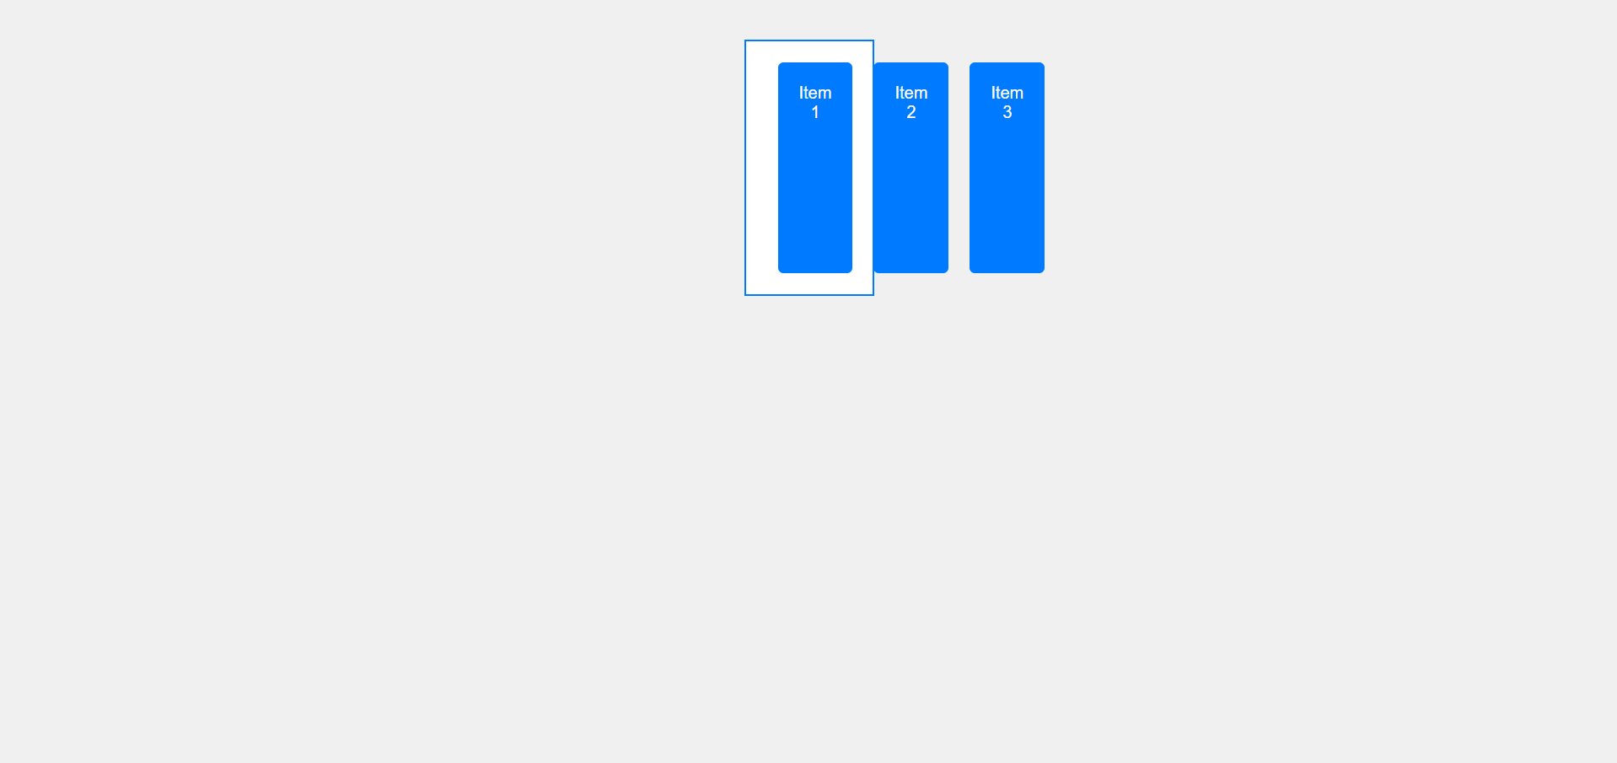

Question 5.

**Media Query**

<!DOCTYPE html>

<html lang="en">

<head>

    <meta charset="UTF-8">

    <meta name="viewport" content="width=device-width, initial-scale=1.0">

    <link rel="stylesheet" href="Q5.css">

    <title>Media Query</title>

</head>

<body>

    <div class="container">

        <div class="item">Item 1</div>

        <div class="item">Item 2</div>

        <div class="item">Item 3</div>

    </div>

</body>

</html>

*CSS*

body {

    font-family: Arial, sans-serif;

    background-color: #f0f0f0;

    margin: 0;

    padding: 20px;

}

.container {

    width: 80%;

    height: 200px;

    padding: 20px;

    border: 2px solid #007BFF;

    margin: 20px auto;

    display: flex;

    justify-content: space-between;

    background-color: #ffffff;

    box-shadow: 0 2px 5px rgba(0, 0, 0, 0.1);

}

.item {

    flex: 1;

    margin: 0 10px;

    padding: 20px;

    background-color: #007BFF;

    color: white;

    text-align: center;

    border-radius: 5px;

}

/* Media Queries */

@media (max-width: 600px) {

    body {

        background-color: #e0e0e0;

    }

    .container {

        flex-direction: column;

        height: auto;

    }

    .item {

        margin: 10px 0;

        font-size: 18px;

    }

    .item {

        text-align: center;

    }

}

@media (max-width: 400px) {

    .item {

        font-size: 16px;

    }

}

Before performing media query

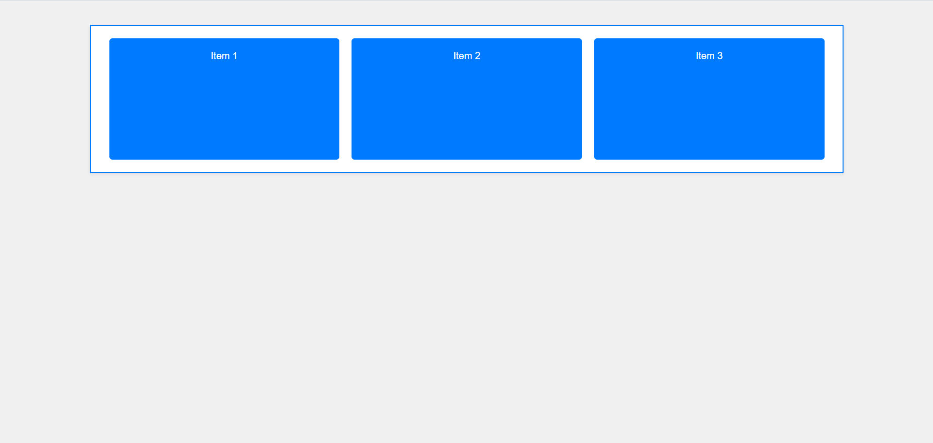

After performing media query

