NAME: Vedanshi Maulikbhai Dungarani

RollNo: 1017

Div: A

**Question 1.**

*HTML*

<!DOCTYPE html>

<html lang="en">

<head>

    <meta charset="UTF-8">

    <meta name="viewport" content="width=device-width, initial-scale=1.0">

    <title>Document</title>

    <link rel="stylesheet" href="Q1.css";

</head>

<body>

    <div class="grid-container">

        <div class="grid-item item1">1.</div>

        <div class="grid-item item2">2.</div>

        <div class="grid-item item3">3.</div>

        <div class="grid-item item4">4.</div>

        <div class="grid-item item5">5.</div>

        <div class="grid-item item6">6.</div>

        <div class="grid-item item7">7.</div>

        <div class="grid-item item8">8.</div>

        <div class="grid-item item9">9.</div>

    </div>

</body>

</html>

*CSS*

body {

    margin: 0;

    padding: 0;

    font-family: Arial, sans-serif;

    display: flex;

    justify-content: center;

    align-items: center;

    min-height: 100vh;

    background-color: #f0f0f0;

}

.grid-container {

    display: grid;

    grid-template-columns: repeat(3, 1fr);

    grid-template-rows: repeat(3, 120px);

    gap: 8px;

    width: 40%;

    /* max-width: 800px; */

}

.grid-item {

    display: flex;

    align-items: center;

    justify-content: center;

    color: white;

    font-size: 20px;

    font-weight: bold;

}

/* Original colors */

.item1 { background-color: #00aaff; } /* Light blue */

.item2 { background-color: #ff5500; } /* Orange */

.item3 { background-color: #4169ff; } /* Blue */

.item4 { background-color: #ffcc00; } /* Yellow */

.item5 { background-color: #9933cc; } /* Purple */

.item6 { background-color: #33cc33; } /* Green */

.item7 { background-color: #ff9966; } /* Light orange/salmon */

.item8 { background-color: #20b2aa; } /* Teal */

.item9 { background-color: #800000; } /* Maroon */

/* Media query to change colors when viewport width is less than 658px */

@media (max-width: 658px) {

    .item1 { background-color: #ff6600; } /* Dark orange */

    .item2 { background-color: #3399ff; } /* Blue */

    .item3 { background-color: #cc33cc; } /* Magenta */

    .item4 { background-color: #009933; } /* Green */

    .item5 { background-color: #ff3366; } /* Pink */

    .item6 { background-color: #663399; } /* Purple */

    .item7 { background-color: #33cccc; } /* Turquoise */

    .item8 { background-color: #ffcc00; } /* Yellow */

    .item9 { background-color: #cc6633; } /* Brown */

}

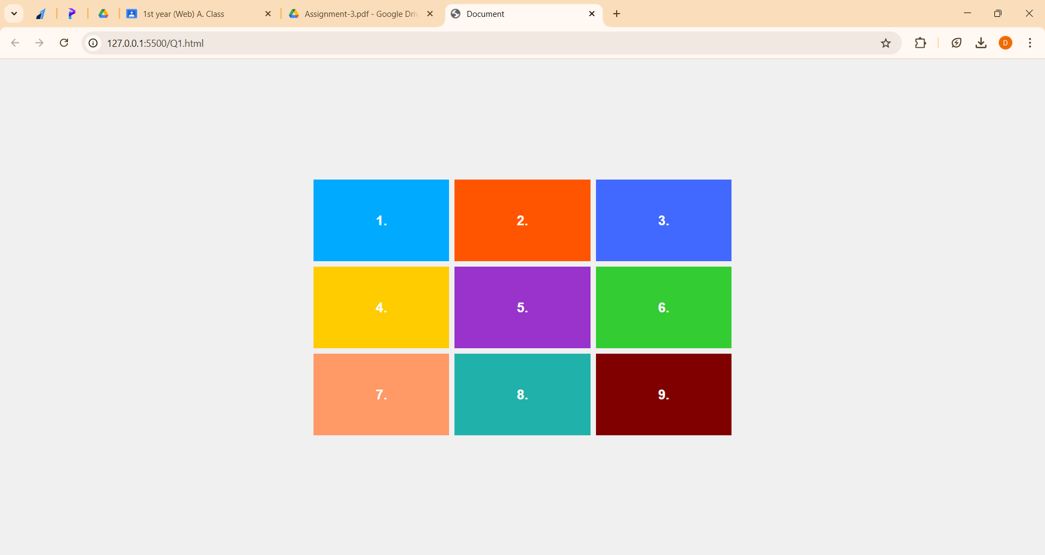

**Question 2.**

*HTML*

<!DOCTYPE html>

<html lang="en">

<head>

    <meta charset="UTF-8">

    <meta name="viewport" content="width=device-width, initial-scale=1.0">

    <title>Document</title>

    <link rel="stylesheet" href="Q2.css">

</head>

<body>

    <div>

        <h1>COLLEGE TIME TABLE</h1>

    <table>

        <tr>

            <th></th>

            <th>8:30-9:30</th>

            <th>9:30-10:30</th>

            <th>10:30-11:30</th>

            <th>11:30-12:30</th>

            <th>12:30-2:00</th>

            <th>2:00-3:00</th>

            <th>3:00-4:00</th>

            <th>4:00-5:00</th>

        </tr>

        <tr>

            <td class="day">MONDAY</td>

            <td>---</td>

            <td class="sub1">SUB1</td>

            <td class="sub2">SUB2</td>

            <td class="sub3">SUB3</td>

            <td rowspan="6" class="lunch">LUNCH</td>

            <td class="sub4">SUB4</td>

            <td class="sub5">SUB5</td>

            <td class="counselling">COUNSELLING CLASS</td>

        </tr>

        <tr>

            <td class="day">TUESDAY</td>

            <td class="sub1">SUB1</td>

            <td class="sub2">SUB2</td>

            <td class="sub3">SUB3</td>

            <td>---</td>

            <td class="sub2">SUB2</td>

            <td class="sub2">SUB2</td>

            <td class="library">LIBRARY</td>

        </tr>

        <tr>

            <td class="day">WEDNESDAY</td>

            <td class="sub1">SUB1</td>

            <td class="sub2">SUB2</td>

            <td class="swa">SWA</td>

            <td>---</td>

            <td colspan="3" class="lab">LAB</td>

        </tr>

        <tr>

            <td class="day">THURSDAY</td>

            <td class="sub1">SUB1</td>

            <td class="sub2">SUB2</td>

            <td class="sub3">SUB3</td>

            <td>---</td>

            <td class="sub2">SUB2</td>

            <td class="sub2">SUB2</td>

            <td class="library">LIBRARY</td>

        </tr>

        <tr>

            <td class="day">FRIDAY</td>

            <td class="sub1">SUB1</td>

            <td class="sub2">SUB2</td>

            <td class="sub3">SUB3</td>

            <td>---</td>

            <td class="sub4">SUB4</td>

            <td class="sub5">SUB5</td>

            <td class="library">LIBRARY</td>

        </tr>

        <tr>

            <td class="day">SATURDAY</td>

            <td class="sub1">SUB1</td>

            <td colspan=3 class="seminar">SEMINAR</td>

            <td class="sub4">SUB4</td>

            <td class="sub5">SUB5</td>

            <td class="library">LIBRARY</td>

        </tr>

    </table>

    </div>

</body>

</html>

*CSS*

*{

    margin: 0px;

    padding: 0px;

}

body{

    font-family: Arial, Helvetica, sans-serif;

    display: flex;

    justify-content: center;

    align-items: center;

    min-height: 100vh;

}

table{

    /* width: 100%; */

    border: 1px solid #000;

}

tr, td{

    border: 1px solid #000;

    text-align: center;

    height: 40px;

}

th{

    border: 1px solid #000;

    font-weight: normal;

    padding: 2px;

}

h1 {

    text-align: center;

    margin-bottom: 20px;

}

.sub1 {

    color: #4a7ee4;

    font-weight:800;

}

.sub2 {

    color: #ff9900;

    font-weight:800;

}

.sub3 {

    color: #9933cc;

    font-weight:800;

}

.sub4 {

    color: #33cc33;

    font-weight:800;

}

.sub5 {

    color: #ff3333;

    font-weight:800;

}

.swa {

    color: #ff3333;

    font-weight:800;

}

.seminar {

    font-weight: 800;

}

.counselling{

    font-weight: 800;

}

.library{

    font-family: 'Times New Roman', Times, serif

}

.lab{

    font-weight: 800;

}

.lunch{

    font-family: 'Times New Roman', Times, serif;

    writing-mode:vertical-lr;

    text-orientation: upright;

    letter-spacing: 2px;

}

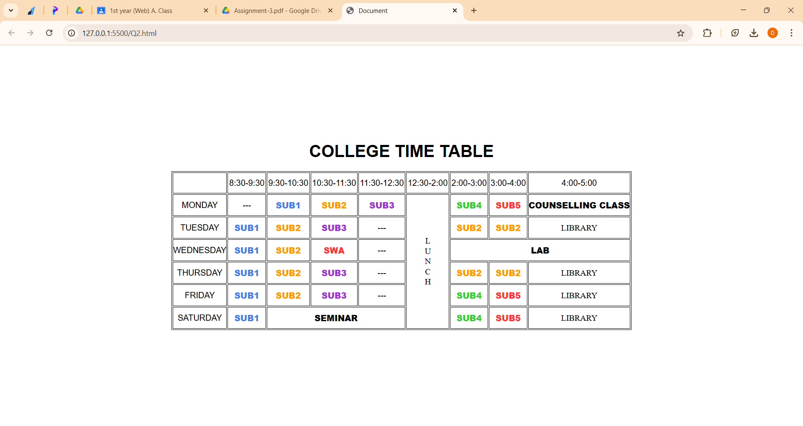

**Question 3.**

*HTML*

<!DOCTYPE html>

<html lang="en">

<head>

    <meta charset="UTF-8">

    <meta name="viewport" content="width=device-width, initial-scale=1.0">

    <title>Document</title>

    <link rel="stylesheet" href="Q3.css">

</head>

<body>

    <h4>My TimeTable</h4>

    <table>

        <tr>

            <th rowspan="2">Day</th>

            <th colspan="2">Session</th>

        </tr>

        <tr>

            <th>Schedule</th>

            <th>Course Name</th>

        </tr>

        <tr>

            <td>Sunday</td>

            <td>16:00-16:50</td>

            <td>Web Technology</td>

        </tr>

        <tr>

            <td>Sunday</td>

            <td>17:00-17:50</td>

            <td>Network Management</td>

        </tr>

        <tr>

            <td>Monday</td>

            <td>18:00-18:50</td>

            <td>IT Project Management</td>

        </tr>

    </table>

</body>

</html>

*CSS*

*{

    margin: 0px;

    padding: 0px;

}

body{

    text-align: center;

}

table{

    margin: 1px auto;

    border: 1px solid black;

}

h1{

    font-family: 'Times New Roman', Times, serif;

    text-align: center;

}

tr,td,th{

    border: 1px solid black;

}

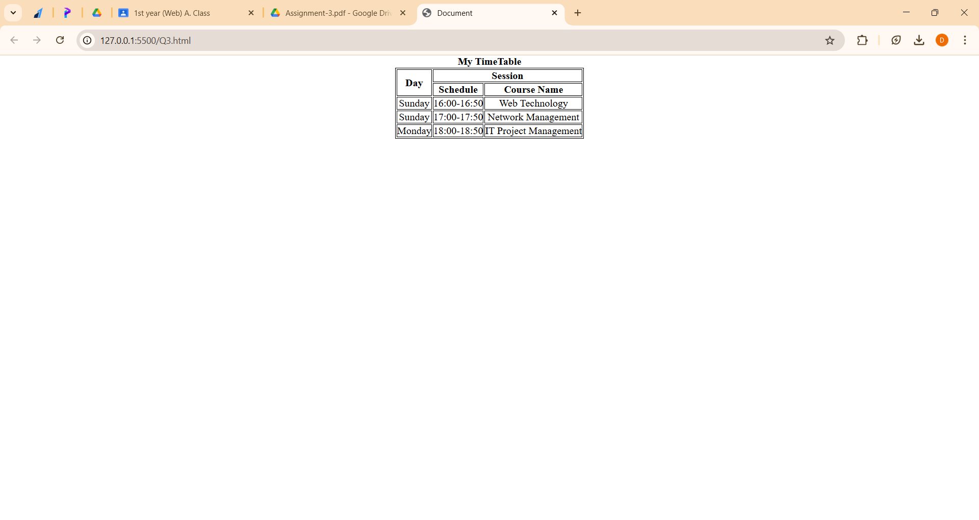

**Question 4.**

*HTML*

<!DOCTYPE html>

<html lang="en">

<head>

<meta charset="UTF-8">

<meta name="viewport" content="width=device-width, initial-scale=1.0">

<title>Document</title>

<link rel="stylesheet" href="Q4.css">

</head>

<body>

<div>This is a box.</div>

</body>

</html>

*CSS*

* {

    margin: 0;

    padding: 0;

    box-sizing: border-box;

}

body {

    display: flex;

    justify-content: center;

    align-items: center;

    height: 100vh;

    font-family: Arial, sans-serif;

}

div {

    width: 200px;

    height: 200px;

    background-color: #4a90e2;

    color: #fff;

    display: flex;

    justify-content: center;

    align-items: center;

}

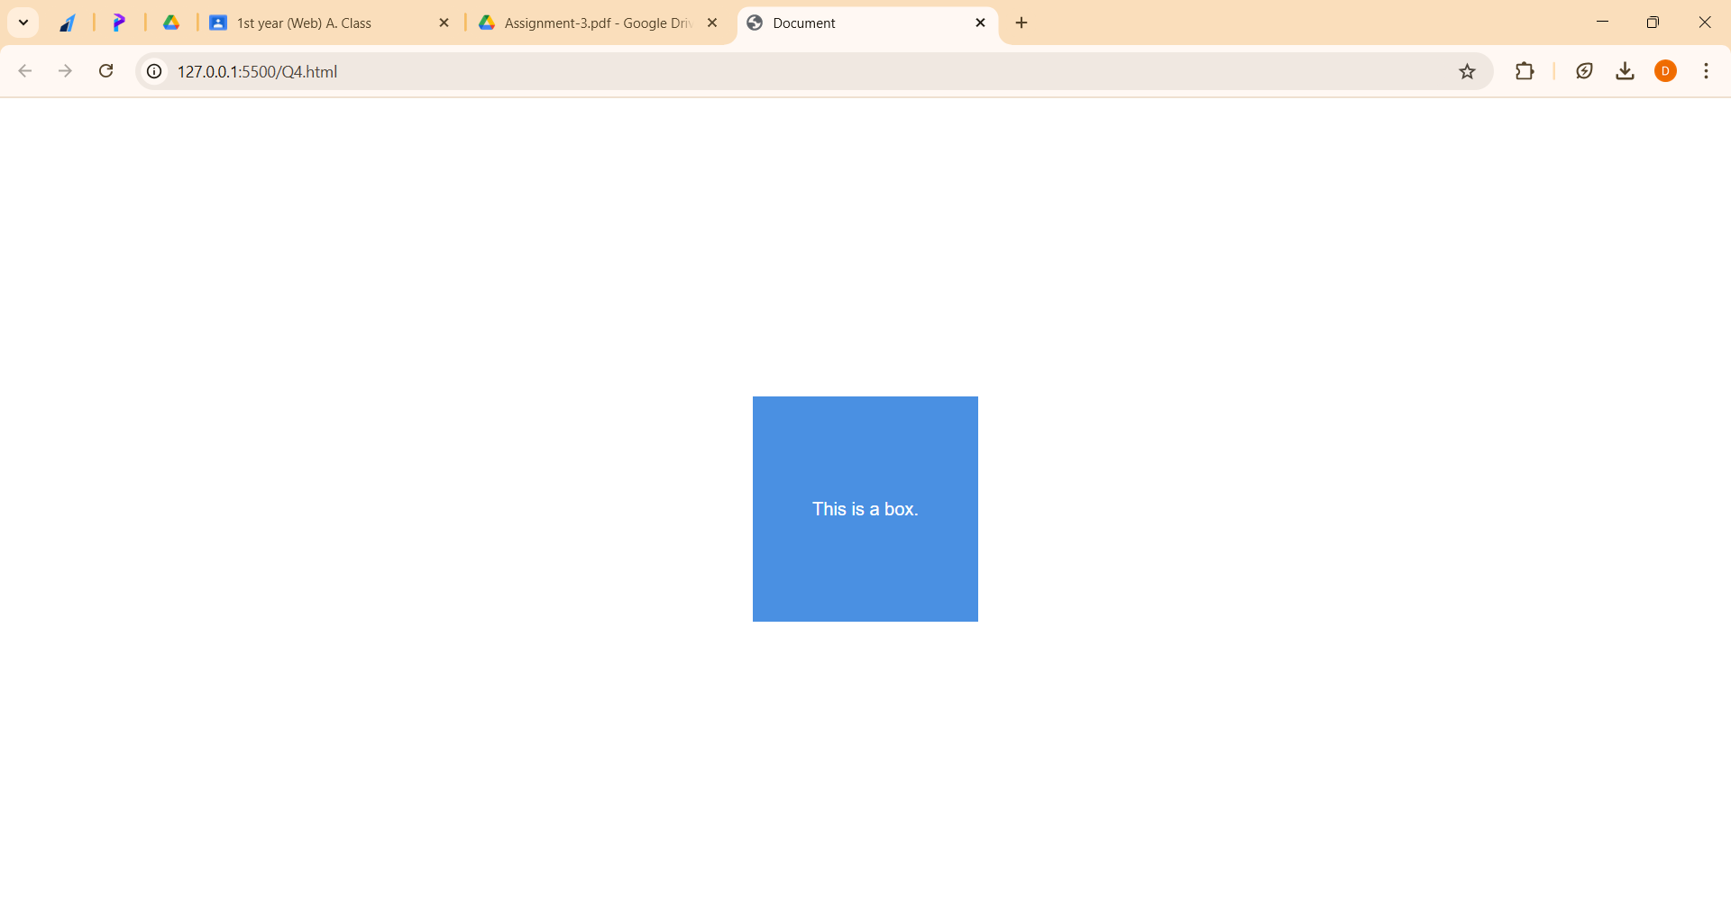

**Question 5.**

*HTML*

<!DOCTYPE html>

<html lang="en">

<head>

    <meta charset="UTF-8">

    <meta name="viewport" content="width=device-width, initial-scale=1.0">

    <title>Document</title>

    <link rel="stylesheet" href="Q5.css">

</head>

<body>

    <div id="navbar">

        <a id="logo">amazon.in</a>

        <a>Account</a>

        <a>MyCart</a>

        <a>ContactUs</a>

        <input type="text" placeholder="search Amazon.in">

        <button>search</button>

    </div>

</body>

</html>

*CSS*  
* {

    margin: 0px;

    padding: 0px;

}

#navbar {

    display: flex;

    justify-content: space-around;

    align-items: center;

    background-color: black;

    color: white;

    height: 60px;

    border-width: 4px;

    border-color: white;

    border-style:solid;

}

a {

    margin-right: 200px;

}

#logo {

    color: #f08804;

    font-size: 25px;

}

button {

    background-color: #f08804;

}

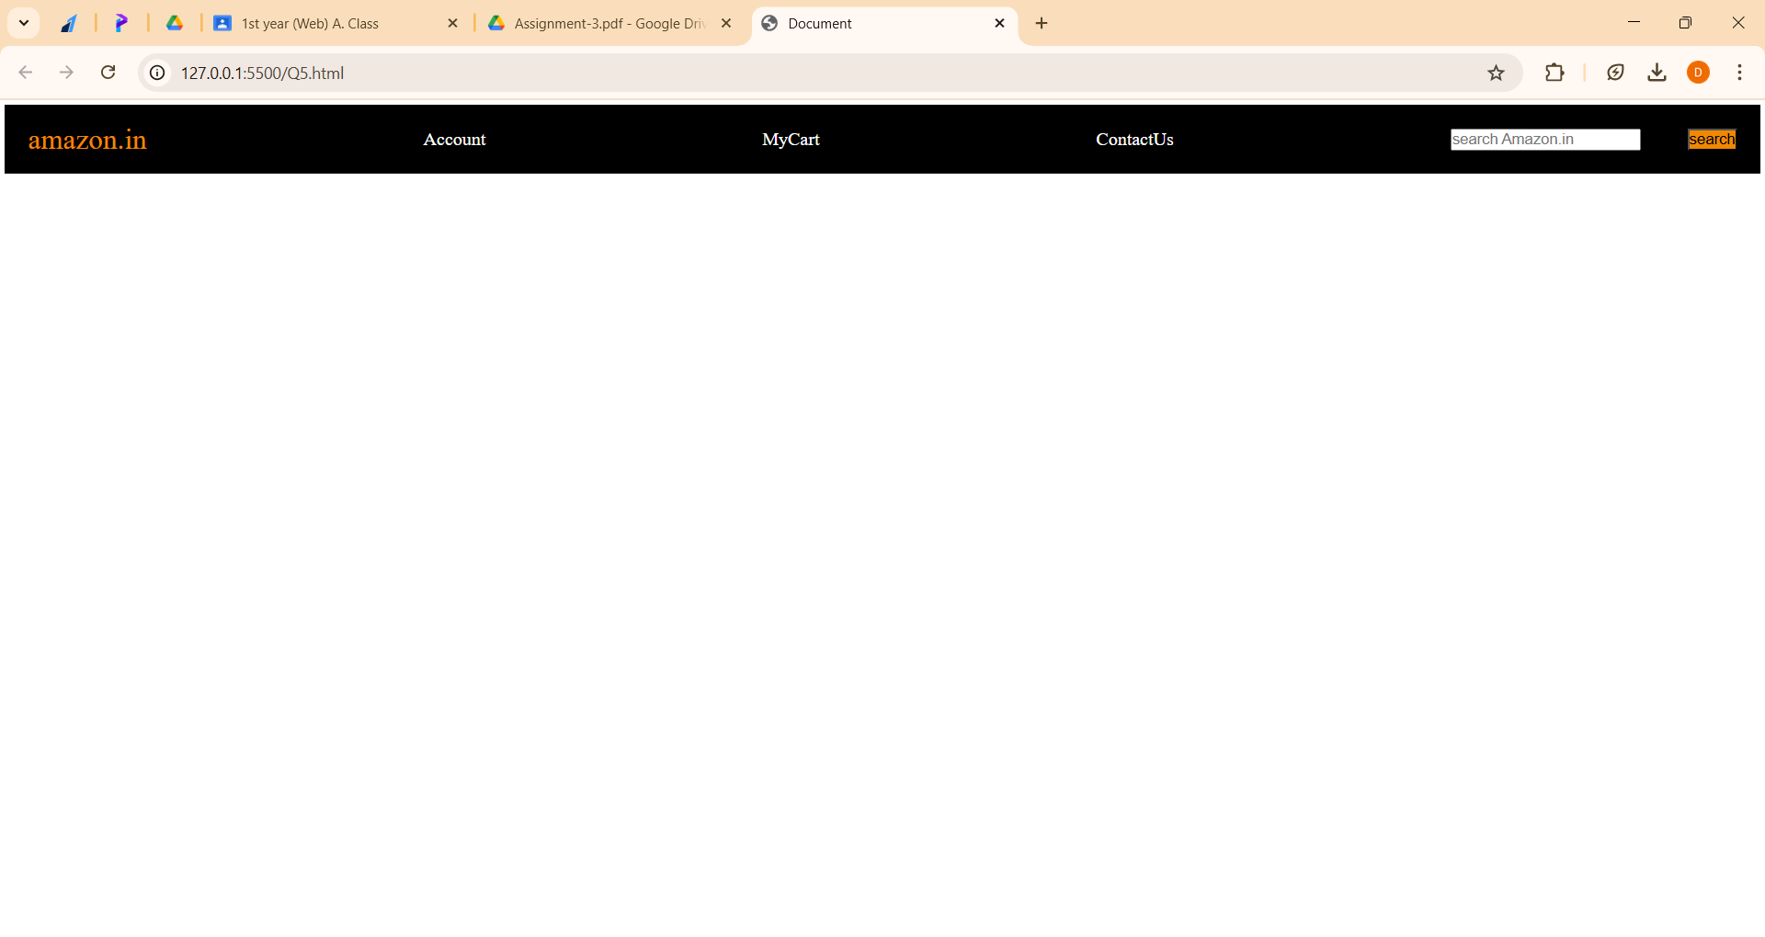

**Question 6.**

*HTML*

<!DOCTYPE html>

<html lang="en">

<head>

    <meta charset="UTF-8">

    <meta name="viewport" content="width=device-width, initial-scale=1.0">

    <title>Document</title>

</head>

<body>

    <!DOCTYPE html>

    <html lang="en">

    <head>

        <meta charset="UTF-8">

        <meta name="viewport" content="width=device-width, initial-scale=1.0">

        <title>Responsive Cards</title>

        <link rel="stylesheet" href="Q6.css">

    </head>

    <body>

        <div class="card-container">

            <div class="card">

                <img src="box5_image.jpg" alt="Image 1">

                <div class="card-description">

                    <h2>Card Title 1</h2>

                    <p>Lorem ipsum, dolor sit amet consectetur adipisicing elit. Facilis saepe consequuntur sint iusto amet vero accusamus, odit quam. Vel nemo cumque pariatur sint velit. Quibusdam distinctio quia fuga eveniet ducimus?</p>

                </div>

            </div>

            <div class="card">

                <img src="box6_image.jpg" alt="Image 2">

                <div class="card-description">

                    <h2>Card Title 2</h2>

                    <p>Lorem ipsum dolor sit, amet consectetur adipisicing elit. Vel vero a aliquid cum suscipit sapiente itaque nulla repudiandae soluta molestiae maiores quos accusantium, dolores ea autem unde? Pariatur, fuga enim!</p>

                </div>

            </div>

            <div class="card">

                <img src="box7_image.jpg" alt="Image 3">

                <div class="card-description">

                    <h2>Card Title 3</h2>

                    <p>Lorem ipsum dolor, sit amet consectetur adipisicing elit. Fuga et ex possimus officia aliquid minus eaque, aliquam nulla tempore debitis impedit cum tempora perferendis, sed doloribus expedita unde odit quod.</p>

                </div>

            </div>

        </div>

    </body>

    </html>

</body>

</html>

*CSS*  
* {

    margin: 0;

    padding: 0;

    box-sizing: border-box;

}

body {

    font-family: Arial, sans-serif;

    display: flex;

    justify-content: center;

    align-items: center;

    min-height: 100vh;

    background-color: #f0f0f0;

}

.card-container {

    display: flex;

    flex-wrap: wrap; /* Makes the cards responsive */

    justify-content: space-around; /* Spreads cards evenly */

    gap: 20px; /* Space between cards */

    width: 90%; /* Makes the container flexible */

}

.card {

    background-color: #ffffff;

    border: 1px solid #ccc;

    border-radius: 10px;

    overflow: hidden;

    box-shadow: 0 4px 8px rgba(0, 0, 0, 0.1);

    max-width: 300px; /* Maximum width for each card */

    flex: 1; /* Ensures all cards shrink/grow equally */

}

.card img {

    width: 100%; /* Ensures the image covers the card width */

    height: auto; /* Maintains aspect ratio */

}

.card-description {

    padding: 15px;

}

.card-description h2 {

    margin-bottom: 10px;

    font-size: 18px;

    color: #333;

}

.card-description p {

    font-size: 16px;

    color: #666;

}

@media screen and (max-width: 768px) {

    .card {

        flex: 1 1 calc(50% - 20px);

    }

}

@media screen and (max-width: 480px) {

    .card {

        flex: 1 1 100%;

    }

}

