**Topic-SQL Task 1**

# TABLE-Employee

# C:\Users\Vedanshi\Desktop\SQL Task-1\TABLE-Employee.PNG

1. Get First_Name from employee table using alias name “Employee Name”.

Ans: SELECT FIRST_NAME 'EMPLOYEE NAME' from employee ;

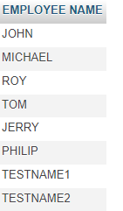

1. Get FIRST_NAME, Joining year, Joining Month and Joining Date from employee table.

Ans:- select FIRST_NAME,JOINING_DATE from Employee;

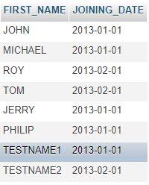

1. Get all employee details from the employee table order by First Name Ascending And Salary descending?

Ans: select * from Employee order by FIRST_NAME,SALARY DESC; 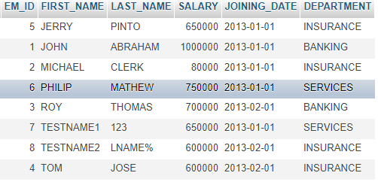

d) Get employee details from employee table whose first name contains „o‟.

Ans: select * from Employee where FIRST_NAME like 'o';

e)Get employee details from employee table whose joining month is “January”.

Ans: select * from Employee where JOINING_DATE like '2013-01-01';

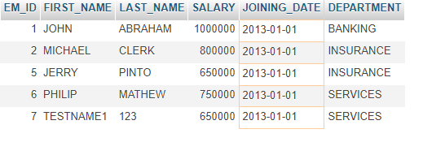

f) Get department, total salary with respect to a department from employee table Order By total salary descending.

Ans: SELECT DEPARTMENT , SALARY SALARY from employee GROUP BY DEPARTMENT order by SALARY DESC ;

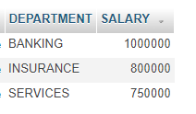

g) Get department wise maximum salary from employee table order by salary ascending?

Ans: SELECT DEPARTMENT , MAX(SALARY) from EMPLOYEE GROUP BY DEPARTMENT ORDER BY MAX(SALARY) ASC ;

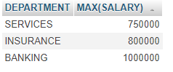

h) Select first name, incentive amount from employee and incentives table for those Employees who have incentives and incentive amount greater than 3000.

Ans: select FIRST_NAME,Incentive_Amount from EMPLOYEE,Incentive wherebSALARY>=3000;

i)Select 2nd Highest salary from employee table.

Ans: select MAX(SALARY) FROM EMPLOYEE where SALARY <(select MAX(SALARY)from EMPLOYEE);

C:\Users\Vedanshi\Pictures\sql q1 i.PNG

j) Select first_name, incentive amount from employee and incentives table for all Employees who got incentives using left join.

Ans:

k) Create View OF Employee table in which store first name, last name and salary only.

Ans:select FIRST_NAME , LAST_NAME, SALARY from employee;

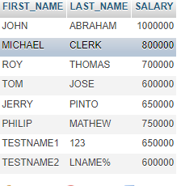

l) Create Procedure to find out department wise highest salary.

m) Create after Insert trigger on Employee table which insert records in view table.

**Task -2**

# TABLE-SALES PERSON

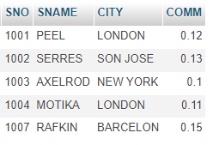

# TABLE-CUSTOMER

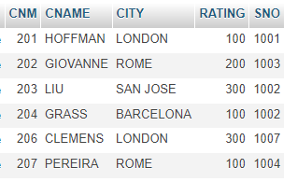

# TABLE-ORDER

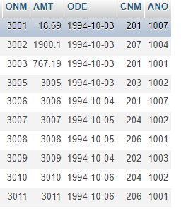

1. All orders for more than $1000.

Ans: SELECT * FROM `order` WHERE AMT > 1000 ;

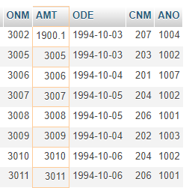

1. Names and cities of all salespeople in London with commission above 0.10.

Ans: SELECT SNAME ,CITY FROM `sales person` WHERE CITY='LONDON' AND COMM > 0.10 ;

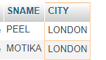

1. All salespeople either in Barcelona or in London.

Ans: SELECT SNAME ,CITY FROM `SALES PERSON` WHERE CITY='BARCELON' OR CITY='LONDON' ;

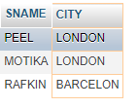

1. All salespeople with commission between 0.10 and 0.12. (Boundary values should be excluded).

Ans: SELECT * FROM `SALES PERSON` WHERE COMM >0.10 AND COMM < 0.12 ;

C:\Users\Vedanshi\Pictures\sql q1 d2.PNG

1. All customers with NULL values in city column.

Ans : SELECT * FROM customer WHERE CITY=NULL;

1. All orders taken on Oct 3Rd and Oct 4th 1994.

ANS: SELECT * FROM `order` WHERE ODE between '1994-10-03' AND '1994-10-04' ;

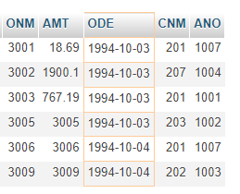

1. All customers serviced by peel or Motika.

Ans: SELECT * FROM `customer` WHERE SNO = 1001 OR SNO = 1004 ;

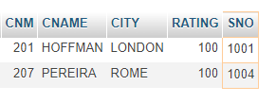

1. All customers whose names begin with a letter from A to B.

ANS: SELECT * FROM `customer` WHERE CNAME like 'A' OR CNAME like 'B' ;

1. All customers excluding those with rating <= 100 unless they are located in Rome.

Ans: SELECT * FROM `customer` WHERE RATING > 100 AND CITY='ROME' ;

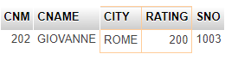

j) All orders except those with 0 or NULL value in amt field.

k) Count the number of salespeople currently listing orders in the order table.