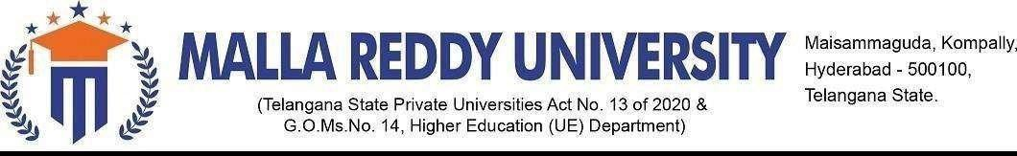

# DEPARTMENTOFCOMPUTERSCIENCE&ENGINEERING

B. Tech-II Year I Semester (R-23 A.Y. 2024-25)

APPLICATION DEVELOPMENT - JAVA EXPLORE (MR23-1CS0111)

# REVIEW–I

1. BATCH NO & SECTION: **AD-69 & Group-2**
2. DATE OF REVIEW :**27-08-24**
3. TITLE OF THE APPLICATION: **UNICART**
4. AREA OF APPLICATION: **MARKETING**
5. STUDENT NAMES & ROLL NUMBERS:
6. **G.VEDANSH REDDY 2311CS010244**
7. **K.SAI THARUNI 2311CS010290**
8. **V.TEJA 2311CS010677**
9. **V.SRINIVASA CHARI 2311CS010680**
10. **Y.MANASA 2311CS010708**
11. GUIDE NAME : Mrs .G . Devi Priya
12. .COMMENTS:

1.

2.

1. APPROVED FOR NEXT REVIEW (YES/NO) SIGNATURE OF GUIDE
2. REVIEW COMMITTEE NAMES & SIGNATURES.

1.

2.